Probability of Estimating a Large Earthquake Occurrence in Yangon and Its Surrounding Areas Using Historical Earthquake Data

Yin Myo Min Htwe ^{1,2}, SHEN WenBin ^{2,*}

- Department of Meteorology and Hydrology, Office Building No-5, Ministry of Transport, Naypyidaw, Myanmar
- Department of Geophysics, School of Geodesy and Geomatics, Wuhan University, 129 Luoyu Road, Wuhan, Hubei 430079, China
wbshen@sgg.whu.edu.cn; jianyou.wu007@gmail.com;

Abstract: Seismologists try to predict how likely it is that an earthquake will occur, with a specified time, place, and magnitude. Earthquake prediction also includes calculating how a strong ground motion will affect a certain area if an earthquake does occur. Estimation of the probability of a large earthquake occurring in the time interval is a difficult problem in the conventional method of earthquake prediction; it is given some distribution of observed interval times between large earthquakes. In this paper, it is estimated the interval time for the next large earthquake, assuming the conditional probability of an earthquake occurrence as a maximum, which can or cannot occur in the next 30, 50, 80, 100 and 200 years since the occurrence of the last large earthquake. The probability distribution of the earthquake model and the method of predicting the annual probability are applied by using historical data on large earthquakes in Yangon and its surrounding areas, and the probability of the future earthquake in the region is suggested. [Journal of American Science 2009;5(4):7-12]. (ISSN: 1545-1003).

Key words: probability, conditional probability of earthquake, annual probability

1. Introduction
Myanmar is one part of a long active tectonic belt extending from Himalayas to the Sunda Trench (Vigny et al. 2003; Myanmar Earthquake Committee, 2005). Historically, Myanmar has experienced many earthquakes (Maung Thein, 1994). The probabilistic prediction of the next large earthquake in Myanmar might be significant. Such a prediction must rely on the observations of phenomena which are related to large earthquakes. Prediction is usually probabilistic in nature to allow for observed differences in individual repeated times and uncertainties in the parameters used in the calculations.
Earthquake prediction is inherently statistical (Lindh, 2003). Although some people continue to think of earthquake prediction as the specification of the time, place and magnitude of a future earthquake; it has been clear for at least two decades that this is an unrealistic and unreasonable definition. Earthquake prediction is customarily classified into long-term, intermediate-term and short-term (Snieder et al. 1997; Committee on the Science of Earthquakes, 2003; and Sykes et al. 1999). Long-term earthquake prediction is to predict the possible shocks occurring in a special region for the period of several years to over ten years in the future (Su Youjing, 2004). The reality is that the earthquake prediction starts from long-term forecasts of place and magnitude, with very approximate time constrains, and progresses, at least in principle, to a gradual narrowing of the time window as data and understanding permit. Thus, knowledge of present tectonic setting, historical records, and geological records are studied to determine locations and recurrence intervals of earthquakes (Nelson, 2004). A method of long-term prediction, which has been studied extensively in connection with earthquakes, is the use of probability distributions of recurrence times on individual faults or fault segments (Ferraes, 2003).
Two kinds of time-dependent models have been proposed: time-predictable and slip-predictable (Ferraes, 2003). In a time-predictable pattern the time between events is proportional to the magnitude of the preceding event, and therefore the date but not the magnitude of the next event can be predicted (Zoller et al, 2007). In a slip-predictable model the time between events is proportional to the magnitude of the following event, and the magnitude of the next event can be predicted, but the date cannot be predicted. In this model, the probability of earthquake occurrence during a period of interest, which is referred to as conditional probability, is related to the elapsed time since the last major event and the average recurrence interval between major earthquakes. In time-interval based prediction, it is given some kind of assumed distribution of interval times and knowing the elapsed time since the last large event.

2. Probability Distribution of Earthquake Models
The probability distribution curves have three different models: characteristic earthquake model, time-predictable model and random model (Martel, 2002). The probability of events depends on the probability density distribution that is sampled and the sampling method.
In fact, we can not tell exactly when an earthquake occurs, because we do not have a theoretical model that successfully describes earthquake recurrence, so we adopt probability distributions based on the earthquake history which for most faults is short (only a few recurrences) and complicated. As a result, various distributions grossly consistent with the limited history are used and can produce quite different estimates.
Time-predictable model states that an earthquake occurs when the fault recovers the stress relieved in the most recent earthquake (Murray et al, 2002). Unlike time-independent models (for example, Poisson probability), the time-predictable model is therefore often preferred when adequate data are available, and it is incorporated in hazard predictions for many earthquake-prone regions. Time-predictable model is dividing the slip in the most recent earthquake by the fault slip rate in approximating the expected time to the next earthquake and only can predict the time of the next earthquake, not the magnitude of the next earthquake.

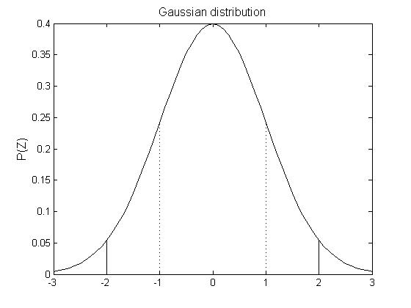
Figure 1 Gaussian or normal (bell curve) distribution.

Gaussian distribution approach can be used with any assumed probability density function. The simplest is to assume that the earthquake recurrence follows the familiar Gaussian or normal (bell curve) distribution
(1)
This distribution is often described by using the normalized variable that describes how far it is from its mean in terms of the standard deviation.

3. Conditional Probability
The purpose of this section is to provide a brief synopsis of conditional probability of event occurrence,, and to discuss some applications of conditional probability. The equations of conditional probability are applied to predict the occurrence of the next large earthquake in Yangon and its surroundings.
Given an interval of years since the occurrence of the previous event, the probability of failure can be determined before time.The conditional probability, which is the probability that an earthquake occurs during the next interval, is
(2)
In terms of the probability density of , say, we have
(3)
and
(4)
Substituting equations (3) and (4) in equation (2), one gets
(5)
Equation (5) provides a reasonable approach for estimating the seismic hazard on a fault or fault-segment and makes the underlying probability distribution of the earthquake recurrence time intervals normal (Ferraes, 2003).

4. Prediction of the annual probability of a large earthquake
There are total 22 large earthquakes from 527 AD to 1930 AD happened in and around the Yangon City of Myanmar (Myanmar Earthquake Committee, 2005). The data set includes 527, 615, 652, 736, 813, 875, 986, 1059, 1161, 1269, 1286, 1348, 1396, 1457, 1464, 1570, 1644, 1757, 1768, 1912, 1917 and 1930.
Based on the time period between the oldest event listed above and the 1930 event, the average (mean) recurrence interval for large earthquakes can be calculated as follows:
Mean (1930-527) years/ 21number
Recurrence = of recurrence interval (6)
Interval
= 67 years.
The earthquakes are not occurring at a perfectly regular pace. The recurrence times between each successive pair of earthquakes are 88, 37, 84, 77, 62, 111, 73, 102, 108, 17, 62, 48, 61, 7, 106, 74, 113, 11, 144, 5, 13.
When we calculate the standard deviation of the 21 recurrence intervals associated with the 22 earthquakes, the following equation is used
(7)
whereis the standard deviation, is the recurrence time between a given pair of events, is the mean recurrence interval, and n is the number of recurrence intervals. Thus, the standard deviation is 40 years.
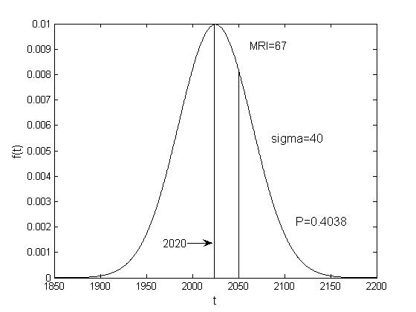
Figure 2 Probability of an Earthquake.

Assuming target year is 2020, how many years have elapsed since the last large earthquake in Myanmar is expressed as
2020-1930 = 90 years (8)
The mean recurrence interval of the years:
90-67 = 23 years (9)
The mean recurrence interval of the standard deviations:
23years/40years = 0.58 standard deviations (10)
We will now suppose the distribution of the recurrence intervals is normally distributed about the mean recurrence interval. On a supplied paper, plot the equation
(11)
where is normal distribution, is time, is the mean, and is the standard deviation. Plot this for 0 ≤ t ≤ 250 years.
Suppose the year is 2020–23 years (0.58 standard deviations) of the mean recurrence interval. In 30 years it would have 7 years (or 7/40 = 0.18 standard deviations) past the mean recurrence interval. The area under the probability density curve from the mean to 0.58 standard deviations of the mean is 0.219. The area under the probability density curve from the mean to 0.18 standard deviations past the mean is 0.0714. The area under the probability density curve from 0.58 standard deviations of the mean to ∞ is 0.5 + 0.219. So:
P= (0.219+0.0714)/ (0.5+0.219) = 40% (12)
Now suppose we consider the earthquakes to be distributed randomly (i.e. they are characterized by a Poisson distribution). Then the probability of an earthquake occurrence does not depend on how much time has elapsed since the last earthquake. The probability of “x” number of earthquakes occurring in a given interval of time t is given by:
(13)
where “v” is the average rate of occurrence. So if the average recurrence interval is 67 years, the probability of getting 1 event in 67 years is:
(14)
= e⁻¹ = 37 %
The probability of getting one event in 30 years is:
(15)
=
= 29 %
Thus the probability of getting no event in 30 years is:
(16)

where “” is the probability of getting no event.
Similarly, the probability of getting one event and no event in 50 years, 80 years, 100 years and 200 years is listed in table 1.
Finally, we have found the probability of getting one event and no event for next 30 years, 50 years, 80 years, 100 years and 200 years as shown by figures 3 and 4.
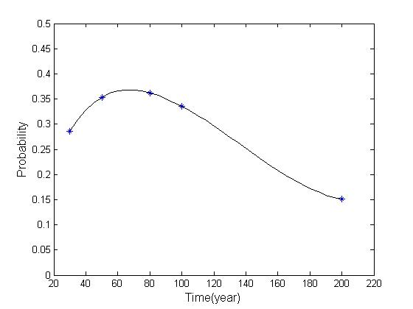
Figure 3 Probability of getting one event.
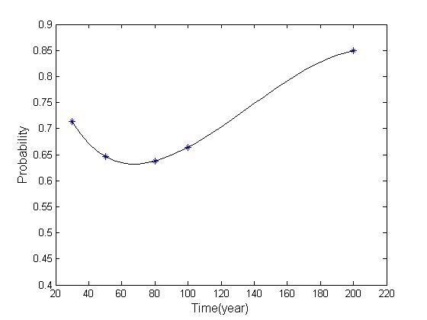
Figure 4 Probability of getting no event.

Table 1. The probability of getting event
No | Time  (Years) | Probability of getting  one event (%) | Probability of getting  no event (%)
1 | 50 | 35 | 65
2 | 80 | 36 | 64
3 | 100 | 34 | 66
4 | 200 | 15 | 85

5. Conclusion
We have determined a time interval for the occurrence of the next large earthquake in Yangon City and its surroundings, using the conditional probability of earthquake occurrence and the annual probability method based on the historical earthquake data. First, the probability predictions are provided for next 30 years by using the prediction of the annual probability method, and then the predictions for next 50 years, 80 years, 100 years and 200 years. The prediction of the annual probability of “the big one” method tells the occurrence of the probability of the next large earthquake in 30 years, 50 years, 80 years, 100 years and 200 years in Yangon and its surrounding areas. In this paper, the time predictable pattern is used and consequently the time of event occurrence is estimated.

Acknowledgement:
Y.M.M. Htwe expresses his sincere gratitude to U Tint Lwin Swe, Engineering Geology Department, Yangon Technological University, Myanmar, for his persistent support in this study. This study is supported by the Natural Science Foundation of China (Grand No.40637034; 40574004)

Correspondence to:
WenBin Shen, Department of Geophysics, School of Geodesy and Geomatics, Wuhan University, 129 Luoyu

Road, Wuhan 430079, China.
Tel.: 0086-027-68778857; Fax: +86-027-68778825
E-mail:; wbshen@sgg.whu.edu.cn;
or Yin Myo Min Htwe
Department of Meteorology and Hydrology
Office Building No-5, Ministry of Transport,
Naypyidaw, Myanmar
Telephone: 0095-067-411250;
E-mail: jianyou.wu007@gmail.com

References
[1] Vigny C, Socquet A., Rangin C, Chamot-Rooke N, Pubellier, M, Bouin M N, Bertrand G., Becker M. Present-day crustal deformation around Sagaing fault, Myanmar. J. Geophys. Res. 2003, 108(B11): 2533.
[2] Myanmar Earthquake Committee. Introduction to the Sagaing fault. Myanmar Earthquake Bureau, 2005.
[3] Maung Thein. Myanmar and earthquake disaster. Department of Geology, Yangon Art and Science University, 1994.
[4] Lindh AG.. The nature of earthquake prediction. U. S. Geological Survey, 2003.
[5] Snieder R, Van Eck T. Earthquake prediction: A political problem? Department of Geophysics, Utrecht University, Netherlands, 1997.
[6] Committee On The Science Of Earthquakes. Living on an active Earth: Perspectives on earthquake science. National Research Council of the National Academies 2003: 54-65.
[7] Sykes LR, Shaw BE, Scholz CH. Rethinking earthquake prediction, Pure Appl. Geophys. 1999, 155: 207- 232.
[8] Su Y. A brief introduction on development and scientific thoughts of earthquake prediction. Developments of Earthquake Prediction 2004: Part-2.
[9] Nelson SA. Earthquake prediction and control. Lecture Notes, Tulane University 2004.
[10] Ferraes SG.. Probabilistic prediction of the next large earthquake in the Michoacan fault-segment of the Mexican subduction zone. Mexico Geofisica Internacional 2003; 42(1): 69-81
[11] Zoller G., Ben- Zion Y., Holschneider, M. and Haiz, S. Estimating recurrence times and seismic hazard of large earthquakes on an individual fault. Geophys. J. Int. 2007; 170: 1300-1310
[12] Martel S. Recurrence intervals and probability (18). University of Hawaii, 2002.
[13] Murray J, Segall P. Testing time-predictable earthquake recurrence by direct measurement of strain accumulation and release. Nature 2002; 419: 287-291.

ISSN: 1545-1003
The journal of American Science
Normal paper structure for the Journal of American Science:
Each manuscript is suggested to include the following components but authors can do their own ways:
- The complete article title.
- Each author’s full name; institution(s) with which each author is affiliated, with city, state/province, zip code, and country; and the name, complete mailing address, telephone number, facsimile number (if available), and email address for all correspondence.
- You must put at least one email address under the authors’ address.
- Abstract: including Background, Materials and Methods, Results, and Discussions, 100-300 words preferred.
- Key Words.
- Introduction.
- Materials and Methods.
- Results.
- Discussions.
- Acknowledgments.
- Correspondence to.
- References.

Description of Manuscript Preparation and Format:
- Software: Microsoft Word file.
- Font: Normal, Times New Roman, 10 pt, single space.
- Indent: 8 spaces in the beginning of each new paragraph.
- Manuscript: Don’t use “Footnote” or “Header and Footer”.
- Spelling check: Do spelling check when you finish.
- Color: Email and website addresses are blue, and all other contents are black.
- Abstract: 100-300 words are preferred, and remember to add “[The Journal of American Science. 2009;x(x):xx-xx]. (ISSN 1545-1003)” in the end of abstract.
- Page setup: Margins: top 72 pt, bottom 72 pt. left 72 pt, right 72 pt.
- Paper size: Letter, width 612 pt, height 792 pt.
- Layout: Header 36 pt, Foot 36 pt.
- Title: Use Title Case in the title and subtitles, e.g. “Debt and Agency Costs”.
- Figures and Tables: Use full word of figure and table, e.g. “Figure 1. Annul Income of Different Groups”, Table 1. Annual Increase of Investment”.
- References: Cite 10-20 references preferred, by “last name, year”, e.g. “(Smith, 2003)”. References should include all the authors’ last names and initials, title, journal, year, volume, issue, and pages etc.
- Reference Examples: Journal Article: Hacker J, Hentschel U, Dobrindt U. Prokaryotic chromosomes and disease. Science 2003;301(34):790-3.
- Book: Berkowitz BA, Katzung BG. Basic and clinical evaluation of new drugs. In: Katzung BG, ed. Basic and clinical pharmacology. Appleton & Lance Publisher. Norwalk, Connecticut, USA. 1995:60-9.
- Insert page number by bottom / center.
- Header for odd: Marsland Press Journal of American Science 2009;x(x):xx-xx.
- Header for even: short title Family name of the first author, et al.
- Footer: http://www.americanscience.org americansciencej@gmail.com.
Submission Address: sciencepub@gmail.com, editor@sciencepub.net, Marsland Press, P.O. Box 21126, Lansing, Michigan 48909, The United States, 347-321-7172.

