Residues of Organochlorine Pesticides in Vegetables from Deyang and Yanting Areas of the Chengdu Economic Region, Sichuan Province, China

Odhiambo Joshua Owago¹*, Shihua Qi*¹, Xing Xinli¹, Zhang Yuan¹ and Muhayimana Annette Sylvie¹

¹School of Environmental Studies and MOE Key Laboratory of Biogeology and Environmental Geology, China University of Geosciences, Wuhan, 430074, China

joowago@hotmail.com; shihuaqi@cug.edu.cn

Abstract: Residual levels of organochlorine pesticides (OCPs) were determined in 34 samples of 19 varieties of vegetables collected from selected sites around Deyang city and Yanting County, Southwest China, in June and September 2007. The analytical method included soxhlet extraction with a mixture of dichloromethane and acetone (2:1 vv). Clean-up was done on superposed layers of alumina/silica gel (1:2 v/v) impregnated with concentrated sulfuric acid. The determinations were done using a gas chromatograph with electron capture detector (GC-ECD). The compounds targeted are: isomers of hexachlorocyclohexane or HCHs (α-HCH, β-HCH, γ- HCH or lindane and δ-HCH); isomers/metabolites of dichloro-diphenyl-trichloroethane (DDTs) namely p,p¹-dichloro-diphenyl-dichloroethylene (p,p¹-DDE), p,p¹-dichloro-diphenyl-dichloroethane ( p,p¹-DDD), p,p¹- and o,p¹-dichloro-diphenyl-trichloroethane ( p,p¹-DDT and o,p¹-DDT). The results indicated that all the vegetable samples had some levels of one or more OCPs in them. Residues of DDTs were found in 94.12% while HCHs were in 91.18% of all the samples analyzed indicating high incidence of these xenobiotics in the vegetables from the areas investigated. Among the HCH isomers, γ- HCH was the most prevalent but β-HCH was the most abundant indicating both old and fresh inputs of HCHs. DDT metabolites p,p-DDE and p,p’-DDD were more prevalent than the parent material, p,p-DDT suggesting minimal fresh inputs of DDT. The OCPs residue levels in the vegetables were generally low (≤ 1.3 ng/ g wet weight) except in one sample of green pepper (Capsicum annum L) in which the concentrations (ng/g wet weight) of o,p’-DDT (82.59), p,p’-DDE (61.41) and total DDT (148.44), all exceeded the Chinese Extraneous Maximum Residue Limit of 50 ng/ g for DDTs in vegetables according to the guidelines of the Chinese quality standard for food (GB 2763-2005). Considering the industrial and agricultural growth around the areas investigated, a deeper investigation and regular ecological and foodstuff monitoring is recommended.
[Journal of American Science 2009;5 (4):91-100]. (ISSN: 1545-1003).

Key words: Vegetables, Organochlorine pesticides, Deyang, Yanting

1.0 Introduction

Oraganochlorine pesticides (OCPs) are among the xenobiotics that have become constituents of the biosphere due to their great use all over the world, stability in several natural conditions and mobility in the environment. In china, large quantities of OCPs, particularly hexachlorocyclohexane (HCH) and dichlorodiphenyltrichloroethane (DDT) were produced and used in agriculture and public health until 1983. Therefore, the occurrence of excessive OCPs residues in Chinese environments is believed to be serious and widespread and has over the years sustained considerable research interests in elucidating environmental contamination status and human exposure in the country. Sichuan province is one of the leading agricultural regions in China and it is an important Southern China vegetable production base (Chen et al, undated, online: http://www.vegsys.nl/files/9f9e444ac40c06e16331d51eb1329c20.pdf). To keep the pest effects at economical levels, obviously, Sichuan province has been a major consumer of pesticides including OCPs. It was estimated that between 10,000 and 20,000 metric tons (MT) of technical HCH and 16 000 MT of DDT were used in Sichuan during the period 1951-1984 and these were among the highest usages in China (Li et al, 1998; Liu et al, 2006). The extent of usage suggests that environmental contamination could also be widespread; however, the magnitude and distribution of this is only just beginning to be accurately characterized.

A survey recently undertaken in the Chengdu Economical Region (CER) which is the main agricultural and industrial region in Sichuan, has shown that OCPs were still detectable in all surface soils despite having been forbidden more than 20 years in China (Xing et al, 2009). Although the OCPs residue levels measured were generally low, relatively elevated ∑DDTs residue levels (above 50 ng/g, the background DDT and HCH residue levels in soil, according to the Chinese environmental standard, GB15618-1995). This called for explanations about the possible occurrence of OCPs in food crops grown in these soils since several crops are known to accumulate OCP in edible parts up to critical levels, and contribute to dietary intake of the contaminants. It is important to note that a national dietary intake survey showed that Sichuan was one of the regions in China with high dietary intakes of DDT (Chen and Gao, 1993). In addition, Li et al ( 2006) found a high prevalence of β-HCH (91.2%), p,p’-DDE (92.1%) and p,p’-DDT (91.2%) as well as positive correlation between high levels of these compounds in the subjects’ sera and breast cancer, particularly among premenopausal women in the province. Therefore, information on OCPs residue levels is of paramount importance to the consumers.
This paper presents the results of the preliminary survey carried on the residue levels of oragnochlorine pesticides in Deyang and Yanting (Sichuan) vegetables. Information on residue levels in vegetables is important for the protection of human health in China because vegetables are important components of the Chinese diet in terms of quantities consumed (Chen and Gao, 1993). Therefore, even low residue levels of toxic contaminants spell high danger given the large quantities of these food substances consumed at a time. Moreover, vegetables are consumed directly without much processing or storage. Vegetables were also selected for this survey because they were the most widely distributed food plants in the study area.

2.0 Materials and Methods

2.1 Description of the Study Areas

The sampling spots are located within two areas, Deyang and Yanting in the Chengdu Economic Region (CER), Sichuan Province. The names of the areas were for the purposes of this report and are not restricted to administrative boundaries with same names.
Deyang sampling area is located at the central part of the CER, western edge of Sichuan Basin between the latitudes: 30⁰ 57’ 56 N and 31⁰ 21’ 00” N and between longitudes 104⁰ 05’ 40” E and 104⁰ 15’ 32”E. It includes selected sites in Pengzhou County of Chengdu City prefecture; Shifang, Mianzhu and Guanghan counties in Deyang City. This is typically a hilly area that falls within a subtropical humid climate zone and have continental monsoon climate. The average annual temperature is about 15.7⁰C (which means no extreme temperatures in summer and winter) while annual precipitation average here is about 1053mm (Beijing review online: http://www.bjreview.com.cn/special/sichuan_earthquake/txt/2008-06/24/content_129013.htm. The soil types are varied, mainly paddy, purple soil, yellow earth. The soils are acidic to neutral (pH: 5.5-7.5) with organic matter content 0.6-4.0%. (Xing et al, 2009). Arable land forest and non-arable land evenly share the total land area. The Mianzhu area is an important vegetable production area in Sichuan. The main vegetables grown are: Pepper, celery, eggplant, tomato, lettuce, four season beans, cowpea, Chinese leaf, rape, cucumber, bitter gourd, rape shoot (Chen et al., undated).
Yanting area in Yanting County of the Mianyang City prefecture falls within the Northeastern CER, central Sichuan Basin or northern part of Sichuan Province between the latitudes 31⁰ 13’ 04” N and 31⁰ 19’ 58”N and longitudes 105⁰ 19’ 53”E and 105⁰ 57’ 56”E. The annual average temperature in Yanting is 17-18⁰C and precipitation 800 -1000 mm, with most of the precipitation occurring during the rainy season from May through August. The soil is classified as purple soil- a lithologic soil (Regosols in FAO Taxonomy) (CERN: http://www.cern.ac.cn:8080/stations/second.jsp?id=432). The soil organic matter contents are low (0.6-2.0%) but pH high (8.0-8.6) (Xing et al., 2009). Steeper hills are forested, flat or gentle slopes are used for crops and lowlands used for irrigated paddy. The main crops are rice, wheat, corn, rape and sweet potato.

2.2 Site Selection and Sampling
The sampling sites were selected following the results of our soil OCPs survey (Xing et al, 2009) that covered the entire Chengdu economic region. Crop samples were taken from the farmlands whose soils had been found with relatively elevated levels of OCPs (≥ 10 ng g⁻¹ dry weights). A global positioning system (GPS) instrument was used to locate sampling locations. Vegetables found growing on the sites or within the immediate vicinity were eligible for sampling. Since a larger area in Deyang than in Yanting had been found to contain relatively elevated soil OCP residue levels ((≥ 10 ng g⁻¹ dry weight), more samples were collected from the former (N=24) than from the latter Yanting area (N=10).
Vegetables were collected directly from the fields to ensure that they originated within the study areas. The samples were collected on June 11-12 (spring vegetables) and September 22-26 (Autumn vegetables) in the year 2007. Each sample was sealed in a clean polythene sampling bag, and immediately transported to the laboratory where they were kept refrigerated at 4⁰C until analysis.

(a) (b)
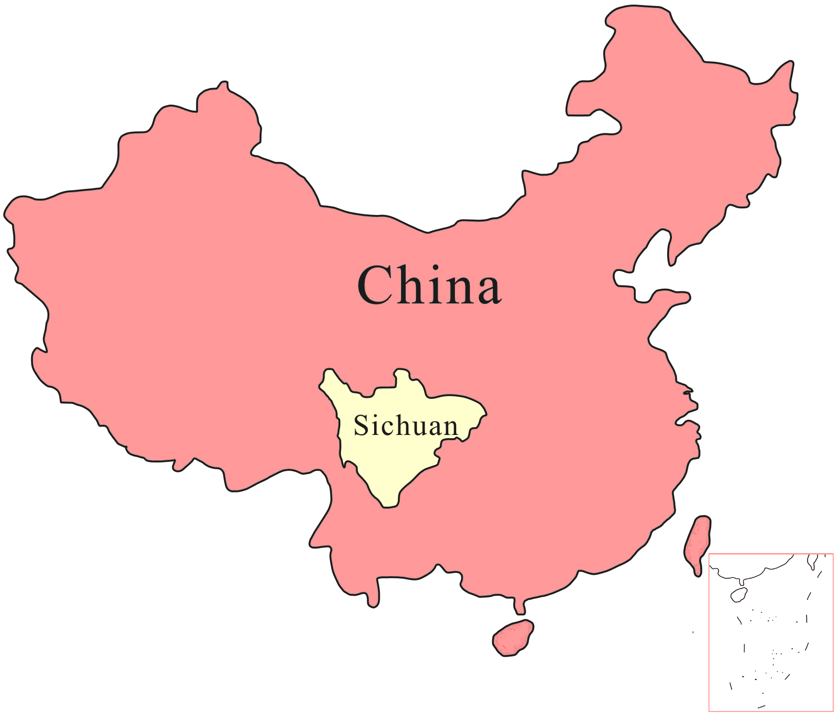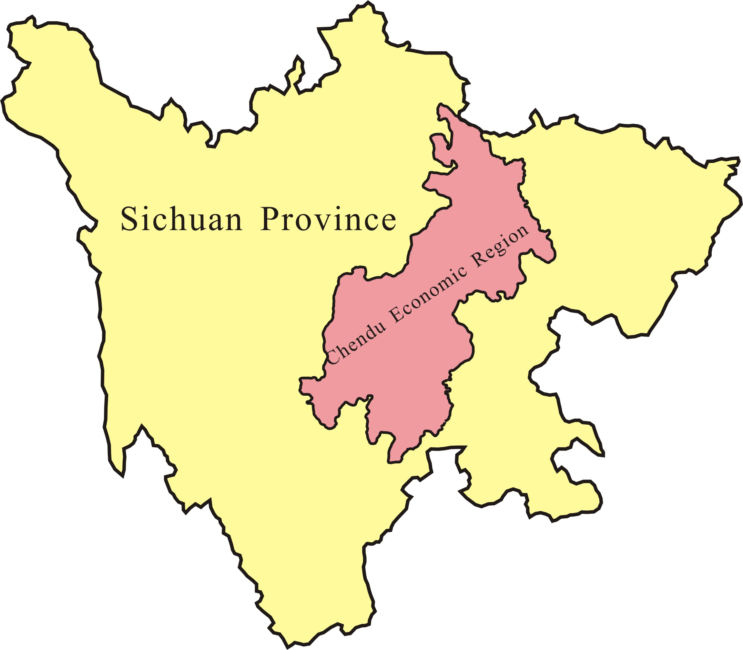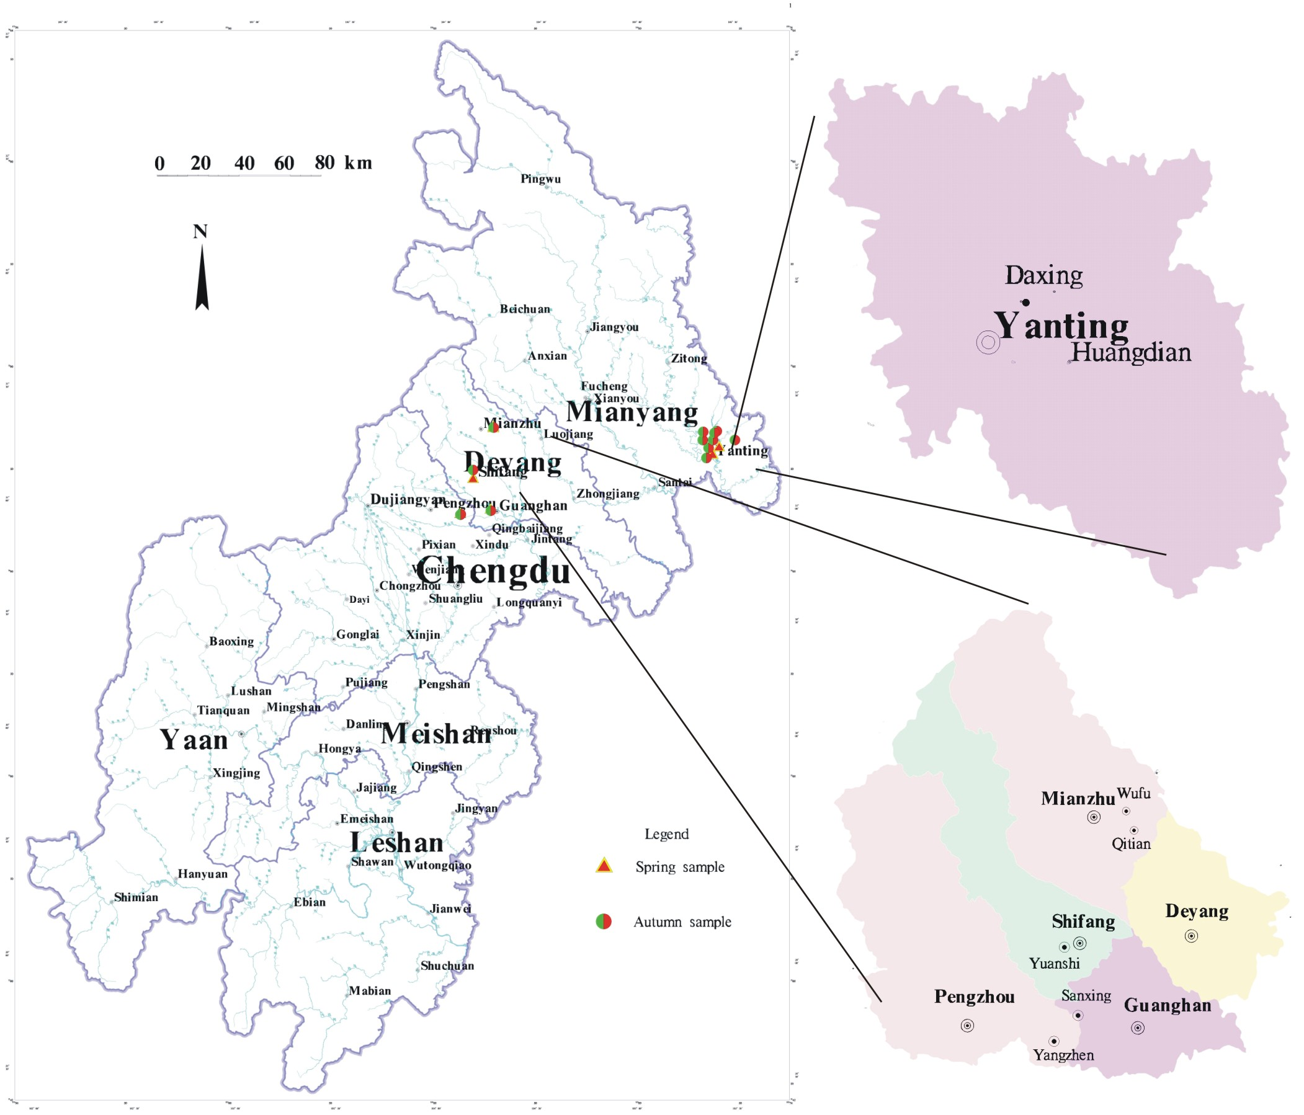
(c)
Figure 1. Map showing the sampling spots in the Deyang and Yanting areas of the Chengdu Economic Region, Sichuan Province, China
(a) Location of Sichuan Province in china (b) Location of Chengdu Economic Region in Sichuan and (c) the location of sampling spots

2.2 Site Selection and Sampling

The sampling sites were selected following the results of our soil OCPs survey (Xing et al, 2009) that covered the entire Chengdu economic region. Crop samples were taken from the farmlands whose soils were found containing relatively elevated levels of OCPs (≥ 10 ng g⁻¹ dry weights). A global positioning system (GPS) instrument was used to locate sampling locations. Vegetables found growing on the sites or within the immediate vicinity were eligible for sampling. Since a larger area in Deyang had been found to contain relatively elevated soil OCP residue levels ((≥ 10 ng g⁻¹ dry weight), more samples were collected from there (N=24) than from Yanting area (N=10). Vegetables were collected directly from the fields to ensure that they originated within the study areas. The samples were collected on June 11-12 (spring vegetables) and September 22-26 (Autumn vegetables) in the year 2007. Each sample was sealed in a clean polythene sampling bag, and immediately transported to the laboratory where they were kept refrigerated at 4⁰C until analysis.

2.2 Experimental 2.2.1 Extraction and Clean Up

About 50g of thawed edible portion of each vegetable sample was chopped (where possible) and blended for 3-5 minutes. Ten grams (10 g) of the homogenate was carefully weighed and transferred into a well tucked filter paper containing about 20 g of anhydrous sodium sulfate. The sealed mixture was spiked with 20ng of 2,4,5,6- tetrachloro-m-xylene (TCMX) and decachlorobiphenyl (PCB 209) as recovery surrogates. The mixture was then soxhlet extracted for 48 hours with 120 mL of dichloromethane and acetone mixture (2:1 vv). The extract was then concentrated to about 2 mL using a rotary evaporator at 40⁰C, solvent-exchanged to n-hexane and transferred into a separatory funnel where about 3 mL of concentrated sulfuric acid (98%) was added with shaking (to remove lipids). The mixture was allowed to stand until two distinct layers were observed. The lower turbid layer (lipids in acid) was then removed and discarded. The procedure was repeated three or until the lower acid layer appeared clear. The remaining organic layer (containing OCP extracts) was passed through alumina/silica gel (1:2 v/v) clean-up column (8 mm i.d.). The sample extract was eluted three times with 30mL dichloromethane/hexane (2:3) mixture to yield the OCPs fraction. The eluate was concentrated to about 0.5 mL before being transferred (using n-hexane) into a 2 ml screw cap cell bottle (Agilent Technologies USA) where it was concentrated further to 0.2ml under gentle stream of purified nitrogen gas at 40-45⁰C. The extracts were stored at -20⁰C, prior to GC-ECD analyses. Pentachloronitrobenzene (PCNB) was added as an internal standard before the analyses.

2.2.2 Instrumental Analysis
Concentrations of organochlorine pesticide residues were determined with HP 6890 gas Chromatograph (GC) system equipped with a micro-cell ⁶³Ni electron capture detector (ECD). The separation was performed on a fused silica capillary column (HP-5, 30 mx 0.32 mm i.d. and 0.25µm film thickness). The carrier gas was nitrogen at a flow rate of 2.5 mL/min in a constant flow mode. Injector and the electron capture detector temperatures were set at 290⁰C and 300 ⁰C respectively. The oven temperature was programmed as follows: Initial temperature 100⁰C held for 4 minutes; increased to 200⁰C at a rate of 4⁰C/min then increased to 230⁰C at a rate of 2 ⁰C/min followed by 8 ⁰C/min till the final temperature of 280⁰C at which it was held for 15 minutes. A 2 µl sample was injected into the GC-ECD for analysis. A six points response factor calibration was established to quantify the target analytes. System control was by HP-3365 Chemstation software .

2.2.3 Quality Assurance and Control
All analytical procedures were monitored using strict quality assurance and control measures. Chemicals used in the sample preparation and analyses were of high grade analytical standards obtained from Tedia Company, USA and J.T Baker, USA. Before use, neutral alumina, neutral silica gel and anhydrous sodium sulfate were soxhlet-extracted for 48 hours with dichloromethane and then baked for 12 hours in 250, 180 and 450⁰C respectively. Laboratory glassware were washed with concentrated sulphuric acid/potassium dichromate mixture, rinsed with distilled water and n- hexane then dried in the oven at 110⁰C overnight prior to use. With each set of samples analyzed, field and procedural blanks were also analyzed to check for cross contamination and interferences. None of the target compounds were detected in the blank samples. The method of detection limits (MDLs) of OCPs ranged from 0.005-0.01 ng/g t. The recovery rates of the surrogates, TMCX and PCB209 were 65±4% and 74±5% respectively. Each sample was analysed in duplicate and the average level for the duplicates was taken as the level for the candidate sample and was used in calculations. The relative standard deviation (RSD) for duplicate samples was 4%. Results of the analysis the vegetable samples are reported in ng/g on wet-weight (wet wt) basis. A reporting limit of >0.01 ng/g wet wt was taken for calculation purposes since some duplicate averages were below the MDLs. Levels below the reporting limit or below MDL were taken as zero (0) in the calculations.

3. Results and Discussion

3.1 Occurrence and Levels of OCPs in Vegetables
A total of 34 samples (18 in spring the rest in Autumn) of different species of vegetables (leafy, fruiting, root/bulbs and beans) were analysed for OCPs. The monitored OCPs are α-HCH, β-HCH, γ-HCH and δ-HCH (HCHs); p,p’-DDE , p,p’-DDD, o,p’-DDT and p,p’-DDT (DDTs). Concentration and prevalence of detected OCPs residues are listed in Table 1. Quantifiable residues of DDTs were found in virtually all the vegetable samples from Deyang and in all but two samples from Yanting, which indicates widespread occurrence of these compounds in vegetables in the areas. The DDT metabolites (p,p’-DDE and p,p’-DDD) were in general more prevalent than their parent materials (o,p’-DDT and p,p’-DDT) suggesting either efficient biotransformation of the parent materials in the plant systems or old sources of DDT contamination. Among the HCH isomers, lindane was the most frequently quantified both in the Deyang and Yanting vegetable samples.
All the vegetable samples had some levels of one or more OCPs in them. Without the single sample of green pepper (Capsicum annuum L.), the average residue level of total HCH (∑HCH) were slightly higher than that of total DDT (∑DDTs) in both Deyang (0.25 vs 0.24 ng/g) and Yanting (0.17 vs 0.11 ng/g). The pepper was not included in the calculations because DDT residue levels in it (totaling 148.44 ng/g wet wt.) appeared anomalous and since there was no other pepper sample to compare, the results were considered as outlier. Previous surveys had also reported ∑HCHs dominance over ∑DDTs but with higher concentrations than found in the present study, which indicates the use limitations of the chemicals are effective. For example, a national dietary survey undertaken in 1992 found average residue levels of ∑HCHs and ∑DDTs to be 7.1 and 1.00 ng/g respectively (Liu et al, 1995) while in Shanghai (in the year 2000) the average concentrations were 4.9 and 2.9 respectively (Nakata et al, 2002). The slightly higher concentrations of ∑HCHs than ∑DDTs is probably because more technical HCH (approximately 4.9 million tons) than technical DDTs (0.4 million tons) were produced and used in China before the agricultural uses of these insecticides were banned in 1983 (Hua and Shan, 1996). Moreover, lindane replaced technical HCH in 1991 and about 3200 tons were used between 1991 and 2000 (Li et al, 2001). It should, however, be noted that in a soil survey of the present study areas, Xing et al (2009) reported much higher mean residue levels of DDT (31.00 ng/g) than HCH (1.96 ng/g). The discrepancy between the residue levels of DDT and HCHs in soil and their accumulative levels in the edible portions of vegetables could be because DDT is more hydrophobic than HCH. Hydrophobic compounds are strongly bound to root and soil organic colloid surfaces resulting in less absorption and/or translocation (Pereira et al, 2006).
Average HCH residue levels in the vegetables from Deyang were in the range, 0.06 -0.56 ng/g wet wt with bean (Phaseolus vulgaris) as the least contaminated vegetables and radish (Raphanus sativus ) as the most, respectively. The range in Yanting was from <0.01 ng/g wet wt in spinach (Spinacia oleracea ) to 0.30 ng/g wet wt in Pumpkin (Cucurbita spp ). As for the ∑DDTs the average residue concentrations ranged from 0.03 ng/g to 0.64 ng/g in Deyang and from <0.01 to 148.44 ng/g in Yanting. Bean (Phaseolus vulgari) was again the least contaminated crop in Deyang where potato (Solanum tuberosum) had the highest mean ∑DDTs value. In addition to the pepper DDT contaminations in Deyang were notable for cabbages (Brassica spp.; 0.39 ng/g) and radish (Raphanus sativus; 0.33). Apart from the pepper sample, vegetables in this study had residue levels far much below the recommended extraneous maximum residue limits (EMRLs) of 50 ng/ g wet wt (for lindane, ∑HCH and DDT), as set forth by the Chinese ministry of public health (Chinese food standard, GB 2763-2005), indicating minimal risk to the consumer.
A comparison between our results with reports from literature was not easy, for the differences in sampled species, analytical method employed (in this case GC-ECD) and to some extent, differences in expression of analytical results (wet weight vs lipid content basis). However, it can be seen in Table 2, that in general ∑DDTs and ∑HCHs or lindane residue levels in this study were at par with those reported in Shanghai (Nakata et al, 2002) but in most cases much lower than reported in Tianjin, China where the ∑DDT residue level in spinach (102 ng/g) exceeded the EMRL for vegetables (50 ng/g) recommended by the Chinese laws (Tao et al, 2005). In comparison with results obtained in other countries the ∑DDT and ∑HCH in this study were comparable to those of Gambia and Senegal (Manirakiza et al., 2003) but lower than found in Agra, India (Bhanti and Taneja, 2005), Debrecen, Hungary (Hovánszki et al, 2007) and Nigerian markets (Adeyeye and Osibanjo,1999). A much more serious vegetable contamination was found in the urban markets of Ghana (Amoah et al, 2006) where residue levels of lindane and ∑DDTs were reported as 300 ng/g wet wt and 400 wet wt respectively.

Table 1. Edible tissue concentration (ng/g wet wt) of organochlorine residues in vegetables from Deyang and Yanting, Sichuan

Vegetable (N) | α-  HCH | β-  HCH | γ-  HCH | δ-  HCH | ∑  HCHs | p,p’-  DDE | p,p’-  DDD | o,p’-  DDT | p,p’-  DDT | ∑DDTs
Samples from Deyang

Amaranth (1) | 0.07 | 0.10 | 0.05 | <0.01 | 0.22 | 0.06 | 0.02 | <0.01 | <0.01 | 0.08
Beans (3) | 0.04  (0.10)a | <0.01 | 0.02  (0.05) | <0.01 | 0.06  (0.16) | 0.03  (0.04) | <0.01 | <0.01 | <0.01 | 0.03  (0.04)
Cabbages (4) | 0.01  (0.02) | 0.12 (0.37) | 0.05 (0.10) | <0.01 | 0.17  (0.46) | 0.25  (0.92) | 0.02 | 0.04  (0.15) | 0.07  (0.29) | 0.3 9  (1.27)
Celery (1) | 0.01 | 0.09 | 0.06 | 0.01 | 0.17 | 0.03 | <0.01 | 0.03 | <0.01 | 0.06
Eggplant (1) | 0.40 | 0.08 | <0.01 | <0.01 | 0.48 | 0.14 | <0.01 | <0.01 | <0.01 | 0.14
Lettuce (6) | 0.04 (0.09) | 0.10  (0.26) | 0.03  (0.08) | 0.18  (0.47) | 0.35  (0.57) | 0.08  (0.31) | 0.01  (0.05) | <0.01 | 0.09  (0.30) | 0.24  (0.85)
Onion (1) | <0.01 | 0.14 | 0.02 | <0.01 | 0.16 | 0.05 | 0.01 | <0.01 | <0.01 | 0.06
Potato (2) | <0.01 | 0.02  (0.03) | 0.04  (0.08) | <0.01 | 0.06  (0.11) | 0.52  (1.02) | 0.01  (0.02) | <0.01 | 0.10  (0.21) | 0.64  (1.22)
Pumpkin (1) | 0.12 | <0.01 | 0.08 | <0.01 | 0.20 | 0.01 | <0.01 | <0.01 | 0.19 | 0.20
Radish (2) | 0.05  (0.09) | 0.36  (0.62) | 0.11  (0.19) | 0.04  (0.08) | 0.56  (0.98) | 0.12  (0.22) | 0.04  (0.09) | <0.01 | 0.17  (0.34) | 0.33  (0.64)
Spinach (2) | 0.01  (0.01) | 0.09  (0.12) | 0.08  (0.09) | 0.06  (0.08) | 0.24  (0.26) | 0.04  (0.05) | 0.03  (0.04) | 0.03  (0.04) | 0.03  (0.05) | 0.12  (0.15)
All Samples  (24) | 0.05 (0.40) | 0.09 (0.62) | 0.05 (0.19) | 0.05  (0.47) | 0.25 (0.98) | 0.13 (1.02) | 0.01  (0.09) | 0.03 (0.19) | 0.06 (0.34) | 0.24 (1.27)
Positive samples (%) | 15  (62.50) | 16 (66.67) | 17 (70.83) | 9  (37.50) | 22 (91.67 | 22  (91.67) | 11  (45.83) | 7  (29.17) | 8 (33.33) | 24  (100.0)
Samples from Yanting
Cabbages (1) | 0.02 | 0.23 | 0.02 | <0.01 | 0.29 | 0.04 | <0.01 | 0.11 | <0.01 | 0.15
Pepper (1) | 0.13 | 0.12 | 0.02 | <0.01 | 0.27 | 61.41 | 0.41 | 82.59 | 4.04 | 148.44
Eggplant (1) | 0.02 | 0.00 | 0.00 | <0.01 | 0.02 | <0.01 | <0.01 | <0.01 | <0.01 | <0.01
Lettuce (2) | <0.01 | 0.07 (0.07) | 0.00 (0.02) | <0.01 | 0.09 (0.09) | 0.01  (0.01) | <0.01 | <0.01 | <0.01 | 0.01  (0.01)
Pumpkin (2) | 0.03 (0.06) | 0.07 (0.15) | 0.02 (0.04) | 0.17  (0.29) | 0.30 (0.48) | 0.05 (0.10) | <0.01 | <0.01 | <0.01 | 0.05 (0.10)
Spinach (1) | <0.01 | <0.01 | <0.01 | <0.01 | <0.01 | 0.07 | 0.02 | 0.08 | 0.17 | 0.34
Rape stalk (2) | 0.08 (0.15) | 0.05 (0.10) | <0.01 | <0.01 | 0.21 (0.23) | 0.02 (0.03) | <0.01 | <0.01 | 0.06 (0.11) | 0.19 (0.34)
All vegetables  (9)^{b} | 0.03  (0.15) | 0.07 (0.23) | 0.03 (0.08) | 0.04 (0.29) | 0.17 (0.48) | 0.03 (0.10) | 0.00  (0.02) | 0.03 (0.11) | 0.04 (0.23) | 0.11 (0.34)
No. of positive samples (%) | 5 (50.00) | 6  (60.00) | 7 (70.00) | 2 (20.00) | 9 (90.00) | 7 (70.00) | 2 (20.00) | 4 (40.00) | 3 (30.00) | 8 (80.00)
EMRL^{c} |  |  | 50 |  | 50 |  |  |  |  | 50
Note:
ª Maximum value of quantifiable residue level for multiple samples of the same species
Residues in pepper (Capsicum annuum L.) not included in the calculations but included in frequency countings
ΣHCHs= α-HCH + β-HCH + δ-HCH + γ-HCH;
ΣDDTs = p, p’-DDE + p, p’-DDD + o, p’-DDT + p, p’-DDT
^{c} The Chinese statutory Extraneous Maximum Residue Limit according to food standard (GB 2763-2005)
N= number of samples analysed

3.2 Compositional Analysis for Possible Sources of OCPs
Relative abundances of the HCH congeners (to ∑HCHs) were quite similar in all crops samples and the overall average followed the sequence of β-HCH >α-HCH ≈γ-HCH>δ-HCH (in Deyang samples) and β-HCH >δ-HCH > α-HCH ≈γ-HCH (in Yanting samples). The predominance of β-HCH was probably due to its high stability, low water solubility and resistance to microbial degradation and because α-HCH can be converted to β-HCH in the environment (Willet et al, 1998). Surprisingly, the most prevalent isomer in the vegetables of this study, γ-HCH (lindane), was not the overall most abundant HCH isomer. This is attributable to the instability of γ-HCH, which may be converted to α-HCH in the presence of solar radiation (Willet et al, 1998).

Table 2. Organochlorine pesticide residues in vegetables: this study compared with reports from other regions and countries (ng/g)

Vegetable | Location | n | Year | ∑HCHs | ∑DDTs | Reference
Cabbage | Deyang, China | 4 | 2007 | 0.17 | 0.39 | Present study
 | Yanting, China | 1 | 2007 | 0.29 | 0.15 | Present study
 | Tianjin, China | - | 2002 | 38.00 | 34.00 | Tao, et.al. (2005)
 | Debrecen, Hungary | - | - | - | 19.30 | Hovánszki et al. (2007)
 | Agra, India | - | 2002-03 | 2.49 ª | 2.33 | Bhanti & Taneja (2005)
 | Gambia/Senegal | - | 2002 | 1.10 | 0.12 | Manirakiza et al. (2003)
Celery | Deyang, China | 1 | 2007 | 0.17 | 0.06 | Present study
 | Tianjin, China | - | 2002 | 40.00 | 32.00 | Tao et al. (2005)
 | Shanghai, China | 1 | 2000 | 1.70 | 2.50 | Nakata et al., 2002
 | Debrecen, Hungary | - | 2004 | - | 10.60^{b} | Hovánszki et al. (2007)
Lettuce | Deyang, China | 6 | 2007 | 0.35 | 0.24 | Present study
 | Yanting , China | 2 | 2007 | 0.09 | 0.01 | Present study
 | Urban markets, Ghana | 60 | 2002 | 300 ª | 400 | Amoah et al (2006)
 | Gambia/Senegal | - | 2002 | 0.30 | 0.45 | Manirakiza et al. (2003)
Amaranth | Deyang, China | 1 | 2007 | 0.22 | 0.08 | Present study
 | Nigeria | 11 | 1991-92 | 5.40 | 22.60 | Adeyeye & Osibanjo (1999)
Spinach | Deyang, China | 2 | 2007 | 0.24 | 0.15 | Present study
 | Yanting , China | 1 | 2007 | <0.01 | 0.34 | Present study
 | Tianjin, China | - | 2002 | 43.00 | 102.00 | Tao, et al (2005)
 | Shanghai, China | 1 | 2000 | <0.03 | 0.14 | Nakata et al. (2002)
 | Agra, India | - | 2002-03 | 14.17 | 6.61 | Bhanti & Taneja (2005)
Eggplant | Deyang, China | 1 | 2007 | 0.49 | 0.14 | Present study
 | Yanting , China | 1 | 2007 | 0.02 | <0.01 | Present study
 | Shanghai, China | 1 | 2000 | 0.09 | <0.03 | Nakata et al.(2002)
 | Agra, India | - | 2002-03 | 6.40 ª | 8.44 | Bhanti & Taneja (2005)
 | Gambia/Senegal | - | 2002 | 0.30 | 5.10 | Manirakiza et al. (2003)
 | Nigeria | 11 | 1991-92 | 3.40 | 21.50 | Adeyeye & Osibanjo (1999)
G.Pepper | Yanting, China | 1 | 2007 | 0.27 | 148.44 | Present study
Pumpkin | Deyang, China | 1 | 2007 | 0.20 | 0.20 | Present study
 | Yanting | 2 | 2007 | 0.30 | 0.05 | Present study
 | Agra, India | - | 2002-03 | 0.04 ª | ND | Bhanti & Taneja (2005)
 | Debrecen, Hungary | - | 2004 | - | 19.3 ^{b} | Hovánszki et al. (2007)
Radish | Deyang, China | 2 | 2007 | 0.56 | 0.33 | Present study
 | Agra, India | - | 2002-03 | 6.15 | 8.44 | Bhanti & Taneja (2005)
 | Gambia/Senegal | - | 2002 | 0.30 | 1.44 | Manirakiza et al. (2003)
Onion | Sichuan, China | 1 | 2007 | 0.16 | 0.06 | Present study
 | Shanghai, China | 1 | 2000 | 0.15 | 0.07 | Nakata et al (2002)
Note: Where more than one site was sampled, the site with highest level was taken for this comparison.
* ng/g dw
ª mean level of γ-YCH; ^{b} mean value for DDE; ^{c} composite samples; ND=not detected; - Not available

The composition pattern in terms of the ratio of α -HCH to γ -HCH (lindane) can be used to monitor whether the source was technical HCHs or lindane The ratio α –HCH/γ-HCH should be 4–7 for technical HCH, and nearly zero (0) for technical lindane (Iwata et al., 1995). In the present study, the ratio α –HCH/γ-HCH varied from 0.00 to 0.00-0.70 in vegetables from Deyang and from 0.00-1.88 in vegetables from Yanting. It is important to note that the soils from the CER, Sichuan (including the present study areas) were also found with predominantly lower α-HCH/γ–HCH ratio than in technical HCH with 95% of the ratios being in the range 0.00 – 0.14 (Xing et al, 2009). Accordingly, it could be concluded that lindane was still being used in the areas studied.
The average concentration levels of DDT isomers/metabolites in the vegetables were observed in the following order: p,p’-DDE > p,p’-DDT > o,p’-DDT > p,p’-DDD in Deyang and p,p’-DDT > p,p’-DDE >o,p’-DDT >p,p’-DDD in Yanting. DDT is known to biodegrade to DDE under aerobic and to DDD in anaerobic conditions. The predominance of p,p-DDE and low levels of p,p-DDD in Deyang show that either the DDT compounds were from the historical sources or that the biotransformation of DDT in the vegetables is very efficacious. Conversely, the fact that p,p-DDT was the main contributor in vegetables from Yanting, indicates recent inputs of DDT in the area. Furthermore, ratios of (DDD + DDE)/ DDTs of >0.5 shows DDTs have been subjected to long term weathering (Doong et al, 2007). In the present study, 58.33% of the samples from Deyang and 40.00% of samples from Yanting had the ratio (DDD + DDE)/ DDTs >0.5 showing that both weathered and fresh DDT could be contaminating crops in the areas.

3.3 Seasonal Variation
The residue levels and the detection rates of the OCPs are given in Table 3. The autumn vegetables had higher OCPs levels than spring vegetables. This may be because mores pests were active during summer when the vegetables were growing, might have attracted the illegal use of some of the OCPs. It is also possible that the high temperatures in summer volatilized the OCPs from their reservoirs such as soil or vegetation and that the edible parts of the crops may have trapped some of the evaporating pesticides.
It can also be seen that residues of β-HCH, γ-HCH (lindane) and hence ∑HCHs were more prevalent in spring samples than in autumn ones. In particular, the insecticide lindane was quantifiable in all the spring vegetables, which suggests that the vegetables might have been contaminated at the beginning of spring or earlier when they were sown. In the southern China region, lindane was mainly used in summer as a seed dressing or a general insecticide (Yang et. al., 2007). However, the incidence of the DDTs was similar in both seasons, with degradation products p,p’-DDE and p,p’-DDD leading in prevalence especially in the winter crops. This further suggests historical rather than current sources of DDTs in the areas studied.

Table 3. Residue levels (ng/g wet wt) and incidence (%) of organochlorine pesticides in vegetables from Deyang and Yanting , Sichuan

 | Spring Vegetables (N=18) |  | Autumn Vegetables (N=16)
Compound | Incidence (%) | Average  (min-max)ª | Incidence (%) | Average  (min-max)ª
α-HCH | 50.00 | 0.02 (<0.01-0.15) | 75.00 | 0.07 (<0.01-0.40)
β-HCH | 94.44 | 0.13 (0.01-0.37) | 25.00 | 0.06 (<0.01-0.62)
γ-HCH | 100.00 | 0.06 (0.02-0.10) | 50.00 | 0.03 (<0.01-0.19)
δ-HCH | 27.77 | 0.01 (<0.01-0.0.08) | 41.67 | 0.08 (0.06-0.47)
∑HCHs | 100 | 0.19 (0.02-0.46) | 81.25 | 0.24 (<0.01-0.98)
p,p’-DDE | 88.89 | 0.03 (<0.01-0.06) | 87.5 | 0.20* (<0.01-61.41)
p,p’-DDD | 38.89 | 0.01 (<0.01-0.04) | 31.25 | 0.01* (<0.01-0.41)
o,p’-DDT | 38.89 | 0.05 (<0.01-0.18) | 18.75 | 0.02*(<0.01-82.59)
p,p’-DDT | 11.11 | 0.02 (<0.01-0.23) | 50.00 | 0.11* (<0.01-4.04)
∑DDTs | 100.00 | 0.09 (0.01-0.34) | 87.50 | 0.34* (<0.01-148.44)
∑DDTs = p,p’-DDT + o,p’-DDT + p,p’-DDD + p,p’-DDE; ∑HCHs= α- + β- + γ- + δ-HCH
* DDT values for one sample, pepper not included in the calculation of the mean

4.0 Conclusions
The analysis of vegetables from Deyang and Yanting areas in Sichuan, Southwest China has demonstrated a quite low level of pollution by OCPs, which generally never exceeded the levels recommended by the Chinese public health authorities. It is possible to deduce a good observance of limitations in agricultural application of chlorinated pesticides. However, a high frequency of occurrence of the pesticides in vegetables was noted and is a matter of concern since organochlorine compounds are known to accumulate in living organisms and so even low levels of intakes may reach toxic levels. Identification and elimination of environmental sources of OCPs in the study area and beyond is recommended.

Acknowledgement
This study was part of the project financed by the Natural Science Foundation of China under Grant No. 40473043 and Geological Survey of Sichuan Province, People’s Republic of China. We thank Su Qiuke and the environmental organic Chemistry post graduate students of China University of Geosciences (Wuhan), who helped with the collection and /or extraction of the samples.

Correspondence to:
Shihua Qi,
MOE Key Laboratory of Biogeology and Environmental Geology
School of Environmental Studies
China University of Geosciences, Lumo Road 388, Wuhan, Hubei, 430074, P.R. China
Email: shihuaqi@cug.edu.cn
Telephone: 0086-27-67883153

References

[1] Li YF, Cai DJ, Singh A. Technical hexachlorocyclohexane use trends in China and their impact on the environment. Arch. Environ. Contam. Toxicol. 1998;35: 688-697.
[2] Liu L, Jian A, Ren N, Jiang G, Li Y. Gridded inventories of historical usage for selected organochlorine pesticides in Heilongjiang River Basin, China. J. Environ. Sci. 2006; 18(4):822-826
[3] Xing X, Qi S, Odhiambo JO, Zhang Y, Liu Y. Influence of Environmental Variables on spatial distribution of organochlorine pesticides in Sichuan, West China. Environ. Earth Sci. DOI 10.1007/s12665-009-0018-4.
[4] Chen J and Gao J. The Chinese total diet study in 1990 Part I. Chemical contaminants AOAC Intl. 1993;76, 1193–1205.
[5] Li, JY, Li H, Tao P, Lei FM. Serum organochlorine pesticide level of non occupational Women exposure and risk of Breast cancer: a case-control study. Wei Sheng Yan-Jiu 2006;35(4): 391-416 (in Chinese).
[6] Liu HZ, Chen HJ, Wang XQ. Chinese total diet study in 1992-pesticide residues. J. Hyg. Res. 1995;24:356-360 (in Chinese).
[7] Nakata H, Kawazoe M, Arizono K, Abe S, Kitano, T, Shimada, H., Li, W., Ding, X. Organochlorine Pesticides and Polychlorinated Biphenyl Residues in Foodstuffs and Human Tissues from China: Status of Contamination, Historical Trend, and Human Dietary Exposure. Arch. Environ. Contam. Toxicol. 2002;43: 473–480.
[8] Hua X M and Shan Z J. The production and application of pesticides and factor analysis of their pollution in environment in China. Advances in Environmental Science 1996;4: 33–45.
[9] Li YF, Cai, DJ, Shan, ZJ, Zhu, ZL. Gridded Usage Inventories of Technical Hexachlorocyclohexane and Lindane for China with 1/6° Latitude by 1/4° Longitude Resolution Arch. Environ. Contam. Toxicol. 2001;41: 261–266.
[10] Pereira RCM, Camps-Arbestain B, Garrido R, Macı´as F, Monterroso C. (2006): Behaviour of α-,β-, γ-, and δ-hexachlorocyclohexane in the soileplant system of a contaminated site. Environ. Poll.144: 210-217
[11] Tao S, Xu F L. Wang X J, Liu W X, Gong Z M, Fang JY, Zhu YM. Luo Organochlorine Pesticides in Agricultural Soil and Vegetables from Tianjin, China Environ. Sci. Technol.2005; 39 (8): 2494 -2499.
[12] Manirakiza P, Akinbamijo O, Covaci A, Pitonzo R, Schepens P.Assessment of Organochlorine Pesticide Residues in West African City Farms: Banjul and Dakar Case Study. Arch. Environ. Contam. Toxicol. 2003;44:171–179.
[13] Bhanti M. and Taneja A. Monitoring of organochlorine pesticide residues in summer and winter vegetables from Agra, India – a Case Study. Environmental Monitoring and Assessment 2005; 10: 341–346.
[14] Hováanszki D, Prokisch J, Gyōri, Z. Case study: Testing of organochlorine pesticide contamination in a backyard garden. Cereal Research Communications 2007;35 (2): 493-496.
[15] Adeyeye A and Osibanjo O. Residues of organochlorine pesticides in fruits, vegetables and tubers from Nigerian markets. Sci. Total Environ.1999; 231: 227-233.
[16] Amoah P. Drechsel P, Abaidoo RC, Ntow WJ. Pesticide and Pathogen Contamination of Vegetables in Ghana’s Urban Markets. Arch. Environ. Contam. Toxicol. 2006;50: 1–6.
[17] Willett KL, Ulrich EM, Hites RA. Differential toxicity and environmental fates of hexachlorocyclohexane isomers. Environ. Sci. . Technol., 1998;32(15): 2197– 2207.
[18] Iwata H, Tanabe S, Ueda K, Tatsukawa R Persistent organochlorine residues in air, water, sediments, and soils from the Lake Baikal Region, Russia. Environ. Sci. Technol. 1995;29:792–801
[19] Doong RA, Peng CK, Sun YC, Liao PL. Composition and distribution of organochlorine pesticide residues in surface sediments from the Wu-Shi River estuary, Taiwan. Marine Pollution Bulletin, 2002;45:246-253
[20] Yang Y., Li, D., Mu, D, (2007). Levels, seasonal variations and sources of organochlorine pesticides in ambient air of Guangzhou, China. Atmospheric Environment, doi:10.1016/j.atmosenv.2007.09.06

The Journal of American Science
ISSN: 1545-1003
The international academic journal, “The Journal of American Science” (ISSN: 1545-1003), is registered in the United States, and invites you to publish your papers.
Any valuable papers that describe natural phenomena and existence or any reports that convey scientific research and pursuit are welcome, including both natural and social sciences. Papers submitted could be reviews, objective descriptions, research reports, opinions/debates, news, letters, and other types of writings that are nature and science related. All the manuscripts will be processed in a professional peer review. After the peer review, the journal will make the best efforts to publish all the valuable works as soon as possible.
This journal will be no charge for the manuscript contributors. If the author needs hard copy of the journal, it will be charged for US$100/issue to cover the printing and mailing fee. Here is a new avenue to publish your outstanding reports and ideas. Please also help spread this to your colleagues and friends and invite them to contribute papers to the journal. Let's work together to disseminate our research results and our opinions.
Papers in all fields are welcome, including articles of natural science and social science.
Please send your manuscript to editor@americanscience.org;
sciencepub@gmail.com;
americansciencej@gmail.com
For more information, please visit http://www.americanscience.org; http://www.sciencepub.net; http://www.sciencepub.org

Marsland Press
2158 Butternut Drive
Okemos, MI 48864
The United States
Telephone: 347-321-7172; 718-404-5362; 517-349-2362
Email: editor@americanscience.org;
sciencepub@gmail.com;
americansciencej@gmail.com
Website: http://www.americanscience.org
http://www.sciencepub.net; http://www.sciencepub.org

