Assessment of fault-zone materials and their impact on hydrocarbon accumulation using integrated Exploration techniques.

Oyedele, K. F. and Adeyemi, A.S.
Department of Physics (Geophysics Programme)
University of Lagos, Lagos, Nigeria.
kayodeunilag@yahoo.com

Abstract
This paper presents the findings of an integrated exploration methods conducted on rock exposures in Enugu, Anambra basin, southeastern Nigeria. The methods employed include geological, geophysical and borehole geophysics to study the properties of fault-zone materials as the sealing mechanisms. Results from this study revealed that outcrop data alongside geophysical and borehole data could be useful in the optimal evaluation of fault-zone materials with respect to their potentials in hydrocarbon accumulation. It is also concluded that both the nature of materials juxtaposed across a fault and the character of materials in the fault zones could play significant and complimentary roles in fluid control across a fault. “[The Journal of American Science. 2009;5(4):113-122]. (ISSN 1545-1003)”

Keywords: Fault-zone, hydrocarbon, fault gouge, siliciclastic sequence.

Introduction

In hydrocarbon exploration, faults play a crucial role in the distribution of hydrocarbon because of their capacity to act as seals (Bouvier et al, 1989).Several oil and gas companies have studied this impact extensively with emphasis on juxtaposition of materials of different hydraulic properties across a fault, rather than on the materials inside the core of the fault zone.

Fault zone can act as either as barrier or preferential flow paths to fluid (knipe et al, 1997, Bense et al, 2003). Fault zones are usually the sites of large discontinuous changes in mechanical and transport properties that are controlled by the composition and structures of the fault gouge. The early development of the fault gouges starting from the initial discontinuities is less well known. The early researchers such as Antonelli and Aydin, 1995, Fulljames et al, 1997 and knipe et al, 1997 have so far mainly concentrated on faults in thick layers and thus single phase materials. In such cases, dependent on lithology and environmental parameters (effective stress, temperature, etc) and a range of gain-scale processes have been documented.

Bouvier et al, 1989, presented a qualitative method of predicting “static” fault seal in siliciclastic sequence from the Num river field in the Niger delta, Nigeria using subsurface data. Since then the method has been developed and applied to faults in many hydrocarbon provinces worldwide, such as the North Sea Gulf of Mexico (Davis et al, 2003). There are several outcrop-based studies of the Anambra basin (Hogue, 1997, Nwajide, 1980 and Ladipo, 1988), yet the basin is not as well understood as the adjourning Niger delta in a totally comprehensive manner.
To this end, this study aims at contributing to the scarce information and limited understanding of fault zone materials in Anambra basin and its potential in hydrocarbon accumulation.

Materials and methods
Geology of the Study area.
The study area is located within the Anambra basin, in the central portion of Southeastern Nigeria (figure1), extending from Longitude 5ºE to 6ºE and Latitude 5ºN to 5º30ºN, and covering an area of about 700 square kilometers. The Anambra basin with over 600m of both pre-santonian and post-santonian sediments is documented to have estimated reserves of 1 billion barrels of oil and 30 trillion cubic feet of gas (Akande, S.O et al, 2005). However, the expolaration history of the basin has been an unsuccessful one, with only six out of over fourty well drilled so far encountering gas and / or oil. This low success rate has greatly reduced the interest of explorationists who considered the besin a more difficuit and less rewarding than the adjacent Niger delta.

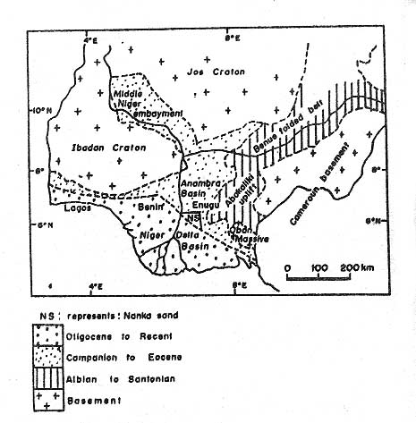

Figure.1: Generalized map of Nigeria showing the Anambra Basin. (Modified from Murat, 1972)

Tectonic Setting and Geological evolution.
The tectonic setting and geological evolution of Anambra basin (figure 2) can be traced back to the mesozoic (late Jurassic) when the splitting of the gondwanaland super continent took place along rift zones of different orientations that met at a triple junction. This triple junction is now the site at which the present day Nigeria delta is located. In this region, rifting started in the late Jurassic and persisted into the middle cretaceous (Murat, 1972).

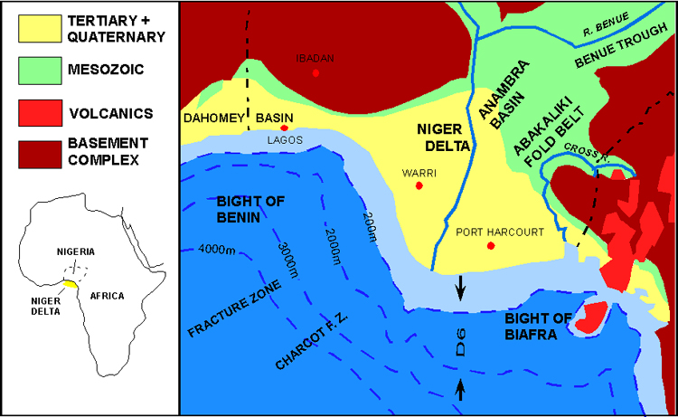Figure 2: Tectonic map of southern Nigeria, modified
after Whiteman; 1962.

The fracture zone ridges subdivided the margin into individual basins, and form the boundary fault of the cretaceous Benin-Abakaliki trough, which cuts far into the West African shield. The trough represent a failed arm of a rift triple junction associated with opening, of the South Atlantic, and gave rise to the Benue aulacogen, a NE-SW trending, folded aborted rift basin that runs obliquely across Nigeria.

The Anambra Basin proper formed after the Santonian tectonic pulse, dating back to 84million years, following the deformation and uplift of the Abakaliki sector of Benue trough. During the Santonian tectonism, the (proto-Anambra platform) are bordering the Benue trough to the West (Anambra platform) and to the East (Afikpo platform) became downwarped to form the Anambra basin and Afikpo respectively (Petter and Ekweozor 1982, Ojoh, 1992). The emergent Abakaliki anticlinorium became a positive area that supplied detritus to these new basins. Sediments were also derived from the uplands beyond the Benin hinge line and the Benue fold belt. Subsequently, the basins were filled with sediments ranging from late to early cretaceous.

Field procedures.
The process of data gathering involved the use of flowchart technique in order to ensure repeatability of process and consistency of results of sampling done in different locations (figure 3). The search for outcrops was aided by literature research of previous work done in the area. Fault identification on outcrops was also aided by the use of some fault recognition criteria, such as offset rock body and topographic features, juxtaposition of different rock bodies, presence of fault gouge or breccia, slickensides and slickenlines and presence of faceted spurs and sag pond.

Search for outcrop

Fault identification

Lithologic logging

Fault attribute logging

Follow up

Sampling and photography

Figure.3: Flowchart for field program

At each location where faults have been identified, the lithologies of the fault planes were logged from bottom to top. Typical thickness of strata at an outcrop was recorded in the field notebook where the layers are drawn to scale and described as rock type, grain size, fossil content, colour, bed dip, sedimentary structures and other attributes. Thickness of strata was measured using the tape rule. In addition to logging the offset strata, the zone within the fault surface in the vicinity of the fault plane were also logged. Some of the measured attributes include fault throw, fault length, strike of the fault, fault slip, dip heave and fault gap. Also measured and described were deformation bands, joints, microfolds, clay smear and fault profile roughness.

Samples were taken at three lecatious: (1) road cut along the expressway to Onitsha from Enugu, close to the flyover) (2) West of Enugu city by the river channel, Ekulu river (3) Road cut at Agbogugu, south of Enugu along Enugu Port-harcourt road) to capture information on different rock types encountered. Similarly, pictures were taken at the various lecatious to detail the fault gouge materials (figures. 4 to 7). The follow-up survey involved input of data into the computer and further literature research.This was done in order to get a full understanding of the cause, process and product of the features being examined. It was also done to correct for any error of oversight that could mar the results of the data collection exercise. The pictures on figures 4 to 7 was used for up-scaling the sampled faults to seismic-scale faults (figures 8 and 9).

Data processing and analysis.
The numeric values obtained from fault surface and lithologic logging were input into a pre-formatted table in MS Excel spreadsheet (Tables 1 to 3). The parameters obtained from field mapping and data acquisition were also input into structural geology software called (GXII), (figure 10) for the purpose of validation of manual interpretation. The measurements and detailed description were done at each of the locations for attributes such as fault throw, fault slip, orientation, deformation bands, fault profile, roughness and fault heave.
The Algorithms that were employed in data analysis and development of fault seal potentials are industry known and accepted. These algorithms include the following:

Clay Smear potentials (CSP): This is the relative amount of clay that has been smeared from individual shale source beds at a certain point along a fault plane.

Shale Smear factor (SSF): This is a ratio of the fault throw to the thickness of the shale bed that provides smear along the fault surface.

Shale Gouge Ratio (SGR): This is the percentage of shale or clay in slipped interval.
The empirical relationships of the algorithms are summarized below:

CSP = (Shale bed interval) ² / Distance from the source bed

SSF = Fault throw / Shale layer thickness

SGR = ∑(thickness of shale bed / fault throw) X 100%

Results and Discussion.

Results
The data set obtained for the various measured elements were interpreted as follows:
Pressure data: pressure data from drilling mud weight were obtained from the wells in the area. From the analysis, it was obtained that there is a lateral variation in pressure across the fields in the area. Also two pressure gradients were obtained in well 2, thus showing that there is a vertical variation in the pressure gradient as well.

Fault geometry: In the outcrop, bedding is horizontal to sub-horizontal, with no dip larger than 6º The faults strike perpendicular to the main outcrops faces (Figures.4 to7). The average fault strike was 090º-300º. The fault plane orientations show that the faults were mainly dipping south.

Deformation bands: In dataset from the study area, deformation bands were quite common, particularly in locations 2 and 3, and show evidence for cataclasis. They usually have displacements of a few millimeters, sometimes up to

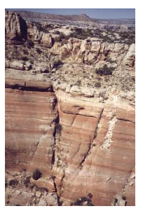

Figure 4: Studied fault system at location 1; Road cut along the Expressway to Onitsha

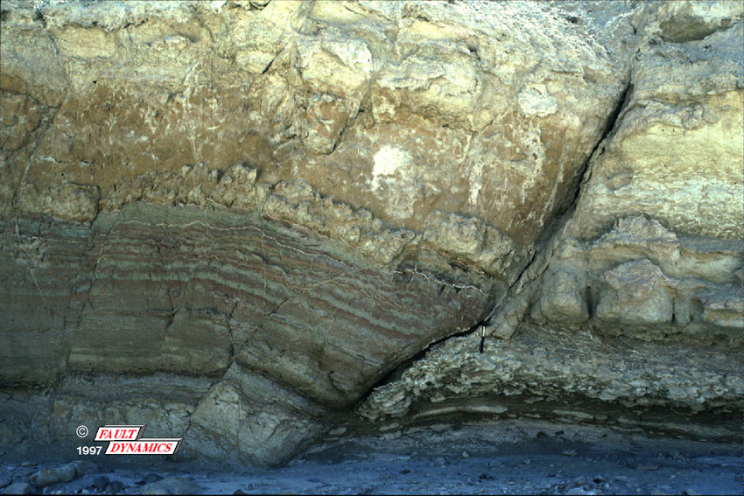

Figure 5: Studied fault system at location 2, West of Enugu city by the river channel (Ekulu river)

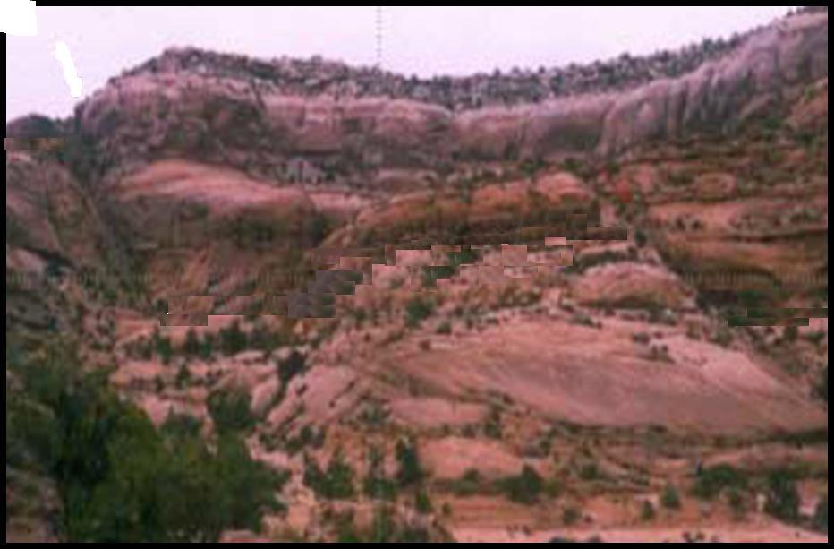

Figure 6: Studied fault system at Location 3, Road cut at Agbogugu.

Figure 7: Zoomed in section from one of the fault splay at location 3.

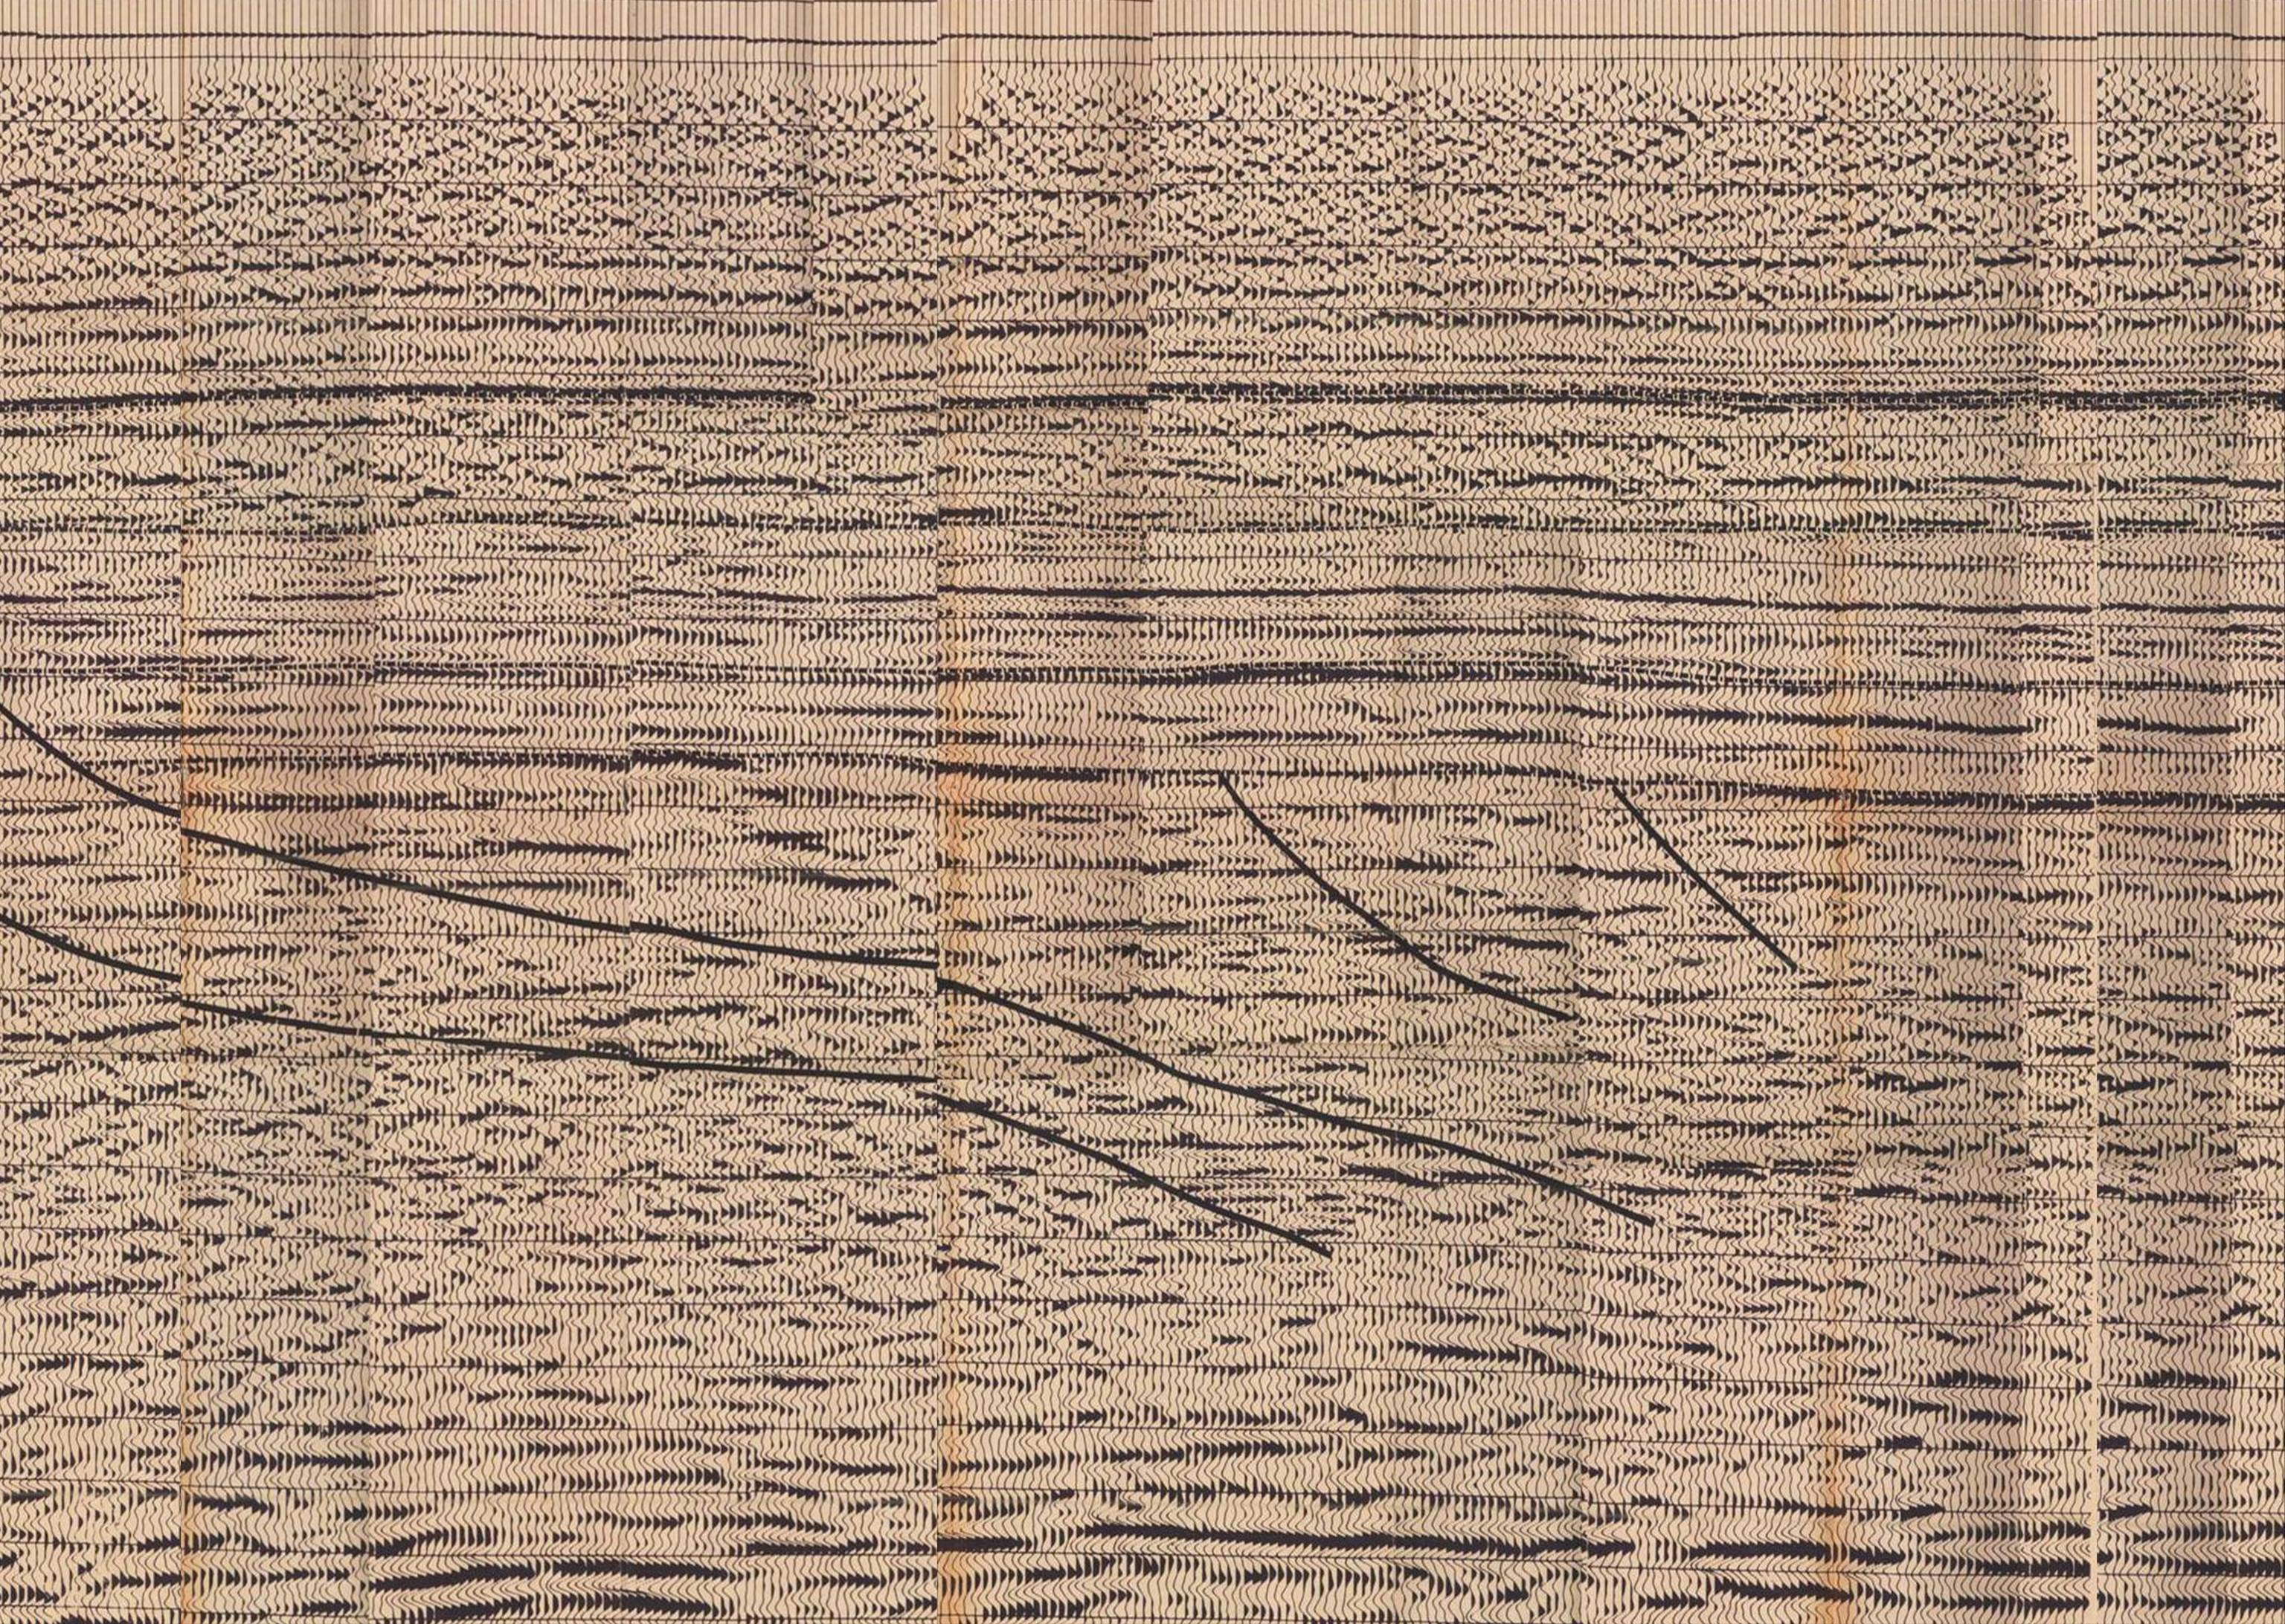

Figure.8:A 3-D Seismic section taken close to the Study Area in Anambra Basin.

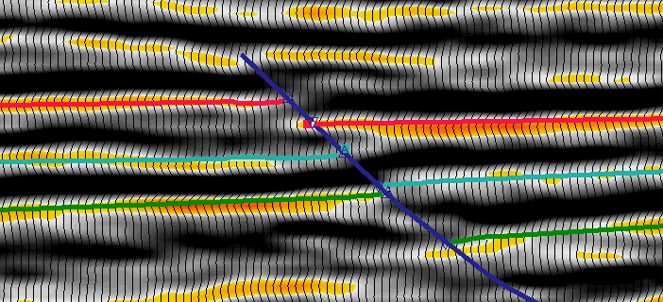

Figure 9: A Zoomed in section of the seismic line in Fig.8 showing the targeted sandstones .
juxtaposed against shales.
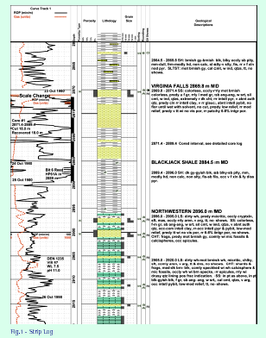
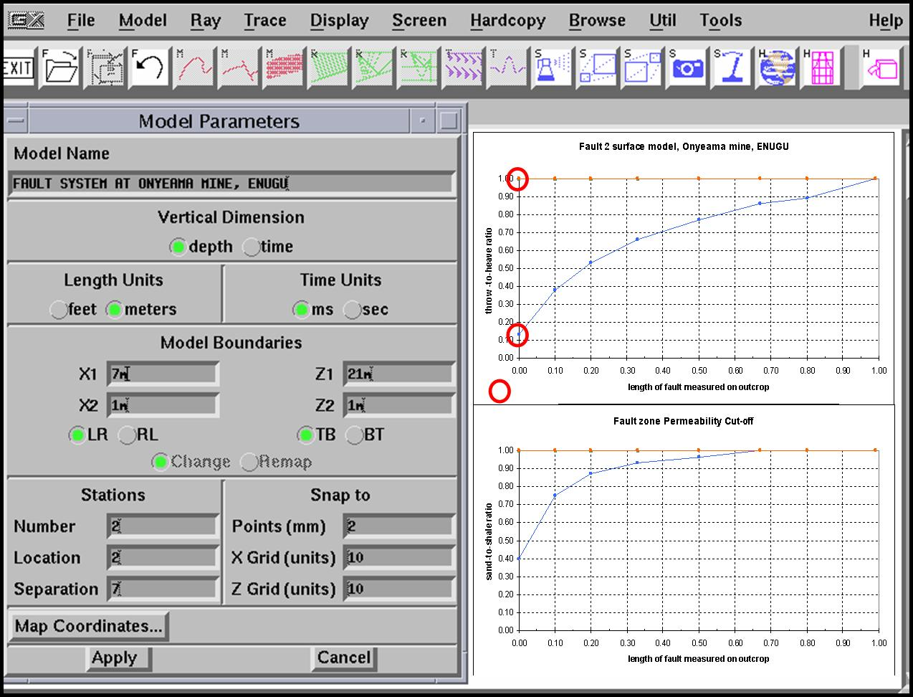
Figure10: Computer modelling workflow

one centimeter. Movement direction is down-dip, with rarely a strike-slip competent. Figure 11 shows a typical pressure data and plots from wells 1 and 2 drilled in the study areas.

Joints: In the Agbogugu outcrops, some beds have a well-developed joint pattern. The average strike of these joints is 035⁰, forming obliquely to the fault strike. The large majority of these joints do not show any movement along the joint surface.
These joints were interprepted as late features, absent during the main phase of deformation; hence do not aggregate enough to evolve into fault surfaces in the study area.

Segmented fault planes: Almost all of the faults obtained from the studied areas were segmented. These segments do not necessarily have the same plane.This causes structures such as soft-linkage and splay faults which is observed clearly at Agbogugu and Onyeama mines.

Figure 11: Pressure data and plots from well 1 and well 2 drilled in the Area.

(the negative depth values indicate sub-surface depths).

Multiple slip planes: Faults containing multiple parallel planes were identified in Agbogugu area, forming different slip angles and varying throw along the main fault surfaces from over 10m in some places to 2m or less in others. Such structures are described as zones of segment linkage, and near restraining bends.

Sealing Mechanisms: Several workers in sandstone-shale sequence of Anambra basin have documented the various sealing mechanisms observable from outcrops samples and geophysical data. The types include clay smear, cataclasis, fault cementation, pressure solution, crystal plasticity, and a combination of mechanism. This present study has shown that more than one of these mechanisms are present at the fault zones in Enugu area of Anambra basin. The study has also produced set of cross plots; which are comparable to similar plots from previous studies using different approaches (figures 12 & 13).

Figure 12a: Cross-plot of Clay Smear Potential

and Shale Gouge Ratio at Location 1.

Figure 12b: Cross-plot of Clay Smear Potential

and Shale Gouge Ratio at Location 2.
Figure13a:Cross-plot of shale smear factor against
Shale gouge ratio at location 1
Figure 13b: Cross-plot of shale smear factor against
Shale gouge ratio at location 2

Discussion of results
A number of mechanisms have been recognized where by fault planes can act as seals. This includes juxtaposition, clay smear, cataclasis, digenesis and pressure solution.
Using the cross-plot studies, it has shown that more than one of these mechanisms are present at the fault zones in Enugu area of Anambra basin. For instance in figure 12, a cross plot of shale smear factor (SSF) and shale Gouge Ratio (SGR) clearly shows a curvilinear relationship between the two algorithms. this implies that a high SGR is equivalent to a low SSF value. This is quite a good match to the plots obtained by Bouvier et al, 1989 and Yielding et al, 1997 for fault K. Num River field, Niger Delta. An SGR value of bout 15-20% is widely considered to represent the threshold between non-sealing and sealing bahaviour of faults in siliciclclastic sequences such as the Niger Delta (Fristad et al 1997).

Figures 12 and 13 show that this documented SGR values of 15-20% correspond respectively to SSF of 3.5 to 10 and CPS of 0.1 TO 3.0. The obtained vales for the CSP are somewhat similar to the values obtained by Bretan et al,(2004) for work done in Niger Delta using different methods. Jev et al, (1993) used the same technique of CSP calculations on the Akaso field in the Niger Delta and quoted a CSP of less than 15 as non-seating and CSP of more than 30 as sealing for faults bounding unsealed prospects.

Similarly, from a study of 80 faults, Lindsay et al, (1993) opined that smaller values of SSF are more likely to correspond to continuous smears and therefore to a sealing layer, than larger values. He therefore concluded that shale smear may be and incomplete for a SSF value greater than 7. Comparing this to figure 13, this actually correlates very well to the SGR values of less than 40% (within threshold).

In the nutshell, a deduction from these analyses is that the results obtained from using integrated approach in the study area, are quite comparable to those from other methods. One can therefore use the results to locally calibrate any future work in Anambra basin using same or different techniques.

This study has shown that outcrop data alongside seismic and well log data could be useful in the delineation and examination of faults sealing mechanisms with respect to their hydrocarbon potentials. From the results obtained from the study area, the following submissions could be drawned:
- The estimated plots agree reasonably well with the measures obtained from similar work, using different techniques and dataset.
- The pressure plots show that both vertical and lateral variations exist in Anambra basin and these variations could be due to processes other than fault sealing.
- The results of seismic interpretaition show the fault throw in the range of 20 meters, which have been classified as sealing.

Although the study has not provided answers to all the questions on fault gouge materials and their impact on hydrocarbon accumulation, but it has provoked some thoughts about possible clues why hydrocarbon may not be trapped against faults in Anambra basin.

Correspondent to:
Oyedele, K.F
Department of physics, University of Lagos, Lagos, Nigeria.
Telephone: +2340833357439
kayodeunilag@yahoo.com.

References.
1. Akande, S.O, Viczian, I. and Erdtmann, B.D: Prediction of petroleum generation intervals in the Southern Nigeria rift basins by means of clay transformation, vitrinite reflectance and fluid inclusions studies. NAPE Bulletin, 2005;Vol. 18 (1). p38 – 51.

2. Antoneli, M. and Aydin, A: Effect of faulting on fluid flow in porous sandstones: Geometry and spatial distribution. Bulletin of the American Association of petroleum Geologists 1995; 79(5) p642-671.

3. Bense V.F., Van Balen, R.T. de Vries, J.J: The impact of faults on the hydrogeological conditions in the Roer Valley Rift Sytem: an overview. Netherlands Journal of Geosciences.2003; 82(1) p41 – 45.

4. Bouvier, J.D., Kaars–Sijpesteijn, C.H. Kluesner, D.F., Onyejekwe, C.C., Vander Pal, R.C. Three-dimensional siesmic interpretations and fault sealing investigations, Num River Field, Nigeria. AAPG Bulletin 1989; 73.

5. Fristed, T. Groth, A., Yeilding, G. Freeman, B. Quantitative fault seal prediction: a case study from Oseberg Sydney. 1997; In: P. Moller-Pedersen, and A.G.

6. Fulljames, J.R., Zijerveld, L.J.J., Franssen, R. C.M.W., Ingram, G.M and Richard, P.D. Fault seal processes, in Norwergian Petroleum Society, eds. Hydrocarbon seal-importance from petroleum exploration and production 9th conference abstract.1996; Oslo, NPS p5.

7. Hogue, M. Petrographic differentiation of tectonically controlled cretaceous sedimentary cycles, Southeastern Nigeria sed. Geol.1997; Vol.17 p235 – 245.

8. Knipe, R.J., Fisher, Q.J., Jones, G. Clennell, M.R. Farmer, A.B., Harrison, A., White, E. A. Fault seal analysis: Successful methothologies, application and future directions. In: p. Moller-pederson, and A.G. Koesther (Eds.). Hydrocarbon Seals, NPF Special publication 7,1997, p15-38.

9. Ladipo, K.O. Paleogeography, sedimentation and tectonic of the upper cretaceous Anambra basin, Southeastern Nigeria. Journ. Of Afr. Earth. Scs. 1988; vol.7p81- 821.

10. Lindsay, N.G., Murphy, F.C., Walsh, J.J., Watterson,J. Outcrop studies of shale smears on fault surfaces special publication of International Association of Sedimentology.1993; 15, p113 – 123.

11. Murat, R.C. Stratigraphy and paleogeography of the cretaceous and lower tertiary in the southern Nigeria.1972; p45-60.

12. Nwajide, C.S. Eocene tidal sedimentation in the Anambra basin, southeastern Nigeria. Nigerian Journ. of min. Geol. 1987; vol.16 p 103-109.

13. Ojoy, K.A. The Southern part of the Benue trough (Nigeria) cretanceous stratigraphy basin analysis, paleo–oceanography and geodynamic evolution of the equatorial domain of the South Atlantic. NAPE Bull. 1992; vol.7 p 131–152.

14. Yielding, G., Freeman, B., Needham, D.T. Quatitative fault seal prediction: AAPG Bull.1997; 81(6) p 897–917.

