Notes on the existence of an additional lagoon in South-western Nigeria: Apẹsẹ Lagoon

I.C. Onyema

*Department of Marine Sciences
University of Lagos, Akoka, Lagos
*E-mail: iconyema@gmail.com

ABSTRACT
The existence of an additional lagoon in south-western Nigeria is reported. Hitherto, nine lagoons were known for south-western Nigeria. This account reports information on the tenth lagoon in south-western Nigeria. Apẹsẹ lagoon is a closed lagoon located in Victoria Island, in Lagos, and lies between Latitude 6º 25^{l} 20.83”N, Longitude 3º 27^{l} 15.52”E and Latitude 6º 25^{l} 20.29”N, Longitude 3º 27^{l} 57.19”E. The lagoon is about 32,000m² in area, lanceolate in shape and about 1.3km long and 0.16km wide. It is separated from the Atlantic Ocean by less than 100m of sand bar. The maritime condition to which the lagoon and its shore are exposed to presents unique marine situation and ecosystem. Details on this and its relationship with other lagoons in south-western Nigeria are highlighted in this paper. [The Journal of American Science. 2009;5 (4):151-156] (ISSN 1545-1003).

Key words: Apẹsẹ lagoon, Lagos, beach, South-western Nigeria.

INTRODUCTION
According to Kjerfve (1994), a coastal lagoon is an inland body of water, usually oriented parallel to the coast, separated from the ocean by a barrier, connected to the ocean by one or more restricted inlets, and having depths which seldom exceed a couple of meters. A lagoon may or may not be subject to tidal mixing from the sea, and salinity may vary from that of a coastal fresh water lake to a hypersaline lagoon, depending on the hydrologic balance of the area (Kirk and Lauder, 2000, Suzuki et al. 2002; Nwankwo, 2004). Kirk and Lauder (2000) are also of the view that lagoons are normally aligned with their largest diameters parallel to the seashore.

Lagoons vary in size and shape in relation to geomorphology and are known to experience forcing from river input, tides, precipitation, wind stress, evaporation and surface heat balance and they respond differently to these forcing functions (Kirk and Lauder, 2000). They are often highly productive habitats for a variety of plants and animals; serve as nurseries for prawns and shrimps and also sites for harbours, wharfs, aquaculture, industries and recreation (Akpata et al. 1993). Lagoons are fragile ecosystems susceptible to pollution effects from municipal, industrial and agricultural runoff (Odiete, 1999). Lagoons are important in water transportation, energy generation, exploitation and exploration of some mineral resources including sand; provide natural food resources rich in protein, fish and fisheries farming sites as well as sites for the disposal of both domestic and industrial wastes (FAO, 1969; Kirk and Lauder, 2000; Onyema et al. 2003, 2007; Chukwu and Nwankwo, 2004).

Lagoons can be classified as open, closed and semi-closed depending on whether they retain a permanent connection to the sea, an annual or less frequent connection, or a restricted and hence closed connection to the sea (Lawson and John, 1982). Adjoroud (1997) reported that there are essentially two types of lagoons based on their communication with the sea namely closed and open lagoons and they are rather special types of environment for marine organisms. Three interlinked properties greatly influence the physical, chemical and biological diversity of lagoons. These are: salinity, amount of ocean flushing, and the degree of enclosure (Kirk and Lauder, 2000).

Lagoons are common features on the coast of West Africa particularly where the coastline lies approximately 45⁰ to the prevailing South west trade winds (Webb, 1958). According to Webb (1958), Ibe (1988) and Dublin-Green and Tobor (1992) there are four main lagoon systems of the Guinea coast. The fourth and the largest of these systems stretched for 256 km from Cotonou in the Republic of Benin to the western edge of the Niger Delta in Nigeria. Their formation as reported by Webb (1958) is evidently a result of the movement of sand from the west to the east along a previously notched coast and has taken place since the last glacial period. Furthermore the sands of the beach and the lagoon deposit show signs of wind etching, and it is suggested that they may be derived from the Sahara, being blown into the sea perhaps off the Senegal coast.

Until now, nine lagoons were known in South-western Nigeria (Kusemiju, 1988; Nwankwo, 2004: Onyema, 2008; Onyema and Nwankwo, 2009). They are the Yewa, Badagry, Ologe, Iyagbe, Lagos, Kuramo, Epe, Lekki and Mahin lagoons (Onyema and Nwankwo, 2009; Onyema and Emmanuel, 2009). Little wonder Lagos, Nigeria has been described as the city of aquatic splendor. Iyagbe lagoon until recently was not clearly familiar as a lagoon but referred to in some literature as Badagry creeks (FAO, 1969; Kusemiju, 1988). However, Webb (1958) recognized it as a lagoon and reported explicitly on its probable mode of formation, hydrology and sediment type characteristics. The formation of the Guinea coast lagoons in south-western Nigeria is evidently dependent on the movement of sand along the coast in a west-east direction forming a prograding barrier cum longshore drift (Webb, 1958).

According to Nwankwo (1990), two factors, fresh water discharge from rivers and tidal seawater incursion influence the biological, physical and chemical characteristics of the Lagos lagoon. There is the existence of an environmental gradient linked with rainfall pattern in the Lagos lagoon (Nwankwo and Akinsoji, 1989). Furthermore, gradient of environmental factors in the coastal lagoons have been shown to be more discernable in the dry season than in the wet season (Nwankwo, 1993). With regard to lagoons in the region, the dry season in these lagoons is usually associated with higher light penetration, transparency, conductivity, salinity, pH and sodium values (Olaniyan 1969, Nwankwo and Akinsoji 1992, Nwankwo et al., 2003). Furthermore, these lagoons over the years have been increasingly exposed to land based anthropogenic stressors leading to their use as sinks, and their resulting deterioration (Chukwu, 2002; Nwankwo, 2004). Onyema et al. (2003) are of the view that pollution of the Nigerian coastal waters has continued unabated through unregulated discharges of a brew of wastes.

The Kuramo lagoon as represented figuratively by Webb, (1958), Hill and Webb (1958), Sandison (1966) and Sandison and Hill (1966) among others extended and tapered further to the East of its current coverage area. Presently, it would seem as if the original dimension of the Kuramo lagoon has now been divided into “two lagoons”. This is probably due to coastal sediment transport (Webb, 1958) and or high level habitat modification (Nwankwo, 2004). Whereas the larger half retains the name Kuramo lagoon (waters) and has been scarcely reported (Yoloye and Adegoke, 1977, Edokpayi et al., 2004 and Nwankwo et al., 2008), the other is unknown (Apẹsẹ lagoon) to the literature of south-western Nigeria. Coastal sediment advance as suggested by Webb (1958) most probably filled in the median of the former and larger Kuramo lagoon as represented by Webb (1958), Hill and Webb (1958), Sandison (1966), Sandison and Hill (1966), hence separating it into two lagoons as currently observed. Consequently giving rise to Kuramo lagoon to the west and Apẹsẹ lagoon to the east. These lagoons exist now as independent entities with distinctive peculiarities. It is quite possible that the end of the effect of the East mole after its increased erosion consequence on the Bar beach caused a build of sand that filled the median and separated the former Kuramo lagoon. Accordingly, it probable that the presence of the east mole lead to the dichotomy that created the “present” Kuramo and Apẹsẹ lagoons from the “former” Kuramo lagoon.

There are presently no reports on any aspect of the physico-chemistry, hydrological characteristics and ecology of the Apẹsẹ lagoon. Furthermore, this is the only completely closed lagoon in the region, as the Kuramo lagoon is semi-closed, in view of the fact that it seasonally opens in the wet season via the Kuramo creek into the Five Cowrie creek to the Lagos lagoon. This usually results from overflow of the Kuramo lagoon from the increased volume associated with storm water inflow during or immediately after rain events. The Apẹsẹ lagoon is located in Apẹsẹ (from where the lagoon derives its name) area of Lagos and it is located eastward of the Kuramo lagoon (1.24km) still in Victoria Island.

The aim of this account was to give some exactitudes on the “new” Apẹsẹ lagoon. This paper is a first of a series on the lagoon. This report therefore will provide first time information on the Apẹsẹ lagoon (the only closed lagoon in Nigeria) which has not previously received attention even in the most general terms, hence the need for this report.

DESCRIPTION OF THE STUDY LAGOON
The Apẹsẹ lagoon (Fig 1) is located in Victoria Island, Lagos state, South-Western Nigeria. The lagoon is located eastward (1.24km) of the Kuramo lagoon and is about one third of its size. It is the smallest of the ten lagoons in the region. It lies between Latitude 6º 25^{l} 20.83”N, Longitude 3º 27^{l} 15.52”E and Latitude 6º 25^{l} 20.29”N, Longitude 3º 27^{l} 57.19”E. The lagoon is about 32,000m² in surface area, lanceolate in shape and approximately 1.3km long and 0.16km across at its widest extreme. It is a narrow lagoon and separated from the proximate sea by a sand bar of less than 100m throughout its length to the south. The popular Kuramo and Oniru beaches in Lagos are also located in the area, a few hundred meters away. The Apẹsẹ lagoon is also about 5 - 6km (crow fly distance) from the Lagos habour.

It is worthy of note that a good number of the exactitudes especially with regard to distances for this ‘new’ lagoon were obtained by using the Google earth satellite mapping software. More importantly, is the fact that the discovery of the lagoon was due significantly to this software before ground confirmation and pilot / other studies were carried out.

The region experiences a tropical climate with south westerlies which are onshore. The lagoon experiences semi-diurnal tidal regime with two inequalities and is exposed to the wet and dry major seasons in the region. The hamattarn (dust haze) – which is a short season in the dry season, is also recorded in the area. Whereas the wet season stretches most times from May to November, the dry season is usually from December to April. The rains usually come at the middle to end of April in most years.

The vegetation type of the shore of the Apẹsẹ lagoon is similar to the strand of scrubby vegetation colonizing the seashore as described by Akinsoji et al., (2002) for the Light house beach (about 9km west) of the Apẹsẹ lagoon. Some identified species occurring at the lagoon shore include sand binders, xerophytic and halophytic species which include Ipomoea pes-caprae, Philoxerus sp., Paspalum vaginatum, Schizachryrium pulchellum and Remirea maritima.

Sediment type in the area is sandy i.e beach (coarse to medim) sand type common on sandy beaches of littoral states of Nigeria. Water colour of the lagoon was predominantly deep sea blue in February especially towards the center of the lagoon. The occurrence of an array of benthic organisms, shell and fin fish life have been reported by the locals. The lagoon is about 30m deep at its center. During the rain there are increases in the volume of the lagoon water and resulting in the submergence of the riparian zone. However, it retains its brackish / marine characteristics in terms of physico-chemistry all year round. Species directly collected, observed and recorded at the shore and shallow parts of the lagoon include Ocypoda cursor and O. africana, Tilapia spp., Callinectes latimanus, Cadmium sp. a good number of schools of fish juvenile which are commonly seen.

Furthermore seawater at spring tide and during rough sea seasons occasionally overflows the beach berm into the lagoon hence possibly impacting on its water chemistry. The months of April and August are known to be characterized by large swells of plunging waves at sea associated with the development of pressure systems far out in the South Atlantic ocean (Ibe, 1988). These waves are wind generated with intensities generally determined by the wind velocity, duration and fetch. Underground flow through / seepage can also not be ruled out as a source of marine conditions intrusions. At the bank of the lagoon are a few shacks. The locals or inhabitants have constructed make shift houses using dried bamboo and planks for frames, structure and pegging. Furthermore, used nylon, sacks and polythene which are used for covering these frameworks. The total numbers of such shacks on the shore of the beach to the south are between 10 and 15. The chief occupation of the locals is artisanal fishing both in the lagoon and the proximate sea. The sale of shells / cowries as souvenir to tourist is also an additional source of income for the inhabitants. A few modern houses / estates are presently coming up further north of the lagoon area. Most adjacent plots of land to the east and west are currently empty but fenced

.

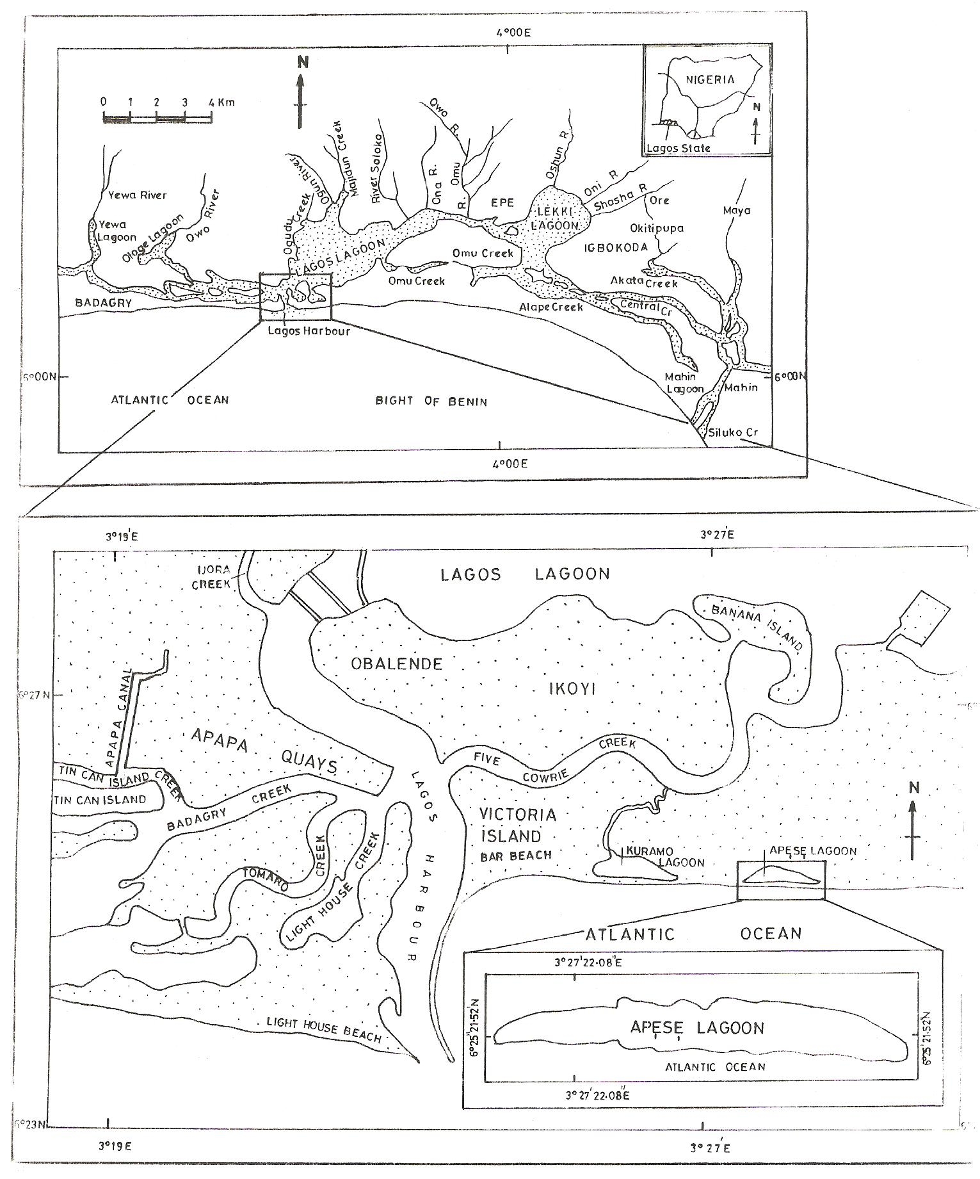
Fig 1: South-western Nigeria lagoons (top) and a map trail to Apesẹ lagoon (bottom left).

RECOMMENDATION.
The Apẹsẹ lagoon is exceptional among the ten lagoons of South-western Nigeria in Lagos since it is the only closed lagoon. There is need for in-depth ecological investigations of this “new” lagoon and to protect it from the effects of high anthropogenic stressors known to plague most of the lagoons in the region. Presently, modicum amount of human activities are observable in the immediate area. The Apẹsẹ lagoon like Tarkwa bay, Lighthouse beach, Kuramo lagoon, vast wetlands and other ecologically sensitive areas in south-western Nigeria that have been suggested as Marine Protected Areas (MPA) (Nwankwo, 2004) must be protected as they are quite vulnerable. There is need for apt coastal management and conservation of the Apẹsẹ lagoon and immediate evnvirons.

ACKNOWLEDGEMENT
I heartily thank Messrs Azeez Abdul Ipaye, Saheed Abimbola Afolabi and Ladega Junaid-Eko for their assistance and help to find and initiate research the Apẹsẹ lagoon. Importantly, thanks also goes to the Management of Google for making the Google earth satellite mapping software available. I am grateful to the department of Marine Sciences, University of Lagos for logistics support and use of its facilities.

References
Adjeroud, M. (1997). Long-term changes of epibenthic macrofauna communities in a closed lagoon (Tairo Atoll, French Polymesia): 1972 – 1994. Hydrobiologia. 356: 11 – 19.
Akpata, T.V.I.; Oyenekan, J.A. and Nwankwo, D.I. (1993). Impact of organic pollution on the Bacterial, Plankton and Benthic Population of Lagos Lagoon, Nigeria. International Journal of Ecology and Environmental Science. 19: 73-82.
Akinsoji, A., Adedoyin, J. and Adekanye, M. (2002). Aquatic macrophytes of three selected
sites in Lagos, Southwest Nigeria. Journal of Science, Technology & Environment. 2(1): 9 – 15.
Chukwu, L.O. (2002). Ecological effects of human induced stressors on coastal ecosystems in southwestern Nigeria. PIM 2002 Conference: The ocean in the New economy. Held in Cape Town, South Africa between 8 – 14, December, 2002. 61 – 70.
Chukwu, L. O. and Nwankwo, D. I. (2004). The impact of land based pollution on the hydro-chemistry and macrobenthic community of a tropical West African Creek. The Ekologia. 2 (1-2): 1 – 9.
Dublin-Green, C.O. and Tobor, J.G. (1992). Marine Resources and activities in Nigeria. NIOMR Tech Paper No. 84. 25pp.
Edokayi, C.A., Lawal, M.O., Okwok, N.A. and Ogunwemo, C.A. (2004). Physico-chemical and macrobenthic faunal characteristics of the Kuramo water, Lagos, southern Nigeria. African Journal of Aquatic Sciences. 29 (2). 235-241.
F.A.O. (1969). Fisheries Survey in the Western and Mid-Western Regions of Nigeria. FAO/Sf: 74/NIR 6. 142pp.
Hill, M.B. and Webb, J.E. (1958). The ecology of Lagos lagoon II. The topography and physical features of the Lagos harbour and Lagos lagoon. Philosophical Transaction of Royal Society, London. 241: 307-417.
Hynes, H.B.N. (1960). The biology of polluted waters. Liverpool University Press, Liverpool.202pp.
Ibe, A. C. (1988). Coastline erosion in Nigeria. University Press, Ibadan. 217pp.

Kjerfve, B. (Ed.) 1994: Coastal lagoon processes. Elsevier Oceanography Series 60. Elsevier, Amsterdam. 577pp.
Kusemiju, K. (1988). Strategies for effective management of water hyacinth in the creeks and
lagoons of south-westrn Nigeria. Proceedings of the international on water Hyayacinth, Lagos 7 – 12 August, 1988. 39 – 45.
Kirk, R.M. and Lauder, G.A. (2000). Significant coastal lagoon systems in the South Island, New Zealand. Coastal processes and lagoon mouth closure. Science for conservation.146: 47 p. Kjerfve, B. (Ed.) 1994: Coastal lagoon processes. Elsevier Oceanography Series 60. Elsevier, Amsterdam. 577pp.
Nwankwo, D.I. (1990). Distribution and seasonal variation of dinoflagellates in Lagos lagoon, Nigeria. Nigerian Journal of Botany. 3: 197-207.
Nwankwo, D.I. (2004). The Microalgae: Our indispensable allies in aquatic monitoring and
biodiversity sustainability. University of Lagos Press. Inaugural lecture seris. 44pp.
Nwankwo, D.I. and Akinsoji, A. (1989). The Benthic Algal Community of a Sawdust Deposition Site in Lagos Lagoon. International Journal of Ecology and Environmental Sciences. 15: 197-204.
Nwankwo, D.I. and Akinsoji, A. (1992). Epiphyte community of water hyacinth, Eichhornia crassipes (MART) Solms in coastal waters of South Western Nigeria. Archiv fur Hydrobiologie. 124(4): 501-511.
Nwankwo, D.I., Onyema, I.C. and Adesalu, T.A. (2003). A survey of harmful algae in coastal waters of south-western Nigeria. Journal of Nigerian Environmental Society. 1(2): 241 – 246.
Lawson, G.W. and John, D.M. (1982). The marine algae and coastal environment of tropical West Africa. Bei hertazur Nor. Hedingia. Heft. 70: J. Cramer.
Nwankwo, D.I., Owoseni, T.I., Usilo, D.A., Obinyan I., Uche, A.C. and Onyema, I.C. (2008). Hydrochemistry and plankton dynamics of Kuramo lagoon. Life Science Journal. 5 (3): 50 – 55.
Nwankwo, D.I. (2004). The Microalgae: Our indispensable allies in aquatic monitoring and
biodiversity sustainability. University of Lagos Press. Inaugural lecture seris. 44pp.
Odiete, W.O. (1999). Environmental Physiology of Animals and Pollution. Diversified Resources Ltd., Lagos. 261pp.
Ogamba, E.N. Chindah, A.C., Ekweozor, I.K.E. and Onwuteaka, J.N. (2004). Water quality of phytoplankton distribution in Elechi creek complex of the Niger delta. Journal of Nigerian Environmental Society. 2(2): 121 – 130.
Olaniyan, C.I.O. (1969). The seasonal variation in the hydrology and total plankton of the lagoons of South West-Nigeria. Nigerian Journal of Science. 3(2): 101-119.
Onyema, I.C. (2008). A checklist of phytoplankton species of the Iyagbe lagoon, Lagos. Journal of Fisheries and Aquatic Sciences. 3(3): 167 – 175.
Onyema, I.C. and Emmanuel, B.E. (2009). Fishing impairment and Spirogyra africanum
(Fruda) in a freshwater lagoon. Estonian Journal of Ecology. 58 (1): 1 – 7.
Onyema, I.C. and Nwankwo, D.I. (2009). Chlorophyll a dynamics and environmental factors in a tropical estuarine lagoon. Academia Arena. 1(1): 18 – 30.
Onyema, I.C., Otudeko, O.G. and Nwankwo, D.I. (2003). The distribution and composition of plankton around a sewage disposal site at Iddo, Nigeria. Journal of Scientific Research Development.7: 11-26.
Onyema, 1.C., Okpara, C.U., Ogbebor, C.I. Otudeko, O. and Nwankwo, D.I. (2007).
Comparative studies of the water chemistry characteristics and temporal plankton variations at two polluted sites along the Lagos lagoon, Nigeria. Ecology, Environment and Conservation. 13: 1 – 12.
Sandison, E.E. (1966). The effect of salinity fluctuation on the life of Balanus pallidus strusburi (Darwin) in Lagos Habour, Nigeria. Journal of Animal Ecology. 35: 365 – 378.
Sandison, E.E. and Hill, M.B. (1966). The distribution of Balanus pallidus Strusburi (Darwin), Gryphaea gasar (Adanson) Dautzenbergi, Mercierella enigmatica farvel and Hydroides uncinata (Philippi) in relation to salinity in Lagos Harbour and adjacent creek. Journal of Animal Ecology. 38: 235-258.
Suzuki, M.S., Figueiredo, R.O., Castro, S.C., Silva, C.F., Pereira, E.A., Silva, J.A. and Aragon, G.T. (2002). Sand bar opening in a castal lagoon (Iquipari) in the Northern region of Rio De Janeiro state: Hydrological and hydrochemical changes. Braz. J. Biol., 62 (1): 51 – 62.
Webb, J.E. (1958). The Ecology of Lagos lagoon. 1: The lagoons of the Guinea Coast. Philosophical Transaction Royal Society London. Ser B: 241-283.
Yoloye, V. and Adegoke, O.S. (1977). A new species of Neritina (Archaeogastroda,
Neritidae) from the Lagos lagoon. Malacologia. 16(1): 303 – 309.

