Diversity of Aquatic Hyphomycetes as Root Endophytes on Pteridophytic Plants in Kumaun Himalaya

S.C. Sati, N. Pargaein and M. Belwal*

Department of Botany, Kumaun University, Nainital-263002
*manish_belwal@yahoo.co.in

Abstract: Present study was carried out to explore the diversity of endophytic hyphomycetes on living roots of healthy pteridophytic plants growing near ravine areas of Jeoli (1150m.asl) and Kilburry (2160m.asl), located at Nainital, Kumaun Himalaya. Root samples of pteridophytic plants were processed and incubated in the laboratory following standard technique. A total of 11 species of aquatic hyphomycetes belonging to 9 genera namely Alatospora, Anguillospora, Campylospora, Clavariopsis, Heliscus, Lunulospora, Pestalotiopsis, Tetrachaetum and Tetracladium were recorded as root endophytic hyphomycetes of pteridophytic plants. Four species namely, Alatospora acuminata, Anguillospora crassa, Pestalotiopsis submersus, and Tetrachaetum elegans are being reported for the first time as root endophytic hyphomycetes of Equisetum, fern and Botrychium plant roots. It was interesting part of the study that the roots of Botrychium were found to colonize the maximum number of endophytic hyphomycetes, while Tetracladium setigerum was recorded as a commonly occurring root endophyte on all the pteridophytic hosts. [Journal of American Science 2009; 5(4):179-182]. (ISSN: 1545-1003)

Key words: aquatic hyphomycetes, endophytes, sporulation, spore types

- Introduction:
Microbes, which live with interior tissues of healthy plants without causing disease symptoms, are called endophytes. Endophytic fungi have been reported from different plants such as mosses, ferns, conifers and angiosperms (Sati and Belwal 2005). Endophyte occupies a unique ecological niche and has major influence on distribution, ecology, physiology and biochemistry of plants (Sridhar and Raviraja, 1995).
The aquatic hyphomycetes were first described by Prof. C.T. Ingold in 1942 as they complete their life cycle on submerged substrate in well aerated water, producing magnificent spore types (Belwal and Sati, 2005; Sati et al, 2002) while, Waid (1954) was the pioneer, for the first time reported some of these aquatic hyphomycetes from root surface too. Fisher et al (1986) recognized a separate group of aquatic hyphomycetes as Endophytic hyphomycetes and later Fisher et al (1991) confirmed their occurrence on the plant roots of aquatic habitats through experimental basis by examining the bark and xylem of aquatic roots of Alnus glutinosa. Similar reports have been made by some other mycologists on the endophytic aquatic hyphomycetes (Marvanova and Fisher, 1991; Marvanova et al, 1992; Pargaien, 2006; Sridhar and Barlocher, 1992; Sati et al, 2006, 2008) on different hosts. In the present paper aquatic hyphomycetes as endophyte of the Pteridophytic plant roots collected from Kumaun Himalaya were studied.

2. Materials and Methods:
‘Three step sterilization’ method of Fisher and Petrini (1989) was followed for the study of root endophytic fungi. Living roots of different tree plant species including herbs and shrubs growing in the ravine and wet areas located at Nainital Kumaun Himalaya were collected in 3 replicates of each. Nearly 10-15 cm long roots were cut off with a sharp sterile knife and washed with sterile water. These root samples were then keep in sterile polythene bags, brought to the lab and processed within 4-5 hours after collection. Root samples were washed under running tap water for about 10 minute to remove extraneous adhering soil particles and cut into 3-4 cm size segments. These were then rinsed with sterile water after surface sterilization with 90% alcohol for 2-3 minutes. The segments were incubated at 20 ± 2⁰C for 5-20 days in sterile petri-dishes containing 30 ml of sterile water. Incubated dishes were observed periodically to detect the conidia of endophytic fungi under low power of microscope.
Simultaneously, some of the surface sterilized root segments were placed in 2% Malt Extract Agar, supplemented with streptopenicillin or tetramycin solution (250mg/l) and incubated for a few days depending upon the growth of emerging fungi following agar plate method. Fungal mycelia growing on agar blocks were transferred into another petri dishes containing sterile water for sporulation and identification.

3. Results and Discussion:
The present study was carried out to investigate the diversity of aquatic hyphomycetes as endophytes from the living roots of pteridophytic plants growing near the selected ravine areas of Kumaun Himalaya. A total of eleven species belonging to 9 genera namely Alatospora, Anguillospora, Campylospora, Clavariopsis, Heliscus, Lunulospora, Pestalotiopsis, Tetrachaetum and Tetracladium of aquatic hyphomycetes were recorded as root endophytes, showing variation in the host diversity (Table 1; Fig. 1).

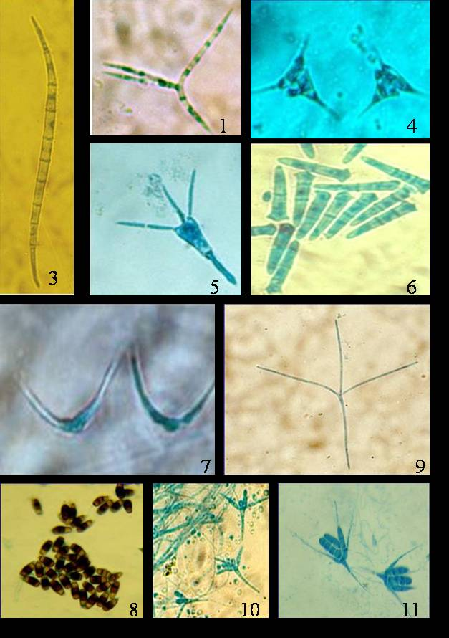

Fig. 1

(Figure no. are corresponding to table 1)

Table 1. Aquatic hyphomycetes isolated from pteridophytic plant of Kumaun Himalaya as root endophytes
S. No. | Root Endophytes | Host* | Locality**
1. | Alatospora acuminata | Eq / F | Jl / Kil
2. | Anguillospora crassa | Eq / F | Jl / Kil
3. | A. longissima | Bot | Jl / Kil
4. | Campylospora purvula | Bot | Jl / Kil
5. | Clavariopsis aquatica | Bot / F | Kil
6. | Heliscus lugdunensis | Bot | Jl / Kil
7. | Lunulospora curvula | Bot | Jl / Kil
8. | Pestalotiopsis submersus | Eq/F | Jl / Kil
9. | Tetrachaetum elegans | Bot | Jl / Kil
10. | Tetracladium marchalianum | F | Jl
11. | T. setigerum | F / Eq / Bot | Jl / Kil

* Eq = Equisetum, Bot = Botrychium, F= Fern,
** Jl = Jeoli, Kil = Kilburry

As evident from table 1, out of eleven species, 7 species were also reported by the earlier workers as commonly occurring endophyte. In the present investigation, however, these were found with their new host records. Two species namely, Anguillospora longissima and Tetracladium marchalianum which were earlier reported from Strawberry plant roots (Nemec, 1969) as well as from Lyonia ovalifolia and ferns (Sati and Belwal, 2005) were also recorded to colonize the roots of fern and Botrychium species, in the present study. Campylospora purvula and Clavariopsis aquatica was earlier reported by Fisher and Petrini (1989,1990), Sridhar and Barlocher (1992) and Sati and Belwal (2005) were also isolated here from Botrychium species. Heliscus lugdunensis was isolated from Botrychium and fern species in this study however, Fisher et al (1991), Sridhar and Barlocher (1992) and Sati and Belwal (2005) reported it from the roots of Alnus glutinosa, A. spicatum, Betula papyrifera, Picea glauca Lyonia ovalifolia and unknown pteridophytic plants. Lunulospora curvula was earlier reported by Sridhar and Barlocher (1992) and Sati and Belwal (2005), but in our study it was isolated from Botrychium and fern roots. Tetracladium setigerum was found as frequently occurring root endophyte as it was isolated from all Pteridophytic plants studied, however, Watanabe (1975) and Sati and Belwal (2005) recorded it from strawberry roots, Lyonia ovalifolia , Murrya koenjii and Fern roots. Botrichium roots were highly colonized by endophytic aquatic hyphomycetes followed by fern and Equisetum. In the present study, the staurosporus conidial forms were found most prevalent followed by variation in forms in order of occurrence (Fig. 1).
Acknowledgement:
The authors thank head, Department of Botany, Kumaun University Nainital, for providing lab facilities. Financial support of DST, New Delhi is greatly acknowledged.

References:
Belwal, M. and Sati, SC. 2005. Fungal flora of two altitudinally different streams of Kumaun Himalaya, In “Recent Mycological Researches” (Ed. S. C. Sati) I. K. International Pvt. Ltd., New Delhi, pp 3-21.
Fisher PJ and Petrini O. 1989. Two aquatic hyphomycetes as endophytes in Alnus glutinosa roots. Mycological Research, 92: 367-368.
Fisher PJ and Petrini O. 1990. A comparative study of fungal endophytes in xylem and bark of Alnus species in England and Switzerland. Mycological Research, 94: 313-319.
Fisher PJ, Anson AE and Petrini O. 1986. Fungal endophytes in Ulex europaeus and Ulex gallii. Trans. Brit. Mycol. Soc., 86: 153-156.
Fisher PJ, Petrini O and Webster J. 1991. Aquatic Hyphomycetes and other fungi living aquatic and terrestrial roots of Alnus glutinosa. Mycol. Res., 95: 543-547.
Ingold CT. 1942. Aquatic Hyphomycetes of decaying alder leaves. Trans. Brit. Mycol. Soc., 25: 339-417.
Nemec S. 1969. Sporulation and identification of fungi isolated from root rot diseased Strawberry plants. Phytopathology, 59: 1552- 1553.
Pargaien, N., Sati, S.C. and Belwal, M. 2006 Endophytic aquatic hyphomycetes of roots from forested plants of Nainital, Kumaun Himalaya. In “Plant Science Research in India: Challenges and Prospect:” (Ed. S. Kumar) pp 213-220.
Sati, S C, Tiwari, N. and Belwal, M. 2002. Conidial aquatic fungi of Nainital, Kumaun Himalaya, India. Mycotaxon 81: 445-455.
Sati SC and Belwal M. 2005. Aquatic Hyphomycetes as root endophytes of Riparian plant roots. Mycologia, 97(1): 45-59.
Sati, SC, Pargaein, N. and Belwal, M. 2006. Three species of aquatic hyphomycetes as new root endophytes of temperate forest plants. Nat. Acad. Sci. India 29 (2): 9-10.
Sati, SC, Belwal, M. and Pargaien, N. 2008. Diversity of water borne conidial fungi as root endophyte in temperate forest of western Himalaya. Nature and Science, 6 : 59-69.
Sridhar KR and Barlocher F. 1992a. Aquatic hyphomycetes in spruce roots. Mycologia, 84: 580-584.
Sridhar KR and Barlocher F. 1992b. Endophytic aquatic hyphomycetes of roots of Spruce, Birch and Maple. Mycol. Res. 96: 305- 308..
Sridhar KR and Raviraja NS. 1995. Endophytes- A crucial issue. Curr. Sci., 69: 570-571.
Waid JS. 1954. Occurrence of aquatic hyphomycetes upon the roots surface of beech grown in woodland soil. Trans. Brit. Mycol. Soc. 37: 420-421.
Watanabe T. 1975. Tetracladium setigerum an aquatic hyphomycetes associated with gentian and Strawberry roots. Trans. Mycol. Soc. Japan, 16: 348-350.

