Different Technique of Microcalorimetry and Their Applications to Environmental Sciences: A Review

Russel Mohammad¹, Jun Yao^{1,*}, Huilun Chen¹, Fei Wang¹, Yong Zhou¹, Martin M. F. Choi^{2,*}, Gyula Zaray³ and Polonca Trebse⁴

¹ School of Environmental Studies & Key Laboratory of Biogeology and Environmental Geology of Chinese Ministry of Education & Sino-Hungarian Joint Laboratory of Environmental Science and Health, China University of Geosciences, 430074 Wuhan, P.R. China
² Department of Chemistry, Hong Kong Baptist University, Kowloon Tong, Hong Kong SAR, P.R. China
³Department of Chemical Technology and Environmental Chemistry, Eötvös University, H-1518 Budapest, P.O. Box 32, Hungary
⁴ Laboratory for Environmental Research, University of Nova Gorica, Vipavska 13, 5000 Nova Gorica, Slovenia

School of Environmental Studies, MOE Key of Biogeology and Environmental Geology Laboratory, Sino-Hungarian Joint Laboratory of Environmental Science and Health, China University of Geosciences, Wuhan, P. R. China, 430074.
Tel: +86 27 67883036, +86-13207152128
Fax: +86 27 87436235
E-mail: yaojun@cug.edu.cn

Abstract: Microcalorimetry plays a significant role with its thermodynamic capacity across a broad range of environmental research fields. Recently developed instrumental methods are easily applied to different fields of study through microcalorimeters and they are commercially available. The effective area of application includes investigation into trace elements, living organisms, solute-solvent interactions, sorption processes and the identification of technical products stability. The combination of microcalorimetry with different specific analytical techniques has taken an effective role in solving the complex study of environmental sciences. Although microcalorimetric analyses have secured a place industrially for quality production, it is still not widely used in industrially. In our understanding it is also possible to apply in ecotoxicological fields of environmental sciences such as wastewater treatment. [The Journal of American Science. 2009;5(4):194-208]. (ISSN: 1545-1003).

Keywords: Microcalrimeter; Isothermal titration; Spectrophotometer; Double twin microcalorimeter; Chip microcalorimeter.

1. INTRODUCTION
All chemical, physical and biological processes result in either heat production or heat consumption. Microcalorimetry is a versatile technique for studying these thermal activities in terms of heat, heat flow and heat capacity. Microcalorimetry can be completely nondestructive and non-invasive to the sample. It seldom requires any prior sample treatment nor does it limit analysis to a physical state of the sample. Solids, liquids and gases can all be investigated. Microcalorimetry does not require a sample that has a particular characteristic to enable measurement like FTIR, UV-VIS, NMR, etc. Microcalorimetry is a direct and continuous measurement of the process under study. Unlike other analytical techniques that give “snapshots” of data, microcalorimetry gives real-time data continuously as the process proceeds. Fig. 1 displays the heat measuring principle of a microcalorimeter.
All calorimeters are thermodynamic instruments but some are also used in kinetics or as analytical tools. Differential scanning calorimetry (DSC) has for a long time been one of the most important techniques in thermal analysis and more recently ‘isothermal microcalorimeters’ are gaining an increasing importance as analytical instruments, in particular in some applied fields. Up to four independent calorimeters can be used simultaneously with Thermal Activity Monitor (TAM III), to perform repetitive or different types of experiments. TAM III is totally modular and enables a smaller system to be added to increase sample capacity or functionality. With the addition of a multi-calorimeter, holding six independent mini-calorimeters, the sample throughput is increased. While the standard version may be sufficient for many applications, the 48 channel version of TAM III, which enables as many as 48 simultaneous measurements, is recommended for high sample throughput. TAM III is simple to use and seldom requires much sample preparation. Since measurement is continuous, there are no breaks in the data collected. All sample set-up and data acquisition steps are performed by a dedicated software package, TAM Assistant™, which can also perform most common types of data analyses. In the isothermal mode, the high level of control enables for both long and short-term experiments to be performed with excellent baseline stability. The step isothermal mode is used to perform isothermal experiments at a number of temperatures in one single experiment. Because the instrument records data continuously, also during the temperature change, phase transitions or other temperature dependent effects will be detected. The scanning mode operates a linear ramp of temperature with time. Since the scanning rate is very slow the sample can be considered to be in thermal, chemical and physical equilibrium during measurement. In kinetic studies, the slow scanning rate ensures that the reaction follows the Arrhenius relation, i.e. the actual reaction rate takes place without significant overshoot in temperature. Fig. 2 shows one unit of TAM III multi-channel isothermal micro calorimeter. Most isothermal micro-calorimeters in current use are of the heat conduction type, for details of heat conduction micro-calorimeter see the references (Backman et al 1994; Wadsö 1994).
Currently calorimeters designed for work in the microwatt range conducted environmental research work under isothermal conditions. Nano-calorimeters, the name of which usually indicates a detection limit approaching one nano-watt, are included here in the group of micro-calorimeters. Recent developments in isothermal microcalorimetry have been substantial and several “easy to use” instruments are now commercially available. When complex processes are characterized by calorimetric measurements, for example in technical products or in biotic materials, it may not be possible to express the results in terms of thermodynamic or kinetic quantities by referring to well-defined reaction steps. In such cases, isothermal micro-calorimeters have found important, but so far limited use, as general ‘process monitors’ (Wadsö 1997).
This review will discuss microcalorimetric technology and its wide range application in environmental research. Its not cover all the applications of microcalorimetric technique in respect of environmental issue. Due to this limitation we apologize. Special attention will focus on different microcalorimeter techniques as process monitors in applied areas and where specific analytical measurements are conducted with the calorimetric experiments. Finding suitable microcalorimetric technique to reduce the environmental waste management and safe our environment.

2. MICROCALORIMETRIC AND OTHER METHODS FOR ENVIRONMENTAL STUDIES
2.1. Flow Microcalorimetric Technique
The microcalorimeter contained one flow through type reaction vessel operated at a constant flow rate and another vessel that could be used for mixing. A bubble of air was allowed to enter the flow system before an experiment; this showed the boundary between the liquids, acted as a marker and also helped to clean the reaction vessel before the new liquid entered.
Morgan and Bunch (2000) suggest that the microcalorimeter plays an excellent role in recovering oral microflora. The oral care market is one of the most important in the pharmaceutical sector, toothpaste sales alone were worth nearly $1 billion per annum a decade ago (Zeeve 1991). Microcalorimetry can be used to measure the heat associated with chemical or biochemical reactions (Buckton et al 1991; Chowdhry et al 1983). It has been to be a useful tool for examining many types of cellular activities in a wide range of organisms (Kemp 1991; Criddle et al 1991; Beezer et al 1977). The advantage of microcalorimetry is that the microorganisms can be challenged with various concentrations of the agent and any response is immediately registered. Microcalorimetry can be used to indicate a wider range of metabolic events that are inhibited by assessment percentage. Indeed, microcalorimetry has provided useful information for the synthetic drug design (Huang et al 1998) and has been used in deriving quantitative structural activity relationships (QSARs) (Montanari 1999). In their study it is proposed that microcalorimetry with cryopreserved cells could be used as a method for rapidly assessing the potential of individual or mixtures of components for commercial preparations designed to control oral microflora.

2.2. Combination Techniques
2.2.1. Flow Microcalorimetry and Spectrophotometry
Debord and others (2005) used a flow microcalorimeter to study enzyme (arylesterase) reactions. The enzyme activity is usually determined by spectrophotometry at 270 nm, using phenyl acetate as substrate. During there studies with various inhibitors of this enzyme, they experienced some limitations of the spectrophotometric technique, due to the high absorption of some inhibitors. So that they are selected microcalorimetry as a suitable alternative technique, since it does not display such limitations. Their main object was to summarizing the theoretical aspects of the microcalorimetric method, taking advantage of recent mathematical developments concerning the integrated Michaelis equation (Schnell & Mendoza 1997; Goudar et al 1999; Barry et al 1995) in order to validate the microcalorimetric study of arylesterase through comparison with the standard spectrophotometric method. Johnson and Biltonen (1975) have shown that the validity of this hypothesis depends on the existence of a thermal equilibrium between the exiting solution and the body of the calorimeter cell. Determining the thermodynamic and kinetic parameters of enzyme reactions is very useful to follow special references (Beezer et al 1972; Beezer & Stubbs 1973; O’Neill et al 2003; O’Neill et al 2004a; O’Neill et al 2004b). The microcalorimetric analysis of enzyme reactions often requires application of the integrated Michaelis equation. This application or integration was previously performed mostly by linear regression applied to a linearized form of the equation (Juszkiewicz et al 1998; Kot et al 2000; Todd & Gomez 2001; Stödeman & Schwartz 2002; Stödeman & Schwartz 2003). The results show that flow microcalorimetry could be a useful method for kinetic studies of arylesterase.

2.2.2. Differential Scanning and Isothermal Titration Microcalorimetry
The capabilities of contemporary differential scanning and isothermal titration microcalorimetry (ITC) for studying the thermodynamics of protein unfolding/refolding and their association with partners, particularly target DNA duplexes, were considered (Privalov & Dragan 2007). Contemporary DSC instruments are characterized not only by high sensitivity but by the high stability of their baseline and the ability to scan aqueous solutions up to and above 100 °C under excess pressure and by super cooling down below 0 °C. The wide operational range is important because changes of many macro molecules take place over a very broad temperature range. The main specificities of the contemporary ITC instruments are their sensitivity (i.e., the nanomolar consumption of material for experiment), the stability work at various fixed temperatures and fast equilibration at reloading the sample and changing the temperature at points whose measurements are conducted. The combined use of the isothermal titration and differential scanning microcalorimeters is critical. One of the important results from that study is the revealed qualitative difference in the energetic signatures of protein binding to the minor and major grooves.

2.2.3. Differential Calorimeter and Respirometer
So far only a few studies have been conducted about wastewater pollution based study in respect to the microcalorimetric analytical method in this specific field. One of these studies has used a combination method with differential calorimeters for animal wastewaters (AWW). The animal wastewaters were sampled from a pig-fattening farm (Dziejowski1995). Long-term and heavy application of AWW to soil may cause the pollution of ground waters, eutrophication of surface waters and biological, chemical and physical changes in soil (Middlebrooks 1974). Animal wastewaters from pig farms are characterized by high values of chemical oxygen demand (COD) and biochemical oxygen demand (BOD), and contain significant amounts of organic and inorganic compounds, N, P and other elements (Middlebrooks 1974). Studies of the microbial decomposition and mineralization of AWW are vital for environmental protection. An important research fact for the calorimetry of soil microbial processes has been concerned with the decomposition of sugars in soil (Yamano & Takahashi 1983; Ljungholm 1979). The main goal of this work is to show the usefulness of a high-volume calorimeter (0.5 dm³) as an applied method for characterization of the decomposition of AWW in soils.
Soil microorganisms play an essential role in the environment due to their role in cycling mineral compounds and in the decomposition of organic material (Silvana et al 2004). Soil microorganisms and their controlled processes are essential for the long-term sustainability of agricultural systems (Aikio et al 2000). However, many studies of agricultural effects on microbiota in soil are short-term. On the other hand, microorganisms also play an important role in degrading many agrochemicals. This action in the soil can promote a decrease in the toxicity of many organic compounds and influence the health of soil. The microbial activity measured in soils can indicate its degree of fertility and quality for agricultural management (Dumontet et al 2001). This procedure leads to the recommendation of desirable soil management, in order to favor agricultural uses (Kushwaha et al 2001). Knowledge of the dominant microbial processes in agricultural soils requires a great number of measurements at different conditions, which also requires a great number of samples and accurate methods (Turner et al 2001). A usual method to quantify microbial activity in soils consists in measuring soil respiration as carbon dioxide evolution or molecular oxygen consumption, which depends on microbial biomass composition in the soil, ambient temperature and moisture content. These methods employed for monitoring the microbiology of soil, have some advantages and limitations with a common characteristic that consists of measuring a given final product (Klein & Paschke 2000). The investigation of soil microbial activity is the use of a calorimetric technique, which has recently increased due to its facility in data collection. Some calorimetric investigations have been compared with classical methods for soil microbiology, referring to temperate soils. Calorimetric measurements for a metabolic process have become a method important for studying microorganisms, but the interpretation of the thermal effect observed requires additional biochemical information, including the simultaneous knowledge of molecular oxygen consumption and carbon dioxide evolution. The thermal effect involved can be followed through power–time curves and the great advantage of this procedure is the evaluation of the enthalpy values. Another advantage of the calorimetric method is related to the fact that it is simple and the measurement does not affect the sample. The signal is continuously recorded and enables to follow measurement of the same sample, a procedure which is not possible for other methods. The lowest incubation time presented smaller correlation values than those from longer incubation times and the best correlation data is verified after 103 days of incubation (Silvana et al 2004). The lowest correlations may be attributed to bioreactions that can be occurring simultaneously with the respiration process. The close correlation between respirometric and calorimetric values suggests that both methods are appropriate for assessing the relationship between the microbial activity and some properties in soils. Based on the obtained calorimetric results, it can be proposed that this technique should be as a useful analytical method for determining the microbial activity in soils.
Control of the utilization of soil for economic purposes is of the utmost importance for sustainable development. The Kyoto protocol states that CO₂ emissions due to soil utilization must be controlled and appropriate methodologies introduced that are rational and allow the monitoring of soil activity. Most studies focused soil microbial activity employ the CO₂ dissipated and the biomass as indicators. The methodologies to quantify CO₂ and soil biomass are very laborious, and provide results only after very long experimental phases. These studies have only an empirical focus, since it is very difficult to obtain quantitative indicators of soil microbial activity. The main consequence of the methodological limitations has been inappropriate soil management, which in many cases has been responsible for important losses in soil fertility (George et al 2002; O'Connor et al 2005; Stewart et al 2005). Thus, there is need for new methodologies to contribute to a better understanding of the biochemical reactions related to the fertility of soil. Calorimetry appears to be an important option for determination of both biomass and activity. The latest results show that this method can provide qualitative (Critter et al 2002a; Critter et al 2002b; Barros et al 2003) and quantitative (Prado & Airoldi 2002; Barros & Feijóo 2003) indicators of soil microbial activity that could be used as early warning signals of soil deterioration. Calorimeters are sensitive enough to detect very low heat rates. They can continuously monitor soil microbial activity in terms of dissipated heat, which is a direct product of the degradation of the soil organic matter. Preparation of the samples is clean and easy, avoiding the use of reagents that may affect the results and that may be pollutants. Barros and Feijóo (2006) took a further step towards quantitative application of calorimetric methods for the evaluation of the environmental impact of NH₄FePO₄.H₂O (AIP) on soil microbial reactions. This work shows a model and analyzes the power–time curves recorded from soil samples under the effect of different amounts of AIP. For phosphorous and iron contents were determined with an ICP-MS and quantify the percentage of soil organic matter by DSC. Using combination technique they get effective result due to the application of AIP on soil microbial metabolism. It is believed that this information can be very useful for the agriculture industry and its newly assumed obligations with respect to the Kyoto protocol.

2.2.4. Isothermal Titration Microcalorimetry and Atomic Absorption Spectrometry
A great variety of crystalline inorganic layered compounds have been employed as host nanomaterials due to favorable organic substance insertions into the interlayer nanospaces, with the purpose to synthesize inorganic–organic supramolecular systems, which enable applications in many fields, such as chemical surface modifications with functionalized agents, catalysis, toxic substance removal from the environment or compound preparations based on guest polymer intercalation into the layered nanostructures (Çapková & Schenk 2003). The intercalation reaction takes place due to acid–base interaction (Nunes & Airoldi 2000), whose progress of reaction can be easily followed through X-ray diffraction patterns. The chemical interaction of these invited species with the matrix can provide an explanation related to the intercalation chemistry as well as the interlayer organization of the guest species and the host–guest interactions (Eypert-Blaison et al 2001; Nunes & Airoldi 2000; Fudala et al 2000). The calorimetric technique has been used as a direct method for measuring the enthalpy of the host–guest interactions in many systems (Lima & Airoldi 2003). However, the complete thermo chemical data for systems comprising the intercalation of polar organic molecules into the cavities of lamellar compounds are, nevertheless, very limited in the literature. Thermodynamic data involved with the host/guest interaction of a chosen molecule or with a series of guest molecules and the inorganic polymeric lamellar matrix can give information of the acid–base reactions. From the experimental view point, calorimetric techniques can be successfully applied to such kinds of heterogeneous systems and the effectiveness of the interactive effect that is established at the solid–liquid interface can be determined (Macedo & Airoldi 2006; Ruiz & Airoldi 2004; Lazarin & Airoldi 2006; ; Lazarin & Airoldi 2005). Lazarin and Airoldi (2007) studied hydrated layered crystalline barium phenylarsonate, Ba(HO₃AsC₆H₅)₂·2H₂O as host for intercalation of n-alkylmonoamine molecules CH₃(CH₂)n-NH₂ (n = 1–4) in aqueous solution. These new intercalated compounds were characterized through physical and thermal methods and some correlations of these data correlate with the energetic of intercalation were observed. Using combination technique and they try to give a new dimension such kind research work. They are getting positive result in respect of that kind of research work. As a result hydrated lamellar crystalline barium phenylarsonate can be used as host support for organic polar molecules. The data obtained from calorimetric determinations are consistent with processes involving n-alkylmonoamines and the phenylarsonate nanocompound at the solid–liquid interface, with thermodynamically favorable values from the viewpoint of negative Gibbs free energy, exothermic enthalpy values and also positive entropic results. The correlations between interlayer distances of guest/host enthalpy and interactions with the carbon atom numbers of the aliphatic amine chain can be useful to infer properties for intercalation of undetermined n-alkylmonoamines.

2.3. Heat Conduction Microcalorimeter Technique
2.3.1. Single Twin Isothermal Microcalorimeter
In recent years, growing concern has been expressed about chemicals such as heavy metals and organic compounds due to their possible effects on the environment and threats to human health (McGulnness & Georges1991). Acute toxicity tests are the first steps in determining accurate toxicological information. An acute toxicity study can establish the relationship between the dose of a toxicant and the effect it has on the tested organism. In respect to this information, Liu and others (2000) has provided substantial data and obtained positive results in the field of environmental ecotoxicology. Microcalorimetry is a quantitative, inexpensive, and versatile method for toxicology research. Miles and Beezer (1986) demonstrated that microcalorimetric studies of bacterial growth reveal temporal details not observable by other techniques. Microcalorimetry can also be used to study the metabolism of mitochondria and the effects of toxicants on mitochondrial metabolism (Liu et al 1996; Tan et al 1996; Xie et al 1993; Wang et al 1991; Liu 1997). Thus, microcalorimetry could be helpful in safeguarding our environment by improving the performance and the operational safety of wastewater treatment plants.
Study of mitochondria is not only of theoretical significance, but also of applied value. Many aspects of the relations between mitochondria and the hardiness of plants, cytoplasmic male sterility of plants, disease and aging have been studied in recent years (Wallace 1992). Moreover, few microcalorimetric studies on the energy release of mitochondria isolated from plants have been previously reported. Zhou and others (2001) studied the energy release of rice mitochondria using a LKB 2277 Bioactivity Monitor under different conditions. After obtaining data on thermodynamic and kinetic behavior of rice mitochondria the results indicated that the lower the temperature the slower the energy release of the rice mitochondria. One can use this method and these results to characterize the ability of rice and other plants to release mitochondrial energy under different conditions.
Isothermal microcalorimetry (IMC) is a rapid technique for measuring changes in the susceptibility of a material to physicochemical change and the aggregate rate of such changes. Changes in heat content accompany all chemical and physical changes, including material degradation (Angberg & Nystromn 1988; Buckton & Beezer 1991;Koenigbauer et al 1992). IMC was utilized to measure the exothermic heat flow from specimens of ultra-high-molecular-weight polyethylene. Charlebois et al. (2003) used Willson’s method for interpreting IMC data. It was based on continuous measurement of heat flow at the temperature of interest for an extended period of time. The method involves obtaining an empirical equation as follows
Percent reaction=H_{p}/H_{t}×100% (1)
The equation is then integrated from time 0 to ∞ to obtain the total theoretical heat content (H_{t}) for the test specimen-medium. The applied equation is then re-integrated from 0 to some specified time to give the heat produced (H_{p}) over that time (Willson et al 1995). They demonstrate in this paper the usefulness of IMC as a viable method for studying the stability of polymeric implant materials.

2.3.2. Double Twin Microcalorimetric Technique
Double twin isothermal microcalorimeter provides a new dimension for the environmental research field. It is a heat conduction microcalorimeter (Wadsö & Markova 2000). In this instrument two twin microcalorimeters are placed adjacent, one on top of the other. The size of the instrument is the same as that of a commercial single twin microcalorimeter and each of the twin parts has similar properties to one normal twin microcalorimeter. There have however, also been reported more advanced measurements where a second calorimeter has been used to assess a secondary parameter characterizing the same process. One example is the number of sorption calorimeters where water vaporized in one calorimeter and absorbed by a sample in another calorimeter (Calvet 1953; Duisterwinkel & Bokhoven 1995; Wadsö & Wadsö 1996; Wadsö & Wadsö 1997). The two important key functions that will be beneficial for the use of this type of microcalorimeter: (1) it is very sensitive with small changes in temperature; (2) with comparison to reference sample side it is consume the time to get steady state for analyzing the sample (fig 3). The advantage with a double calorimeter is that one may easily perform two related calorimetric experiments at the same time and in close proximity.

2.3.3. Multi-channel Isothermal Microcalorimetric Technique
Techniques of isothermal micorcalorimetry have been greatly improved during the past two decades (Wadsö 2002). In addition to their use in fundamental research, applications of practical importance have been established in other areas. However, no significant use of isothermal microcalorimetry has yet been seen in practical applications of biology, despite many methodological studies reported from that discipline. Significant progress has recently, however, been made in the design of multi-channel isothermal microcalorimeters and in techniques where specific analytical methods have been combined with isothermal microcalorimetery.
A microcalorimeter that measures total heat output (µW) was used to determine the total metabolic rate (aerobic and anaerobic) and the cost of feeding (specific dynamic action, SDA) in larval Atlantic cod (Gadus morhua) (McCollum et al 2006). This study provides new information on individual measurements of total heat output in larval Atlantic cod. Previously there had been many studies undertaken by measuring oxygen uptake by respirometry (Fyhn & Seristag 1987; Finn et al 1995a; Finn et al 1995b, Finn et al 2002; Herbing & Boutilier 1996; Herbing et al 2001). This study shows that the metabolic cost of feeding increased with development and remained elevated suggesting that cod larvae allocate a large part of their energy budget to growth in order to meet the demands of their fast growth rates.
Using multichannel microcalorimetry Wang fei, et.al (2008) recent work to evaluate the toxic effect of Heavy metal ion Iron (iii) on different biological model. It is an ideal work for concentrate the environmental toxicological issue. They are main object to focus on the microbial ecology of bacteria and fungi in ecological niches. The presences of high metal concentrations have significant adverse effects on whole soil microbial biomass and activity (Preston et al 2000) and soil hydrolase activities (Renella et al 2004, Renella et al 2005). The major scientific and medical interest in iron is based on the essential bio-element, but toxicological considerations are also important in terms of accidental acute exposures by sensitive and accurate methods to assess the microbial activities in vitro. So that using multichannel microcaloriemtry to get power-time curves from thermal effect of different microbial activity. The results also will be useful to understand the tolerance of prokaryotes and eukaryotes to iron overload.

2.3.4. Multi-channel “Chip Calorimeters”
Chip calorimeters are heat power sensors which are developed in MEMS technology (micro-electromechanical systems), i.e. all essentially components of a calorimeter such as well defined heat conductance and heat sink, temperature sensors, sensors for the detection of temperature differences, heating resistors and sample containers are integrated on one single chip. A detailed overview of common technologies of chip fabrication for calorimetric devices is given in (Herwaarden 2005). Typically it is made from silicon, silicon nitride, silicon oxide and polymer foils. The design is based on a silicon chip which is etched in the central part in order to obtain a thin membrane (Fig.4).
Microcalorimetric methodology is used widely in the pharmaceutical field for quality production. It is a perfect instrument for pharmaceutical chemical analysis. We would like to interpret the recent advances in the study of solid state pharmaceutical materials and the importance of microcalorimeter application. The practical example selected is that of formulated products containing benzoyl peroxide – a treatment for acne and athlete’s foot (Beezer et al 2004). A newly developed procedure for data analysis is outlined and preliminary results from chemo metric-based analysis of complex solid state reaction schemes are presented. Those solid state reactions are not described by integral reaction orders but through non-integral fitting parameters (Ng 1975, Urbanovici & Segal 1999) that indicates a mechanism for the solid state reaction process is another rather significant limitation. The purpose of this study is to outline new approaches that may ameliorate some of these limitations. Microcalorimetric determinations of stability offers significant time saving relative to traditional high temperature storage studies as these take months to years to complete (Aulton 1988). In contrast, microcalorimetric studies may require, only some 50 hours to yield the appropriate rate constant data (Willson et al 1995, Beezer et al 2001). The overall conclusions of the study were that experimentation was 24 hours faster and this was sufficient to identify solid-state reaction rate coefficient and other relative factors (Zaman et al 2001a, Zaman et al 2001b). Finally, the microcalorimetric requirements for such stability studies are contrasted with the newly emerging multi-channel “chip calorimeters” that operate in the nanorange with high throughput potential.
Recently Johannes Lerchner analyzes the chip microcalorimeter potentiality for biochemical and cell biological investigation (2008).Essential progress in the development and application of chip calorimeters was made due to the growing technological potential evolved during the last decade. It is evident that the invention of chip calorimeters led to a considerable extension of the application field of calorimetry. Thus, it is hardly possible to determine heats of fusion of nano-scaled single crystals without using chip calorimeters (Kwan et al 2001). For the measurement of heats of reaction in nanoliter droplets chip calorimeters are favourable too (Torres et al 2004). Furthermore, chip calorimetry is the method of choice for investigations of absorption phenomena in thin films (Lerchner et al 2004). The membrane serves as sample carrier and contains temperature sensors and heater elements. The thickness of the membrane depends on the kind of application and ranges from several nanometers for high-speed temperature scanning experiments to a few micrometers for isothermal operations. The main advantages of chip calorimeters are their low costs, the ability of multiplex operations, the short sample transfer time and the simple construction. The latter enables the application as control device in bioreactors. Limitations arise from the restricted volume-specific heat power resolution.

2.4. Polarized Microcalorimeter Energy Dispersive X-Ray Spectrometric Technique
The use of microcalorimeter increases day by day according to its versatile analytical properties (Redfern et al 2002). Here we introduce a new type of microcalorimeter which is used commercially for trace metal element. The requirement for improvement in x-ray detector technology has been a major necessity for the semiconductor industry is their long term goal to address the analytical requirements of particles down to 35 nm as discussed in the 1997 National Technology Roadmap for semiconductors (NTRS 1997). To achieve these analytical requirements, the National Institute of Standards and Technology developed a transition edge sensor (TES) Microcalorimeter (Wollman et al 1996). To introduce this exiting technology to industrial applications, EDAX INC and CSP (Cryogenic Spectrometers) GmbH established a partnership to develop a commercially available microcalorimeter and installed the first beta unit at Infineon Munich.

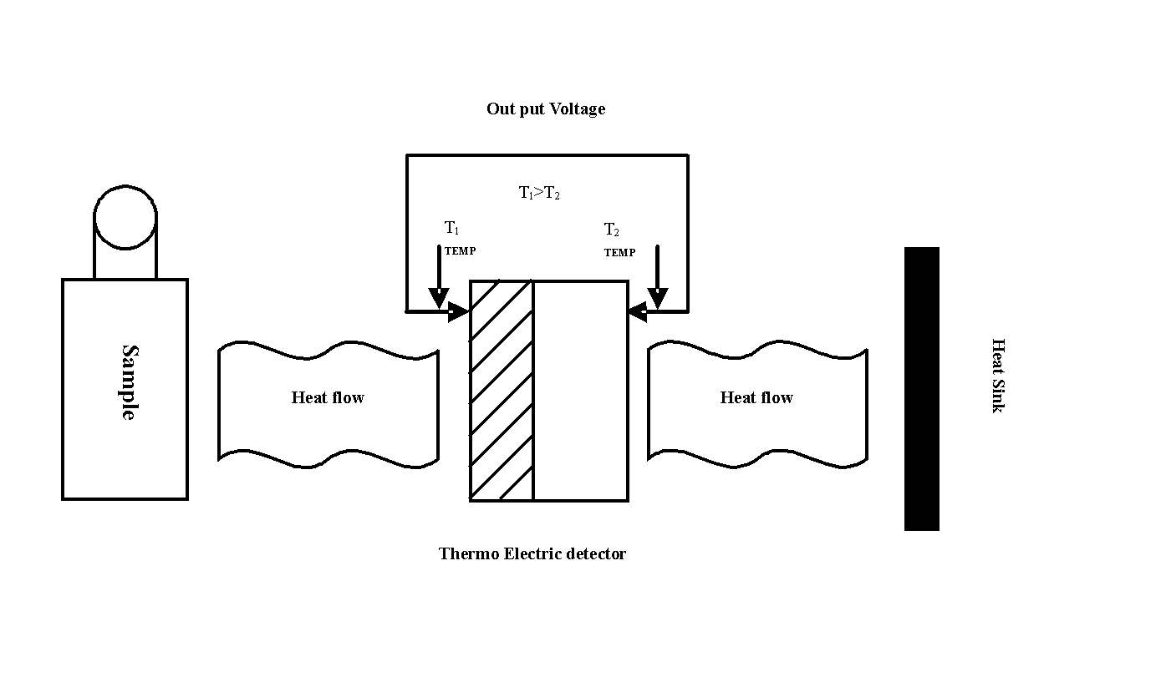

Fig. 1 Principle of measuring the heat by Microcalorimeter.

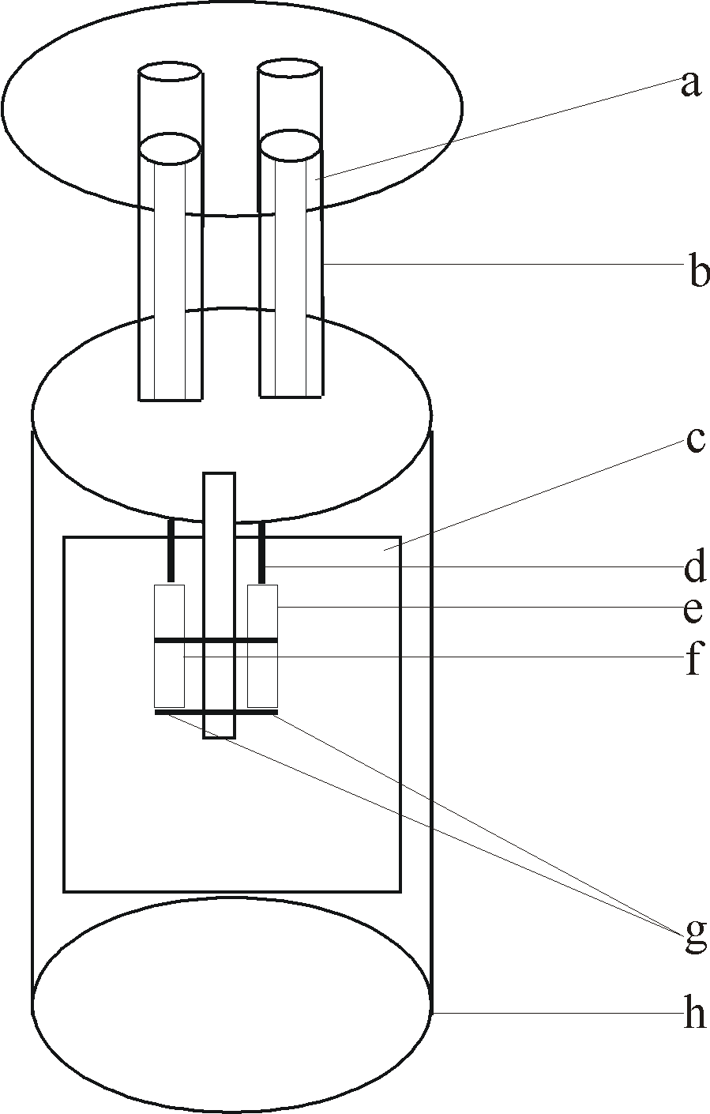
Fig.2 One unit of TAM III multi-channel isothermal micro calorimeter ; (a) Ampoule
Lifter; (b) Equilibration Tube; (c) Heat Sink; (d) Ampoule lifter; (e) Sample
measuring cup;(f) Reference measuring cup; (g) Thermoelectric modules; (h) Cylinder.

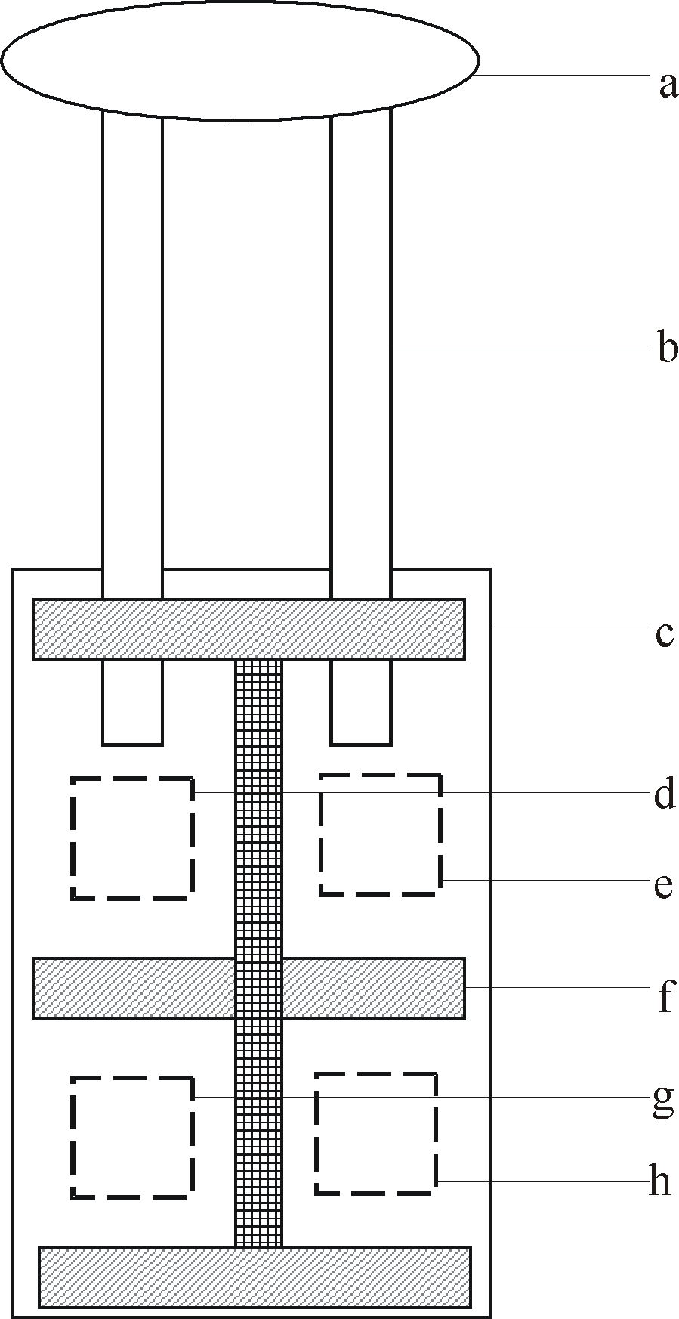

Fig.3 Cross sections of the double twin microcalorimeter; (a) Ampoule lifter ; (b) Tubes
through which the calorimeters are charged; (c) Steel can; (d) Top reference
ampoule position; (e) Top measuring ampoule position; (f) Heat flow breaker. (g)
Bottom reference ampoule position; (h) Bottom measuring ampoule position.

Fig.4 Schema of a chip calorimeter device with a thermopile as temperature sensor; (a)
Membrane; (b) Sample; (c) silicon frame; (d) Chip heater; (e) Thermopile.

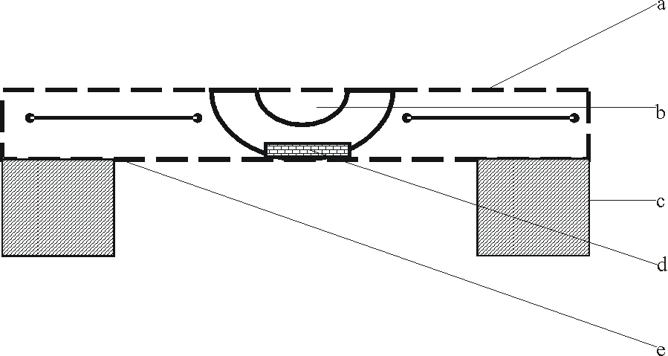
Table 1 Main application of microcalorimetric analysis and combined techniques to environmental sciences

Application | Techniques | Reference
Identified antimicrobial agents in respect of oral microorganism | Flow microcalorimeter | (Morgan & Bunch 2000)
Enzyme kinetics | Flow microcalorimeter and spectrophotometer | (Debord et al 2005)
Study the biological macromolecules | DSC and Isothermal titration microcalorimeter | (Privalov & Dragan 2007)
Study the animal wastewaters soil characteristics | Differential calorimeter and electolytical respirometer | (Dziejowski 1995)
Determine the soil properties | TG and DSC | (Barros et al 2006)
Determination of process involving at solid/ liquid interface | Isothermal micorcaloriemeter , AAS and X-ray diffraction pattern | (Lazarin & Airoldi 2007)
Determine the metabolism of cells | Heat conduction microcalorimeter | (Liu et al 2000)
Determine energy released from the mitochondria | Heat-Flow microcalorimeter | (Zhou et al 2001)
Studying the stability of polymeric implant material | Isothermal microcalorimeter | (Charlebois et al 2003)
Physical, chemical, biological change can be measured | Double twin isothermal microcalorimeter | (Wadsö & Markova 2000)
Working on living materials | Multi-channel isothermal microcalorimeter | (Wadsö 2002)
Study the metabolic cost of feeding in atlantics cod (larvae) and Evaluate the toxic effect of heavy metal ion on different biological model | Multi-channel isothermal microcalorimeter | (McCollum et al 2006; Wang 2008)
Study the solid state reaction of pharmaceutical importance and Biochemical and cell biological investigation | Multi-channel “chip calorimeter” | (Beezer et al 2004; Lerchner et al 2008)
Determine metal ion | Polaris microcalorimeter energy dispersive x-ray spectrometer | (Redfern et al 2002)

3. CONCLUSION
After overall discussion it is clear that microcalorimetric techniques are dramatically changed from inception to present. This overview cannot cover all applications of microcalorimetric techniques in environmental sciences, aim, however at showing the improvement of the current microcalorimetric analysis techniques regarding qualification, reproducibility and automation as well as the new emerging combined techniques. Table 1 summarizes the current applications of microcalorimetric techniques. Combination of the microcalorimetry methodology with other applications, such as high performance liquid chromatography, inductively coupled plasma mass spectrometry, and various spectroscopic analyses, would help better understand of the intrinsic mechanisms of various surface reactions, ligand-binding processes, microbial activity, and the interactions among soil constituents. In our opinion, the application of this equipment is insufficient for wastewater treatment. Therefore, it is essential to research application methods which can be combined with microcalorimetry for the safety of our environment.

4. ACKNOWLEDGEMENTS
This work was supported in part by grants from the Sino-Italian, Sino-German PPP Governmental International Scientific and Technological Cooperation Project (Annex No.3, 20063139, respectively), National Natural Science Foundation of China (No. 40425001, No.40673065), the Specialized Research Fund for the Doctoral Program of Higher Education (20060491508), the Key Project of Chinese Ministry of Education (107077), and the Hubei Key International Cooperation Project (2006CA007).

Corresponding authors:
Prof. & Dr. Jun Yao,
School of Environmental Studies
& Key Laboratory of Biogeology
& Environmental Geology of Chinese Ministry of Education
& Sino-Hungarian Joint Laboratory of Environmental Science and Health,
China University of Geosciences, Wuhan 430074, P.R. China.

Dr. Martin M. F. Choi,
Department of Chemistry,
Hong Kong Baptist University,
224 Waterloo Road, Kowloon Tong,
Hong Kong SAR, P.R. China
Tel.: +86 27 6788 3036 (J. Yao), +852 3411 7839 (M.M.F. Choi);
Fax: +86 27 6788 5032 (J. Yao), +852 3411 7348 (M.M.F. Choi).
E-mail: yaojun@cug.edu.cn (J. Yao), mfchoi@hkbu.edu.hk (M.M.F. Choi)

School of Environmental Studies,
MOE Key of Biogeology and Environmental Geology Laboratory,
Sino-Hungarian Joint Laboratory of Environmental Science and Health,
China University of Geosciences, Wuhan, P. R. China, 430074.
Tel: +86 27 67883036, +86-13207152128
Fax: +86 27 87436235
E-mail: yaojun@cug.edu.cn

5. References:
- Aikio, S., Väre H., and Strömmer R. (2000).Soil microbial activity and biomass in the primary succession of a dry heath forest. Soil Biology Biochemistry 32, 1091-1100.
- Angberg, M. and Nystrom, C. (1988). Evaluation of heat-conduction microcalorimetry in pharmaceutical stability studies. Acta Pharmaceutica Suecica 25, 307-320.
- Aulton, M.E. (1988). Pharmaceutics. Churchill Livingstone.
- Backman, P., Bastos, M., Hallen, D., Lönnbro, P., and Wadsö, I. (1994). Heat conduction calorimeters: time constants, sensitivity and fast titration experiments. Journal of Biochemical and Biophysical Methods 28, 85-100.
- Barry, D.A., Barry, S.J. and Culligan-Hensley, P. (1995). Algorithm 743: WAPR: A fortran routine for calculating real values of the w-function. Acm Transactions on Mathematical Software 21, 172-181.
- Barros, N., Feijóo, S., and Fernández, S. (2003). Microcalorimetric determination of the cell specific heat rate in soils: relationship with the soil microbial population and biophysic significance. Thermochimica Acta 406, 161-170.
- Barros, N., and Feijóo, S. (2003). A combined mass and energy balance to provide bioindicators of soil microbiological quality. Biophysical Chemistry 104, 561-572.
- Barros, N., Airoldi, C., Simoni , J. A., Ramajo, B., Espina, A., and García, J. (2006). Calorimetric determination of the effect of ammonium-iron(II) phosphate monohydrate on Rhodic Eutrudox Brazilian soil.Thermochimica Acta 441,89-95.
- Beezer, A.E., Chowdhry, B.Z., Newell, R.D. and Tyrrell, H.J.V. (1977). Bioassay of antifungal antibiotics by flow micorcalorimetry. Analytical Chemistry 49, 34-37.
- Beezer, A.E., Tyrrell, H. and Steenson, T. (1972). Protides of the Biological Fluids. Pergamon Press, p. 563.
- Beezer, A.E. and Stubbs, C. (1973). Application of flow microcalorimetry to analytical problems—I Determination of organophosphorus pesticides by inhibition of cholinesterase. Talanta 20, 27-31.
- Beezer, A.E., O’Neill, M.A.A., Urakami, K., Connor, J.A. and Tetteh, J. (2004). Pharmaceutical microcalorimetry: recent advances in the study of solid state materials. Thermochimica Acta 420, 19-22.
- Beezer, A.E., Morris, A.C., O’Neill, M.A.A., Willson, R.J., Hills, A.K., Mitchell, J.C. and Connor, J.A. (2001). Direct determination of equilibrium thermodynamic and kinetic parameters from isothermal heat conduction microcalorimetry. Journal of Physical Chemistry 105, 1212-1215.
- Buckton, G., Russell, S.J. and Beezer, A.E. (1991). Pharmaceutical calorimetry: a selective review. Thermochimica Acta 193, 195-214.
- Buckton, G. and Beezer, A.E. (1991). The applications of microcalorimetry in the field of physical pharmacy. International Journal of Pharmaceutics 72, 181-191.
- Chowdhry, B.Z., Beezer, A.E. and Greenhow, E.J. (1983). Analysis of drugs by microcalorimety: isothermal power-conduction calorimetry and thermometric titrimetry. Talanta 30, 209-243.
- Criddle, R.S., Breidenbach, R.W. and Hansen, L.D. (1991). Plant calorimetry: how to quantitatively compare apples and oranges. Thermochimica Acta 193, 67-90.
- Critter, S. A. M., Freitas, S. S., and Airoldi, C. (2002a). Microbial biomass and microcalorimetric methods in tropical soils. Thermochimica Acta 394,145-154.
- Critter, S. A. M., Freitas, S. S., and Airoldi, C. (2002b). Comparison between microorganism counting and a calorimetric method applied to tropical soils. Thermochimica Acta 394, 133-144.
- Çapková P., and Schenk H., (2003). Host–guest Complementarity and Crystal Packing of Intercalated Layered Structures . Journal of Inclusion Phenomena and Macrocyclic Chemistry, 47, 1-10.
- Charlebois, S.J., Daniels, A.U. and Lewis, G. (2003). Isothermal microcalorimetry: an analytical technique for assessing the dynamic chemical stability of UHMWPE. Biomaterials 24, 291-296.
- Calvet, E. (1953). Adaptation of a microcalorimeter of four elements to the thermogravimetry of adsorption. C R Academic Science (Paris) 236, 486-488.
- Debord, J., Harel, M., Bollinger, J., Verneuil, B., Merle, L. and Dantoine, T. (2005). Flow microcalorimetric study of enzyme reactions: application to arylesterase from human serum. Thermochimica Acta 427, 85-91.
- Dziejowski, J.E. (1995). Calorimetric and respirometric characteristics of the decomposition of animal wastewaters in soil. Thermochimica Acta 251, 37-43.
- Dumontet, S., Mazzatura, A., Casucci, C., and Perucci, P. (2001). Effectiveness of microbial indexes in discriminating interactive effects of tillage and crop rotations in a Vertic Ustorthens. Biology and Fertility of Soils 34, 411-416.
- Duisterwinkel, A.E. and Bokhoven, J.J.G.M. (1995). Water sorption measured by sorption calorimetry. Thermochimica Acta 256, 17-31.
- Eypert-Blaison, C., Sauzéat, E., Pelletier, M., Michot, L. J., Villiéras, F., and Humbert, B. (2001) Hydration Mechanisms and Swelling Behavior of Na-Magadiite. Chemistry of Materials 13, 1480-1486.
- Fudala, Á., Kónya, Z., Kiyozumi, Y., Niwa, S. I., Toba, M., Mizukami, F., Lentz, P. B., Nagy J., and Kiricsi, I. (2000). Preparation, characterization and application of the magadiite based mesoporous composite material of catalytic interest. Microporous and Mesoporous Materials 35, 631-641.
- Fyhn, H.J. and Seristag, B. (1987). Free amino acids as energy substrate in developing eggs and larvae of the cod (Gadus morhua). Marine Biology 96, 335-341.
- Finn, R.N., Fyhn, H.J. and Evjen, M.S. (1995a). Physiological energetics of developing embryos and yolk-sac larvae of Atlantic cod (Gadus morhua). I. Respiration and nitrogen metabolism. Marine Biology 124, 355-369.
- Finn, R.N., Hendersen, J.R. and Fyhn, H.J. (1995b). Physiological energetics of developing embryos and yolk-sac larvae of Atlantic cod (Gadus morhua). II. Lipid metabolism and enthalpy balance. Marine Biology, 124 371-379.
- Finn, R.N., Ronnestad, I., van der Meeran, T. and Fyhn, H.J. (2002). Fuel and metabolic scaling during the early life stages of Atlantic cod (Gadus morhua). Marine Ecology-Progress Series 243, 217-234.
- Goudar, C.T., Sonnad, J.R. and Duggleby, R.G. (1999). Parameter estimation using a direct solution of the integrated Michaelis-Menten equation. Biochimica et Biophysica Acta -Protein Structure Molecular Enzymology 1429, 377-383.
- George, T., Magbanua, R., Garrity, D. P., Tubaña, B. S., and Quiton J. (2002). Rapid Yield Loss of Rice Cropped Successively in Aerobic Soil. Agronomy Journal 94, 981-989.
- Huang, Z.Y., Liu, Y., Qu, S.S. and Feng, Y. (1998). A comparative study on half-inhibitory concentration of Schiff base-metal complexes reacting with bacteria. Thermochimica Acta 320, 121-126.
- Herbing, H. V. I. and Boutilier, R.G. (1996). Activity and metabolism of larval Atlantic cod (Gadus morhua) from the Scotian Shelf and Newfoundland source populations. Marine Biology 124, 607-617.
- Herbing, H. V. I., Gallager, S.M. and Halteman, W. (2001). Metabolic costs of pursuit and attack in early larval Atlantic cod. Marine Ecology-Progress Series 216, 201-212.
- Herwaarden, A.W.C. (2005) Overview of calorimeter chips for various applications,
Thermochimica Acta 432, 192–201.
- Johnson, R.E. and Biltonen, R.L. (1975). Determination of reaction rate parameters by flow microcalorimetry. Journal of the American Chemical Society 97, 2349-2355.
- Juszkiewicz, A., Kot, M. and Zaborska, W. (1998). Calorimetric study of inhibition of urease by 2-mercaptoethanol: procedures based upon integrated rate equations. Thermochimica Acta 320, 45-52.
- Kemp, R.B. (1991). Calorimetric studies of heat flux in animal cells. Thermochimica Acta 193, 253-267.
- Kot, M., Zaborska, W. and Juszkiewicz, A. (2000). Inhibition of jack bean urease by thiols: calorimetric studies. Thermochimica Acta 354, 63-69.
- Kushwaha, C. P., Tripathi, S. K., and Singh, K. P. (2001). Soil organic matter and water-stable aggregates under different tillage and residue conditions in a tropical dry land agro ecosystem. Applied Soil Ecology 16, 229-241.
- Klein, D. A., and Paschke, M. W. (2000). A soil microbial community structural-functional index: the microscopy-based total/active/active fungal/bacterial (TA/AFB) biovolumes ratio. Applied Soil Ecology 14, 257-268.
- Koenigbauer, M.J., Brooks, S.H., Rullo, G. and Couch, R.A. (1992). Solid-state stability testing of drugs by isothermal calorimetry. Pharmacological Research 9, 933-944.
- Kwan, A.T., Efremov, M.Yu., Olson, E.A., Schiettekatte, F., Zhang, M., Geil, P.H. and Allen, L.H. (2001). Nanoscale calorimetry of isolated polyethylene single Crystals. Journal of Polymer Science B 39, 1237–1245.
- Ljungholm, K., Norėn, B., Sköld, R., Skold, R. and Wadso, J. (1979). Use of microcalorimetry for the characterisation of microbial activity in soil. Oikos 33, 15-2.
- Lima, C. B. A., and Airoldi, C. (2003).Crystalline calcium phenylphosphonate thermodynamic data on n-alkylmonoamine intercalations. Thermochimica Acta 400, 51-59.
- Lazarin, A. M., and Airoldi, C. (2006) Host hydrated barium phenylphosphonate/guest heterocyclic amine intercalation energetics by calorimetric titration. Thermochimica Acta 445 57-60.
- Lazarin, A. M., and Airoldi, C. (2005). Calorimetric data on intercalation of some aromatic amines into barium phenylphosphonate at the solid/liquid interface. The Journal of Chemical and Thermodynamics 37, 243-248.
- Lazarin, A. M. and Airoldi, C. (2007). Thermochemistry of intercalation of n-alkylmonoamines into lamellar hydrated barium phenylarsonate. Thermochimica Acta 454, 43-49.
- Liu, Y., Li, X., Qu, S.S. And Shen, P. (2000) Microcalrimetric investigation of the toxic action of Cd²⁺ on Rihizopus nigricans growth. Journal of Biochemical and Biophysical Methods 45, 231-239.
- Liu, Y., Wang, X.Q., Xie, C.L., Qu, S.S., Deng, F.J. and Guo, Y. (1996). Microcalorimetric study of metabolic inhibition by humic acids in mitochondria from Oryctolagus cuniculus domestica liver cells. Chemosphere 33, 99-105.
- Liu, Y. (1997). Thermochemical studies on the metabolic characteristics of bacteria and mitochondria. Wuhan University, Wuhan, China: Ph.D. Thesis.
- Lerchner, J., Maskow, T. and Wolf, G. (2008) Chip calorimetry and its use for biochemical and cell biological investigations. Chemical Engineering and Processing 47, 991–999.
- Lerchner, J., Kirchner, R., J. Seidel, Waehlisch, D. and Wolf, G. (2004). Determination of molar heats of absorption of enantiomers into thin chiral coatings by combined IC calorimetric and microgravimetric (QMB) measurements. I. IC calorimetric measurement of heats of absorption, Thermochimica Acta 415, 27–34.
- Morgan, T.D. and Bunch, A.W. (2000). Cryopreservation of Streptococcus mutans for microcalorimetry based applications. Thermochimica Acta 349, 9-15.
- Montanari, M.L.C., Beezer, A.E. and Montanari, C.A. (1999). QSAR based on biological microcalorimetry: the interaction of Saccharomyces cerevisiae with hydrazides. Thermochimica Acta 328, 91-97.
- Middlebrooks, E.J. (1974). Animal wastes management and characterization. Water Research, 8, 697-712.
- Macedo, T. R., and Airoldi, C. (2006). Host lamellar silicic acid magadiite for some heterocyclic amine inclusions and quantitative calorimetric data. Microporous and Mesoporous Materials 94, 81-88.
- McGulnness, M.S. and Georges, B.B. (1991). Acute toxicity measurements on aquatic pollutants using microcalorimetry on tissue-cultured cells. Environmental Science & Technology 25, 1092-1098.
- Miles, R.J., Beezer, A.E. and Lee, D.H. (1986). Growth of mycoplasma mycoides subspecies mycoides on media containing various sugars and amino sugars: An ampoule microcalorimetric study. Microbios 45, 7-19.
- McCollum, A., Geubtner, J. and Herbing, H. V. I. (2006). Metabolic costs of feeding in Atlantic cod (Gadus morhua) larvae using microcalorimetry. Ices Journal of Marine Science 63, 335-339.
- NTRS. (The National Technology Roadmap for Semiconductors). (1997). The semiconductor industry association, 4300 Stevens Creek Boulevard, Suite 271, San Jose, CA 95129.
- Nunes, L. M., and Airoldi, C., (2000). The Intercalation of Some Heterocyclic Amines into α-Titanium Hydrogenphosphate—Structural and Calorimetric Data. Journal of Solid State Chemistry 154, 557-563.
- Ng, W.L. (1975). Thermal decomposition in the solid state. Australian Journal of Chemistry 28, 1169-1178.
- O’Neill, M.A.A., Beezer, A.E., Labetoulle, C., Nicolaides, L., Mitchell, J.C., Orchard, J.A., Connor, J.A., Kemp, R.P. and Olomolaiye, D. (2003). The base catalysed hydrolysis of methyl paraben: a test reaction for flow microcalorimeters used for determination of both kinetic and thermodynamic parameters. Thermochimica Acta 399, 63-71.
- O’Neill, M.A.A., Beezer, A.E., Mitchell, J.C., Mitchell, J.C., Orchard, J.A. and Connor, J.A. (2004a). Determination of Michaelis–Menten parameters obtained from isothermal flow calorimetric data. Thermochimica Acta 417, 187-192.
- O’Neill, M.A.A., Beezer, A.E., Vine, G.J., Kemp, R.P., Olomolaiye, D., Volpe, P.L.O. and Oliveira, D. (2004b). Practical and theoretical consideration of flow-through microcalorimetry: determination of “thermal volume” and its flow rate dependence. Thermochimica Acta 413, 193-199.
- O'Connor, G. A., Elliott, H. A., Basta, N. T., Bastian, R. K., Pierzynski, G. M., Sims, R. C., and Smith, J. E., Jr.,(2005). Sustainable Land Application: An Overview. Journal of Environmental Quality 34, 7-17.
- Privalov, P.L. and Dragan, A.I. (2007). Microcalorimetry of biological macromolecules. Biophysical Chemistry 126, 16-24.
- Prado, A. G. S., and Airoldi, C. (2002). The toxic effect on soil microbial activity caused by the free or immobilized pesticide diuron. Thermochimica Acta 394 155-162.
- Preston, S., Coad, N., Townend, J., Killham, K. and Paton, G.I.(2000). Biosensing the acute toxicity of metal interactions: are they additive, synergistic, or antagonistic. Environmental Toxicology and Chemistry 19, 775–780.
- Ruiz, V. S. O., and Airoldi, C. (2004). Thermochemical data for n-alkylmonoamine intercalation into crystalline lamellar zirconium phenylphosphonate.Thermochimica Acta 420, 73-78.
- Renella, G., Mench, M., Van der Lelie, D., Pietramellara, G., Ascher, J., Ceccherini, M.T., Landi, L. and Nannipieri, P.(2004) Hydrolase activity, microbial biomass and community structure in long-term Cdcontaminated soils. Soil Biology and Biochemistry 36, 443–451.
- Renella, G., Landi, L., Mench, M. and Nannipieri, P. (2005). Microbial activity and hydrolase synthesis in long-term Cd-contaminated soils. Soil Biology and Biochemistry 37, 133–139.
- Redfern, D., Nicolosi, J., Höhne, J., Weiland, R., Simmnacher, B. and Hollerich, C. (2002). The microcalorimeter for industrial applications. Journal of Research of the National Institute of Standards and Technology 107, 621-626.
- Schnell, S. and Mendoza, C. (1997). Closed form solution for time-dependent enzyme kinetics. Journal of Theoretical Biology 187, 207-212.
- Stödeman, M. and Schwartz, F.P. (2002). Importance of product inhibition in the kinetics of the acylase hydrolysis reaction by differential stopped flow microcalorimetry. Analytical Biochemistry 308, 285-293.
- Stödeman, M. and Schwartz, F.P. (2003). Temperature dependence of the kinetics of the acylase hydrolysis reaction by differential stopped flow microcalorimetry. Analytical Biochemistry 321, 1-7.
- Silvana, A.M., Critter , Sueli, S., Freitas and Airoldi, C. (2004). Comparison of microbial activity in some Brazilian soils by microcalorimetric and respirometric methods. Thermochimica Acta 410, 35-46.
- Stewart, W. M., Dibb, D. W., Johnston, A. E., and Smyth T. J. (2005). The Contribution of Commercial Fertilizer Nutrients to Food Production. Agronomy Journal 97, 1-6.
- Todd, M.J. and Gomez, J. (2001). Enzyme kinetics determined using calorimetry: A general assay for enzyme activity. Analytical Biochemistry 296, 179-187.
- Turner, B. L., Bristow, A. W., and Haygarth, P. M. (2001).Rapid estimation of microbial biomass in grassland soils by ultra-violet absorbance. Soil Biology and Biochemistry 33, 913-919.
- Tan, A.M., Xie, C.L., Qu, S.S., Ku, P. and Guo, Y. (1996). Microcalorimetric study of mitochondria isolated from fish liver tissue. Journal of Biochemical and Biophysical Methods 31, 189-193.
- Torres, F.E., Kuhn, P., Bruyker, D. D., Bell, A.G., Wolkin, M.V., Peeters, E., Williamson, J.R., Anderson, G.B., Schmitz, G.P., Recht, M.I., Schweizer, S., Scott, L.G., Ho, H.J., Elrod, S.A., Schultz, P.G., Lerner, R.A. and Bruce, R.H. (2004). Enthalpy arrays, PNAS 101, 9517–9522.
- Urbanovici, E. and Segal, E. (1999). General kinetic equation for solid state reactions. Journal of Thermal Analysis and Calorimetry 55, 919-924.
- Wadsö, I. (1994). In Solution calorimetry, ed Marsh K N and O’Hare PAG, Blackwell, Oxford, p 267.
- Wadsö, I. (1997). Trends in isothermal microcalorimetry. Chemical Society Reviews 26, 79-86.
- Wang, X.Q., Xie, C.L., Qu, S.S. and Zhou, Z.J. (1991). Microcalorimetric study of mitochondrial metabolism. Thermochimica Acta 176, 69-74.
- Wallace, D.C. (1992). Mitochondrial genetics: a paradigm for ageing and degenerative disease. Science 256, 628-632.
- Willson, R.J., Beezer, A.E., Mitchell, J.C. and Loht, W. (1995). Determination of thermodynamic and kinetic parameters from isothermal heat conduction microcalorimetry: applications to long term reaction studies. Journal of Physical Chemistry 99, 7108-7113.
- Wadsö, L. and Markova, N. (2000). A double twin isothermal microcalorimeter. Thermochimica Acta 360, 101-107.
- Wadsö, I. and Wadsö, L. (1996). A new method for determination of vapour sorption isotherms using a twin double microcalorimeter. Thermochimica Acta 271, 179-187.
- Wadsö, I. and Wadsö, L. (1997). A second generation twin double microcalorimeter: measurements of sorption isotherms, heats of sorption and sorption kinetics. Journal of Thermal Analysis and Calorimetry 49, 1045-1052.
- Wadsö, I. (2002). Isothermal micorcalorimetry in applied biology. Thermochimica Acta, 394, 305-311.
- Wang, F., Yao, J., Chen, H., Zhou, Y., Chen, Y.J., Chen, H., Gai, N., Zhuang, R., Tian, L., Maskow, T., Ceccanti, B., Trebse, P. and Zaray, G. (2008), Microcalorimetric measurements of the microbial activities of single and mixed species with trivalent iron in soil. Ecotoxicology and Environmental Safety, doi:10.1016/j.ecoenv.2008.01.012
- Wollman, D.A., Hilton, G.C. and Irwin, K.D. (1996). Proceedings of Microscopy and Microanalysis pp. 488-489
- Xie, C.L., Tan, A.M., Song, Z.H., Qu, S.S., Ku, P. and Quo, Y. (1993). Microcalorimetric study on mitochondrial metabolism inhibited by toxicant. Thermochimica Acta 216, 15-18.
- Yamano, H. and Takahashi, K. (1983). Temperature effect on the activity of soil microbes measured from heat evolution during the degradation of several carbon sources. Agricultural Biology and Chemistry 47, 1493-1499.
- Zeeve, R.N. (1991). Toothpaste market-feeling the squeeze. Soap/Cosmet/Chem Specialities 67, 41-44.
- Zhou, P.J., Zhou, H.T., Liu, Y., Qu, S.S., Zhu, Y.G. and Wu, Z.B. (2001). Studies on the energy release of rice mitochondria under different conditions by means of microcalorimetry. Journal of Biochemical and Biophysical Methods 48, 1-11.
- Zaman, F., Beezer, A.E., Mitchell, J.C., Clarkson, Q., Elliot, J., Nisbet, M. and Davis, A.F. (2001a). The stability of benzoyl peroxide formulations determined from isothermal microcalorimetric studies. International Journal of Pharmaceutics 225, 135-143.
- Zaman, F., Beezer, A.E., Mitchell, J.C., Clarkson, Q., Elliot, J., Davis, A.F. and Willson, R.J. (2001b). The stability of benzoyl peroxide by isothermal microcalorimetry. International Journal of Pharmaceutics 227, 133-137.

