The Journal of American
Science

ISSN 1545-1003
Volume 5 - Number 4 (Cumulated No. 20), July 30, 2009, ISSN 1545-1003

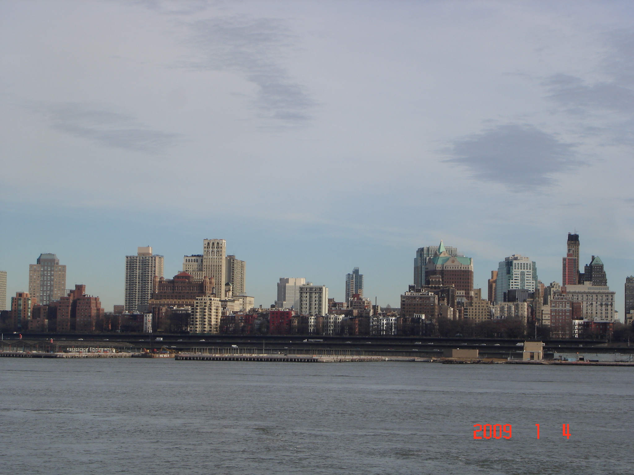

Marsland Press, Michigan, The United States

The Journal of American Science

ISSN 1545-1003

Marsland Press
2158 Butternut Drive
Okemos, Michigan 48864
The United States
Telephone: (517) 349-2362

Emails: editor@americanscience.org;
americansciencej@gmail.com

Websites: http://www.americanscience.org;
http://www.sciencepub.net

ISSN 1545-1003
