Physico-Chemical Analysis of Ground Water in Angul-Talcher Region of Orissa, India

Rizwan Reza¹ and Gurdeep Singh²

¹JRF, Dept. of Environmental Science & Engineering, ISM University, Dhanbad, Jharkhand, India
²Professor and Head, Dept. of Environmental Science & Engineering, ISM University, Dhanbad, Jharkhand, India Email: raza_ism@rediffmail.com

ABSTRACT: The study was carried out to assess the impacts of industrial and mining activities on the ground water quality in Angul-Talcher region of Orissa. The quality was assessed in terms of physio-chemical parameters. Ground water samples were collected from thirteen (13) open well at various locations in study area during pre and post monsoon season. The physico-chemical parameters such as pH, Electrical conductivity, TDS, Total hardness, Ca hardness, Mg hardness, Ca ion, Mg ion, Chloride, and COD were analyzed (APHA, 1998) to know the present status of the groundwater quality. Drinking water quality (IS: 10500) of pre-monsoon season was better than post monsoon season. Few water samples were slightly alkaline along with high dissolved solids.
[The Journal of American Science. 2009;5(5):53-58]. (ISSN 1545-1003).

Key words: Ground water, physico-chemical parameters, water quality, drinking water standard

INTRODUCTION:

The safe portable water is absolutely essential for healthy living. Ground water is ultimate and most suitable fresh water resource for human consumption in both urban as well as rural areas. The importance of ground water for existence of human society cannot be overemphasized. There are several states in India where more than 90% population are dependent on groundwater for drinking and other purpose (Ramachandraiah, 2004). Ground water is also frequently using as the alternative source for agricultural and industrial sector.
In India, there are over 20 million private wells in addition to the government tube wells (Datta, 2005). The wells are generally considered as the worst type of ground water sources in the term of physio-chemical contamination due to the lack of concrete plinth and surrounding drainage system (WHO, 1997). Over burden of the population pressure, unplanned urbanization, unrestricted exploration and dumping of the polluted water at inappropriate place enhance the infiltration of harmful compounds to the ground water (Pandey and Tiwari, 2009).
There are various ways as ground water is contaminated such as use of fertilizer in farming (Altman and Parizek, 1995), seepage from effluent bearing water body (Adekunle, 2009). Most of the industries discharge their effluent without proper treatment into nearby open pits or pass them through unlined channels, resulting in the contamination of ground water (Jinwal and Dixit, 2008). The incidence of ground water pollution is highest in urban areas where large volumes of waste are concentrated and discharge into relatively small areas (Rao and Mamatha, 2004). The hydro-geochemical conditions are also responsible for causing significant variations in ground water quality (Mahanta et. al., 2004). The paper makes an attempt to carry out qualitative analysis of some physico-chemical parameters of ground water in study area.

STUDY AREA:

The Angul-Talcher area lies between latitudes 20º 37’ N to 21º 10’ N and longitudes 84º 53’ E to 85º 28’ E. and situated at an average height of 139 m above Mean Sea Level(MSL). Vast mineral deposits, availability of water and good infrastructure conducive for industrialization in the Brahmani river basin has resulted in heavy industrialization of the area. Many small, medium and large scale industries such as coal mines (Mahanadi Coalfields Limited), Super Talcher Thermal Power plant (Kaniha), Talcher Thermal Power Stations (Talcher), Nalco smelter and its captive power plant and other iron & steel industries are situated in the region. The ground water quality of the study area is adversely affected by the industrialization. Increased population and improper drainage system have potential to influence the ground water quality. Geographical location of study area is shown in the Figure 1.

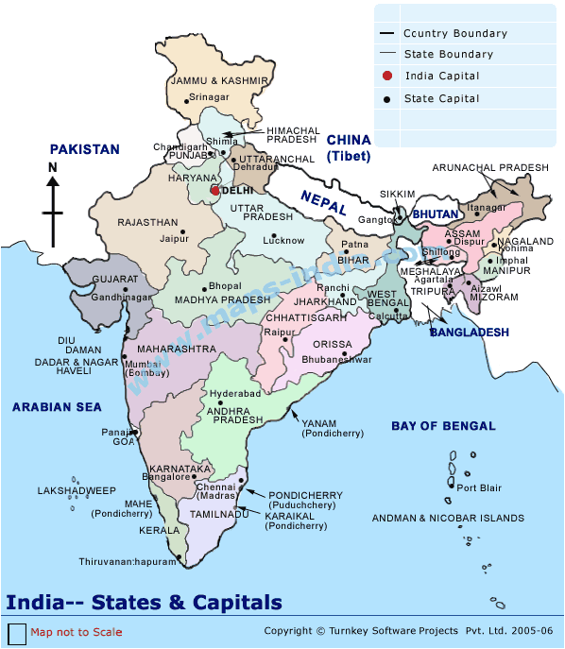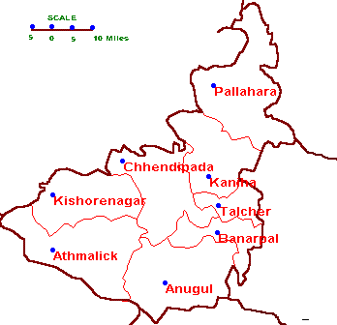

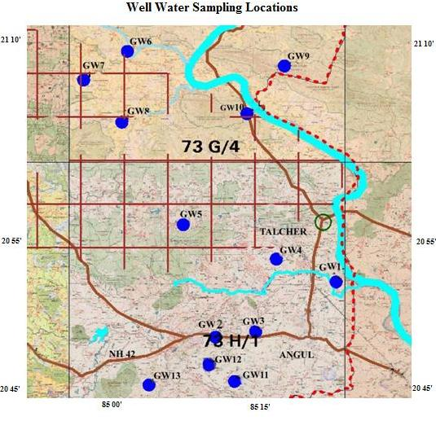

Figure 1: Ground Water Sampling Stations in the Study Area

SAMPLE COLLECTION:

The sampling locations consist of urban as well rural area. Ground water samples were collected from thirteen (13) well at various locations within study area during pre and post monsoon season. Details of sampling locations along with their latitude and longitude are illustrated in Table1. Samples were collected in plastic container to avoid unpredictable changes in characteristic as per standard procedure (APHA, 1998).

Table 1. Well water Sampling Locations within the study area

Code | Sampling Location | Latitude | Longitude
GW1 | Dasnala Village, well water | 20º 53’ 33” | 85º 14’ 33”
GW2 | Kandasar Village, well water | 20º 50’ 33” | 85º 07’ 58”
GW3 | Girang Village, well water | 20º 50’ 52” | 85º 10’ 08”
GW4 | Sharma Chak, well water | 20º 54’ 44” | 85º 11’ 15”
GW5 | Danara village, well water | 20º 56’ 36” | 85º 06’ 12”
GW6 | Takua Village, well water | 21º 06’ 04” | 85º 03’ 10”
GW7 | Baragundari Village, well water | 21º 04’ 47” | 85º 00’ 02”
GW8 | Kamarel village, well water | 21⁰02’10” | 85⁰02’50”
GW9 | Blinda village, well water | 21⁰05’20” | 85⁰11’40”
GW10 | Ekgharia Village, well water | 21⁰02’38” | 85⁰09’39”
GW11 | Nuashahi village, well water | 20⁰48’10” | 85⁰09’00”
GW12 | Tulsipal village, well water | 20⁰49’00” | 85⁰07’40
GW13 | Longibeda village, well water | 20⁰47’50” | 85⁰04’20”

PHYSICO-CHEMICAL ANALYSIS OF GROUND WATER:

The collected samples were analyzed for different physico-chemical parameters such as pH, Electrical conductivity, Turbidity, TDS, Total hardness, Ca hardness, Mg hardness, Ca ion, Mg ion, Chloride, and COD as per the standard methods (APHA, 1998), and the results were compared with the Indian Standards (IS: 10500) for potable water.

RESULTS AND DISCUSSION:

The water quality analysis of different ground water samples have been carried out for pH, Electrical conductivity, TDS, Total hardness, Ca hardness, Mg hardness, Ca ion, Mg ion, Chloride, and COD. The status of water quality of these ground water sources are presented in table 2.
pH value of ground water samples varied between 6.4 to 7.4 and 7.0 to 9.2 during pre and post monsoon season respectively. The pH value of Dasnala village, well water (GW1) was found to be 9.2 which are beyond the permissible limit as per IS: 10500. Turbidity of samples was found within the permissible limits except the Blinda village, well water (GW9) in pre monsoon season. It may be due to absence of bricking of well.
Electrical conductivity varied between 140 to 606 μmhos/cm to 420 to 839μmhos/cm in pre and post monsoon season. The same trend was observed in the case of TDS of various ground water sources. It varied from 69 to 318 mg/l and 172 to 485 mg/l in pre and post monsoon respectively. Total hardness in all the samples were found to be within standard limits (< 300 mg/l as CaCO₃). Values are slightly higher in post monsoon than pre monsoon season. In few samples the ions of calcium and magnesium have crossed the standard limit (IS: 10500) during post monsoon season.
Chloride content of the ground water samples were in the range of 15- 135 mg/l to18.5-75.5 mg/l in pre and post monsoon season respectively. The COD values of various ground water samples were found from 9.3 – 47.5 and 11.3 – 45.5 mg/l during pre and post monsoon season respectively. Highest values of COD were found 47.5 Kamarel village open well water (GW6) during post monsoon season. It may be due to seepage from sewage drainage or industrial discharge in nearby localities.

Table 2. Concentration of various parameters in pre and post monsoon seasons
 | pH |  | Turbidity (NTU) |  | Elec. Cond. (μmhos/cm) |  | Total Hardness (mg/l)
Codes | Pre Monsoon | Post Monsoon | Pre Monsoon | Post Monsoon | Pre Monsoon | Post Monsoon | Pre Monsoon | Post Monsoon
GW1 | 6.8 | 9.2 | 3.7 | 6.2 | 250 | 465 | 56 | 115
GW2 | 6.4 | 7.3 | 3.8 | 7.4 | 162 | 408 | 46 | 102
GW3 | 7.3 | 7.1 | 0.9 | 1.5 | 146 | 694 | 130 | 146
GW4 | 6.9 | 7.0 | 6.6 | 4.3 | 145 | 497 | 28 | 115
GW5 | 7.4 | 7.3 | 4.2 | 7.1 | 140 | 620 | 28 | 127
GW6 | 6.8 | 7.3 | 3.6 | 4.0 | 170 | 420 | 50 | 112
GW7 | 6.7 | 7.1 | 3.1 | 5.0 | 148 | 642 | 12 | 146
GW8 | 6.9 | 7.2 | 8.7 | 6.5 | 540 | 649 | 164 | 125
GW9 | 7.1 | 7.0 | 10.2 | 9.5 | 295 | 733 | 36 | 205
GW10 | 7.1 | 8.2 | 3.5 | 4.7 | 154 | 839 | 20 | 170
GW11 | 7.2 | 7.5 | 8.3 | 8.0 | 429 | 479 | 120 | 110
GW12 | 7.1 | 7.0 | 9.4 | 9.3 | 331 | 351 | 165 | 170
GW13 | 7.3 | 7.1 | 4.6 | 4.0 | 606 | 696 | 178 | 148
Mean | 7.0 | 7.4 | 5.4 | 6.0 | 270 | 576 | 79 | 147
SD | 0.29 | 0.62 | 2.88 | 2.32 | 161.69 | 148.58 | 62.04 | 30.09
IS: 10500 | 6.5 – 8.5 |  | 5.0 – 10* |  | -- |  | 300 - 600*
* = IS: 10500 Permissible limit in the absence of alternate source

 | TDS (mg/l) |  | Ca Ion (mg/l) |  | Mg Ion (mg/l) |  | Chloride (mg/l) |  | COD (mg/l)
Codes | Pre Monsoon | Post Monsoon | Pre Monsoon | Post Monsoon | Pre Monsoon | Post Monsoon | Pre Monsoon | Post Monsoon | Pre Monsoon | Post Monsoon
GW1 | 124 | 265 | 47.2 | 203.5 | 152.1 | 137.8 | 34 | 39.5 | 9.3 | 19.2
GW2 | 80 | 249 | 84 | 172.8 | 50.8 | 134.9 | 24 | 30.5 | 15.5 | 25.5
GW3 | 172 | 337 | 175 | 266.0 | 82.0 | 162.4 | 135 | 41 | 9.3 | 11.3
GW4 | 72 | 272 | 63 | 228.3 | 11.5 | 97.2 | 22.5 | 36.5 | 12.4 | 17
GW5 | 69 | 307 | 63 | 245.0 | 11.5 | 118.9 | 15 | 32.5 | 9.3 | 41.5
GW6 | 84 | 270 | 42 | 226.5 | 136.1 | 87.7 | 22.5 | 35.5 | 12.4 | 45.5
GW7 | 72 | 363 | 21 | 260.5 | 14.8 | 171.4 | 27.5 | 18.5 | 15.5 | 36.5
GW8 | 268 | 323 | 200 | 252.8 | 244.4 | 98.0 | 17 | 42.5 | 13.4 | 22.8
GW9 | 146 | 485 | 57.7 | 412.8 | 52.9 | 163.6 | 57 | 58.6 | 43.5 | 36.5
GW10 | 76 | 400 | 30 | 319.8 | 32.8 | 172.6 | 17.5 | 75.5 | 15.5 | 25.2
GW11 | 228 | 289 | 181.7 | 216.8 | 193.9 | 95.5 | 50.5 | 33.5 | 31.5 | 24.5
GW12 | 187 | 397 | 271.2 | 321.3 | 231.7 | 170.2 | 62.5 | 41.5 | 47.5 | 22.5
GW13 | 318 | 337 | 331 | 280.5 | 187.0 | 146.8 | 44.5 | 30.5 | 21.4 | 12
Mean | 145.8 | 330 | 119.0 | 262.0 | 107.8 | 135.1 | 40.7 | 39.7 | 19.6 | 26.3
SD | 83.67 | 67.46 | 97.27 | 62.01 | 86.7 | 32.32 | 32.49 | 14.11 | 12.57 | 11.13
IS: 10500 | 500 - -2000* |  | 75 – 200* |  | 30 – 100* |  | 250 - 1000* |  | ---
* = IS: 10500 Permissible limit in the absence of alternate source

Correlation matrix was prepared within the studied parameters in pre and post monsoon season and tabulated in Table 3 and 4 respectively. The total dissolved solids and electrical conductivity can be used to delineate each other. Conductivity is proportional to the dissolved solids; total hardness was positively correlated with chloride, calcium and magnesium ions. The strong correlation-ship between these parameters could be due to changes in land use, mining and improper effluent discharge in the study area. The correlation among parameters of both seasons has shown the analogous trends of seasonal variation, it may be due to the weathering and heavy rain fall in study area during monsoon.

Table 3. Pearson Correlation Matrix of Pre-monsoon Season

 | pH | Elec cond. | TDS | Total hardness | Ca ion | Mg ion | Chloride | COD | Turbidity
pH | 1.00 | 0.24 | 0.37 | 0.33 | 0.39 | 0.12 | 0.40 | 0.23 | 0.16
Elec cond. |  | 1.00 | 0.94 | 0.79 | 0.78 | 0.79 | 0.00 | 0.36 | 0.52
TDS |  |  | 1.00 | 0.91 | 0.88 | 0.80 | 0.31 | 0.33 | 0.38
Total hardness |  |  |  | 1.00 | 0.96 | 0.86 | 0.43 | 0.30 | 0.30
Ca ion |  |  |  |  | 1.00 | 0.75 | 0.40 | 0.39 | 0.32
Mg ion |  |  |  |  |  | 1.00 | 0.14 | 0.34 | 0.44
Chloride |  |  |  |  |  |  | 1.00 | 0.22 | -0.14
COD |  |  |  |  |  |  |  | 1.00 | 0.77
Turbidity |  |  |  |  |  |  |  |  | 1.00

Table 3. Pearson Correlation Matrix of Post-monsoon Season

 | pH | Elec cond. | TDS | Total hardness | Ca ion | Mg ion | Chloride | COD | Turbidity
pH | 1.00 | -0.01 | -0.23 | -0.19 | -0.25 | 0.05 | 0.30 | -0.10 | -0.02
Elec cond. |  | 1.00 | 0.57 | 0.56 | 0.55 | 0.42 | 0.50 | -0.09 | -0.31
TDS |  |  | 1.00 | 0.98 | 0.97 | 0.69 | 0.56 | 0.10 | 0.31
Total hardness |  |  |  | 1.00 | 0.98 | 0.74 | 0.58 | 0.03 | 0.23
Ca ion |  |  |  |  | 1.00 | 0.58 | 0.61 | 0.10 | 0.27
Mg ion |  |  |  |  |  | 1.00 | 0.31 | -0.19 | 0.03
Chloride |  |  |  |  |  |  | 1.00 | -0.06 | 0.11
COD |  |  |  |  |  |  |  | 1.00 | 0.30
Turbidity |  |  |  |  |  |  |  |  | 1.00

CONCLUSIONS:

In general ground water quality of Angul-Talcher region is not harmful to human beings. Except few instances where some parameters such as COD at Blinda, Danara and Takua Village, well water and turbidity at Blinda Village, well water were crossed prescribed limits of drinking water (IS: 10500). The reason behind this may be due to industrial and mining activities, weathering and erosion of bed rocks. Most of parameters showed analogous trend in seasonal variation. The values are comparatively high in post monsoon. It indicates that the extent of pollution occurred due to mining, industrial discharge, urbanization and other anthropogenic activities increased human interventions in the ground water quality. Correlation studies have also indicated the contribution of changes in land use, industrial discharge and runoff during post-monsoon season.

Acknowledgement:
The authors are thankful to State Pollution Control Board, Orissa for sponsoring this study. One of the authors (Rizwan Reza) is grateful to ISM University/MHRD/Govt. of India, for providing research facility.

Corresponding author’s name: Rizwan Reza
Dept. of Environmental Science and Engineering
Indian School of Mines University
Dhanbad-826004
Jharkhand, India
Ph. No.: +91-9939587890
Email: raza_ism@rediffmail.com

REFERENCES

Altman, S. J, Parizek, R. R. Dilution of nonpoint source nitrate in ground water. J. Environ. Quality1995: 24:707-717.
APHA, Standard Methods for the Examination of Water and Wastewater. APHA-AWWA-WPCF 1998. Washington D.C.
Adekunle, A. S. Effects of Industrial Effluent on Quality of Well Water Within Asa Dam Industrial Estate, Ilorin, Nigeria. Nature and Science 2009:7(1).
Datta, P.S. Ground water ethics for its sustainability. Cerrent Science 2005: 89 (5).
IS: 10500, Drinking Water Specification. 1992. (Reaffirmed 1993)
Jinwal, A, Dixit, S. Pre and post monsoon variation in physio-chemical characteristic in groundwater quality in Bhopal, India. Asian j. Exp. Sci. 2008: 22 (3).
Mahanta, B.N, Sarkar, B.C, Singh. G, Saikia, K, Paul, P. R. Multivariate statistical modeling and indexing of ground water quality in and around Jharia coalfields, Jharkhand. NSEEME. 2004.
Ramachandraiah, C. Right to drinking water in India, Centre for Economic and Social Studies. 2004:56.
Pandey, Sandeep K, Tiwari, S. Physico-chemical analysis of ground water of selected area of Ghazipur city-A case study. Nature and Science. 2009:7(1).
World Health Organization-WHO. Guidelines for drinking water quality (2nd Edition). Volume 3.Surveillance and Control of community supplies. Geneva, Switzerland. 1997.
Rao, Sudhkar M, Mamatha, P. Water quality in sustainable water management, Current science. 2004:87 (7).

