Anatomical features of Lilium polyphyllum D. Don ex Royle (Liliaceae)

Anurag Dhyani¹, Yateesh Mohan Bahuguna¹, Dinesh Prasad Semwal², Bhagwati Prasad Nautiyal³,
Mohan Chandra Nautiyal¹

1. High Altitude Plant Physiology Research Centre, Srinagar, Pin- 246174, Uttarakhand, INDIA
2. Department of Botany, Delhi University, Pin-110007, Delhi, INDIA
3. Department of Horticulture, Aromatic and Medicinal Plant, Mizoram University, Aizawl, Pin- 796001, Mizoram, INDIA
anuragdhyani@gmail.com

Abstract: Present paper reports anatomical investigation of Lilium polyphyllum, a critically endangered important medicinal herb. Plant samples were collected from Dhanolti, a temperate region in North-west Himalaya, Uttarakhand, India. Transverse sections of plant parts viz., stem, leaf, anther, stigma, ovary, seed, bulb scale, bulb peel and root were investigated. In leaves, stomata are hypostomatic and anomocytic type. Pollen shape was ellipsoid and its surface was reticulate, it also possesses oil drops. Ovary is superior and having axile placentation, ovules are anatropous. Sections of bulb scale show eccentric type starch grains and tracheids. Stem section show scattered vascular bundles. These anatomical features will help to provide information of taxonomic significance. [Journal of American Science 2009; 5(5): 85-90]. (ISSN: 1545-1003).

Key Words: Anatomy; Oil drop; Pollen; Starch grains; Stomata; Tracheids

1. Introduction:
The taxonomic classification divides the genus Lilium into seven sections (Comber, 1949; De Jong, 1974) with approximately 100 species distributed throughout the cold and temperate region of the northern hemisphere. The importance of the genus in the world flower market is due to diversity and large number of hybrids and cultivars commercially available (De Hertogh, 1996). However, some species are also known for medicinal and food value (Chang et al., 2000; Wawrosch et al., 2001; Khawar et al., 2005; Dhyani, 2007), which increased its economic importance many folds.

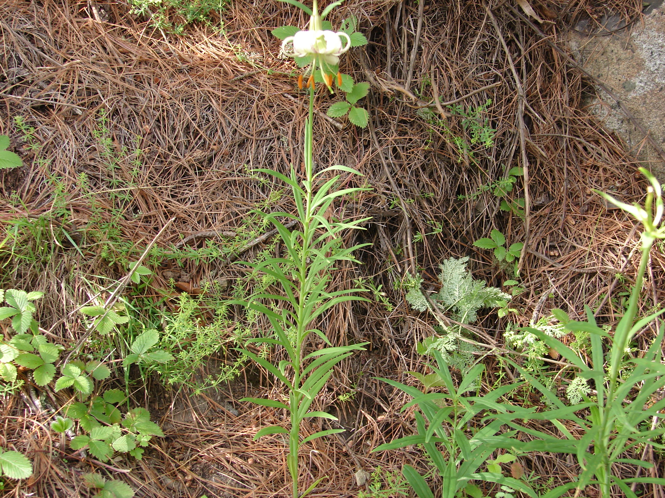
Figure 1.

Lilium polyphyllum is a bulbous, perennial herb (Figure 1, 2) and recently reported as critically endangered (Ved et al., 2003). The species found in North-west Himalaya in India to westward of Afghanistan (Hooker, 1894; Gaur, 1999) between 2200 to 3200m asl. It is known as ‘White lily’ and Ksirakakoli in trade. Medicinally, bulb of the species has been used for refrigerant, galactagogue, expectorant, aphrodisiac, diuretic, antipyretic and tonic (Warrier et al., 1997; Dhyani, 2007). In traditional system of medicine, the species reported to restore health immediately and works as antioxidant in the body (Mathur, 2003; Sharma & Balkrishna, 2005; Pandey, 2005).

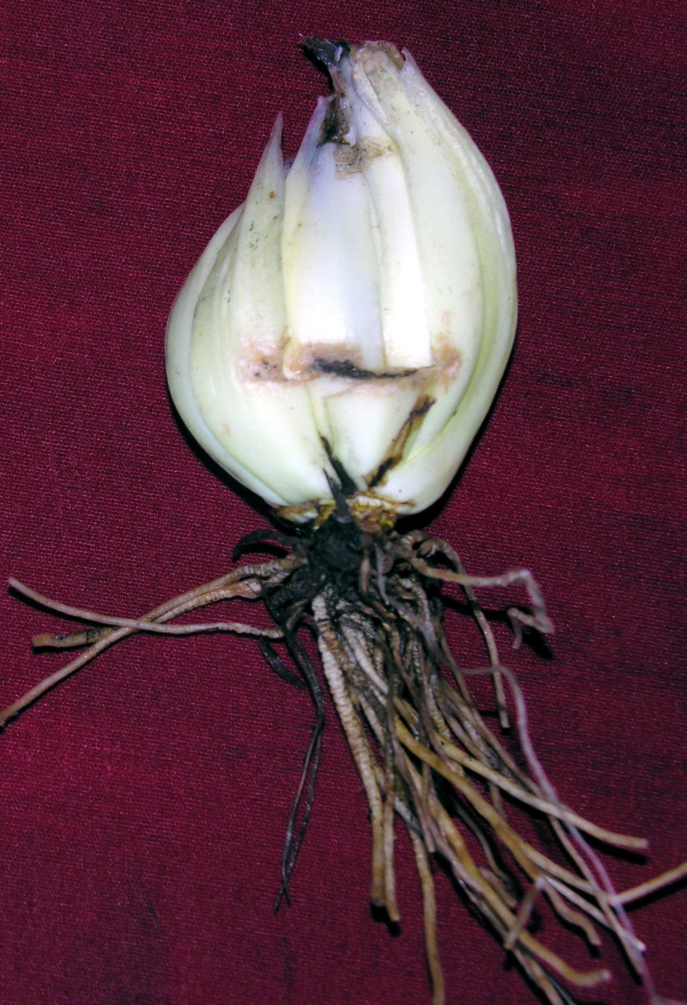
Figure 2.

Studies on anatomy of the genus Lilium are very limited (Farasam et al., 2003; Kaviani et al., 2008). In addition, there were no anatomical studies on Lilium polyphyllum to date. Therefore, the aim of the present study is to investigate the anatomical features of the species which will be of taxonomic significance.

2. Materials and Methods
Plants of Lilium polyphyllum in vegetative (May, 2008) and reproductive phase (June, 2008) were collected from Dhanolti region (2200m, 30°25' N, 78°15' E) of Uttarakhand, North-west Himalaya, India. The specimens for anatomical studies were kept in 70% alcohol till the sections were prepared. The cross- sections of the stem, leaf, anther, stigma, ovary, seed, bulb scale, bulb peel and root were taken manually. The sections were stained with safranin and examined under a Nikon Eclipse E800 microscope. Pictures were snapped using a Nikon Digital Sight Camera. Identification of different cells and tissues were fulfilled on the digital images of the specimens in late July, 2008.

3. Results and Discussion
The stem of the plant is hollow and 30-100cm high which aid in distant seed dispersal. Transverse section (T.S.) of stem has following overview; the epidermis is composed of single layer, compactly arranged square cells and is covered with cuticle. Immediately after epidermis, is a three layered parenchyma cells which are almost circular. This is followed by 4-5 layered chlorenchymatous cells. Ground tissues are distributed throughout the space under chlorenchyma which is composed of circular cells. Several pigment cells can be seen in chlorenchymatous tissue. Vascular bundles are scattered throughout the cortex. Endodermis, pericycle and cambium cells are not present. The vascular bundles are surrounded by a bundle sheath composed of sclerenchyma (Figure 3, 4).
Leaves are alternate, spirally arranged, acuminate with parallel venation and 6-12cm long. TS of leaf reveal the presence of epidermis (covered by cuticle) on both upper and lower surface. All the stomata are present on abaxial side of the leaf, therefore, leaves are hypostomatic. Similar stomata position has been reported earlier in Lilium ledebourii (Kaviani et al., 2008). Midrib is surrounded by a parenchymatic bundle sheath (Figure 5).

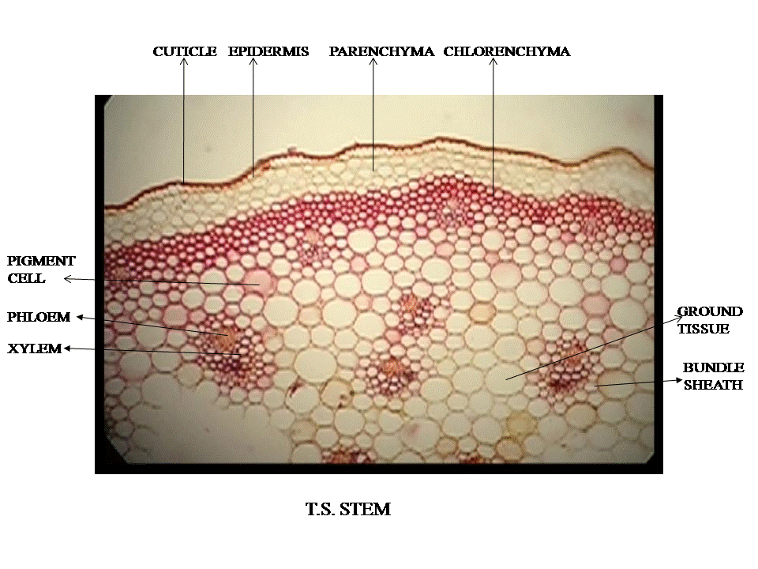
Figure 3.
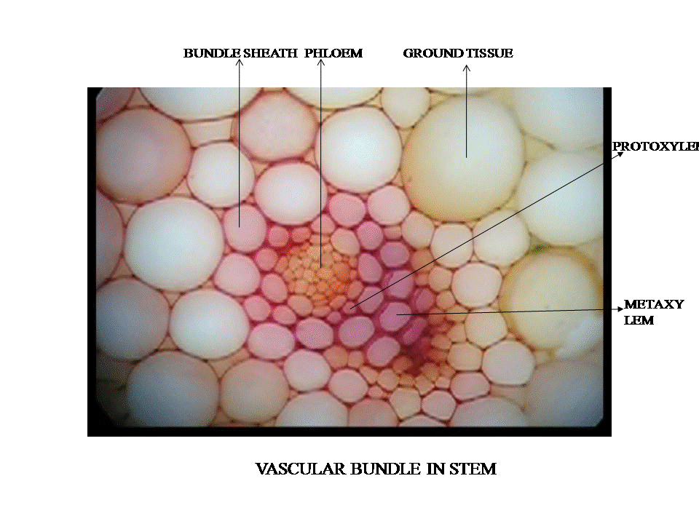
Figure 4.
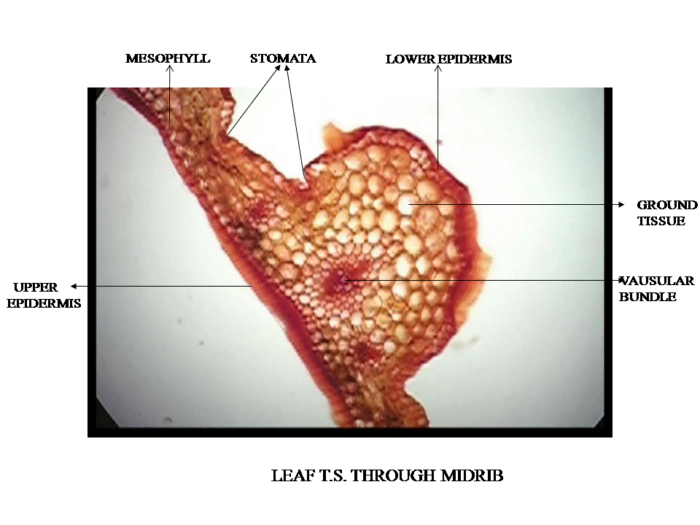
Figure 5.

In leaf peel, stomata are anomocytic (Irregular – celled type; formerly known as Ranunculaceous type). Each stomata was surrounded by two kidney shaped guard cells with the presence of chloroplast (Figure 6).

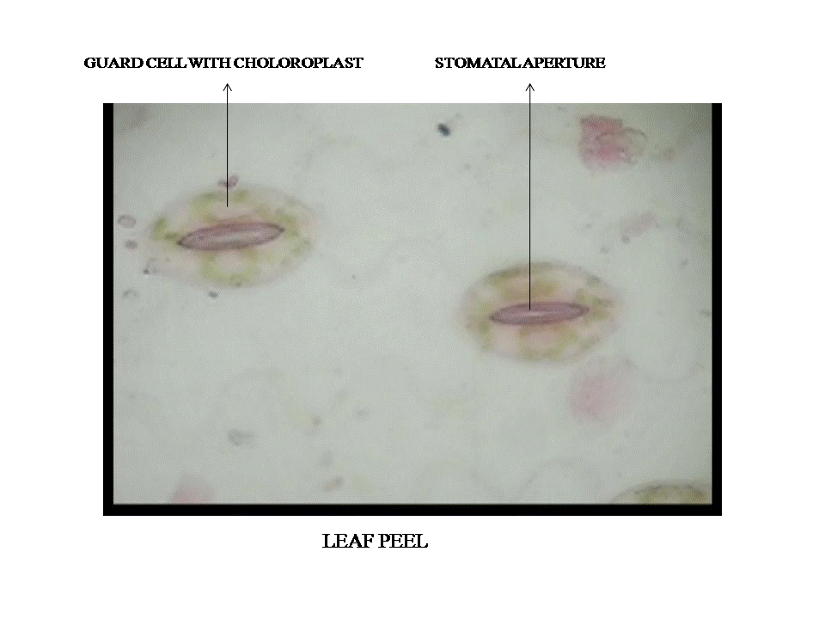
Figure 6.

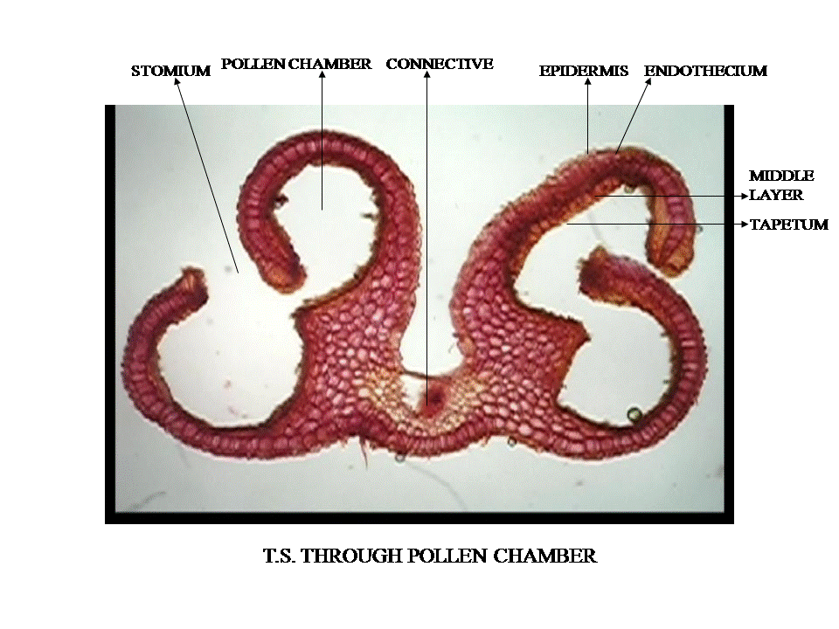
Figure 7.
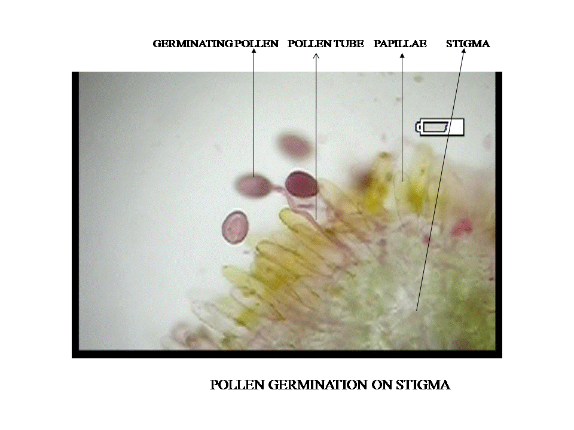
Figure 8.

Similar stomata were earlier reported by Farasam et al. (2003) and Kaviani et al. (2008) in L. ledebourii and in the species of families Boraginaceae, Ranunculaceae and Geraniaceae.
The flowers of this lily are large and showy, fragrant, pendulous, white and speckled with pink, having six tepals in terminal racemes with nectar gland at their bases. Each flower has six stamens and a carpel. T.S. of anther reveals, that it has two lobes with four chambers (dithecous) held together by connective (Figure 7). The wall consists of an outer epidermis, endothecium, one to three middle layers and an innermost tapetum. Tapetum at maturity is multinucleate and contains dense cytoplasm which is finally used by the developing microspores. Pollen grains discharged through stomium. Prior to dehiscence, tapetum and middle layer degenerates.
Pollens are ellipsoid in shape and its surface is reticulate. The pollen grains form in tetragonal tetrads and are therefore, monosulcate, having a single furrow as their aperture. Pollen contains oil drops which assist in pollination. Exine is laid down in a reticulate pattern. Lilium is insect pollinated; when pollen is transferred on to the stigma it develops a pollen tube (monosiphonous) down the hollow style. Pollen germinates on stigma, papillae are tubular in shape and fertilizes ovules to produce seed for the season (Figure 8).

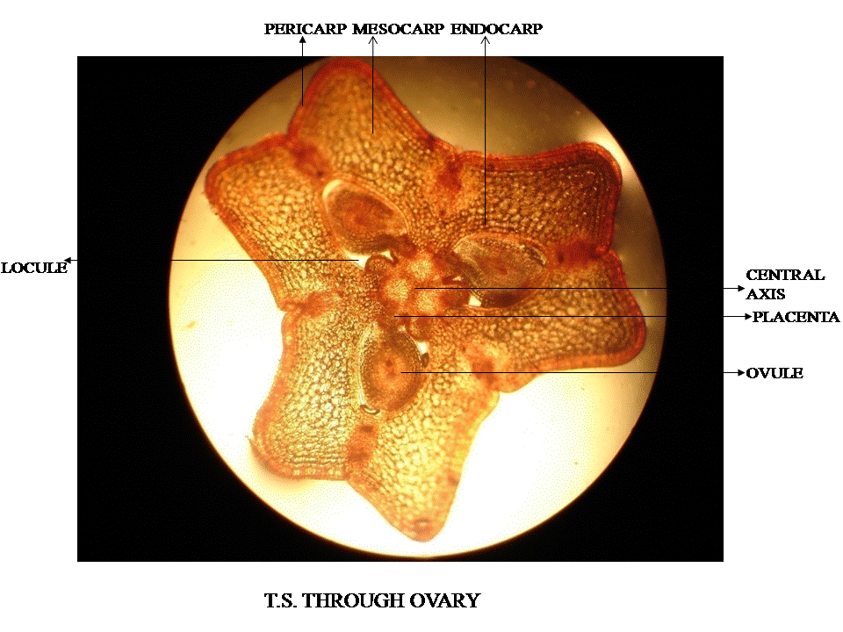
Figure 9.
Ovary is superior and each of its three locules contains many ovules with axile placentation. Similar placentation reported earlier in Lilium lebebourii. The ovules are anatropous i.e. they are curved around so that the micropyle is right next to the funiculus. Style is hollow and stigma is three-lobed and papillate (Figure 9). The fruit is a loculicidal capsule.

Capsules are oblong, three angled and 3-6 cm long. A capsule holds approximately 100 seeds. Seeds are circular and brown in color. Cross section of seed (average length 7.25mm) shows a small embryo (average length 3.8mm) (Figure 10, 11). Endosperm is also present which acts as a main source of food for embryo till it develops into seedling. Earlier Baskin and Baskin (1998) also reported linear seeds for Lilium species.
Bulb is a specialized structure, morphologically underground stem with fleshy scale – leaves and root attached with basal plate with one or more growing points. Scales are modified leaves and stores food for next year growth and provide nutrients for developing plant until it has ample leaf area and root system to do the task. Bulb peel shows cells contain nucleus and pigments (Figure 12). Sections of bulb scale showing eccentric type starch grains (hilium present on one side) deposited in parenchymatous cells (Figure 13). These starch grains are insoluble carbohydrates and having various shape i.e. polygonal, oval, truncated and numbers may be 5-12 in one parenchymatous cell. These are most important reserve material also found in rhizome, tuber, fruits and seeds. They provide energy and thus form an important part of the food. We observe during our field study that people use its scales for vegetable. Starch granules also reported in Lilium ledebourii by Farsam et al., 2003.

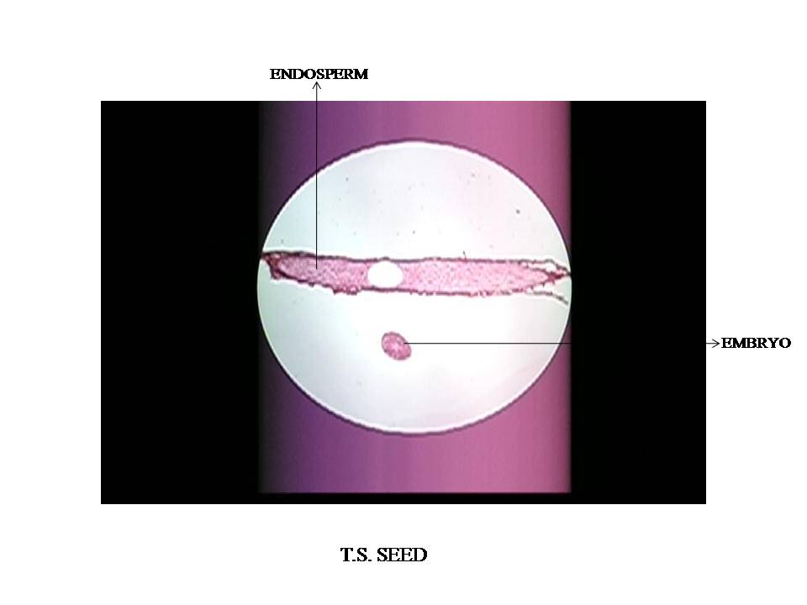
Figure 10.

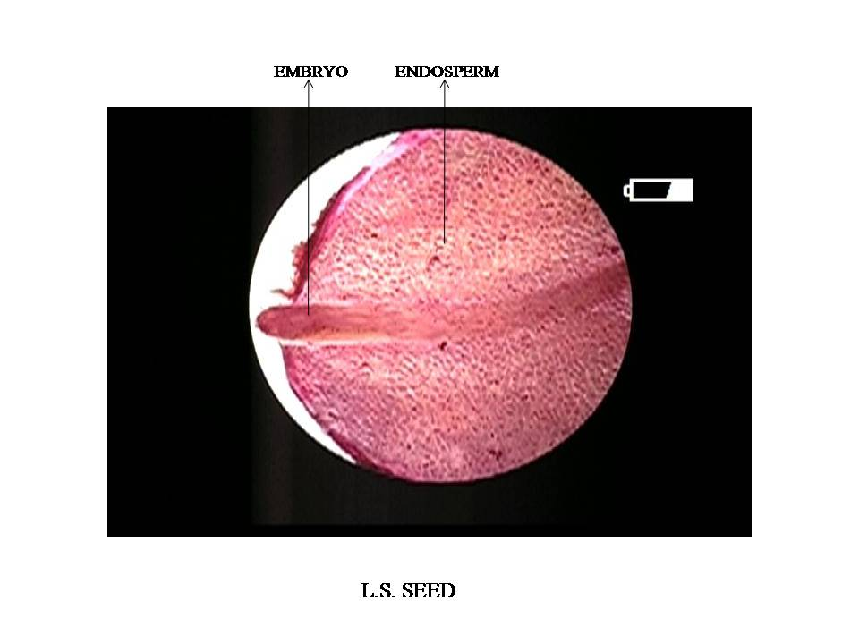
Figure 11.

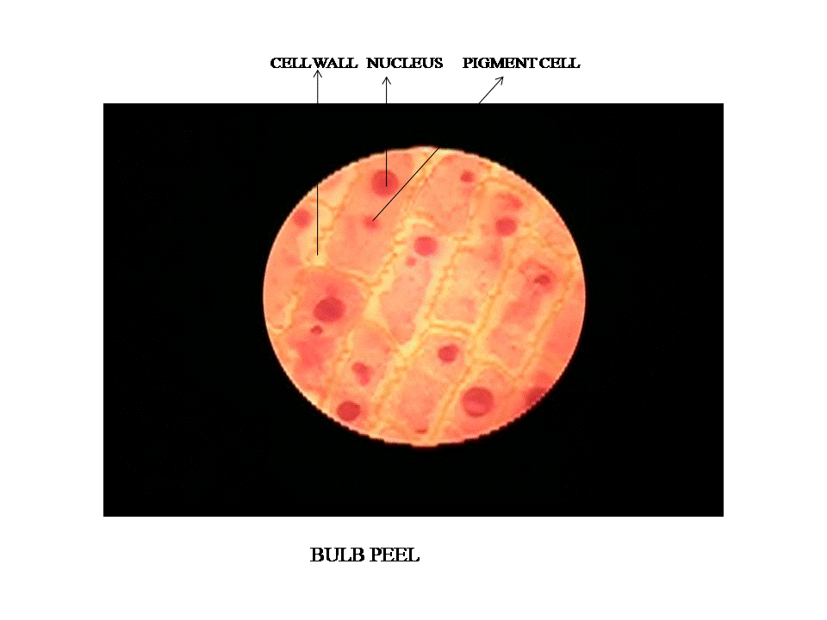
Figure12.

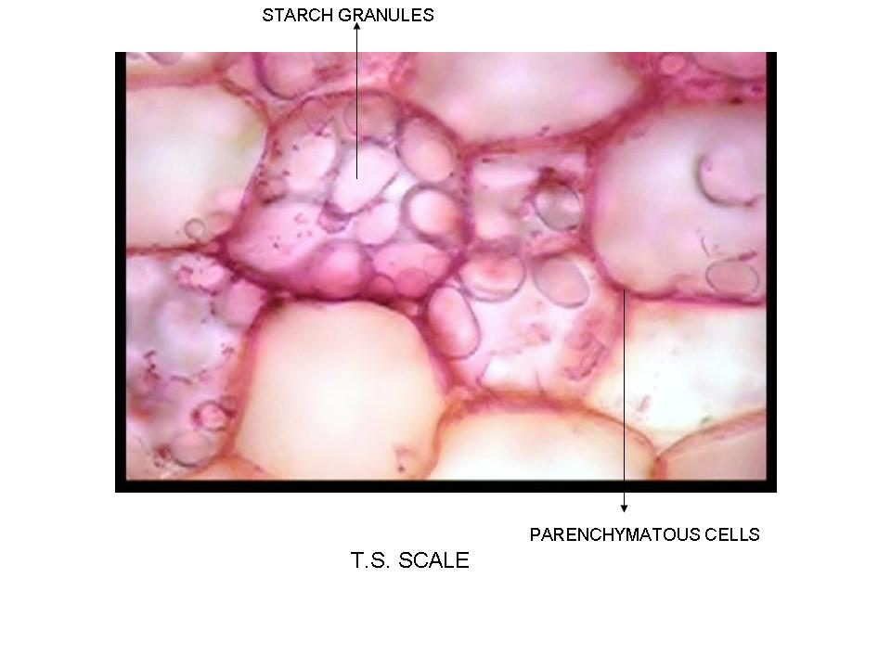
Figure 13.

Longitudinal section of bulb scale shows tracheids which is composed of narrow, elongated and tubular cells (Figure 14). The lignified secondary cell wall is scalariform i.e. secondary cell wall material is deposited on primary cell wall forming a ladder like pattern. The primary cell wall deposits are cellulose, hemicellulose and pectin. Tracheids are water conducting vascular tissues also reported in other vascular plants i.e. pteridophytes, gymnosperms and angiosperms.
There are two types of roots in L. polyphyllum i.e. basal and contractile. Basal roots help in nutrient, water absorption and are important during early spring when the growth starts. The contractile roots function is to anchor and pulling bulb deeper in the soil during harsh climatic conditions to preserve it from frost injury. However, temperature fluctuations at the surface determine how long the contractile roots will continue (Waisel, 1998). T.S. of contractile root indicates that epidermis is composed of single layer of pentagonal cell. Cortex is composed of parenchymatous cells, hexagonal in shape without intercellular spaces (Figure 15). The main function of parenchyma tissue is food storage. Below cortex is a thick walled, single layered endodermis cells. It is selective barrier to movement of water and mineral salts (between cortex and xylem) in roots. Pericycle is present which composed of thin and single layered cells. The primary xylem is distributed towards the pith zone. Thus the main part of pith area is occupied by the metaxylem. Pith is composed of parenchyma cells (Figure 16). Observations suggest general anatomical similarity of Lilium polyphyllum root with the roots of other monocots.
Most important findings in this study were stomata type, pollen shape, presence of oil drops in pollen, ovary placentation, eccentric type of starch grains and tracheids. The information put forth the importance of further botanical and medicinal research on the species in spite of its confined distribution.

Acknowledgements:
Authors are thankful to Director, Prof. A.R. Nautiyal of the Institute for continuous encouragement. We also wish thanks to Prof. R.D. Gaur and R.C. Bahuguna (Dept. of Botany, HNB Garhwal University, Srinagar Garhwal) and Dr. P.L. Uniyal (Dept. of Botany, Delhi University, Delhi) for their valuable suggestions. Financial support from IERP, GBPIHED, Almora is greatly acknowledged.

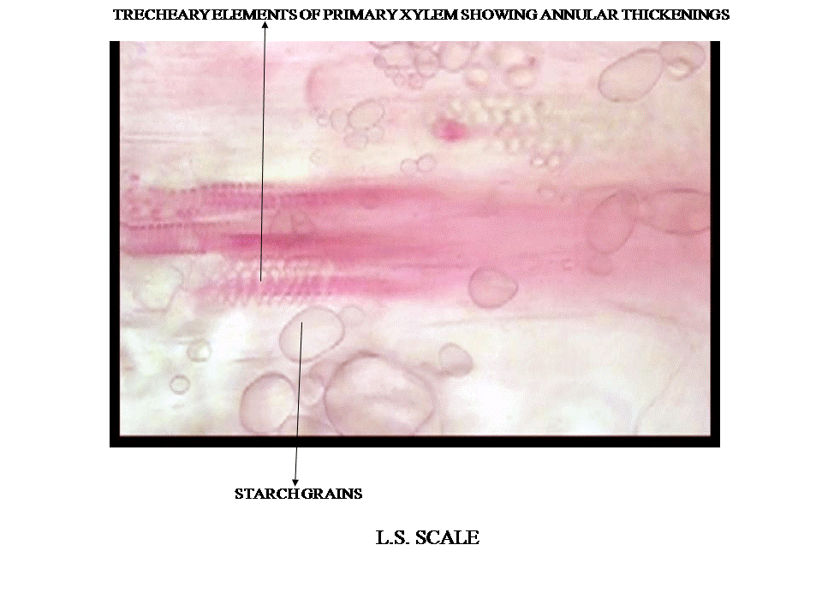
Figure14.
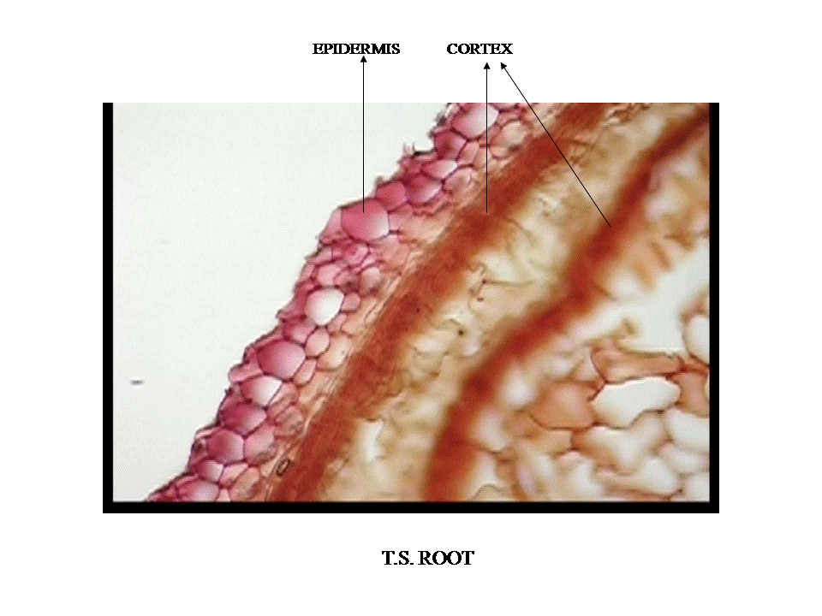
Figure 15

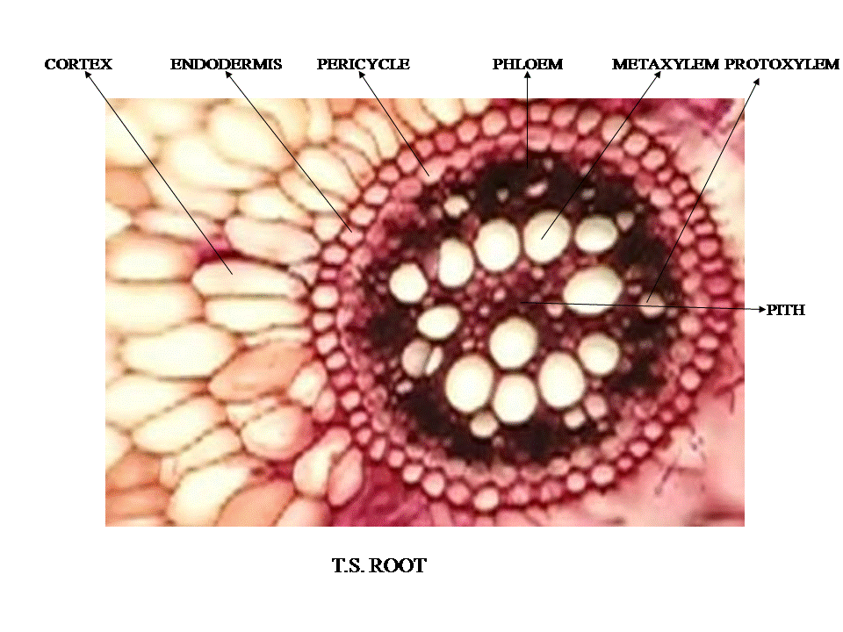
Figure 16

Correspondence to:
Anurag Dhyani
High Altitude Plant Physiology Research Centre, Srinagar, Post Box no. 14, Pauri Garhwal
PIN- 246174 Uttarakhand, INDIA
Email- anuragdhyani@gmail.com
Telephone: 01346-252172 Fax 01346-252070

References
[1] Baskin CC and Baskin JM. Seeds Ecology, Biogeography, and Evolution of Dormancy and Germination. Academic Press, San Diego, California, USA. 1998.
[2] Chang C, Chen CT, Tsai YC and Chang WC. A tissue culture protocol for propagation of a rare plant, Lilium speciosum Thunb. var. glorisoides Baker. Bot. Bull. Acad. Sin. 2000. 41: 139-142.
[3] Comber HF. A new classification of the genus Lilium. The Lily Yearbook of the Royal Horticultural Society. 1949. London. 13: 86-105.
[4] De J PC. Some notes on the evolution of lilies. The Lily yearbook of the North American Lily Society. 1974. 27:23-28.
[5] Dhyani A. Exploring Lilium polyphyllum in Uttarakhand, India. The Lily Yearbook of North American Lily Society. 2007.pp.79-82. Edt David Sims.
[6] Farasam H, Amanlou M, Amin G, Nezamiv and Chegini G, Salehi- Surmaghi MH, and Shafiee A. Anatomical and phytochemical study of Lilium ledebourii (Baker) Bioss, A rare endemic species in Iran. Daru. 2003. 11:164-170.
[7] Gaur RD. Flora of the District Garhwal, North West Himalaya with ethnobotanical notes. Transmedia Publication, Srinagar Garhwal. 1999.
[8] Hooker JD. The Flora of British India. L. Reeve & Co. London. 1894.
[9] Kaviani B, Dehkaei MNP, Darabi AH, Rafizadeh A, Rahmati B. The Anatomical Properties of Endemic Lilium ledebourii (Baker) Bioss. (Liliaceae) Species. International Journal of Botany. 2008. 4(1): 62-66.
[10] Khawar KM, Cocu, S, Parmaksiz, I, Sarihan, EO and Ozcan S. Mass proliferation of Madonna lily (Lilium candidum L.) under in vitro conditions. Pakistan Journal of Botany. 2005. 37(2): 243-248.
[12] Pandey D(Ed). Sarangadharasanhita, Chaukhamba Amarabharati Prakashan, Varanasi, India. 2005.
[13] Sharma BD and Balkrishna AV. Vitality strengthening Astavarga Plants (Jeevaniya & Vayasthapan Paudhe). Divya Publishers, Divya Yog Mandir, Haridwar, Uttaranchal. 2005.
[14] Ved DK, Kinhal GA., Ravikumar K, Prabhakaran V, Ghate U, Shankar VR and Indresha JH. Conservation Assessment and Management Prioritisation for medicinal plants of Himachal Pradesh, Jammu and Kashmir and Uttaranchal. Shimla, 2003. May 19-24.
[15] Waisel Y. Biology of root formation and development. Hingham MA (eds.).: Kluwer Academic Press.1998.
[16] Warrier PK, Nambiar VPK and Ramankutty C. Indian Medicinal Plants. A compendium of 500 medicinal plants.Arya Vaidya Sala. Orient Longman. 1997
[17] Wawrosch C, Malla PR and Kopp B. Clonal propagation of Lilium nepalense D.Don, a threatened medicinal plant of Nepal. Plant Cell Reproduction. 2001. 20;285-288.

