Design and Prototyping of a Microcontroller Based
Synchrocheck Relay for Improved Reliability

Ali Peiravi

Ferdowsi University of Mashhad,
Department of Electrical Engineering, School of Engineering, Mashhad IRAN
Telephone number: (0098) 511-881-5100
Ali_peiravi@yahoo.com

Abstract: Redesign of traditional relays with microcontroller-based relays can be used to achieve a higher level of reliability. In this study, the results of redesign and prototyping of a synchrocheck relay using an 8952 microcontroller with improved reliability is discussed. These relays are usually used for paralleling two load-generation islands, or for closing an open loop in an electric power system. The designed circuit measures voltage, frequency and phase angle difference between the voltage signal on the two sides of an open circuit breaker; evaluates the existence of necessary conditions for synchronism, and then decides whether or not a command should be issued to allow the circuit breaker to close. If these conditions do not exist when the circuit breaker closes, the power system equipment on the two sides of the circuit breaker may be damaged due to the inrush current at the instant of closing the circuit. The integration of three timer-counters, internal code and data memory plus the single-bit handling and 8-bit divide and multiply instructions of 8952 make it suitable for this application. No external RAM or EPROM are needed and the processor internally performs all the necessary computations. [Journal of American Science 2009;5(5):181-188]. (ISSN: 1545-1003).

Key words: Synchrocheck Relay, Power System, Protection, Microcontroller, Reliability Improvement

1. Introduction
As part of a manual control system, an operator makes adjustments to the generator voltage and frequency using a synchroscope or lamps, and then attempts to manually close the breaker. This manual synchrocheck protection will qualify that the two systems are closely matched before permitting the breaker to close. As part of an automatic synchronizing arrangement, a synchroceck relay can be used as an independent backup or checking device to ensure that the two systems are suitably matched before the breaker is closed.
Synchronism is referred to the conditions on both sides of an electric connection where the voltages on the two sides are equal to each other, are in phase with each other, and have the same frequency. This requires the measurement and/or determination of voltage, frequency and phase angle difference for the power signals on the two sides of the circuit breaker before closing. The rms value of the voltage is needed.
Conventional synchrocheck relays are of either induction or electronic types. In the induction type of synchrocheck relays, there are two electromagnets each consisting of two coils. In the first electromagnet which is the driver, the coils are connected to each other in such a manner that the two voltages applied are added together to produce the induced torque in the disc resulting in a closure of the relay's contacts. The failure rate of electromagnetic devices is much higher than that of electronic devices. One of the best approaches to the reliability improvement of protective relays in power systems is the substitution of classical relays with modern ones using integrated electronic circuits. The use of programmable chips that helps reduce hardware is another means of improving reliability. The present study reports the design and prototyping of synchrocheck relays using microcontroller implementation of the sync check relay function.
Synchrocheck relays are usually used to parallel two load-generation islands or closing an open loop of a section of the power system. The first responsibility of a synchrocheck relay is measuring voltage and frequency on both sides of the circuit breaker. Then the voltages and frequencies must be compared with each other to determine whether or not they are close enough to allow the circuit breaker to close. The relay electrically determines if the difference in voltage magnitude, frequency and phase that usually varies with the location on the power system angle fall within allowable limits. Synchrocheck relays usually do not provide indication of the voltage magnitude, frequency or phase angle, but internally determine whether or not conditions for closing are satisfied. In this design, much of the signal processing and decision making is carried out by software in order to reduce hardware complexity and achieve a higher level of reliability.
Manual closing of circuit breakers is made possible by the use of synchroscopes in power plants. Synchrocheck relays can be used to automate the control of synchronism conditions and allow the closing of the circuit breaker to prevent improper closing. There are also automatic synchronizers in modern power plants that send pulses to the generator exciter and governor to change the voltage and frequency. Then the synchronizer will automatically close the circuit breaker when it is within allowable range. Nowadays, since most circuit breaker operations are done remotely, synchrocheck relays are usually used to supervise closing of breakers.
Voltage zero-crossing has been widely used to measure frequency in power systems. The sensitivity of this approach to noise, DC value and harmonics led to its being abandoned. Curve fitting and data smoothing were used by Begovic et al. [1] who presented zero-crossing, DFT and phase demodulation to measure the instantaneous value of power system frequency, phase and voltage magnitude. They reported that these techniques perform well in the presence of noise and harmonics. Phase angle has also been estimated or measured using transducers or electronic means.
Real time microprocessor-based phasor measurement and its application to obtaining synchronizing information for current differential protection was presented by Thorp et al. [2]. Their focus was on adaptive protection whereby the relay characteristics are modified in response to external signals. However, this is not the case in the problem under consideration in this paper with the goal of redesign of synchrocheck relays to assist in the semi-automatic paralleling of two AC power systems or two sides of a separated power system. The relay contacts should be allowed to change state when the voltage level, phase relationship and frequency are within allowable synchronizing limits. Connecting two power systems that are not closely matched can cause expensive damage to the electrical system. It may even lead to a severe disturbance of the power system. Using synchrocheck relays ensures that such undesirable events do not occur.
Certain equipment including power transformers (PT), lamps, voltmeters, a synchroscope, etc. are used in the process of manual synchronization. In practice, an operator has to check the proper conditions for synchronism before the circuit breaker is closed to connect the two sides together. For an automatic closure, synchrocheck relays are used to verify synchronized conditions on the two sides of the circuit breaker. Once the existence of these conditions is verified, synchrocheck relays automatically issue a signal permitting the circuit breaker to close. The actual act of closure is to be performed by operator, the synchronizer or the auto-recloser. Synchrocheck relays are also used for delayed reclosure after the occurrence of a contingency results in disconnection of a line.
Considering the lower failure rates and programmability of modern microprocessors and microcontrollers, the replacement of traditional relays with microcontroller-based relays can be used to improve reliability. Since much of the necessary signal processing is also possible through software, the reduction of hardware complexity can also help further improvement of reliability.
In this paper, the results of research carried out in the design and prototyping of a synchrocheck relay are presented. These relays are usually used for paralleling two generation and load zones, or for closing an open ring in a section of the power system. The main processor used in this system is an 8952 microcontroller. The integration of three timer-counters, internal code and data memory plus the single-bit handling and 8-bit divide and multiply instructions of this microcontroller make it very suitable for this application. There is no need for any external RAM or EPROM memory, and the processor can internally perform all the necessary computations at a very fast rate. The necessary signal processing functions are done through software, and the availability of proper conditions for synchronism is checked after measurements are made on both sides of the circuit breaker. The code developed senses voltage and frequency on both sides of the circuit breaker, determines the phase difference, and checks for the availability of proper preconditions for synchronization. Once the conditions for sysnchronism are established, a signal is issued to permit or enable the connection.

2. Hardware Design
The design of hardware for a microcontroller-based synchrocheck relay is shown in Fig. 1. In this design, an 8952 microcontroller is used with 8K EEPROM, 256 bytes of RAM, 4 eight bit I/O ports, 3 sixteen bit timer/counters, serial port interface with 64KB of external addressable memory for code, Boolean operations on bits, 210 bit-addressable locations and fast 8 bit divide and multiply operations. No external memory was used in the designed system.

ZC1
ZC2
÷2
MUX
2.1
Digital MUX
AT 8952

P3.0 P0.0
P3.1 P0.7
P2.4
P3.1(select)
P2.5
P2.1
P3.1(INT1)
P2.0
(RD)P3.7
(WR)P3.6
P2.2
P1.0
P1.7
P2.6
P2.7
P2.3
LPF1
LPF2
V_{i}
V_{r}
÷2
WR
RD
8255
MICROCONTROLLER
LCD
E R/WR RS
PA0
PA7
A1
A0
BUFFER
C.B._Status
Let_C.B._Close
D.FF
D
CLK.
P3.4
P3.5
D0
D7
WR
EOC
F.R.
MUX
2.1
Analog MUX
select
KEY BOARD
Zero Crossing
Detectors
Full Wave
Rectifier
A/D
Figure 1. The hardware block diagram of the microcontroller-based synchrocheck relay

3 Voltage Measurement
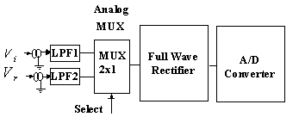
In this study, the fact that voltage and frequency variations in power systems are slowly changing parameters due to the high inertia of the power system is used to compute these parameters using software. The effective value of the main component of the voltage signal is measured. The rectified voltage measured is first input to an 8 bit A/D converter. Sampling is done during a complete cycle and the effective value of the voltage is computed by the microcontroller based on the results obtained from the A/D conversion of the samples taken as shown in Figure 2.

The voltage on both sides of the circuit breaker is computed using recursive discrete Fourier Transform over the full cycle.

Figure 2 Voltage rectification and conversion to digital value
The real and imaginary parts of the main component of the voltage are computed from the following:
(1)
(2)
where N=40 representing the number of samples used in each cycle (f=50Hz). Then the rms value of the voltage is computed as follows:
(3)
The sampling starts at the beginning of the cycle of a sinusoidal wave at its zero crossing. Therefore, at that instant, equation (3) above may be rewritten as:
(4)
In the system designed, the interrupt service routine for Timer 2 is programmed to compute the rms voltage as shown in Figure 3.

4 Frequency Measurement
Various different techniques have been proposed for measuring the frequency of a power system. Wang et al. [3] proposed a curve fitting approach using digitized samples of voltage at a relaying point. Petrovic et al. [4] proposed a digital method of power frequency measurement using rectifiers, a microcontroller, latch, RAM, EEPROM, a 16 bit A/D converter, etc. and a PC. Lee and Devaney [5] proposed a software-based technique for frequency measurement based on the estimation of zero crossings and measuring the time between an even number of estimated zero crossings with smoothing. Their approach is iterative in nature with an adjusted sample rate to be a multiple of the estimated frequency to allow a progressive refinement of frequency.
The approach adopted in this study to measure the power system frequency on either side of the circuit breaker is based on software to calculate the inverse of the average value of period of the voltage waveform over 40 consecutive cycles. Since the frequency difference between the two sides of the circuit breaker is important, it is computed as follows:
(5)

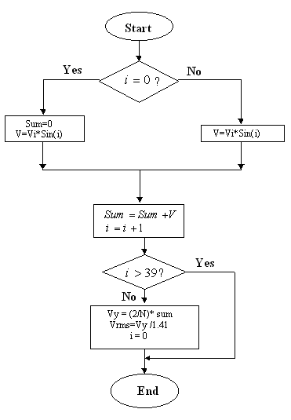
Figure 3 The flowchart of computing the effective value of the voltage

This value is recursively averaged as follows:

(6)

5 Phase Angle Measurement
It is known that real power flow occurs based on
$P=\frac{V_{s}⋅V_{r}}{X_{L}}\text{Sin}δ$ (7)
where is the voltage on one side of the circuit breaker, is the voltage on the other side of the circuit breaker, is the impedance and denotes the phase angle between the two sides of the circuit breaker when closed. Should there be a large phase angle difference between the two sides of the circuit breaker at the time of closing a large power flow may result in damage to the equipment. Therefore, the phase angle should be measured on both sides, and the difference should be computed. One possible application of this measurement would be in real time security monitoring as proposed by Soonee et al. [6] for the Indian electric power system. They made phase angle measurements at various strategic locations in the integrated Indian power system to provide knowledge about the neighboring system for regional control centers in the absence of a national control center. One possible approach to phase angle determination proposed by them is the use of the formula below if the needed parameters are known.

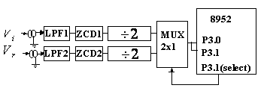
(8)

A second approach is to use a voltage/angle transducer. A more sophisticated approach would be to use digital circuits or even benefit from the software/hardware capabilities of microprocessors/microcontrollers. Al-Ali et al. [7] presented an intelligent system to monitor the phase angle continuously and initialized corrective action if the phase angle deviated beyond allowable limits in order to continuously compensate for the difference by continuously changing a variable capacitor. They used an 8 bit microcontroller, an 8 bit D/A converter, zero crossing detectors and programmable capacitance to achieve this goal.
In this study, the voltage signal of each side of the circuit breaker is passed through anti-aliasing low pass filters. Then they are fed to a zero crossing detection circuit which provides a high digital output as soon as the input goes above zero and a low digital output as soon as the input goes slightly below zero, thereby changing the sinusoidal shape of the input to a square wave. This waveform is passed through a frequency divide by two as shown in Fig 4.
Figure 4 The low pass filter, zero-crossing detection and divide by two operations on voltages

The outputs from the two sides are fed to an AND gate which generates a pulse whose width is proportional with the voltage phase difference. Then this is input to the zero interrupt input of the microcontroller which computes the frequency with software. The waveforms are as shown in Figure 5.

6 Conditions of Synchronism
After the voltage, the frequency and the phase angle on the two sides of the circuit breaker are obtained, the conditions for synchronization must be evaluated. Equations (9) and (10) are used for this purpose.

(9)

(10)

where is the maximum allowable frequency difference between the two sides, is the maximum allowable percent voltage difference between the two sides, and $V_{n}$ is the system's nominal voltage. The flowchart of the operation of the designed microcontroller-based synchrocheck relay indicating how a decision is made to close the circuit breaker is shown in Fig 6. The system continuously monitors the voltage difference and only goes on to compute the frequency and the frequency difference if this condition is met. It also only computes phase angle difference after the voltage difference and frequency difference conditions are met.

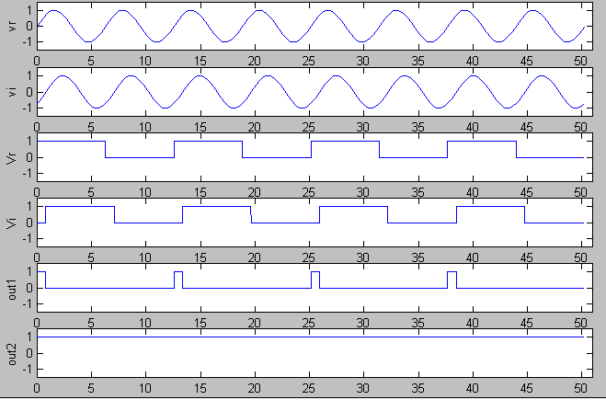
Figure 5 Action of zero crossing detectors for the voltages on the two sides of the circuit breaker. The width of Out1 indicates the time from the zero crossing of Vr to the zero crossing of Vi.

6 Conclusions
A prototype of this design was built using an 8 bit microcontroller, an 8 bit A/D converter, a digital multiplexer, an analog multiplexer, a parallel I/O port, an LCD, a keyboard plus several other gates. The proposed method of measuring frequency, voltage and phase angle used in the design of this microcontroller based synchrocheck relay all work well. The precision used is 0.01Hz for frequency, and 0.1 degrees for phase angle. Discrete Fast Fourier (DFT) transform was used for measuring voltage, and high frequency components were eliminated using hardware low pass anti-aliasing filters. The DFT itself acts as a natural filter for high frequency harmonics, too. The algorithm successfully measures the main characteristics of the voltage on both sides of the circuit breaker. The recursive nature of the algorithm eliminates the need for storing samples taken and by eliminating external RAM and simplifying the resulting circuit greatly improves its reliability. Another major design feature of this relay which also simplifies the circuit and improves reliability is the use of a precise full wave rectifier so that employing just an 8 bit D/A converter provides sufficient accuracy for the synchrocheck relay. An 8952 microcontroller which has 256 byte RAM, 8KByte EPROM, 128 bytes of bit addressable memory and three 16bit timer/counters is used. The integration of all needed circuits into a single microcontroller chip greatly improves the reliability of the synchrocheck relay. The ability of this chip to perform 8bit multiply/divide operations in only two microseconds plus its bit addressable I/O capability makes it a very suitable choice for a reliable sysnchrocheck relay design.
Acknowledgement
I would like to thank Mr. Ebrahim Sagvandi for carrying out the initial work and his help in the practical aspects of the circuit prototyping and testing. I also like to thank the Office of Vice Chancellor of Research and Technology of Ferdowsi University of Mashhad for the grant project that has assisted me in the preparation of this manuscript.

Allow circuit breaker to close
Start
Initialization of synchronism parameters
Sample and compute voltage and voltage difference between the two sides of the circuit breaker
Is the voltage difference within allowable limits?
Is frequency difference within allowable limits?
Compute frequency and frequency difference between the two sides of the circuit breaker
Compute phase angle difference between the two sides of the circuit breaker
Is phase angle difference within allowable limits?
No
Yes
No
Yes
No
Yes
Cannot allow circuit breaker to close
Figure 6 Flowchart of the decision making process of the designed synchrocheck relay

References
[1] M. M. Begovic, M. Djuric, G. Phadke, Frequency tracking in power networks in the presence of harmonics, IEEE Transactions on Power Delivery, Vol. 8, No. 2, (1993), pp.480-486.
[2] J. S. Thorp, A. G. Phadke, S. H. Horowitz, M. M. Begovic, Some applications of phasor measurements to adaptive protection, IEEE Transactions on Power Systems, Vol. 3, No. 2, (1988), pp.791-798.
[3] A. D. Wang, Y. Z. Ge, L. L. Lai, A. T. Johns, A new digital algorithm for power system frequency measurements, IEE 2nd International Conference on Advances in Power System Control, Operation and Management, Hong Kong, (1993), pp.729-733.
[4] P. Petrovic, S. Marjanovic, M. Stevanovic, Digital method for power system frequency measurement using synchronous sampling, IEE Proc. Electr. Power Appl., Vol. 146, No. 4, (1999), pp.383-390.
[5] J. H. Lee, M. J. Devaney, Accurate measurement of line frequency in the presence of noise using time domain data, Proceedings of the 10th Anniversary Instrumentation and Measurement Technology Conference IMTC'94, (1994), pp. 1016-1019.
[6] S. K. Soonee, S. R. Narasimhan, R. K. Porwal, S. Kumar, R. Kumar, V. Pandey, Application of phase angle measurement for real time security monitoring of Indian Electric Power System - An Experience, Water and Energy International, Vol. 65, No. 3, (2008).
[7] A. K. Al-Ali, M. T. Abuelma'atti, I. Hussain, Microcontroller-based phase-angle measurement and correction technique, International IEEE/IAS Conference on Industrial Automation and Control: Emerging Technologies, 22-27, (1995), pp.569-571.

