Yacht Construction In Myanmar

Kay Thwe, Gao Gao

Naval Architecture and Ocean Engineering Dept, Wuhan University of Technology, 430063, China
thwe.kay@gmail.com, gaogao1949@yahoo.com.cn

Abstract: This paper reviews the construction of the yacht Sunshine that influences the Myanma Shipyards (MS). Historically, the wooden yachts have been built in Myanmar since 19th century. Myanma Shipyards has been building and repairing the various kinds of ships since 1970. Fortunately, the classic-yacht Moonbeam was repaired in 1998 and approved by the regional Lloyd's surveyor. Interestingly, the owner, Peter Wood, Corvette Shipping Ltd, France, of the yacht Sunshine was seduced by the place where Moonbeam rebuilt. In early 2000, the construction of the Sunshine was started. The hull design plans were supported by the owner. The steel frames and hull plates were cut with CNC machine and there was no human error. Everything on the yacht was made locally, nearly all the fittings are from local foundries and the carpenters made all the wood work. It was challenging and time-consuming for the construction of the latest Fife design in Myanma Shipyards. For future development and commercialization of yacht constructions, this paper will describe the specifications and functionality enhancement of Myanma Shipyards. [Journal of American Science 2009;5(5):189-196]. (ISSN: 1545-1003).

Key words: Yacht, CNC, NDT

1. Introduction
This paper sets out to review some of the construction problems of the yacht faced by MS. The restoration of the yacht doesn’t need the design process but construction of a new yacht requires the design process. The owner of the yacht Sunshine gave full-size lofted frame templates so that Detail Design stage was eliminated.
There are a large number of processes that are required for the construction of yacht. The design process is the major step to satisfy the customer’s requirements because yacht construction is a design-oriented view. To improve the way of the construction of ship is to reduce costs, manhours, and administration and improve quality. For the type of classic-yacht, the cost is not the object. The goal or purpose of the yacht is to win the best 4 of 7 match races around a specific course made up of known angles and distances. So the biggest job is to determine the velocity potential of a design to the wind speed, sailing angle, and the dimensions of the hull and rig. For pleasure yacht, the owners specify a target cost, speed, cruising range, and some description of accommodations for the yacht. Actually, it is difficult to get an optimum design. There are many design phases to consider for the best design.
MS started constructing the first yacht in March 2000. Delivery was late, but quality on the first yacht was excellent. Since that time, MS has built in traditional measurement terms and it is a small shipyards. Now MS is a commercial-oriented shipyard, a second facility, floating dry-dock, and a growing work backlog from repeat and new customers.
2. Historical Perspectives
In Myanmar, the best hardwoods held out the promise of a slow but faithful restoration by repair. There is no doubt that a wooden deck, interior decoration and superstructure is a beautiful sight from both without and within. The owner of Moonbeam discovered the low labour rates, skilled craftsmen and access to supplies of the best hardwoods in Myanmar. The hull had been copper sheathed and this had protected the wood below the waterline. Moonbeam had only left a steel skeleton which retained its original shape and the keel and deadwood remained attached to stabilize the structure. Two-thirds of the original steel had been saved and the shape was unaltered. The hull shape was fairly straightforward but manhandling.
The whole of the interior was hand-built by local craftsmen with all of the paneling coming from a single tree of padauk on satinwood frames. She has beautiful accommodation for six guests staying on board. While there is space for many more during day racing. The rosewood-pannelled saloon is an absolute feast of traditional woodwork and a great credit to the craftsmen who painstakingly re-created it.
Although there are many survivors in the cutter category few classic schooners still exist today, so it was thought appropriate in building a replica, that should be borne in mind. Also the early 1900's was probably the time when sailing ships and yachts were at the height of their evolution, before steam and diesel engines, and racing rating rules, began to interfere with the purity of their original function and beauty. Looking into the future it is also likely that there will be a reduction in the numbers of original vessels in existence, due to the high and ever increasing costs of maintaining these few remaining original vessels.
The yacht Sunshine was built in Yangon, as the facility there at MS, is very suitable and the building and handcraft techniques can still be found in Myanmar, that are as close as one could find to the skills originally employed in the England of the early 20th century.
The yacht Sunshine is a two masted gaff rigged identical to the two earlier Fife Schooners. The hull and rig are exactly faithful to the original 1900 design. By early 2000, the boat was plated and ready to be turned over in the yard. Her keel is steel box section with lead poured in from the inside. [3]
Metal yacht construction has been around for a long time, long enough for its benefits and drawbacks to be common knowledge. However, with the acquisition of knowledge and technology, the methods of working with and treating materials change for the better, expanding the benefits and limiting the drawbacks.
Developments in hull shapes and plating techniques have also gone a long way in helping to reduce the prejudice against steel yachts. The secret of a good steel design is clean simplicity, in both the hull and the deck. The more cutting and welding that can be eliminated while maintaining good aesthetics, the more successful the design is likely to be.

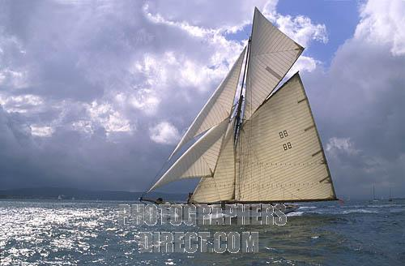
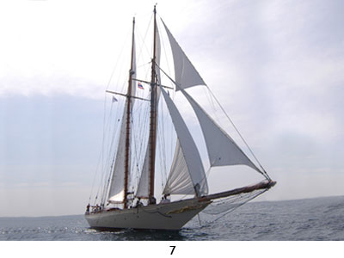

Figure.1 Moonbeam
Figure.2 Schooner Sunshine

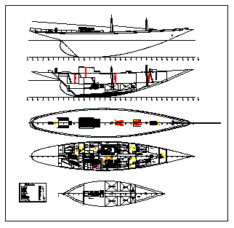

Figure.3 G.A Plan of Sunshine

3. Construction Activities
Construction activities include the followings:
- Material supply
- Fabrication
- Body assembly and shell plate erection
- Overturning
- NDT check
- Outfitting
- Piping and Machinery
- Launching
- Superstructure and Interior Decoration
The steel hull construction, outfitting and piping works were done by employees of MS. It was also performed to test NDT check and some design performance. Some skillful craftsmen from external contractor were hired to do superstructure and interior decorations works.

3.1 Material Supply
Hull materials, machineries, outfitting, anchoring and mooring equipments for construction of yacht and working drawings were approved by Lloyd’s class and supported by owner. Some parts had been cut by CNC
machine and other necessary parts were cut by CNC at MS.

3.2 Fabrication
For fabrication, the parts of frames were assembled and arranged by their numbers and tack-welded the frames together. To strengthen the frames, face plates of 50x6mm were used to become T-frames. After checking against the patterns, make the final welds. A good way to avoid distortion is to follow the same sequence for assembling each frame. To get the camber of main deck, hydraulic press machine was used for deck beams according to template of workshop floor.

3.3 Body assembly and shell plate erection
After fabrication, the frames, girders and bulkheads were arranged to their positions from aft to forward. Upside-down method was used because most of the important hull welding can be done in the down-hand position and made it easier to install the radius plating. Care must be taken to get the correct level, alignment and to fix exact frame situations. First, the deck stringers, deck girders and bulkheads were installed and then bottom centerline girder and tank top plate. When the frames were complete, shell plating was started. Because of the radius chine and bow curvature, the skillful welders had done with much care.

Fabrication
Body Assembly
Shell Plate
Overturning
NDT check
Outfitting
Piping & machinery
Launching
Superstructure & Interior decoration
Time
Figure.4 The Construction Time Plan

Table 1. The frames and plates used in this yacht

Material Specification |  | measurements (mm)
All Plating  Profiles |  | Grade A  Certificate from manufacturer according to grade A
Transverse Frames
Hullframe spacing above tanktop  Hullframe spacing under tanktop  Hull frames above tanktops  Hull frames below tanktops  Web frames above tanktops  Web frames below tanktops  Deck beams |  | 1000 mm  500 mm  120x4 & flange 50x5  120x5 & flange 50x5  L120x10+100x8  L120x8 & flange 60x8  Hp 80x5 and Hp 100x6
Longitudinal members
Side Shell Stringers  Deck girders  Deck stringer |  | 60x6  100x6 and flange 60x8  500x7 and 400x6 (ends)
Hull Plating
Keel & side plate till 2000 mm  Above base  Side plating from 2000 mm above base  Weather deck  Tanktop  Bulwarks |  | 8  6  45 mm wood  5  6
Bulkheads
Fr.0  Fr.5  Fr.15  Fr.21 | Plating  Stiff.  Plating  Stiff.  Plating  Stiff.  Plating  Stiff. | 4  50x5 (Spacing 450)  4  60x8 (Spacing 450)  4  60x8 (Spacing 450)  4  60x40x5 (Spacing 450)
Equipment Number According to LRSSC
Rules for the Classification – Certification of Yachts
Engine | 62.96
Anchor | 2
Weight | 75/55 kg
Chain | 110 m each | 12.5 mm

3.4 Overturning
The hull turning was a social event and it was done in 12/22/2000. Leveling, alignment and dimensions were checked again. After making some temporary staging, some overhead welding were finished. The hull was pulled out along with the carriage and then lifted with cranes.
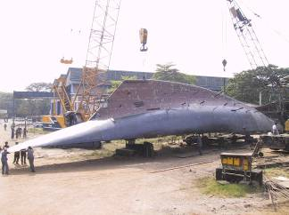

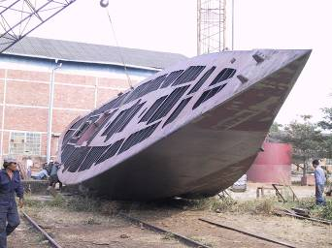

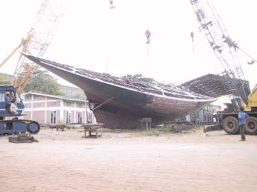

Figure. 5 Overturning Process

3. 5 NDT check
Shell plate welding joints were checked with radiographic inspection method. Fuel tanks, grey water tank, black water tank and drinking water tank were tested with air pressure text.

3.6 Outfitting
After construction the main body, bulwark, hawse pipe, fairlead, fore-stay, bow sprit heel, echo sounder seating, watertight doors, dolphin striker, main and fore mast arrangement, daily service tank, eye piece, eye bolt, anchor davit socket & crane, manhole cover, side scuttles and zine anode fittings were fitted. Lead weight 3,466 kg per cubic meter combined with its low melting point of 327°C was used for superior ballast material. 25 ton of lead was melted and then poured into the steel box keel section.
3.7 Piping and machinery
Bilge system, fuel oil service system, fresh water service system, black and grey water system were designed by MS. For bilge piping system, one bilge pump was electrically powered unit situated in the lowest point of the bilge and two hand-operated bilge pumps were fitted on the main deck. Semi-rotary hand pump with Ø32 and one fuel oil transfer pump were used for fuel service system.
Cummins Marine Diesel Engine of Model 6CTA-83 MI, 300 BHP @ 2500 RPM for a good cruising speed and Onan Gen-set of 17.5 KVA were fitted in the engine room. Chockfast was used to fit stern tube and propeller shaft.

3.8 Launching
After fabricating the hull construction, it had to put on the cradle. Because of the high lightship draft, the cradle must be modified from 2 feet to 1 foot in high. After finishing of block assemblies, it was turned over and seated onto the modified cradles which were placed at the auxiliary side slipway. Before side shifting onto the small traverser, special side supports were provided because of having very steep in depth. Then it was released into the basin. Finally it was successfully launched on the day of 22-7-2002.
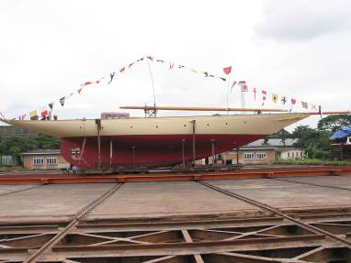

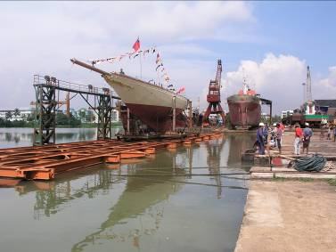

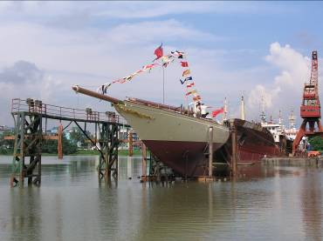

Figure. 6 Launching Processes
3.9 Superstructure and interior decoration
The interior design of the yacht was built almost entirely of teak wood. The interior which is hand crafted from teak and rosewood has been compromised from the original layout to allow for the required modern safety standards, such as the 4 watertight bulkheads. The deck is laid down in long thick lengths of solid teak planks over the steel frames, and caulked with cotton in the traditional way. The masts and spars are all of Sitka Spruce and the standing rigging is of galvanised steel.
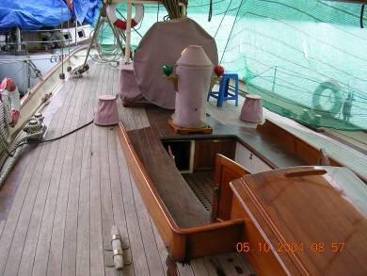

Figure.7 Deck floor
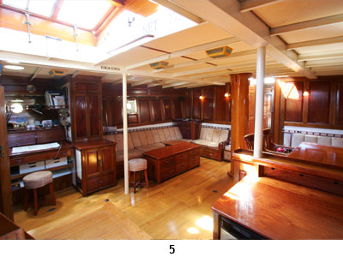

Figure.8 Salon

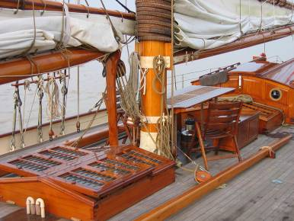

Figure.9 Hatch, Mast and Boom

4. Improving yacht design and construction
It is often said that there is nothing new in yacht design, that whatever we come up with that is innovative has been done by someone else in the near or distant past. That applies to radius chine hulls as much as to anything else. Each designer or builder has developed his own version of it which works well for his own style of yacht design or construction. Most modern yachts tend to have little, if any, curvature to the topsides near to the bow. Radius chine construction gives straight sections in this area, with all the radius below waterline. This can give a wet boat if there is not good flare to the hull to prevent the bow wave from coming straight up on deck.
Naval architecture department of MS made some design performance of the yacht Sunshine[1], [2]. Designers always have some ideas on how to improve or optimize an existing design, especially if the previous boat has been built and the designer has had a chance to evaluate the result. For racing yacht, the design improvements and changes are smaller and there is a greater need for an objective analysis of the changes. This is where parametric analysis and design optimization can be used most effectively.
Computer can help the design process by providing an easy way to start with a complete hull shape. Many accurate calculations can be performed. Detailed weight information and the layout of the arrangements and determination of whether everything fits can also be supported by computer.
Designers involved with the computer use both hull design program and a general purpose CAD program. The hull design program is used to create, fair and perform calculations on a 3D mathematical model of the hull. The general purpose CAD program is used to receive either the 3D model of the hull to create a full 3D interior, or to receive several 2D views of the required plans.
In a competitive shipbuilding market, MS wants to improve the construction of ships including yacht. Because of product complexity, such as tank and cargo barges, tug boats, power barges, passenger vessels, offshore vessels and vessel repair, MS wants to improve return on past and future investment decisions.
Since yacht is not mass produced, the synergy of multiple brains and experiences will tend to challenge or reject bad information and concentrate on good information. Management information is critical to productivity. The process tends to build organizational learning, shared vision, team function, and while reducing fear and mistrust and misunderstanding. MS recorded of action assignments, performance measurements, recognized unknowns, and other useful management information of the yacht.
MS has skilled and experienced employees who are very astute concerning their role in acquiring knowledge. Employees can also learn beyond the experience curve. Productivity can increase by the accessible knowledge base, skill and related learning, work organization, communication and leadership, and attitudes, such as willingness to accept change under the tent of corporate culture. MS has facilitated self-directed or conscious learning by encouraging and rewarding employee suggestions and innovation
Technology supports productivity by leveraging human abilities through facilities; suite choices; arrangement of production, support equipment, and tools; communication and information systems; and maintenance and safety equipment. Designers and engineers had thought little about work specification that could be enhanced with computer-aided design or manufacturing technology.
MS business functions depend on external help. MS also hires contractors to perform those functions on new vessels and vessels under repair that are beyond in-house capability. Contractors also provide training and services, such as insurance, accounting, payroll, and so fourth.
The construction cost will depend mainly on the weight of the hull. MS quoted low price to the owner of Sunshine because he gave full-size lofted frame templates. The price will be noticeably lower since the 3D computer hull form model will eliminate all traditional lofting by hand. If MS has to be selected the detail design, the owner has to discuss the exact type of information. The longer the owner waits, the more he increases his chances of having to modify his design and drawings.
Since MS is commercial-oriented shipyard, it constructs and repairs various kinds of vessels and it is not specialized in yacht building. For racing yacht, it is also necessary to design rig. It includes sailplans, respective structural calculations, mast and boom section. All structural elements can be dimensioned to comply with the ABS classification rules for Offshore Racing Yacht or for more efficient structures, finite element analysis can be performed. To complete the detail design, it can take much time on design processes.

5. Conclusion
The shipyards in Myanmar construct and repair mainly the inland waterway transport vessels. MS has been constructed many kinds of classed ships up to 90 m in length. There are many customers from foreign countries. The good management factor, the skillful workers and the advanced technology satisfy the customers.
From the first construction of racing yacht, MS had learnt much knowledge about yacht design and construction from the experiences. Although MS doesn't have well-trained yacht designers, the owners can discuss their required information about yacht design. If a similar designed metal yacht wanted to build in MS, it would not be time-consuming and well-trained workers and carpenters can work better than the old one.
composting processes. Adjusting operation conditions through changing key factors, optimal operation condition could be determined through comparing the results of numerical simulation. In this study, the optimal way of air supply was designed with the help of numerical model. Real experimental results showed that it could reduce 79.61% of oxygen supply with the same compost efficiency. Therefore, developed numerical model is of great significance to instruct the operation of real composting processes and reduce the operation cost.

Acknowledgement:
The author’s work is supported by Myanma Shipyards, Yangon, Myanmar.

Correspondence to:
Kay Thwe
Wuhan University of Technology
Wuhan 430063, China
Telephone: 86-27-63995353
Emails: thwe.kay@gmail.com

References
[1] International Measurement System. A Handicapping system for Crusing/Racing Yachts. ORC, World Leader in Rating Technology. 2001 Offshore Racing Council
[2] Guide for Building and Classing, Offshore Racing Yachts, 1994, American Bureau of Shipping

6/1/2009

