Morphology, Germination and early Seedling Growth in Phaseolus mungo L. with Reference to the Influence of Various Plant Growth Substances

J. S. Chauhan¹*, Y.K. Tomar², Anoop Badoni¹, N. Indrakumar Singh¹, Seema Ali¹ and Debarati¹

1. Department of Seed Science & Technology, H.N.B. Garhwal Central University, Srinagar Garhwal, Uttarakhand-246 174 (India).
2. Department of Horticulture, H.N.B. Garhwal Central University, Srinagar Garhwal, Uttarakhand-246 174 (India).
jaisinghchauahn@gmail.com

ABSTRACT: The paper presents the results of studies on morphological characters, seed germination and the influence of different concentrations of plant growth substances on Phaseolus mungo including the comparative growth patterns of the seedlings. Seeds were pre-soaked for 24h under the various concentrations (0.1, 1.0 and 10 ppm) of GA₃, IBA and NAA. Soaked seeds were arranged in sterilized petriplates lined with filter paper for germination at thermostatically controlled seed germinator. A control set was soaked only in distilled water. Observations were taken in 16 hrs light and 8 hrs dark at 25±2°C conditions. The mean value of germination percentage, growth of root, shoot and cotyledonary expansion and biomass of seedlings were computed. The highest percentage of germination was recorded when seeds were treated with 0.1ppm concentration of IBA while 1ppm concentration of IBA resulted in highest root length. The fresh and dry weight of shoots increased with GA₃ treatment. GA₃ 10 ppm showed highest shoot length and cotyledonary expansion and highest biomass production in the form of root dry weight. GA₃ 0.1ppm gained maximum shoot-root ratio. After seed germination, all the developmental processes decreased with increasing dose of hormonal concentrations. Invariably all the growth regulators stimulated high percentage of seed germination compared to the control which has shown only highest shoot dry weight. Present findings deal with comparative use of plant growth substances for the improvement of germination potential of Phaseolus mungo under the controlled laboratory conditions. [Journal of American Science 2009;5(7):34-41]. (ISSN: 1545-1003).

Keyword: Phaseolus mungo, Morphology, Plant Growth Substances, Seed Germination, Seedling Growth.

INTRODUCTION

Production of high quality seeds is primary source to the success of Indian agriculture. Every farmer is sensitive to need for the rapid uniform seedling emergence and establishment of an even and productive stand. Crop production relies heavily on high quality planting seeds. The latest ISTA rules (ISTA, 2008) contain seed testing protocols of a large number of species cultivated all over the world and it forms the basic reference book for all kinds of seed testing activities and also for the international seed trade. Seeds are fundamental input to agriculture and natural ecosystem. The production of high percentage of viable seeds with capacity to germinate quickly is necessary for the propagation. Phaseolus mungo is basically a warm season crop, but in India it is grown in both summer and winter, up to 1800 m above MSL. It is quite drought resistant but intolerant of frost and prolonged cloudiness. It is normally grown in areas with an average temperature of 25–35°C and an annual rainfall of 600–1000 mm. In higher rainfall areas it may be grown in the dry season on residual moisture. However, well-drained soils such as black-cotton soils with pH 6–7 are preferred.
This is one of the most highly prized and important short duration pulse crop grown in cropping systems of India as a mixed crop and sequential crop besides growing as sole crop under residual moisture condition after harvesting of rice. In India it is grown on an area of about 3.90 million hectare with a total production of 1.80 million tones with an average productivity of 498 Kg/ha. As a tropical crop it is cultivated both in kharif and rabi season due tolerance to high temperature. It is an erect, sub-erect or trailing, densely hairy annual herb. The tap root produces a branched root system with smooth, rounded nodules. The pods are narrow, cylindrical and up to 6 cm long.
Its seeds are highly nutritious with protein, carbohydrates, vitamins and minerals. It is an aphrodisiac and nervine tonic. It should not be taken by those who are easily predisposed to rheumatic diseases and urinary calculi as it contains oxalic acid in high concentration. Seeds and fruits of different species vary greatly in appearance, shape, size and ornamentation and structure of the embryo in relation to storage tissues. The germination of seed is affected by hormonal secretion and enzymatic activity with in the seeds. The major event occurring in the seed germination is water imbibitions. Germination represents a critical event in plant’s life cycle and its timing largely predetermines the chances of survival of a seedling up to maturity. Temperature is an important physical parameter of an environment, which determines the success or failure of a species of a species in a particular locality, which in turns depends mostly on the germinability of the seed of particular specie. It is well known that the different population of the same species varies in their temperature and light requirements for germination. Germination requirements of a particular species are a result of the interaction of its genetic makeup with the environment and dormancy pattern of seeds of various plant species, which enable them to survive during adverse conditions (Wittington, 1973; Nikolaeva, 1977). The present investigation is carried out to investigate the response of different concentrations of the Plant Growth Substances on seed germination, root, shoot and hypocotyls elongation and biomass production of seedlings. Some morphological features of seed have also been observed along with seedling development process.

MATERIAL AND METHODS

Experiments were conducted to investigate morphological characters, seed germination and the influence of different concentrations of plant growth substances including the comparative growth patterns of the seedlings on Phaseolus mungo. It is an erect, sub-erect or trailing, densely hairy annual herb. The tap root produces a branched root system with smooth, rounded nodules. The pods are narrow, cylindrical and up to 6 cm long and seeds are small, oblong cylindrical and slightly truncated (Table 1). It is very nutritious and is recommended for diabetics.

Table 2. The effects of various concentrations of different plant growth substances on seed germination and seedling growth of Phaseolus mungo.
GA₃ | 0.1ppm | 1ppm | 10ppm
IBA | 0.1ppm | 1ppm | 10ppm
NAA | 0.1ppm | 1ppm | 10ppm
Control | Only distilled water

Seeds were pre-soaked for 24h under the various concentrations (0.1, 1.0 and 10 ppm) of Plant Growth Substances viz. GA₃, IBA and NAA. A control set was soaked only in distilled water (Table 2). The seeds were placed on a wet filter paper in petridish and kept in seed germinator. On each alternate day, the mean valve of germination percentage, growth of root, shoot and cotyledonary expansion and biomass of seedlings were computed.

Table 1. The Morphological Features of Phaseolus mungo Seeds
S.No. | Parameters studied | Range of variation
 | Shape of fruit | A cylindrical pod with long hairs and short hooked beak
 | Fruit size | 4–7 cm × 0.5 cm, erect or almost so. 4-19 seeded
 | Shape | Seed are small, ellipsoid oblong and cylindrical to ovoid, slightly truncated at square ends, raised and concave hilum
 | Flower colour | Bright yellow
 | Flowering | Starts 30–60 days after sowing.
 | Maturity | Reaches in 60–140 days after sowing.
 | Color | Brown to black in color
 | ornamentation | Smooth
 | Length | 4.0 – 5.2 mm.
 | Width | 3.5 – 4.1 mm.
 | Seed Weight | The 1000-seed weight is 15–60 g.
 | The seed rate | 10–30 kg/ha,
 | Seedling | Emerges through epigeal germination
 | Germination time | Germination of black gram normally takes 7–10 days.

After thorough mixing the whole lot was sampled and dried in open air for 10 days and stored at room temperature till they were used for the experiment. The observation recorded on various morphological features of the seed such as seed color, shape, size and texture of the seeds. For this, 50 seeds were taken into consideration and their mean values computed for the morphological study. The moisture content of seeds was determined by air oven method. Subsequently, the sample contained in glass and dried thermostatically at room temperature and weighed, then placed in hot air oven at 80⁰C for 48hrs to find out the average dry weight and calculated using the following formula (Anonymous, 1976).

Moisture content (%) = Fresh Weight – Dry weight X100
Fresh weight

Observations on root, shoot growth and dry weight along with cotyledonary expansion have been recorded on each alternate day up to the final day of experimentation.
RESULTS AND DISCUSSION
The observations recorded from the experiment showed that IBA 0.1ppm resulted in cent percent germination which was followed by 99 percent of germination recorded through GA₃1 ppm, IBA1ppm, and IBA10ppm. The control set and NAA10ppm showed the lowest germination (96%) slightly less than GA₃1ppm, GA₃10ppm and NAA 0.1ppm (Table 3).
In case of the seedling growth, IBA-1ppm attained maximum (6.17 cm) root length while NAA 10ppm showed minimum (1.65 cm) root length. The higher shoot elongation was observed under GA₃ 10ppm (11.1 cm) and minimum in NAA 10 ppm (4.42 cm). GA₃ 10ppm (3.52±0.5) have shown the best expansion of the cotyledons which was followed by IBA 0.1ppm (3.46 ±0.2). The lowest performance was recorded through NAA 10 ppm 0.29±0.4 and IBA 10ppm 1.87±0.5 while the controlled set exhibited better cotyledonary expansion (3.25±0.5) than these hormonal concentrations (Fig.1-3).
On the biomass observations, GA₃ 10 ppm have shown maximum root dry weight (0.074 g) followed by NAA 0.1ppm (0.035±0.1) almost similar (0.0034±0.1) to control set, whereas GA₃ 0.1-ppm resulted minimum (0.002g) root dry weight (Table 4). Heavy seeds generally have superior germination, survivorship, and seedling mass Aaron M. Ellison (2001). Seed size and germination requirements can be determined to be useful characters for resolving systematic and phylogenetic problems Douglass H (1985).
Heavy seeds generally have superior germination, survivorship, and seedling mass as mentioned by Aaron M. Ellison (2001). In the findings of Douglass H (1985) have also been summarized that seed size and germination requirements can be determined to be useful characters for resolving systematic and phylogenetic problems. Archna and Shivana (1985) have studied the requirements for seed germination and seedling formation of a hemi-root parasite Sopubia delphinifolia. Light was found to be essential for germination; none of the growth substances could replace the light requirement. Light responses seem to be mediated through the phytochrome system. They indicated that the emergence of the radicle, its further growth into the root and the emergence of cotyledons are controlled by different factors.

Table 3: Effect of various concentrations of Plant Growth Substances on seed germination and seedling development of Phaseolus mungo

Treatments | Germination % | Shoot Length (cm) | Root Length (cm) | Cotyledon Expansion (cm)
GA₃ 0.1 ppm. | 97 | 9.77 ±0.5 | 5.2 ±0.6 | 2.92 ±0.5
IBA 0.1 ppm. | 100 | 10.14 ±0.6 | 4.82 ±0.5 | 3.46 ±0.2
NAA 0.1 ppm. | 97 | 8.6 ±0.4 | 5.75 ±0.5 | 2.45 ±0.4
GA₃ 1 ppm. | 99 | 7.4 ±0.4 | 5.77 ±0.5 | 2.62 ±0.4
IBA 1 ppm. | 99 | 9.87 ±0.5 | 6.17 ±0.4 | 3.44 ±0.5
NAA 1 ppm | 98 | 8.13 ±0.5 | 3.9 ±0.6 | 2.58 ±0.5
GA₃ 10ppm. | 97 | 11.1 ±0.5 | 4.0 ±0.8 | 3.52 ±0.5
IBA 10 ppm. | 99 | 6.94 ±0.6 | 5.0 ±0.8 | 1.87 ±0.5
NAA 10ppm. | 96 | 4.42 ±0.4 | 1.65 ±0.4 | 0.29 ±0.4
Control | 96 | 10.47 ±0.6 | 5.2 ±0.8 | 3.25 ±0.5

Seeds must attain certain minimum specific moisture content, before they germinate thus germination may be inhibited if the amount of water is too low and it is further inhibited if too much water is present (Negbi et.al. 1966; Coumans et.al. 1979). Role of the growth regulators in the promotion of cell division and the growth through changes occur in the pattern of enzyme development have mentioned by a number of researchers such as Liu and Loy (1976); Adams et.al. (1973) and Broughton McComb (1971). Similar studies were carried out by Parameswari & Srimathi (2008) to evaluate the influence of growth regulators on seed germination and seedling quality characteristics of tamarind seeds.

Table 4: Effect of various concentrations of Plant Growth Substances on shoot and root dry weight of Phaseolus mungo.

Treatments | Shoot Dry Weight (gm) | Root Dry Weight (gm) | Shoot: root ratio | Epicotyls length (cm) | No. of Roots
GA₃ 0.1 ppm. | 0.025 ±0.001 | 0.002 ±0.001 | 1: 13 | 2.92 | 7
IBA 0.1 ppm. | 0.023 ±0.002 | 0.005 ±0.001 | 1: 4.1 | 3.46 | 8
NAA 0.1 ppm. | 0.021 ±0.001 | 0.035 ±0.001 | 1:0.6 | 2.45 | 7
GA₃ 1 ppm. | 0.023 ±0.002 | 0.027 ±0.002 | 1:0.8 | 2.62 | 9
IBA 1 ppm. | 0.022 ±0.002 | 0.006 ±0.001 | 1:3.6 | 3.44 | 8
NAA 1 ppm | 0.020 ±0.002 | 0.005 ±0.002 | 1:40 | 2.58 | 7
GA₃ 10ppm. | 0.020 ±0.001 | 0.074 ±0.002 | 1:0.2 | 3.52 | 9
IBA 10 ppm. | 0.021 ±0.001 | 0.006 ±0.002 | 1:3.5 | 1.87 | 8
NAA 10ppm. | 0.018 ±0.001 | 0.010 ±0.003 | 1:1.8 | 0.29 | 6
Control | 0.0276 ±0.001 | 0.0034 ±0.001 | 1: 6.7 | 3.25 | 8

The seeds were imposed with pre-sowing fortification treatment using growth regulators viz., GA3, IAA, IBA and Kinetin in different concentrations of 50,100 and 200 ppm for 16 hours in a seed to solution volume ratio of 1:1.

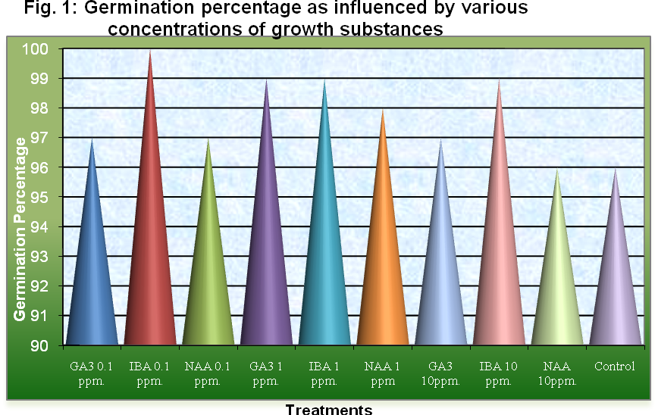

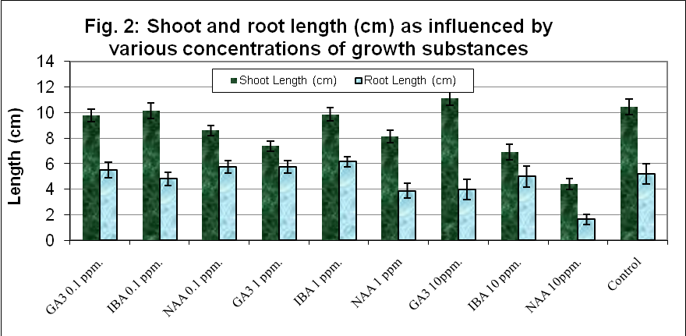

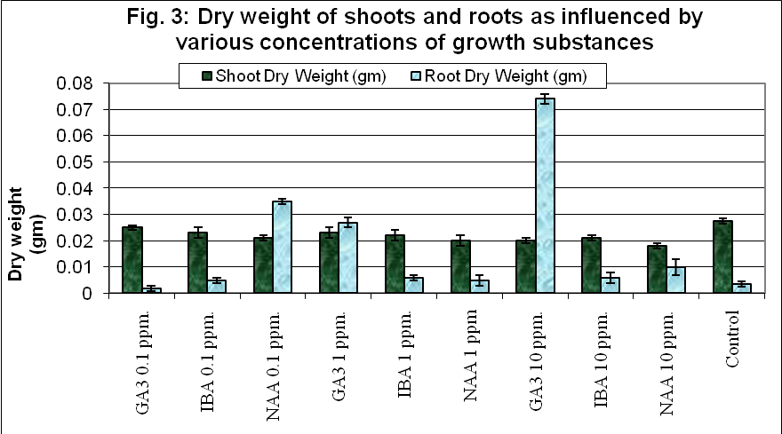

They revealed that the concentration of 100 and 200 ppm GA₃ were found to enhance both the seed germination and seedling vigour parameters, such as root length, shoot length, hypocotyl length, dry matter production and vigour index values. Seed fortification with GA₃ 100 ppm performed well even under nursery conditions recording a higher leaf number and stem circumference.
The effect of seed-soaking for 24 hours with different Plant Growth Substances has been examined by M. Grzesik. (2006) on the growth of seedlings of Lathyrus odoratus, Zinnia elegans, Matthiola incana and Antirrhinum majus. GA₃ improved the germination of the treated seeds. The seedlings of Zinnia, Matthiola and Antirrhinum treated with NAA, GA₃ and GA₄₊₇ where higher, better branched and of better quality than the non-treated plants. The experiment was designated by M. Farooq et al. (2006) to investigate the possibility of rice seed invigoration by pre-sowing ethanol seed treatment. They revealed that employing ethanol treatments at lower concentrations can invigorate fine rice seeds.
High temperature both delayed and inhibited the germinations of barley and radish seeds (Cavusoglu K & Kabar K 2007). Irfan Afzal et al., (2005) have shown the effects of seed soaking with plant growth regulators (IAA, GA₃ and kinetin) on wheat emergence and seedling growth under normal and saline conditions and found their usefulness in increasing relative salt-tolerance. Among the 14 pre-sowing treatments, KNO₃ (150 min) and NaHClO₃ (30 min) significantly stimulated seed germination of Angelica glauca and reduced mean germination time under both laboratory and nursery trials, as well as developed seedling vigour under nursery conditions (Jitendra S. Butola and Hemant K. Badola 2004). A similar experiment was carried out by Gao HuanZhang et al., (2002) in which Walnuts cv. Jianshi were soaked in water (control), IBA at 80 mg/kg, IAA at 100 mg/kg, NAA at 80 mg/kg, ABT root-growing powder at 1 g/kg, or 6-BA at 5 mg/kg. In this experiment, different concentrations of GA₃, IBA and NAA, the maximum germination percentage (100%) was recorded in seed treated with IBA 0.1 ppm, which shows that the lower concentrations of growth hormone shows better performance than higher which was similar to the results of James Chukwuma Ogbonna and P.G. Abraham (1989). Heavy seeds generally have shown superior germination, survivorship, and seedling mass.

Control 0.1ppm 1ppm 10ppm
IBA

Control 0.1ppm 1ppm 10ppm
NAA

Control 0.1ppm 1ppm 10ppm
GA₃

Figure 4. Seed germination and seedling growth in Phaseolus mungo as influenced by Plant Growth Substances

IBA treated seedlings grow 37.5% taller than the control (Fig. 4). The most effective root length (6.17 cm) was observed in IBA 1ppm while maximum shoot length and highest cotyledonary expansion in GA₃ 10ppm. In the biomass calculation of seedlings, the maximum ‘root dry wt.’ observed under GA₃ 10ppm while maximum shoot dry weight was responded by control set but best shoot-root ratio has gained under GA₃ 0.1ppm.

Corresponding Author:
Dr. J.S. Chauhan
Assoc. Professor,
Department of Seed Science & Technology
H.N.B. Garhwal Central University,
Srinagar Garhwal, Uttarakhand-246 174 (India).

Phone: +911370267664
Email: jaisinghchauahn@gmail.com

REFERENCES

- Aaron M Ellison (2001) Interspecific and intraspecific variation in seed size and germination requirements of Sarracenia (Sarraceniaceae). American Journal of Botany 88: 429-437.
- Adams PA, PB Kaufman, H Ikuma (1973) Effect of gibberellic acid and Sucrose on the growth of oat (Avena) Stem segment. Plant Physiology 51: 1102- 1108.
- Archna Sahai, KR Shivanna (1985) Seed Germination and Seedling Growth in Sopubia delphinifolia- a Hemi-root Parasite: Germination Requirements. Annals of Botany 55: 775-783.
- Brougton WJ, Mucous A (1971) The pattern of enzyme development in gibberellins in treated pea internodes. Annals of botany. 35: 215- 228.
- Cavusoglu K, Kabar K (2007) Comparative effects of some plant growth regulators on the germination of barley and radish seeds under high temperature stress. EurAsia J BioSci 1 (1): 1-10.
- Douglass H Morse, Johanna Schmitt (1985) Propagule size, dispersal ability, and seedling performance in Asclepiassyriaca. Oecologia 67: 3.
- Gao HuanZhang, Bao XinMei, Hu XiaoXiang (2001) Effect of plant growth regulators on seed germination and seedling growth of walnut. Journal of Hubei Agricultural College. Jingzhou 434025, Hubei, China
- Irfan Afzal, Shahzad MA Basra, Amir Iqbal (2005) The effects of seed soaking with plant growth regulators on seedling vigor of wheat under salinity stress. Journal of Stress Physiology & Biochemistry 1(1): 6-14.
- ISTA (2008) International Rules For Seed Testing. ISTA, Bassersdrof, CH. Switzerland.
- James Chukwuma Ogbonna, PG Abraham (1989) Effect of Seed Pretreatment with some Plant growth regulator on germination, growth and yield of Cowpea (Vigna sinensis). Japan Jour. Crop. Sci. 58(4): 641-647.
- Jitendra S Butola, Hemant K Badola (2004) Effect of pre-sowing treatment on seed germination and seedling vigour in Angelica glauca, a threatened medicinal herb. Current science 87(6): 25.
- Liu PBW, JB Loy (1976) Action of Gibberellic acid on cell proliferation in the sub-apical shoot meristem of watermelon seedling. American journal of botany 63: 700 – 704.
- M Farooq, Shahzad MA Basra, Hefeez-Ue-Rehman, Tariq Mehmood (2006) Germination and early seedling growth as affected by pre-sowing ethanol seed treatments in fine rice. International Journal of Agriculture & Biology 8(1): 19–22.

M Grzesik (2006) Effect of Growth Regulators on the Seedling-Growth of Lathyrus Odoratus, Zinnia Elegans, Matthiola incana and Antirrhinum majus. Acta Horticulturae. pp 251.
- Negbi M, Rushkin E, Koller D (1966) Dynamics aspects of water relations germination of Hirschfeldia incena seeds. Plant cell Physiology 7: 363-376.
- Nikolaeva MG (1977) Factors controlling the seed dormancy pattern. In: The Physiology and Biochemistry of Seed Dormancy and germination. (Ed. AA Khan) pp5174. Elsevier.
- Parameswari K, Srimathi P (2008) Influence of growth regulators on elite seedling production in tamarind (Tamarindus indica) Legume Research. 31(4) ISSN: 0250-5371.
- Singh H, Dara BL (1971) Influence of presoaking of seeds with gibberellin and auxins on growth and yield attributes of wheat (Triticum aestivum L.) under high salinity, sodium adsorption ratio and boron levels. Indian J. Agr. Sci., 41: 998-1003.
- Wittington WJ (1973) Genetic regulation of germination. In: Seed Ecology (ed. W. Heydecker) Proc. Nineteenth Ester School in Agric. Sci. Butterworth, Lond. Pp5-30.

