Increase in somatostatin immunoreactivity in the organotypic slice culture of mouse hypothalamic suprachiasmatic nucleus

Ehab Tousson¹ and Khalil Abou-Easa²

- Zoology Department, Faculty of Science, Tanta University, Egypt
- Dept. of Cytology and Histology, Faculty of Vet. Med., Kafr-El-Sheikh University, Egypt.
ehabtousson@yahoo.com khalil_aboueasa@hotmail.com

Abstract: The suprachiasmatic nucleus (SCN), site of the dominant mammalian circadian clock, contains a variety of different neurons that tend to form groups within the nucleus. Somatostatin was first discovered in hypothalamic extracts and identified as a hormone that inhibited secretion of growth hormone. Subsequently, somatostatin was found to be secreted by a broad range of tissues, including pancreas, intestinal tract and regions of the central nervous system outside the hypothalamus. In vivo the localization of somatostatin immunoreactivity (SS-ir) in mouse SCN was examined before. However, detailed information about the localization and developmental distribution of SS-ir neurons in the mouse SCN slice culture is lacking. SCN derived from 3 day old mouse, were maintained in culture at the interface between air and a culture medium. SS-ir neurons are detected within the general central SCN area and the surrounding region. The density of SS-ir was clearly increased during the SCN development in organotypic slice cultures at the level of the cell bodies. The results show that not all SCN-neuropeptidergic systems decline with in vitro development, and suggest a specific age-related role for SS in the SCN. These findings may provide new morphologic evidences for explaining the functional mechanism in the SCN. [Journal of American Science 2009;5(7):91-98]. (ISSN: 1545-1003).

Key words: Somatostatin immunoreactivity, Immunohistochemistry, Hypothalamus suprachiasmatic nucleus, Tissue culture, Mice.

1. Introduction
In mammals, the master clock located in the suprachiasmatic nucleus of the hypothalamus is able to generate and distribute a rhythmic message to the whole body (Reppert and Weaver, 2001; Tousson, et al., 2003; Tousson and Meissl, 2008; Silver and Schwartz, 2005; Reghunandanan and Reghunandanan, 2006; Choi et al., 2008). These paired SCN in rodents are composed of about 8000 neurons and are divided anatomically into a ventrolateral, an intermediate and a dorsomedial part, or, as more recently proposed a core and a shell, corresponding to the ventral input site with large neurons and the dorsal region with smaller neurons, respectively (Abrahamson and Moore, 2001; Moore et al., 2002; Morin and Allen, 2006). Some of the neuropeptides that have been identified to date in the rodent SCN (in vivo) are vasopressin (VP), vasoactive intestinal polypeptide (VIP), Gamma-amino butyric acid (GABA), gastrin releasing peptide (GRP), substance P, somatostatin (SS) and calbindin (CalB) (Moore, 1996; Abrahamson and Moore, 2001; Moore et al., 2002; Tousson, 2005b; Reghunandanan and Reghunandanan, 2006; Tousson and Meissl, 2008). Neurons synthesising VIP, substance P and GRP are located in the core of the SCN (Moore, 2001; Moore et al., 2002; Biemans et al., 2002), where as VP neurons are found in the shell (Abrahamson and Moore, 2001; Moore et al., 2002; Tousson, 2005b). GABA and CalB producing neurons have been demonstrated in the core and shell (Wang et al., 1996; Biemans et al., 2002; Moore et al., 2002; Novak and Albers, 2004; Morin and Allen, 2006). Ageing of the circadian system has been associated with amplitude reduction of circadian rhythms, fragmented rhythms, and higher day-to-day rhythm variability, shortening of period length and altered responses to light (Turck et al., 1985). The physiological basis for these age-related changes in circadian rhythms may be (partly) found in altered SCN neuropeptide organization. Decrease of VP-ir, VIP-ir and CalB-ir neurons were detected in aged SCN rodents (Biemans et al., 2002) while an increase of Calretinin-ir neurons were detected in aged SCN rodents (Ikeda and Allen, 2003). Somatostatin was first discovered in hypothalamic extracts and identified as a hormone that inhibited secretion of growth hormone. Subsequently, somatostatin was found to be secreted by a broad range of tissues, including pancreas, intestinal tract and regions of the central nervous system outside the hypothalamus (Fukuhara et al., 1994). Somatostatin is often referred to as having neuromodulatory activity within the central nervous system, and appears to have a variety of complex effects on neural transmission (Reghunandanan and Reghunandanan, 2006). Injection of somatostatin into the brain of rodents leads to such things as increased arousal and decreased sleep, and impairment of some motor responses (Biemans et al., 2002). Detailed information about the localization of SS-ir during the mouse SCN development in vitro is lacking. Therefore, we are showing the changes of SS-ir neurons during the mouse SCN development in organotypic slice cultures.

2. Materials and Methods
2.1 Animals
The animals used in this study were male CD1 mouse (24 mouse of ages 3 days old), the mice were bred in the department facilities under controlled conditions (12h : 12h light – dark cycle, light on at 6:00 a.m) with about 60% humidity and 25°C temperature.
2.2 Organotypic slice cultures
Organotypic slice cultures from hypothalamus were prepared using the interface culture methods described by Tousson and Meissl (2004). Four hours after light on, animals were taken from the animal house and killed by decapitation, the skulls were opened with fine scissors and the brains were quickly removed under sterile conditions into ice-cold artificial cerebrospinal fluid (aCSF; 124 mM NaCl, 5 mM KCl, 1.25 mM KH₂PO₄, 1.3 mM MgSO₄, 26 mM NaHCO₃, 2.2 mM CaCl₂, 10 mM glucose, 10 mM HEPES). Hypothalami were excised and 300 μm thickness coronal slices were made using a vibroslicer. Slices were transferred into ice-cold aCSF in a Petri dish and those presumed to contains the bilateral SCN and the PVN. Selected slices were trimmed dorsally at the level of the anterior commissure and laterally just before the supraoptic nuclei and kept in drops of aCSF for 30 minutes. The selected slice was then positioned over Millicell filter in Petri dish and incubated for 1 hour at 37°C in 5% CO₂/95% air with a small amount of culture medium (DMEM/F12 supplemented with 10% fetal calf serum, 10mM HEPES, 100 U/ml penicillin and streptomycin and 100 μg/ml ascorbic acid). Then, the Petri dish was filled with culture medium. The culture medium must be not completely cover the Millicell filter. The culture medium was exchanged every 3 days. SCN slice at different time (1day (1DIV), 1Week (1WIV), 2Weeks (2WIV) and 4Weeks (4WIV) in vitro) were excised and fixed in 4% paraformaldhyde in phosphate buffered saline (0.1M, pH 7.4 PBS) for 24 hours at 4°C and then cryoprotected in 30% sucrose in PBS at 4°C for 72 hours. SCN slices were sectioned with a freezing microtome at the level of the hypothalamus into 20 µm coronal sections and mounted on gelatine coated slides and stored at -20°C prior to processing for SS immunohistochemistry.
2.3 Somatostatin immunoreactivity:
Immunohistochemical labeling was carried out by using the indirect fluorescence method (Cho et al., 2007). Sections were blocked for 1 hour in a solution containing 10% NGS, 1% bovine serum albumin (BSA) and 0.5% Triton- X-100 in PBS. Sections were incubated in primary antibody diluent (3% NGS, 1% BSA and 0.5% Triton-X-100 in PBS) prior to incubation in rabbit anti-SS primary antisera (dilution 1:1000, Sigma) for overnight at room temperature. Sections were rinsed in 0.1M PBS and then incubated for 1 hour (in dark room) in a goat anti-rabbit as secondary antibody (1:500). Then they were rinsed for 10 minutes in PBS and mounted and cover slipped with vectashield antifading mounting medium and examined under epifluorescence for SS-ir. All fluorescent specimens were viewed by using a Leica TCS fluorescence microscope and a digital camera (Cannon 620) captured images. Each region was imaged under high magnification (40X) and labeled cells were individually marked and manually counted. For analysis, the mean number of CalB-ir cells was calculated from the counts of four alternate images showing the highest number of labeled cells. Brightness and contrast of the images were adjusted using Adobe Photoshop software.

3. Results:
In stationary organotypic culture, the mouse SCN consists of paired nuclei, located on either side of the midline just dorsal to, and extending into, the optic chiasm in the anterior hypothalamus (Figs. 1, 2). Medially, the periventricular nucleus and the third ventricle border SCN (Fig. 3). The dorsal, lateral, rostral and caudal boundaries can be determined in Nissl stained material because of the greater packing density of cells in SCN relative to the surrounding other parts of the hypothalamus.

Due to the small size and tight packing density of SCN cells, it is difficult to ascertain the finer morphological characteristics of individual neurons in Nissl stained material (Figs. 3, 4.). Explants survival was excellent, only about 3% of the slices being discarded as unfit for experiments, due to detachment from the filter. Slice explants flattened appreciably, however, the twin bulges of SCN remained somewhat thicker than the surrounding tissue in the end of 3rd week in vitro (Fig. 2). At 4th week of incubation, the slice cultures were thinner enough to allow observation of cell layers and the fine morphological characteristics of individual neurons in SCN.
The detection and distribution of SS-ir neurons in the hypothalamic SCN organotypic slices are illustrated in figures 5-13. Numerous intensely labelled SS-ir neurons were evident throughout the cultured SCN (Figs. 5 & 6). Labeling SS-ir neurons outside SCN was associated mainly with the PVN and scattered periventricular magnocellular neurons. A small number of SS-ir cells that either bipolar or multipolar where found in the area of lateral hypothalamus and in PVN that are more abundant several hundred microns dorsal to SCN, and seen to be of the same population due to their large size and close apposition to the third ventricle (Fig. 5). In 0DIV (3 day old mouse in vivo and zero day in vitro) a clear SS-ir neurons were found in the optic chiasm (Fig. 5). SS-ir labelled neurons showed variations in morphology within the SCN where the majority of neurons were round and oval cells with multipolar dendrites (Fig.6).
SS-ir neurons were scattered in the whole SCN (core and shell). At the medial level, they were primarily located in the intermediate zone and more lateral at the caudal level (Fig. 7). The intensity of SS-ir neurons was increased during the SCN in vitro development where the number of SS-ir neurons in core more than in shell (Fig. 8-13). At the 1st and 4th days in vitro (1DIV & 4DIV) no marked increasing in SS-ir neurons (Figs, 7 & 8) while at 7, 14, 21 and 21 days in vitro, marked increasing were observed in SCN core (Figs. 9-12). From the 7DIV, the intensity of SS-ir neurons in the intermediate zone and shell region of SCN were increased (Figs. 9-12).

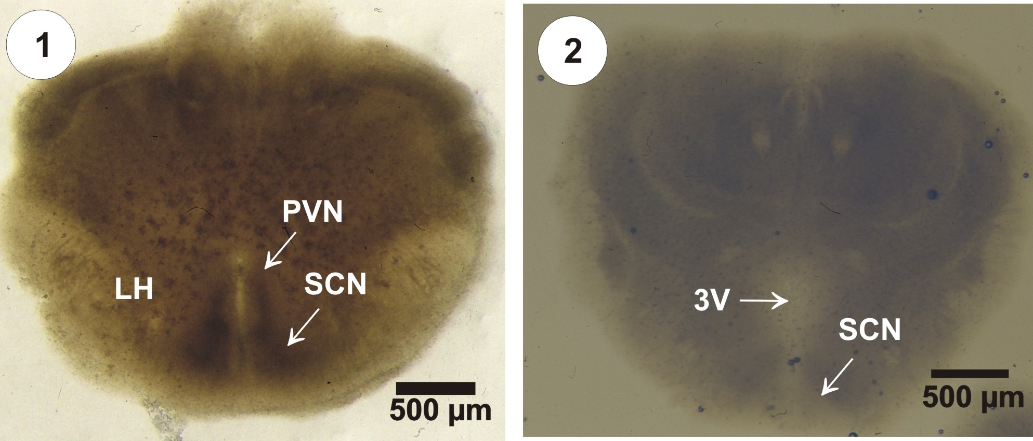

Fig. 1: Photomicrograph of an organotypic slice culture maintained 21day in vitro (21DIV). The explants slice is flattened and the different hypothalamic areas can be clearly distinguished.
Fig. 2: Photomicrograph of an organotypic slice culture maintained 28 day in vitro (28DIV).

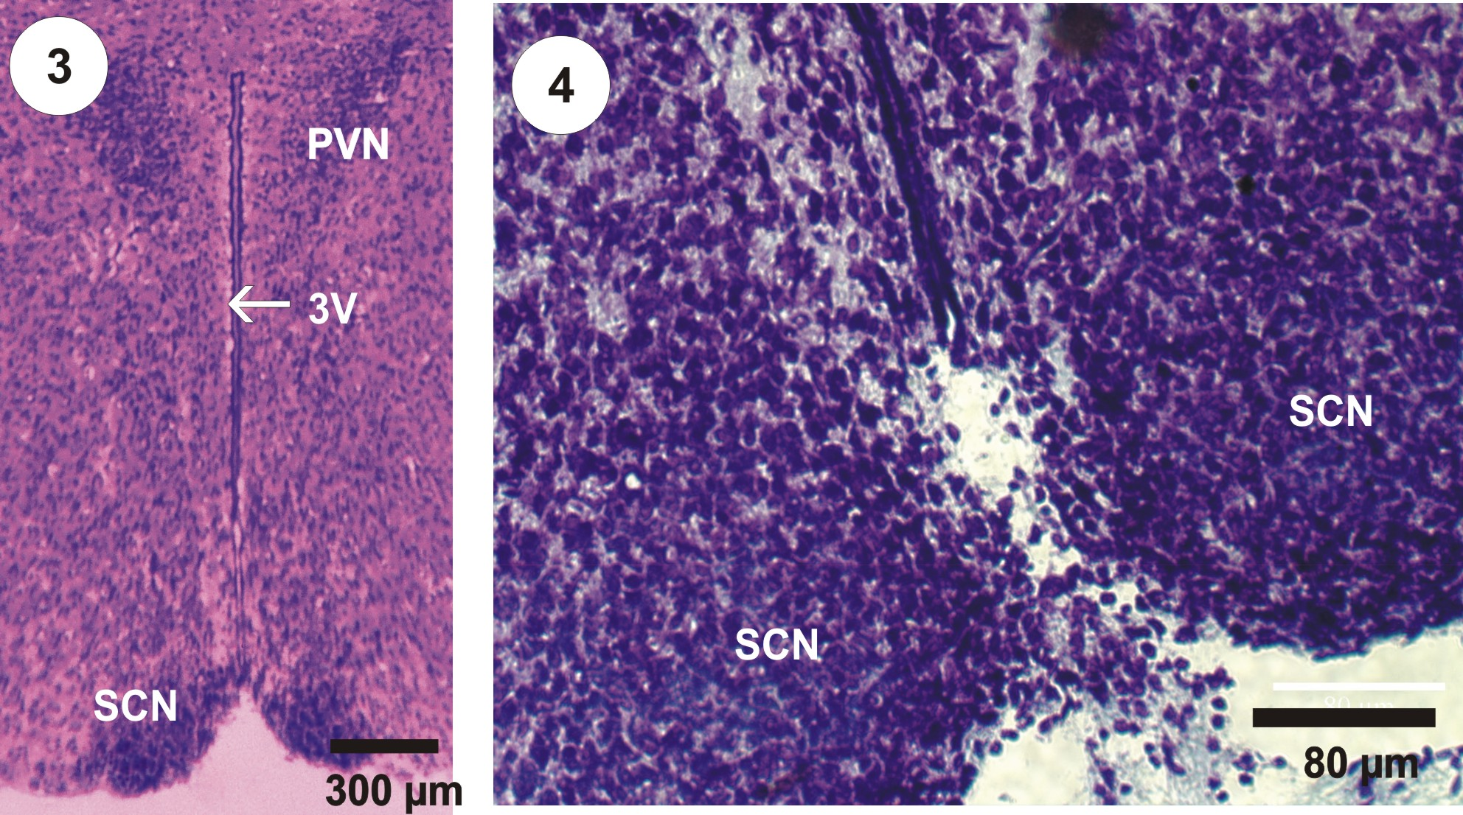

Fig. 3: Photomicrograph stained with cresyl violet showing the bilateral PVN and SCN lying lateral to the third ventricle and dorsal to the optic chiasm.
Fig. 4: High power photomicrograph stained with cresyl violet showing SCN in culture but without the optic chiasm.

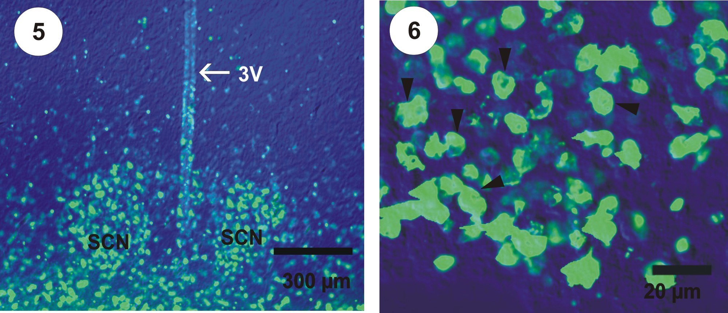

Fig. 5-12: Photomicrographs of SS-ir neurons in the mouse hypothalamic organotypic slice culture.
Fig. 5: Photomicrograph of SS-ir showing the SS-ir neurons within SCN in vitro (0DIV).
Fig. 6: High power micrograph displaying SS immunoreactive neurons in the unilateral SCN.

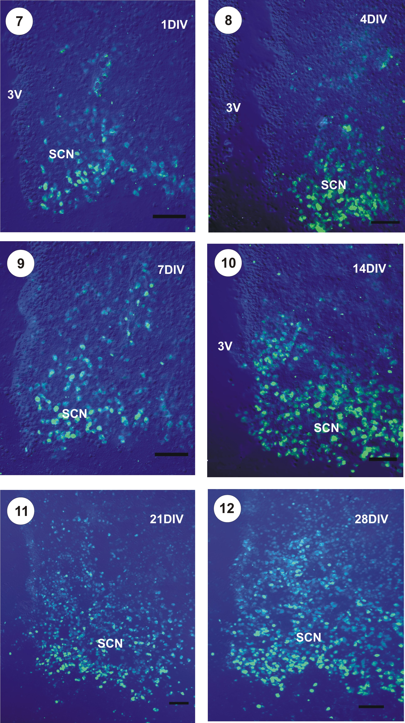

Fig.. 7-12: Photomicrographs of immunoreactive SS neurons in the hypothalamic organotypic slice culture (7: 1DIV; 8: 4DIV; 9: 7DIV; 10: 14DIV; 11: 21DIV; 12: 28DIV) showing the density of SS-ir neurons during the development of SCN in the slice cultures (3V: third ventricle, OC: optic chiasm) Scale bar 50 µm.
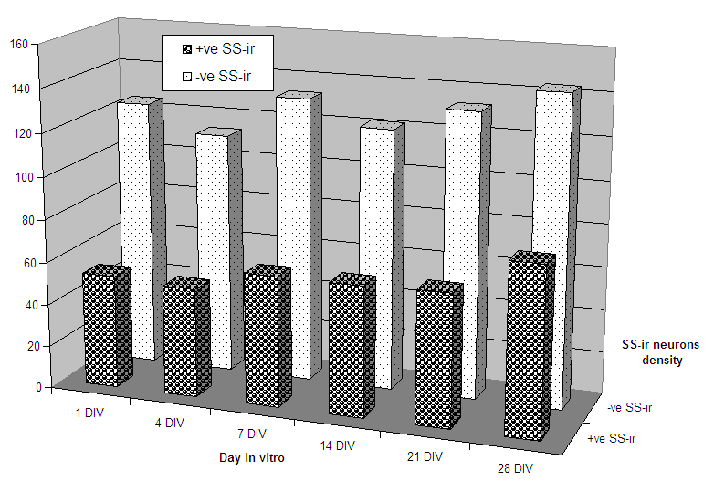

Fig. 13: Histogram showing the density of SS-ir neurons during the development of SCN in the slice cultures.

4. Discussion
In this study, it is reported that this simple culture technique is very convenient and successful for explants of nervous tissue and more specifically hypothalamic slices also we report a remarkable, SCN-specific increase of SSir in vitro. In vivo, a number of neuropeptides, including VP, VIP, cholecystokinin, GRP, peptide histidine isoleucine, SS and SP have been immunolocalized within SCN (Wang et al., 1997; Van Easseveldt et al., 2000; Abrahamson and Moore, 2001; Adolph, 2002; Albers et al., 2002; Biemans et al., 2002; Moore et al., 2002; Caldwell and Albers, 2004; Tousson, 2005b; Tousson and Meissl, 2008). The distribution of SS-ir neurons in the mouse organotypic cultures were similar to the pattern found in the adult mouse (Abrahamson and Moore, 2001; Biemans et al., 2002; Moore et al., 2002; Tousson, 2005b) and in the SCN culture (Belenky et al., 1996; Adolph, 2002; Tousson et al., 2003; Tousson, 2005a).
Ageing of the circadian system has been associated with amplitude reduction of circadian rhythms, fragmented rhythms and higher day-to-day rhythm variability, shortening of period length and altered responses to light (Turck et al., 1985; Biemans et al., 2002). The physiological basis for these age-related changes in circadian rhythms may be (partly) found in altered SCN neuropeptide organisation. From our previous study it appeared that loss of AVPir and VIPir (Biemans et al., 2002; Van der Zee et al., 2005) has been shown in aged rats. Biemans et al., (2002) reported a significant increase in SS and SP immunoreactivity in aged Wistar rats as compared to young ones, thereby indicating that not all SCN neuropeptidergic systems decline with age.
In long-term organotypic cultures, the expression of SS immunoreactivity during the mouse SCN development has never been reported before. Our results' showing that, SS-ir neuron is present within the general central SCN area, the surrounding region and generally throughout the entire nucleus. Results also revealed that, the intensity of SS-ir neurons were increased In vitro. Somatostatin is produced by neuroendocrine neurons of the periventricular nucleus of the hypothalamus, these neurons project to the median eminence, where somatostatin is released from neurosecretory nerve endings into the hypothalamo-hypophysial portal circulation (Morin, et al., 2006; Reghunandanan and Reghunandanan, 2006). These blood vessels carry somatostatin to the anterior pituitary gland, where somatostatin inhibits the secretion of growth hormone from somatotrope cells. The somatostatin neurons in the periventricular nucleus mediate negative feedback effects of growth hormone on its own release; the somatostatin neurons respond to high circulating concentrations of growth hormone and somatomedins by increasing the release of somatostatin, so reducing the rate of secretion of growth hormone (Morin and Allen, 2006). In vitro, the circadian rhythmicity in the hypothalamus depends on the presence of an intact SCN (Tousson and Meissl, 2004). Completely lesions of SCN from the mouse hypothalamus slice culture showing circadian rhythmicity in the other hypothalamic regions (Tousson et al., 2003), but bilateral ablation of the SCN completely abolished all rhythms in the PVN and in adjacent hypothalamic areas. The circadian locomotor rhythm is restored after implantation of fetal SCN tissue into the third ventricle of previously SCN-lesioned adult hamsters (Ralph et al., 1990) or in acute slice of mouse (Tousson et al., 2004).

ACKNOWLEDGMENTS
I thank Prof.Dr. Nabila El-desoky (Zoology dep., Fac. of Science, Tanta Univ., Egypt) for her critical and helpful comments on a draft of this manuscript.

Correspondence to:
Ehab Tousson
Zoology Department, Faculty of Science, Tanta University, Egypt.
ehabtousson@yahoo.com
Tel: 002193905527 Fax: 002453353800

References:
[1] Abrahamson E, Moore RY. Suprachiasmatic nucleus in the mouse: retinal innervations, intrinsic organization and efferent projections. Brain Research 2001; 916: 172-191.
[2] Adolph S. Neurone des Hypothalamischen Suprachiasmatischen Nukleus in Zellkultur und Organotypischen Kulturen: Wachstum, Synaptische Verbindungen, Iokale Netzwerke. Diplomarbeit, Frankfurt Univ., Deutschland, 2002.
[3] Albers HE, Karom M, Smith D. Serotonin and vasopressin interact in the hypothalamus to control communicative behaviour. Neuroreport 2002; 13: 931—933.
[4] Belenky M, Wagner S, Yarom Y, Matzner H, Cohen S, Castel M. The SCN in stationary organotypic culture. Neuroscience 1996; 70: 127—143.
[5] Biemans BA, Gerkema MP, Van der Zee EA. Increase in somatostatin immunoreactivity in the suprachiasmatic nucleus of aged wistar rats. Brain Research 2002; 958: 463-467.
[6] Caldwell HK, Albers HE. Effect of photoperiod on vasopressin-induced aggression in Syrian hamsters. Hormonal Behavioural 2004; 46: 444—449.
[7] Cho ES, Lee SY, Park J, Hong SG, Ryu PD. Organotypic slice culture of the hypothalamic paraventricular nucleus of rat. Journal of Veterinary Science 2007; 8: 15–20.
[8] Choi HJ, Lee C, Schroeder JA, Kim YS, Jung SH, Kim JS, Kim DY, Son EJ, Han HC, Hong SK, Colwell CS, Kim YI. Excitatory actions of GABA in the suprachiasmatic nucleus. Journal of Neuroscience 2008; 28: 5450-5459.
[9] Fukuhara C, Hamada T, Shibata S, Watanabe S, Aoki K, Inouye S. Phase advances of circadian rhythms in somatostatin depleted rats: effects of cysteamine on rhythms of locomotor activity and electrical discharge of the suprachiasmatic nucleus. Journal of Comparative Physiology [A] 1994; 175: 677-685.
[10] Ikeda M, Allen CN. Developmental changes in calbindin-D28k and calretinin expression in the mouse suprachiasmatic nucleus. European Journal of Neuroscience 2003; 17:1111-1118.
[11] Morin LP, Allen CN. The circadian visual system. Brain Research Review 2006; 51: 1 –60.
[12] Morin LP, Shivers K, Blanchard JH. Complex organization of mouse and rat suprachiasmatic nucleus. Neuroscience 2006; 137 (4): 1285-1297.
[13] Moore RY. Entrainment pathways and the functional organization of the circadian system. Progress Brain Research 1996; 111:103–119.
[14] Moore RY, Speh JC, Leak RK. Suprachiasmatic nucleus organization. Cell and Tissue Research 2002; 309: 189-198.
[15] Novak MC, Albers HA. Circadian phase alteration by GABA and light differs in diurnal and nocturnal rodents during the day. Behavioral Neuroscience 2004; 118: 498-504.
[16] Ralph MR, Foster RG, Davis FC, Menaker M. Transplanted suprachiasmatic nucleus determines circadian period. Science 1990; 247: 975–978.
[17] Reghunandanan V, Reghunandanan R. Neurotransmitters of the suprachiasmatic nuclei. J Circadian Rhythms 2006; 4:2 doi: 10.1186/1740-3391-4-2
[18] Reppert SM, Weaver DR. Molecular analysis of mammalian circadian rhythms. Annual Review of Physiology 2001; 63: 647– 676.
[19] Silver R, Schwartz WJ. The suprachiasmatic nucleus is a functionally heterogeneous timekeeping organ. Methods of Enzymology 2005; 393: 451–465.
[20] Tousson E. Identification of arginine vasopressin, vasoactive intestinal polypeptide, somatostatin and gamma-amino butyric acid immunoreactivites in the organotypic explants of the mouse hypothalamic suprachiasmatic nucleus. Journal of Egyptian German Society of Zoology 2005a; 47 (C): 133-151.
[21] Tousson E. Immunohistochemical identification of arginine vasopressin containing neurons and fibers in some hypothalamic nuclei of the neonatal mouse. Egyptian Journal of Experimental Biology 2005b; 1: 139 – 148.
[22] Tousson E, Meissl H. Suprachiasmatic nuclei grafts restore the circadian rhythm in the PVN of the hypothalamus. Journal of Neuroscience 2004; 24: 2983-2988.
[23] Tousson E, Meissl H. Extracellular Recordings of the Spontaneous Activity of Suprachiasmatic Nucleus Organotypic Cultures and their Immunohistochemical Characterization. Proc. 5th International Confference Biological Science (Zoology) 2008; 5: 17 – 23.
[24] Tousson E, Adolf S, Meissl H. The hypothalamic suprachiasmatic nucleus cultured on multi-microelectrode arrays as a tool to study the circadian output from the biological clock. 54. Mosbacher Colloquium, March 28-30. 2003; Mosbach, Baden, Germany.
[25] Tousson E, Mahr S, Klisch C, Meissl, H. Circadian activity rhythms in acute and organotypic explants of the hypothalamus of the mouse. Proceeding of 4th MEA meeting on Substrate-integrated microelectrode arrays technology Parc Tübingen, July 06-09, 2004; Reutlingen, Germany.
[26] Turck FW. Circadian rhythms in mammals. Review Physiology 1985; 47: 49—64.
[27] Van der Zee EA, Roman V, Ten Brinke O, Meerlo P. TGFα and AVP in the mouse suprachiasmatic nucleus: Anatomical relationship and daily profiles. Brain Research 2005; 1054:159-16.
[28] Van Easseveldt LE, Lehman MN, Boer GJ. The suprachiasmatic nucleus and the circadian timing system revisited. Brain Research Review 2000; 33: 34—77
[29] Wang Z, Zhou L, Hulihan TJ, Insel, TR. Immunoreactivity of central vasopressin and oxytocin pathways in microtine rodents: a quantitative comparative study, Journal of Comparative Neurology 1996; 366: 726–737.
[30] Wang Z, Toloczko D, Young LJ, Moody K, Newma JD, Insel T. Vasopressin in the forebrain of common marmosets studies with in situ hybridization, immunocytochemistry and receptor autoradiography. Brain Research 1997; 768: 147— 156.

7/20/2009

