Fishing crafts characteristics and preservation techniques in Lekki lagoon, Nigeria

Emmanuel, Babatunde Eniola
Department of Marine Sciences, Faculty of Science, University of Lagos, Akoka, Lagos, Nigeria.
monetemi@yahoo.com

Abstract: The fishing crafts characteristics and preservation techniques in Lekki between March, 2006 and February, 2008 were investigated. The fishing crafts in the lagoon were mainly the monohull (single hull) wooden dugout canoes, planked canoes and the planked dugout or half dugout canoes. The dugout canoes were carved out from a log of red iron wood (Lophira alata) which predetermines its size with length overall (LOA) which ranged between 3.10 and 6.76 m, the maximum breadth (moulded) ranged between 0.71 and 1.00m. The LOA of half dugout canoes ranged between 5.33 and 10.20 m, the maximum breadth (moulded) ranged between 0.86 and 1.49m and the depth moulded ranged between 0.42 and 0.77 m. The planked canoe had flat bottom hull completely built with planks fixed together with frames, u-shaped metal fasteners and nailing a strip of galvanized iron aluminum pluck caulking over the plank seams (joints). The canoe preservative used in the lagoon was by painting with bitumen, coating the back hull with cement and bitumen with ground pepper, although there has not been any scientific backing for the use of pepper against biofouling attack, the fisherfolks guaranteed its success. [Journal of American Science 2009;5(8):7-12].

Keywords: Fishing craft, dug out, planked canoes, biofouling, fisherfolks.

Introduction
Like fishing gears, crafts have passed the test of time, evolving from logs of wood, floating calabash and papyrus raft to wooden dugout canoes, planked canoes and fibre glass, all in an attempt to improve effectiveness, complement changing water condition and various fishing gear developed and employed (Ambrose et al., 2001). They stated further that in the coastal artisanal fisheries, crafts are designed to suit the following: Surf crossing, beach landing, buoyancy and stability at sea and different types of artisanal fishing techniques. Gulbrandson (1974) and Haug (1974) outlined the construction and suitability of V-shaped and flat shaped bottom canoes respectively in different water bodies and stated the restrictive use of flat bottom cause in inland protected water ways. Udolisa and Solarin (1985) gave an account of the performance of a 13-metre (LOA) wooden shallow draft vessel designed to cross over the estuarine sand bars of Imo River. Ambrose et al. (2001) recorded that the design and construction of an ideal fishing craft is an illusive idea, because the condition for an ideal crafts so varied and depends on an array of factors such as people’s culture, fishing gear, water body and motorization. It is therefore easier to design a craft that will satisfy a few major concerns at a time.
According to Kwei (1961) the attachment of outboard motors to the dugout canoes presents quite a problem. It was further recorded that in Ivory Coast the fishermen used outboard motor/engine in a well in the centre of the boat to enable them to get to and from the fishing grounds faster. The fitting of outboard engine was also reported by Udolisa et al (1994) for most planked canoes in Nigeria. Kwei (1961) reported side fitting of outboard engine in Ghana. Solarin (1998) recorded the canoes types used in the Lagos lagoon where the three aforementioned types of canoes were identified.
Solarin (1998) stated that dugout canoes generally provided little space to accommodate the crew, gear and the fish caught during fishing operation. It was further reported that the dugout
canoes had relatively small free board and thereby displayed low reserved buoyancy and were less stable compared to any other canoe types. It was added that all the dugout canoes were propelled with paddles.
Solarin (1998) also stated that the planked canoe with flat bottom hull was completely built with planks fixed together with frames, U-shaped metal fasteners and nails. It was further implicated that the joints were generously sealed by caulking with natural fibres or yarns especially cotton often soaked in oil mixed with the lime to prevent leakage or seepage. In Lagos lagoon less than half of the planked canoe actually used out board engine (8-15 Hp) for fishing operation (Solarin, 1998).
According to Udolisa et al (1994) dugout canoes are carved by skilled craftsmen scattered throughout the country from green logs of Opepe (Nauchia diderrichii), Mahogany (Khaya ivorensis), Afara (Terminalia ivorensis) White afara (Terminalia superb), red iron (Lophira alata), Silk cotton free (Ceiba pentandra and Bombax buonopozense), Missada (Erythrophleum suaveolens) and Obeche (Triplochiton scleroxylon and Alstonia sp.).

Materials and Methods
Canoe types, specifications and wood materials used in their construction and mode of propulsion were investigated. Monthly inventory of the operational fishing canoes was carried out in 25 villages, settlements and fish landing sites. Principal and constructional dimensions of the canoes such as thwart distance from stern, length overall, length between perpendicular moulded depth at midship, moulded breadth at midship draft and free board were taken with a measuring tape according to the method described by Nomura and Yamazaki (1975) and Ambrose et al (2001). The canoes used in the lagoon exclusively for fishing was distinguished from those used for transportation, sand digging and for buying fish. Biofouling organisms of wooden canoes were collected by scraping part of the affected canoes and identified in the laboratory using appropriate texts (Edmund, 1978).

Results

Small-scale fishing craft type and specifications in Lekki lagoon
The fishing crafts in the lagoon were mainly the monohull (single hull) wooden dugout canoes, planked canoes and the planked dugout or half dugout canoes. The canoes used in Lekki lagoon had lesser length overall compared to those used in the other lagoon like Lagos lagoon. Constructional features of the canoes are elaborated in Table 1.

Hull Features of Canoes in the Lagoon

Dugout Canoes:
The dugout canoes were carved out from a log of red iron wood (Lophira alata) which predetermines its size. The thickness of the canoe hulls in Lekki lagoon ranges between 2 and 2.3 cm. The length overall (LOA) ranged between 3.10 and 6.7 6m, the maximum breadth (moulded) ranged between 0.71 and 1.00 m. Due to the nature of its construction, the hull is strong and rigid. Longitudinal re-enforcement of hull was not required while transverse strength was achieved by few number of thwarts (3-4) laid across the deck from one side of free board deck line to another. The dugout canoes had relatively small free board and thereby displayed low reserved buoyancy and were less stable compared to plank and half dugout types.

.

Table 1: Features of wooden canoes used in Lekki lagoon between March 2006 and February 2008
Characteristics | Dugout | Planked canoe | Half Dugout  (planked - dugout)
Length overall (LOA)(m) | 3.10 – 5.86 | 5.20 – 11.00 | 5.33 – 10.20
Maximum width or moulded breadth (m) | 0.71 – 1.00 | 0.93 – 1.80 | 0.86 – 1.49
Draft/ maximum Depth (moulded) (m) | 0.18 – 0.40 | 0.27 – 0.60 | 0.42 – 0.77
Load water line (LWL) (m) | 2.60 – 4.77 | 2.10 - 6.10 | 3.52 – 8.20
Number of Thwarts | 3 – 4 | 4 – 6 | 4 - 7
Cubic Number / Size (m³) | 0.42 – 2.70 | 1.31 – 11.88 | 1.93 – 11.70
Trim | More or less equal | By stern | More or less equal
Transom | Absent | Present in motorized canoe only | Present in motorized canoe only
Keel | Absent | Present | Absent
Frame | Absent | Present | Present
Gunwale | Absent | Present | Present
Bottom Profile | Round | Flat | Round
Free Board | Low | High | Medium
Breast hook | Absent | Present | Present
Stern piece | Absent | Present | Absent
Free board ratio | 2:1 | 1:2 | 1:1
Bouyancy | Poor | Average | Good
Mode of Propulsion  (Percentage in parenthesis ) | Paddle (100)  Outboard engine (0.0) | Paddle (90)  Outboard engine (10) | Paddle (85)  Outboard engine (15)

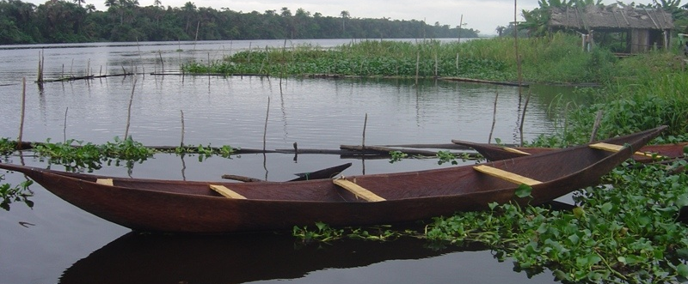

Plate 1: A newly carved dugout canoe at Emina water front in Lekki lagoon

The aft of the canoes terminated in a stern piece which served as a platform for standing during fishing gear operations and for sitting while paddling. The shape was narrow, low curvature with long water line length. The log was excavated from inside to form the canoe shape. Excavation was completed by burning out the interior, using dry grass as fuel. This was done to disinfect and preserve the fabric of the boat and to drive out insects and other parasites. During the burning, the wood tends to expand; then contraction on cooling was prevented by placing struts of wood across the canoe. The controlled burning with grass is to gives the canoe the characteristics black colour after carving. Paddles are made of wood, carved according to various patterns (pointed, rounded and blunted edges) and poles from bamboo or palm. Two types of paddles were observed in the lagoon (the arrow - like and the blunt end type). Plate 1 shows newly carved dugout canoe at Emina water front in Lekki lagoon.

Half-Dugout Canoes:
This is the combination of the dugout and the planked canoe features. The round bottom hull profile of the dugout canoe was built up with planks on each side to increase the size or cubic number of the canoe. The LOA of half dugout canoes ranged between 5.33 and 10.20m, the maximum breadth (moulded) ranged between 0.86 and 1.49m and the depth moulded ranged between 0.42 and 0.77m. The heavy hull reduced buoyancy of dug-out canoe was buffered by the addition of one or more planks made of soft wood like Opepe (Nauclea diderrichi), Mahogany (Khaya ivorensis) and black afara (Terminalia ivorensis), to both sides of the free board and deck line. The rigidity of the hull was maintained by more thwarts laid across the deck for transverse strength. The cubic number was relatively larger than dugout canoe and ranged between 1.93 and 11.70m³ and provided enough space to carry a lot more crew and large fishing gear such as the seine net operated at Igbodola, Iwopin and Imeki also for floating Island fishery at Ikeran Olatunji. Gunwale is another hull feature that impacts longitudinal strength and stiffness to the canoe. This was nailed to the top side of the freeboard deck line and runs from the fore to after on both side of canoe. It had a long water line with low degree of curvature. Trim was equal at both stem and sterm. The canoe was propelled with paddle (85%) and outboard engine (15%).

Planked Canoe:
The canoe had flat bottom hull completely built with planks fixed together with frames, u-shaped metal fasteners and nailing a strip of galvanized iron aluminum pluck caulking over the plank seams (joints). The longitudinal and transverse reinforcement was by gunwale and the thwarts ranged between 4 and 6. The frames also provide transverse strength. The canoe had a flat keel about 5 – 9cm wide for upright sit on the roller or on the sand when being hauled on beach. Reserved buoyancy in high, at load waterline, a freeboard draft ratio of 1:2 was recorded. The canoes had a long narrow beam and equal trim. About 10% of them were provided with transom for installation of outboard engine to propel the canoe. The outboard used ranged between 8 and 40Hp from Yamaha, Suzuki, Tohatsu and Marina brand. Plates 7.1– 7.4 show the various stages in planked canoe construction at Epe.
Most dugout canoes used in Lekki lagoon were carved at Saga village by the Ijaws while the planked canoes were constructed at Epe (Lagos State Government, Ministry of Agriculture Co-operative and Rural Development, United Nation Development Programme (UNDP), Support programme on Artisanal fisheries, fisheries development unit, Ebute Afuye, Epe Local Government), Iwopin and Ebute Lekki.
The most common canoe used in Lekki lagoon was planked canoe. The production of dugout canoes was restricted to Ijaw carvers at Saga village and was limited by the scarcity of timber which competed for some other uses like in furniture and building construction. Most canoes used in the lagoon were generally tied to the planked jetties and left in water throughout the year. The wood absorbed a lot of water infested with algae such as Spirogyra spp which added more to the weight which eventually reduce the speed of the canoe when propelled.

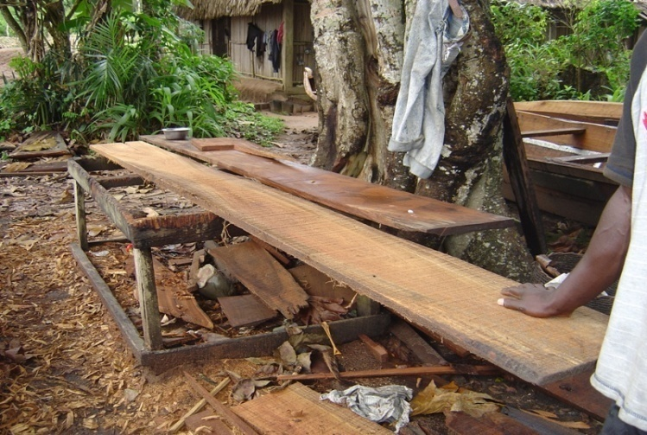
Plate 1.1: Planks placed on attender for framing before it is used in canoe construction at Epe.

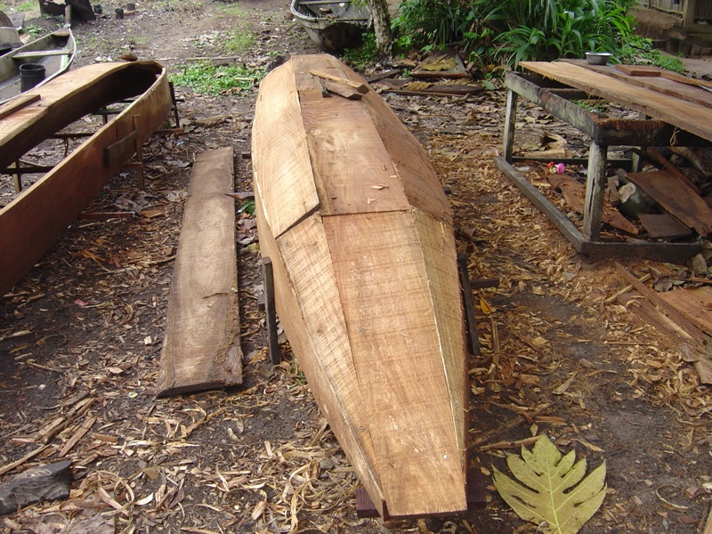
Plate 1.3: New constructed planked canoe at Epe (back hull)

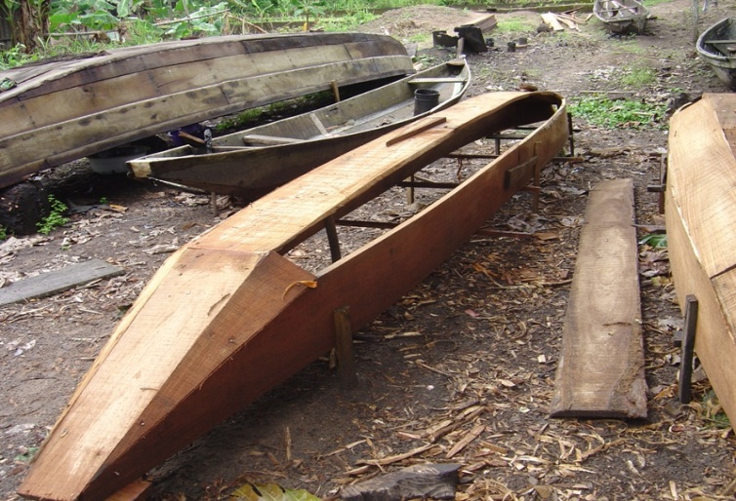
Plate 1.2: Planked canoe under construction at Epe.

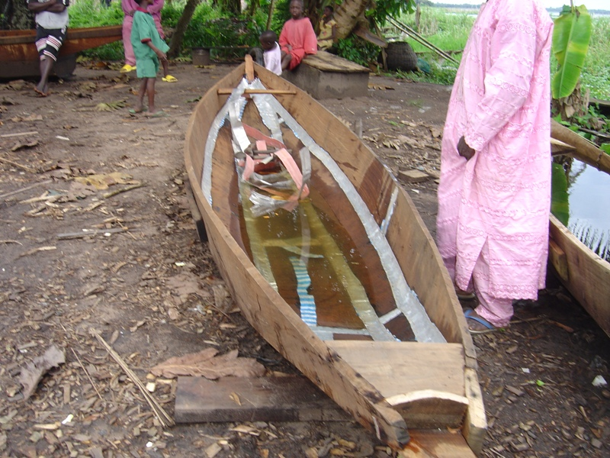
Plate 1.4: A newly constructed planked canoe with strips of galvanized iron aluminum

Fisheries frame survey of Lekki lagoon
The numerical compositions as well as the percentages of the canoes types between 2006 and 2007 are shown in Table 2. In 2006 there were 1027 wooden canoes made up of 24.29% dugout, 54.29% planked and 21.43% planked dugout canoes. In 2007 the canoes number was reduced drastically with a total number of 995 wooden canoes made up of 248 (24.93%) dugout, 558 (56.08%) planked canoes and 189 (18.99%) planked dugout canoes. The details of the canoe units recorded in the fishing villages within the lagoon between 2006 and 2008 are presented in Table 3. The percentage decrease in the number of canoe was 3.12% between 2006 and 2007.

Table 2: Types of fishing canoes in Lekki lagoon (Percentage in parenthesis)
Year | Wooden canoe types |  |  | Total
Year | Dugout | Planked | Planked dugout | Total
2006- 2007 | 249 (24.29) | 558 (54.29) | 220 (21.43) | 1027
2007- 2008 | 248 (24.93) | 558 (56.08) | 189 (18.99) | 995

Table 3: Fishing villages and the canoe units in Lekki lagoon between 2006 and 2008
Fishing village | Number of functional fishing canoes
Fishing village | March, 2006 – Feb. 2007 | March, 2007 – Feb. 2008
Emina | 43 | 43
Abomiti – nla | 34 | 33
Abomiti – Sokoto | 20 | 19
Ajegunle | 17 | 16
Ikeran Olatunji | 46 | 45
Take | 19 | 18
Luboye | 19 | 18
Abatitun | 29 | 28
Iwopin | 123 | 119
Siriwon | 39 | 38
Dopanu | 32 | 31
Dopanu-Ajegunle | 73 | 72
Idata | 21 | 20
Igbolomi | 42 | 42
Aba – oyinbo | 24 | 23
Ikeran –Aba Ilaje | 52 | 51
Origbe | 48 | 47
Oriyanrin | 46 | 45
Imeki | 45 | 44
Lakoye | 17 | 16
Ebute – Lekki | 51 | 50
Arala | 22 | 21
Igbodola | 25 | 24
Aba – Onigangan | 31 | 30
Ise | 109 | 105
Total | 1027 | 995

Fishing crafts preservation techniques
Most canoes used in the lagoon were generally tied to the planked jetties and left in water throughout the year. The wood absorbed a lot of water infested with algae such as Spirogyra spp which added more to the weight which eventually reduce the speed of the canoe when propelled. The attack of barnacles and annelid worm (Mercierella enigmatica) was not common in Lekki lagoon, it was only observed at Iwopin in only two canoes (planked) and one planked canoe at Ebute Lekki.
The canoe preservative used in the lagoon was by painting with bitumen, coating the back hull with cement and bitumen with ground pepper, although there has not been any scientific backing for the use of pepper against biofouling attack, the fisherfolks guaranteed its success. The pepper was used in ratio 1:2 to the bitumen, mixed thoroughly, rubbed on the outer canoe hull and dried under the sun for 3 to 5 days before use.

Discussion
In Lekki lagoon the most common canoe used was the planked canoe. The production of dugout canoes was restricted to Ijaw carvers at Saga village and was limited by the scarcity of timber which competed for some other uses like in furniture and building construction. This agreed with Solarin (1998) who reported that dugout canoes production was limited by the scarcity of timber which competed for some other uses like in furniture and building construction in Lagos lagoon.
Most canoes used in Lekki lagoon were generally tied to the jetties and left in water throughout the year. The wood absorbed a lot of water infested with algae such as Spirogyra spp. which added to the weight and reduce the speed of the canoes when propelled. The attack of barnacles was not common in the Lekki lagoon, it was observed at Iwopin in only two canoes (planked) and one planked canoe at Ebute-Lekki. The canoes were also left uncovered and water logged during the rainy season which could submerge or sink it. In most cases, if the storm were too much at any time, it may result in permanent loss of dugout canoes carved from Opepe (Nauclea diderrichi) due to its poor bouyancy. Exposure to the hot sun also results in cracks leading to water seepage. The preservative used for canoes in Lekki lagoon was by painting with bitumen, coating the back hull with cement and bitumen combined with grinded pepper. Although there has not been any scientific backing for the use of pepper in biofouling attack prevention, the fisherfolk have accepted its success.
Construction of more robust planked canoes is to compensate for the shortage of large dugout canoe to non-availability of big timber, to increase the deck working space and to improve their lagoon worthiness. The technological status and development prospects of small scale fishing crafts in Nigerian coastal water were documented by Ambrose et. al. (2001) which supported the observation in this study.
Canoe maintenance should focus on:
- The prevention or reduction of water absorption by the wooden structure.
- The prevention of rot, decay as well as the control of boring and fouling organisms.
- Protection against splits or cracks as reported by Solarin (1998) in Lagos lagoon.

Wooden canoes have had a wide acceptance by the fishermen and will continue even if a new material for construction is introduced. Planked canoe can be improved by increase in hull size and stiffness, water tightness of deck by appropriate coating, caulking and fastening.
Safety measures in canoes should include adequate provision of life jackets. In Lekki lagoon the use of light indicator bouy for night fishing operation is highly important because of the tugging and cargo boat movement to prevent life and net losses.

*Correspondence author:
Dr Emmanuel, Babatunde Eniola
Department of Marine Sciences
University of Lagos, Akoka, Lagos, Nigeria.
Cellular Phone: 234 – 802 – 853 – 945- 9
Email: monetemi@yahoo.com

References
[1] Ambrose EE, Udolisa REK, Solarin BB, Lebo PE. Technological status and development prospects of small scale fishing crafts in Nigerian Coastal Water. Proceedings of the 14th Annual Conference of the fisheries Society of Nigerian (FISON) held at Ibadan, 19th–23rd January 1998, 2001;140–145.
[2] Gulbrandsen O. Fishing boat design: 2: V– bottomboats. FAO Fish. Tech. Pap 1974;(134):22pp.
[3] Haug AF. Fishing boat designs 1: Flat bottom boats. FAO Fish. Tech Pap (117) Rev 1974;1:47pp.
[4] Udolisa REK, Solarin BB. Fishing trials of a 13 – metre (LOA) shallow draft vessel. NIOMR Technical Paper. 1985; No.24.
[5] Kwei EA. Recent developments in the canoe fisheries in Ghana. Journal of Science. 1961; 1(1&2): 29 – 35
[6] Udolisa REK, Solarin BB, Lebo P, Ambrose EE. A catalogue of small scale fishing gear in Nigeria. RAFR Publication RAFR/041/F1/94/02: 1994 ; 142pp.
[7] Solarin BB. The hydrobiology, fishes and fisheries of the Lagos lagoon, Nigeria. Ph.D Thesis. University of Lagos. 1998; 235pp.
[8] Nomura M, Yamazaki T. Fishing techniques. Compilation of SEAFDEC lectures. Japan International Co–operation Agency. 1975;206pp.
[9] Edmunds J. Seashells and other mollusks found on West African shores and estuaries. Ghana University Press, Accra. 1978; 146pp.

8/8/2009

