Biofertilizer Potential of Traditional and Panchagavya Amended with Seaweed Extract
Sangeetha, V and Thevanathan, R*

Post Graduate and Research Department of Botany, Presidency College,
Chennai-5, Tamil Nadu, India. sangeethadotv@gmail.com
*Centre for Advanced Study in Botany, University of Madras (Guindy campus),
Chennai-25, Tamil Nadu, India. thevanathan@gmail.com.

ABSTRACT: The potential of utilizing panchagavya as biofertilizer was tested on the pulses Vigna radiata, Vigna mungo, Arachis hypogea, Cyamopsis tetragonoloba, Lablab purpureus, Cicer arietinum and the cereal Oryza sativa var. ponni by growing in soil amended with dried traditional and seaweed based panchagavya. Experimental seedling recorded higher rates of linear growth of both shoots and roots as compared to controls. These seedlings produced 264 to 390% more lateral roots than the control and maximum lateral root production was always observed in seedlings grown in soil amended with seaweed based panchagavya at low concentrations (1:100; panchagavya: soil). A similar observation was made on the number of leaves produced, leaf area and the number of root nodules formed in the pulses by rhizobia. A marked decrease in Chlorophyll a/b ratio, C/N ratio in the plants grown in seaweed based panchagavya indicating high chlorophyll b levels and a better nitrogen use efficiency in these plants respectively. [The Journal of American Science. 2010;6(2):39-45]. (ISSN 1545-1003).

Key words: Panchagavya, Seaweed based, biofertilizer potential, pulses, cereal.

INTRODUCTION
The current global scenario firmly emphasizes the need to adopt eco-friendly agricultural practices for sustainable agriculture. Chemical agriculture has made an adverse impact on the health-care of not only soil but also the beneficial soil microbial communities and the plants cultivated in these soils. This eventually has lead to a high demand for organic produce by the present-day health conscious society and sporadic attempts are being made by farmers all over the world to detoxify the land by switching over to organic farming dispensing with chemical fertilizers, pesticides, fungicides and herbicides. In India, organic farming was a well developed and systematized agricultural practice during the past and this ‘ancient wisdom’ obtained through Indian knowledge systems such as ‘Vedas’ specify the use of ‘panchagavya’ in agriculture for the health of soil, plants and humans. In Sanskrit, panchagavya means the blend of five products obtained from cow, namely cow dung, cow urine, cow milk, curd and ghee (Sugha, 2005). The Vriskshayurveda systematizes the use of panchagavya. Few farmers in the southern parts of India have used modified formulations of panchagavya and found them to enhance the biological efficiency of the crop plants and the quality of fruits and vegetables (Natarjan, 2002). In the past three decades, crude extracts from seaweeds have been show to exhibit many bioactivities that include biostimulant, fertilizer and antimicrobial properties. Different forms of seaweed preparations such as LSF (Liquid Seaweed Fertilizer), SLF (Seaweed Liquid Fertilizer), LF (Liquid Fertilizer) and a manure prepared by using either whole or finely chopped seaweeds have been experimented and all of them have been reported to produce beneficial effects on cereals, pulses and flowering plants (Radley, 1961; Stephenson, 1974; 1981; Smith and van Staden, 1983; 1984; Tay et al., 1985; Temple and Bomelle, 1989; Sekar et al., 1995). In this paper, we present the results of an investigation made to evaluate the fertilizer potential of traditional and modified form of panchagavya amended with liquid seaweed preparations using some pulses and paddy as experimental plants.

MATERIAL AND METHODS
Traditional panchagavya
Traditional panchagavya was prepared following the procedures outlined by Pandurang Vaman Kane, 1941. It contained fresh cow dung - 0.5 kg; cow urine - 1.0 L; cow milk - 7.0 L; curd - 1.0 L; ghee - 1.0 L and water - 1.0 L. These ingredients were taken in a 25.0 L concrete pot, mixed well and allowed to stand in shade for 21 days with intermittent stirring. After 21 days, the preparation was allowed to dry for 180 days in shade and the dried panchagavya was mixed with sterilized garden soil at a ratio of 1: 100 (panchagavya : soil) and used.

Seaweed based Panchagavya
Seaweed based panchagavya is a modified preparation (Natarajan, 2002) containing the aqueous extract of the alga, Sargassum wightii. The preparation contained Cow dung - 5.0 Kg; cow urine - 3.0 L; cow milk - 2.0 L; cow curd - 2.0 L; cow ghee - 1.0 Kg; sugarcane juice - 3.0 L; tender coconut water - 3.0 L; banana - 12 nos; yeast powder -100 g; jaggery - 100 g; water - 2.0 L. The above composition gives approximately 20.0 L of panchagavya. Cow dung and cow ghee were mixed together in a 25.0 L concrete pot and kept for 3 days with intermittent stirring to exhaust methane gas. On the fourth day all the other ingredients were added to the cow dung - ghee mixture along with spores of Lactobacillus sporogenes (one SPOROLAC tablet having 60 million spores / tablet) and mixed thoroughly. The mouth of the container was covered with a thin cloth and kept in the open in shade. This mixture was stirred twice everyday and after 18 days, 5.0 g of the algal extract residue was added to the preparation and used in experiments. Algal extract residue was prepared by extracting 100.0 g of shade dried Sargassum wightii with 5.0 L of boiling water for 30 minutes. The extract was allowed to cool, filtered through a layer of muslin cloth and dried in vacuo and the dry residue was used.

Assay of panchagavya preparations on the germination and development of seedlings of pulses and rice
The effect of panchagavya preparation on germination and development of rice Oryza sativa var. ponni and the pulses, Vigna radiata, Vigna mungo, Arachis hypogaea, Cyamopsis tetragonoloba, Lablab purpureus, Cicer arietinum seedlings were studied. The growth medium was a mixture of dry panchagavya residue and soil at a ratio of 1: 100 (traditional), 1: 50 (seaweed based) and 1: 100 (seaweed based) v/v. Seeds were surface sterilized with 1.0% mercuric chloride, washed several times in running water, soaked overnight in sterile water and allowed to germinate in dark. Germinating seeds were implanted in soil preparations kept in pots of the size 5.2” tall and 3.5” radius. Seedlings raised in sterilized garden soil were used as control. Ten replicates were used for all experimental plants. The seedlings of pulses were inoculated with Rhizobium R₄ (approximately 1x10⁹ cells/mL of sterile nutrient solution) twice, i.e. on the 5th day and then on the 11th day in both control and test pots (except for Oryza sativa var. ponni). All the developing seedlings except Oryza sativa were watered on alternate days with Wilson’s N-free nutrient solution. For Oryza sativa, normal water was used. Twenty one days old seedlings were carefully removed and their linear growth, the number of leaflets produced, leaf area, number of lateral roots formed, number of root nodules, and other biochemical parameters as detailed below were determined.
Rhizobium (R₄) was used in the inoculation of plants were grown on YMA (Yeast Mannitol Agar) medium as specified by J.M. Vincent with slight modifications (Thevanathan, 1980). Purity of the organism was checked frequently using 0.05% Congo Red YMA medium. Wilson’s nitrogen-free nutrient solution (Wilson and Reisenauer, 1963) was used in the preparation of the inoculum as well as for watering the developing seedlings. An effective 72 hours old strain of Rhizobium R₄ strain was used for inoculating the seedlings. The seedlings were inoculated twice, first on the 5th day after germination followed by a second inoculation on the 11th day. Ten milliliters of a thick suspension of the inoculum (approximately 1x10⁹ cells/mL of sterile nutrient solution) was pipetted out around the base of each seedling. During the first few days after inoculation, care was taken in watering the plants so as to avoid washing the inoculum out of the soil. Wilson’s nitrogen-free nutrient solution was used to water the developing seedlings on alternate days.

Estimation of photosynthetic pigments
Pigments from leaves of the developing seedlings were extracted with 80% acetone and the amounts of chlorophyll_{a} and chlorophyll_{b} were determined as described by Arnon (1949) and Yoshida et al.(1976).
Chlorophyll_{a} = 12.21 A₆₆₃ – 2.81 A₆₄₆ mg/g tissue
Chlorophyll_{b} = 20.13 A₆₄₆ – 5.03 A₆₆₃ mg/g tissue
Where, A₆₆₃ and A₆₄₆ represent the optical density (OD) values at the respective wavelengths.
Estimation of nitrogen and carbon
At different stages of development, whole plants were carefully removed from sand, cleaned and dried. Shoot, root and nodules formed in pulses were dried separately in an oven at 90ºC, until the weights remained constant. Then the dry weights of these parts were determined. The dried plant material was ground in a glass mortar with glass pestle and the nitrogen content was determined by modified micro-Kjeldahl method (Nesslerisation) (Umbreit et al., 1972). Carbon content was calculated from total dry matter yield of the seedlings (Kvet et al., 1971; Terry and Mortimer, 1972; Turgeon and Webb, 1975; Causton and Venus, 1981).

RESULTS
The potential of utilizing panchagavya as biofertilizer was tested on the pulses Vigna radiata, Vigna mungo, Arachis hypogea, Cyamopsis tetragonoloba, Lablab purpureus, Cicer arietinum and the cereal Oryza sativa var. ponni by growing in soil amended with dried traditional and seaweed based panchagavya. Traditional panchagavya was used at a proportion of 1: 100 (panchagavya: soil) while seaweed based panchagavya was tried at 1: 50 and 1: 100 dilutions with soil. After 21 days, the seedlings were harvested and studied for their growth and development.

Effect on the linear growth of experimental seedlings:
Effect on shoot and root growth
Soil amended with seaweed based panchagavya increased the linear growth of both shoot and root systems in all the pulses and rice as compared to respective controls (Figures 1 & 2). Enhancement in the growth of root and shoot systems in the experimental plants was more pronounced in seedlings grown in soil amended with seaweed based panchagavya rather than with traditional panchagavya. At a ratio of 1: 100 (panchagavya: soil), shoots of the rice seedlings grown in seaweed based panchagavya exhibited nearly 100 % more growth than that of the control plants. In pulses, the percent increase in the linear growth of shoots over control plants in Vigna radiata, Vigna mungo and Cicer arietinum was relatively low in the range of only 16 – 20% as compared to other experimental plants, in which it was 64 – 98%. Even in seedlings grown in traditional panchagavya, the shoots of the treated plants exhibited 3 – 50% more growth than the controls. Linear growth of root in the experimental plants too exhibited a similar response to treatment with panchagavya (Figure 2). In seaweed based panchagavya treatment, a two fold increase in the linear growth of root could be observed in Vigna radiata, Vigna mungo and Oryza sativa as compared to controls. Roots of other experimental plants responded to the same treatment with an increase in growth ranging from 37 to 89%. Increasing the concentration of panchagavya (1: 50 dilution) decreased the effect on linear growth of both shoots and roots of the experimental plants. Nevertheless, the effect of seaweed based panchagavya was more than that observed for treatment with traditional panchagavya.

Effect on lateral root growth
As observed for the linear growth of shoots and roots, the number of lateral roots formed also was more in the seedlings raised in soils amended with both traditional and seaweed based panchagavya (Figure 3). However, use of the latter produced more lateral roots than the former in all the cases. Effect on lateral root formation was more pronounced in Arachis hypogea as compared to other experimental plants. Seedlings grown in soil amended with panchagavya produced 264 to 390% more lateral roots than the control and maximum lateral root production was always observed in seedlings grown in soil amended with seaweed based panchagavya (1:100; panchagavya: soil). Treatment with seaweed based panchagavya was higher than that observed for both control and traditional panchagavya.

Effect on leaf development and growth
Plants grown in soil amended with panchagavya produced more leaflets ( in pulses) or leaves (in Oryza sativa) than their respective controls (Figure 4) and the effect was more pronounced in seedlings grown in soil amended with low levels of seaweed based panchagavya (1: 100, panchagavya : soil ). In Cyamopsis tetragonoloba, Lablab purpureus and Oryza sativa, the number of leaflets formed in seedlings grown in seaweed based panchagavya at 1: 100 dilution was observed to be twice of that recorded for their respective controls. Arachis hypogea, Cicer arietinum and Oryza sativa also exhibited positive response to the treatments with both traditional and seaweed based panchagavya while Vigna radiata showed poor response. Seedlings grown in soil amended with traditional panchagavya produced less number of leaves per plant than those grown in seaweed based panchagavya. In all the plants, increasing the levels of seaweed based panchagavya in soil resulted in decreased production of leaves (Figure 4). Apart from the large number of leaf or leaflet production, the leaf area or the lamina of the leaves in plants grown in soil amended with panchagavya was always larger than those of the control plants (Figure 5).
The growth of leaves in all the experimental plants was high when grown in seaweed based panchagavya. In Lablab purpureus, the lamina size was nearly 27% larger with seaweed based panchagavya as compared to those grown in soil amended with traditional panchagavya (Figure 5). As compared to control, these seedlings produced leaves which had 93% more surface area than that of their respective controls. Percent increase over control in the leaf area of the seedlings of Vigna radiata, Vigna mungo, Arachis hypogea, Cyamopsis tetragonoloba and Cicer arietinum grown in soil amended with seaweed based panchagavya at a ratio of 1: 100 was 27%, 35%, 46%, 140% and 37% respectively. In Oryza sativa, the percent increase in leaf area in response to the same treatment (1: 100 panchagavya: soil) was 96%.

Effect on photosynthetic pigments
Panchagavya amended soil had a profound effect on the quantities of chlorophylls too in leaves of the experimental plants (Figure 6). A low chlorophyll a/b ratio as compared to the control was recorded in the leaves of all the plants grown in panchagavya soil preparations. Seaweed based panchagavya was more effective than the traditional panchagavya irrespective of the dilutions tried. The ratio decreased with a decrease in the levels of seaweed based panchagavya in soil. In other words, low levels of the panchagavya in soil effectively decreased chlorophyll a/b ratio without decreasing the levels of the individual pigments. The treatment increased the quantities of chlorophyll b in the leaves of the experimental plants resulting in a low chlorophyll a/b ratio.

Effect on nodule formation
Since all the experimental plants except rice were legumes, the effect of panchagavya on root nodule formation was also studied in these legumes.
Root nodule formation was also enhanced in the presence of panchagavya. Again, the effect was marked in the seedlings grown in soil amended with low levels of seaweed based panchagavya (panchagavya: soil; 1: 100). The effect was maximum in Arachis hypogea and minimum in Cyamopsis tetragonoloba. Even traditional panchagavya treatment could cause an increase from 18% to 62% in the formation of root nodules (Figure 7).

Effect on C/N ratio
The seedlings raised in soil amended with panchagavya registered a low C/N ratio as compared to their respective controls (Figure 8). Percent reduction in the C/N ratio of seedlings grown in panchagavya amended soils was in the range of 1 – 22%. The C/N ratio of Arachis hypogea grown in seaweed based panchagavya preparation was 22% less than that of its control. Oryza sativa recorded a value that was 16% less than that of the control seedlings (Figure 8). Lowest values for C/N ratio in the experimental plants were recorded in seedlings grown in soil amended with low levels of seaweed based panchagavya (1: 100; panchagavya: soil). Even at a concentration of 1: 50 (Panchagavya: soil), the seaweed based preparation was able to reduce the C/N ratio by about 3 to 17% than the controls.

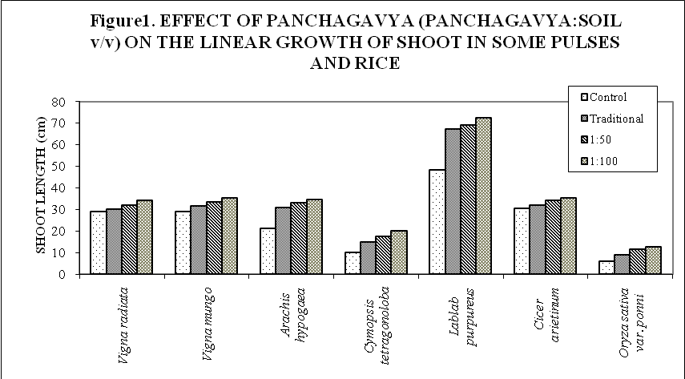

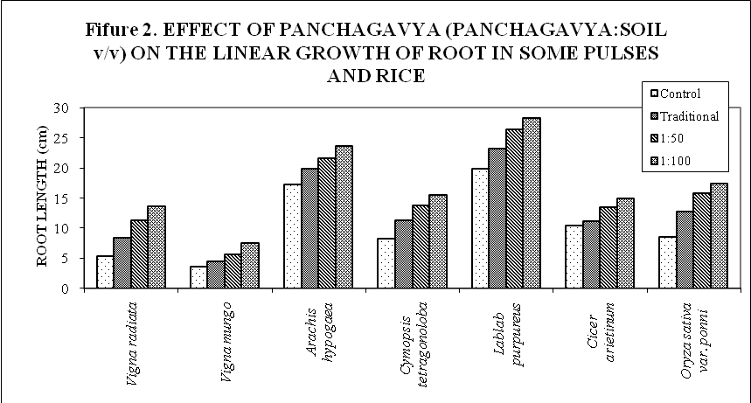

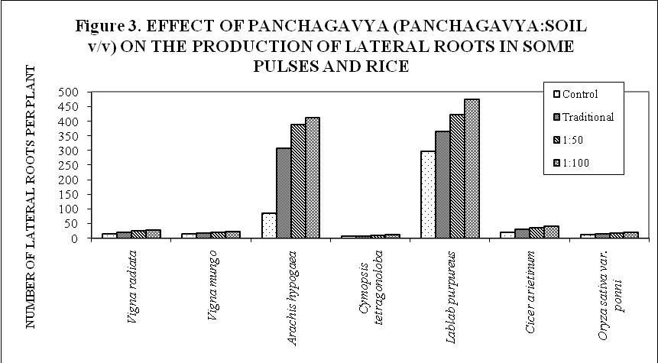
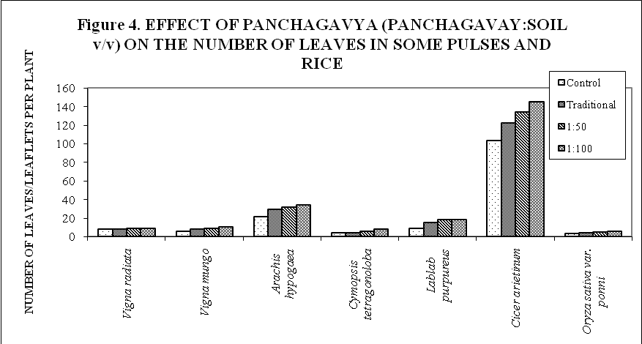
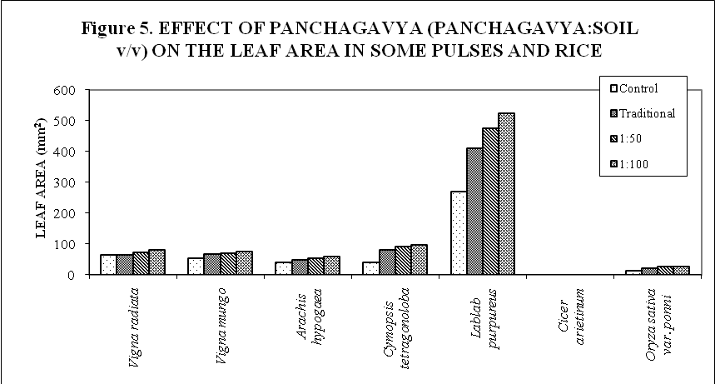
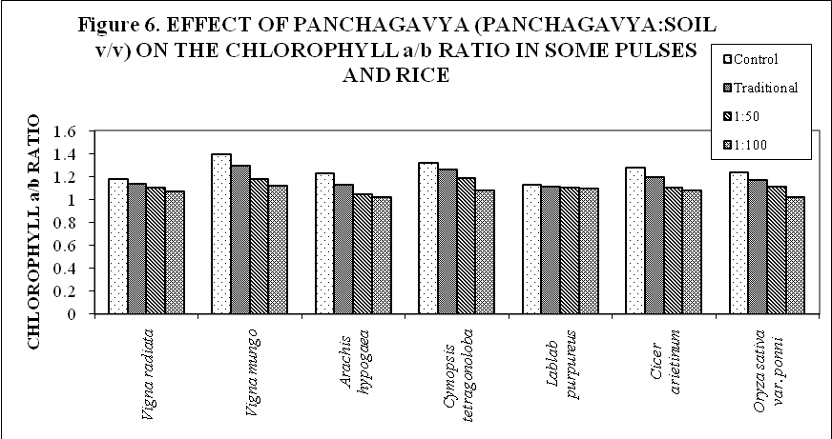
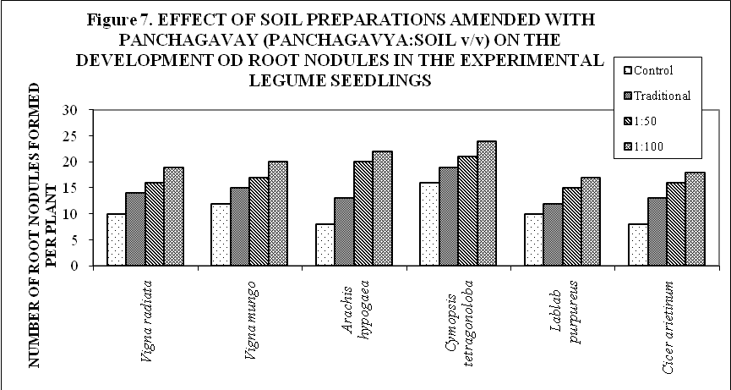
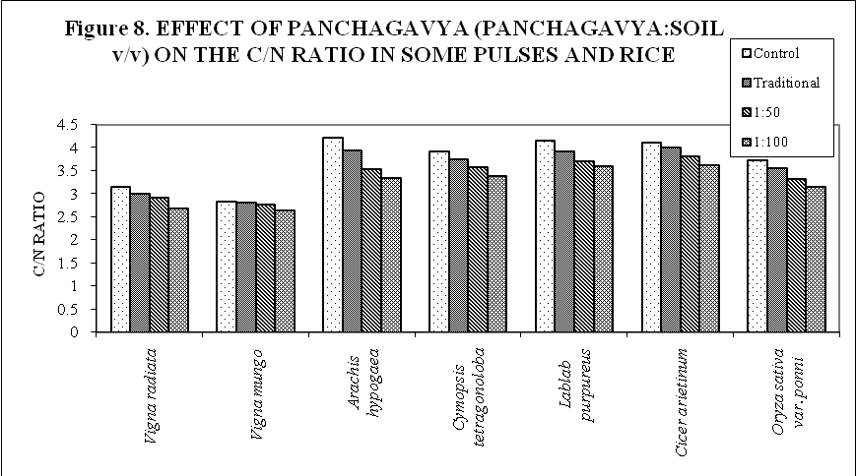
DISCUSSION
The biofertilizer potential of panchagavya prepared in the traditional way and a modified preparation amended with seaweed extract have been evaluated for their fertilizer potential using the pulses Vigna radiata, Vigna mungo, Arachis hypogea, Cyamopsis tetragonoloba, Lablab purpureus, Cicer arietinum and the cereal Oryza sativa var. ponni as the experimental plants. Some farmers in the southern parts of India use a modified panchagavya that contains many other plant products to boost fermentation and to support the growth of beneficial microorganisms. In the past three or four decades, the potential of seaweeds and their liquid extracts in agriculture as a biofertilizer and a source of growth promoters have been indicated by many (Bentley, 1960; Bhosle et al., 1975; Williams et al., 1981; Jeanin et al., 1991; Immanuel and Subramaniam, 1999; Thevanathan et al., 2005). These reports formed the basis for a new formulation of panchagavya with the inclusion of an aqueous extract of the brown alga, Sargassum wightii and assess for its biofertilizer potential in the present investigation.
Panchagavya is normally advocated as foliar nutrition (Caraka-Samhita, 1981; Susruta Samhita, 1985; Chauhan, 2002 b; 2004 b; 2005; Fulzele et al., 2001; Joshi, 2002; Garg and Chauhan, 2003 a; Saxena et al., 2004) and has not been tried as manure. Nevertheless dried and powdered seaweeds have been shown to be a good source of manure when mixed with soil in small quantities for the cultivation of vegetable crops and tea. In the present investigation dried traditional panchagavya and seaweed based panchagavya were tested as manure. Dried panchagavya (both traditional and seaweed based) when mixed with soil at a ratio of 1:100 (panchagavya: soil v/v) and used as a growth medium promoted the linear growth of both the shoot and roots of the seedlings of both the pulses and the cereal, the paddy (Figures 1 and 2).The effect was pronounced in soils amended with seaweed based panchagavya even at 1:50 (v/v) dilution. The effect on all experimental plants except Lablab purpureus was moderate in the sense that the linear growth did not mimic etiolation. Similarly, soils amended with panchagavya (both traditional and seaweed based) promoted the production of lateral roots, leaves, leaflets and the growth of lamina in all the experimental plants (Figures 3, 4 and 5). As compared to control, the seedlings produced leaves which had 93% more surface area than that of their respective controls. Percent increase over control in the leaf area of the seedlings of Vigna radiata, Vigna mungo, Arachis hypogea, Cyamopsis tetragonoloba and Cicer arietinum grown in soil amended with seaweed based panchagavya at a ratio of 1: 100 (v/v) was 27%, 35%, 46%, 140% and 37% respectively. Increased production of lateral roots would provide more surface area for absorption of water and minerals by the experimental seedlings than their controls. Similarly, large number of leaves or leaflets with greater surface area could be construed as an indication of enhanced photosynthetic efficiency in plants grown in soil amended with panchagavya. This is further confirmed by the marked decrease in the ratio of chlorophyll a to chlorophyll b (Figure 6) in leaves of the plants grown in soil amended with both traditional and seaweed based panchagavya. The C/N ratio also was very low in these plants as compared to controls (Figure 8). A low C/N ratio is normally indicative of a better carbon and nitrogen use efficiency than plants with high C/N ratio. Since all the experimental plants except rice were legumes, the effect of panchagavya on root nodule formation by rhizobia was also studied in these legumes. Panchagavya promoted the formation of root nodules by the inoculated rhizobia (Rhizobium, R4) in the experimental plants (Figure 7). The effect was marked in the seedlings grown in soil amended with low levels of seaweed based panchagavya (panchagavya: soil; 1: 100). The effect was more pronounced in Arachis hypogea. Even the use of traditional panchagavya as manure was able to increase nodule formation by nearly 18% to 62% (Figure 7). Though panchagavya has been claimed to have antibacterial activities (Subramaniam, 2005; Sugha, 2005), use of panchagavya as manure in the present investigation was found to promote both the survival ability and nodulating efficiency of the inoculated strain of Rhizobium (Figure 7). High levels of trace elements and adequate amounts of potassium and nitrogen have been shown to be present in seaweeds (Smith and van Staden, 1983, 1984; Tay et al., 1985; Temple and Bomelle, 1989; Sekar et al., 1995). But for the low levels of phosphate, seaweed meal has been shown in this lab to be an alternative to farm yard manure in raising cereals, pulses and nodal cuttings of tea (Thevanathan et al., 2005). This could be the reason for the enhanced effect of seaweed based panchagavya over traditional panchagavya in promoting the growth and development of experimental pulses and cereals.

CONCLUSION
The biofertilizer potential of traditional and a modified panchagavya containing liquid seaweed preparation of Sargassum wightii were investigated.
Soil amended with panchagavya at a concentration of 1: 100 (panchagavya: soil v/v) increased the linear growth of both shoot and root systems of the seedlings of the pulses Vigna radiata, Vigna mungo, Arachis hypogea, Cyamopsis tetragonoloba, Lablab purpureus, Cicer arietinum and the cereal Oryza sativa var. ponni. Increase in linear growth of the shoots and roots was associated with a concomitant increase in the number of lateral roots produced, the number of leaves or leaflets produced, increase in leaf area, nodule formation by Rhizobium and a decrease in the chlorophyll a/b and C/N ratio. The effect was further enhanced when seaweed based panchagavya was used as manure at the same concentration.

CORRESPONDING AUTHOR
Thevanathan, R.
Centre for Advanced Study in Botany,
University of Madras (Guindy campus),
Chennai-25, Tamil Nadu, India.
thevanathan@gmail.com.

REFERENCES
Arnon, D. I. 1949 Copper enzymes in isolated chloroplast polyphenol oxidase in Beta vulgaris. Pl. Physiol. 24: 1 – 15.
Bently, J. A. 1960 Plant hormones in marine phytoplankton, zooplankton and seaweeds. J. Mar. Biol. Ass. UK 39: 433 – 444.
Bhosle, N. B., Untawale, A. G. and Dhargalkar, V. K. 1975 Effect of seaweed extract on the growth of Phaseolus vulgaris L. Ind J Mar Sci 4:208–210.
Caraka-Samhita 1981 Editor-Translator P. Sharma, Chaukhambha Orientalia, Varanasi, India, 1: 213.
Causton, D. R. and Venus, J. C. 1981 The Biometry of Plant growth. Edward Arnold (publishers) Ltd., London.
Chauhan, R. S. 2002 b Medical importance of panchagavya (Cow therapy). In: National Symposium on Historical Overview on Veterinary Sciences and Animal Husbandry in Ancient India, Vedic and Ashokan Period. IVRI, Izatnagar, April 16 – 17.
Chauhan, R. S. 2004 b Panchagavya therapy (Cowpathy): Current status and future directions. The Indian Cow 1: 3 – 7.
Chauhan, R. S. 2005 Cowpathy: A new version of Ancient Science. Employment News 30: 9 – 15.
Fulzele, S. V., Satturwar, P. M. and Dorle, A. K. 2001 Immunostimulant activity of cow’s ghee. Journal of Immunology and Immunopathology 3: 87 – 88.
Garg, N. and Chauhan, R. S. 2003 a Cow therapy as an alternative to antibiotics. Indian Science Congress, 3 – 7 January, 2003, Bangalore.
Immanuel, R. and Subramaniam, S. K. 1999 Effect of fresh extracts and seaweed liquid fertilizer on some cereals and millets. Seaweed Res. Utiln 21: 91 – 94.
Jeanin, I., Lessure, J.C. and Marot Gaundry, J. F. 1991 The effect of aqueous seaweed sprays on the growth of maize. Bot. Mar. 34: 469 – 473.
Joshi, M. M. 2002 Cow therapy (Panchagavya) and cattle based economy. Inaugural speech in Vishva Ayurvedas Sammelan on 7.9.2002. IIT, New Delhi.
Kvet, J., Ondok, J.P., Necas, J. and Jarvis, P.G. 1971 Methods of growth analysis. In: Plant Photosynthetic Production – Manual of Methods. Ed. by Z. Sestak, J. Catsky and P.G. Jarvis. W. Junk N.V. Publishers, The Hague, p 343 – 391.
Natarajan, K. 2002 Panchagavya – A manual. Other India Press, Mapusa, Goa, India, pp: 33.
Pandurang Vaman Kane, 1941 Bhojana – Sacredness of cow. History of Dharmasastra (ancient and medival religious and civil law) 2: 773 – 774.
Radley, M. 1961 Gibberellin like substance in plants. Nature London 191: 684 – 685.
Saxena, S., Garg, V and Chauhan, R. S. 2004 Cow Urine Therapy: Promising cure for human ailments. The Indian Cow 1: 25 – 30.
Sekar, R., Thangaraju, N. and Rengasamy, R. 1995 Effect of seaweed liquid fertilizer from Ulva lactuca L. on Vigna ungiculata L. (Walp). Phykos 34: 49 – 53.
Smith, F. B. C. and van Staden, J. 1983 The effect of seaweed concentration and fertilizer on the growth of Beta vulgaris. A.pflanzenphysiol 112: 115 – 162.
Smith, F. B. C. and van Staden, J. 1984 The effect of seaweed concentration and fertilizer on the growth of endogenous cytokinin content of Phaeolus vulgaris. South African Journal of Botany 3: 375 – 379.
Stephenson, W. A. 1974 Seaweed in agriculture and horticulture. 3rd Edn. Rateaver. Peruma valley. California. pp 241.
Stephenson, W. A. 1981 The effect of seaweed extract in the yield of variety of field and glass house crops. Abstracts: 8th International Seaweed Symposium, p 740 – 744.
Subramaniam, A. 2005 Effect of panchagavya on Escherichia coli in procured milk. Indian Veterinary Journal 82: 799 – 800.
Sugha, S. K. 2005 Antifungal potential of panchagavya. Plant Disease Research Ludhiana 20: 156 – 158.
Sustra Samhita – The Medical Science of the Ancient Aryans’, Tr. and Ed. A. C. Bandopadhyaya, 2nd ed. Calcutta. 1885.
Tay, S. A. B., Mac Leod, J. K., Palni, L.M.S. and Lethan, D. S. 1985 Detection of cytokinin in a seaweed extract. Phytochemistry 24: 2611 – 2614.
Temple, W. D. and Bomelle, A. A. 1989 Effect of Kelp (Macrocystis integrifolia and Ecklonia maxima) foliar applications on bean crop growth. Plant and Soil 117: 85 – 92.
Terry, N. and Mortimer, D. C. 1972 Estimation of the rates of mass carbon transfer by leaves of sugar beet. Can. J. Bot. 50: 1049 – 1054.
Thevanathan, R. 1980 Assimilation of fixed nitrogen and asparagine synthesis in nodules of cluster bean (Cyamopsis tetragonoloba Taub.). Doctoral Thesis, University of Madras.
Thevanathan, R., Dutta, A., Dinamani, D. S. and Bhavani, I.L.G. 2005 Effect of liquid fertilizer of some seaweeds on nodulation by rhizobia in some legume seedlings. Seaweed Res. Utiln 27: 81 – 85.
Turgeon, R. and Webb, J. A. 1975 Leaf development and phloem transport in Cucurbita pepo: carbon economy. Planta 123: 53 – 62.
Umbreit, W. W., Burris, R. H. and Stauffer, J. F. 1972 Manometric and biochemical Techniques (Fifth edition) pp 259 – 260. Burgess Publishing Company, Minnesota
Williams, D. C., Brain, K. R., Blunden, G., Wildgoose, P. B. and Jeoers, K. 1981 Plant growth regulatory substances in commercial seaweed extracts. In: Proc. 8th Int. Seaweed Symposium, Bangkok.
Yoshida, S. D., Farno, A., Cock, J. H. and Gomez, K. A. 1976 Laboratory manual for physiological studies of rice (Third edition) IRRI. LosBanos. Philippines.

8/8/2009

