Exploration Potentiality Test of some Electrical Geophysical Equipment

Makinde, V.^{1*}, Bello, A.M.A. ², Coker, J.O.³

Department of Physics, University of Agriculture, Abeokuta, Nigeria.

Department of Physics, Kwara State Polytechnic, Ilorin.

Department of Physics, Lagos State Polytechnic, Ikorodu, Lagos.
victor_makindeii@yahoo.com, belloabdulmajeedfa@gmail.com, cokerclara@yahoo.com

Abstract: Errors that emerge as either of under/over estimation of depth of investigation in electrical resistivity surveys may not necessarily be wholly due to data processing implementation structure or field measurement procedure A VES exploration procedure aimed at determining the exploration potentiality of a newly acquired resistivity equipment marked here as T, was carried out using the equipment, an older well tested version of terrameter equipment, and an adaptive generator-powered assemblage at the same location within a survey site whose geophysical and hydrogeologic parameters were well known. The result obtained at each VES for each of the equipment was compared with the known information for the site obtained from the borehole log of a functional borehole located at the site. The then newly acquired terrameter was found to consistently underestimated layer thicknesses and depth to basement in comparison with other equipment. [Journal of American Science 2010;6(2):54-57]. (ISSN: 1545-1003)

Key words: vertical electrical sounding (VES), exploration potentiality, equipment

1. Introduction
Sources of error in geophysical prospecting are most often than not associated to inaccuracies in taking field measurements or improper handling of equipment. Often times, inherent errors in instruments are seldom considered due to the mentality that anything made from across the seas, which are very neatly and attractively packaged, especially from highly technologically sophisticated societies, are perfect. Although most of the time, equipment manufactured there are to high precision, yet often times, equipment sent out, most especially as donations to developing countries, are only refurbished and are therefore prone to having system errors.
A terrameter T, was investigated to determine its level of accuracy and suitability for taking field readings. The interpreted result of its data was compared with similar result obtained with an arrangement of an electricity generator, a digital voltmeter, a digital ammeter set from a digital multimeter PM 2522, connecting wires, and four copper electrodes. This was also compared with the borehole log value obtained from a productive borehole drilled by Messrs Preussag at the Jamm’a village in the Kubanni river basin. The test site for the terrameter and the alternative arrangement is the site of the mentioned productive borehole. In both sets of instruments, the normal Schlumberger array was used.

2. Field Test Area
The field test area is the location of a productive borehole drilled in the Jama’a village in the Kubanni River Basin. The basin was chosen on the ground that a lot of work had been undertaken within the basin by numerous researchers. There is therefore an abundance of geologic and geoelectric information on the basin. The basin occupies the centre of the South-Eastern sector of the Zaria sheet (No 102 S.W.) of the 1:50,000 sheet ordinances series of the Nigeria ordinances survey maps. It is approximately bounded by latitudes 11⁰4’25” N and 11⁰10’45” N; and longitudes 7⁰36’56” E and 7⁰44’22” E (Shemang, 1990). The basin has an average area of about 150 km² (Egbeifo, 1978). It lies on a plateau with a height of about 570 m above sea level, and has a dendritic drainage pattern. The basin is elongated in the NW-SE direction (fig. 1), being the direction of dominant faulting and jointing in the basement complex of Nigeria (McCurry, 1970).
Akpoborie (1972) suggested that the presence of joints and fractures predominantly control the flow of underground water in the basin. Ososami (1968) found that the depth to bedrock in the basin vary in thickness from less than 1 m, to about 30 m. Egbeifo (1978) established that the depth to water table at various locations within the basin ranges between 3 m and 10 m. Olugbemiro (1985) estimated the depth to basement around Jama’a Kubanni village in the basin to be about 36 m. This was corroborated by the borehole drilling work done by Messrs Preussag Nigeria Limited in 1985. Recent geophysical work in the basement include that of Bajeh (1992), who conducted a ground magnetic survey of the basin, and estimated the depth to basement to be between 0 m and 50 m. Makinde (1996), using the Schlumberger array and a variant of the two-electrode method, established the depth to basement within the basin to be between 1.3 m and 50 m.

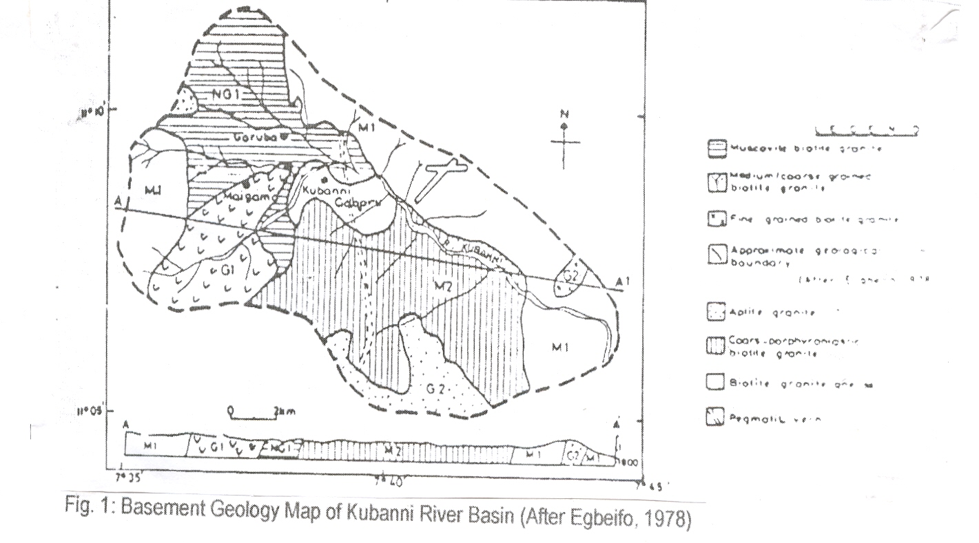

3. Field Investigation
Vertical Electrical Sounding (VES) is a geophysical method used for depth profiling and exploration. The parameter of interest is the variation of resistivity, ρ with depth, which by implication enunciates the variation of conductivity, σ with depth. The underground is made up of layers of apparently inhomogeneous media. Earth electrical resistivity profiling instruments normally measure the apparent resistivity, ρ_{a} of the earth media. The apparent resistivity has a direct bearing on the conductivity of the fluid contained in the pores of the layers of earth in the area under investigation.
In conducting the field investigation, use was made of a terrameter T — the instrument whose performance was in doubt, an older version of terrameter, and an alternative VES instrument package consisting of an electricity generator, a digital voltmeter, a digital ammeter set from a digital multimeter PM 2522, connecting wires, and four copper electrodes. These sets, which had proved to produce accurate results were used to give the standard set of readings against which the readings from the terrameter was compared in order to be able to detect the level of inaccuracy in the terrameter. The Schlumberger array was employed in carrying out the investigation using the three sets of equipment. In using the alternative VES instrument package, two of the copper electrodes were set as current electrodes, while the other two served as the potential electrodes.

Electric current I, measured with the digital ammeter, was driven into the earth through the current electrodes, while the potential developed in the earth due to the interaction between the current and the earth structure was fed into the digital voltmeter through the potential electrodes.
In carrying out the field investigation using the normal Schlumberger array, for each combination of potential electrode spacing MN, and current electrode spacing AB, which gave a measurable value of the potential developed, a configuration K- factor was calculated. This was used alongside the measured value of I and V to obtain the resistance, R and subsequently the apparent resistivity ρ_{a} for that field observation. The terrameter reading gives the direct value of R. The applicable general field equation in all the cases is given as:
$ρ_{a} = \text{KR}$ ………………… (1)
where R = ^{V}/_{I}.

According to Mares (1984), the configuration factor, K can be calculated using

$K = π \left[\frac{{\text{AB}}^{2}}{\text{MN}} − \frac{\text{MN}}{4}\right]$ .……...…… (2)

The computed apparent resistivity was then plotted against ½ AB on a bi-logarithmic scale.

4. Results
Figure 2 shows the VES 1 plot obtained over the selected location using the terrameter T; fig. 3 the VES 2 plot obtained over the same location using the older version of terrameter; fig. 4 shows the VES 3 plot obtained over the location using the assembled VES equipment; and fig. 5 shows the borehole log (BHL) for the productive borehole at the selected location in the Jama’a Kubanni village.
An interpretation of the VES curves shows the following:

Layer | Borehole log BHL Thickness (m) | VES 1 |  | ≈ % Error wrt BHL | VES 2 |  | ≈ % Error wrt BHL | VES 3 |  | ≈ % Error wrt BHL
Layer | Borehole log BHL Thickness (m) | ρ (Ωm) | h (m) |  | ρ (Ωm) | h (m) |  | ρ (Ωm) | h (m)
1. | 9.0 | 116 | 7.4 | 17.78 | 72 | 8.8 | 2.22 | 71 | 8.4 | 6.67
2. | 18.0 | 69 | 13.8 | 23.33 | 26 | 17.5 | 2.78 | 28 | 17.3 | 3.89
3. | 36.0 | 617 | 31.5 | 12.50 | 191 | 36.0 | 0.00 | 204 | 36.1 | 0.28
4. | ∞ | 988 | ∞ |  | 1827 | ∞ |  | 1944 | ∞

The above represents the average values obtained using the terrameter T, the older version of terrameter, and the assembled VES equipment.

The thickness shown is the total depth from the earth surface to the base of the identified layer.

Fig. 2: VES Curve for the Terrameter, T

Fig. 3: VES Curve for the Older Terrameter

Fig. 4: VES Curve for the Assembled Equipment

5. Conclusion
From the interpreted result obtained, and shown in the table, it is evident that there is gross error in the result obtained using the terrameter T. The terrameter T was observed to have contributed errors ranging from 12.5 % to 23.33 % into the layer thickness of the earth media under investigation. Result obtained over VES 2 and VES 3 show that the older version of terrameter and the assembled VES equipment used gave almost the same result as what was given by the borehole log obtained over the Jama’a village borehole drilled by Messrs Preusag Nig. Ltd. and hence are dependable. The resuls of VES 2 and 3 are in line with similar results obtained over the same site by previous workers such as Ajyi and Hassan (1990), Shemang et al. (1992), and Bajeh (1992).

Topsoil: Clayey and Silty, Brownish (lateritic)
Weathered Basement. Sand: fine to medium clayey with quartz and feldspar
Sand, fine partly silty, greyish
Fresh basement rock
9.0 m
0 m
18.0 m
36.0 m
++ + + + + + + ++ + + + + + + ++ + + + + + + ++ + + + + + + ++ + + + + + + ++ + + + + + + + + + + + +
Fig. 5: Geological Well-log obtained by Preussag Nig. Ltd. at Jama'a Kubanni (After Olugbemiro, 1985)

This therefore suggests that for any newly introduced equipment, it is necessary to conduct equipment test over a site on which there is adequate geophysical information, and against information collected using already tested and trusted equipment.

Correspondence to:
Victor Makinde
P.O.Box 94, UNAAB Post Office,
Alabata, Abeokuta.
e-mail: victor_makindeii@yahoo.com

References
[1] Ajayi, C.O. and Hassan, M. The Delineation of the Aquifer overlying the Basement Complex in the Western Part of the Kubanni Basin of Zaria (Nigeria). Journal of Mining and Geology. 1990:16(1): 117 - 124.
[2] Akpoborie, I.A. Hydrogeological Control of Structures along Samaru Creek. Unpublished B.Sc. Thesis. Ahmadu Bello University, Zaria. 1972.
[3] Bajeh, I. Ground Magnetic Investigation of the Kubanni River Basin, Zaria. Unpublished M.Sc. Thesis. Ahmadu Bello University, Zaria. 1992.
[4] Egbeifo, C. Hydrogeology of the Kubanni Drainage Basin, Zaria. Unpublished M.Sc. Thesis. Ahmadu Bello University, Zaria. 1978.
[5] Makinde, V. Laboratory and Field Investigations of a Variant of the Two-Electrode d.c. Resistivity Array. Unpublished PhD. Thesis. Ahmadu Bello University, Zaria. 1996.
[6] Mares, S. Introduction to Applied Geophysics. D. Reidel Publishing Co., Boston. 1984.
[7] McCurry, P. The Geology of Degree Sheet 21, Zaria. Unpublished M.Sc. Thesis. Ahmadu Bello University, Zaria. 1970.
[8] Olugbemiro, R.O. Hydrogeology of Jama’a Kubanni Area (zaria Sheet 102 S.W.). Unpublished B.Sc. Thesis. Ahmadu Bello University, Zaria. 1985.
[9] Ososami, I.A. Assessment of the Groundwater in the Kubanni Valley. Unpublished M.Sc. Thesis. Ahmadu Bello University, Zaria. 1968.
[10 Shemang, E.M. Electrical Depth Soundings at Selected Well-Sites within the Kubanni River Basin, Zaria. Unpublished M.Sc. Thesis. Ahmadu Bello University, Zaria. 1990.
[11] Shemang, EM., Ajayi, C.O. and Osazuwa, I.B. The Basement Rocks and Tectonism in the Kubanni River Basin, Zaria, Nigeria: Deductions from D.C. Resistivity Data. Journal of Mining and Geology. 1992: 28(1): 119 - 125.

06/09/2009

