Micro Structural Analysis of Cadmium Oxide Thin Films Prepared by Spray Pyrolysis Method

B.G. Jeyaprakash^{1*}, K. Kesavan ², R. Ashok kumar², S. Mohan², A. Amalarani¹
- Department of Physics, Ponnaiyah Ramajayam College of Engineering and Technology,
Thanjavur- 613 403, Tamilnadu, India
- Department of Physics, PRIST University, Thanjavur – 614 904, Tamilnadu, India
*Corresponding author email: bgjpabr@yahoo.co.in

Abstract: CdO thin films on glass substrate were prepared by home built spray pyrolysis unit from aqueous solution of Cd(CH₃COO)₂.2H₂O at different substrate temperatures. X-ray diffraction (XRD) studies indicate the formation of polycrystalline cubic CdO phase with preferential orientation along (111) plane. X-ray line broadening technique is adopted to study the effect of substrate temperature on microstructural parameters such as grain size and microstrain. Scanning electron microscopy (SEM) shows that the film prepared at 250ºC consists of spherical shape grains with size in nanometer range and is comparable with the XRD studies. [Journal of American Science 2010;6(2):75-79]. (ISSN: 1545-1003).

Key words: Spray pyrolysis, line broadening, microstructural parameters

1. Introduction
Spray pyrolysis technique [Chopra et al 1982] has been used for several decades in glass industry and in solar cell production to deposit electrically conducting electrodes. Thin film formation using this technique involves spraying a metal salt solution onto a heated substrate. The sprayed droplet reaching the hot substrate surface undergoes pyrolytic decomposition and forms desired product. The other volatile by-products escape in the vapour phase. The quality and properties of the films depends largely on substrate temperature, precursor solution concentration, atomization type and substrate [Chamberlin et al 1966; Patil et al Chen et al 1996]. Recently nanostructured metal oxide materials are widely used for microelectronic applications which are widely prepared using spray technique. CdO is one such semiconducting materials having wide range of applications as transparent conducting oxide (TCO), solar cells, smart windows, optical communications, flat panel display, phototransistors etc., [Zhao et al 2002; Su et al 1984]. These applications are based on its physical properties which inherently depend on the microstructural parameters like grain size and microstrain. Further these parameters depend on the preparation method. Hence the objective of the present study is to deposit CdO thin film on glass substrate by home built spray pyrolysis technique. Effect of substrate temperature and precursor concentration on microstructural parameters is analysed and discussed.

2. Experimental
Cadmium Oxide thin films have been deposited on the glass substrate from aqueous solution of cadmium acetate [Cd(CH₃COO)₂.2H₂O] in concentration range from 0.02 to 0.1M in steps of 0.04M using spray pyrolysis technique. A home made spraying system shown in figure (1) has been developed to obtain high quality thin films. It consists of i) spray gun ii) plate heater with thermostat and iii) glass chamber with exhaust system. Spray gun is made up of two co-axial glass nozzles of length 15cm. The inner nozzle of tip diameter 0.52mm is connected to the precursor solution reservoir via flow meter and outer nozzle of 0.78mm air gap to inner nozzle is connected to an air compressor. Electric plate heater was made from nichrome coil of 1500W wound parallel with a separation gap of 1cm on ceramic base of 15 cm diameter and 3cm thickness. The free ends of coil were connected to 230V/16A power supply through a digital thermostat. A 304 grade stainless steel plate of 20cm x 20cm area with 12mm thickness is placed 1cm above the ceramic base so that glass substrate placed on it can be heated uniformly. The spray gun fitted in the stand and the plate heater were kept inside a glass covered wooden chamber (3 ft x 2 ft x 2.5ft) with exhaust fan of 40W /1800 rpm kept above the heater.
The solution was sprayed at an angle of 45º onto preheated glass substrate kept at a distance of 50cm from the spray gun. Prior to deposition, the substrate were chemically cleaned. Compressed dry air at a pressure of 2 kg/cm² from an air compressor via an air filter-cum regulator was used as the carrier gas and spray rate of the solution was maintained at 3 ml/min. To avoid excessive cooling of substrates, successive spraying process was used with time period of 15 seconds between successive bursts. Substrate temperature was controlled by a chrome-nickel thermocouple fed to a temperature controller with an accuracy of ± 1ºC. The temperature on top side of the substrate is measured by placing thermocouple on a reference glass substrate kept near to the coating substrate so as to measure the exact temperature. Large numbers of films were prepared by varying solution concentration, volume of solution and substrate temperature to analysis the optimum growth condition for nanocrystalline grains. For all above varying parameters solution flow rate (3ml / min) and air pressure is kept constant. The overall reaction process can be expressed as heat decomposition of cadmium acetate to form cadmium oxide in presence of water as

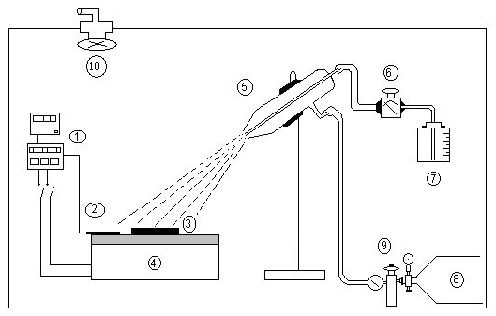
Cd(CH₃COO)₂.2H₂O_{(aq)} CdO_{(s)} + CH₃COCH_{3(g)} + CO_{2(g)} + 2H₂O_{(g)}

Figure 1. Schematic diagram of home built spray pyrolysis unit
1. Thermostat
2. Thermocouple
3. Substrate
4. Plate heater
5. Spray gun
6. Flow meter
7. Solution reservoir
8. Air compressor tank
9. Pressure regulator
10. Exhaust fan

Film thickness was estimated by weighing method and verified with cross sectional view of SEM image. To investigate the microstructural detail of the film, PANalytical X-ray diffractometer (Model X’per PRO) using Ni-filtered CuKα radiation (λ = 1.5148Å), was employed with generator setting of 30mA and 40kV. Continuous scanning was applied with a scanning speed of 10º/min. A range of 2θ from 10º to 100º was scanned from a fixed slit type, so that all possible diffraction peaks could be detected. X-ray line broadening technique is adopted to determine microstructural details. Surface morphology of the films was investigated by using HITACHI Scanning Electron Microscope (Model S-3000H) with an accelerating potential of 18 kV. Prior to imaging, the films were sputtered with thin gold film to enhance the emission of secondary electron for better imaging.

3. Results and discussion
3.1 Structural studies
Figure (2) shows the XRD pattern of film prepared at different temperature from precursor solution concentration of 0.06M. It shows presence of different strong diffraction peaks which confirm polycrystalline cubic CdO phase formation. All the diffraction peaks of the films are indexed to (111), (200), (220), (311) and (222) as compared with standard bulk CdO [JCPDS: 05-0640]. Crystalline nature increases as substrate temperature increased to 250ºC. This is clear from the increase in peak intensity. But film prepared at 300ºC has lesser peak intensity due to lesser deposition. This can be confirmed from the observed film thickness which decreases from 870nm to 610nm prepared at 250ºC and 300ºC respectively. The decrease in film thickness at higher temperature is due to vaporization of precursor before it reaches the substrate [Perednis et al 2005]. No appreciable difference is observed in the XRD pattern of the film prepared at various concentrations. This indicates the crystalline nature strongly depends on substrate temperature alone. Texture coefficient (TC) is used to quantify the preferential orientation of the film deposited at different substrate temperature using the following relation [Hadouda et al 1995]. In the relation I is the measured intensity, I_{o} is the Joint Committee on Powder Diffraction Standards (JCPDS) standard intensity and N is the number of diffraction peaks. It is found to be maximum for (111) plane for all the films deposited at different temperature. This indicates no orientation and phase change in the CdO film.
$$T_{c}=\frac{{I_{(\text{hkl})}}/{I_{o(\text{hkl})}}}{(1/N)\left[\sum_{N}{{I_{(\text{hkl})}}/{I_{o(\text{hkl})}}}\right]}$$

3.2 Microstructural details
XRD lines are usually broadened in their shape. These effects can be classified into instrument and specimen broadening. Instrument broadening originates from the non-ideal optical effects of the diffractometer and from the wavelength distribution of the radiation. In the present work instrumental broadening is corrected by using a standard defect free silicon sample.
Specimen broadening arises due to small crystallite (grain) size and strain (lattice distortion). Grain size causes the radiation to be diffracted individually [Williamson et al 1953]. The prepared CdO film shows polycrystalline in nature, and hence large number of grains with various relative positions and orientations cause variations in the phase difference between the wave scattered by one grain and the others. The total intensity scattered by all grains is the sum of individual intensities scattered by each grain. On the other hand, lattice strain broadening is caused by varying displacement of the atoms with respect to their reference-lattice positions. A uniform compressive or tensile strain (macrostrain) results in peak shift [Sciti et al 2007] of X-ray diffraction lines, whereas a non-uniform of both tensile and compressive strain results in broadening of diffraction lines (microstrain). Thus grain size and microstrain effects are interconnected in the line broadening of peaks, which makes it difficult to separate. Many approaches exist for the evaluation and separation of size and strain parameters from the occurring line broadening. Williamson-Hall technique [Williamson et al 1953] is adopted in the present work where grain size D and micro strain ε is related as
β_{C} is the instrumental effect corrected full width at half maximum of the peak measured in radian, θ the diffraction angle and λ is the wavelength of X-ray. The slope of the plot between $β_{c}\text{cos}θ/λ$ and $\text{sin}θ/λ$ gives micro strain and the inverse of intercept on y-axis give grain size value. Figure (3) shows the Williamson-Hall plot of CdO thin film prepared from precursor solution concentration of 0.06M with different substrate temperature. It shows grain size increases from 32nm to 52nm as substrate temperature increases but strain value decreases from 0.22X10⁻³ to 0.10X10⁻³.

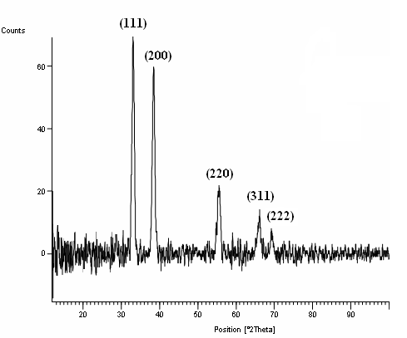
200ºC

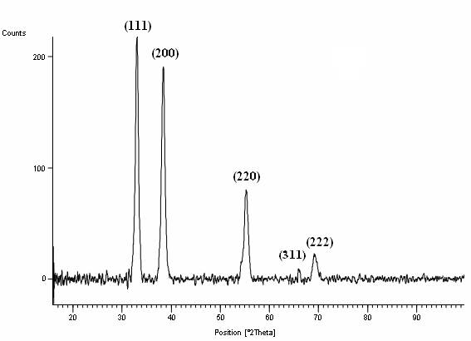
250ºC

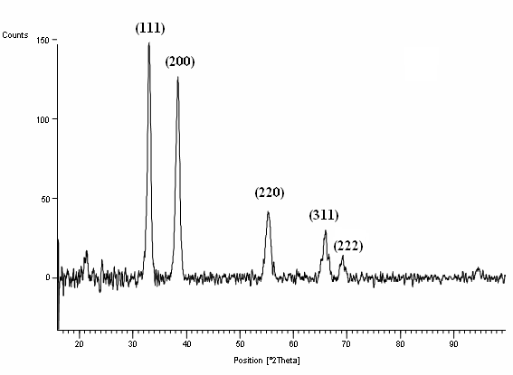
300ºC

Figure 2. XRD pattern of CdO thin film prepared at different substrate temperature from the precursor solution concentration of 0.06 M

3.2.1. Grain Size Analysis
From figure (3) it shows that the grain size is lesser for the film deposited at lower temperature 200ºC. It is due to the droplet splashes onto the substrate and decomposes to yield smaller grains. But the surface morphology of the film prepared at this temperature shown in figure 4(a) has cracks. This is because a thin, wet layer is present on the film during deposition.

Figure 3. Williamson – Hall plot to determine grain size and strain of CdO film prepared at different substrate temperature

Too fast drying of this layer results in stresses and subsequent cracking [Chen et al 1996].Figure 4(b) shows the SEM image of film prepared at 250ºC. It consists of closely packed uniform spherical shape grains without crack. This indicates the film is well adherent with substrate. The grain size as seen from the image is comparable with the XRD studies. At 300ºC the deposited spray droplets are almost dry. Therefore, discrete particles are formed on the surface due to slow spreading. This can be explained that at higher temperature the precursor vapourizes before it reaches the substrate and consequently the solid particles are formed as powdery and non-adherent deposit [Perednis et al 2005]. Also from figure (5) the grain size found to increases as precursor solution concentration increased. This is due to increase in the number of species involving in the formation of CdO film.

3.2.2. Microstrain Analysis
XRD pattern for the films deposited at different temperature do not show significant peak shift but the lines are broadened as the function of diffraction angle. This indicates the presence of microstrain rather than macrostrain. As it is seen from figure (6), the microstrain is higher than film prepared at low temperature and at higher temperature the linear dependence of Williamson-Hall plot is weaker and indicating the broadening is due to grain size. Also from figure (6) it shows that as precursor solution concentration increases the microstrain found to increases. This observation may be related to the temperature miss-match between the formed under layer and the newly sprayed solution accompanied with film relaxation due to slower spreading of droplet at higher concentration.

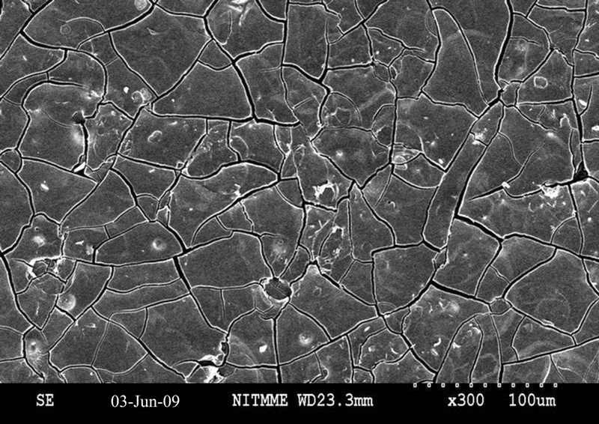
(a) 200ºC

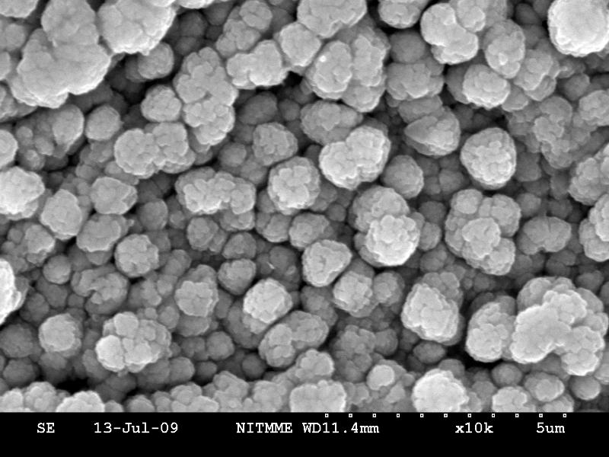
(b) 250ºC

Figure 4. SEM image of CdO thin film prepared from precursor solution concentration of 0.06M

Figure 5. Plot of grain size Vs substrate temperature for different precursor solution concentration

Figure 6. Plot of microstrain Vs substrate temperature for different precursor solution concentration

4. Conclusion
Thin film of CdO on glass substrate is prepared by home built spray pyrolysis unit. XRD pattern confirm CdO phase with preferential orientation along (111) plane. Grain size and microstrain is obtained from Williamson-Hall plot method. As substrate temperature increased grain size found to increases and microstrain found to decreases. Film prepared at 200ºC has microcrack and at 250ºC has spherical shape grains of 45nm size without crack and found to be adherent with substrate. Thus the substrate temperature of 250ºC is an optimum temperature to obtain nano size grains of CdO thin film with lesser microstrain.

Correspondence to:
B.G. Jeyaprakash
Department of Physics
Ponnaiyah Ramajayam College of Engineering and
Technology, Thanjavur – 613 403, Tamilnadu, INDIA
Telephone: +91-431-2770145
Cellular phone: 098654-21411
Email: bgjpabr@yahoo.co.in

References

Chamberlin R R, Skarman J S. Chemical spray deposition process for inorganic Films.
J. Electrochemi Soc., 1966; 113(1): 86-89.

Chen C H, Kelder E M, Vander put P J J M, Schoonman J. Morphology control of thin LiCoO₂ films fabricated using the electrostatic spray deposition (ESD) technique. J. Mat. Chem, 1996; 6(5): 765-771.

Chopra K L, Kainthla R C, Pandya D K , Thakoor A P. In: Physics of Thin films. Academic Press, New york and London, 1982; (12): 167.

Hadouda H, Pouzet J, Bernede J. C, Barreau A. MoS₂ thin film synthesis by soft sulfurization of a molybdenum layer. Mat. Chem. Phys. 1995; 42(4): 291-297.

JCPDS (Joint Committee on Powder Diffraction Standards - Data file: 05-0640).

Patil P S. Versatility of chemical spray pyrolysis technique. Mater. Chem. Phys. 1999; 59 (3): 185-198.

Perednis D, Gauckler L J. Thin Film Deposition Using Spray Pyrolysis. J. Electroceramics. 2005; 14(2): 103-111.

Sciti D, Celotti G, Pezzotti G, Guicciardi S. On the toughening mechanisms of MoSi₂ reinforced Si₃N₄ ceramics. Appl. Phys. A. 2007; 86: 243-248.

Su L M, Grote N, Schmitt F. Diffused planar InP bipolar transistor with a cadmium oxide film emitter. Electron. Lett. 1984; 20(18): 716-7.

Williamson G K, Hall W H. X-ray line broadening from filed aluminum and wolfram. Acta Metall. 1953; 1: 22-31.

Zhao Z, Morel D L, Ferekides C S. Electrical and optical properties of tin-doped CdO films deposited by atmospheric metal organic chemical vapor deposition. Thin Solid Films. 2002; 413(1-2): 203-211.

09/21/2009

