Morphometric and molecular variability of three Artemia strains (El–Max and Wadi El-Natrun, Egypt and San Francisco Bay, U.S.A)

Mona M. El- Gamal
Zoology Department, Faculty of Science, Tanta University, Egypt
Drmona2005@hotmail.com

Abstract: Random amplified polymorphic DNA (RAPD) technique was used to analyze the degree of similarity among two Egyptian Artemia strains (Wadi El Natrun and El-Max) together with a commercially popular U.S.A strain (San Francisco Bay). Discriminate analyses of morphometric characters and laboratory tests for reproductive isolation were performed to investigate whether the conclusions drawn from traditional comparative tools are congruent with the pattern of genetic divergence detected by DNA markers. Correlation coefficients between the DNA banding patterns were calculated; these served as input values for the construction of a UPGMA dendrogram (Unweighted Pair- Group Method with Arithmetic Mean Average). RAPD analysis showed a reliable and reproducible differentiation between the three examined Artemia isolates. There was good agreement of some morphometric aspects for isolation, such as the length of first antennae, distance between compound eyes, the general shape (ventral view) and width of the brood pouch, % of abdomen length/total length and length of furca. Discrimination based on morphometric characters separated A. tunisiana (Wadi EL- Natrun strain) from the other two populations (El-Max and San Francisco Bay strain). While El- Max strain was genetically demonstrated to be different from the San Francisco Bay strains and very distinct from it, despite they showed considerable biometric similarities. The same was true, accumulative proximity matrix showed 96% similarity between Wadi El-Natrun and San Francisco Bay strains, despite the evident morphometric differences between them. Hybridization tests supported the concept of strain isolation. [Journal of American Science 2010;6(2):98-107]. (ISSN: 1545-1003).

Keywords: Artemia, divergence, genetic, hybridization, morphometric, RAPD

1. Introduction
Artemia is one of the best known aquatic organisms, and is considered to be a paradigmatic crustacean that can help to fill gaps in knowledge in evolutionary and comparative biology of arthropods and closely related groups (Abreu-Grobois, 1987; Browne and Bowen, 1991; Marco et al., 1991; Gajardo et al., 2002). Moreover, the easy transportation of cysts and cultivation of populations under laboratory conditions have permitted broad inter_ population comparisons.
The genus Artemia is regarded as a complex of bisexual species and super species, as well as a large number of parthenogenetic forms, morphologically very similar, and species are very likely to have diverged from living in the Mediterranean area some 5.5 million years ago (Abreu-Grobois, 1987 and Badaracco et al., 1987). The hypothesis of the Mediterranean as the centre of radiation for Artemia is also supported by the diversity of Artemia types currently found in one area i.e. bisexuality and parthenogenesis on the one hand, together with diploidy and polyploidy on the other hand (Gajardo et al., 2002). Artemia populations are found in about 600 natural salt lakes and man-made salterns scattered throughout the tropical, subtropical and temperate climatic zones, along coastlines as well as inland (Van Stappen ,2002). In Egypt, Artemia resources are mostly restricted to five spots, among which El-Max saline and Wadi El-Natrun are the most productive areas (El-Sherif, 1989 and El- Bermawi, et al., 2004).
Speciation is still a highly debated topic and this evident from the many species concepts (Templeton, 1989 and Avise, 1994) and speciation mode (Turelli et al., 2001). Based on morphological bases, Clark and Bowen (1976) able to distinguish six sibling species (after many cross breeding tests): Artemia franciscana, A. tunisiana, A. urmiana, A. monica, A. persimilis and A. parthenogenetica. Later on, speciation has been conducted by means of cytogenesis, allozyme studies and chromocentre numbers (Abreu-Grobois, 1987; Pilla and Beardmore, 1994; Perez et al., 1994). Furthermore, different molecular approaches exist, including gene cloning, DNA sequencing and mtDNA analysis (Gajardo et al., 2001 and 2004; Eimanifar et al., 2006 and Ruiz et al., 2008). For instance, random amplified polymorphic DNA (RAPD) analysis developed by Williams et al. (1990), is a PCR-based method using a single short random primer which, under low stringency conditions, gives rise to amplification products wherever the primer binds on opposite strands within an easily amplifiable distance. This method is widely used for the study of population genetics in a large variety of species (Wang et al., 1993). The RAPD technique has been used to construct genetic maps (Rowland and Levi, 1994), detect genetic variation (Garcia et al., 1994), assist in breeding programs (Garcia and Benzie, 1995) and for phylogenetic studies, which led to valuable isolation (Badaracco et al., 1995; Sun et al., 1999 and Camargo et al., 2002). In most cases, strains would be considered identical if their RAPD patterns are identical with several primers.
Despite strain isolation by distance and environmental conditions, Artemia populations in all strains could be linked. It is very likely that birds play an important role in dispersing Artemia, especially in artificial coastal saline (Ogilvie and Ogilvie, 1986). In genetic terms there is a potential for gene flux among these isolated populations. The study of the species and accurate identification of all Artemia populations are undoubtedly required for selected morphological and genetic characteristics.
The present study aims 1) to test the phylogeny relationship between the two Egyptian strains (El- Max and Wadi El- Natrun), 2) to test the hypothesis that they may be divergent from the American species Artemia franciscana (San Francisco Bay) and 3) to investigate whether the conclusions drawn from traditional comparative tools (morphology, biometry and hybridization) are congruent with the pattern of genetic divergence detected by DNA markers.

2. Material and Methods

2.1 Collection of cysts
Local Artemia cysts were collected from one coastal saltwork (El- Max) and one inland saline lake (Wadi El-Natrun), all situated in northern Egypt. The coastal El- Max saltwork (31º 08′ N, 30° 07′ E) is located along the Mediterranean coast. Wadi El-Natrun (30º 10′ N,30° 27′ E) is one of the depressions of the Western Desert of Egypt. Only bisexual population was found in Wadi El- Natrun, and parthenogenetic was detected at El-Max saltwork. Cysts were stored and transported to the laboratory in plastic bags, then cleaned and dried. San Francisco bay cysts were obtained from King British Aquarium Accessories Co Ltd, Bradford, U.K.
2.2 Culture techniques
All cysts were hatched in artificial sea water (Tropic Marine, S=37%_{o}) under conditions of continuous illumination and aeration. Culture vessels, artificial sea water and aeration equipment were autoclaved. The culture vessels were maintained at a temperature of 28ºC. Newly hatched nauplii were transferred directly to flasks with initial density 2 nauplii/ml of culture medium and kept under the previous conditions. After 2 days from hatching, individuals in each of the culture flasks were fed every 2 days on Liquifry (0.4 ml) until around stage 10 (Weisz, 1946). From stage 10 through the late stage, each culture consists of approx. 100 individuals; brine shrimp were supplied with 0.6 ml of Liquifry every 2 days. This feeding regime, worked out in details in initial experiments, ensured that growth was not resource limited (El Gamal, 1997). The culture medium was replaced every 4 days. Under these conditions, adults were evident after 4 weeks. All the strains were bisexual except El-Max strain, was parthenogenesis.
2.3 Biometry
Cysts are fully hydrated after incubation at room temperature for at least 3hrs (Lavens and Sorgeloos, 1987) in artificial sea water. From each population a random sample was taken and diameter of 50 hydrated cysts was measured using an eye-piece micrometer. The length of 50 recently hatched nauplii (stage 0) and 50 cultured adult females (all adults were 30 days old) from each strain were anaesthetized in chloroform saturated seawater and measured using the same equipment. Body length was taken as the distance from the front of the median eye to the posterior margin of the body in nauplii, while in adults to the posterior margin of the telson. More morphological parameters were quantified in each female as: length of the first antennae, distance between the compound eyes; abdominal length; % abdominal length /total length; width of the third abdominal segment; width of the ovisacs; length of furca; and number of setae/furca.
2.4 Molecular methods
Unless otherwise stated, buffers and protocols were used according to Sambrook et al. (1989).
2.4.1 Genomic DNA extraction and purification
Frozen tissues of Artemia (30 mg) were kept at room temperature for 2 min to be slightly softened without thawing the tissue completely, then pulverized. The minced tissue was transferred to 1.5 ml Eppendorf tube, before incubating (2-3 hrs) with mild shaking at 55°C in 0.5 ml lysing buffer (2 ml, 5M. NaCl; 1ml, 1M. Tris HCl, pH 8; 5ml, 0.5M. EDTA, pH 8; 5ml, 10% SDS; 87 ml H₂O and 0.1 mg/ml proteinase K). The mixture was centrifuged (13,000 x g, 1 min) and the supernatant was retained and genomic DNA was purified using phenol-chloroform method. The DNA was then precipitated by the addition of 2.5 volume of ethanol at room temperature after adding 1/10 volume of 3M sodium acetate. DNA samples were cooled for 10 min on ice and DNA was pellet by centrifuging for 10 min at 10,000 x g, washed in 70% ethanol and dried at room temperature before resuspending in TE buffer (1ml, 1M Tris. HCl, pH8; 0.02ml 0.5 M EDTA, pH8; 98.98ml H₂O). Finally, DNA was stored at 4°C for further analysis.
2.4.2 Amplification of genomic DNA
Eight oligonucleotides primers (10-mers) with G+C content ranging from 60-70% were eventually used to amplify genomic DNA. The sequences of the primers (5′ -3′) are represented in Table 1.

Table 1. Primer Sequences and their G+C Contents.
G+C% | Sequence 5′ to 3′ | Code
60 | TTC GAG CCA G | 1
70 | TGG ACC GGT G | 2
60 | AAA GCT GCG G | 3
60 | AAG CCT CGT C | 4
60 | TGC GTG CTT G | 5
70 | TTC CCC CCA G | 6
60 | CAC ACT CCA G | 7
60 | GTG ATC GCA G | 8

Optimal results were obtained using 10-15 ng of nucleic acid template in 15 μl reaction volume. PCR buffer contained 10 mM Tris-HCl (pH9), 50mM KCl, 1.5mM MgCl₂, 15 pM primer, 2 mM of deoxynucleoside triphosphate and 1 unit of Taq DNA polymerase (0.2 µl). The reaction mixtures were overlaid with mineral oil (Sigma). The amplification reactions were carried out in a Biometra Thermal Cycler following an initial denaturation step at 96°C for 10 min. The reactions were subjected to 40 cycles of amplification at 96°C (30 sec), 35°C (30 sec) and 72 °C (45 sec) followed by a 5 min final extension at 72°C. Additionally, each set of reactions incorporated a negative control with the DNA template replaced with double distilled water.
The generated amplification products were resolved by electrophoresis on 1.4% (wt/vol) agarose gel in 1x TBE buffer (0.89M Tris. Base; 0.89 M boric acid pH (8.3); 2.5mM EDTA) for 3 hrs at 60V. A one hundred bp ladder (sigma) was loaded as a size marker. After electrophoresis, the gel was stained with ethidium bromide, visualized under UV trans-illuminator and photographed by a Polaroid CU5 camera. Pictures were scanned and the images were processed with the photoshop software.
2.5 Hybridization
Generally 15 crosses were made between males of the first strain (San Francisco Bay) and females of the second (Wadi El-Natrun), another 15 crosses were made between females of the first strain and males of the second. The experiment was carried out in the following way: material from each strain was raised separately as soon as the sex could be determined. When the egg sac was well filled, they were brought together with males from the other strain. Other individuals were crossed with the opposite sex from their own locality as controls. Crosses were inferred to be fertile when full/intact cysts or live nauplii were produced. The viability of the cysts was determined according to their ability to hatch (and give live nauplii) in standard conditions following deactivation of diapause (i.e. dehydration at 38 ± 1°C for at least 48 h, rehydration/dehydration cycles and/or hibernation at-30°C for at least 2 weeks). The viability of the nauplii was tested by raising them to sexually mature adults.
2.6 Data analysis:
One-way analysis of variance (ANOVA) was used to determine if there were significant differences between the means of biometric measurements among the three populations. XlMiner dendrogram was used to detect the relationships between individuals within each group. The results were processed with discriminant analysis using SPSS. The rough set data analysis was used to distinguish the variables for each population using Rosetta.
For RAPD each examined strain was scored for the presence or absence of every amplification product. Cluster analyses between DNA banding patterns were calculated and served as input values to create a dendrogram using unweighted pair group method with the arithmetic mean (UPGMA) by NTSYS program (Numerical Taxonomy System, Exeter Software).
3. Results

3.1 Morphometric analysis
The morphometric analysis is shown in table (2 and 3). The morphometric characteristic that most significantly contribute to the discrimination among the three groups were: the length of the 1st antenna, distance between compound eyes, width and shape of ovisacs, abdominal length and the length of furca. These five variables were highly statistically significant (p≤ 0.001). San Francisco Bay and El-Max strains do not differ statistically in cyst diameter, nauplius length, female length, third abdominal length and the number of setae, but they were highly statistically significant from Wadi El- Natrun population.
Table 2. Demographic Data of Various Morphometric Parameters of Cyst, Nauplii and Female Artemia (30 days old) for SFB, WN and MAX strains reared under laboratory conditions. (A) Diameter of hydrated cyst, (B) Length of newly hatched nauplii, (C) Total length, (D) % of Abdomen
length /Total length, (E) Width of the 3rd abdominal segment, (F) Length of the 1st Antenna, (G) Distance between compound eyes, (H) Width of ovisac, (I) Furca length and (J) Number of Setae/Furca. (Parameters A-J is mm except D is %).
 |  | N | Mean± SD | Minimum | Maximum | p-value
A | SFB | 50 | 0.22±0.01 | 0.20 | 0.24 | 0.000**
A | WN | 50 | 0.19±0.014 | 0.14 | 0.23 | 0.000**
A | MAX | 50 | 0.23±0.01 | 0.22 | 0.25 | 0.000**
A | Total | 150 | 0.22±0.02 | 0.14 | 0.25 | 0.000**
B | SFB | 50 | 0.51±0.02 | 0.48 | 0.54 | 0.000**
B | WN | 50 | 0.46±0.02 | 0.43 | 0.50 | 0.000**
B | MAX | 50 | 0.50±0.07 | 0.05 | 0.56 | 0.000**
B | Total | 150 | 0.49±0.05 | 0.05 | 0.56 | 0.000**
C | SFB | 50 | 8.75±0.45 | 7.70 | 9.90 | 0.000**
C | WN | 50 | 5.48±0.41 | 4.50 | 6.40 | 0.000**
C | MAX | 50 | 8.87±0.38 | 8.00 | 9.40 | 0.000**
C | Total | 150 | 7.70±1.63 | 4.50 | 9.90 | 0.000**
D | SFB | 50 | 43±0.03 | 38 | 57 | 0.000**
D | WN | 50 | 39±0.02 | 35 | 47 | 0.000**
D | MAX | 50 | 48±0.03 | 38 | 53 | 0.000**
D | Total | 150 | 43±0.74 | 35 | 57 | 0.000**
E | SFB | 50 | 0.52±0.034 | 0.42 | 0.62 | 0.000**
E | WN | 50 | 0.46±0.024 | 0.36 | 0.55 | 0.000**
E | MAX | 50 | 0.51±0.03 | 0.42 | 0.58 | 0.000**
E | Total | 150 | 0.49±0.05 | 0.36 | 0.62 | 0.000**
F | SFB | 50 | 0.77±0.05 | 0.62 | 0.85 | 0.000**
F | WN | 50 | 0.42±0.05 | 0.33 | 0.57 | 0.000**
F | MAX | 50 | 1.25±0.28 | 0.87 | 2.41 | 0.000**
F | Total | 150 | 0.81±0.38 | 0.33 | 2.41 | 0.000**
G | SFB | 50 | 1.78±0.17 | 1.43 | 2.20 | 0.000**
G | WN | 50 | 0.86±0.06 | 0.73 | 0.97 | 0.000**
G | MAX | 50 | 1.37±0.08 | 1.12 | 1.53 | 0.000**
G | Total | 150 | 1.34±0.39 | 0.73 | 2.20 | 0.000**
H | SFB | 50 | 1.37±0.12 | 1.10 | 1.56 | 0.000**
H | WN | 50 | 0.52±0.06 | 0.40 | 0.65 | 0.000**
H | MAX | 50 | 1.66±0.10 | 1.42 | 1.91 | 0.000**
H | Total | 150 | 1.18±0.49 | 0.40 | 1.91 | 0.000**
I | SFB | 50 | 0.28±0.05 | 0.18 | 0.43 | 0.000**
I | WN | 50 | 0.14±0.03 | 0.10 | 0.21 | 0.000**
I | MAX | 50 | 0.44±0.05 | 0.32 | 0.56 | 0.000**
I | Total | 150 | 0.29±0.13 | 0.10 | 0.56 | 0.000**
J | SFB | 50 | 15.84±1.67 | 12.00 | 19.00 | 0.000**
J | WN | 50 | 6.08±0.88 | 4.00 | 8.00 | 0.000**
J | MAX | 50 | 14.98±1.33 | 13.00 | 18.00 | 0.000**
J | Total | 150 | 12.30±4.62 | 4.00 | 19.00 | 0.000**
* sig. at 0.05, ** sig. at 0.001
Table 3. Discriminant Analysis of the Morphometric Parameters of Cyst, Nauplii and female Artemia individuals for SFB, WN and MAX populations reared under laboratory conditions; standardized coefficients for canonical variables, eigen values, cumulative percentage of variance and predicted classifications for each root are presented. For the abbreviations of the variables, see Table 2.

Classification Function Coefficients |  |  |  | Standardized Coefficient for Canonical Variables
 | SFB | WN | MAX |  | Root1 | Root2
A | 1886.7 | 1660.13 | 1939.27 | A | 0.16 | 0.04
B | 182.7 | 195.67 | 170.02 | B | -0.05 | -0.07
C | 59.2 | 35.28 | 60.46 | C | 0.58 | -0.12
D | 445.6 | 374.70 | 495.52 | D | 0.16 | 0.17
E | 322.1 | 288.65 | 306.65 | E | 0.06 | -0.12
F | 25.7 | 22.25 | 37.41 | F | 0.10 | 0.28
G | 134.3 | 74.07 | 105.06 | G | 0.28 | -0.66
H | 162.7 | 60.93 | 186.95 | H | 0.64 | 0.16
I | 23.2 | 6.78 | 110.66 | I | 0.17 | 0.57
J | 6.12 | 1.34 | 5.79 | J | 0.34 | -0.19
(Constant) | -989.78 | -499.04 | -1049.71 | Eigenvalues | 69.75 | 6.38
 |  |  |  | Cum. Perc. | 91.6% | 100%
Predicted Classifications
SFB | 100%
WN | 100%
MAX | 100%
Total | 100%

Discriminant analysis based on the strain type as separator factor was performed (Figure 1). There was an absolute discrimination among (WN) and the other two strains (SFB and MAX), both also can be distinguished from each other. The total predictability of the model was 95.8%, the graph in Figure (1) was based on two roots and these two roots explained 100% of the total variation in the data collection (Table 2).
Concerning the morphology of brood pouch as shown in Figure (2) it was laterally rounded, heart shaped, without lateral lobes in El- Max females and with two protruded circles on the ventral side. Females from San Francisco Bay had also rounded brood pouch but with lateral lobes, while brood pouch were triangular with lateral lobes in Wadi El- Natrun strain. No structure differences were observed on the abdomen except for length and width (Figure 2).
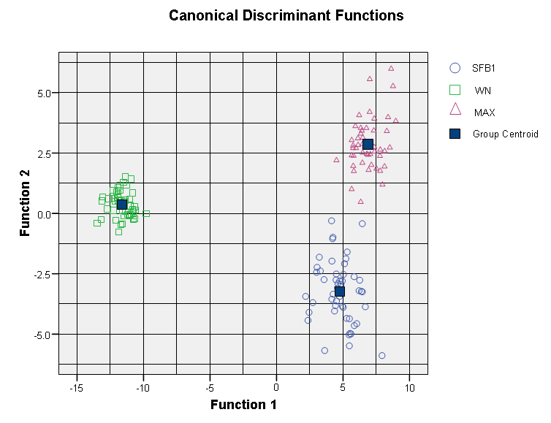
Figure 1. Scatter plot resulting from the discriminant analysis (canonical scores). When using strain origin SFB: San Francisco Bay; WN; Wadi El Natrunand MAX: El-Max as separating factor.

The morphology and length of furca showed clear differences according to the type of strain as shown in Figure (2), while no differences between males and females in the same strain were observed.
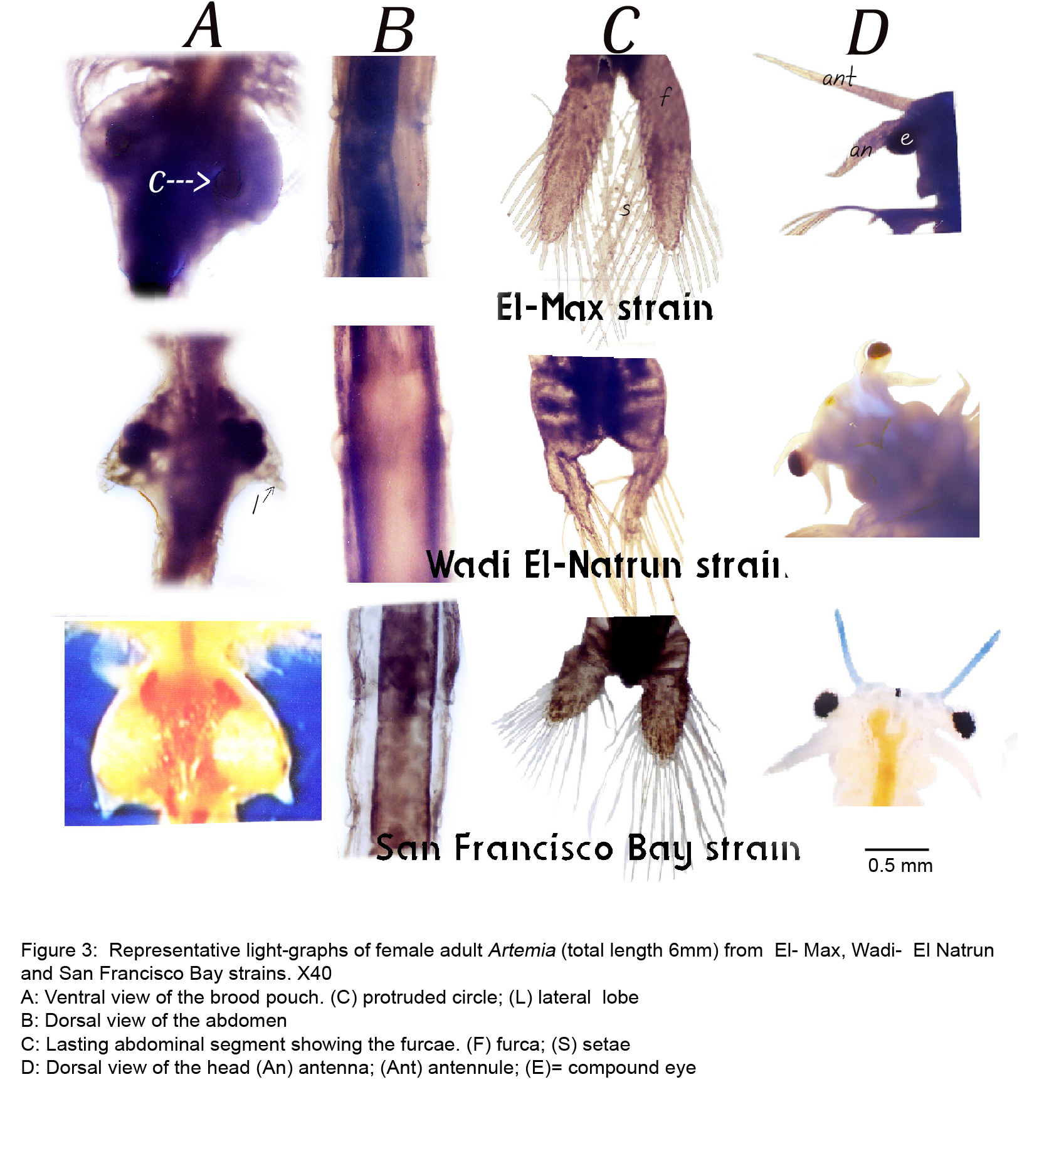
Figure 2. Representative light-graphs of female Artemia (total length 6mm) from El- Max, Wadi El- Natrun and San Francisco Bay strains. A: Ventral view of the brood pouch; B: Dorsal view of the abdomen; C: Last abdominal segment showing the furcae.

The number of setae in each furca branch increased with the length of the animal and at the same length it was significant higher in El- Max and San Francisco Bay (P≤0.001) than Wadi El-Natrun strain.
3.2 RAPD profiles
Eight random primers were tested for fingerprinting of the three Artemia strains. Primer 8 gave no reproducibility while the other primers provided strongly amplified fragments. The fingerprints generated by the 7 primers revealed unique profiles for each strain. Seven primers were able to produce consistent amplification and yielded a total of 18, 14, 11, 13, 4, 10 and 8 fragments, respectively, ranging in size from 118 to 1353 bp figure (3). The greatest number of PCR fragments was found with primers 1, 2, 3, 4 and 5 (5-7 bands) while less fragments were obtained with primers 6 and 7 (1-3 bands). RAPD profiles showed that the greatest differences between strains were observed with primers 1 and 2.
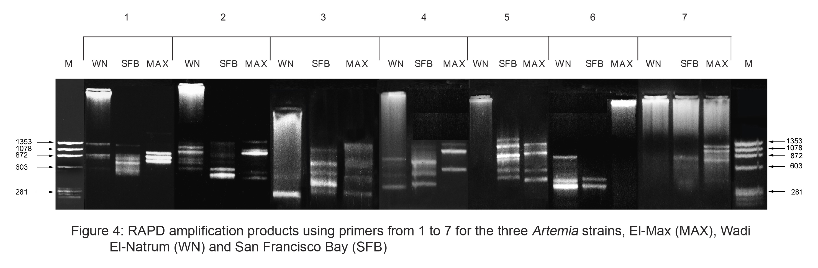

Figure 3. RAPD amplification products using primers from 1-7 for the three Artemia strains, Wad El- Natrun (WN), San Francisco Bay (SFB) and El- Max (MAX).

The similarities among species revealed certain relationships and differentiated them into two clusters (figure 4). The first cluster with primers 1, 2, 4 and 7 was between Wadi El-Natrun and San Francisco Bay strains, while the second cluster was El- Max strain. On the other hand, the first cluster with primers 3 and 6 was between Wadi El-Natrun and El- Max strains, while the second cluster was San Francisco Bay strain. The only cluster between El- Max and San Francisco Bay strains was obtained by primer 5.
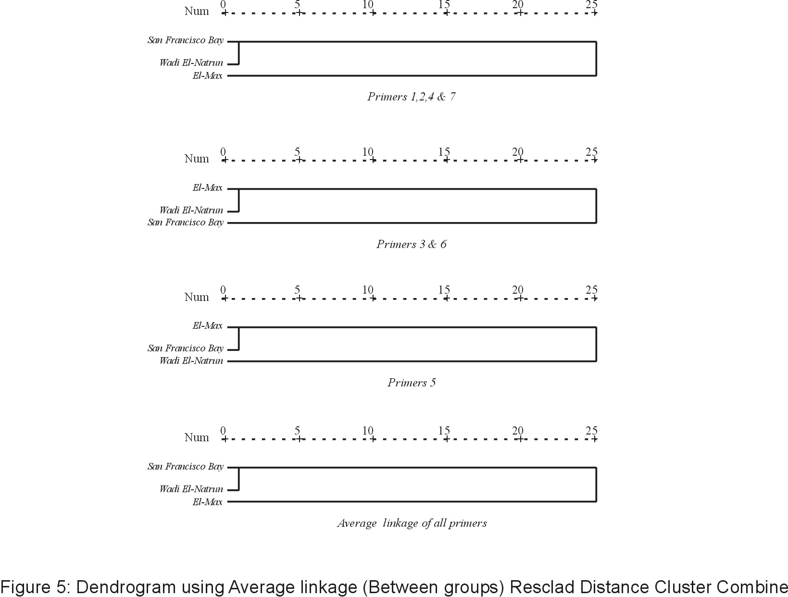
Figure 4. Dendrogram using Average linkage (between groups) Resclad Distance Cluster Combine
The dendrogram calculated from all primers using average linkage between groups illustrated two clusters: the first between San Francisco Bay and Wadi El-Natrun strains while the second group was El- Max strain.
Accumulative proximity matrix calculated from the investigated primers showed 96% similarity between Wadi El-Natrun and San Francisco Bay and 33% similarity between Wadi El- Natrun and El- Max strains.
3.3 Hybridization
None of the hybridization crosses between Wadi El- Natrun and San Francisco Bay strain gave rise to an F1 generation, although 9 and 11 copulations respectively were observed from the two 15 crosses. They laid broods of transparent eggs (no nauplii) every 3 or 4 days. All attempts to hatch the eggs failed.
Control individuals crossed with the opposite sex from their own locality gave birth to a new generation freely, which developed normally.
4. DISCUSSION
The previous work on the morphology of Artemia (Gilchrist, 1960) has shown that Artemia individuals undergo morphological changes according to the environmental conditions and between males and females even when the animals were cultured in the same medium. The previous conclusion was cited by Amat (1980) after a complete morphological study on 22 different Mediterranean populations. He concluded that the variation in these characters observed among Artemia males and females from different populations allows one to classify the different main types of Artemia, but it is difficult to distinguish among populations of the same type. The same was observed when the strains under investigation were cultured under laboratory conditions and compared with those collected from the field. This may be due to the characteristic of the salterns that the populations inhabited. For example Wadi El-Natrun has a different ionic composition of the brine (alkaline hypersaline soda), also El- Max population are more euryhaline which has a very strong influence on the morphology of Artemia (El-Sherif 1989; and El- Bermawi, et al., 2004). Triantaphyllidis, et al, (1995) changed the discriminant parameter when compared between two populations according to the age and salinities, if low used the length of the first antenna and the width of the head for higher salinities also, marked differences at intrapopulation as well as interpopulation level.
Many studies frame the most discriminant variables as cyst volume, diameter of eyes; the distance between the eyes, width of the head; length of the first antenna; width of brood pouch, and length of furca (Hontoria and Amat, 1992; Torrentera and Dodson, 1995, Asem et al., 2007). Generally the cyst diameter of different produced batches of the same strain remains rather constant. Other biometrical characteristics such as cyst dry weight, instar 0-naupliar length, individual naupliar weight and energy content etc., show a high correlation with the cyst diameter. As a consequence, biometrical parameters, in particular the cyst diameter, are good tools to characterize Artemia strains, and help to define the origin of unknown or even mixed cyst samples. The present study indicated slightly differences in cyst diameters and newly hatched nauplii between the San Francisco Bay and El-Max strains, although Zhenqiu et al. (1991) showed that parthenogenetic populations and their cyst size is larger than those of bisexual species. Hontoria (1990) studied 14 Artemia Franciscana populations and recorded a diameter ranging between 217 and 230µm. The herein size (200-240µm) were smaller when compared with those of the hydrated cyst from the commercially important Great Salt Lake populations, and the same as San Francisco and San Bablo Bay strains (Abdel Rahman, 1995). Wadi El-Natrun cysts had the lowest diameter when compared to El- Max and San Francisco Bay populations. These finding was in agreement with those presented by El-Sherif (1989), where Wadi El- Natrun cysts were smaller than A. salina and A. franciscana from San Francisco Bay. The same was recorded with the newly hatched nauplii and adults (30 days old) of Wadi El- Natrun, they were smaller than the other two studied strains and this confirmed with the result of El-Sherif (1989) and El-Bermawi, et al. (2004) comparable to El- Max and Borg El- Arab strains. The previous may be due to the ionic composition in WN natural environment, that mostly different from that of the culturing medium. According to the results of El-Bermawi (2004) the best salinity for culturing Artemia strains from Egypt in order to discriminate individuals is 80gl⁻¹.
Triantaphyllidis, et al, (1995) revealed that the length of the 1st antenna is the best characteristic for identification of parthenogenetic individuals. He found that the 1st antenna is significantly longer in parthenogenetic Artemia from Tanggue than in A. franciscana. The previous finding is compromised with the 1st antenna in El- Max strain, it was significantly longer than the other two bisexual strains. (Amat, 1980) showed the same, where 1st antennae in the San Francisco Bay Artemia are shorter than those from the Spain parthenogenetical strains.
Although Amat et al. (1995) and El-Bermawi, et al. (2004) recognized that the size of furca and the number of setae various considerably in wild populations, due to environmental conditions. They used these morphological variables as a systematic tool provided with well defined culture conditions. Amat et al. (1995) found that the furcal characters were the major factors for discriminating a group of Southern Spanish populations from the rest of the Spanish bisexual Artemia. The present work encourage this parameter because it was good to distinguish the three strains.
Many authors focused on the morphological data of the genitalia of arthropods, due to their taxonomical characters that are fairly constant within a given group and are usually given high taxonomical weight even in closely related species (Torrentera and Dodson, 1995 and Mayer, 2002). Torrentera and Dodson (1995) when studied populations of Artemia from Yucatan, concluded that, numerical and categorical characters of the female brood pouch are critical discriminating characters. Mayer (2002) emphasized that the female brood pouch morphology is the most useful morphological character when discriminate between two Artemia populations from Puerto Rico and one from the Dominican Republic. The general shape and structure of the brood pouch of the investigated populations were completely different and can be used to discriminate between them. Therefore, the probability that they were the same or related species is very low.
DNA is needed as cited by Mayer (2002) to supplement morphometric findings to evaluate the phylogenetic and taxonomic status of any population. Recently it has been demonstrated that polymorphisms in genomic fingerprints generated by arbitrarily primed polymerase chain reaction (PCR) can distinguish between strains in many organisms (Badaracco et al., 1995). In the present study, this technique was used to estimate the phylogenetic relationships existing between three Artemia strains existing in El- Max and Wadi El- Natrun (Egypt) and San Francisco Bay (USA).
The RAPD patterns obtained using the random primers revealed differences in the intensities of some bands between Artemia isolates. However, one of the short comings of the objective analysis of RAPD profiles is that bands are scored as either present or absent. Consequently, there is no account between variations in the brightness of bands. In such case there is a possible loss of discriminatory power. Nevertheless, when comparing RAPD profile analysis to any of the morphological or hybridization methods of species discrimination, RAPD is always superior (Sun et al., 1999 and Camargo et al., 2002).
The clustering patterns obtained with the primers 1-7 corroborated that the populations in these clusters were not identical and genetic dissimilarities between them might exist. Other RAPD analyses showed a significant differentiation between populations belonging to A. franciscana (Badaracco et al., 1995). Camargo et al. (2002) analyzed 14 Artemia strains belonging to A. franciscana and A. persimilis and demonstrated genetic dissimilarities between them. Sun et al. (1999) used the same analysis to distinguish the four species of the genus Artemia (A. franciscana, A. urmiana, A. sinica and A. parthenogenetica) and cited significant differences between the four strains.
The cumulative relationship between the three strains in the present work showed two groups, one of which contained the two bisexual species and the other form the parthenogenetic population. Sun et al. (1999) come to the same conclusion when they emphasized significant differences between bisexual Artemia species and parthenogenetic populations. El- Max strain was demonstrated to be apart from the San Francisco Bay population and very distinct from it, which tempts to suggesting that El-Max strain didn’t evolved from A. franciscana. Contradictory, Abreu-Grobois and Beardmore (1980) and Barigozzi (1989) revealed that parthenogenetic forms would be derived from bisexual genotypes and parthenogenetic populations from inland salt lakes could have followed an evolutionary path that was different from that of the coastal populations (Gao et al., 1994).
Despite the genetic differences between the San Francisco Bay (Artemia franciscana) and El-Max strain, they were morphologically and morphometrically very similar (5 out of 10 biometric characters). The same was observed between A. franciscana and A. persimilis; the two species were described as being morphologically very similar in spite of the genetic differences between them (Browne and Bowen, 1991 and Gajardo et al., 1999).
The opposite was observed between Wadi El-Natrun and San Francisco Bay strain. Despite their genomic similarities, they were significantly different in other morphometric aspects. Abreu-Grobois (1987), Badaracoo et al. (1987) and Browne and Bowen (1991) thought that Artemia franciscana is closely related to the original group of species that evolved in the Mediterranean.
The herein results were further supported by the hybridization test, where there is impossibility of producing normal offspring by crossing. According to the biological species concept, this is a sufficient proof that they do not belong to one species. The study of Kuenen (1939) provides the first example of sexual isolation within Artemia salina between two bisexual forms. Gilchrist (1960) found sexual isolation between Artemia from California and Artemia from North Africa. Bowen (1965) found sexual isolation between California and Sardinia Artemia. Other researches (Pilla and Beardmore, 1994) showed that the production of laboratory hybrids between morphologically or genetically divergent allopatric populations appears to be a common phenomenon in some Artemia populations and other members of the order. Maeda-Martinez et al. (1992) showed that morphologically distinct species that have been separated for a long period of time are sexually compatible. For this reason, a number of authors maintain that reproductive isolation is not necessarily a key aspect of the Biological Species Concept (Templeton, 1989).

CONCLUSIONS
The results supported the strains distinction and the Egyptian strains were divergent from American strain (Artemia franciscana). There wasn’t agreement between genetic divergence (detected by DNA markers) and the morphometric aspects. Reproductive isolation was in the same line with genetic divergence. Morphometric data could be used through discriminant analysis to study relatedness among Artemia populations.
Acknowledgements
The author would like to acknowledge Dr. Abd El-Monsef, M. M. E. for his helpful assistance in statistical analysis.

Correspondence to:

Mona M. El- Gamal
Zoology Department, Faculty of Science, Tanta University, Egypt
Drmona2005@hotmail.com
Tel: 0020403304542 Mobile: 00124031111
Acceptance day : on Sat. 9/12/2009

REFERENCES
[1] Abdel Rahman S, Characteristics and nutritive value of local and imported Artemia strains as food for fish larvae. Journal of the Egyptian German Society of Zoology 1995; 16(D): 77-100.
[2] Abreu-Grobois F, A review of the genetics of Artemia. In "Artemia Research and its Applications". Vol. I. P. Sorgeloos, D.A. Bengtson, W. Decleir and E. Jaspers (eds.), Universa Press, Wetteren, Belgium, 1987; pp. 61-99.
[3] Abreu-Grobois F, Beardorme J. Genetic characterization of Artemia populations: an electrophoretic approach In: "The Brine Shrimp Artemia " Vol. 1. G. Persoone, P. Sorgeloos, O. Roels and E. Jaspers (eds.), Universa Press, Wettern, Belgium, 1980; pp. 133-146.

[4] Amat D. Differentiation in Artemia strains from Spain. In: "The Brine Shrimp Artemia". Vol. 1. Persoone, G., Sorgeloos, P., Roels, O. and Jaspers, E. (eds.)., Universa Press, Wetteren 1980; pp. 19-40.
[5] Amat F, Barata C, Hontoria F. Biogeography of the genus Artemia (Crustacea, Branchiopoda, Anostraca) in Spain. International Journal Salt Lake Research 1995; 3: 175–190.
[6] Asem A, Rastegar PN, Agh N. Biometrical Study of Artemia urmiana (Anostraca: Artemiidae) Cysts Harvested from Lake Urmia (West Azerbaijan, Iran). Journal of Turkish Zoology 2007; 31, 171-180.
[7] Avise J. Molecular Markers: Natural History and Evolution, Chapman and Hall, London 1994.
[8] Badaracco G, Baratelli L, Ginelli E, Meneveri R, Plevani P, Valsasnini P, Barigozzi C. Variations in repetitive DNA and heterochromatin in the genus Artemia. Chromosomea 1987; 95: 71-75.
[9] Badaracco G, Bellorini M, Landsberger N. Phylogenetic study of bisexual Artemia using random amplified polymorphic DNA. Journal Of Molecular Evolution 1995; 41: 150-154.
[10] Barigozzi C. Genus Artemia: Problems of systematic. In: " The Brine Shrimp Artemia", Vol.1 G.Persoone, P. Sorgeloos, O. Roels and E. Jaspers (eds.). Universa Press, Wetteren, Belgium. 1989; pp. 147-153.
[11] Bowen S. The genetics of Artemia salina. Crossing over between the X and Y chromosomes. Genetics 1965; 52: 695-710.
[12] Browne R, Bowen S. Taxonomy and population genetics of Artemia. In: R.A. Browne, P. Sorgeloos and C.N.A. Trotman (eds.) "Artemia Biology", CRC Press, Boca Raton, Florida 1991; pp. 221-235.
[13] Camargo W, Bossier P, Sorgeloos P, Sun Y. Preliminary genetic data on some Caribban Artemia franciscana strains based on RAPD's. Hydrobiologia 2002; 468: 245-249.
[14] Clark L, Bowen S. The genetics of Artemia salina. VII. Reproductive isolation. Journal of Heredity 1976; 67: 385-388.
[15] Eimanifar A, Rezvani S, Carapetian A. Genetic differentiation of Artemia urmiana from various ecological populations of Urmia Lake assessed by PCR amplified RFLP analysis. Journal of Experimental Marine Biology and Ecology 2006; 333: 275-285.
[16] El-Bermawi N, Baxevanis A, Abatzopoulos T, Stappen, G, Sorgeloos P. Salinity effects on survival, growth and morphometry of four Egyptian Artemia populations (International Study on Artemia. LXVII). Hydrobiologia 2004; 523: 175–188.
[17] El-Gamal M. Development of respiratory function in the brine shrimp Artemia franciscana Kellogg 1980, culture under different oxygenation regimes. Ph.D. thesis, Sheffield University U.K. 1997.
[18] El- Sherif M. Comparative studies of Egyptian Artemia (Crustacea, Anostraca). Ph.D. thesis, Suez Canal University, Egypt. 1989.
[19] Gajardo G, Mercado C, Beardmore J, Sorgeloose P. International study of Artemia. LX. Allozyme data suggest that a new Artemia population in southern Chile is A. persimilis. Hydrobiologia 1999; 405: 117-123.
[20] Gajardo G, Beardmore J, Sorgeloose P. Genomic relationships between Artemia franciscana and A. persimilis, inferred from chromocentre numbers. Heredity 2001; 87: 172-177.
[21] Gajardo G, Abatzopoulos T, Kappas I, Beardmore J. Evolution and speciation. In Artemia: Basic and applied biology (ed. by Th.j. Abatzopoulos, J.A. Beardmore, J.S. Clegg and P. Sorgeloos) 2002; 225-250.
[22] Gajardo G, Crespo J, Triantafyllidis A, Tzika A, Baxevanis A, Kappas I, Abatzopoulos T. Species identification of Chilean Artemia populations based on mitochondrial DNA RFLP analysis Journal of Biogeography 2004; 31: 547-555.
[23] Gao M, Ge L, Cai Y. Isoenzyme analysis on the relationships between parthenogenetic and bisexual Artemia from China. Acta Oceanologica Sinica 1994; 16 (5): 92-98.
[24] Garcia D, Benzie J. RAPD markers of potential use in penaeid prawn (Penaeus monodon) breeding programs. Aquaculture1995; 130: 137-144.
[25] Garcia D, Faggart M, Rhoades L, Alcivar-Warren A. Genetic diversity of cultured Penaeus vannamei shrimp using three molecular genetic techniques. Molecular Marine Biology Biotechnology 1994; 3(5): 270-280.
[26] Gilchrist B. Growth and form of the brine shrimp, Artemia salina (L). Proceeding of the Zoollogical Society of London 1960; 134: 221-235.
[27] Hontoria F. Caractrizacion de tres poblacionrs originarias del area levantina Espanola del crustaceo branquiopoda Artemia. Aplicacion en acuicultura, PhD thesis, Universidad Autonoma de Barcelona, Barcelona, Spain 1990; 326pp.
[28]Hontoria F, Amat F. Morphological characterization of adult Artemia (Crustacea, Branchiopoda) from different geographical origins. American populations, Journal of Plankton Research 1992; 14: 1461-1471.
[29] Kuenen D. Systematical and physiological notes in the brine shrimp Artemia. Archives Neerllandaises des Zoology 1939; 3: 365-449.
[30] Lavens P, Sorgeloos P. The cryptobiotic state of Artemia cysts, its diapause deactivation and hatching: a review. In: Artemia research and its applications. Vol. 3. Ecology, Culturing, Use in Aquaculture. (eds. P. Sorgeloos, D.A. Bengtson, W. Decleir, E. Jaspers), Universa Press, Wetteren, Belgium1987; 27-63.
[31] Maeda-Martinez A, Obergon-Barboza H, Dumont H. Branchinecta belki n. sp. (Branchiopoda: Anostraca), a new fairy shrimp from Mexico, hybridizing with B. packardi Pearse under laboratory conditions. Hydrobiologia 1992;.239: 151-162.
[32] Marco R, Garesse R, Cruces J, Renart J. Artemia molecular genetics. In "Artemia Biology" R.A. Browne, P. Sorgeloos and C.N.A. Trotman (eds.), CRC Press, Boca Raton, Florida, 1991; pp1-19.
[33] Mayer R. Morphological and biometery of three populations of Artemia from the Dominican Republic and Puerto Rico. Hydrobiologia 2002; 486: 29-38.
[34] Ogilvie M, Ogilvie C. “Flamingos”. Alan Sutton Publishing Limited. 1986; pp. 95-103.
[35] Perez M, Valverde J, Batuecas B, Amat F, Marco R, Garesse R. Speciation in the Artemia genus: mitochondrial DNA analysis of bisexual and parthenogenetic brine shrimps. Journal of Molecular Evolution 1994; 38: 156-168.
[36] Pilla E, Beardmore J. Genetic and morphometric differentiation in Old World bisexual species of the brine shrimp Artemia. Heredity 1994; 73: 47-56.
[37] Rowland L, Levi A. RAPD-based genetic linkage map of blueberry derived from across between diploid species (Vaccinium darrowi and V. elliottii). Theoretical and Applied Genetics 1994; 87: 863-868.
[38] Ruiz O, Amat F, Saavedra C, Paspeschi A, Cohen R, Baxevanis A, Kappas I, Abatzopoulos T, Navarro J. Genetic characterization of Argentinean Artemia species with different fatty acid profiles. Hydrobiologia 2008; 610: 223-234.
[39] Sambrook J, Fritsch E, Maniatis T. Molecular cloning: a laboratory manual. Cold Spring Harbour Labouratory Press, New York. 1989.
[40] Sun Y, Zhong Y, Song W, Zhang R, Chen R. Detection of genetic relationships among four Artemia species using randomly amplified polymorphic DNA (RAPD). International Journal of Salt Lake Research. 1999; 8 (2): 139-147.
[41] Templeton A. The meaning of species and speciation: a genetic perspective. In "Speciation and its Consequences" D. Otte and J.A. Endler (eds.), Sinauer Associates Inc., USA. 1989; pp. 3-27.
[42] Torrentera L, Dodson S. Morphological diversity of populations of Artemia (Branchiopoda) in Yucatan. Journal of Crustacean Biology 1995; 15: 86-102.
[43] Triantaphyllidis G, Poulopoulou K, Abatzopoulos Th, Pinto Perez C, Sorgeloos P. 1995. International Study on Artemia XLIX. Salinity effects on survival, maturity, growth, biometrics, reproductive and lifespan characteristics of a bisexual and a parthenogenetic strain of Artemia. Hydrobiologia 1995; 302: 215-227.
[44] Turelli M, Barton N, Coyne J. Theory and speciation. Trends in Ecology & Evolution 2001; 16: 330-343.
[45] Van Stappen G. Zoogeography. In: Artemia Basic and Applied Biology. (eds. T.J. Abatzopoulos, J.A. Beardmore, J.S. Clegg, P. Sorgeloos), Kluwer Academic Publishers, Dordrecht, 2002; pp. 171-224.
[46] Wang G, Wittam W, Berg C, Berg D. RAPD (arbitrary primer) PCR is more sensitive than multilocus enzyme electrophoresis for distinguishing related bacterial strains. Nucleic Acids Research 1993; 21: 5930-5933.
[47] Weisz P. The space time pattern of segment formation in Artemia salina. Biological Bulletin Marine boilogical Laboratory (Woods Hole) Mass., 1946; 91: 119-140.
[48] Williams J, Kubelik A, Livak K, Rafalski J, Scott V. DNA polymorphism amplified by arbitrary primers are useful as genetic markers. Nucleic Acids Research 1990; 18: 6531-6535.
[49] Zhenqiu P, Jianhua S, Mingren L, Bozhong B. The biometry of Artemia parthenogenetica from different localities in Shandong and Xinjiang. Oceanology and Limnology 1991; 2: 62-69.

9/10/2009

