Seasonal Variations in the Water Chemistry and Benthic Macroinvertebrates of a South Western Lagoon, Lagos, Nigeria

*Nkwoji, J. A., Yakub A., Ajani, G. E., Balogun, K. J., Renner, K.O.,
Igbo, J. K., Ariyo, A. A., Bello, B. O.

Nigerian Institute for Oceanography and Marine Research, Lagos, Nigeria

Email: josephniomr@yahoo.com; Phone: +2348023739253

ABSTRACT: The water chemistry and benthic macroinvertebrates of a south-western lagoon, Lagos, Nigeria was studied in July, 2008 and March, 2009 representing wet and dry seasons respectively. The salinity ranged from 0.0 ⁰/₀₀ in the wet season indicating a typical freshwater condition to 32.0 ⁰/₀₀ in the dry season indicating a marine condition. Higher Dissolved Oxygen values were recorded in the wet season than in the dry season.47.47% of the total organisms was sampled in the wet season while 52.53% was collected in the dry season. Species diversity was also higher in the dry season than the wet season. Tellina nymphalis, Clibanarius africana, and Penaus notialis sampled in the dry season were absent in the wet season. Only one species (Crassostrea gazar) sampled in the wet season was absent in the dry season. There was an indication of a general defaunisation of this lagoon for which reasons including pollution of the lagoon are plausible. [Journal of American Science 2010;6(3):85-92]. (ISSN: 1545-1003)

Keywords: Benthic, Macroinvertebrates, Rainfall pattern, Salinity, Defaunisation.

INTRODUCTION

Benthic macroinvertebrates are animals without backbone that live on or in the sediment of the water body or attached to rocks or debris at the bottom. The minimum size is 0.55mm in diameter. They include crustaceans, molluscs, aquatic worms and larval forms of aquatic insects. They are important in the aquatic ecosystem because they form part of the aquatic food chain. They are also used to assess water quality and as pollution indicators.

Biological communities have been seen as effective tools for assessing organic pollution. Macrobenthic animals are easy to monitor, because they can be sampled quantitatively and also respond to man-made disturbance (Otway et al, 1996).

According to Pearson & Rosenberg (1978), organic enrichment of sediments due to sewage and other organic contaminants may result in a series of non-linear changes in the abundance, biomass and diversity of benthic organisms, in both spatial and temporal patterns.

Early works on the benthic macroinvertebrates of the Lagos lagoon were on genus Pachymelania (Oyenekan, 1979), Iphigenia truncata (Yoloye, 1977; Oyenekan & Bolufawi, 1986), and (Oyenekan, 1988). Ajao and Fagade (1990b) worked on the seasonal and spatial distribution of the population of benthic macroinvertebrate, Capitella capitata in Lagos lagoon and recorded that the abundance of this organism was influenced by the type and organic content of the sediment as well as the sediment metals and hydrocarbon content.

Edokpayi and Nkwoji (2007) worked on the physico-chemical and macrobenthic invertebrate characteristics of a sewage dumpsite along the bank of Lagos lagoon and recorded a relatively high abundance of the polychaete family Nereidae in the station closest to the sewage dump.

In determining ecological changes in the tropics, temperature may not be as significant as rainfall (Webb 1960; Nwankwo 2004b). Rainfall distributive pattern has great impact on both the chemistry of the water of the lagoon as well as the population dynamics of the fauna and flora of the lagoon (Onyema et al, 2009).

This present study seeks to investigate the impact of seasons on the water chemistry and benthic macroinvertebrates assemblage in this lagoon.

DESCRIPTION OF THE STUDY SITE

Lagos lagoon is a major part of the barrier-lagoon complex of the Nigerian coastal zone. The barrier-lagoon complex extends eastwards for about 200km from the Nigerian-Benin Republic border to the western limit of the transgressive mud coast. The morphology has been described in terms of coastal dynamics and drainage and largely affected by the long shore current actions (Ibe, 1988).

The lagoon is located between latitude 6º 26' N and 6º 38' N longitude 3º 23' E and 3º 43' E. It covers an area of about 208 km² (FAO, 1969). It is generally between 0.5 – 2m deep in most parts with a maximum of about 5m in the main lagoon and 25m in some dredged parts of the Lagos Harbour. The tidal range is only about 0.3m – 1.3m. The interconnecting creeks are also very shallow and are sites of active silting and deposition of mud. The lagoon sediments range between mud, sandy mud, muddy sand, and sand (Ajao and Fagade, 1991) and has a defined salinity gradient, linked with the rainfall pattern extending inland westwards and eastwards (Nwankwo and Akinsoji, 1992).

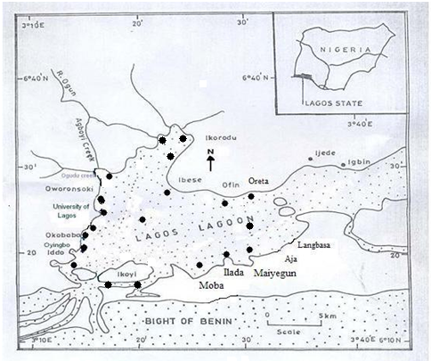
Figure 1: Map of the study area showing the sampling sites

Station Location N-coordinates E-coordinates
- Queen’s Drive N06⁰27.040’ E003⁰26.648’
- Park view N06⁰ 27.337’ E003⁰ 27.092’
- Moba N 06⁰ 27.724’ E 003⁰ 28.269’
- Ikate N 06⁰ 28.228’ E 003⁰ 28.988’
- Itedo N 06⁰ 27.476’ E 033⁰ 29.284’
- Off Itedo N 06⁰ 29.315’ E 003⁰ 30.021’
- Oreta N 06⁰ 31.954’ E 003⁰ 30.664’
- Ofin N 06⁰ 32.309’ E 003⁰ 30.003’
- Ibese N 06⁰ 32.116’ E 003⁰ 29.534’
- Nichemtex N 06⁰ 34.731’ E 003⁰ 28.557’
- Ikorodu port N 06⁰ 36.032’ E 003⁰ 28.835’
- Majedun N 06⁰ 36.383’ E 003⁰ 28.398’
- Iddo N06⁰ 28.032’ E003⁰ 23.024’
- Makoko N06⁰ 29.252’ E003⁰ 23.492’
- Abule Agege N06⁰ 30.197’ E003⁰ 23.558’
- Ogudu N06⁰ 33.494’ E003⁰ 24.145’

Collection and Analysis of Samples
Data on rainfall distributive pattern were obtained from the Federal Meteorological Department Oshodi, Lagos, Nigeria and the measurement was in mm. Surface water samples were collected with a 1dm³ water sampler and stored in 1litre water bottles and analysed in the laboratory for pH, conductivity, salinity and turbidity using a multi-meter water checker (Horiba U-10). Separate water samples were collected in 250ml dissolved oxygen bottles at each station for dissolved oxygen estimation using iodometric Winkler’s method. Air and surface water temperature were measured in situ using mercury-in-glass thermometers.

Benthic samples were collected with the use of Van-veen grab. The sediment samples collected were sieved through 0.5mm aperture size sieve. The materials retained in the 0.5mm sieve were then preserved in 5% formalin. Sorting was done to get the clean samples of the benthic organisms.

The sorted macro benthic fauna were identified to species level where possible. They were counted and numbers recorded. Identification was done after Edmund (1978), Yankson and Kendall (2001), Olaniyan, (1968), and Schneider (1990).

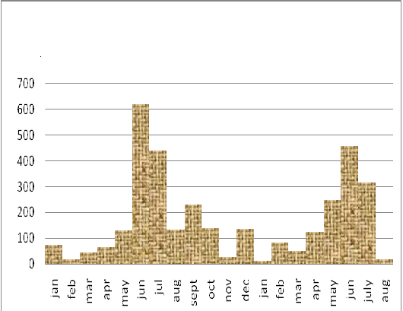
Months
Figure 2: Rainfall (mm) distribution Jan. 2008-Aug. 2009

Community Structure Analysis

Species Richness Index (d)
The Species richness index (d) according to Margalef (1951) was used to evaluate the community structure. The equation below was applied and results were recorded to two decimal places.
d = (S – 1)/ Loge N
Where:
d = Species richness index
S = Number of species in a population
N = Total number of individuals in S species.

Shannon and Wiener diversity index (H)
Shannon and Weiner (1949) diversity index (H) given by the equation:
Hs = Σ Pi 1n Pi

Where
Hs = Diversity Index
i = Counts denoting the ith species ranging from 1 – n
Pi= Proportion that the ith species represents in terms of numbers of individuals with respect to the total number of individuals in the sampling space as whole.

RESULTS

Water chemistry
Highest salinity recorded for the wet season was 3.10 º/_{oo} in Iddo sampling station. Most stations sampled in the wet season recorded a zero salinity indicating a freshwater condition. The dry season generally recorded high salinity with the highest value (32.0 º/_{oo}) recorded in Iddo sampling station. The highest pH value (9.1) for the period of study was recorded in the wet season at Ikate sampling station while the lowest value (6.56) was observed in the dry season at Ofin sampling station. Conductivity values were generally lower in the wet season than in the dry season. There were no significant differences in the values of both the air and water temperatures between the wet season and the dry season (P<0.05). The Dissolved Oxygen recorded for both wet and dry seasons at all the stations (except Makoko and Ogudu mouth in the dry season) were above the WHO standard (Table 1). Seasonal variations salinity, conductivity, turbidity and dissolved oxygen in the stations are presented in Figures 3-6.

Table 1: Physico-Chemical Parameters of the Water Samples

 |  | Queen’s Drive | Park view | Moba | Ikate | Itedo | Off Itedo | Oreta | Ofin | Ibese | Nichmtex | Ikorodu port | Majidun | Iddo | Makoko | Abule Agage | Ogudu Mouth
Air Temp. (^{O}C) | WS | 28.0 | 27.2 | 26.0 | 28.0 | 30.0 | 30.0 | 30.0 | 30.0 | 30.5 | 30.0 | 30.0 | 31.0 | 28.0 | 28.5 | 28.0 | 29.0
Air Temp. (^{O}C) | DS | 28.5 | 28.0 | 29.0 | 29.5 | 30.0 | 29.5 | 29.5 | 29.0 | 30.5 | 30.5 | 30.0 | 30.5 | 29.0 | 29.0 | 28.5 | 29.0
H₂O Temp. (^{O}C) | WS | 29 | 29 | 28 | 28 | 28.9 | 29 | 29 | 29 | 29.5 | 28 | 28 | 28 | 28 | 26.5 | 27 | 26
H₂O Temp. (^{O}C) | DS | 28.0 | 27.0 | 28.5 | 28.5 | 29.0 | 29.5 | 29.0 | 29.0 | 29.0 | 28.5 | 29.5 | 29.5 | 28.0 | 28.0 | 27.5 | 28.5
pH | WS | 9.1 | 8.9 | 9.0 | 9.1 | 8.9 | 8.8 | 9.2 | 8.9 | 9.0 | 9.0 | 8.8 | 9.1 | 8.10 | 7.96 | 7.69 | 7.81
pH | DS | 8.08 | 8.02 | 8.10 | 7.90 | 7.48 | 6.75 | 6.76 | 6.73 | 7.50 | 6.60 | 6.56 | 6.71 | 8.01 | 7.80 | 7.79 | 7.49
Conductivity  (mScm⁻¹) | WS | 0.84 | 1.0 | 0.64 | 0.67 | 0.61 | 0.12 | 0.19 | 0.3 | 0.24 | 0.54 | 0.18 | 0.61 | 5.84 | 1.10 | 0.39 | 0.17
Conductivity  (mScm⁻¹) | DS | 46.0 | 46.5 | 45.8 | 34.7 | 32.2 | 32.5 | 29.0 | 29.0 | 28.9 | 22.4 | 19.5 | 19.8 | 49.1 | 41.4 | 39.5 | 11.6
Turbidity  (NTU) | WS | 78 | 366 | 126 | 108 | 208 | 226 | 86 | 386 | 248 | 256 | 346 | 276 | 133 | 72.0 | 51.0 | 229.0
Turbidity  (NTU) | DS | 10 | 10 | 10 | 10 | 147 | 135 | 10 | 100 | 101 | 107 | 109 | 10.0 | 57.0 | 72.0 | 51.0 | 129.0
Salinity  (º/_{oo} ) | WS | 0.00 | 0.00 | 0.00 | 0.00 | 0.00 | 0.00 | 0.00 | 0.00 | 0.00 | 0.00 | 0.00 | 0.00 | 3.10 | 0.5 | 1.10 | 0.00
Salinity  (º/_{oo} ) | DS | 29.9 | 30.5 | 29.8 | 22.0 | 20.0 | 20.4 | 17.8 | 17.9 | 17.8 | 13.4 | 11.4 | 11.7 | 32.0 | 26.5 | 25.0 | 6.60
D.O (mgl⁻¹) | WS | 11.2 | 13.6 | 18.4 | 15.6 | 12.0 | 11.2 | 12.4 | 12.4 | 13.2 | 9.6 | 10.4 | 8.4 | 8.0 | 5.2 | 8.4 | 8.8
D.O (mgl⁻¹) | DS | 8.00 | 13.2 | 10.0 | 14.8 | 7.20 | 11.6 | 8.40 | 10.4 | 12.8 | 9.2 | 8.0 | 5.6 | 3.10 | 3.50 | 4.40 | 3.90

WS= Wet Season
DS= Dry Season

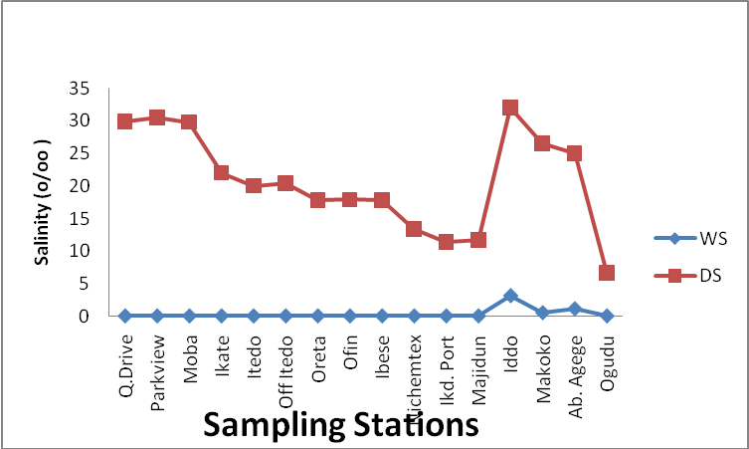
Figure 3: Seasonal Variations in Salinity/Station

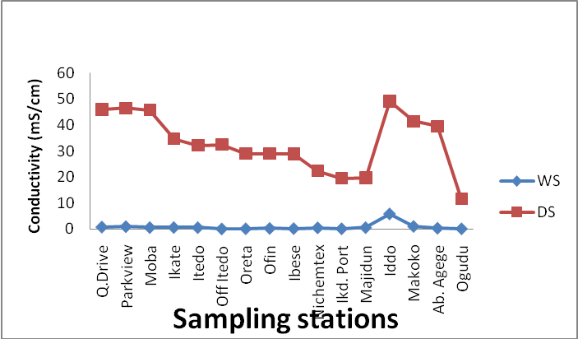
Figure 4: Seasonal Variations in Conductivity/Station

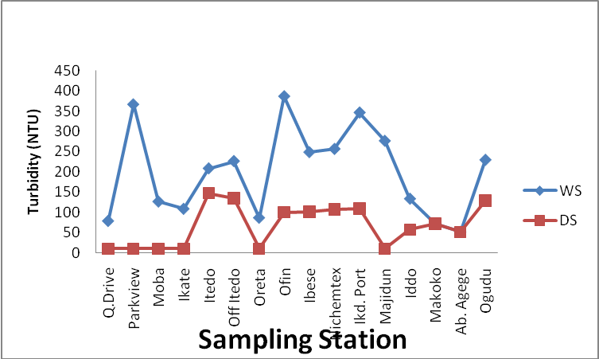 Figure 5: Seasonal Variations in Turbidity/Station

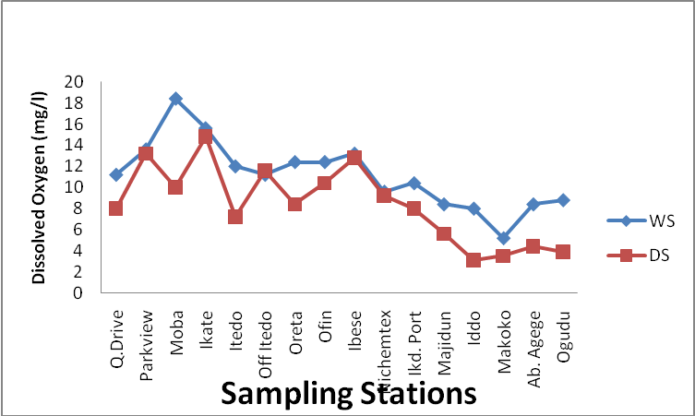

Figure 6: Seasonal Variations in D.O/Station

Population Dynamics of the Benthic Macroinvertebrates

A total of 788 individuals were sampled in the wet season accounting for 47.47% of total individuals sampled during the period of study. 872 individuals were sampled in the dry season which accounts for 52.53% of the total individuals sampled. More species were recorded in the dry season than in the wet season during the period of study. Tellina nymphalis, Clibanarius africanus, and Peneaus notialis sampled in the dry season were absent in all the station during the wet season. On the other hand, only Crassostrea gazar sampled in the wet season was absent in all the stations in the dry season.

The highest number of individuals (505) sampled in the wet season during the period of study was collected in Ofin sampling station accounting for 64.09% of the total individuals collected in the wet season during the period of study. In the dry season samples, the highest number of individuals (351) was collected in Oreta sampling station accounting for 40.25% of the total individuals collected during the period of study (Table 2). Figure 3 shows variations in total number of individuals collected in the sampling stations for the two seasons.

Table 2: Numerical Abundance and Occurrence of the Benthic
Macroinvertebrates

 |  | Q . Drive | Ikate | Itedo | Off Itedo | Oreta | Ofin | Ibese | Nichmtex | Ikd. Port | Majidun | Iddo I | Iddo IV | Makoko | Okobaba | Ab Agege | Midlgoon | Ogudu | Unilag frt | Total
Mytilus edulis | WS | _ | _ | 1 | _ | _ | 2 | _ | _ | _ | _ | _ | _ | _ | _ | _ | 17 | _ | _ | 20
Mytilus edulis | DS | 1 | _ | _ | _ | 11 | _ | _ | _ | _ | _ | 1 | _ | _ | _ | _ | _ | _ | 2 | 15
Aloides trigona | WS | _ | 1 | _ | _ | 6 | 85 | 1 | 2 | 27 | _ | _ | _ | _ | _ | _ | _ | _ | 1 | 123
Aloides trigona | DS | _ | _ | _ | 1 | 101 | 2 | _ | _ | 2 | _ | _ | _ | _ | _ | _ | _ | _ | _ | 106
I. truncate | WS | _ | _ | _ | _ | 21 | 65 | _ | 2 | 3 | _ | _ | _ | _ | _ | 3 | 3 | _ | _ | 97
I. truncate | DS | 55 | _ | _ | 4 | 119 | 2 | _ | 2 | _ | 1 | _ | _ | _ | _ | _ | 2 |  | 5 | 190
Tympanotonus sp | WS | _ | _ | _ | _ | 6 | 2 | _ | 2 | 2 | _ | _ | _ | 5 | 9 | 4 | _ | _ | 25 | 55
Tympanotonus sp | DS | _ | _ | 16 | _ | 1 | _ | _ | 1 | _ | 1 | _ | _ | 11 | 1 | _ | 7 | _ | 8 | 46
P. aurita | WS | _ | 13 | 3 | 1 | 5 | 273 | 1 | 6 | 4 | _ | _ | _ | _ | 2 | 6 | _ | _ | 58 | 372
P. aurita | DS | 1 | 26 | _ | _ | 12 | 45 | _ | 4 | _ | 2 | _ | _ | _ | 2 | 176 | 6 | 1 | _ | 275
Neritina glabrata | WS | 1 | 1 | _ | _ | _ | 18 | _ | 1 | 4 | _ | 1 | _ | _ | _ | 12 | _ | _ | _ | 37
Neritina glabrata | DS | _ | 5 | 1 | _ | 102 | 69 | _ | 4 | _ | _ | _ | _ | 2 | 2 | 7 | 3 | _ | 7 | 202
Neritna senegalensis | WS | _ | _ | _ | _ | 2 | 60 | _ | _ | _ | _ | _ | _ | _ | _ | _ | _ | _ | 4 | 66
Neritna senegalensis | DS | _ | _ | _ | _ | _ | 14 | _ | _ | _ | _ | _ | _ | _ | _ | _ | _ | _ | _ | 14
Nereis sp | WS | _ | _ | _ | 6 | _ | _ | _ | _ | 1 | _ | _ | _ | _ | 1 | _ | _ | _ | 2 | 10
Nereis sp | DS | 4 | _ | _ | _ | 1 | _ | _ | _ | _ | _ | _ | _ | _ | _ | _ | 2 | _ | _ | 7
Capitella  Capitata | WS | _ | _ | _ | 2 | _ | _ | _ | _ | _ | _ | _ | _ | _ | _ | _ | _ | _ | 4 | 6
Capitella  Capitata | DS | _ | _ | _ | _ | _ | _ | _ | _ | _ | _ | _ | _ | _ | _ | _ | 1 | _ | 1 | 2
Crassostrea gazar | WS | _ | _ | _ | _ | _ | _ | _ | _ | _ | _ | _ | _ | _ | _ | 2 | _ | _ | _ | 2
Crassostrea gazar | DS | _ | _ | _ | _ | _ | _ | _ | _ | _ | _ | _ | _ | _ | _ | _ | _ | _ | _ | 0
Tellina nymphalis | WS | _ | _ | _ | _ | _ | _ | _ | _ | _ | _ | _ | _ | _ | _ | _ | _ | _ | _ | 0
Tellina nymphalis | DS | 1 | 1 | _ | 2 | 4 | _ | _ | _ | _ | _ | _ | 1 | _ | _ | _ | _ | _ | _ | 9
Clibanarius Africana | WS | _ | _ | _ | _ | _ | _ | _ | _ | _ | _ | _ | _ | _ | _ | _ | _ | _ | _ | 0
Clibanarius Africana | DS | 1 | 3 | _ | _ | _ | _ | _ | _ | _ | _ | _ | _ | _ | _ | _ | _ | _ | _ | 4
Penaus notialis | WS | _ | _ | _ | _ | _ | _ | _ | _ | _ | _ | _ | _ | _ | _ | _ | _ | _ | _ | 0
Penaus notialis | DS | _ | 1 | _ | _ | _ | _ | _ | _ | _ | _ | _ | _ | _ | _ | _ | _ | _ | _ | 1
No. of Species | WS | 1 | 3 | 2 | 3 | 5 | 7 | 1 | 5 | 6 | 0 | 1 | 0 | 1 | 3 | 5 | 2 | 0 | 6
No. of Species | DS | 6 | 6 | 2 | 3 | 8 | 5 | 1 | 4 | 1 | 3 | 1 | 1 | 2 | 3 | 2 | 6 | 1 | 5
No. of Indiv. | WS | 1 | 15 | 4 | 9 | 40 | 505 | 1 | 13 | 41 | 0 | 1 | 0 | 5 | 12 | 27 | 20 | 0 | 94
No. of Indiv. | DS | 63 | 36 | 17 | 7 | 351 | 132 | 1 | 11 | 2 | 4 | 1 | 1 | 13 | 5 | 183 | 21 | 1 | 23

WS= Wet Season
DS= Dry Season

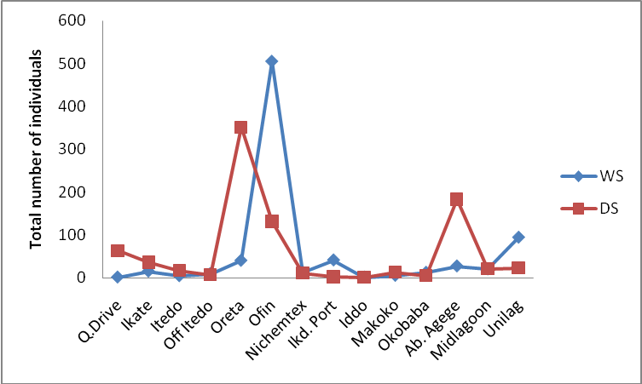 Stations
collected /Sampling stations
Figure 7: Seasonal variations in total number of individuals

Species Diversity and Richness Indices
The species diversity and richness indices of the study areas for the period of study are presented in Table 3.
The highest value of 1.60 for species diversity index was recorded in the dry season at Mid-lagoon sampling station while the highest for species richness (Margalef’s index) was also recorded in dry season and at the same sampling station. The highest number of individuals (505) sampled throughout the period of study was recorded in Ofin sampling station in the wet season (Table 3).

Table 3: Species Diversity and Richness Indices

Bio-indices |  | Queens Drive | Ikate | Itedo | Off Itedo | Oreta | Ofin | Nichmtex | Ikd. Port | Iddo | Makoko | Okobaba | Ab Agege | Midlagon | Unilag
Total species diversity (S) | WS | 1 | 3 | 2 | 3 | 5 | 7 | 5 | 6 | 1 | 1 | 3 | 5 | 2 | 6
Total species diversity (S) | DS | 6 | 6 | 2 | 3 | 8 | 5 | 4 | 1 | 1 | 2 | 3 | 2 | 6 | 5
Total Species abundance (N) | WS | 1 | 15 | 4 | 9 | 40 | 505 | 13 | 41 | 1 | 5 | 12 | 27 | 20 | 94
Total Species abundance (N) | DS | 63 | 36 | 17 | 7 | 351 | 132 | 11 | 2 | 1 | 13 | 5 | 183 | 21 | 23
Shannon-Wiener Index (Hs) | WS | 0 | 0.49 | 0.56 | 0.85 | 1.32 | 1.31 | 1.41 | 1.16 | 0 | 0 | 0.72 | 1.41 | 0.42 | 1.05
Shannon-Wiener Index (Hs) | DS | 0.56 | 0.91 | 0.22 | 0.96 | 1.39 | 1.07 | 1.26 | 0 | 0 | 0.43 | 1.05 | 0.16 | 1.60 | 1.41
Margalef’s Index (d) | WS | - | 0.74 | 0.72 | 0.91 | 1.08 | 0.96 | 1.56 | 1.34 | - | 0 | 0.80 | 1.21 | 0.33 | 1.10
Margalef’s Index (d) | DS | 1.21 | 1.11 | 0.35 | 1.03 | 1.19 | 0.82 | 1.25 | 0 | - | 0.39 | 1.24 | 0.19 | 1.64 | 1.28

DISCUSSION

Monthly rainfall volumes observed before, during and after the period of study is typical of a bi-modal rainfall distributive pattern recorded by earlier authors ( Chukwu 2002; Nwankwo et al. 2003; Edokpayi and Nkwoji 2007; Onyema, et al.2009) .The results of the air and water temperatures for all the stations during the period of study showed that temperature differences in the two seasons are highly negligible. This result agrees with earlier studies (Webb, 1960; Nwankwo, 2004; Edokpayi and Nkwoji, 2007) that temperature is not a major factor in tropical aquatic ecosystem. There were profound differences in the salinity values between the two seasons. According to Onyema, et al. (2009), the rainfall distributive pattern has great impact on the chemistry of the water of the lagoon. This impact is mostly expressed in the salinity values. This is because the rain water is a fresh water which when added to the lagoon water, greatly reduces the salinity.

The strong positive correlation in the values of salinity and conductivity recorded in this study as seen in Figures 3 & 4 is in agreement with studies carried out earlier in the lagoon (Ogunwenmo and Osuala, 2004; Edokpayi and Nkwoji, 2007; Onyema and Nkwoji, 2009). Conductivity and salinity have been previously reported as associated factors (Onyema and Nwankwo 2009). The water samples were more turbid in the wet season than in the dry season at all the stations during the period of study. The particulate matters brought into the lagoon by surface run-off and flood must have been responsible for the high turbidity recorded in the wet season.

Dissolved oxygen was also higher in the wet season and positively correlated with turbidity. Onyema et al (2009) had attributed high level of dissolved oxygen to the perturbation of water and this was prevalent in the wet season. A higher level of dissolved oxygen recorded during the wet season could also be linked to floodwater dilution and reduced resident time of the polluted water. Low dissolved oxygen was however recorded in the dry season at the western industrialised parts of the lagoon. According to Nwankwo and Akinsoji (1989) the Lagos lagoon is under intense pressure from pollution such as untreated sewage, sawdust, petrochemical materials, detergent and industrial effluents.

The composition, abundance and distribution of the benthic macroinvertebrates in the study area for the two seasons are presented in Table 2. In the wet season samples, 10 taxa were identified from a total of 788 individuals collected. This accounts for 76.9% and 47.47% of the total taxa and individuals respectively, collected during the period of study. For the dry season samples, 12 taxa were identified from a total of 872 individuals collected accounting for 92.3% and 52.53% of the total taxa and individuals respectively, collected during the period of study. The number of species and individuals sampled in the dry season was higher than in the wet season. Tellina nymphalis, Clibanarius africana, and Penaus notialis sampled in the dry season were absent in the wet season. Only one species (Crassostrea gazar) sampled in the wet season was absent in the dry season

The macrobenthic abundance and composition were low and the more dominant taxonomic groups were molluscs. There is an observable low diversity and low abundance of the benthic macro invertebrates in the sampling area. Some species such as Dosinia isocardia, Tagellus angulata, Tellina nymphalus, reported by earlier workers (Oyenekan, 1979, Ajao & Fagade, 1990 and Brown, 1991) in the lagoon were missing in this study.

Only one individual each of the bivalve Aloidis trigona was recorded in the western axis of the lagoon in the wet season. This agrees with similar observations by Ajao and Fagade (1990), that this benthic fauna was virtually absent from the western industrialised parts of Lagos lagoon which received a complex mixture of domestic and industrial wastes.

There is an observable overall low diversity of benthic macroinvertebrates in the study area. Both Margalef’s species richness (d) and Shannon-Weaver diversity index (H) were highest in the dry season. These values 1.64 and 1.60 respectively, were indicative of very low species richness and diversity of the study area. The sampling station with the highest value for both species richness and diversity (Midlagoon) is removed from land when compared with the other sampling stations and hence relatively shielded from land based stressors.

The macrobenthic abundance and composition at the study stations were low. This could be attributed to some ecological imbalance arising from alterations of some important factors governing the abundance and distribution of the benthic communities. Such factors include water quality, immediate substrates for occupation and food availability (Dance and Hynes, 1980). Therefore, it appears that the low macrobenthic invertebrate community abundance, composition and diversity may have been greatly affected by stress imposed by land based pollutants (Chukwu and Nwankwo, 2003). There is an indication of a general defaunisation of the lagoon for which reasons including pollution of the lagoon are plausible.

REFERENCES
Ajao, E.A and Fagade, S.O. (1990b). The
ecology of Capitella capitata in Lagos lagoon, Nigeria. Arch. Hydrobiol., 120(2): 229-239.
Ajao, E.A. and Fagade, S.O. (1991). Study of
the sediments and communities in Lagos lagoon, Nigeria. Oil and Chemical Pollution. Elsevier Science Publishers Ltd., England.
Brown, C.A. (1991). Community structure and
secondary production of benthic macrofauna of Lagos lagoon and harbour. M.Phil. Thesis, University of Lagos, Nigeria. 359pp.
Chukwu, L.O. and Nwankwo, D.I. (2003). The
impact of land based pollutants on the
hydrochemistry and macrobenthic community of a tropical West African creek. Diffuse Pollution Conference, Dublin pp.67-72.
Dance, K. W. and Hynes HBN. (1980). Some
effects of agricultural land use on stream insect communities. Environ Pollut Ser A. 1980: 22; 19 – 28.
Edokpayi, C.A. and Nkwoji, J.A. (2007).
Annual changes in the physico-chemical and macrobenthic invertebrate characteristics of the Lagos lagoon sewage dump site at Iddo, Southern Nigeria. Ecol. Env. & Cons. 13(1): 13-18.
F.A.O. (1969). Fisheries Survey in the Western
and mid-Western Regions of Nigeria. FAO/sf.74/NIR6. 142pp.
Ibe, A.C. (1988). Coastline Erosion in Nigeria.
Ibadan University Press, Ibadan. 147pp.
Margalef, D.R. (1951). Diversidad de especies
en les communideades natural Public Institutte of Biologic Barcelonia 9 : 5– 27.
Nwankwo, D.I. and Akinsoji, A. (1992).
Epiphyte community on water hyacinth Eichhornia crassipes (Mart.).Solms. in coastal waters of southwestern Nigeria. Arch. Hydrobiol., 124(4): 501-511.
Ogunwenmo, C.A. and Kusemiju, K. (2004).
Annelids of a West African Estuarine system. Journal of Environmental Biology 25(2): 227-237.
Ogunwenmo, C.A and Osuala, I.A. (2004).
Physico-Chemical Parameters and Macrobenthos of an Estuarine Creek and Artificial Pond in Lagos, Southwestern Nigeria. Acta SATECH 1(2): 128-132
Onyema, I.C. and Nkwoji, J.A. (2009). The
Water Chemistry and Plankton Dynamics of a Tropical High Energy Erosion Beach in Lagos. Journal of American Science, 2009, 5 (7)
Onyema, I.C. and Nwankwo, D.I. (2009).
Chlorophyll a dynamics and environmental factors in a tropical estuarine lagoon. Academia Arena. 1(1): 18 – 30.
Otway, N. M. and Gray, C.A. (1996).
Assessing the impacts of deepwater outfalls on spatially and temporally variable marine communities. Mar. Environ. Res., Oxford, 41:45-71.
Oyenekan, J.A. (1988). Benthic macrofaunal
community of Lagos lagoon, Nigeria. Nigeria Journal of Science. 21: 24-57.
Oyewo, E.O. (1998). Industrial sources and
distribution of heavy metals in Lagos lagoon and their biological effects on estuarine animals. Ph.D Thesis, University of Lagos, Nigeria. 279pp.
Pearson, T.H. and Rosenberg, R. (1978).
Macrobenthic succession in relation to organic enrichment and pollution of marine environment. Oceanogr. Mar. Biol. Ann. Rev., Aberdeen, 16:229-311
Pielou, E.C. (1969). An Introduction to
Mathematical Ecology John Wiley, New York, 286 pp
World Health Organisation(1984).
Guidelines for Drinking Water
Quality. W.H.O, Geneva

ACKNOWLEDGMENT
The authors are grateful to the Nigerian Institute for Oceanography and Marine Research, Lagos, Nigeria for providing most materials used for the collection and analyses of samples in this study.

17/10/2009

