Lesser Chamber Effect inside Open Top Chambers Provides Near-Natural Microenvironment for CO₂ Enrichment Studies in an Alpine Region of India
Ashish Kumar Chaturvedi,* Pratti Prasad and Mohan Chandra Nautiyal
High Altitude Plant Physiology Research Centre
Post Box No. -14, H N B Garhwal University
Srinagar Garhwal – 246174,
Uttarakhand, India
*ashi_spc@rediffmail.com,
ashispc@gmail.com
Abstract: Open top chambers (OTCs) were designed and established for the first time in an Indian alpine territory for revealing the effects of realistic elevated carbon dioxide (CO₂) concentrations on growth forms of alpine region of India in natural conditions. Comparison of the microclimatic parameters which affect the growth and physiology of alpine plants was done in three conditions viz. open field, polyhouse and OTCs to trace out the chamber effect inside OTCs. Present communication reveals the efficiency of Open Top Chambers for climate simulation techniques in Indian alpine region. Simple designing and construction of open top chambers make them the most probable method to be used for long-term elevated CO₂ revelation of alpine ecosystems. The operation of the system was satisfactory during the first growing season and repeatability of the gas treatments can be regarded well in this low cost exposure system. [Journal of American Science 2010;6(3):109-117]. (ISSN: 1545-1003)

Keywords: Climate change; Open Top Chambers; CO₂ enrichment; Alpine region; Garhwal Himalaya

1. Introduction
The Himalaya represents the largest mountain chain covering approximately 8 million km² in surface area and occupying a length of approximately 3000 km. Owing to enormous size and elevation, the Himalaya represents a complete transaction from tropical to temperate conditions despite its location near the tropics. Out of 7000 endemic species of plants found in India, over 3000 grow in the Himalayan region (Chatterjee, 1980). Whereas alpine environment is exceptionally variable and as a result of decreasing atmospheric pressure, the partial pressures of O₂ and CO₂ in the atmosphere fall with altitude. For overcoming all these adverse climatic factors, the alpine plants adapt themselves morphologically as well as physiologically. The prediction of global climate change has extracted a wide multiplicity of research in the past 25 years. One of the aspects that have received liberal attention is prickly rise in the atmospheric CO₂ concentration and the effects thereof on plant growth and functioning (Ward and Strain, 1999; Körner, 2001; Bazzaz and Catovsky, 2002). Changes in ecosystem carbon and water balance have been predicted to result from increased temperature and from the direct effect of rising CO₂ on photosynthesis and evapotranspiration. But ecosystem retorted for elevated CO₂ cannot be forecasted without field experiments, because the interface of elevated CO₂ with other environmental factors particularly temperature, nutrient and water supply is complex chiefly in alpine region. Such field experiments will essentially be enduring and the intrinsic inconsistency in native ecosystems experiments will require many replications. All experimental methods for exposing plants to altered atmospheric composition also alter the microenvironment which means that the need to understand the effect of the chamber microenvironment on the experimental results increases with the complexity of the questions concentrated on.
An immense work has already been done on the alpine communities of Garhwal (Semwal et al, 1981; Ram and Arya, 1991; Nautiyal et al, 1997) but to the best of our knowledge, research using climate simulation experiments in alpine region of India is still lacking. A simple hypothesis on climate change research needed in alpine region of India has been forecasted by some workers (Chaturvedi et al, 2007). Research investigations for climate change on plants have given three possible equipments, namely open-field CO₂ enrichment (FACE) systems (Mcleod and Baker, 1988), fully-enclosed chambers (Lucas et al, 1987) and Open top chambers (Heagle et al, 1973). The three techniques, namely FACE, OTCs and fully-enclosed chambers, have different performance/cost benefits and cannot be compared directly. The research reported in this communication identifies the sensitivity of OTCs microclimate, capabilities and limitations of open top chambers for elevated CO₂ studies and to demonstrate the potential applications in context to alpine regions of India.

2. Materials and methods
2.1 Site description
The selected site for the establishment of Open top chambers is the alpine field station (Figure1) of High Altitude Plant Physiology Research Centre of H.N.B. Garhwal University, Srinagar, Garhwal, situated at Tungnath (30⁰ 14'N Latitude and 79⁰ 13'E longitude at an altitude of 3600m above MSL). The heavy snowfall, frost, high wind velocity, low oxygen and carbon dioxide concentration have a great impact on the habit of plant species including their growth forms, life form and life cycle pattern. The site is also famous as treasury of diverse alpine medicinal plants.

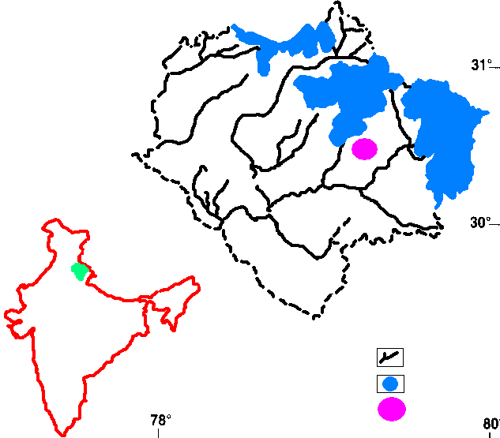
Tungnath
Snow cover area
River
Garhwal Himalaya
Garhwal Himalaya
Figure1. Location map of the study site

2.2 Indian Scenario regarding CO₂ enrichment facilities
For studying the response of crop plants under elevated CO₂ conditions in India design (3 m diameter x 3 m height) used for OTCs was according to South Asian climatic conditions (Uprety, 1998). These Chambers with frustum are being used by South Asian CO₂ research network for multi country multidisciplinary CO₂ crop response studies.
Besides Open Top Chambers, a new advanced “Free Air CO₂ Enrichment Technique” also provides a technology for enriching larger areas of vegetation with CO₂ for extended areas of vegetation with CO₂ for extended period of time at lesser cost per unit area than any other known technique. FACE concept of producing CO₂ concentration gradient experiments are done with promising results (Uprety et al, 2007).
2.3 Alpine scenario for CO₂ enrichment facilities in India
An alpine region due to its harsher climate is much tougher region to conduct climate change experiments. Thorny transportation and hard conditions

throughout the season makes it difficult for designing the experiments soon.
Therefore, we have designed the Open Top Chambers that can survive in harsher conditions of alpine. We have modified the design for alpine region as the vertically 3 m high OTCs can’t withstand the higher wind velocity of alpine. So, in this design the OTCs of 3 m diam. and 2.4 m in height are installed at the alpine region of Tungnath.
2.4 Specifications of OTCs used for CO₂ enrichment in alpine region of India
Structure of OTC having a size of 3m diameter x 2.4 m height. OTCs are made of square G.I. pipe 38mm x 38mm ± 1 mm with aluminium strips, leak proof auto closing doors. Complete structure fixed at 2’ below ground on a cement concrete platform up to 3’ from earth surface. Covering of OTCs is UV stabilized transparent low density polythene film 200 GSM with special distribution system. In CO₂ supply control solenoid valve and pressure gauge with timer were fitted within the air blower (along with connecting duct covered with polythene sheet). Chambers are equipped with a frustum at the top to deflect air and prevent dilution of the CO₂ concentration within the chamber. A cylindrical double walled plenum around the base for uniform CO₂ circulation. Inner side of the plenum was perforated with numerous gas outlets (Figure 2). Distribution of CO₂ was done using fan 12” blower. Blowers also helped in maintaining inside air temperature closure to that of outside ambient atmosphere. Double stage double meter gas regulator of brass fitted with stainless steel diaphragm suitable for CO₂ supply was used. CO₂ gas was supplied through this whole system using CO₂ cylinders of 20 Kg gas capacities fitted in a row.

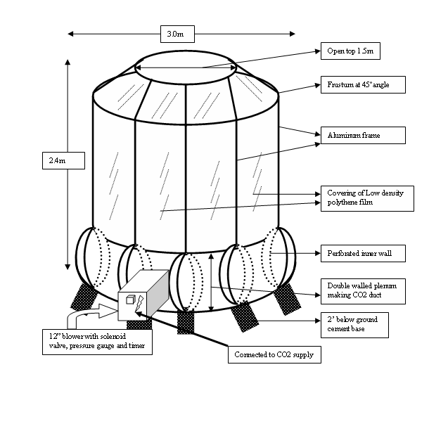
Figure2. Open top chamber design for alpine region of India

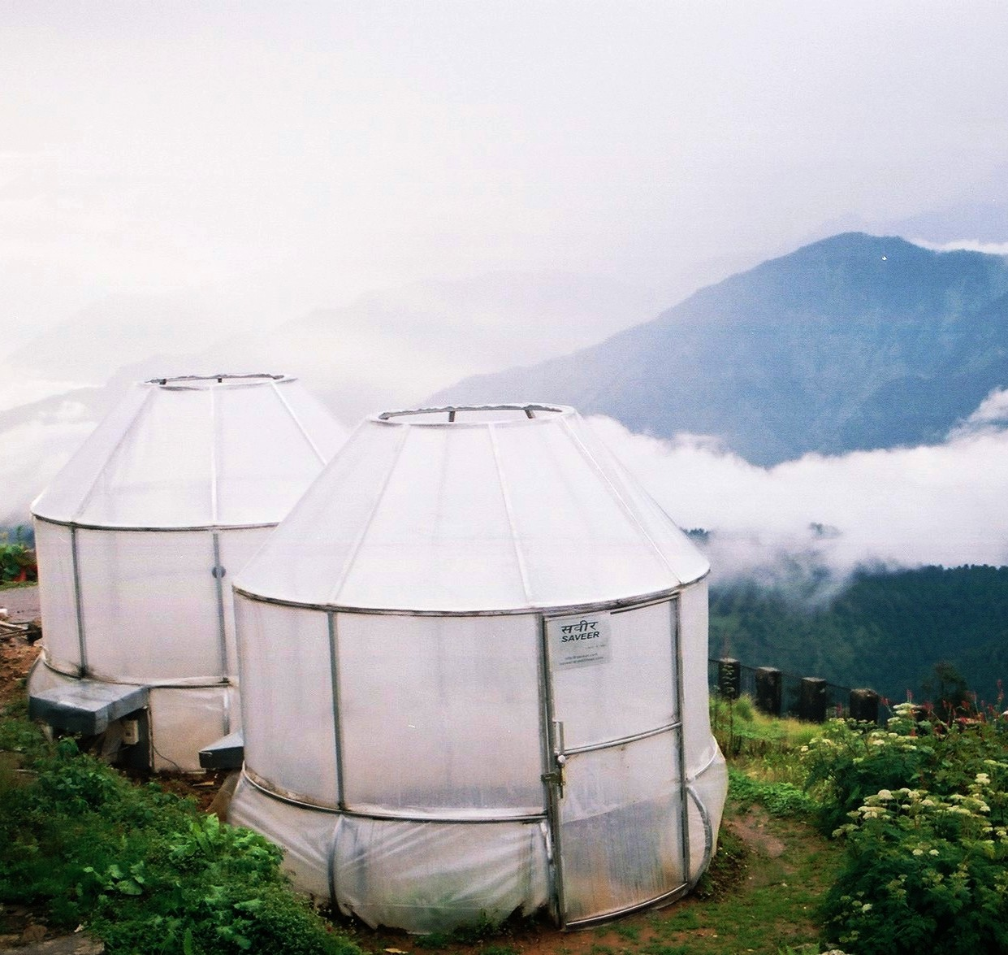
Open Top Chamber established at Tungnath (3600m above MSL), an alpine region of Garhwal Himalaya. (Photo credit: Ashish K.Chaturvedi)
2.5 CO₂ treatments and observations
In two installed Open Top Chambers (OTCs) one was treated as Control Open Top Chamber (COTC) in which ambient air was circulated and monitored whereas in other Open Top Chamber (EOTC) elevated CO₂ (600-700 µmolmol⁻¹) concentration was given. The pure carbon dioxide was supplied using 20 Kg gas capacity carbon dioxide cylinders. Air circulation was done to the chamber via air blowers located near the base of the chamber, and CO₂ was added to the incoming air maintaining a positive air pressure and flow within the chambers.
CO₂ and PAR (Photosynthetically active radiation) measurements were made by a portable Infra Red Gas Analyzer, IRGA (ADC, LCPro+ Hoddesdon, UK). Daily meteorological observations for air temperature, Humidity % and Soil temperature (15 cm Depth) inside OTCs, Polyhouse and in open conditions were done to compare the microclimatological variations. Monthly variations in CO₂ Concentration inside OTCs, Polyhouse and open conditions were recorded throughout the season from May 2008 to September 2008. For studying the diurnal variations, measurements were performed for cloudless days in the last week of May 2008. Data collected every two hours from 8:00 to 18:00 solar time were analyzed statistically.
3. Results and discussion
3.1 Variation in CO₂ concentration
A representative time course of CO₂ concentration in open and polyhouse condition is shown in Figures 3 whereas Figure 4 depicted the diurnal variation in COTC (control OTC) having ambient CO₂ and in EOTC (elevated open top chambers) having elevated CO₂. Results exemplify the natural diurnal variability of CO₂ concentrations inside polyhouse, open and in OTCs and the capability of the system to maintain separation between the ambient and elevated treatments. CO₂ concentrations vary at a single monitoring location and between monitoring locations within a chamber (Drake et al, 1989). But varying CO₂ concentration inside Open top chambers in comparison to polyhouse was attributed to the storming of air surrounding the chamber and was relative to outside wind speed. The enhancement in control achieved in the chamber with frustum confirms the importance of this design characteristic. Control of CO₂ concentration can be achieved without automated CO₂ delivery (Drake et al, 1989; Rogers et al, 1983). Little advantage in scheming spatial variations in CO₂ concentrations is probably to be achieved by automating CO₂ control because these variations are mainly determined by outside wind velocity and interior variations in turbulence. Figure 8 shows the monthly variation in CO₂ concentration in different conditions.
3.2 Temperature differences
Temperature plays an important role in morphophysiology of alpine plants. Keeping this fact in view this is very necessary to see how much variation in temperature occurs inside the OTCs. Air temperature within open top chambers used in studies of crop species are commonly reported to be less than 1°C greater than air temperatures outside the chambers, but in an extensive study of the environment in open top chambers, some workers (Weinstock et al, 1982) found temperature differences of up to 3.7°C. Monthly variation in min/max temperature and air temperatures of OTC, polyhouse and open conditions are shown in Table 1 and 2 respectively. Temperature difference in the OTCs was non significant in all months except in May where on average 2.0⁰C increased was observed in comparison to polyhouse where the increase in min as well as max temperature was significantly higher. Air temperature differences between Control OTCs (COTC) and elevated OTC (EOTC) were not much affected by CO₂ treatment (Figure5). Temperature differences can be minimized by using a high aeration rate.
3.3 Humidity
Humidity % was slightly higher inside the open top chambers than in open condition but statistically non significant whereas in case of polyhouse a significant increase in humidity was observed throughout the season (Table 3).

Figure 3. Diurnal Changes of CO₂ concentration in Open and polyhouse conditions

Figure 4. Diurnal Changes of CO₂ concentration inside Open Top Chambers

Figure 5. Diurnal changes of temperature inside Open Top Chambers

Figure 6. Diurnal variation of PAR in Open Top Chambers, Polyhouse and Open conditions

Figure 7. Monthly variation in Photosynthetically Active Radiation (PAR) in Open, Polyhouse and OTC

Figure 8. Monthly variation in CO₂ concentration in Open, Polyhouse and OTC

Table 1. Monthly variation in min/max temperature in different conditions
Minimum temperature (⁰C) | Open | Polyhouse | OTC | P value (LSD)
May | 6.27±1.70 | 11.60±2.46* | 8.27±1.64* | <0.001(1.31)
June | 8.23±1.68 | 12.73±3.18* | 8.53±1.61 | <0.001(1.51)
July | 8.93±2.15 | 11.77±2.67* | 9.13±2.40 | <0.001(1.61)
August | 9.90±1.09 | 15.87±1.59* | 10.53±0.78 | <0.001(0.80)
September | 6.63±1.33 | 14.57±1.01* | 6.90±1.18 | <0.001(0.78)
October | 4.23±1.45 | 9.60±4.86* | 4.53±1.41 | <0.001(2.02)
Months X Conditions | P<0.001
Maximum temperature (⁰C) | Open | Polyhouse | OTC | P value (LSD)
May | 16.53±3.54 | 21.07±5.85* | 18.70±3.03 | <0.001(2.87)
June | 20.70±4.68 | 30.60±5.47* | 21.07±1.93 | <0.001(2.86)
July | 19.83±1.82 | 30.27±3.83* | 20.03±2.41 | <0.001(1.87)
August | 20.47±1.41 | 32.80±1.99* | 20.83±1.42 | <0.001(1.08)
September | 18.07±2.21 | 32.73±4.42* | 18.53±2.05 | <0.001(2.05)
October | 12.67±4.88 | 26.10±6.08* | 11.73±1.28 | <0.001(3.03)
Months X Conditions | P<0.001
*significant

Table 2. Monthly variations in air temperature in different conditions

Solar Time | Conditions | May | June | July | August | September | October | Months X  Conditions
8.00 | OPEN | 11.83±3.13 | 13.33±2.55 | 13.43±2.46 | 12.60±1.92 | 10.83±2.44 | 6.70±2.04 | <0.001
8.00 | POLYHOUSE | 15.60±4.88* | 21.07±5.84* | 17.77±3.43* | 21.33±3.77* | 20.87±3.54* | 11.13±1.53* | <0.001
8.00 | OTC | 13.23±3.10 | 13.47±2.94 | 13.47±3.13 | 12.90±1.71 | 11.13±2.29 | 7.20±1.92 | <0.001
8.00 | P Value (LSD) | <0.001(2.53) | <0.001(2.70) | <0.001(2.02) | <0.001(1.75) | <0.001(1.90) | <0.001(1.22)
12.00 | OPEN | 17.00±3.63 | 18.47±6.27 | 16.53±2.96 | 14.50±1.53 | 13.40±2.03 | 11.87±1.81 | <0.001
12.00 | POLYHOUSE | 21.73±3.81* | 22.47±3.76* | 22.03±3.79* | 25.87±4.22* | 26.43±5.28* | 18.60±2.01* | <0.001
12.00 | OTC | 18.83±3.81 | 18.97±3.72 | 17.50±2.60 | 14.97±1.35 | 13.77±1.65 | 12.13±1.50 | <0.001
12.00 | P Value (LSD) | <0.001(2.49) | <0.01(3.15) | <0.001(2.10) | <0.001(1.80) | <0.001(2.26) | <0.001(1.19)
4.00 | OPEN | 15.33±3.27 | 17.60±7.67 | 13.20±2.89 | 14.00±1.86 | 13.27±3.59 | 10.73±1.87 | <0.001
4.00 | POLYHOUSE | 21.17±3.73* | 22.43±3.43* | 17.33±4.80* | 22.43±3.38* | 25.47±6.47* | 17.13±1.93* | <0.001
4.00 | OTC | 16.73±3.18 | 18.10±2.22 | 14.87±2.21 | 14.40±1.33 | 13.97±2.91 | 11.10±1.49 | <0.001
4.00 | P Value (LSD) | <0.001(2.27) | <0.001(3.34) | <0.001(2.31) | <0.001(1.57) | <0.001(3.05) | <0.001(1.18)
*significant

Table 3. Monthly variations in % Humidity in different conditions

Solar  Time | Conditions | May | June | July | August | September | October | Months X  Conditions
8:00 | OPEN | 50.20±13.39 | 70.23±12.09 | 63.83±13.94 | 66.33±14.97 | 65.33±17.65 | 47.20±11.46 | <0.001
8:00 | POLYHOUSE | 72.90±8.97* | 78.50±7.20* | 73.57±10.51* | 70.90±11.46 | 74.37±6.14 | 72.43±3.52* | <0.001
8:00 | OTC | 54.60±12.59 | 70.40±11.76 | 64.60±12.97 | 67.87±12.74 | 67.33±14.82 | 50.67±9.70 | <0.001
8:00 | P Value (LSD) | <0.001(7.85) | <0.01(7.04) | <0.01(8.34) | >0.05(8.73) | <0.05(9.15) | <0.001(5.92)
12:00 | OPEN | 41.00±12.95 | 62.73±10.79 | 56.57±12.51 | 58.00±12.65 | 55.20±11.33 | 44.53±9.12 | >0.05
12:00 | POLYHOUSE | 50.93±13.88* | 71.03±7.11* | 70.47±12.17* | 64.90±13.98 | 64.90±13.98* | 50.63±10.47* | >0.05
12:00 | OTC | 45.97±12.73 | 63.07±10.08 | 57.03±11.84 | 59.20±10.93 | 56.53±10.29 | 46.53±7.76 | >0.05
12:00 | P Value (LSD) | <0.05(8.77) | <0.01(6.29) | <0.001(8.09) | >0.05(8.36) | <0.01(7.96) | <0.05(6.10)
4:00 | OPEN | 50.10±16.23 | 60.23±8.86 | 52.77±14.38 | 54.80±16.54 | 53.87±14.66 | 47.50±11.40 | >0.05
4:00 | POLYHOUSE | 60.63±16.77* | 67.27±8.14* | 68.80±11.66* | 61.07±8.81 | 68.53±9.88* | 53.87±14.66 | >0.05
4:00 | OTC | 51.13±10.60 | 60.63±7.99 | 53.90±13.62 | 57.50±12.84 | 55.50±12.21 | 48.57±10.15 | >0.05
4:00 | P Value (LSD) | <0.05(9.84) | <0.01(5.54) | <0.001(8.82) | >0.05(8.72) | <0.001(8.25) | >0.05(8.12)
*significant

Table 4. Monthly variations in soil temperature in different conditions

Solar  Time | Conditions | May | June | July | August | September | October | Months X  Conditions
8:00 | OPEN | 11.73±2.03 | 12.10±2.66 | 13.50±2.22 | 13.43±2.37 | 12.93±1.82 | 10.30±2.77 | >0.05
8:00 | POLYHOUSE | 15.83±2.59* | 16.30±2.76* | 18.17±2.17* | 16.93±2.27* | 16.57±1.52* | 12.73±3.47* | >0.05
8:00 | OTC | 11.87±2.16 | 12.23±2.31 | 13.73±2.02 | 13.83±2.13 | 13.00±1.74 | 10.67±2.56 | >0.05
8:00 | P Value(LSD) | <0.001(1.51) | <0.001(1.72) | <0.001(1.42) | <0.001(1.50) | <0.001(1.13) | <0.01(1.96)
12:00 | OPEN | 14.67±3.46 | 15.20±3.00 | 16.13±3.20 | 16.00±3.14 | 15.53±3.09 | 12.13±4.07 | >0.05
12:00 | POLYHOUSE | 17.97±2.77* | 17.90±3.13* | 20.37±3.15* | 19.33±2.86* | 19.30±1.90* | 14.40±3.99 | >0.05
12:00 | OTC | 14.80±3.27 | 15.23±3.00 | 16.40±2.98 | 16.67±2.43 | 15.70±2.91 | 12.27±3.85 | >0.05
12:00 | P Value (LSD) | <0.001(2.11) | <0.001(2.02) | <0.001(2.06) | <0.001(1.87) | <0.001(1.78) | >0.05(2.63)
4:00 | OPEN | 13.50±3.29 | 13.30±3.75 | 11.90±3.10 | 12.90±1.97 | 12.60±1.65 | 11.50±2.83 | <0.05
4:00 | POLYHOUSE | 15.90±3.33* | 16.50±3.28* | 17.13±3.01* | 16.27±2.35* | 15.90±1.84* | 13.13±3.48 | <0.05
4:00 | OTC | 13.60±3.12 | 13.33±3.72 | 12.07±2.95 | 13.37±1.30 | 12.87±1.41 | 11.77±2.39 | <0.05
4:00 | P Value (LSD) | <0.01(2.15) | <0.001(2.38) | <0.001(2.00) | <0.001(1.27) | <0.001(1.09) | >0.05(1.95)
*significant
Table 5. Comparison of diurnal reductions of photosynthetically-active radiation (PAR) through polyhouse and Open Top Chambers

Solar Time | (PAR) Open | (PAR) Polyhouse |  | (PAR) OTC
 | µmolm⁻²s⁻¹ | µmolm⁻²s⁻¹ | % reduction | µmolm⁻²s⁻¹ | % reduction
8:00 | 1056.17±13.38 | 671.75±6.18 | 36.39 | 932.60±138.20 | 11.7
10:00 | 1908.00±74.26 | 1272.00±11.53 | 33.33 | 1631.75±48.04 | 14.51
12:00 | 1840.60±123.25 | 1172.56±75.06 | 36.26 | 1584.39±3.21 | 13.92
14:00 | 704.67±18.04 | 530.67±2.52 | 24.69 | 606.15±5.51 | 13.98
16:00 | 628.33±4.04 | 392.33±14.22 | 37.55 | 552.93±3.79 | 12
18:00 | 431.00±6.71 | 310.00±7.70 | 28.07 | 370.66±15.58 | 14
20:00 | 37.00±2.89 | 15.73±3.54 | 57.48 | 31.73±3.57 | 14.24

3.4 Soil temperature
Soil temperature inside the Open top chambers with little variations remains closer to the open ambient conditions in comparison to polyhouse where a significant increase in soil temperature throughout the season was recorded (Table 4).
3.5 Solar radiation dwindling
Intense solar radiation in alpine region makes the alpine vegetation to have special physioanatomical acclimation to high irradiance. Thus, necessity of less light attenuation inside open top chambers makes them easy to conduct the CO₂ enrichment studies in alpine region. Generally, solar radiation is attenuated 10-20% by open top chambers (Drake et al, 1989; Weinstock et al, 1982; Heagle et al, 1979; Sanders et al, 1991)
In this study, we have found about 12-14% decrease inside OTCs in comparison to polyhouse where the decrease was near about 33-35%. A diurnal course of incident PAR inside OTCs, polyhouses compared with open ambient condition is depicted in Figure 6. Table 5 shows comparison of diurnal % reduction of PAR in polyhouse and Open top chambers in relation to open condition. In case of monthly variation in incident PAR same pattern was observed. Figure 7 depicts that there was a significant variation in PAR in different conditions throughout the season.
4. Conclusion
In alpine environment, the dynamics and functionality are controlled by low-temperature conditions, are considered to be particularly sensitive to climate change and global warming (Körner, 1999, IPCC, 2001). Hence effect of elevated CO₂ will have unpredictable impact on the alpine plants of India. Therefore, forecasting of dynamism of morpho-physiological and biochemical response of alpine plants under elevated CO₂ can only be possible with a leak proof CO₂ enrichment facility. The system described for CO₂ exposure of alpine ecosystem is simple and many replications in a harsh natural ecosystem are possible. This makes it a cost-effective means of gathering the requirements for field research on the effect of CO₂ on alpine ecosystems. There are several research needs to improve the open top chamber as a field experimental tool in context to alpine region of India. The combined effect of increased atmospheric humidity and temperature with increased CO₂ on plant growth in the field is also desirable to be addressed. We do declare that building these systems is easy, only that these systems are intrinsically simpler than others, provided that the effects on microenvironment are not as much as inside polyhouse, Open top chambers are probably the only practical option at present for studies on effects of elevated atmospheric CO₂ on Alpine ecosystems of India. Thus establishment of Open Top Chambers in Alpine of Tungnath (at 3600m above MSL) in Garhwal Himalaya will certainly be fruitful in observing the impact of increasing CO₂ concentration on alpine plants in context to global climate change and its response on alpine plants of India.
Acknowledgement
We wish to acknowledge the assistance of Dr. R. K. Vashistha, Miss. Neelam Rawat, Mr. S. S. Rawat, Mr. Girish Nautiyal and Mr. Karan Singh in the field. Thanks are due to Prof. A. R. Nautiyal, Director, HAPPRC for providing necessary facilities. The research was supported by a grant (14/3/2006-ERS/RE) from Ministry of Environment and Forest (MoEF), New Delhi.
Correspondence to:
Ashish Kumar Chaturvedi
High Altitude Plant Physiology Research Centre
Post Box No. -14, H N B Garhwal University
Srinagar Garhwal – 246174, Uttarakhand, India
Phone No. – 09411056641 (M), 01346252172 (O)
Fax No. – 01346252070
ashi_spc@rediffmail.com
ashispc@gmail.com

References
- Chatterjee, D., Studies on the endemic flora of India and Burma. Jour. Asiat. Soc. Bengal, 1980, vol. 5, pp. 19-67
- Ward, J. K., and Strain, B. R., Elevated CO₂ studies: past, present and future. Tree Physiol., 1999, vol 19, pp. 211-220.
- Korner, C., Biosphere responses to CO₂ enrichment. Ecological Applications, 2001, vol. 10, pp. 1590-1619.
- Bazzaz, F. A. and Catovsky, S., Impact of global environmental change on plants: From cells to ecosystems. In: Mooney HA, Canadell JG, eds. Encyclopedia of global environmental change, Chichester, UK: Wiley, 2002, vol. 2, pp. 94-111.
- Semwal, J. K., Gaur, R. D. and Purohit, A. N., Floristic patterns of Tungnath alpine zone in Garhwal Himalaya. Acta. Botanica. Indica., 1981, vol. 9, pp. 110-114.
- Ram, J. and Arya, P., Plant forms and vegetation analysis of an alpine meadow of Central Himalaya, India. Proc. Ind. Nat. Sci. Acad., 1991, vol. 57, pp. 311-318.
- Nautiyal, B. P., Pandey, N. and Bhatt, A. B., Analysis of vegetation pattern in an alpine zone in north–west Himalaya: a case study of Garhwal Himalaya with reference to diversity and distribution patterns. Ind. J. Ecol. Envir. Sci., 1997, vol. 23, pp. 49-65.
- Chaturvedi, Ashish K., Vashistha, R. K., Prasad, P. and Nautiyal, M. C., Need of innovative approach for climate change studies in alpine region of India. Curr. Sci., 2007, vol. 93(12), pp. 1648-1649.
- Mcleod, A. R. and Baker, C. K., The use of open field systems to assess yield response to gaseous pollutants. In: W. Heck, O.C. Taylor and D.T. Tingey (Editors), Assessment of Crop Loss from Air Pollutants, ISBN 1-85166-244-8. Elsevier Applied Science, Barking, 1988, pp. 181-210.
- Lucas, P. W., Cottom, D. A. and Mansfield, T. A., A Large-Scale Fumigation System for investigating Interaction between Air Pollution and Cold Stress on Plants. Environ. Pollut., 1987, vol. 43, pp. 25-28.
- Heagle, A. S., Body, D. E. and Heck W. W., An open top field chamber to assess the impact of air pollution on plants. Environ. Quai., 1973,vol. 2, pp. 365-368.
- Uprety, D. C., Carbon dioxide enrichment technology: Open top chambers a new tool for global climate research, J. Sci. Ind. Res., 1998, vol. 57, pp. 266-270.
- Uprety D.C., Bisht, B. S., Dwivedi, N., Saxena, D. C., Mohan, R., Raj, A., Paswan, G., Mitra, A. P., Garg, S. C., Tiwari, M. K., Maini, H. K., and Singh, D., Comparison between Open Top Chamber (OTC) and Free Air CO₂ Enrichment (FACE) Technologies to study the responses of rice cultivars to elevated CO₂. Physiol. Mol. Biol. Plants, 2007, vol. 13(3&4), pp. 259-266.
- Drake, B. G., Leadley, P. W., Arp, W. J., Nassiry, D. and Curtis, P. S., An open top chamber for field studies of elevated atmospheric CO₂ concentration on salt marsh vegetation. Funct. Ecol., 1989, vol 3, 363-371.
- Rogers, H. H., Heck, W. W. and Heagle, A. S., A field technique for the study of plant responses to elevated carbon dioxide concentrations. Air Poll. Contr. Ass., 1983, vol. 33, pp. 42-44.
- Weinstock, L., Kender, W. J. and Musselman, R. C., Microclimate within open-top air pollution chambers and its relation to grapevine physiology. Am. Soc. Hort. Sci. 1982, vol. 107, pp. 923-929.
- Heagle, A. S., Philbeck, R. B., Rogers, H. H. and Letchworth, M. B., Dispensing and monitoring ozone in open-top field chambers for plant-effects studies. Phytopath., 1979, vol. 69, pp 15-20.
- Sanders, G. E., Clark, A. G., and Coils, J. J., The influence of open top chambers on the growth and development of field bean. New Phytol., 1991, vol. 117, pp. 439- 447.
- Körner, C., Alpine Plant Life: Functional Plant Ecology of High Mountain Ecosystem. Springer, Berlin, 1999.

- IPCC, Emissions Scenarios. Special Report of the Intergovernmental Panel on Climate Change [Nakicenovic, N. and R. Swart (eds.)]. Cambridge University Press, Cambridge, United Kingdom and NewYork, NY, USA, 2001, pp. 599.

11/20/2009

