Biodegradation of Produce Water Hydrocarbons by Pure Cultures of Alcaligenes sp.

Chuma C Okoro ¹, Olukayode O Amund ²

¹ Department of Biological Sciences and Biotechnology, Caleb University, Lagos
² Department of Botany and Microbiology, University of Lagos, Nigeria
chuma2k2001@yahoo.com

Abstract: Biodegradation studies of hydrocarbons in untreated produce water from an oil production facility in Nigeria was undertaken over a period of time using pure cultures of Alkaligenes sp. Isolated from Escravos River where produce water was being discharged as at the time the studies were carried out. Gas chromatography and mass spectrometry were used to monitor the rate of reduction in some petroleum hydrocarbon fractions while the index used to evaluate biodegradation was the decreasing trend in the ratios of nC17/Pristane and nC18/Phytane. Gas chromatographic analysis showed that untreated produced water used for the study had an oil and grease content of 1407mg/L, this includes n-alkanes (608mg/L), Aromatics (13.88mg/L), NSO compounds (12.68mg/L) PAHs(0.833mg/L) and some unidentified greasy components. Upon mechanical treatment, the oil and grease component of produce water was reduced to 44mg/L comprising of n-alkanes (38.40mg/L), Aromatics (2.65mg/L), NSO compounds (1.78mg/L), PAHs (0.0655mg/L) and some unidentified greasy component. A pure culture of Alcaligenes sp. after 40 days of exposure to untreated produced water reduced the oil and grease content to 19.58mg/l comprising of n-Alkanes (16.87mg/l), Total aromatics (1.25mg/l), NSO compounds (0.98mg/l) and PAH (0.0096mg/l). This result indicate that produce water is readily biodegradable and pure cultures of Alcaligenes sp. used for the study were very efficient in the degradation of produced water hydrocarbons especially the recalcitrant PAH component when compared with the conventional mechanical treatment process. [Journal of American Science 2010;6(4):107-113]. (ISSN: 1545-1003).

Key words: Pure culture, Produce water, Biodegradation, Hydrocarbon, Alcaligenes sp.

1. Introduction
Produce water is a by-product of the production of oil and gas hydrocarbons from underground oil reservoirs. When the hydrocarbons are produced, the water component is separated from the oil and gas at the initial stage of processing. For offshore operations, separated produce water is treated and discharged into the sea. Produced water constitutes a source of chronic pollution to the marine environment since it is continuously discharged into the sea over a very long period of time.
The chemical properties of produce water that could cause harmful effect to marine organisms include its elevated salinity, altered ion ratios, low dissolved oxygen, heavy metals, biocides, petroleum hydrocarbons and other organics (Middleditch, 1984). The fate of these components when discharged into the environment will depend upon the chemical and physiochemical properties of the individual components, the properties of the receiving environment as well as the metabolic versatility of the biota in that environment (Neff, 1988).
Produce water are known to be toxic to fishes and other marine animals (Middleditch, 1984). A major cause for concern in recent times has been the presence of polycyclic aromatic hydrocarbons (PAHs) such as anthracene, phenanthrene, benzo(a)pyrene, and benzo(a) anthracene in produced water (OGP, 2002). Some of these compounds are recalcitrant and potential carcinogens and they have the capability to bio-accumulate in food chains since they are not easily degradable (Neff, 1985).
The issue of bio-accumulation or recalcitrant organic compounds from produce water in the marine sediment is a possibility because the produce water treatment systems currently in use by most oil production companies are primarily designed to remove particulate or dispersed oil and therefore has little effect on the concentrations of the dissolved petroleum hydrocarbons such as aromatics and other organics in produce water (Lysyj, 1982).
Biological treatment (breakdown of hydrocarbons by microorganisms) has been suggested in some circles as the best means of breakdown and removal of dissolved aromatic hydrocarbons in produced water (OGP, 2002). Produce water has been proved to be readily biodegradable and both pure and mixed microbial cultures have been used successfully to degrade petroleum hydrocarbons in produce water (Andrea et al, 2001, Okoro and Amund, 2002, Okoro, 2008).
In the present study, an attempt was made to use an ubiquitous bacterial isolate from Escravos river, an Alcaligenes sp. which was isolated around the produce water discharge zone to degrade various components of produce water hydrocarbons with much emphasis on the recalcitrant polycyclic aromatic hydrocarbons (PAHs). Alcaligenes sp. has been known to be excellent hydrocarbon degraders (Krooneman et al, 1996), they are small gram negative rod like bacteria and most species are found in marine environment. Some members of this group like the A. dinifricans, A. odorans, and A. eutrophus are known to be excellent hydrocarbon degraders including the polycyclic aromatic hydrocarbons (Weissenfeis et al, 1990, Harayama et al, 1999).
The aims and objectives of the present study therefore is to evaluate the biodegradation potentials of the Alcaligenes sp. isolated around the discharge zone of produce water discharge into the marine environment, especially as it relates to the polycyclic aromatic hydrocarbon components of the produce water hydrocarbon.

2. Materials and Methods:

Sample Collection
Untreated produce water samples were collected with sterile 1000 L Wheaton glass bottles at a point before the final process stream of the Wemco treatment plant at Chevron’s Escravos tank farm while the treated produce water samples were collected at a point after the final process stream where it is being discharged to the receiving water.

Enumeration of hydrocarbon utilizing bacteria:
Hydrocarbon utilizing bacterial counts in produced water samples were obtained by using the mineral salts medium of Mills et al ( 1978 ). The composition of the medium is as follows in ( g/L ): NaCl ( 10 ), MgSO₄.7H₂0 ( 0.42 ), KCl ( 0.29 ), KH₂PO₄ (0.83), Na₂HP O₄ (1.25 ), NaNO₃ ( 0.42 ), Agar bacteriological ( 15 ), and pH adjusted to 7.2. The medium was autoclaved at 1.1 kg/cm² for 15 min. The inoculated mineral agar plates were then inverted over sterile membrane filters moistened with crude oil ( Escravos light ) and held in the lid of the Petri dishes. The dishes were wrapped round with a masking tape so as to increase the vapor pressure within the Petri dishes while the plates were incubated at 29 ⁰C for 6 days after which the growth of hydrocarbon degrading bacteria were observed and counted.

Analytical methods:
Separation of Aliphatic and Aromatic components of hydrocarbons in produced water using High Performance Liquid Chromatography ( HPLC ).
A measured quantity of the oil sample (10ml) was introduced into the bond elute filter to separate the hydrocarbons from the Nitrogen, Sulfur and Oxygen (NSO) containing components of the petroleum mixture. The filtrate (2 ml) containing both the aliphatic and the aromatic components of the petroleum mixture was injected into the HPLC (WATERS 486). The aliphatic component eluted after 18mins while the aromatic component after 45mins. Each fraction ( 0.2 μL ) was subsequently analyzed by means of Gas chromatography attached to a mass selective detector.

Analysis of Total hydrocarbons, n-Alkanes and Polyaromatic hydrocarbons.
The method used in the analysis was described by Neff et al, (1989). The hydrocarbon extract was concentrated in a Kuderna-Danish flask on a 70⁰C water bath to approximately 1.0 ml. The concentrated extract was transferred to a 1-dram vial with a disposable pipette and the flask rinsed twice with 1 ml methylene chloride. The rinses were added to the vial and the volume of the extract was reduced to about 1ml with a gentle stream of purified nitrogen gas.
Total n-alkanes and aromatic concentrations were determined by GC-MS analysis of the F1 and F2 fractions respectively. Both resolved and unresolved hydrocarbons were quantified. The resolved concentrations were determined by summing the total resolved area with valley integration and then using an average n-alkane or PAH response factors to calculate an amount relative to the internal standard. The unresolved concentrations were calculated by integrating the total area of the chromatogram ( both resolved and unresolved complex mixture ( ucm area ), subtracting the resolved area and determining the amount relative to the internal standard.

Gas Chromatography of Oils
Fresh and degraded oil were analyzed by Gas chromatography using Hewlett Packard 5890 series 11 Gas chromatograph equipped with single flame ionization detector (FID) fitted with Perkin Elmer Nelson analog digital converter ( 900 series ) and a Compaq deskpro computer. A J and W scientific DB-1 capillary column of 15 m length and an internal diameter of 0.32 mm wide bore of 1micron film thickness was used. A temperature program of 50-305⁰C increasing at 3.5⁰C per minute for 27.15min was employed. Hydrogen with a flow rate of 2ml per min was used as a carrier gas while the flow rate of air was 400ml per min. The detector temperature was 325⁰C while the injection port temperature was 305⁰C. The oil extracts of culture supernatants were dissolved in methylene chloride while a sample volume of 0.2μl was injected. The nC17/Pristane and nC18/Phytane ratios were subsequently calculated from the height of various chromatograms.

Biodegradation and Growth studies
Growth and degradation studies over a time course were carried out using untreated produce water from Escravos tank farm as the sole carbon and energy source. The untreated produce water used for the study had an initial oil and grease content of 1407 mg/l. Starter cultures were originally prepared using the minimal salts formulations of Mills et al, 1988 and the produce water as the sole carbon and energy source. 5 ml. of the pure bacterial culture broth ( Alcaligenes sp.) was introduced into 500mL of produce water in a 1000 mL capacity wheaton glass bottle. The bottle was covered with a non-absorbent cotton wool and placed in a slanted position to allow air passage through the pores of the cotton wool. Appropriate controls were set up with sterile produce water broth without the test organism. The bottles were shaken manually at regular intervals to allow adequate mixing and homogeneity of the contents. The experimental setup was monitored for a period of 40 days and at every 10 day interval, cultural samples were collected and analysed for microbial load while the residual hydrocarbon was extracted with methylene chloride and analysed by Gas chromatography.

3. Results
The Untreated and Mechanically Treated Produce Water
The untreated produce water used for the experiment had an oil and grease content of 1407mg/L comprising of n-Alkanes (608mg/l), aromatics (13.88mg/l), NSO compounds (12.68 mg/l) and PAHs (0.833mg/l) and an initial nC17/Pristane and nC18/Phytane ratios of 1.41 and 2.93 respectively while the mechanically treated produced water used as a reference had an initial oil and grease content of 44mg/l comprising of n–alkanes ( 38.4 ), aromatics (2.65), NSO compounds (1.78) and PAHs (0.0655) and an initial nC17/Pristane and nC18/Phytane ratios of 1.24 and 3.0 respectively. The GC chromatograms of both the untreated and the mechanically treated produced water are shown in Figs. 1 and 2 respectively.

Biodegradation of Produced water hydrocarbons with pure cultures of Alcaligenes sp.
The GC Chromatograms of untreated produce water after 40 days of exposure to pure cultures of Alkagenes sp. are shown in Figure 3, while the corresponding nC17/pr. And nC18/ph. Ratios are shown in Figure 4. It was observed that after 40 days of exposure, the pure culture of Alcaligenes sp. reduced the oil and grease content of produced water from 1407mg/l to 19.58mg/l comprising of n-Alkanes (16.87mg/l), Total aromatics (1.25mg/l), NSO compounds (0.98mg/l) and PAH (0.0096mg/l). On the corresponding levels of nC17/pr. and nC18/ph. Ratios, it was observed that both ratios dropped below 1 at day 40 and this signifies significant biodegradation.

4. Discussion
Alkagenes sp is a predominant microbial flora of Escravos river, found mostly within the discharge zone of produce water effluents (Okoro, 1999). The evaluation of its biodegradation potential is therefore necessary because of the persistence of significant soluble hydrocarbon fractions from produce water around the discharge zone.
Most Alkaligenes sp. are known to be good hydrocarbon degraders (Krooneman et al, 1996), some species like Alkaligenes odorans, A. dinifricans, and A.eutropheus have been implicated in the degradation of Polyclorinated biphenyls in mixed culture (Clark, 1979) while others have been implicated in the degradation of Polycyclic aromatic hydrocarbons ( Weissenfel et al, 1990) but produce water hydrocarbons have not been implicated in any of these studies.
The Alkaligenes sp. used in the present study degraded total petroleum hydrocarbons in produce water from its original concentration of 1407 mg/l to 19.58mg/l after 40 days of exposure. The PAHs were equally degraded from its original concentration of 0.833mg/l to 0.0096mg/l. These results were better when compared with the total TPH and PAH levels of mechanically treated produce water which were 44 and 0.0655 mg/l respectively. The degradation profile and pattern of Alkaligenes sp. used in the study was similar to the results obtained with pure cultures of Achromobacter sp. (Okoro and Amund, 2002), the only difference was that Alkaligenes species were more predominant than Achromobacter in mixed cultures.
The index used to monitor the progress of biodegradation is the rate of decrease in the ratios of nC17/Pristane and nC18/Phytane. Pritchard and Coaster (1991) used the same index to monitor the progress of biodegradation during the EPA Alaska oil spill biodegradation project. The application of this concept is based on the principle that during biodegradation, decreases of total oil residues could occur because of other non biological processes, thus changes in hydrocarbon composition that are indicative of biodegradation must be measured accurately. This is done historically by examining the weight ratios between hydrocarbons known to be readily biodegradable such as the C17 and C18 alkanes and those that biodegrade slowly such as the branched alkanes (Pristane and Phytane) but with very close chromatographic behaviour. A weight ratio less than 1 signifies considerable biodegradation Pritchard and Coaster (1991).

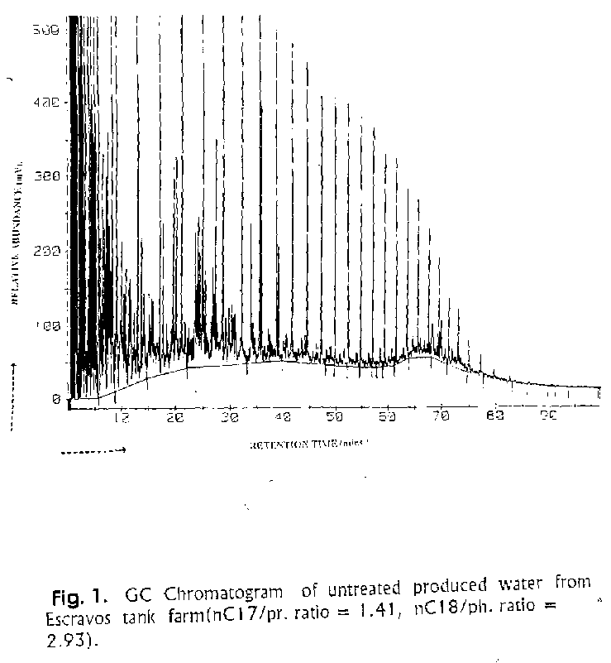
Retention Time (Mins)
Relative Abundance (mV)

Figure 1: GC Chromatogram of untreated produced water from Escravos tank farm (nC17/pr. Ratio = 1.41, nC18/ph. Ratio = 2.93)

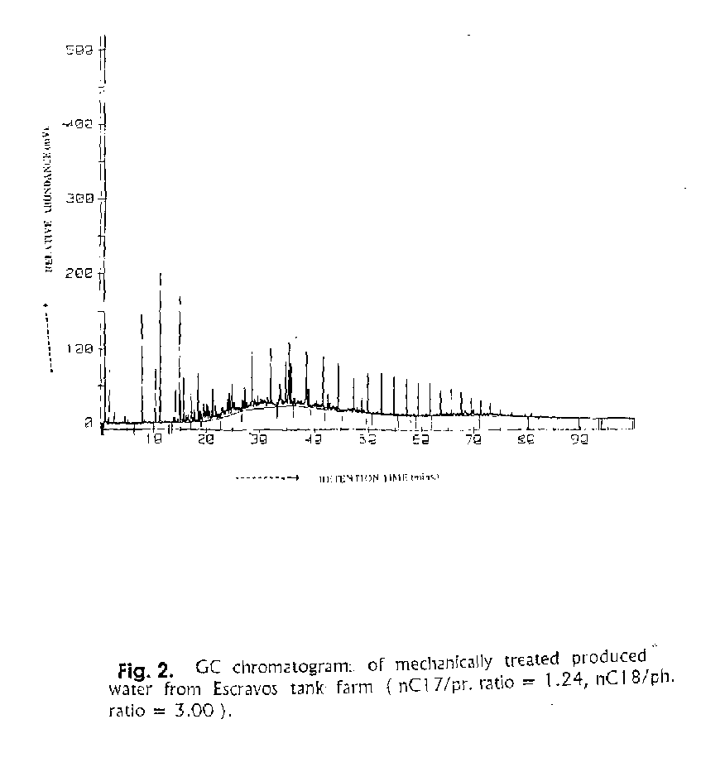
Retention Time (Mins)
Relative Abundance (mV)
Figure 2: GC Chromatogram of mechanically treated produced water from Escravos tank farm (nC17/pr. Ratio = 1.24, nC18/ph. Ratio = 3.00)
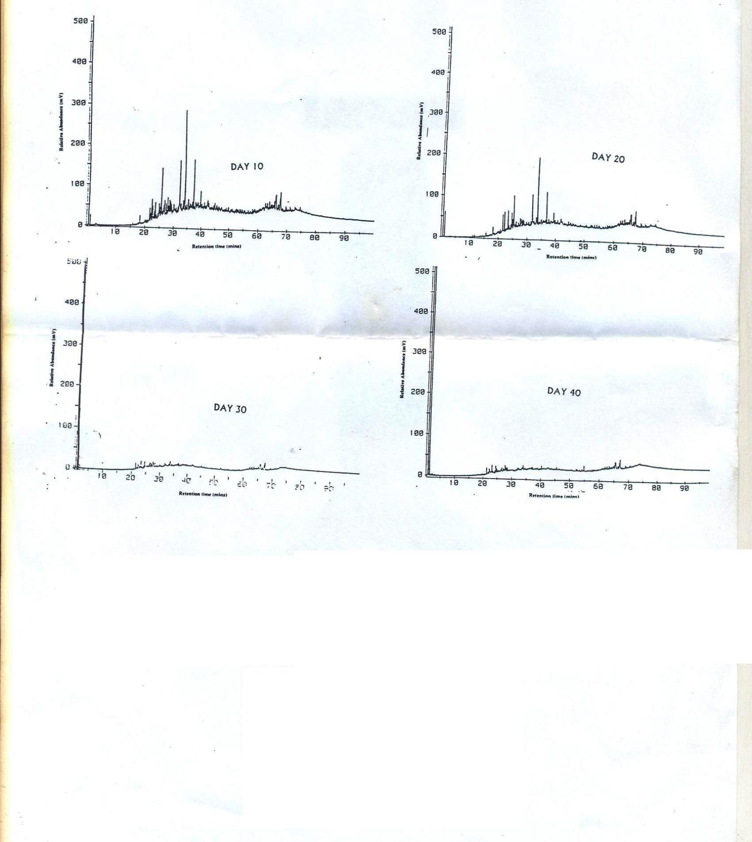
Relative Abundance (mV)
Relative Abundance (mV)
Retention Time (mins)
Retention Time (mins)
Retention Time (mins)
Retention Time (mins)
Relative Abundance (mV)
Relative Abundance (mV)
Fig.3. GC Chromatograms of untreated produce water after a 40 day exposure to a pure culture of Alcaligenes sp.

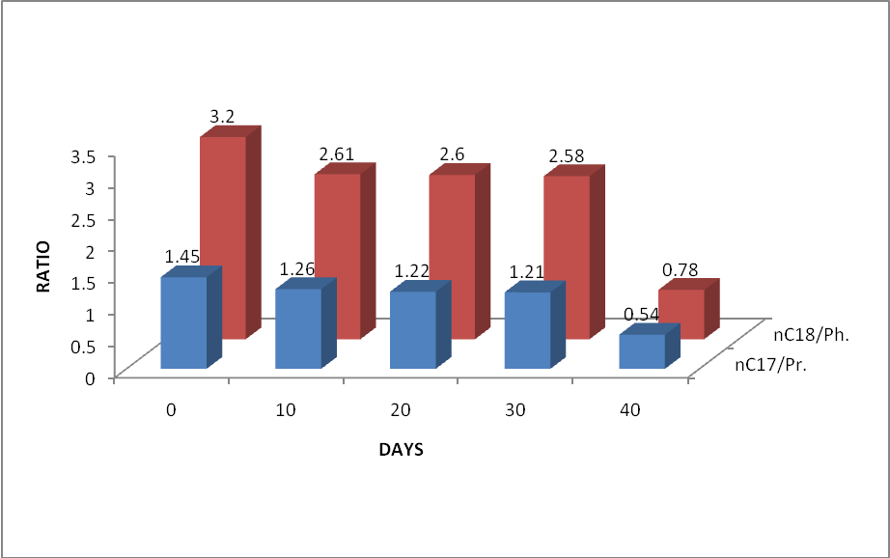
Fig. 4: Biodegradation of untreated produce water with pure cultures of Alcaligenes sp. The result is evaluated as decrease in nC17/Pristane and nC18/Phytane ratios

After 40 days of exposure of produce water with pure cultures of Alkaligenes sp., the weight ratios of nC17/Pristane and nC18/Phytane was less than 1 (0.54 and 0.78 respectively ) and this according to Pritchard and Coaster (1991) signifies significant biodegradation.
In conclusion therefore it can be advanced that Produce water effluents from Chevrons Escravos tank farm used in the study is readily biodegradable and the Alkaligenes sp. found within the vicinity of produce water discharge zone are capable of degrading produce water hydrocarbons and most especially the sparingly soluble components such as PAHs that are very difficult to remove with the conventional mechanical treatment presently in use. This is a sure indication that the Alkaligenes sp. that dominate microbial activities at the discharge zone of produce water effluents can be beneficial to the environment because of its excellent hydrocarbon degradation potential.

Acknowledgements
Chevron Nigeria Limited is gratefully acknowledged for providing facilities and logistics for this research.

Corresponding Author:
Dr. Chuma C Okoro
Department of Biological Sciences and Biotechnology
Caleb University, Lagos Nigeria
Tel: 08033072754, 01-7430285
E-mail: chuma2k2001@yahoo.com
P. O. Box 146, University of Lagos Post Office, Lagos, Nigeria

References:
- Andrea RC, Tania AA, Lucia RD Biodegradation of polycyclic aromatic hydrocarbons by soil fungi. Braz. J. Microbiol. 2001; 32(4 ):124-129.
- Ayers RC, Parker, M. Offshore Produce water management-Technical report to CAPP. 2003. No:29125.
- Clark RR. Biodegradation of Polychlorinated biphenyls with mixed cultures of Alkaligenes sp. Appl. Environ. Microbiol. 1979; 37(4):680-685.
- Harayama S, Keshira H, Kasai Y, Shutsubo K. Petroleum Biodegradation in Marine Environments. J. Molec. Microbiol. Biotechnol. 1999;1(1):63-70
- Krooneman, J, Wieringa EB, Moore ER, Gerritse J, Prius RA, Gottschal JC. Isolation of Alkaligenes sp. strain L6 at low oxygen concentration and degradation of 3-chlorobenzoate via a pathway not involving Chlorocathecols. Appli. Environ. Microbiol. 1996;62(7):2427-2434.
- Lysyj L. Chemical composition of produced water in some off- shore oil platforms. Report to USEPA Municipal Environmental Research Lab. Cincinnati, OH. 1982 ;600/ 282-034.
- Middledich BS. Ecological effects of produced water discharges from offshore oil and gas production platforms. Final report on API project. American Petroleum Institute, Washington, D.C. 1984 NO. 248.
- Mills AL, Breuil C, Colwell RR. Enumeration of petroleum-degrading marine and estaurine microorganisms by the most probable number method. Can. J. Microbiol. 1978. 24: 552-557
- Neff JM. The potential impacts of drilling fluids and other effluents from exploratory drilling in the living resources.. R.H.Bachus (ed.) Cambridge Massachusetts. 1985;224
- Neff JM, Sauer TC, Maciolec N.. Fate and Effects of Produce water discharges in near shore marine waters. American Petroleum Institute, Washington D.C. API Publication No. 4472. 1989.
- OGP. Aromatics in Produce water: Occurence, Fate, Effects and Treatment. OGP Publications. No. 1.20/324, 2002. International Oil and Gas Producers England.
- Okoro CC. Microbial degradation of hydrocarbons in produced water from crude oil production operations in Escravos tank farm. Ph.D. Thesis, University of Lagos. 1999;269 .
- Okoro CC, Amund OO. Biodegradation of hydrocarbons in untreated produce water using pure and mixed microbial cultures.;J. Sci. Tech. and Environ. 2002;2(2): 14-23
- Okoro CC. Biodegradation of hydrocarbons in untreated produce water using pure fungal cultures. Afr. J. Microbiol. Res. 2008 2:217-223.
- Pritchard, P. H. and Coaster, C.F. EPA’S Alaska oil spill bioremediation project. Environ. Sci. Technol. 1991;25 (3): 372-373
- Read AD. Treatment of oily water in North Sea Oil installations. In: Oil Water Discharges; Regulatory, Technical and Scientific Considerations. Johnson C.S.and Morris, R.J. (ed). Applied Science Publishers, Barking Essex, England. 1978;127-136.
- Weissenfeis WD, Beyer M, Klein J, Rehm HJ. Microbial metabolism of Fluoranthene by pure bacterial cultures. Appl. Microbiol. Biotechnol. 1990;32:479-484.

02/11/2010

Dr. Chuma C Okoro is presently a senior lecturer
at the Department of Biological Sciences and Biotechnology
Caleb University, Lagos, Nigeria.

