Nano structural characteristics of Zirconium Sulphide thin films

R. Thiyagarajan¹, M. Mahaboob Beevi ², M. Anusuya ²

- Urumu Dhanalakshmi College, Trichy, Tamil Nadu, India
- Trichy Engineering College, Trichy, Tamil Nadu, India
beevi75@yahoo.co.in, anu51069@yahoo.com

Abstract: Spray deposition and characterization of zirconium sulphide (ZrS₂) thin films deposited onto a glass plates at 430⁰C from an aqueous solution containing zirconium oxy chloride (ZrO₂Cl₂.8H₂O) and thiourea (CH₄N₂S) is discussed in this manuscript. Two different films were prepared by varying the molarity of zirconium oxy chloride and thiourea. The prepared films were characterized by X-ray diffraction analysis (XRD), scanning electron microscopy (SEM) and optical absorption techniques. Systematic XRD analysis of the film clearly indicates the polycrystalline hexagonal phase of the film with (110) orientation. The average grain size of the film is calculated using Scherrer’s relation and it is found to be 18 nm. SEM study shows that the total substrate surface is well covered with densely packed nanotubes. The spectral absorption coefficient of the film at the fundamental absorption region (400nm-900nm) was determined using the spectral data of absorbance. The energy band gap (Eg) was determined from Tauc’s plot and it is found to be 2.55eV.
[Journal of American Science 2009;5(6):6-12]. (ISSN: 1545-1003).

Key words: thin films; spray pyrolysis; nano structures

1. Introduction
Recently, considerable progress has been made in the synthesis of metal chalcogenide semiconductor nanostructures due to their important physical properties and their great potential applications [Murray, et al 1995; Spanhel,et al 1987; Bawendi, et al 1990; Brus,1999; Weller,et al 1993] These fascinating systems are expected to exhibit remarkable optical, electrical, and structural properties that are quite different from those of their corresponding bulk materials [Huang,et al 2001;. Wang, et al .2002; Liao, et al 2002]. Transition-metal sulfides have wide utility in catalytic and electronic applications because of their high sulfur bond energies, their oxophilicity, as well as their intrinsic electronic and structural properties [Ilona Kretzschmar et al 2006]. ZrS₂ belongs to the group 4B transition metal dichalcogenides which are semiconductors with layered structures. In the past many experiments on the optical properties of the group 4B transition metal dichalcogenides including ZrS₂ and HfS₂ have been reported. Greenaway and Nitsche [Greenaway, et al 1965] found the indirect transition in the absorption edge of ZrS₂ and HfS₂. The DICHALCOGENIDES of transition metals steadily attract a great attention of researchers due to the variety of their properties that are of both fundamental and practical interest [Hughes, et al 1977]. Thin films of zirconium based material can be prepared by number of technique which includes Plasma enhanced CVD method [Maskell,2000] Chemical vapor deposition [Bertrand,et al 1997; Cameron, et al 1999], and spray method [Brusaco, 1989]. Among the various thin film deposition technique available home built spray pyrolysis [Wuttiphan, et al 1997] technique is particularly attractive because of its low cost commercially scalable route for uniform deposition of zirconium sulphide thin films over large area substrate [Thiagarajan, et al 2001; Chen, et al 1995; Malik et al 1998]. To the best of our knowledge, no report is available for ZrS₂ thin film. On account of the numerous applications of zirconium sulphide thin film, an attempt has been made to prepare zirconium sulphide film using the spray method. In the present manuscript, we report, for the first time, the synthesis of ZrS₂ thin films by spray technique.

2. Experiment
2.1. Preparation of Thin Films
Two different Zirconium sulphide thin films were prepared by varying the molarity of zirconium oxy chloride and thiourea and were deposited on an optically flat well cleaned glass substrate by using a home made double nozzle sprayer. The 50 ml of the spray solution was prepared from aqueous 0.01 M of zirconium oxy chloride (ZrOCl₂.8H₂O); 0.01 M of thiourea (CS(NH₂) ₂). The chemicals used in this deposition process were of analytical grade. The atomized chemical solution is sprayed on to the preheated substrate maintained at 430⁰C with the help of compressed air as carrier gas. The carrier gas flow rate was maintained at 3ml/min at a pressure of 2kg/cm². The distance between the spray nozzle and the substrate is 35 cm. To avoid excessive cooling of the substrate, spraying was done with time gap of 30 seconds between successive spray. Details of this setup have been published elsewhere [Thiagarajan, et al 2001]. If the substrate temperature is too high(>500⁰C) the spray gets vaporized before reaching the substrate and the film becomes almost powdery, whereas at optimum substrate temperature (i.e.) in the range of 230⁰C - 450⁰C, the spray reaches the substrate surface in the semi vapour state and complete oxidation will takes place to give clear thin film as a final product which is observed in our experiment. By increasing the molarity ratio of Zirconium oxy chloride and thiourea to 0.02M: 0.02M in the precursor solution another set of Zirconium Sulphide thin films were deposited without changing the other process parameter. For each molarity the reproducibility of the films were verified by repeating the experiments several times. Basically, film thickness is very sensitive function to various preparative parameters such as deposition time, temperature, spray rate, spray interval and molar concentrations. In our studies, all other parameters (except molarity) were kept at their optimum values. The terminal thickness of the film was measured by loss of weight method and it is found to be in the order of micrometer. The thickness of ZrS₂ thin film prepared with 0.01M and 0.02M are found to be 1.2 micrometer and 1.4 micrometer respectively. This was consequently verified by the cross sectional studies of the film using Scanning Electron Microscope (SEM). Here, the film is mounted vertically to measure the thickness directly [Chen, et al 1995]. An increase in film thickness with increasing molarity has been observed. It is clear that, as the solution molarity increases, the amount of material that participates in forming the deposited film increases with subsequent increase in the film thickness.

3. Result and Discussion
3.1 XRD Studies
XRD pattern of the Zirconium Sulphide films were studied at room temperature by using RIGAKU diffractometer (model RAD II A) with CuKα radiation (1.5418 Å) where other radiations are suppressed using Ni filter. The data were recorded at a scan rate of 0.2⁰/min and in the range of 20⁰<2θ<80⁰. The crystallinity pattern of as deposited films (0.01M and
Figure 1. XRD pattern of ZrS₂ thin film
0.02M of Zirconium Sulphide) on clean glass substrate prepared by spray pyrolysis technique at 430⁰C is shown in figure (1). Observation of the film shows smooth surface and well adhesive nature of the film with substrate. The peaks observed in all the diffractograms confirm the nanocrystalline nature of the ZrS₂ film. The pattern also reveals that the film is polycrystalline with hexagonal crystal structure having preferential orientation along (110) plane. No other impurities peaks are observed. Also the intense peak oriented along (110) lattice plane indicates that the growth of the grains is parallel to the substrate. The other strong peaks observed correspond to (101) and (201) orientations. The diffraction peaks appears in the spectrum have been identified as 31.94⁰, 49.48⁰ and 60.46⁰ which are verified with the known patterns of standard X-Ray diffraction data file (JCPDS file No:03-1099), While comparing the X-ray diffraction pattern of 0.01M and 0.02M ZrS₂ it is obvious that, Bragg peaks became more intense for higher concentration indicating a clear improvement in crystallinity. X-Ray diffraction line broadening (XDLB) was used to estimate the grain size of the film by utilizing Scherer’s formula [Berry, 1967; Bragg, 1912],
$D=\left(\frac{\text{Kλ}}{\text{βcosθ}}\right)$ (1)
Where k is the shape factor constant (0.89), λ is the wavelength of CuKα line, θ the Bragg’s angle, β is the full width half maximum (FWHM) of intense peak. The mean crystallite size of ZrS₂ calculated using Scherer’s equation is 28nm for both 0.01M and 0.02M. Here, the grain size calculated by Scherer’s formula is less than 50 nm. This small grain size is due to the evaporation of individual fine droplets during the spray process [Ma, et al 1977].
3.2. Optical Studies

A computer controlled ELICO make (SL 159 UV-VIS) single beam spectrophotometer was used to obtain absorbance (A) of undoped Zirconium Sulphide thin films over wide wavelength range of 420nm - 900nm at room temperature with unpolarized radiation. The experimental accuracy of the absorbance is ± 0.005 and the wavelength is ±0.05nm. The observed absorbance data were corrected relatively to optically identical uncoated glass substrate. The absorption spectra of the undoped Zirconium Sulphide with molarity of 0.01M and 0.02M prepared at 430⁰C were recorded as a function of wavelength range 420nm - 900nm with glass as the reference is shown in figure (2). It shows the representatives of optical absorbance which reveals that the absorbance of the film decreases gradually with increase in wavelength. It is clear from the graph that, in the visible region there is no significant change in band edge by increasing the molarity of the solution from 0.01M - 0.02M. This implies that the basic crystal structure is not changed [Agarwal,et al 2006]. It also shows that as the molarities of the film increases from 0.01M - 0.02M there is a drastic increase in absorbance. The overall increase in absorbance with increase in molarity may be associated with the increase in film thickness. This is because in the thicker films more atoms are present in the film so more states will be available for the photons to be absorbed [Nadeem et al 2000]. Transmittance spectra recorded for as deposited film as a function of wavelength is shown in figure (3). The plot shows a sharp rise in transmittance near the band edge attributed to the good crystallinity of the film [Al-Sabayleh,et al 2008]. Transmittance spectra of as deposited films show a narrow range of variation with the increase in molarity of the precursor solution. Here the film deposited with lower molarity (0.01M of ZrS₂) shows higher transmittance (>85%). This property of high transmittance makes it a good material for optical coatings. The decrease in the transmittance with increase in molarity may be due to increasing absorption. It can be seen from the transmittance spectra that the films are transparent even in the shorter wavelength region of the visible spectrum. Hence the films are considered as almost absorption free in the higher wavelength region of the visible spectrum. Typical spectral variation in reflectance and absorbance is nearly similar in all cases. The variation in the reflectance with wavelength of the film shows low value in all the region of the visible spectrum as in figure (4). But, the films prepared from higher molarity shows higher reflectance value. This is consistence with the visual appearance of the films surfaces particularly for larger thickness. Therefore, the film thickness is another cause added to the effect of surface roughness, which participates in the drastic enhancement of film transmission for films prepared with lowest solution concentration.
Figure 2. Absorbance spectra of ZrS₂ thin film
Figure 3. Transmittance & Reflectance of ZrS₂ films
The absorption co-efficient (α) is calculated using Lambert’s law [Hoffmann, et al 1997]:
$α=\left(\frac{2\text{.}\text{303 A}}{t}\right)$ (2)
Where ‘A’ is the absorbance, ‘t’ is the thickness of the film, neglecting the reflection co-efficient which is negligible and insignificant near the absorption edge. The absorption co-efficient (α) calculated is found to be in the order of 10⁵cm⁻¹. The high α value (>10⁴) confirms the existence of direct band gap [Tarsame,et al 2004]. According to Tauc [Tauc,1974] it is possible to separate three distinct regions in the absorption edge spectrum of amorphous semiconductors. The first is the weak absorption tail, which originates from defects and impurities, the second is the exponential edge region, which is strongly related to the structural randomness of the system and the third is the high absorption region that determines the optical energy gap. The optical band gap Eg was calculated using Tauc’s plot (αhν)² Vs hν. The photon energy at the point where (αhν)² is zero represents Eg, which is determined by extrapolation of the linear portion of the curve. The typical plots of (αhν)² versus hν for undoped Zirconium Sulphide thin films with 0.01M and 0.02M molarities deposited on glass substrate is shown in figure (4).
Figure 4. Tauc’s plot for ZrS₂ Thin Films
It is observed that increase in molarity of Zirconium Sulphide precursor solution yields a slight shrinkage in optical band gap from 2.62eV to 2.54eV [Ezema, 2003]. This shrinkage was generally attributed to Moss-Burstein shift [Brustien, 1954;Moss,1954 ]. This may be due to the presence of allowed states near the conduction band in the forbidden region. In case of thick films these allowed states could well merge with the conduction band resulting in the reduction of the band gap [Hoffmann, et al 1997]. For semiconductor and insulator thin films there exists a relation between the reflectance (R) and refractive index (n), given by [Ndukwe, 1995; Ezema, et al 2002; Ezema et al 2003].
$R=\left(\frac{{\left(\text{n-1}\right)}^{2}+k^{2}}{{\left(n+1\right)}^{2}+k^{2}}\right)$ (3)
Refractive index of undoped Zirconium Sulphide with molarity of 0.01M and 0.02M was calculated using the above relation and it is plotted against the wavelength of the incident radiation is shown in figure (5). This plot reveals that refractive index of the film increases with increase in molarity. It is also observed that refractive index of both the films decreases with the wavelength and attains almost constant value towards higher wavelength. The over all increase in the refractive index is the results of increase in the film reflectance and which is attributed to the over all increase in film thickness. This variation is quite common in spray deposited films attributed to the substrate temperature, which favours the denser films as well as higher refractive index. The optical conductivity (σ) and absorption co-efficient (α) are related by [Ndukwe, 1995; Ezema, et al 2002; Ezema, et al 2003],
$α=\left(\frac{4\text{πσ}}{\text{nc}}\right)$ (4)
Figure 5. Refractive index of ZrS₂ films
Figure 6. Optical Conductivity of ZrS₂ Films

Thus the Optical conductivity [Ndukwe I.C 1995; Ezema.F.I et al 2002; Ezema.F.I et al 2003], σ is
$σ=\left(\frac{α\text{nc}}{4π}\right)$ (5)
Optical conductivity of the undoped Zirconium Sulphide films prepared from molarity 0.01M and 0.02M is calculated using the above equation and it is plotted against photon energy and it is shown in figure 6. It is obvious that optical conductivity reaches the maximum value at high photon energies is due to high absorbance of thin films in that region. The optical conductivity is found to increase with increase in the molarity of the precursor in the as deposited film.

3.3. SEM Studies
The SEM picture of the undoped Zirconium Sulphide thin film deposited on a clean glass slide at 430⁰C using Zirconium Sulphide precursor in the molar ratio of 0.01M and 0.02M, is taken using cold field emission of SEM (JEOL, JSM 6701F, Japan) to support the XRD observations.
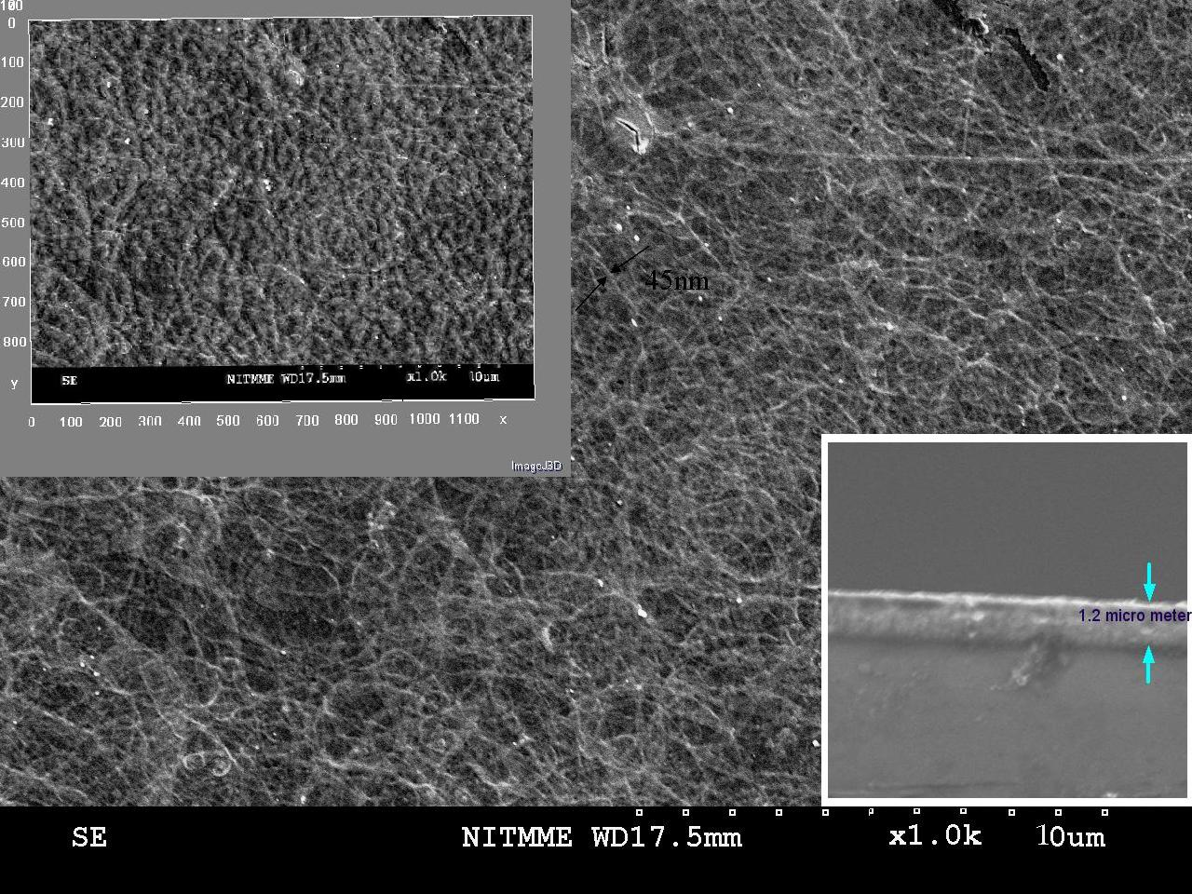
Figure 7. SEM picture of ZrS₂ (0.01 M) thin film

Prior to the observation, using an auto sputter fine coater (JFC 1600, JEOL Japan) about 50Å gold was sputtered on the thin film surface for better contrast and to avoid charge accumulation. Figure (7 & 8) is the SEM picture showing the undoped Zirconium Sulphide thin films with morphology of nanotubes very similar to the other nanotubes reported earlier [Manashi Nath et al 2002; Li-Dong Gao Yuan Le et al ; Jiangtao Hu et al 1999; Yakobson, et al 1996;]. The SEM image in figure (7 & 8) reveals that a good yield of the nanostructures is obtained. Interestingly, a large proportion of these nanostructures are nanotubes. The Zirconium Sulphide nanotube structures could be created reproducibly and they were randomly oriented as a porous membrane and found to cover the entire substrate. Although, Zirconium Sulphide nanotube (figure 7 & 8) are not as well defined as other non carbon nanotubes reported [Manashi Nath et al 2002; Li-Dong Gao Yuan Le et al ; Jiangtao Hu et al 1999; Yakobson, et al 1996;]. The nanotubes as can be seen from the SEM image in figure (7 & 8) are quite lengthy, some being more than a micron long with a smooth surface. The 3D magnification of SEM picture (left top) shows that the growth of the nano tube is along the surface of the substrate. The cross sectional view of the film to measure the thickness is shown at the right bottom of the figure (7 & 8). Their outer diameters are found using image identifier which is found to be 45nanometer. However, the inner diameters of the Zirconium Sulphide nanotubes are smaller. Breaks in nanotubes were rarely observed which implies that nanotubes have very high strength [Yakobson, et al 1996;].
On close inspection; layer fringes are visible along the tube walls. Interrupted layer growth is observed in the inner edge of the tube wall, causing terminated layers and thus non uniformity in the wall thickness. Also visible in figure (7 & 8) is the nanoscale sub-structure of undoped Zirconium Sulphide nanotubes, demonstrating their polycrystalline nature.
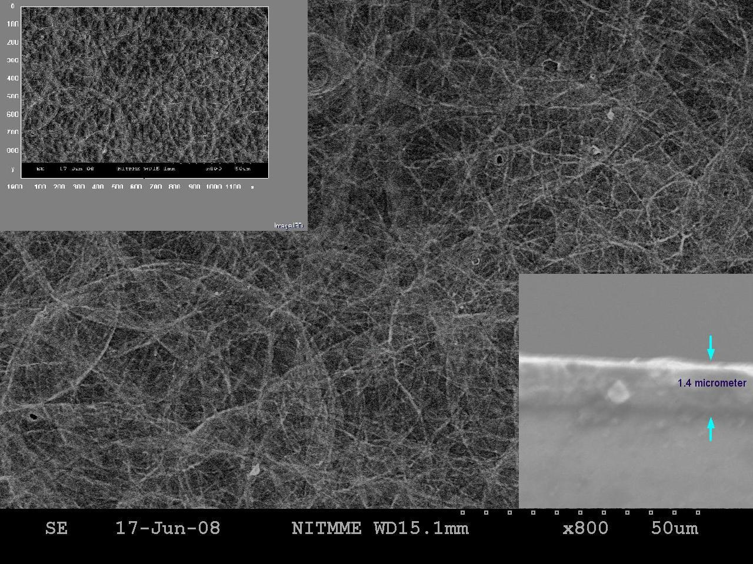
Figure 8. SEM picture of ZrS₂ (0.02 M) thin film
4. Conclusion
Spray deposited Zirconium sulphide film with two different molarities were deposited on glass substrate at 430⁰C are polycrystalline having HCP structure. Deposited film shows preferential orientations along (110) plane in addition to other prominent planes (101) and (201). The grain size of the deposited film found using Scherer‘s relation is 18nm. Sem picture confirms the good yield of nanotubes. Our results do show that the growth of nano tubes of Zirconium sulphide can be achieved by simple and economical spray technique. Large quantities of nanotubes can be synthesized by this method; advances in growth processes are making NTs more commercially viable.
Correspondence to:
M.Mahboob Beevi, M.Anusuya
Department of Physics,
Trichy Engineering College,
Trichy, Tamilnadu,
INDIA 621132
Cellular phone: 09952767994; 09789535618
Emails: beevi75@yahoo.co.in*, anu51069@yahoo.com

References
[1] Murray. C.B, Kagan. C.R & Bawendi. M.G., Self Organization of CdSe Nanocrystallites into Three Dimensional Quantum Dot Superlattices,” Science, 1995; (270) 1335

[2] Spanhel.M, Haase.H, Weller.A, Henglein Photo chemistry of Semiconductor Colloids.20. Surface Modification and Stability of Strong Luminescing CdS Particles, J. Am. Chem. Soc. 1987; 109: 5649-5655.

[3] Bawendi. M.G, Wilson. W.L, Rothberg. L, Carroll P.L, Jedju T.M, Teigerwald.M.L & L.E. Brus, Electronic structure and photoexcited-carrier dynamics in nanometer-size CdSe clusters, Phys. Rev. Lett.,1990; 65:623.

[4] Brus L, Quantum Crystallites and nonlinear optics Appied . Physics.1999; 1 A53:465.

[5] Weller. H Kolloidale Halbleiter-Q-Teilchen: Chemie im Übergangsbereich zwischen Festkörper und Molekül Angew. Chem., Int. Ed. Engl. 1993; 32: 41

[6] Huang. M.H, Mao. S, Feick. H, Yan. H.Q, Wu. Y.Y, Kind.H, Weber.E, Russo.R & Yang.P.D, Room-temperature ultraviolet nanowire nanolasers Science. 2001;292(5523)1897-1899

[7] Wang. S.G, Zhang. Q, Yoon. S.F, Ahn. J, Wang. Q, Zhou. Q & Yang. D.J, Computational models of the single substitutional nitrogen atom in diamond. Phys. Status Solidi.2002; A193:546.

[8] Liao.M.H & Chen. D.H, Preparation and characterization of a novel magnetic nano-adsorbent, J. Mater. Chem., 2002; 12:3654.

[9] Ilona Kretzschmar Detlef Schroder, Helmut Schwarz & Armentrout.P.B, Gas-phase thermochemistry of the early cationic transition-metal sulfides of the second row: YS⁺, ZrS⁺, and NbS⁺ International Journal of Mass Spectrometry.,2006;263-278

[10] Greenaway, D.L & Nltche.R, Preparation and Optical Properties of Group IV-VI2 Chalcogenides having the CdI₂ Structure, J Phys Chem Solids. 1965; 26:1445.

[11] Hughes. H.P & Liang W.Y.Yoffe, Vacuum ultraviolet reflectivity spectra of the disulphides and diselenides of titanium, zirconium and hafnium, (1977) J. Phys. C: Solid State Phys. 10 1079-10

[12] Maskell.W.C, Progress in the development of zirconia gas sensors.Solid State Ionics,2000; 134: 43-50

[13] Bertrand. G & Mevrel. R, Zirconia coatings realized by microwave plasma-enhanced chemical vapor deposition. Thin Solid Films.1997; 292: 241-246.

[14] Cameron, M.A. & S.M. George. ZrO2 Film Growth by Chemical Vapor Deposition using Zirconium Tetra-tert-Butoxide. Thin Solid Films.1999; 348:90-98.

[15] Brusaco, R.M. In: C.A.Klein (ed.). Proc. SPIE: Mirrors and Windows for HighPower/High Energy Laser Systems.1989; 23:1047.

[16] Wuttiphan.S, Pajares. A & Lawn.B.R,On Contact Damage In Zirconia-Based Plasma Sprayed Coatings. Thin Solid Films. 1997;293: 251-260.

[17] Thiagarajan, R. and R. Kanaga Sabapathy. 2001. International Conference on Materials for Advanced Tech. Singapore. 200;. 1-6.

[18] Chen.Q,Quian.Y,Chen.Z & Zang. Y, Fabrication of ultrafine SnO₂ thin films by the hydrothermal method 1995. Thin Solid Films. 264: 25.

[19] Malik,.A, Seco.A & Fortunato.E, J. Non-Cryst.Solids, 1998;1092:227-230.

[20] Berry. L.G.(Ed.) ASTM Powder Diffraction File, Sets 1 to 5, Inorganic. Vol.PDIS-5LRB,1967.

[21] Bragg W.L, The Diffraction of Short Electromagnetic Waves by a Crystal, Proc.Camb Phil., Soc. 1912;17:43.

[22] Ma.Y.Y & Bube.R.H, J. Electrochem. Sci.1977; 124:1430.

[23] Agarwal.D.C, Amit Kumar & D.Kabiraj, Nuclear Instruments and Methods in Physics Research.,2006; B244:136.

[24] Nadeem M.Y & Waqas Ahmed, Optical Properties of ZnS thin films, Turkey Journal of Physics. 2000; 24:651.

[25] Al-Sabayleh.M.A, The effect of substrate temperature on the optical properties of spray deposited ZnS thin films prepared from non-aqueous media Umm Al-Qura Univ, J. Sci. Med. Eng. 2008;20:17

[26] Hoffmann.F, Mayr.P, Mehner.A & Klumper -Westkamp H., Crystallisation and residual stress formation of sol-gel derived zirconia films. Thin Solid Films.1997; 308: 365.

[27] Tarsame S.Sian &Reddy G.B, Optical, structural and photoelectron spectroscopic studies on amorphous and crystalline molybdenum oxide thin films, Solar Energy Materials & Solar Cells. 2004; 82:375.

[28] Tauc. J, Amorphous and liquid semiconductors New York, Plenum,1974;Ch.4.

[29] Ezema.F.I.Estimation of Optical and Electrical Properties of Zirconium Sulphide Thin Films Prepared by Chemical Bath Deposition Technique and Using Spectrophotometer, Greenwhich Journal of Phys,2003; 4:38.

[30] Brustien. E, Anomalous Optical Absorption Limit in InSb, Phys. Rev, 1954; 93:632.

[31] Moss. T.S, The Interpretation of the Properties of Indium Antimonide, Proc.Phys.Soc.London.1954; B67:775-782

[32] Ndukwe I.C’Solution Growth Characteristics and Applications of Zinc Sulphide Thin films Sol.Ener.Mater.Sol.Cells.1995; 40:123.

[33] Ezema.F.I & Okeke C.E ’Preparation and Characterization of Bismuth Oxide Thin films by Solution Growth Technique’Nig.Journal of Phys. 2002;142:48.

[34] Ezema.F.I & Okeke C.E. Chemical bath Deposition of Bismuth Oxide Thin films and its Applications’,Greenwhich Journal of Science And Technology. 2003; 3(2)-90.

[35] Che G., Lakshmi B. B, Martin. C. R & Fisher E. R, Chemical vapor deposition based synthesis of carbon nanotubes and nanofibers using a template method, Chem. Mater.1998; 10:260.

[36] Manashi Nath & Rao C. N. R, Nanotubes of Group 4 metals disulphides, Pure Appl. Chem.2002;74:1545.

[37] Li-Dong Gao Yuan Le, Jie-Xin Wang and Jian-Feng Chen Preparation and characterization of titania nanotubes with mesostructured walls, Mater.Lett.Vol 60, Iss 29-30, 3882-3886

[38] Jiangtao Hu & Teri Wang Odom,and Charles, Chemistry and Physics in one dimenstion: Synthesis and properties of nanowires and nanotubes. Acc. Chem. Res. 1999; 32:435.
[39] Yakobson B. I, Brabec. C. J & Bernholc J, Nanomechanics of Carbon tubes:Instabillites beyond linear response. Physics Rev. Lett.1996; 76:2511.

.

7/1/2009

