Mechanical Characterization of Spray Pyrolytic Cadmium Sulphide Thin Films by Indentation Technique

R.Thiagarajan ¹ , M. Anusuya ^{2*} , M.Mahaboob Beevi ³

1. Department of Physics, Urumu Dhanalakshmi College, Trichy, Tamilnadu, INDIA-620018
2. Department of Physics, Trichy Engineering College, Trichy, Tamilnadu, INDIA-621132
anu51069@yahoo.com*, beevi75@yahoo.co.in

Abstract: Thin films of Cadmium Sulphide have been successfully grown by Spray Pyrolysis technique at two different temperatures. The grown thin films are confirmed by X-ray diffraction (XRD) and it reveals that the films are nanocrystalline in nature with grain size in the order of nanometers. Scanning electron microscopy (SEM) was used to characterize the coating morphology and it indicate that the grains are uniformly distributed throughout the sample area. The mechanical behavior of Cadmium Sulphide thin films under point loading conditions was studied by Ultra low load micro indentation using Vicker’s indenter with 100nm tip radius. The value of hardness and elastic modulus of the film reaches 4.89GPa and 51.01GPa at 250°C, 4.4GPa and 49.02GPa at 300°C respectively.
[Journal of American Science 2009;5(6):51-56]. (ISSN: 1545-1003).

Key words: thin films; structural properties; hardness; elastic modulus

- Introduction
In recent years, thin film science has grown world wide into a major research area. The importance of coatings and the synthesis of new materials for industry have resulted in a tremendous increase of innovative thin film processing technologies. Currently, this development goes hand in hand with the explosion of scientific and technological break through in microelectronics, optics and nano technology [Siegel, et al, 1997]. Presently, rapidly changing needs for thin film materials and devices are creating new opportunities for the development of new processes, materials and technologies. The mechanical properties of bulk materials are quite different from those of metallic thin films [Hoffman, et al, 1964]. Mechanical properties are significantly influenced by the deposition conditions, and can be considerably different from those of their bulk material counterpart [Huan, et al, 2005]. In the past two decades, depth sensing indentation technique has attracted the attention of researchers as a simple, relatively non-invasive means of quantifying basics material properties, especially hardness and elastic modulus of thin films on substrates [Bhattacharya, et al, 1988, Olive, et al 2004]. Note that this technique provides a possibility to evaluate a mechanical property in ‘real’ values i.e. the influence of substrate material is eliminated since the minimum depth of indentations remains lower than 10-15% of the coating thickness [Fernandez et al., 2000]. Generally, several applications of Cadmium Sulphide thin films are known in electrical, optical and mechanical equipments [NASCAR et al 1997]. Since CdS materials are widely used in absorbing material in solar cell and MEMS based devices. Mechanical properties of CdS thin films like hardness, elastic modulus, adhesion etc., are not investigated in detail in literature, although they are very important for stable device performance. Hence the material life span depends on it mechanical properties like stiffness, hardness as well as elastic modulus. It is well known that material’s mechanical property is one of the most important effect factors in the manufacturing of the optoelectronic devices because of the unavoidable extensive handling. In this work, pure CdS thin films were prepared by a Spray Pyrolysis technique on glass substrate at 250°C and 300°C and reported hardness and elastic modulus values are moderately higher than the bulk material.

2. Experimental
2.1 Preparation of Solution
The precursor solution used to form Cadmium Sulphide thin films was obtained by dissolving the salts of Cadmium acetate (Cd(CH₃COO)_{2.}2H₂O) and thiourea (CH₄N₂S) in the molar ratio (0.1M: 0.1M) in double distilled water along with the complexing agent Ethylene-Diamine-Tetra-Aceticacid(EDTA)(C₁₀H₁₆N₂O₈) of 0.1M is chooses to stabilize the grain size. The amount of solution was made together as 50ml.The chemicals used this deposition were of analytical grade.

2.2 Spraying Process and Characterization
The Spray Pyrolysis setup consists of a substrate heater, spray gun, air compressor, solution reservoir and a gas exhaust unit. Details of this setup have been published elsewhere [Bruneaux et al., 1991]. The heating of the substrate was performed using a ceramic heating plate with electrical heating wires. Optically plane cleaned glass plates was placed over the hot plate. The aqueous solution was then sprayed on the preheated glass substrate maintained at two different temperatures of 250ºC and 300°C by conventional chemical spray pyrolysis technique to obtain homogeneous thin films. Compressed dry air at a pressure of 2 kg/cm² from an air compressor via an air filter cum regulator was used as the carrier gas and spray rate of the solution was maintained at 3ml/min. The distance between the spray nozzle and the substrate is 35cm. The spray time was maintained constant about one second throughout the deposition. An increase in spray time causes thermal shock of the substrate due to excessive cooling. A two minute waiting time is allowed between each spray to maintain the substrate temperature and enable to decompose the starting material completely. Total time is 45 minute for all deposition. Film obtained due to endothermic thermal decomposition that takes place at the hot surface of the substrate. For each temperature the reproducibility of the films were verified by repeating the experiments several times. The film thickness was measure using a JEOL, JSM 6701F, Japan, Scanning Electron Microscope (SEM). The film is mounted vertically to measure the thickness directly [Chen. 1995]. The measured thickness of the films is found to be in the range of 1-1.2 micrometer. The surface morphologies of the films were observed by using an SEM and the nanostructure was determined by X-ray diffractometry (XRD) [Rigaku Model RAD II A]. Indentation experiments were performed using an Ultra low load micro indenter unit (Shimadzu -DUH 211/211-S). The system was fitted with a Vicker’s diamond indenter (four sided pyramid shape tip).

3. Result and Discussion
3.1 XRD Studies
XRD pattern of the Cadmium Sulphide films were studied at room temperature by using RIGAKU diffractometer (Model RAD II A) with CuKα radiation (1.5418Å) where other radiations are suppressed using Ni filter. The data were recorded at a scan rate of 0.2° /min and in the range of 20°<2θ<80°. The Crystallinity pattern of Cadmium Sulphide (0.1M) film prepared by spray pyrolysis technique at 250°C and 300°C is as shown in figure (1). Observation of film shows smooth surface and well adhesive with substrate. The narrow peaks in all the diffractograms confirm the nanocrystalline nature of the CdS film. The XRD pattern of the films also reveals that the CdS film is polycrystalline with cubic crystal structure and
Figure 1. XRD pattern of CdS films

preferential orientation along (111) plane. No other impurity peaks are observed and this indicates the presence of single CdS phase the prepared film. Also the intense peak oriented along (111) lattice plane indicate the growth of the grains is parallel to the substrate. The other strong peaks observed correspond to the (200) and (222) orientations. The diffraction peaks appears in the spectrum have been identified at 26.54°, 30.74° and 54.67° are verified with the known patterns of standard X-Ray Diffraction data file (JCPDS file No: CdS 80-0019)) and can be indexed to (111), (200) and (222) reflections respectively. While comparing the X-ray diffraction pattern of 250°C and 300°C of 0.1 M CdS it is obvious that, Bragg peaks became more intense for higher temperature of CdS, indicating a clear improvement in crystalline which is also confirmed in the SEM results. The X-ray diffraction line broadening (XDLB) was used to estimate the grain size of the film by utilizing Scherer’s formula [Berry. 1967, Bragg. 1912] given as equation (1),
$D=\left(\frac{\text{Kλ}}{\text{βcosθ}}\right)$ (1)
Where k is the shape factor constant (0.89), λ is the wave length of CuKα line, θ the Bragg’s angle of reflection, β full width half maximum (FWHM) of intense peak. The grain size was found to increase with increasing substrate temperature, which is the same behavior, reported in literature for both Spray Pyrolysed and vacuum evaporated CdS thin films. Here, the grain size calculated by Scherer’s formula from the XRD data of CdS is less than 60nm.The grain size of as deposited film is the temperature 250°C and 300°C are 45nm, 60nm respectively. This small grain size is due to the addition of complexing agent [EDTA] [Inamdar. et al., 2007].
3.2 SEM Studies
The SE micrograph of the Cadmium Sulphide thin film is taken to support the XRD observations. Figure 2(a) and 2(b) shows the SE micrographs showing surface topography of Cadmium Sulphide films deposited at 250˚C and 300˚C. The cross sectional view of the film to measure the thickness is shown at the right bottom of the figure (2a & 2b). From the image of figure (2a), the grains are closely placed with some pinhole and it showed compact nano sized grains distribution over the surface and good connectivity between grains. From the micrographs it is clearly seen that the grain size of the film deposited at 250˚C is in the nanometer range they are spherical in shape. The fluffy mass was present in cluster form and they were uniformly distributed. But in Fig. (2b), the grains are larger in size and the space between the grains is wide compared to 250˚C. In this case, increasing the deposition temperature the average grain size, along the preferred orientation corresponding to (111) plane, increases from 45nm (T= 250˚C) to 60nm (T=300˚C).

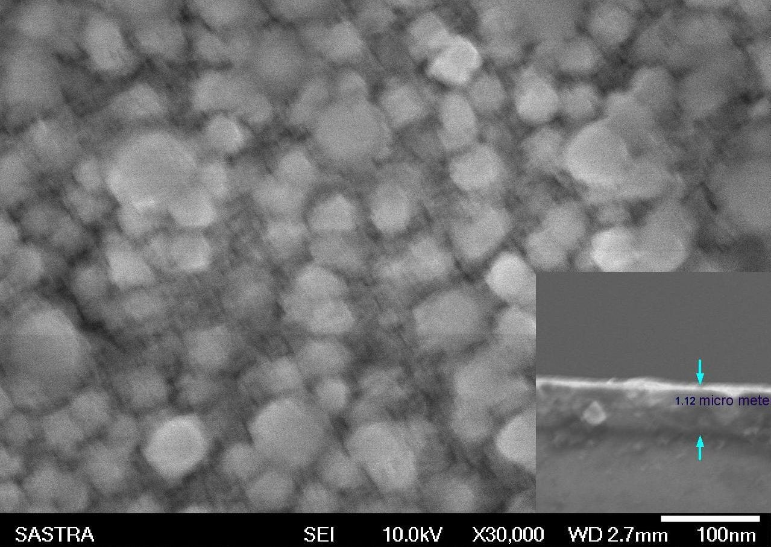
Figure 2a. SEM image of CdS film prepared at 250˚C
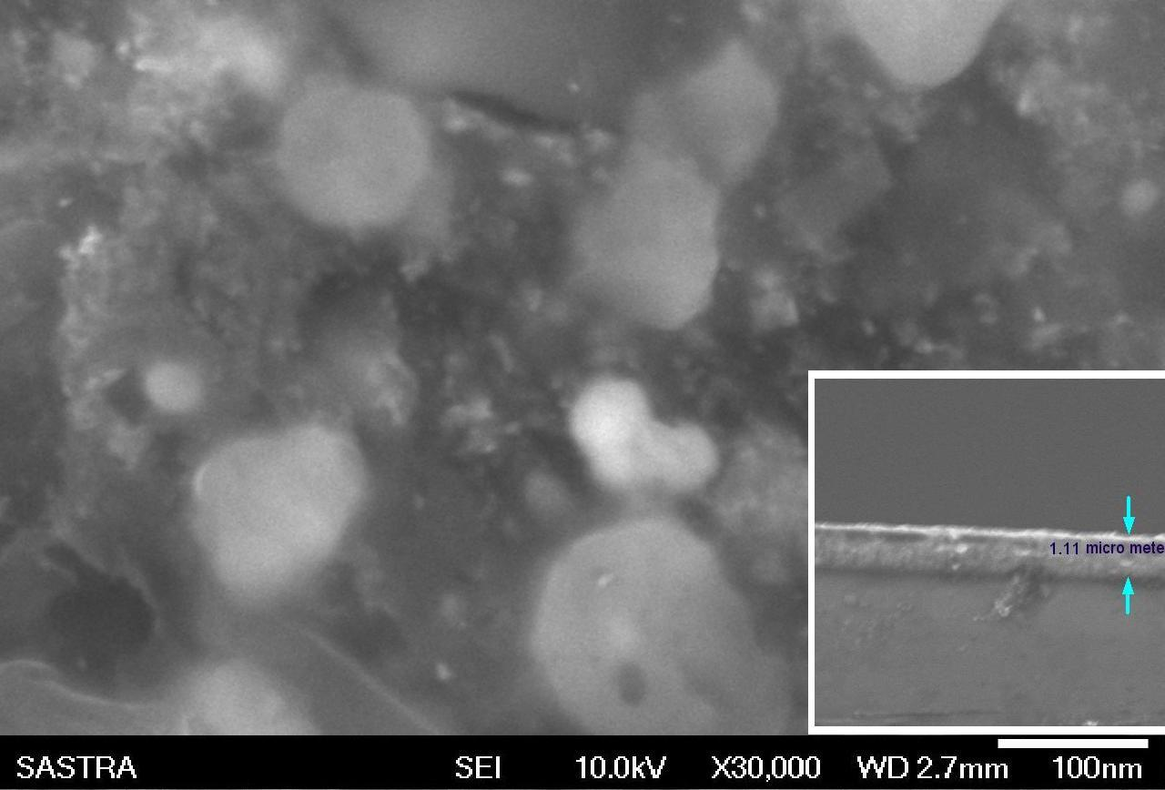
Figure 2b. SEM image of CdS film prepared at 300˚C

This confirms that at higher deposition temperatures, large grain size are obtained, suggesting that crystal growth is limiting step in thin film obtaining. The SEM image of CdS film prepared at 250°C clearly indicates the hardness is maximum, because of the grains are tightly bound to each other.

3.3 Mechanical Studies
In this work a computer controlled Shimadzu DUH 211/ DUH 211-S Ultra low load micro indenter unit is used to calculate the value of hardness (H) and elastic modulus (E) of Cadmium Sulphide thin films deposited at 250°C and 300°C. It estimates the hardness value of the film with a Vickers diamond pyramid indenter whose opposing faces are inclined at an angle of 136°. The indenter tip radius is 0.1μm and the ultra-wide test force range of 0.1 to 1,961mN. All tests were preformed at room temperature. Measurements were made in this work by increasing the loading force in simple steps, to the maximum force of 7mN, then decreasing the loading force by the same steps. For all hardness measurements, approximately four impressions were made at each load, and the average was taken as the representative value. Also, the indentations were done at different regions of the films, space approximately 100nm apart, so that there is no intervention on the P-h curves at each spot. This instrument exhibits depth and load resolution of 0.0001μm-10μm and 0.196μN respectively.
The hardness measurements of the Cadmium Sulphide with molarity of 0.1 prepared with the complexing agent (EDTA) of 0.1M deposited at 250°C and 300°C were recorded as a function of loading force 1-9mN are as shown in Fig (3). It reveals that the hardness of the film slightly increases with increase in load of 1-7mN. At loads greater than 7mN, the hardness saturates to a constant value. Typically, the
measured hardness has at 7mN load. The value of hardness is increased in the 1-7mN load range was attributed to work-hardening of the film [Ramajothi. et al., 2004, Dhanraj et al., 1994]. The hardness is highly linear with load, and these values are found to be considerably higher for the thin films as compared to the bulk [Arthur Clive Bishop, 1990]. The value of hardness (H) is as deposited film is calculated using the expression [Oliver. et al., 1992]

$H=\left(\frac{P_{\text{max}}}{A}\right)$ (2)
Where ‘P_{Max}’ is the load, A is projected contact area at that load and H is the hardness value it is expressed in GPa. In this work, the calculated value of hardness at the 7mN load is Cadmium Sulphide thin films are at the substrate temperatures 250°C and 300°C are 4.89GPa, 4.44GPa respectively. At 250°C temperature the defect density is reduced of CdS leads to work hardening and hence increases in the value of hardness. In ideal circumstances, measured hardness values should be independent of the applied load. But in practice, load dependence is observed [Subhadra et al., 2000]. In this case, the value of hardness was found to increase with load. The grain size calculated from Scherer’s relation and found from SEM studies agrees each other and is 45 and 60nm respectively. Generally, due to the better atomic mobility and coalescence during the film growth as the deposition temperature increases to 300°C, there is an increase in grain size which leads to decrease in hardness value obeying Hall-Petch relation [Hall.1951, Petch. 1953], there is an increase in grain size. But, in this case addition of complexing agent decreases the grain size as the temperature decreases. It infers that the surface morphology is dependent on EDTA concentration [Inamdar. 2007, Varasi Krishna. 2003]. According to Mishra et.al, hardness is found to increase with decrease in grain size [Mishra. et al., 2004] which is attributed to the increase in the number of grains, which, in turn, increases the surface energy and reduce dislocations. This increase in hardness may be grain morphology [Zhang. et al., 1995] as well as the formation of nanocrystalline CdS thin film. Figure (4) shows the load-displacement curve of CdS prepared at 250°C and 300°C obtained by increasing then decreasing the loading force of 1-7mN. They are continuous and no pop-in event is found. The Cds films are single phase with grain size of 45nm at 250°C and those grains will act as strain compensation sites which are responsible for the absence of pop-in events as suggested by Coleman et al [Coleman, 2005].

Figure 3. Load Vs Hardness of CdS films

h_{max}
Figure 4. Load Vs Displacement of CdS films

Each indentation consisted of three steps; loading, holding the indenter at peak loads for 10 s, and unloading completely. In this case, curves obtained were continuous and smooth which shows the purely elastic behavior of the film. During indentation the unloading curve `is smooth which shows that it is purely the recovery on relaxation. This suggests that the indenter did not penetrate into the substrate during the indentation process, and no micro cracks and bulging were observed in optical photograph. The entire loading-unloading curve represents the overall elasto-plastic response of the film [Pharr, 1998] The physical properties and models used to determine H and E from indentation load-depth data are based on Oliver-Pharr theory [Oliver, 1992]. The important quantities are the peak load (P_{max}), the maximum depth (h_{max}), residual depth after unloading (h_{f}) and slope of the upper portion of the unloading curve (S=dP/dh) are found in load-depth curve. The parameter S is known as the elastic contact stiffness. The hardness and elastic modulus can be derived from these values. The fundamental relations to calculate H and E are,
$E_{r}=\frac{\sqrt{π}}{2}⋅\frac{S}{\sqrt{\text{Ac}}}$ (3)
Where E_{r} is the reduced elastic modulus which accounts for the fact that elastic displacements occur in both indenter and the sample. The elastic modulus of as deposited film, E is calculate from E_{r} using
$\frac{1}{E_{r}}=\frac{(1−ν^{2})}{E}+\frac{(1−ν_{i}^{2})}{E_{i}}$ (4)
Where ν is the Poisson ratio for CdS is 0.3, and E_{i} and ν_{i} are the elastic modulus and Poisson ratio of the indenter respectively. The elastic constants E_{i}= 1141GPa and νi = 0.07 [Pharr. 1998] are often used for a diamond. Figure (5) shows that as the penetration depth increases there is slightly increase in elastic modulus of the as deposited film and it is found that elastic modulus do highly linear with depth. At 250°C the maximum penetration depth is 73nm, which is predetermined to be less than 10-15% of minimum thickness of spray coated Cadmium Sulphide thin film, and the elastic modulus is 51.76GPa.The elastic modulus of as deposited film prepared at 300°C is 49.27GPa. The elastic modulus was obtained as average value from more than five measurements of a specimen. The elastic modulus of spray coated CdS thin film increased with decreasing the deposition temperature. The elastic modulus measured by the indentation test is dependent on depth and grain size of as deposited film, but is independent on the error from geometric measurement.
However, we could see a slight increase in elastic modulus while comparing it with the literature value [Martin Vrbanczyk, 2005, Lev Issakovich Berger, 1996]. This higher modulus may be due to the low porosity of the as deposited film.
Figure. 5. Displacement Vs Elastic modulus for CdS

4. Conclusions
CdS thin films are prepared by spray pyrolysis technique at 250°C and 300°C. The structural properties of CdS thin films have been investigated by XRD and SEM. The XRD pattern of as deposited films visualize of intense peak oriented along the (111) plane and the grain size found to be in the order of nanometers, and it confirms SEM results. The coating morphology is studied by SEM images and it revels that at lower temperature the grain size are small compared to higher temperature. The hardness and elastic modulus of CdS thin films have been evaluated by ultra low load indentation technique. One can obtain a larger hardness and elastic modulus of 4.89GPa, 51.01GPa in CdS films deposited at 250°C, which is higher than the film prepared at 300°C.

Correspondence to:
M.Anusuya, M.Mahboob Beevi,
Department of Physics,
Trichy Engineering College,
Trichy, Tamilnadu,
INDIA 621132
Cellular phone: 09952767994;
09789535618
Emails: anu51069@yahoo.com*, beevi75@yahoo.co.in

References

[1] Siegel R.W., Evelyn Hu. and Roco M.C., Workshop, WTEC Panel Report on R&D Status and Trends in Nanoparticle, Nano structural Materials and Nano devices 1997.

[2] Hoffman, R.W. In: Wilsdort HGF, editor, Thin films, Metals Park (OH): American Society of Metals. 1964; Chapter 4.

[3] Huang H,.Winchester K.J.,.Liu Y., Hu X.Z., .Musca C,.Dell J. and Faraone.L., Determination of Mechanical properties of PECVD Silicon Nitride Thin films for tunable MEMS Fabry-Perot Optical Filter, Journal of Micromechanical and Microengineering, 2005; 15: 608-614

[4] Bhattacharya.A.K and Nix.W.D. Analysis of elastic and plastic deformation associated with indentation testing of thin films on substrates. International .Journal of Solids and Structures, 1988; 24: 1287-1298

[5] Oliver W.C. and Pharr G.M., Journal of Material Research, Measurement of hardness and elastic modulus by instrumented indentation: Advances in understanding and refinements to methodology, Journal of Material Research. 2004; 19 (1): 3

[6] Fernandez J.V., Trindade A.C., Menezes L.F. and Cavaleiro A., Influence on substrate hardness on the response of W-C-Co coated samples to depth-sensing indentation, Journal of Material Research. 2000; 17: 1766

[7] Nascu C., Ionescu V., Indrea E. and Bratu I., Material Letters, Spray pyrolysis deposition of CuS thin films. 1997; 32:2-3(73-77)

[8] Bruneaux J., Cachet H...Froment A., Messad A.,Correlation between structural and electrical properties of sprayed tin with and without fluorine doping. Thin Solid Films, 1991; 197:129
.
[9] Chen, Q., Y. Quian, Z. Chen, and Y. Zang. Fabrication of ultra fine SnO₂ thin films by the hydrothermal method 1995. Thin Solid Films. 264: 25.

[10] Berry L.G. (Ed.) ASTM Powder Diffraction File, Sets 1 to 5, Inorganic, Vol.PDIS-5LRB, 1967

[11] Bragg W.L., The Diffraction of Short Electromagnetic Waves by a Crystal, Proc.Camb Phil. Soc. 1912; 17: 43

[12] InamdarA.I, Mujawar.S.H and Patil.P.S, The Influences of Complexing agents on Growth of Zinc Oxide Thin Films from Zinc Acetate Bath and Associated Kinetic Parameters, International Journal of Electrochemical Science. 2007; 2, 797-808

[13] Ramajothi.J, Dhanuskodi S and .Nagarajan K,Crystal growth, thermal, optical and microhadness studies of tris zinc sulphate-a semi organic NLO material, Crystal Research Technology, 2004;39(5) 414- 420

[14] Dhanraj G, .Bhat H.L and Narayanan P.J.Ferroelectric domains in pure liNbO3 and their influence in microhardness Ferroelectrics. 1994; 157 ( 1) 7-12

[15] Arthur Clive Bishop, Alan Robert Wooltey, Rocks and Fossils, Cambridge Guide to Minerals, 1990

[16] Oliver W.C and Pharr G.M, An improved technique for determining hardness and elastic modulus using load–displacement indentation experiments. Journal of Materials Research. 1992; 7: 1564 1992

[17] K.G.Subhadra, K.Kishan Rao and D.B.Sirdeshmukh, Systematic hardness studies on lithium niobyte crystals, Bulletin of Material Science, 23, 147, 2000

[18] Hall E.O. The Deformation and Ageing of Mild Steel: III Discussion of Results, Proc.Phys.Soc.B, 1951; 64: 747-753

[19] Petch N.J. The cleavage strength of polycrystals J.Iron Steel Inst. 1953; 174: 25-28

[20] Varasi Krishna K. and Dutta V, Spray deposition of CdTe-Te thin films using ethylene-diamine-tetra-acetic acid as a complexing agent in the precursor solution, Solar Energy Materials and Solar Cells, 2003;80 247-256

[21] Mishra R and Basu B and.Balasubramanian R, Effect of grain size on the tribological behavior of nanocrystalline nickel. Materials Science and Engineering, 2004; A 373: 370-373

[22] Zhang H.Y., Hu Z.Q. and Lu K., Hall-Petch relationship in the nanocrystalline selenium prepared by crystallization from the amorphous state, Journal of Applied Physics. 1995; 6:77 1995

[23] Coleman V.A, Brdby I.E and Manroe P. Mechanical properties of ZnO epitaxial layers grown on a- and c-axis sapphire Applied Physics Letters 2005; 86: 203105

[24] Pharr G.M, Measurement of Mechanical properties by Ultra low load indentation, Materials Science and Engineering, 1998; A 253: 151-159

[25] Martin Vrbanczyk, Wieslaw Jakubik, Erwin Maciak Sensor Properties of Cadmium Sulphide thin films in Surface Acoustic wave system-Preliminary results, Molecular and Quantum Acoustics, 2005; 26: 273-281

[26] Lev Issakovich Berger, Semiconductor Materials, Chapter 5-Binary II-VI and I-VII Tetrahedral Semicondutors. 1996; 199

