Water Quality Parameters, Chlorophyll a and Zooplankton of an Estuarine Creek in Lagos.

²Onyema, I.C., ¹Lawal-Are, A.O., Akinremi, T. A. and Bassey, O.B.
1,2 Department of Marine Sciences, University of Lagos, Akoka.
¹ aolawalare@gmail.com, ² iconyema@gmail.com

Abstract: The monthly variations in water quality parameters, chlorophyll a and zooplankton in Badagry creek, Lagos were investigated for a period of six months (October, 2007 - March, 2008). The hydrological characteristics showed trends that were related to rainfall pattern in the region and effects of tidal situation. The slightly alkaline marine environment expressed higher biological oxygen demand, lower nitrate and phosphate in the wet months while dissolved oxygen, transparency, salinity, total dissolved solids, pH, conductivity were recorded increases with the dry season. Productivity of the creek as measured by chlorophyll a was also observed to increase in the dry season. Zooplankton diversity (S) and abundance (N) were significantly higher in the dry than the wet season. The zooplankton spectrum was dominated by copepods (6 calanoid and 4 cyclopoid forms). Other zooplankton groups comprised two cladocerans, one mysid and an array of larval forms. Margalef’s (d) and Shannon-Wiener (Hs) indices were lower in the wet than the dry months while species equitability (j) was generally lower in the dry than the wet season months. The water chemistry characteristics, adult and juvenile zooplankton composition of the creek points to an estuarine system that acts additionally as a breeding and nursery ground for both endemic and migratory pelagic and benthic organisms. [Journal of American Science 2009;5(6):76-94]. (ISSN: 1545-1003)

Key words: water quality, primary production, chlorophyll a, zooplankton spectrums, meroplankton

- Introduction
The creeks and lagoons of south-western Nigeria, apart from their ecological and economic significance, serve as sink for the disposal of an increasing array of waste types (Onyema, 2007). Sewage, wood waste, refined oil, waste heat, municipal and industrial effluents among others find their way unabated into immediate coastal waters through conduits such as storm water channels, rivers, creeks and lagoons (Akpata et. al., 1993; Chukwu and Nwankwo, 2004). The Badagry creek towards the harbour is exposed to unique stressors such as habour related wastes discharges (Onyema et al., 2006). According to Onyema et. al., (2006) waste discharges from the Lagos Island, Ikoyi and Victoria Island find their way unabated into the Five Cowrie creek. This creek adjoins the Lagos lagoon just like the Badagry creek. Floating garbage / debris and oil base discharges especially from commercial boat operators are very frequent sites within the creek. In the Badagry creek, harbour and port related activities and their associated waste input also impact the creek. The region is exposed to high levels of human and vehicular (motor cars, boat and ship) traffic.
According to Kadiri (1999) the phytoplankton of coastal waters of Nigeria particularly the fresh and brackish zones could be adjudged floristically diverse. Nwankwo and Gaya (1996) and Solarin and Kusemiju (2003) are of the view that, the coastal wetlands around Lagos are nursery ground for an array of aquatic biota. Two physiographic factors, rainfall and salinity, determine the hydro-climatic conditions of the Lagos lagoon complex (Nwankwo, 1998; Emmanuel and Onyema, 2007). Tidal seawater incursion and flood water inflow from adjoining sea, rivers and creeks are also known to affect the hydrodynamics of the Lagos lagoon and adjoining creeks such that rainfall dilutes the lagoon water, breaks down any environmental gradient and enriches the environment (Nwankwo et al, 2003; Onyema, 2007).
However information on the chlorophyll a and zooplankton species of the creek ecosystems in Lagos is scanty. Published studies on the zooplankton include Olaniyan (1969) which reported on the plankton of the Lagoons of South-Western Nigeria and Akpata et. al. (1993) which studied the effects of organic pollution on plankton and benthic population of Lagos lagoon. More recent studies include Onyema et. al. (2003, 2007), Emmanuel and Onyema (2007) and Onyema and Ojo (2008) for the region. The aim of this project was to investigate the water quality parameters, Chlorophyll a, zooplankton composition and abundance in the Badagry creek in Lagos.

- Materials and Methods
  - Description of Study site
The Badagry creek (Fig. 1) is approximately 177km long (FAO, 1969). It is an adjoining creek to the Lagos lagoon, and part of the Lagos lagoon complex in the South-western part of Nigeria. It is the connection through which the Yewa and Ologe lagoons flow into Lagos lagoon (Egborge, 1988).
The study site for this investigation was located at the Apapa Wharf (Quay) area of the Badagry creek (Buoy 24) at about Latitude 06⁰ 26’01N and Longitude 03⁰ 22’26E (Fig. 1). This area, like all parts of South Western Nigeria experiences a wet season (May-November) and a dry season (December-April). The region experiences tidal influences from the sea via the Lagos lagoon to which it opens. Within the rising creek, rising tide ushers in high water levels which increasing salinity, while at low tide, the water level and salinity falls.
The shore of the study site is characterized by mangrove plants including Rhizophora racemosa (Red Mangrove) and Avicenna sp. (White Mangrove) and clusters of water hyacinths on the surface of the water (especially in the wet season) and along the edges, with Rhizophora racemosa being the dominant riparian vegetation in areas with minimal or no human constructions or activities.
The creek is flanked on one side (southward shore) with mangrove assemblages, a sparsely populated fishing community showing minimum urbanization and on the other side by the Apapa Wharf. The main anthropogenic activities in the area are harbour related activities with a lot of ship ocean vessels and boats either docked or leaving. Commercial boating activities are also common in the creek area. Pollution is suspected from the ships mostly as ballast water and other harbour related activities and waste discharges. Films of oil are also a common sight.

  - Collection of Water and Plankton samples
Monthly surface water samples were collected for water quality analysis for six months from October 2007 – March 2008 at the study site. The samples were collected in well labeled 750ml plastic bottles with screw caps. Plankton samples were collected each

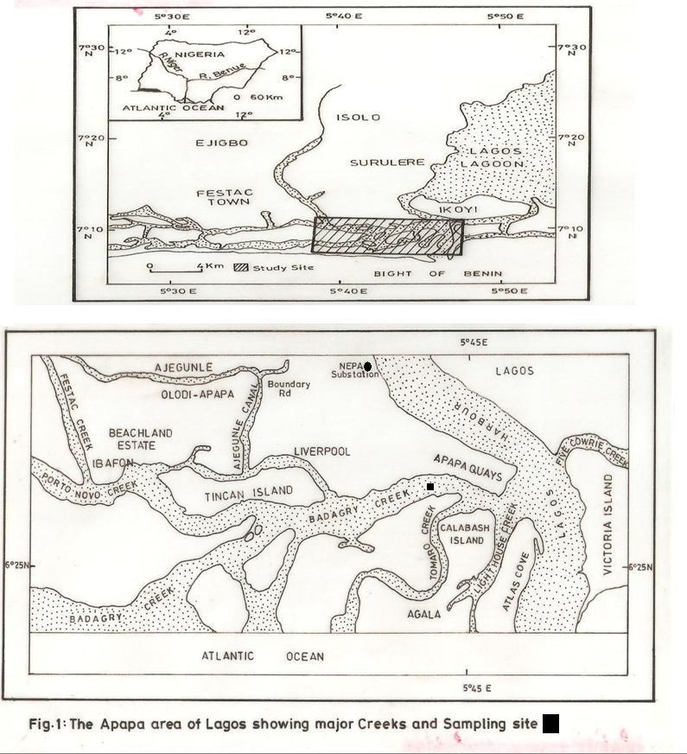

month by horizontal plankton tow using a standard plankton net of 55µm mesh size hauled for five minutes by a motorized boat at low speed (≤4 knots). Samples were collected between 09.00 and 12.00hr.
The samples were stored in well labeled 500ml plastic containers with screw caps and preserved with 4%
unbuffered formalin. The plastic containers were labeled appropriately to reflect the date, name of site and contents.

  - Analysis of water quality parameters.
Methods and devices for the analysis of water quality parameters are shown in Table 1.

  - Biological Characteristics
    - Chlorophyll a (µg/l)
Chlorophyll a concentration of each sample was determined using a Fluorometer equipped with filters for light emission and excitation. 200ml of the water sample was filtered through a 0.45µm fiber membrane filter after which the residue on the filter was transferred to a tissue blender, covered with 3ml of 90⁰/₀ aqueous acetone and macerated for 1min. The sample was then transferred into a centrifuge tube, capped and allowed to stand for 2hr in the dark at 4⁰C (in a refrigerator). Thereafter, it was centrifuged at 500g for 20min and the supernatant decanted. Volume left after decanting was noted. Different readings were taken from the flourometer (which had been pre-calibrated with 2, 5, 10 and 20µg standard chlorophyll solutions) at x1, x3, x10, x30 sensitivity settings and noted. The calibration factors to convert flourometric readings for each sensitivity to concentration of Chlorophyll a was derived using the equation below and values expressed in mg/L.
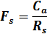
Where; F_{S} = Calibration factor for sensitivity settings
R_{S} = Flourometer reading for sensitivity settings
C_{a} = Concentration of Chlorophyll a

    - Zooplankton analysis
Plankton samples were allowed to settle in the lab for at least 24hr and concentrated by filtering via a filter paper to 20ml (filtrate). For each bottle five drops of well mixed samples were thoroughly investigated. On each occasion, one drop of sample was investigated using the Drop Count Method described by Onyema (2007). For each mount as many transects were thoroughly investigated with each transect at right angles with the first. Zooplankton species were examined, identified and counted using a Carl Zeiss Standard IV monocular microscope also consulting appropriate texts to aid identification (Newell and Newell, 1966; Wimpenny, 1966; Olaniyan, 1975; Gibbons, 2001; Waife and Frid, 2001). The number of each taxa occurring in each field and the total number of taxa per group were recorded as number of organisms per ml.

    - Community Structure
      - Species Richness index (d)
The Species richness index (d) proposed by Margalef (1951) was used to evaluate the community structure of each sample by applying the following equation.
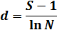
Where; d = Species Richness Index, S = number of species in the population, N = total number of individuals in the population

Table 1: Summary of method/device for the estimation of water quality parameters.
 | Parameter/ Unit | Method / Device | Reference(s)
1 | Air temperature (ºC) | Mercury – in – glass thermometer | Nwankwo (1984)
2 | Water temperature (ºC) | Mercury – in – glass thermometer | Onyema (2008)
3 | Transparency (cm) | Secchi disc method | Onyema (2008)
4 | Depth (cm) | Graduated pole | Brown (1998)
5 | Rainfall (mm) | Acquired from NIMET, Oshodi, Lagos
6 | Total Dissolved Solids (mg/L) | Cole Palmer TDS meter
7 | Total Suspended Solids ( mg/L) | Gravimetric method | APHA (1998)
8 | Chloride ( mg/L) | Argentometric method | APHA (1998)
9 | Total hardness (mg/L) | Titrimetric method | APHA (1998)
10 | pH | Electrometric / Cole Parmer Testr3
11 | Conductivity (µS/cm) | Philip PW9505 Conductivity meter
12 | Salinity (‰) | HANNA Instrument | APHA (1998)
13 | Alkalinity (mg/L) | Titration method | APHA (1998)
14 | Acidity (mg/L) | Titration method | APHA (1998)
15 | Dissolved oxygen (mg/L) | Titration method | APHA (1998)
16 | Biological oxygen demand (mg/L) | Incubation and Titration | APHA (1998)
17 | Chemical oxygen demand (mg/L) | Titration method | APHA (1998)
18 | Nitrate – nitrogen (mgL) | Colorimetric method | APHA (1998)
19 | Phosphate – phosphorus (mg/L) | Colorimetric method | APHA (1998)
20 | Sulphate (mg/L) | Turbidimetric method | APHA (1998)
21 | Silica (mg/L) | Colorimeter (DR2010) | APHA (1998)
22 | Calcium (mg/L) | Titrimetric method | APHA (1998)
23 | Magnesium (mg/L) | Titrimetric method | APHA (1998)
24 | Copper (mg/L) | Atomic Absorption Spectrophotometer  Perkin Elmer 5000 AAS | Perkin Elmer Application methods (2002)
25 | Iron (mg/L) | Atomic Absorption Spectrophotometer  Perkin Elmer 5000 AAS | Perkin Elmer Application methods (2002)
26 | Zinc (mg/L) | Atomic Absorption Spectrophotometer  Perkin Elmer 5000 AAS | Perkin Elmer Application methods (2002)
27 | Chlorophyll a (µg/L) | Florometric method | APHA (1998)

      - Species Diversity / Shannon – Wiener Index (Hs)

The Species diversity index (Hs) (Ogbeibu, 2005) of each sample was evaluated using the equation below.

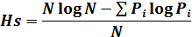
Where; Hs = Shannon-Weiner Index, N = total number of individuals in the population, i = counts denoting the ith species ranging from 1 to i., P_{i} = proportion that the ith species represents in terms of number of individuals with respect to the total number of individuals in the sampling space as a whole.

      - Equitability or Evenness (j)
Species equitability or evenness (Pielou, 1969) of each sample was evaluated using the equation below.
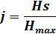
Where; H_{s} = Shannon-Wiener Index, H_{max} = logarithm of the number of species in the population.

      - Simpson’s Dominance Index (C)
Simpson’s dominance index (C) (Ogbeibu, 2005) for each sample was estimated using the equation below.
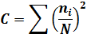
Where n_{i} = number of individuals of the ith species, N = total number of individuals.

      - Correlation Coefficient (γ)
The Spearman’s Rank Correlation Coefficient (Ogbeibu, 2005) for the relationship between biotic structure and environmental variables was determined using the following equation.
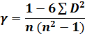
Where γ = correlation coefficient; ∑D² = sum of squares of difference of the ranks; n = number of months.

3.0. Results
Monthly variations in the water quality parameters at the Apapa Wharf (Quay) area of the Badagry creek (Buoy 24) between October, 2007 and March, 2008 are presented in Table 1. Air temperatures during the study ranged from 23.9°C in February to 31°C in November while the mean temperature over the period was 27.6°C. Air temperatures were relatively higher in the dry season than the wet season. Water temperature values were also generally higher in the dry months than the wet months. The lowest value (25.2°C) was recorded in February while the highest value (31.4°C) was recorded in December. Mean water temperature was 28.1°C. Transparency at the study site was higher in the dry months than in the wet months. It ranged from 67.9cm recorded in November to 170.5cm recorded in February with a mean value of 118.9cm. Total dissolved solids were highest in February (18,288mg/L) and lowest (868 mg/L) in October with a mean value of 10019.3mg/L. Higher TDS values were recorded in dry months than in the wet months. Total suspended solids were higher in the dry months than in the wet months. The highest value (125mg/L) was recorded in March while the lowest value (12mg/L) occurred in November. Rainfall at the study site ranged from 8.9mm recorded in December to 87.9mm recorded in October.
Salinity during the period investigated increased steadily from 0.90‰ recorded in October to 20.8‰ recorded in February while average value was 11.20‰. Salinity was higher in the dry season than in the wet season. Chloride ion concentrations ranged widely from 406.0 to 10,966.0mg/L with a mean value of 5843.35mg/L. The lowest value (406.0mg/L) was recorded in October while the highest value (10,966.0mg/L) was recorded in February. Chloride ion concentrations were higher in the dry than the wet months. Conductivity during the study ranged from 1,664 to 34,900µS/cm. The highest value (34,900µS/cm) was recorded in February while the lowest value (1,664µS/cm) was recorded in October. Mean conductivity during the study was 19839.83µS/cm. The pH was alkaline and was higher in the wet months than the dry months. It ranged from 7.33 recorded in October and December to 7.53 recorded in February while the average value for the period of study was 7.44. Acidity was higher in the dry months than in the wet months. It increased from 2.0mg/L recorded in October to 8.8mg/L recorded in January and then decreased gradually to 6.6mg/L in March. Mean acidity during the study was 5.70mg/L. Alkalinity was higher in the dry months than in the wet months ranging from 70.0mg/L recorded in October and November to 1400.0mg/L recorded in March with a mean value of 583.33mg/L. Dissolved oxygen at the study site was relatively higher in the dry months than in the wet months. It ranged from 3.73mg/L recorded in November to 5.3mg/L recorded in February. Biochemical oxygen demand at the study site was generally high ranging from 22 to 70mg/L. The highest value (70mg/L) was recorded in January while the lowest value (22mg/L) was obtained in October. BOD₅ was relatively higher in the wet months than in the dry months. Chemical oxygen demand was highest (400mg/L) in December while the lowest value (125mg/L) was recorded in January. COD values were higher in the dry season than in the wet months.
The total hardness varied widely from 486.5 to 6950.1mg/L. The lowest value (486.5mg/L) and the highest (6950.1mg/L) were recorded in October and February respectively. Total hardness was significantly higher in the dry season than in the wet season. The calcium concentration at the study site ranged from 27.8 to 1800mg/L. Calcium concentration was highest (1800mg/L) in February and lowest in October. Data obtained showed that Calcium concentration was higher in the dry months than the wet months. Magnesium concentration at the study site was higher in the dry months than the wet months ranging from 102.3mg/L recorded in October to 736.0mg/L in February. The nitrate concentration was higher in the dry months than the wet months ranging between 2.0 and 10.1mg/L with an average value of 4.25mg/L. Nitrate was highest (10.1mg/L) in January while the lowest value (2.0mg/L) was recorded in October. Phosphate concentrations were higher in the dry months than the wet months. The highest (2.50mg/L) and lowest (0.28mg/L) values were recorded in January and October respectively. Sulphate concentration at the study site ranged widely from 4.5mg/L recorded in October to 902.3mg/L recorded in February. Sulphate concentration was generally higher in the dry months than in the wet months.
Silica concentration at the study site was higher in the dry months than in the wet months and ranged from 2.2 to 4.2mg/L. Silica concentration was highest (4.2mg/L) in December and lowest (2.2mg/L) in October with a mean value of 3.08mg/L. Copper values were fairly constant ranging between 0.002mg/L and 0.004mg/L. The lowest value (0.002mg/L) was recorded in October, December and January respectively while the highest value (0.004mg/L) was recorded in February and March. The mean value for the period of study was 0.003mg/L. Iron concentrations ranged from 0.10mg/L to 0.26mg/L. The lowest (0.10 mg/L) and highest (0.26mg/L) values were recorded in October and January respectively while the mean value was 0.18mg/L. Iron values were relatively higher in the dry than in the wet months. Zinc concentration values were higher in the wet months than in the dry months ranging from 0.008mg/L recorded in October and January to 0.025mg/L in March. Mean value for the period of study was 0.13.

3.2. Biological Characteristics
3.2.1. Chlorophyll a (µg/L)
Chlorophyll a concentration ranged from 4µg/l recorded in October to 16µg/L recorded in November and February respectively. Mean chlorophyll a concentration was 11.5µg/l. Chlorophyll a values were higher in the dry months than the wet season months (Fig. 2 and 3).

3.2.2. Zooplankton spectrum
An inventory of zooplankton species at the Badagry creek between October, 2007 and March, 2008 are presented in Table 2. Zooplankton population and diversity were more abundant in the dry months than in the wet months. A total of 5 groups of zooplankton were identified with the copepods constituting 74% of the number of individuals recorded (Fig. 4). The copepods were represented by two (2) orders, Calanoida and Cyclopoida, with the most abundant copepod species being Arcatia clausii representing 44.86% of the total zooplankton population (Fig. 4). Other copepod species identified were A. discaudata, A. tonsa, Paracalanus parvus, P. scotti, Temora stylifera, Cyclops sp., Corycaeus obtusus and Oithona sp. and Oncaea venusta. The mysids were represented by Mysis sp. while there were a number of unidentified Cnidarians from the class Scyphozoa. The cladocerans were represented by Alona sp. and Penilia avirostris while the larvaceans were the least abundant group represented by Oikopleura sp (Table 3). Meroplanktonic forms encountered include juvenile stages of different animal phyla such as Arthropoda (zoea larva), Chordata (Fish larva) and Mollusca (Gastropod larva) (Fig. 5). Juvenile stages represented 22.56% of the total zooplankton groups observed (Table 3; Fig. 4) and were more abundant in the dry months than the wet months.

3.3.3. Zooplankton community structure
Monthly variations in community structure are as presented in Table 4. Species diversity (S), richness (d) and Simpson’s Dominance (C) indices were higher in the dry season while species equitability index (j) was higher in the wet season.
Correlation coefficient (γ) between water quality parameters and species richness and abundance at the Badagry creek.
The Spearman’ rank correlation coefficient matrix between water quality parameters and zooplankton species richness and abundance at the Badagry creek are presented in Table 5. Spearman’s Correlation Coefficient associations that shows positive and negative relationships (≥+0.40 or ≤-0.40) for water quality parameters, Chlorophyll a, Species Diversity and Abundance are further presented in Table 6.

Table 2: Monthly Variations in water quality Parameters at the Badagry creek (October, 2007 – March, 2008).

PARAMETERS | Oct. | Nov. | Dec. | Jan. | Feb. | Mar. | Mean | Std. Dev.
Air temperature (°C) | 27 | 31 | 29 | 28.5 | 23.9 | 26.2 | 27.6 | 2.46
Water temperature (°C) | 27.1 | 28 | 31.4 | 27.4 | 25.2 | 29.4 | 28.0833 | 2.12
Transparency (cm) | 81 | 67.9 | 112.8 | 126.4 | 170.5 | 155 | 118.933 | 40.24
Rainfall (mm) | 87.9 | 19.5 | 8.9 | 74.4 | 17.6 | 44.5 | 42.1333 | 32.74
Total Dissolved Solids (mg/L) | 868 | 2420 | 6910 | 13350 | 18288 | 18280 | 10019.3 | 7731.33
Total Suspended Solids (mg/L) | 32 | 12 | 115 | 120 | 23 | 123 | 70.8333 | 53.57
pH at 26°C | 7.33 | 7.44 | 7.33 | 7.43 | 7.53 | 7.6 | 7.44 | 0.099
Acidity (mg/L) | 2 | 2.8 | 6 | 8.8 | 8 | 6.6 | 5.7 | 2.75
Alkalinity (mg/L) | 70 | 70 | 700 | 280 | 980 | 1400 | 583.33 | 539.80
Salinity (‰) | 0.9 | 2.3 | 8.7 | 15 | 20.8 | 19.5 | 11.2 | 8.57
Conductivity (µS/cm) | 1664 | 4480 | 16095 | 27300 | 34900 | 34600 | 19839.8 | 14701.3
Dissolved Oxygen (mg/L) | 3.9 | 3.7 | 4 | 4 | 5.3 | 4.6 | 4.25 | 0.60
Biological Oxygen Demand (mg/L) | 70 | 33 | 48 | 22 | 28 | 34 | 39.1667 | 17.39
Chemical Oxygen Demand (mg/L) | 230 | 150 | 400 | 125 | 192 | 70 | 194.5 | 114.72
Total Hardness (mg/L) | 486.5 | 625.5 | 2085 | 4170 | 6950.1 | 6860.1 | 3529.53 | 2932.01
Chloride (mg/L) | 406 | 928.1 | 4060 | 7900 | 10966 | 10800 | 5843.35 | 4731.69
Calcium (mg/L) | 27.8 | 44.6 | 150.2 | 489.5 | 1800 | 1720 | 705.35 | 834.053
Magnesium (mg/L) | 102.3 | 123 | 417.1 | 736 | 612.5 | 620.3 | 435.2 | 270.11
Zinc (mg/L) | 0.008 | 0.012 | 0.011 | 0.008 | 0.015 | 0.025 | 0.01317 | 0.0064
Iron (mg/L) | 0.1 | 0.2 | 0.17 | 0.26 | 0.15 | 0.18 | 0.17667 | 0.053
Copper (mg/L) | 0.002 | 0.003 | 0.002 | 0.002 | 0.004 | 0.004 | 0.00283 | 0.00098
Nitrate (mg/L) | 2 | 3.3 | 4 | 10.1 | 0.8 | 5.3 | 4.25 | 3.26
Sulphate (mg/L) | 4.5 | 120.3 | 360.2 | 330.6 | 902.3 | 989 | 451.15 | 406.10
Phosphate (mg/L) | 0.28 | 1.9 | 0.3 | 2.5 | 0.8 | 0.88 | 1.11 | 0.90
Silica (mg/L) | 2.2 | 3.2 | 4.2 | 2.8 | 3.3 | 2.8 | 3.08 | 0.67
Chlorophyll a (µg/L) | 4 | 16 | 11 | 12 | 16 | 10 | 11.5 | 4.46
Fig. 2: Monthly variations in Rainfall, Salinity and Chlorophyll a at the Badagry creek (October, 2007 – March, 2008).

Table 3: An inventorial of the Zooplankton of the Badagry creek (October, 2007- March, 2008).

TAXA
PHYLUM I: ARTHROPODA
CLASS I: CRUSTACEA
SUB-CLASS I: COPEPODA
ORDER I: CALANOIDA
Acartia clausii Giesbrecht
Acartia discaudata Giesbrecht
Acartia tonsa Giesbrecht
Paracalanus parvus Claus
Paracalanus scotti Fruchtl
Temora stylifera Dana
ORDER II: CYCLOPOIDA
Corycaeus obtusus Dana
Cyclops sp.
Oithona plumifera Baird
Oncaea venusta Phillipi
SUB-CLASS II: MALACOSTRACA
ORDER: MYSIDACEA
Mysis sp.
SUB-CLASS III: BRANCHIOPODA
ORDER: CLADOCERA
Alona sp.
Penilia avirostris Dana
JUVENILE STAGES
Copepod eggs
Lucifer foxoni zoea larva
Megalop larva
Nauplii larva of Barnacle
Nauplii larva of Copepods
Zoea larva
PHYLUM II: CNIDARIA
CLASS: SCYPHOZOA
Unidentified jellyfish
PHYLUM: MOLLUSCA
JUVENILE STAGES
Gastropod larva
PHYLUM: CHORDATA
CLASS: LARVACEA
Oikopleura sp.
JUVENILE STAGES
Fish eggs
Fish larvae

Table 4: Community Structure Indices at the Badagry creek.

MONTHS | Oct. | Nov. | Dec. | Jan. | Feb. | Mar. | Mean
Species diversity (S) | 7 | 8 | 13 | 14 | 12 | 11 | 10.83
Species abundance (N) | 50 | 60 | 560 | 475 | 550 | 320 | 335.83
Margalef’s Index (d) | 1.53 | 1.71 | 1.90 | 2.11 | 1.74 | 1.73 | 1.79
Shannon-Weiner Index (Hs) | 0.80 | 0.86 | 0.78 | 0.93 | 0.74 | 0.55 | 0.78
Equitability Index (j) | 0.94 | 0.95 | 0.70 | 0.81 | 0.69 | 0.53 | 0.77
Simpson's Dominance Index (C) | 0.18 | 0.15 | 0.25 | 0.16 | 0.27 | 0.50 | 0.25

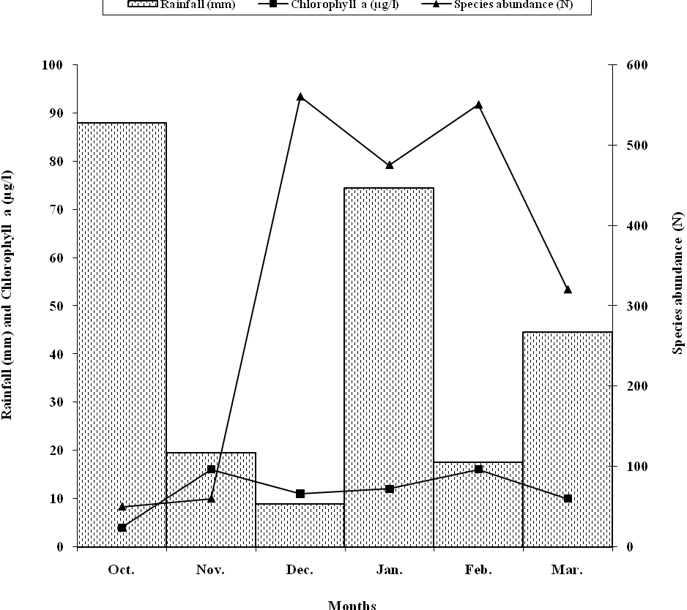
Fig. 3: Monthly variations in Rainfall, Chlorophyll a and Species abundance at the Badagry creek (October, 2007 – March, 2008).

Table 3: Relative Abundance of Zooplankton Groups (per ml) at Badagry creek (October, 2007 – March, 2008).
ZOOPLANKTON GROUP | POPULATION | % COMPOSITION
Copepoda | 1500 | 74.44
Juvenile stages | 450 | 22.33
Malacostraca | 30 | 1.49
Cnidaria | 20 | 0.99
Branchiopoda | 10 | 0.50
Larvacea | 5 | 0.00
TOTAL | 2015 | 100

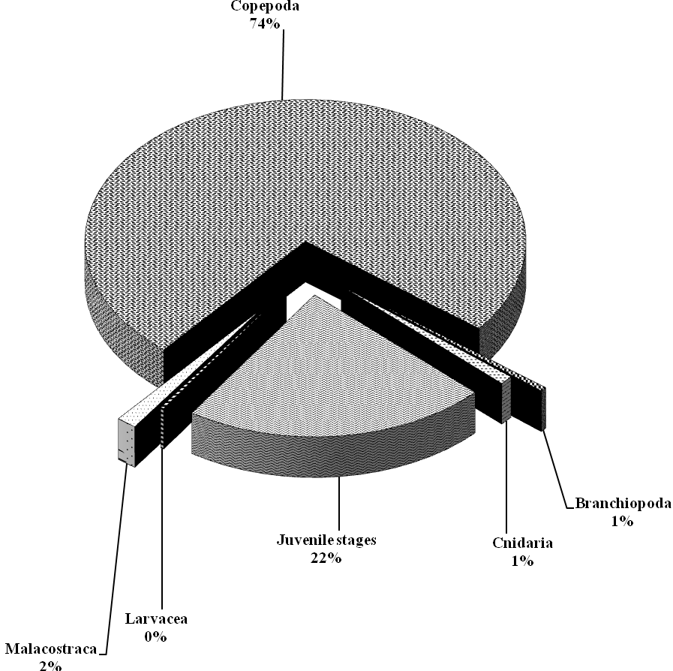
Fig. 4: Relative abundance of Zooplankton groups at the Badagry creek.

Fig. 5: Relative abundance of zooplankton juvenile stages.

Table 5: Spearman’s rank Correlation Co-efficient Matrix of Water Quality Parameters, Chlorophyll a, Species Abundance and Diversity at the Badagry creek (October, 2007 - March, 2008).
 | Air temp. | Water temp. | Transparency | Rainfall | TDS | TSS | pH | Acidity | Alkalinity | Salinity | Conductivity | DO | BOD | COD | Total Hardness | Chloride | Calcium | Magnesium | Zinc | Iron | Copper | Nitrate | Sulphate | Phosphate | Silica | Chlorophyll – a | Species diversity | Species abundance
Air temp. | 1.00
Water temp. | 0.50 | 1.00
Transparency | 0.79 | -0.20 | 1.00
Rainfall | -0.09 | -0.29 | -0.20 | 1.00
TDS | -0.67 | -0.19 | 0.98 | -0.17 | 1.00
TSS | 0.50 | 0.64 | 0.37 | 0.11 | 0.42 | 1.00
pH | 0.50 | -0.32 | 0.71 | -0.22 | 0.82 | 0.05 | 1.00
Acidity | 0.42 | -0.09 | 0.83 | -0.15 | 0.86 | 0.57 | 0.49 | 1.00
Alkalinity | -0.63 | 0.19 | 0.85 | -0.38 | 0.83 | 0.44 | 0.70 | 0.56 | 1.00
Salinity | -0.68 | -0.18 | 0.98 | -0.20 | -0.78 | 0.42 | 0.78 | 0.89 | 0.82 | 1.00
Conductivity | -0.64 | -0.14 | 0.97 | -0.19 | 0.99 | 0.47 | 0.77 | 0.90 | 0.82 | 0.99 | 1.00
DO | -0.90 | -0.45 | 0.90 | -0.29 | 0.82 | -0.06 | 0.70 | 0.58 | 0.75 | 0.83 | 0.80 | 1.00
BOD | 0.03 | 0.20 | -0.51 | 0.34 | -0.68 | -0.22 | -0.68 | -0.74 | -0.32 | -0.67 | -0.68 | -0.36 | 1.00
COD | 0.17 | 0.44 | -0.24 | -0.36 | -0.43 | 0.02 | -0.74 | -0.17 | -0.17 | -0.37 | -0.37 | -0.20 | 0.51 | 1.00
Total Hardness | -0.74 | -0.24 | 0.97 | -0.17 | 0.99 | 0.34 | 0.84 | 0.98 | 0.86 | 0.98 | 0.98 | -0.87 | -0.61 | -0.44 | 1.00
Chloride | -0.69 | -0.20 | 0.97 | -0.16 | 0.99 | 0.42 | 0.80 | 0.87 | 0.83 | 0.99 | 0.99 | 0.83 | -0.66 | -0.41 | 0.99 | 1.00
Calcium | -0.81 | -0.32 | 0.92 | -0.21 | 0.92 | 0.14 | 0.89 | 0.61 | 0.87 | 0.91 | 0.89 | 0.92 | -0.49 | -0.47 | 0.96 | 0.92 | 1.00
Magnesium | -0.46 | -0.06 | 0.86 | -0.54 | 0.91 | 0.64 | 0.56 | 0.98 | 0.63 | 0.92 | 0.93 | 0.58 | -0.71 | -0.30 | 0.85 | 0.91 | 0.67 | 1.00
Zinc | -0.41 | 0.17 | 0.59 | -0.31 | 0.64 | 0.26 | 0.81 | 0.24 | 0.87 | 0.61 | 0.61 | 0.54 | -0.30 | -0.46 | 0.69 | 0.63 | 0.78 | 0.36 | 1.00
Iron | 0.44 | 0.13 | 0.11 | -0.05 | 0.31 | 0.48 | 0.24 | 0.57 | -0.05 | 0.30 | 0.34 | -0.20 | -0.80 | -0.37 | 0.19 | 0.29 | -0.02 | 0.55 | -0.03 | 1.00
Copper | -0.56 | -0.31 | 0.63 | -0.42 | 0.67 | -0.19 | 0.92 | 0.26 | 0.72 | 0.64 | 0.61 | 0.77 | -0.45 | -0.53 | 0.74 | 0.66 | 0.87 | 0.31 | 0.84 | -0.09 | 1.00
Nitrate | 0.36 | 0.25 | 0.06 | -0.38 | 0.22 | 0.73 | 0.03 | 0.49 | -0.08 | 0.22 | 0.27 | -0.34 | -0.47 | -0.33 | 0.11 | 0.22 | -0.12 | 0.54 | -0.10 | 0.85 | -0.36 | 1.00
Sulphate | 0.70 | -0.80 | 0.93 | -0.36 | 0.93 | 0.31 | 0.85 | 0.67 | 0.95 | 0.93 | 0.92 | 0.87 | -0.52 | -0.34 | 0.96 | 0.93 | 0.97 | 0.72 | 0.83 | 0.06 | 0.83 | -0.05 | 1.00
Phosphate | 0.43 | -0.24 | -0.10 | 0.16 | 0.12 | 0.09 | 0.24 | 0.32 | -0.33 | 0.10 | 0.13 | -0.26 | -0.73 | -0.58 | 0.04 | 0/10 | -0.10 | 0.30 | -0.19 | 0.88 | -0.07 | 0.70 | -0.14 | 1.00
Silica | 0.22 | 0.53 | 0.14 | -0.87 | 0.09 | 0.21 | -0.12 | 0.28 | 0.26 | 0.14 | 0.14 | 0.83 | -0.24 | 0.64 | 0.04 | 0.09 | -0.03 | 0.15 | 0.02 | 0.18 | -0.01 | -0.10 | 0.17 | -0.16 | 1.00
Chlorophyll – a | 0.09 | -0.21 | 0.27 | -0.72 | 0.36 | -0.22 | 0.49 | 0.41 | 0.16 | 0.37 | 0.36 | 0.33 | -0.81 | -0.17 | 0.32 | 0.34 | 0.31 | 0.29 | 0.16 | 0.51 | 0.49 | -0.02 | 0.34 | 0.49 | 0.52 | 1.00
Species diversity | -0.18 | 0.20 | 0.65 | -0.24 | 0.66 | 0.70 | 0.20 | 0.93 | 0.44 | 0.70 | 0.73 | 0.34 | -0.62 | 0.12 | 0.17 | 0.67 | 0.35 | 0.88 | 0.07 | 0.60 | -0.01 | 0.56 | 0.47 | 0.25 | 0.51 | 0.35 | 1.00
Species abundance | -0.38 | 0.13 | .75 | -0.39 | 0.68 | 0.53 | 0.19 | 0.88 | 0.55 | 0.73 | 0.73 | 0.55 | -0.48 | 0.30 | 0.62 | 0.69 | 0.46 | 0.80 | 0.11 | 0.32 | 0.11 | 0.24 | 0.57 | -0.03 | 0.62 | 0.35 | 0.94 | 1.00

Table 6: Spearman’s Correlation Coefficient Associations for Chlorophyll a, Species Diversity and Abundance
PARAMETERS | CORRELATION
PARAMETERS | Chlorophyll a | Species diversity (S) | Species abundance (N)
Air temp. | x | x | x
Water temp. | x | x | x
Rainfall | (-) | x | x
TDS | x | (+) | (+)
TSS | x | (+) | (+)
Transparency | x | (+) | (+)
Salinity | x | (+) | (+)
Chloride | x | (+) | (+)
Conductivity | x | (+) | (+)
pH | (+) | x | x
Acidity | (+) | (+) | (+)
Alkalinity | x | (+) | (+)
DO | x | x | x
BOD | (-) | (-) | (-)
COD | x | x | x
Total Hardness | x | (+) | (+)
Calcium | x | (+) | (+)
Magnesium | x | (+) | (+)
Zinc | x | x | x
Iron | (+) | (+) | x
Copper | (+) | x | x
Nitrate | x | (+) | x
Sulphate | x | (+) | (+)
Phosphate | (+) | x | x
Silica | (+) | (+) | (+)
Chlorophyll a | 1 | (+) | (+)
Species diversity | (+) | 1 | (+)
Species abundance | x | (+) | 1

Key:
(+) → Strongly positive (≥ +0.40)
(-) → Strongly negative (≤ −0.40)
x → not strongly correlated

- Discussion
The present information on the seasonality of hydrological characteristics of the Badagry creek is in agreement with earlier observations on some creeks in South-western Nigeria (Nwankwo and Amuda, 1993; Onyema and Nwankwo, 2006; Onyema, 2007; Onyema and Ojo, 2008). According to these reports, two physiographic factors rainfall and salinity determine the hydro-climatic conditions of the creek ecosystems of South-western Nigeria and subsequently the biotal spectrum. According to Nwankwo (1996) and Nwankwo et al. (2003) reported that the dynamic interplay between tidal seawater incursion and flood water inflow from adjoining rivers and creeks are also known to affect the hydrodynamics of the Lagos lagoon.
High air (23.9° - 31°C) and water (25.2° - 31.4°C) temperatures recorded during the study are typical of the region (Nwankwo et. al., 2003; Onyema et al., 2003). However the range of water temperature values are in contrast to earlier observations by Hill and Webb (1958) and Sandison and Hill (1966) which reported that water temperature in the Lagos lagoon never varied more than 4°C. This may be due to increased insolation arising from greater solar radiation, possibly a reflection of global warming trends. Air and water temperatures were relatively higher in the dry months (Dec. – Feb.) than in the wet months which could be attributed to reduced cloud cover conditions and subsequent increase in solar radiation (Onyema et al., 2003).
Transparency was observed to increase progressively with the dry season months. The reduction in transparency levels in the wet months may be connected with the incursion of the creek by majorly flood waters with corresponding introduction of allochtonous materials from the adjacent land. This confirms earlier report by Nwankwo (1990) which highlighted that the seasonal variation of transparency in coastal waters of South-western Nigeria is linked to the rainfall pattern and associated floods.
The salinity values observed throughout the period of the study suggests that the study site is a brackish environment. The high salinity values during the dry season may be attributed to low rainfall, high evaporation rate coupled with low humidity, increased tidal seawater incursion, reduced flood water and water inflow from associated rivers and creeks. According to Onyema et. al. (2003) and Emmanuel and Onyema (2007) the salinity regime in the Lagos lagoon is seasonal with high salinities reported from December to April and low salinities observed between May and November. In agreement with this, the salinities were higher from December to March and lower in October and November. Hence hydro-meteorological forcings may be implicated in the control of the water quality conditions of the Badagry creek, namely freshwater associated with rains and seawater incursion (Emmanuel and Onyema, 2007; Onyema and Emmanuel, 2009).
The pH values recorded during the study were alkaline, but were higher in the dry season months than the wet season months. This increase may be due to the buffering effect of seawater as a result of increased tidal seawater incursion. According to Nwankwo (1988), dissolved oxygen decreases with increased temperature and biological oxygen demand due to increased metabolic activities of most species. Furthermore biochemical oxygen demand values higher than 8mg/L according to Hynes (1960) point to severe pollution. The low dissolved oxygen levels (<5.3) recorded during the study coupled with very high biochemical oxygen demand levels within the creek (>22mg/L) are indicators of severe pollution stress within the creek. The increased DO content of the Badagry creek during the dry season months may be as a result of high transparency and increased productivity by both the macrophyte vegetation and algae around the area. Lower DO levels in the wet season may be ascribed to flood and municipal drains depositing waste (organic, inorganic and debris) thereby leading to increased fouling, turbidity and consequently a reduction in primary productivity.
Kadiri (1993) reported a seasonal pattern in variation of Chlorophyll a in Benin, Nigeria and noted a major peak usually occurring in the dry season between January and February and a minor peak occurring in the late rainy season between August and November. The pattern of variation of Chlorophyll a values observed during this study is in agreement with Kadiri (1993). Chlorophyll a values were also generally observed to be higher in the dry season than in the wet months confirming earlier observations by Ogamba et. al. (2004). This may be attributed to high light intensity, reduced cloud cover and more stable conditions which permitted maximum use of available nutrients by the phytoplankton hence an increase in biomass (Onyema and Emmanuel, 2009). Further to this, Erondu and Chindah (1991) and Kadiri (1999) are of the view that, alkalinity is regarded as a measure of the productivity of natural waters. Positive correlation between alkalinity and chlorophyll a values recorded during the period of study confirms the afore-mentioned relationship between alkalinity and productivity. For instance, dissolved oxygen levels throughout the period of study were comparatively lower in the wet months than the dry. Furthermore, chlorophyll a values were also lower in the wet than the dry months. It is possible that higher primary productivity in the dry months gave rise to higher chlorophyll a concentrations which lead to a similar trend in dissolved oxygen concentrations since oxygen is a by-product of photosynthesis.
Generally, zooplankton diversity was higher in the dry than in the wet months. More stable conditions including water flow characteristics, light penetration, reduced rainfall and increased salinity conditions experienced in the dry season could have encouraged the development of a richer zooplankton spectrum within the creek, while freshwater conditions during the wet months reduced zooplankton abundance. Similar observations have been made by Kusemiju et. al. (1993), Onyema et. al. (2003, 2007) and Onyema and Nwankwo, (2009) in similar environments in the region. The high species abundance and diversity, recorded in December may be attributed to a bloom in phytoplankton population which according to Nwankwo (2004), may have occurred in the preceding period. The zooplankton community was dominated by calanoid copepods mainly Arcatia clausii and Paracalanus parvus confirming earlier reports by Onyema et. al., (2003, 2007) and Onyema and Ojo (2008).
The abundance of an array of developmental stages in the zooplankton spectrum especially crustaceans of known estuarine and migratory fauna may point to the suitability of the Badagry creek as a nursery and breeding ground. This observation is in consonance with reports of Nwankwo and Gaya (1996) and Solarin and Kusemiju (2003). According to Onyema et. al. (2007), the occurrence of fish eggs, larvae and juvenile stages of known marine forms may confirm suggestions that the Lagos lagoon is populated by immigrant forms from the sea particularly during the dry season. A similar situation may exist in the Badagry creek.
The dominance of calanoid copepods particularly Acartia clausii may have accounted for the low species richness index (<2.11) and low species diversity index (<0.93) recorded during the study. It’s important to note that Table 6 very likely represents relationships (directly or indirectly) between these water quality parameters and zooplankton species occurrence.

Acknowledgement
The authors are grateful to the Department of Marine Sciences, University of Lagos for logistics and the use of her facilities.
Correspondence to:
Lawal-Are, Aderonke O.
Department of Marine Sciences, Faculty of Science, University of Lagos.
Akoka - Lagos,
Nigeria.
Telephone: +234 1 8781555
Cellular phone: +234 803 330 20969
Emails: aolawalare@gmail.com;
aderonkelara@yahoo.com

References
- Akpata, T.V.I., Oyenekan, J.A. and Nwankwo, D.I. (1993). Impact of Organic Pollution on the Bacterial, Plankton and Benthic Populations of Lagos lagoon, Nigeria. International Journal of Ecology and Environmental Sciences. 17: 1 – 10.
- APHA (1998). Standard Methods for the Examination of Water and Wastewater. (20th Ed.). American Public and Health Association, New York. 1270pp
- Brown, C.A. (1998). Distribution and population dynamics of an estuarine population of Aloidis trigona Hinds (Bivalvia). Acta. Hydrobiol. 40(4): 227 – 237.
- Brown, C.A. and Oyenekan, J.A. (1998). Temporal variations in the structure of benthic microfauna communities of the Lagos lagoon and harbor, Nigeria. Polskie Archiwum Hydrobiologii. 45 (1). 45 – 54.
- Chukwu, L.O. and Nwankwo, D.I. (2004). The impact of Land based pollution on the hydrochemistry and macrobenthic community of a tropical West African creek. Ekologia. 2 (1 - 2): 1 – 9.
- Egborge, A.B.N. (1988). Water hyacinth: a biological museum. In: The proceedings of the International workshop seminar on the water hyacinth, Lagos. (7th – 12th August, 1988). 52 – 70.
- Emmanuel, B.E. and Onyema, I.C. (2007). The Plankton and Fishes of a Tropical Creek in South-Western Nigeria. Turkish Journal of Fisheries and Aquatic Sciences. 7 (2): 105 – 114.
- Erondu, E.S and Chindah, A.C. (1991). Physico-chemical and Plankton changes in a Tidal Freshwater Station of the New Calabar River, South-Eastern Nigeria. Environment and Ecology. 9 (3). 561 – 570.
- F.A.O. (1969). Fisheries Survey in the Western and Mid-Western Regions of Nigeria. FAO/Sf: 74/NIR 6: 142pp.
- Gibbons, M.J. (2001). An introduction to the zooplankton of the Benguela Current Region. NDB, Western Cape, South Africa. 54pp.
- Hill, M.B. and Webb, J.E. (1958). The ecology of Lagos lagoon II. The topography and physical features of the Lagos harbor and Lagos lagoon. Philosophical Transactions of the Royal Society of London. 241: 307 – 417.
- Hynes, H.B.N. (1960). The biology of polluted waters. Liverpool University Press, Liverpool. 200pp.
- Kadiri, M.O. (1993). Seasonal changes in the phytoplankton biomass of a shallow Tropical reservoir. Nigerian Journal of Botany. 6: 167 – 175.
- Kadiri, M.O. (1999). Phytoplankton distribution in some coastal waters of Nigeria. Nigerian Journal of Botany. 12 (1): 51 – 62.
- Kusemiju, K.K., Nwankwo, D.I. and Bamisaye, R.B. (1993). The Hydrobiology and Fishes of Opobo Channel, Rivers State, Nigeria. Journal of Science Research and Development. 1(1): 74 – 79.
- Margalef, R. (1951). Diversidad de species en las comunidales naturales. Publ. Inst. Biol. Apl. 9: 5 – 27.
- Newell, G.E. and Newell, R.C. (1966). Marine Plankton: A Practical Guide. Revised Edition. Hutchinson, London. 225pp.
- Nwankwo, D.I. (1984). Seasonal changes of phytoplankton of Lagos lagoon and the adjacent sea in relation to environmental factors. Ph.D. Thesis, University of Lagos. 447pp.
- Nwankwo, D.I. (1986). Phytoplankton of a sewage disposal site in Lagos lagoon, Nigeria. Nigerian Journal of Biological Sciences. 1: 89 – 91.
- Nwankwo, D.I. (1988). A preliminary checklist of planktonic algae in Lagos lagoon, Nigeria. Nigeria Journal of Basic & Applied Sciences. 2 (1): 73 – 85.
- Nwankwo, D.I. (1990). Distribution and Seasonal Variation of Dinoflagellates in Lagos Lagoon, Nigeria. Nigerian Journal of Botany 3: 197 – 208.
- Nwankwo, D.I. (1991). Periphyton algae on fish fences “Acadja” in a tropical open lagoon. International Journal of Ecology and Environmental Sciences. 17: 1 – 10.
- Nwankwo, D.I. (1993). Cyanobacteria bloom species in coastal waters of South Western Nigeria. Archiv fur Hydrobiologie. 90: 533 – 542.
- Nwankwo, D.I. (1994). Hydrochemical properties and bottom-dwelling Diatoms of a Lagos lagoon sewage disposal site. Polskie Archiwum Hydrobiologii. 41 (1): 35 – 47.
- Nwankwo, D.I. (1996). Phytoplankton diversity and succession in Lagos lagoon, Nigeria. Archiv fur Hydrobiologie. 135 (4): 529 – 542.
- Nwankwo, D.I. (1998). Seasonal changes in phytoplankton population and diversity in Epe lagoon, Nigeria. Acta Hydrobiologia. 10 (2): 83 – 92.
- Nwankwo, D.I. (2004). The Microalgae: Our indispensable allies in aquatic monitoring and biodiversity sustainability. University of Lagos Press Inaugural Lecture Series. 44pp.
- Nwankwo, D.I. and Amuda, S.A. (1993). Periphyton Diatoms on three floating Aquatic Macrophytes in a polluted South-Western Nigerian Creek. International Journal of Ecology and Environmental Sciences. 19: 1 – 10.
- Nwankwo, D.I. and Gaya, E.A. (1996). The algae of an estuarine mariculture site in South Western Nigeria. Tropical Freshwater Biology. 5: 1 – 11.
- Nwankwo, D.I., Onyema I.C., Adesalu T.A., Olabode, R.J., Osiegbu, G.O. and Owoseni T.I. (2003). Additions to a Preliminary check-list of Planktonic Algae in Lagos Lagoon, Nigeria. Journal of Science, Technology and Environment. 3 (1 and 2): 8 – 12.
- Ogamba, E.N., Chindah, A.C., Ekweozor, I.K.E. and Onwuteaka, J.N. (2004). Water quality of phytoplankton distribution in Elechi creek complex of the Niger Delta. Journal of Nigerian Environmental Society. 2 (2): 121 – 130.
- Ogbeibu, A.E. (2005). Biostatistics: A practical approach to research and data handling. Mindex Publishing Company Limited, Benin City, Nigeria. 264pp.
- Olaniyan, C.I.O. (1969). The seasonal variation in the hydrology and total Plankton of the Lagoons of South-West Nigeria. Nigerian Journal of Science. 3 (2): 101 – 119.
- Olaniyan, C.I.O. (1975). An Introduction to West African Ecology. Heinemann Education Books Ltd., London. 170pp.
- Onyema, I.C. (2007). The phytoplankton composition, abundance and temporal variation of a polluted estuarine creek in Lagos, Nigeria. Turkish Journal of Fisheries and Aquatic Sciences. 7 (2): 114 – 128.
- Onyema, I.C. (2008). Phytoplankton biomass and diversity at the Iyagbe lagoon Lagos, Nigeria. University of Lagos, Akoka. Department of Marine Sciences. 266pp
- Onyema, I.C. and Emmanuel, B.E. (2009). Fishing impairment and Spirogyra africanum (Fruda) in a freshwater lagoon. Estonian Journal of Ecology. 58 (1): 1 – 7.
- Onyema, I.C., Otudeko, O.G. and Nwankwo, D.I. (2003). The distribution and composition of plankton around a sewage disposal site at Iddo, Nigeria. Journal of Scientific Research Development. 7: 11 – 26.
- Onyema, I.C., Okpara, C.U., Ogbebor, C.I., Otudeko. O. and Nwankwo, D.I. (2007). Comparative studies of the water chemistry characteristics and temporal plankton variations at two polluted sites along the Lagos lagoon, Nigeria. Ecol. Env. And Cons. 13 (1): 1 – 12.
- Pielou, E.C. (1969). An Introdction to Mathematical Ecology. John Wiley, New York. 286pp.
- Sandison, E.E. (1966). The effect of salinity fluctuations on the life cycle of Balanus pallidus stutsburi (Darwin) in Lagos harbor, Nigeria. The Journal of Animal Ecology. 35 (2): 363 – 378.
- Sandison, E.E. and Hill, M.B. (1966). The Distribution of Balanus pallidus stutsburi (Darwin), Gryphea gasar (Adanson) Dautzenbergi, Mercierella enigmata (Fauvel), and Hydroides uncinata (Philippi) in relation to salinity in Lagos harbor and adjacent creeks. The Journal of Animal Ecology. 35: 235 – 250.
- Solarin, B.B. and Kusemiju, K. (2003). Fish shelters as fisheries enhancements techniques Lagos lagoon, Nigeria. Nigerian Journal of Fisheries. 1: 57 – 61.
- Waife, G. and Frid, C.L.J. (2001). Marine zooplankton of West Africa. Marine Biodiversity Capacity Building in the West African Sub-region. Darwin Initiative Reports 5, Ref. 162/7/451. 120pp.
- Webb, J.E. (1958). The life history of Branchiostoma nigeriense. Philosophical Transactions of the Royal Society of London. Series B: 307 – 318.
- Wimpenny, R.S. (1966). The Plankton of the Sea. Faber and Faber Ltd, London. 330 – 373.

