Role of phase interactions in formation of photoluminescent and dielectric properties of polymeric nanocomposites PP + CdS

A.M. Маgerramov, М. А. Rаmаzanov, F.V. Gadjiyeva
Baku State University,
AZ 1148, Z.Khalilov 23, Baku, Azerbijan

E-mail: nanomaterials@bsu.az , mamed_r50@mail.ru

Abstract: In present work has been investigated the influence of phase interactions in formation of photoluminescent and dielectric properties of polymeric nanocomposites on the basis PP + CdS. Has been shown that the increasing of concentration of initial solutions leads to adhesion of CdS nanoparticles i.e. with increasing of concentration the more Cd²⁺ and S²⁻ ions are not used on formation of new germs, but ones are used on coagulation of initial particles. It is supposed when the sizes of nanoparticles are commensurable with supermolecular formation, then polymeric macromolecules effectively excite new additional luminescent centers by light influense. It is also shown that boundary phase interactions in polymeric nanocomposites PP+CdS plays important role on formation of its photoluminiscent properties. It means that it is possible to adjust photoluminiscent properties not only by component and its geometrical parameters matching, but also by impact on conditions of boundary and interphase effects. [Journal of American Science 2009; 5(6):95-101]. (ISSN: 1545-1003).

Keywords: nanocomposite, photoluminescent, nanoparticle

Introduction
Semiconductor materials as cluster, distributed in organic polymeric matrix is a question of great scientific and practical importance of scientists, working on problems, related to physics and chemistry of microsize systems [1-2]. Such kind materials reveal unusual electronic and optical properties. For preparation nanosize semiconductors are used several methods such as ash-gel technology [3], Lengmure-Blodjet method [4], molecular-beam epitaxy [5] and multicyclic treatment method [6]. One of the main obstacles of possible application of the structures with semiconductor nanoclusters in optic electronics is low effectiveness of cluster luminescence, caused by high density of surface. Surface density depends on preparation method, further treatment of nanocluster and matrix, containing nanoparticles. Investigation of composite structures, ascertainment of links between intermolecular forms characters and polymers properties allows pointedly regulate the structure of prepared material with demanded properties. Studying of the structure of such kind materials allows predict its properties, and the changes of the properties give the information of nanocomposite structure. In the present work has been studied photoluminiscence of CdS nanoparticles in polymeric polypropylene matrix.

The samples and experiment method
In this work is given the results of research of photoluminescent properties of nanocomposites on the basis of polypropylene (PP) and filler CdS treated in wavelength interval λ= 300-1000 nm. The polymeric powder (size of particles 0, 5-1,0 mkm) with aim to increase the reactivity towards the transition metal ions was treated by electrical discharge in various intervals of time [7]. The treatment of powder was carried in quartz tube (d=15mm, wall thickness=1 mm), high voltage passed into the tube trough fluorineplastic pipe. Clearance between electrode and tube surface was filled by PP powder (d=50mm). The nanocomposite polymer + CdS was prepared by treatment of samples of powder of PP in solution of Na₂S×9H₂O with following concentrations 0,1 M, 0,5 M and 1 M. Further from that powder was prepared the samples of nanocomposites PP + CdS by hot-pressing method at the melting point of PP. Photoluminescent spectra have been studied on spectrofluorimeter Cary Eclipse in wavelength interval 300-1000 nm. Has been studied the relief of nanocomposites samples by AFM spectroscopy. The sizes of nanoparticles and distribution of CdS in polymeric matrix have been studied by electron microscopy method. Dielectric permeability and tg of dielectric loss angle were measured by means automatic bridge E8-4 with 1 kHz frequency. Developing of oxidative destructive processes in nanocomposites PP + CdS, obtained by hot-pressing method at the melting point of PP and treated by electric discharge in various time intervals, were studied by IR spectroscopy method.

- The results and discussion
The spectra, presented in Pic.1 are IR spectra of PP and nanocomposite PP + CdS samples, treated and not treated by electric discharge. It is clear from the pic.1 that there is strong change in IR spectra especially in wavelength region 3461 sm⁻¹, 1456-1186 sm⁻¹ and 864-500sм⁻¹. Change in IR spectra especially in wavelength region 3461 sm⁻¹, is connected with formation of hydroxyl groups in polymer. Depending on duration of treatment, was observed the increasing of absorption band strength in wavelength region 2950 sm⁻¹ and 2846 sm⁻¹, to result from the activation of CH valence vibrations in spectra of polypropylene. One of the major parameters influencing on distribution of dispersed phase in sample volume is the complex formation ability of polymeric matrix towards the transition metal ions complex formation ability of polymeric matrix stimulates the formation of CdS nanoparticles. It is also shown in IR spectra of nanocomposite PP + CdS samples, treated by electric discharge, the activation of absorption band strength of CH valence, deformation vibrations and vibrations mutual influence of CH and CH₂ groups were observed.
Have been studied by the atomic-force microscope (AFM) the relief of nanocomposites PP + CdS samples, obtained from PP powder, treated and untreated by electrical discharge in air quality in 0,5 hours (Pic.2). As it is seen in the pic.2 the relief of treated samples in various intervals of time becomes rough. The increasing of exposure time leads to increasing of concentration of CdS particles in polymeric matrix to certain extend. As it is seen from pic.2 the size of CdS particles in polymeric matrix is 15-18 nm. Earlier we found that ability of polymeric matrix to form complex increase with discharge treatment, i.e. the majority of dispersed component forms around the oxidation centers in polymer. The AFM-scanning of PP + CdS samples relief shows the increasing the CdS nanoparticles on the samples surface. The concentration change of CdS in PP with duration of discharge treatment seemingly is correlated with forming of oxidizing centers in polymer, which are the nuclease center for CdS[8].
We also found [8] the CdS nanoparticles size is 15-27 nm and do not depend the time of discharge treatment, and the concentration of CdS nanoparticles in polymeric matrix depends the duration of discharge treatment. The increasing of discharge treatment duration evidently leads to structural damage of polymer. The AFM-scanning pic.2 and electron-microscope spectroscopy investigations pic.3 show that CdS nanoparticles are equally distributed in polymeric matrix.

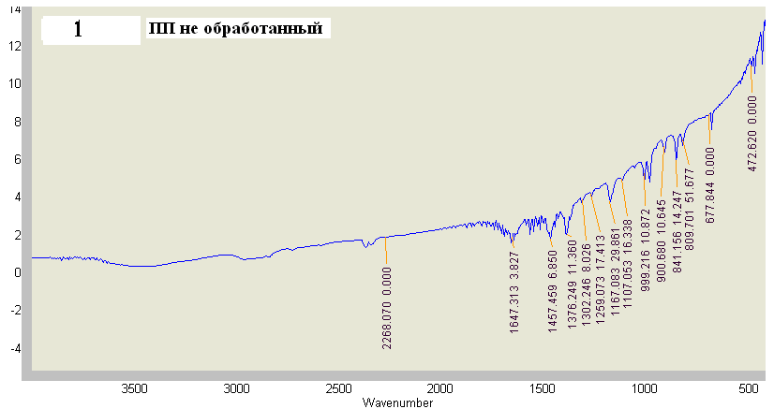
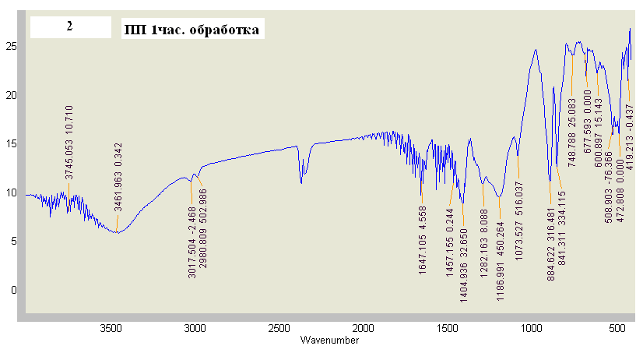
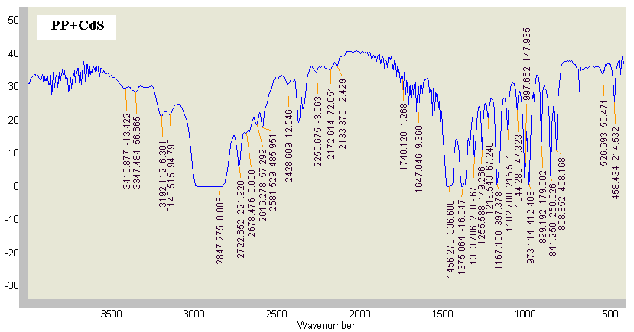
Pic.1 IR spectra of PP and nanocomposite samples, treated and not treated by
electric discharge

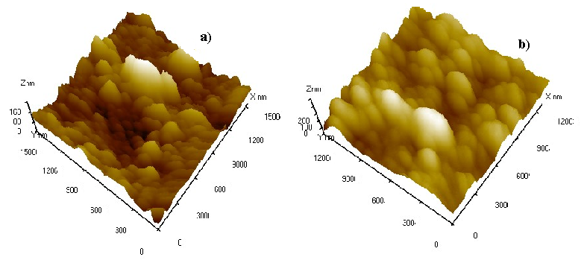
Pic.2 3D image observed by AFM of nanocomposite PP + CdS
a) Untreated powder of PP by electric discharge in air quality
b) Treatment duration of PP powder 30 minutes by electric discharge in air quality

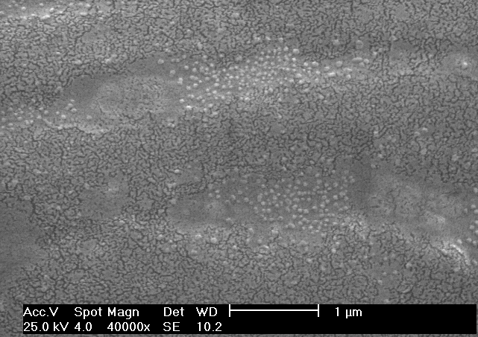
Pic.3 Electron-microscopic image of CdS nanoparticle in polypropylene

Has been studied the influence of concentration of initial solutions on size of formed CdS nanoparticles. The experiments show that increasing of concentration of initial solutions leads to increasing of CdS size nanopparticles in polypropylene matrix, i.e. in the process of nanoparticle formation CdS stick in germ crystal center.
There are AFM images of PP+CdS nanocomposite, prepared from 0,1М, 0,5М и 1М solutions CdCl₂×H₂O and Na₂S×9H₂O on pic. 4 It is found that increasing of concentration leads to increasing of CdS nanoparticles size in polypropylene. In 0,1М solution we observed formation of 15-25 nm sized nanoparticles, and in 0,5М, 1М solutions the size of nanoparticles were 35-40 nm and 70-90 nm correspondingly.
It is due to the more ions Cd²⁺ и S²⁻ are used not for formation of new germs, but on coagulation of initial particles.

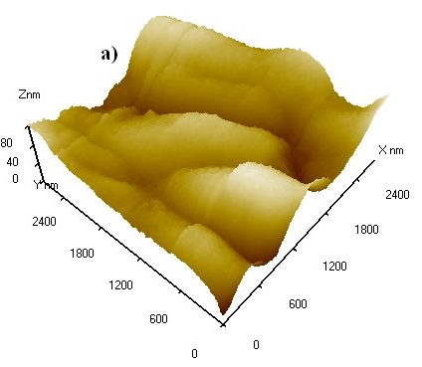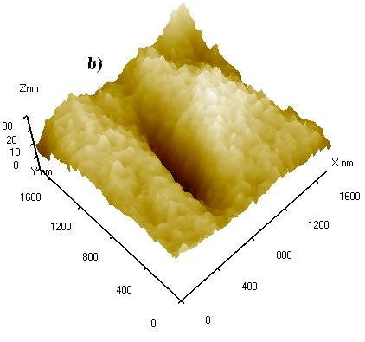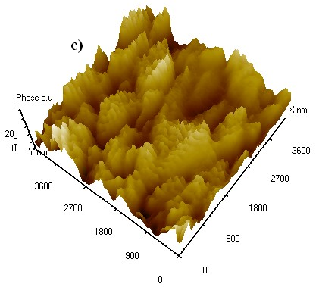

Рic. 4 AFM image of PP+CdS nanocomposite, prepared from 0,1М, 0,5М и 1М solutions CdCl₂×H₂O and Na₂S×9H₂O.

Also have been studied luminescent spectra of nanocomposite PP + CdS, prepared from solutions with various concentrations on Cary Eclipse., treated and untreated by electrical discharge in various intervals of time in the pic.5. It is clear for all samples luminescent spectra there are three basic maximums in wavelength interval λ=534 nm 627 nm and 809 nm. It is clear that increasing CdS nanoparticle size the maximum at λ=809 nm inherently decrease, but the intensity at λ=627 nm increases.

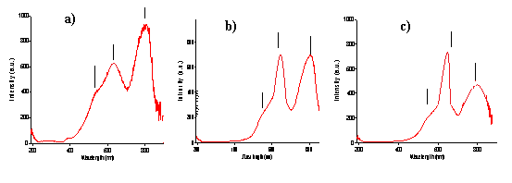
Pic.5 Photoluminescent spectra of nanocomposite PP + CdS, prepared from
0,1М(а), 0,5М(в) и 1М (с) solutions of CdCl₂×H₂O и Na₂S×9H₂O.

By our opinion the observed maximums at λ₁=627 nm are connected with thickness and properties of boundary layer and interaction degree of composite CdS+PP components, which is by its physical and chemical properties differs of polymer and semiconductor. Observed maximum at λ=534 nm characteristic for CdS in volume. The maximum at λ=809 нм is connected with recombination through defect levels in matrix and CdS nanoparticle. As it seen from pic.5 the increasing of CdS size nanoparticle leads to suppression of fluorescence at λ=809 nm. Obtained IR and fluorescence spectroscopy data let us explain character of the maximums changes at λ=627 nm and 809 nm by π* - π pass in conjugated bonds –C – C -, and - С=О. IR spectroscopy of nanocomposite samples shows as a result of degradation of molecular bonds in polymer at the process of formation of nanocomposite CdS+PP and further reactions of free radicals, forms interphase layer on the boundary of composite components. Borrowing energy of these bonds nanoparticles and polymer pass to exited state and changes in photoluminescence spectra are observed. It is known formation of chemical bond between photosemiconductors atoms and separate functional groups of polymer brings to strengthening of adhesion durability, but the physical interactions of electrostatic and Van-der-vaals forces are accompanied with week adhesion. Adhesion durability of fotoactive semiconductor and polymeric matrix is defined by interaction character on interphase boundary. Due to high activity of nanoparticle in polymeric matrix it reveals high interphase interactions. By our opinion macromoleculas of polymer can effectively excite new additional luminescent centers in semiconductor fillers, when size of nanoparticles are commensurable with supermolecular formation (lamella, fibrils, spherolites). Molecule passes on excited state after light absorption, and then is deactivated by radiating or not radiating, by intermolecular and intramolecular mechanisms. The transfer of electron excitement energy comes to be from donor to acceptor in nanocomposite as well as in low molecular compounds. One of the factors stipulating the effectiveness of energy transfer in polymer is migration of energy. It should be noted for double phase nanocomposite structure supermolecular formation has structure of nanoheterogenic morphology. It is known from molecular chemistry [8] the average distance of energy transmission between chromophor groups is 5 nm. Also low size supermolecular formation has higher mobility. High mobile supermolecular structure is sensitive to light.
Have been studied dielectric properties of nanocomposite on the basis izotactic propylene, treated by discharge in air quality which is higher than breakdown strength of air and filler CdS, depending on temperature and frequency.
There is on pic.6 dependence of dielectric permeability (ε) and tg of dielectric loss angle ($\text{tg}δ$) on frequency for nanocomposite PP+CdS treated by discharge in various time interval. As it is seen from pic.6 the increasing of frequency the values ε and $\text{tg}δ$ of nanocomposite decrease, the increasing of treatment interval of polymer powder dielectric permeability (ε) and tg of dielectric loss angle ($\text{tg}δ$) increase at that.
The increasing of ε and $\text{tg}δ$ depending on time interval shows that electric discharge treatment increases the traps concentration, and as a result increases dielectric permeability. Decreasing $ε$ of nanocomposite with increasing of frequency value is probably connected with deterioration of polarization process.
There is dependence of dielectric permeability (ε) and resistivity on temperature for nanocomposite PP+CdS treated by discharge in various time interval on pic.7. As it is seen the increasing of temperature up to 1350С the values ε decreases slowly, and then quickly, the with increasing of treatment interval of polymer powder dielectric permeability (ε) first increases and then decreases at that. Analogous results are observed depending on $\text{log}ρ_{x}$ of temperature, i.е. resistivity increases first and then decreases, depending treatment duration

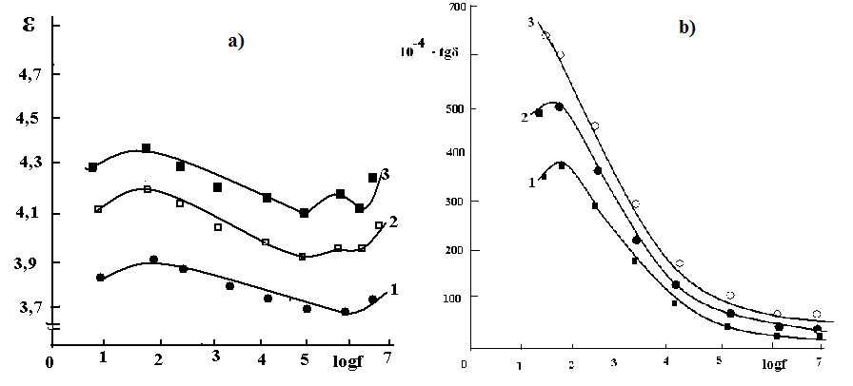
Pic.6 Dependence of dielectric permeability (a) and tg of dielectric loss angle (b) on
frequency for nanocomposite PP+CdS 1.PP+CdS untreated by discharge
2.PP+CdS treated in 30 min. 3. PP+CdS treated in 1hour

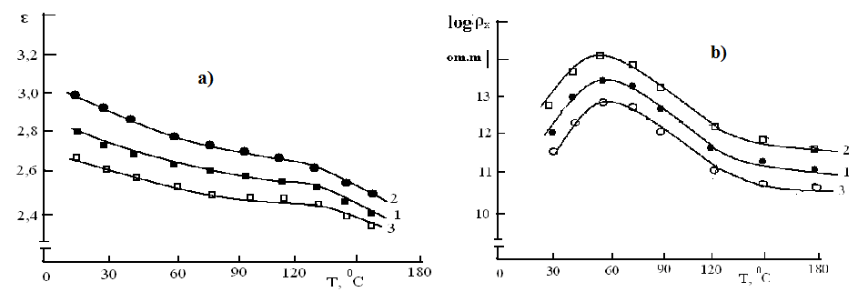
Pic.7 Dependence of dielectric permeability (a) and resistivity (b) on
temperature for nanocomposite PP+CdS 1. PP+CdS untreated by
discharge 2. PP+CdS treated in 30 min. 3. PP+CdS treated in 1hour

Changes of ε and $\text{tg}δ$ for PP+CdS, treated by discharge in various time interval, caused by frequency change are connected with deterioration of polarization process, аnd changes of ε and $\text{tg}δ$, caused by temperature are connected with changes in supermolecular structure of polymer and interphase interactions between components of boundary layer.
So, we can conclude that boundary phase interactionsin polymeric nanocomposites PP+CdS plays important role on formation of its photoluminiscent properties. It means that it is possible to adjust photoluminiscent properties not only by component and its geometrical parameters matching, but also by impact on conditions of boundary and interphase effects.

Correspondence to:
Ramazanov M.A.
Baku State University
AZ 1148, Z.Khalilov 23, Baku, Azerbijan

Telephone:994-12438-72-17
Cellular phone: 99450-398-32-84
Emails: nanomaterials@bsu.az ,
mamed_r50@mail.ru

References
[1] E. S. Snow, P. M. Campell, R. W. Rendel, F. A. Buot, D. Park, C.R.K. Marian, R.Magno Semicond. Sci. Technol.13, A75(1998)
[2] H.Weller, Angew. Chem. Int. Ed.,Engl. 37, 1658(1958)
[3] P.V. Kamat, D. Meisel. Semiconductor Nanoclasters(N.Y.Elsevier), v.103 (1996)
[4] E.A. Baqaev, K.S.Juravlev, L.P.Sveshnikova, I.A. Badmaeva, S.M.Repinskiy j. Fizika i tekhnika poluprovodnikov, т.37, в.11, с.1358(2003)
[5] D. Leonard, M.K. Krishnamurthy, C. M. Reeves, S.P. Denbaars, P.M.Petroff. Appl.Phys.Lett., 63, 3203 (1993).
[6] M.A.Ramazanov j. Prikladnaya fizika, 6, p.8-11(2007)
[7] M.Q.Saxtaxtinskiy, A.I.Mamedov, M.A.Kurbanov, М.А.Ramazanov Patent USSR 148163. 22.01.1989.B.I.1989, №4
[8] A.M.magerramov, M.A.Ramazanov, F.V. Gadjiyeva j. Fizika I ximia obrabotki materialov, №1, p.71-74(2008)
[9] Turro N.J. Molecular Photochemistry. N.Y.: W.A. Bejamin, Inc.. 328 p.(1965)

