Marsland Press
Journal of American Science, 2010;6(1)

Path-analysis Model of the Development of Handicraft (Batik) Industries in Kelantan, Malaysia

Ma’rof Redzuan, Fariborz Aref

Department of Social and Development Sciences, Faculty of Human Ecology
Putra University Malaysia, 43400, Selangor, Malaysia
marof@putra.upm.edu.my & fariborzaref@yahoo.com

Abstract: This study identify factors that contribute to the development of handicrat industries. The focus is on batik industries. The study was carried out in the District of Kota Bharu in the State of Kelantan, Malaysia, and targeted the entrepreneurs in the batik handicraft enterprises. The study is based upon both quantitative and qualitative analysis of material derived from field-work in several villages in the study area. The analysis of data employed path-analysis model in order to determine the factors that contribute to the explanation of the dependent variable – the development of the industries. The finding show that the selected factors have contributed significantly in the explanation of the development of the industries. The findings imply that it is imperative to consider and understand the local resources, skills, attitudes and aspirations in any government efforts to foster the development of these handicraft industries. [Journal of American Science 2010;6(1):129-136]. (ISSN: 1545-1003).

Keywords: handicraft , batik,rural development, rural industries

1. Introduction

It is widely recognised that rural development in most developing countries is unlikely to be achieved by the development of one sector alone, such as agriculture. Although the agricultural sector is of prime importance in the development of rural areas, other fields of social and economic development must be included in a truly integrated approach (Austin, 1981, p 1). It has been postulated that industrialisation can make a significant contribution to rural development through increased rural production and productivity, the provision of employment opportunities and the satisfaction of basic needs, and the establishment of linkages with other sectors of the economy (Hogg, 1978, p. 19). In relation to this, interest in rural non-agricultural development has been growing in many developing countries as a result, inter alia, of severe limitations on the capacity of the agricultural sector to absorb the existing supply of rural labour and to satisfy even minimum subsistence requirements for a large proportion of the rural population (Sand, 1983, p 1). Given agriculture's limited capacity to absorb labour, rural non-farm activity assumes increased importance as an alternative or supplementary source of rural employment and income. Thus, the promotion of the small enterprise sector (e.g. handicrafts, cottage industries, small-scale rural industries) could play an important role in the implementation of a development strategy.
On the hand, rural development starts with people and their education, organisation, and discipline. Without these three, all resources remain latent, untapped potential" (Schumacher, 1975, p. 168). Meanwhile, Wellisz writes that,"Technological progress is the prime mover of economic development, but unfortunately, it is not a miracle drug. To develop, the economically backward countries must modernize, but a simple injection of modernization does not cure poverty. It is clear, first of all, that modernization is not a substitute for investment. Obsolete equipment must be replaced, new factories built, and new machines installed to embody the new techniques. Investment in human beings is also needed if a country is to modernize."(Wellisz, 1966, p. 234). Human factors or "human resources" constitute some of the main factors that can either constrain or hold the key to future development and change. However, besides those factors, the physical resources such as capital for investment in new technology are also clearly important. Thus, this paper attempts to explain a path-analysis model which depict the factors that contribute to the development of handicraft industries.

2. Litrature Review
General background of the development of batik industries
We attempt to illustrate the general overview of the development of the batik industries, particularly in the state of Kelantan. The word “batik” is originally a Javanese term, denoting a resist technique for producing designs on fabrics (Krevitsky, 1964, p. 7). The exact origin of batik is uncertain. It is so old a craft that its true origin has never been determined, but it can safely be presumed to be 2,000 years old. It is in Java, Indonesia, that batik was most extensively developed and has been continually practised on a large scale. From Java batik was introduced to Europe by Dutch traders, who first imported it to the Netherlands in the middle of the seventeenth century (Hitchcock, 1991). Today, batik is still identified throughout the world with Java or Indonesia. The development of batik-making in Malaysia can be traced from the making of traditional pelangi batik, in which the pelangi technique preceded efforts to adopt batik locally. This method (tie-resist) of decorating cloth was practised by Malays during the eighteenth and nineteenth centuries. It is believed that pelangi batik was available during the reign of the third ruler of Trengganu, Sultan Zainal Abidin II (1773-1808), where Minah Pelangi was the most famous producer of batik during the time. The "modern" way of batik making began with the canting method, believed to be a Javanese invention which dates back to the seventeenth century. A rather new method of batiking which was introduced in the middle of the nineteenth century was called the chop (or cap) or "printing block", which was also invented by the Javanese. The invention rapidly enabled the far-sighted batik manufacturers to place their production on a semi-industrial basis. There were several factors that contributed to the development of the industry during the time. Among others were (i) the importation of raw materials such as dye stuff from Germany, and cotton cloth from India; (ii) the availability of a market; (iii) the small amount of capital needed for the establishment of the industry; and (iv) the many workers who had obtained experience and had opened their own businesses. The demand for batik products is increasing. Some of the Malaysian batiks have been exported to the overseas market, among others to the United States, Japan, Europe, Australia and Africa. In the country the wearing of batiks has been encouraged by the government in order to preserve a national identity. Batik shirts (especially hand-drawn) are considered an appropriate formal attire for Malaysian men. In women's attire, batik provides a Malaysian flavour for high fashion western style dresses. Batik has been recognised as a national dress, worn by all ethnic groups and is no longer associated with the Malays (Arney, 1987). Our study also illustrate the dynamic aspects of the industries, in terms of whether they have improved, have declined within the past ten years, or have experienced no change ("stagnation"). The development of the aspects or elements of the industries could indicate the process of their development: for instance, where an enterprise has started well but is now gradually shrinking, while others are developing and enlarging. Table 1 reveals the development process of the study enterprises within the last ten years.

Table 1: The development of aspects of the silverware and batik industries
during the past ten years (N=140)
Aspect of Development | Improved | Stagnant | Declined
Design | 84 | - | -
Quality | 63 | 21 | -
Productivity | 51 | 24 | 9
Size | 42 | 24 | 18
Numbers of workers | 36 | 21 | 27
Quantity of product | 18 | 57 | 9
Market | 12 | 60 | 12
Technology | 3 | 75 | 6

The heuristic model of development of handicraf industries
In this study, for the purpose of the analysis and for convenience of discussion, we attempt to put the variables into a simple heuristic framework as follows. The state of development of the industries employed in this study is specifically indicated by the size (i.e. based on the number of workers, capital, and production); and not the level of "modernity" of the industries (level of technology, and so on), since all of the batik industries employ traditional technology and management in production. Modern small industry is characterised by appropriate use of efficient machines, good plant layout, precise control of production processes; appropriate use of business planning and budgeting, market analysis, cost accounting and so on (Staley and Morse, 1965, p. 4).
Although there are conceivably an infinite variety of factors (such as the personality of entrepreneurs, socio-psychological aspects, physical resources, family histories, economic background, etc) associated with the development of the industries, we employed the above-mentioned composite variables as the explainers largely because they represent the "tangible" and "intangible" factors of development. The tangible factors we refer to include the background of the producers such as age (which can also be used as a proxy variable for other factors, such as level of education and other personal background variables), their possession of physical resources (such as land and income), and also the priority given by the producers to the industries (in terms of, for instance, time allocated to the industries vis-a-vis other forms of economic activity, level of involvement in the industries, i.e. whether part-time or full-time, and so on). On the other hand the intangible factors we refer to include the attitudinal and experiential features of the producers: level of entrepreneurship of the entrepreneurs. Furthermore, these variables describe the ability and willingness of the entrepreneurs to change. In other words we hypothesize that the development of the industries is principally explained by the variables mentioned. In order to analyze the relationships between variables, we placed the variables in a path-diagram, as illustrated in the results and discussions.

3. Study Area
The study was carried out in the state of Kelantan, Malaysia, where Kota Bharu District was chosen as study location based on the existence of the batik industries. In Kelantan, and even in Malaysia more generally, the District of Kota Bharu is famous for its batik industry. The state of Kelantan itself is always recognised as the "home of Malaysian batik", and most of the batik industries are found in the District of Kota Bharu. The batik industries were chosen based on the following criteria: (i) comparatively they involved a quite large number of people, and contributed significantly to the livelihood of the people; (ii) they are relatively long-established handicraft industries, and are technologically underdeveloped although with early signs of technological and organisational change; (iii) they are among the more popular crafts and thus have a certain amount of development potential; and (iv) in terms of location the industries tend to be clustered in certain areas where they are easily reachable. The state of Kelantan is located in the northern part of the east coast of Peninsular Malaysia, and covers an areas of 14,943 square kilometres (see Appendix).

4. The Research Methodology
In order to achieve the goals of the study we utilised a combination of research methods. Thus, this study included a variety of methods: interviews with government officials; library research; interviews with key informants and fieldwork in the Districts of Tumpat and Kota Bharu in the state of Kelantan. The fieldwork consisted of observation activities and informant interviews in the initial months at the primary research site; a preliminary survey of batik industrial activities in the research site; intensive interviewing of samples of producers/ entrepreneurs and intensive interviewing of key informants/selected 'cases'. Generally, the questionnaires comprised questions or statements which demanded information regarding the attributes, beliefs, attitudes and behaviour of the respondents. They consisted of a collection of background information of the respondents and the industries, their attitudes, their willingness, and their personal characteristics. From the entrepreneurs' questionnaire we identified seven main variables which are related to our analysis. The variables are:
- The state of development of the industries (DEVST). The composite variable DEVST refers to the level of development of the enterprises, and is strictly indicated by their size. The variable is made up of other variables: total amount of production (financial value), total capital involved, total income from the enterprise, number of workers, and the kind of organisation of production.
ii. The level of willingness of the entrepreneurs to make certain sacrifices in order to develop their industries (WILLING). The variable WILLING represents the entrepreneurs' willingness to take part in the development of their enterprises. The variable is a composite variable consisting of willingness to increase production, willingness to participate in using machines, willingness to participate in development when there is a market, and willingness to participate in adopting new designs..
iii. The entrepreneurs' attitude towards the development of their industries (ATTDEV).
iv. The entrepreneurs' attitude towards their industries (ATTINDUS).
v The entrepreneurs’ level of “entrepreneurship” (ENSHIP).
vi The availability of "physical resources" (including capital and land) (PHYING)
vii. The age of the entrepreneurs (AGE).

With the exception of age, the remaining seven variables are composite variables. Although it is recognised that these composite variables may not be the ideal way of showing the variables of interest to our study, we anticipate that each composite variable should be a more generally accurate indicator than a single variable

The path-analysis model: relationships between variables.
We summarise the seven variables of interest in a simplified form by using a linear, recursive model, involving only a one-way causation framework (i.e. no feedback loops). The main dependent variable in this analysis is the state of development of the industries (DEVST). The other variables are considered as the dependent and intervening variables or factors. Based on assumptions (theoretical ideas) about the sequence of causation of the development we posit this causal model, though there may be reciprocal causation among some of the factors, and these causal orderings may not necessarily fit every industry or entrepreneur.
A path-analysis model is employed in identifying the relative strength of the contribution of the various factors (when analysed simultaneously) in explaining the dependent variable (i.e. the state of development). The aim of path-analysis is to provide quantitative estimates of the causal connections between a set of variables. Path-analysis uses statistical techniques of correlation and multiple regression in order to identify the strength of each factor in explaining the other variables, and the strength of the model itself. As ordered in the path diagrams (i.e. based on the logic of causal relationships), each variable is assumed to have causal influences on the variables to its right. The relative strength of the direct influence of one variable on the other is measured by the path coefficient, while the strength of the model is measured by the value of the R2. Meanwhile, the causal models we derived are essentially unsaturated or over-identified, i.e. leaving out some linkages that are statistically non-significant or considered not important in the theoretical framework. The results of the statistical analyses of the factors that related to the stage of development of the batik enterprises are presented in the path-diagrams found in Figure 1.

5. Results and Discussions
The results of the statistical analyses of the factors that related to the stage of development of the silverware and batik enterprises are presented in the path-diagrams found in Figure 1. Table 2 shows the correletion coefficient between variables of the study.

Table 2: Zero-order correlation coefficients of variables related to the batik industry

Variables | V1 | V2 | V3 | V4 | V5 | V6 | V7
V1 DEVSTATE | -
V2 WILLING | -24 | -
V3 ATTDEV | -.42 | .92 | -
V4 ATTINDUS | .25 | -.10 | -.07 | -
V5 ENSHIP | .84 | -.18 | -.39 | .21 | -
V6 PHYING | .84 | -.52 | -.65 | .19 | .82 | -
V7 AGE | .48 | -.94 | -.95 | .10 | .40 | .71 | -
Age
Devstatete
Enship
Attindus
Phying
Attdev
Willing
e =.22
R²=.82
.42
-.81
e = .42
e =.71
.71
r= -.82
.40
e =.30
e =.97
e= .92
-.14
-.1.05
.30
-.23
.26
-.82
.11
Figure 1: Recursive path-diagram of factors effecting the state of development of the batik industries

Based on the R² values in the diagrams, we can establish that our model is very "powerful" and "successful" in explaining variation in the state of the development of batik industries. We find that 82 percent (R²=.82) of variation in the state of development of batik industries is explained by the variables selected, i.e. those variables located to the left of the dependent variable (DEVST). Specifically, the state of development in the the batik industries is significantly explained by age (p=.84), willingness (p=-.81), attitude towards the industries (p=.11), level of entrepreneurship (p=.30), and the availability of physical resources (p=.42). For convenience, in the discussion of constraints and potential we attempt to discuss each factor separately. Bearing in mind that the variables/factors are related to each other, we also attempt to discuss one factor in relation to other factors. First, we attempt to illustrate the contribution of physical resources in the development of batik industries. We refer to physical resources as those resources that could be employed as capital for the development of the industries, such as income, savings and land (for collateral in borrowing money). However for the purpose of discussion in this section we also include external factors such as the availability of raw materials, technology, market, workers and also the physical support provided as a result of government policies. From the path-diagrams, it is evident that the availability of physical resources, as we might expect, has a powerful influence on the development of the industries (p=.42). This is supported empirically by the correlation analysis. The availability of physical resources is in turn significantly explained by age (p=.71). These findings imply that the physical resources are an important pre-requisite for development. In other words, we assume that the limited availability of physical resources could represent constraints, and thus underpin or perpetuate the underdevelopment of the industries.
In terms of entrepreneurship (which include skills and knowledge), it is found from the path-diagrams that the level of entrepreneurship has contributed to the explanation of the state of the development of the industry (p=.30). Meanwhile, the correlation coefficients show that there is a positive correlation (r=.40) between age and entrepreneurship. Since age is also a proxy for other background variables, such as education and years of experience as entrepreneurs, which might also explain the level of entrepreneurship, these correlation findings need further discussion. Our question is to what extent does age contribute to the explanation of entrepreneurship in the industries? In the batik industries we believed that the entrepreneurs were "self-made", i.e. they acquired their entrepreneurship through many years experience in business. For the older entrepreneurs, the more years they have been managing the industries, the more experience they have in the business, thus the more entrepreneurial they were.
In terms of attitude towards the industries the findings in the path-diagrams and correlation coefficients we could identify those group of entrepreneurs who were less favourably and those who were more favourably disposed towards the industries. The attitude towards industries has contributed significantly towards the development of the industries (P=.11). Meanwhile, the attitude is explained by the entrepreneurhip variable (p=.14), meaning that the higher the level of entrepreneurshp, the lower their attitude towards the industries. It seems that factors, such as the availability of resources and age do not contribute signifuicantly in the explaination of the attitude.
In terms of the variables related tod the attitude towards development and willingness, the findings of the path-analyses show that 92 percent of variation/change in the attitudes towards development of the industries among the batik entrepreneurs is explained by variations in the variables selected. In the batik industries the variation is significantly explained by age (p=-1.05), and the possession of physical resources (p=-.23). Meanwhile, from the path diagrams we also find that in the batik industry 95 percent (R2=.95) of the variations in the entrepreneurs' willingness to participate in the development of the industries is explained by the factors on its left. We safely derive that these "sub-models" are very successful. Specifically, it is explained by age (p=-.82) and attitude towards development (p=.26). Additionally, the willingness to participate in development has contributed significantly in the explanation of the state of the development (p=-.81). The findings of the analyses of the entrepreneurs' attitudes and willingness could be summarised thus: the younger entrepreneurs, despite having limited physical resources, have the tendency to have a more favourable attitude towards the development of the industries and were more willing to participate in their development than the older entrepreneurs.

6. Conclusion
In this study we attempt to present a summary of the findings based on the research hypotheses. First, the industries in the study area are underdeveloped because they are treated as a secondary or supplementary activity to agriculture or other occupations. The findings indicate those entrepreneurs who are involved in the industry as their part-time occupation have a comparatively smaller size of enterprise than those who are involved full-time and have made the enterprises the main source of income. The findings indicate that there are linkages or correlations between the characteristics of the entrepreneurs and the state of the development of their industries. The findings indicate that the comparatively more developed industries were owned by the older entrepreneurs who have lower levels of education but have more income. Fourth, there is a link between producers' characteristics and their ability to change in a way which is necessary to modernise the industries. The findings show that the older entrepreneurs have a lower tendency or ability to change in terms of their negative attitude towards development and their unwillingness to participate in the development of their enterprises. Fifth, the development of the industries will necessitate some disruptions and sacrifices; some entrepreneurs will be unwilling to accept these changes. The findings indicate that, particularly among the older entrepreneurs, the development of the industries was perceived to threaten to disturb their rhythm of life. Furthermore, the introduction of new machines was seen as harmful not only to the product but also to the community's identity and reputation. Thus it can be seen that, on the basis of the quantitative and qualitative analysis presented in this chapter, it is possible generally to support the hypotheses which were posed at the commencement of this thesis, and which provided the basis for our enquiry. In the following chapters we will examine the constraints and potential facing the development of the handicraft industries under investigation from a fresh perspective by assessing the attitudes, attributes and ability of handicraft workers and non-participants to make a contribution to rural industrial development in the future. The findings imply and recommend that it is imperative to consider and understand the local resources, skills, attitudes and aspirations in any government efforts to foster the development of these handicraft industries. The entrepreneurs and those who are involved in the industries should be consulted and involved during the process of policy formation. During the process of development of the industries the focus should be on the elimination of the constraints of development through, inter alia, the provision of infrastructure (such as capital, raw materials and marketing), and the acquisition of skills. In relation to the model of development, the Government should promote an appropriate model which is accorded with the artisans' needs and expectations, and which does not jeopardise the industries and their relationships with the community. Meanwhile, innovations such as new designs and value-added products should be pursued. Furthermore, for future development more people (particularly the younger people) should be encouraged to get involved in the industries. Finally, it is recommended that rural industrial development programmes need to be fully integrated within the national development framework, and with national industrial programmes.

Correspondance to :
Ma’rof Redzuan
Department of Social and Development Sciences, Faculty of Human Ecology,
Putra University Malaysia, 43400 Serdang, Malaysia
Telephone:+60389467062
Cellular phone: +123484810

References
Arney, S. (1987). Malaysian Batik, Kraftangan Malaysia. Kuala Lumpur.
Austin, V. (1981). Rural Industrial Development, London: Cassel
Cramer, C. and Bryman, A. (1990) Quantitative analysis for social scientists, London: Routledge, 1990
de Vaus, D.A (1990).Survey in Social Research, (Second edition). London:Unwin Hyman, London, 1990, Hill, A. H. (1951). Kelantan Silverwork. Journal of the Malayan Branch Royal of the Asiatic Society, XXIV, Pt. I, 99.
Hitchcock, M. (1991). Indonesian Textiles. London: British Museum Press.
Hogg, M. V. (1978)"Industrialisation and Rural Development: An Analysis of the Basic Needs Issues," in UNIDO, Industrialisation and Rural Development, New York: UNIDO
Krevitsky, N. (1964). Batik, Art and Craft: Van Nostrand Reinhold Company.
.Shand, R.T. (1983) "The Role of Off-Farm Employment in the Development of Rural Asia: Issues", in R.T. Shand (ed.), Off-Farm Employment in the Development of Rural Asia, Australian National University: National Centre for Development Studies
Schumacher, E. F. (1975). Small is Beautiful: Economics as if people mattered. New York: Perennial Library.
Staley, E., & Morse, R. (1965). Modern Small Industries for Developing Countries. New York: McGraw-Hill Book Company.
Wellisz, S. H. (Ed.). (1966). The modernization of technology. New York: Basic Books, Inc.

8/27/2009

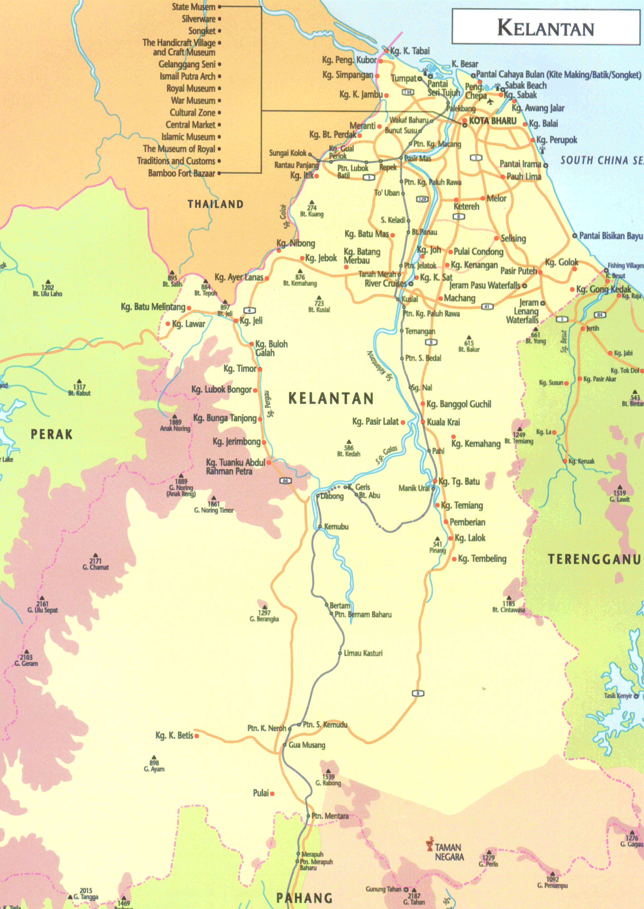
Appendix: Map of Kelantan

