The Journal of American
Science

ISSN 1545-1003
Volume 6 - Number 1 (Cumulated No. 23), January 1, 2010, ISSN 1545-1003

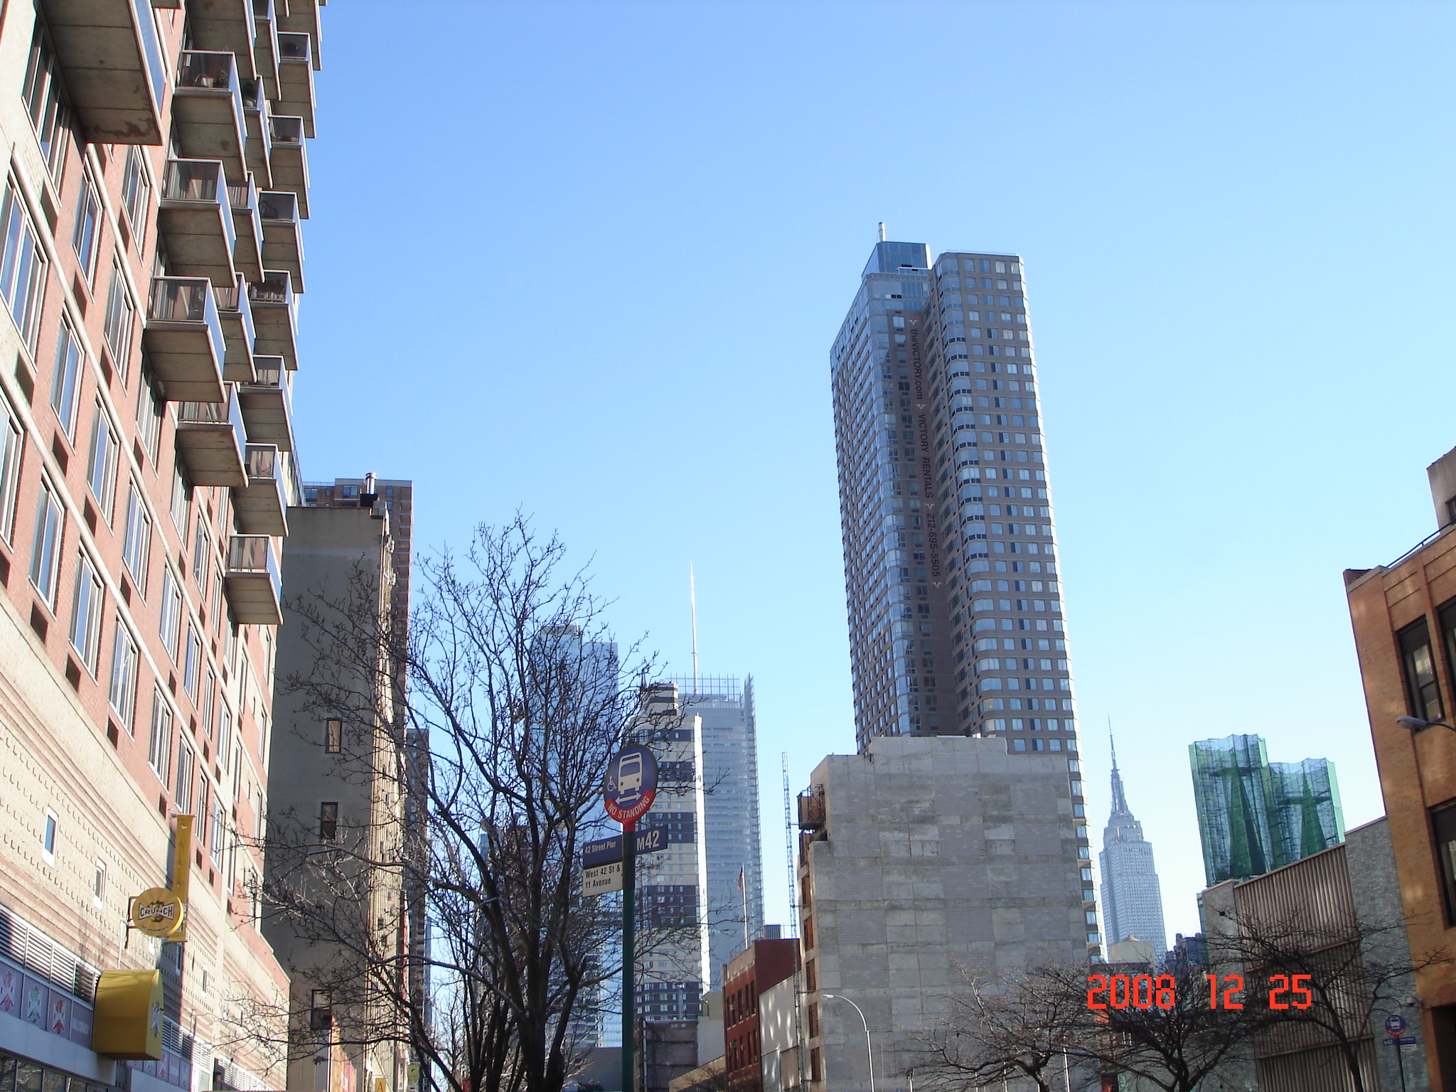

Marsland Press, Michigan, USA

The Journal of American Science

ISSN 1545-1003

Marsland Press
2158 Butternut Drive
Okemos, Michigan 48864, USA
Telephone: (517) 349-2362

Emails: editor@americanscience.org;
americansciencej@gmail.com

Websites: http://www.americanscience.org;
http://www.sciencepub.net

ISSN 1545-1003
