Geostatistical Analyses of Accuracies of Geologic Sections Derived from Interpreted Vertical Electrical Soundings (VES) Data: An Examination Based on VES and Borehole Data Collected from the Northern Part of Kwara State, Nigeria

Bello, A.M.A.¹, Makinde, V.^{2*}, Coker, J.O.
1. Department of Physics, Kwara State Polytechnic, Ilorin, Kwara State, Nigeria.
2. Department of Physics, University of Agriculture, Abeokuta, Nigeria.
3. Department of Physics, Lagos State Polytechnic, Ikorodu, Lagos State, Nigeria.
belloabdulmajeedfa@gmail.com, victor_makindeii@yahoo.com, cokerclara@yahoo.com

Abstract: The interpreted (geoelectric and geologic) sections of thirty-six (36) VES data collected from borehole sites in Edu, Pategi and Moro LGAs of Kwara State were compared with their corresponding borehole logs primarily to determine the accuracies of the interpretation both in terms of the number of layering and in the determination of the boundaries of the various interpreted layers. The results show that one geoelectric layer may contain up to four or more layers in the corresponding borehole logs. The percentage errors associated with the interpreted layer thicknesses may vary from ±0.72% to ±14.80%. Furthermore, the results suggest that in some instances, the accuracy of the borehole logging is suspect as the resistivity values associated with some layers suggest the layers must be something different from what the logger said they are. Thus, while the work quantitatively confirms, "a geoelectric layer is not necessarily a geologic layer", it also suggests that the borehole log may not be 100% correct. [Journal of American Science 2010;6(2):24-31]. (ISSN: 1545-1003)

Key words: vertical electrical sounding (VES), geoelectric and geologic sections/layers, borehole logs

1. Introduction
In d.c. resistivity geoelectric studies for groundwater exploration, the interpreted results of the collected Vertical Electrical Sounding (VES) data are usually presented as derived geoelectric sections. As can be seen in the works of Okwueze and Ezeanyim (1985), Okwueze, et al (1988), Van Overmeeren (1989), Ajayi and Hassan (1990), Shemang, et al (1992), Idornigie and Olorunfemi (1992) among others, the derived geoelectric sections are usually subsequently converted to generalized geological sections based on the resistivity values of the various lithologies (rock types) existing in the areas studied. This means, in most of these previous geophysical studies, typical interpreted VES data give generalized geological information using geoelectrical (VES) data. However, it is a common knowledge that an "electrical layer" is not necessarily a geological layer". Hence, this work quantitatively examines the accuracies of geoelectrical layers derived from VES data by comparing such interpretations with actual borehole logs obtained from boreholes drilled in different parts of Edu, Pategi and Moro LGAs of Kwara State. The accuracy of the logging is also examined in the light of the resistivity values of the geoelectric and/or geologic layers.
The general locations of the study areas within Nigeria are shown in fig. 1. The locations of the areas studied within the three LGAs of Kwara State are also presented in figs. 2(a) and (b).
According to Adeleye (1976) and ldornigie and Olorunfemi (1992), Edu and Pategi LGA which form part of the Lower Niger (Nupe) According to Adeleye (1976) and ldornigie and Olorunfemi (1992), Edu and Pategi LGA which form part of the Lower Niger (Nupe)Basin are approximately NW-SE trending topographic depression filled with
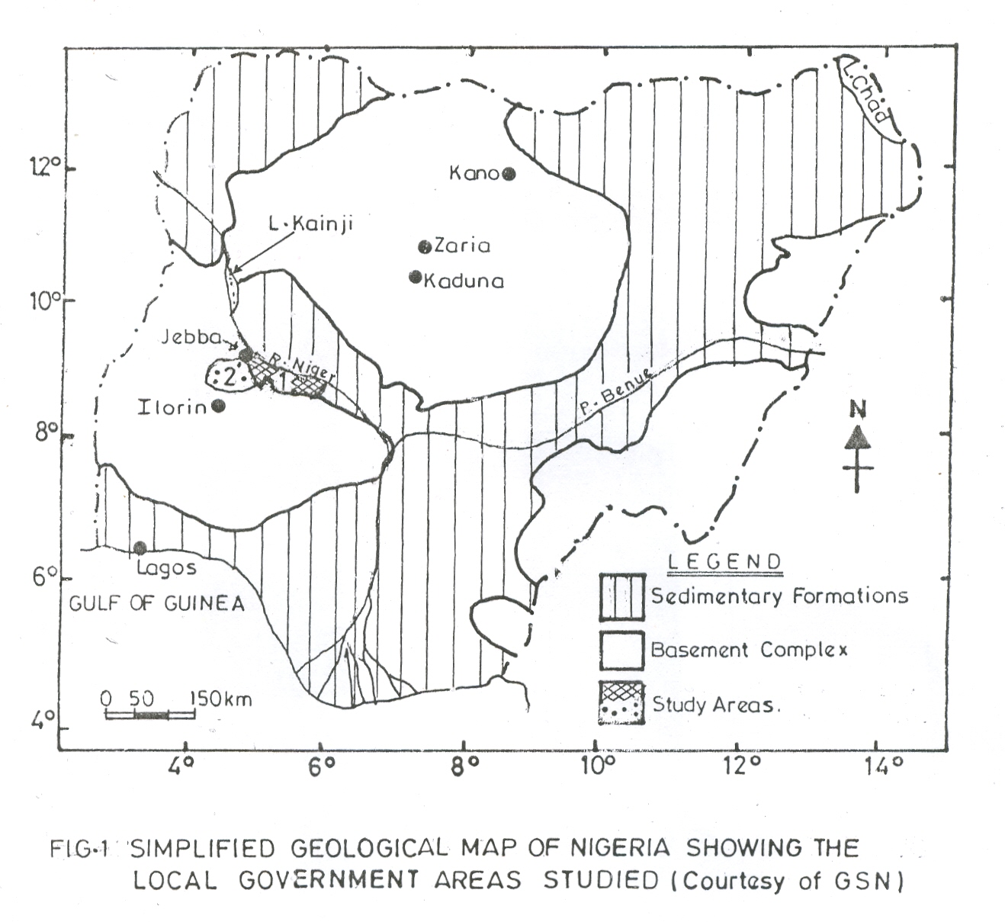
mainly Santonian (82-76Ma) to Maestrichtian (68-65Ma) sediments of sandstones, siltstone, ironstones and superficial alluvial deposits. The spatial distribution of the geologic formation, and/or materials, as well as the crystalline rocks underlying the sedimentary terrains of Edu/Pategi LGA are illustrated in fig. 3. On the other hand, the borehole log reports of the United Nations International Children Education/Emergency Fund Rural Water Sanitation, UNICEF-RUWATSAN Project (1985;1988), Messrs. Biwater Shellabear (Nigeria) Limited (1986) as well as the works of Amadi and Nurudeen (1990) and Olarewaju et al (1997) suggest that the main rock types found in the study area of Moro LGA which lie in the northwest edge of the Southwestern Nigerian Precambrian Basement Complex are: migmatites, quartzites, pelites, schists, pegmatites, biotite-hornblende, gneiss, porphyrrhitic biotite-gneiss, biotite granite, laterites and alluvial deposits.

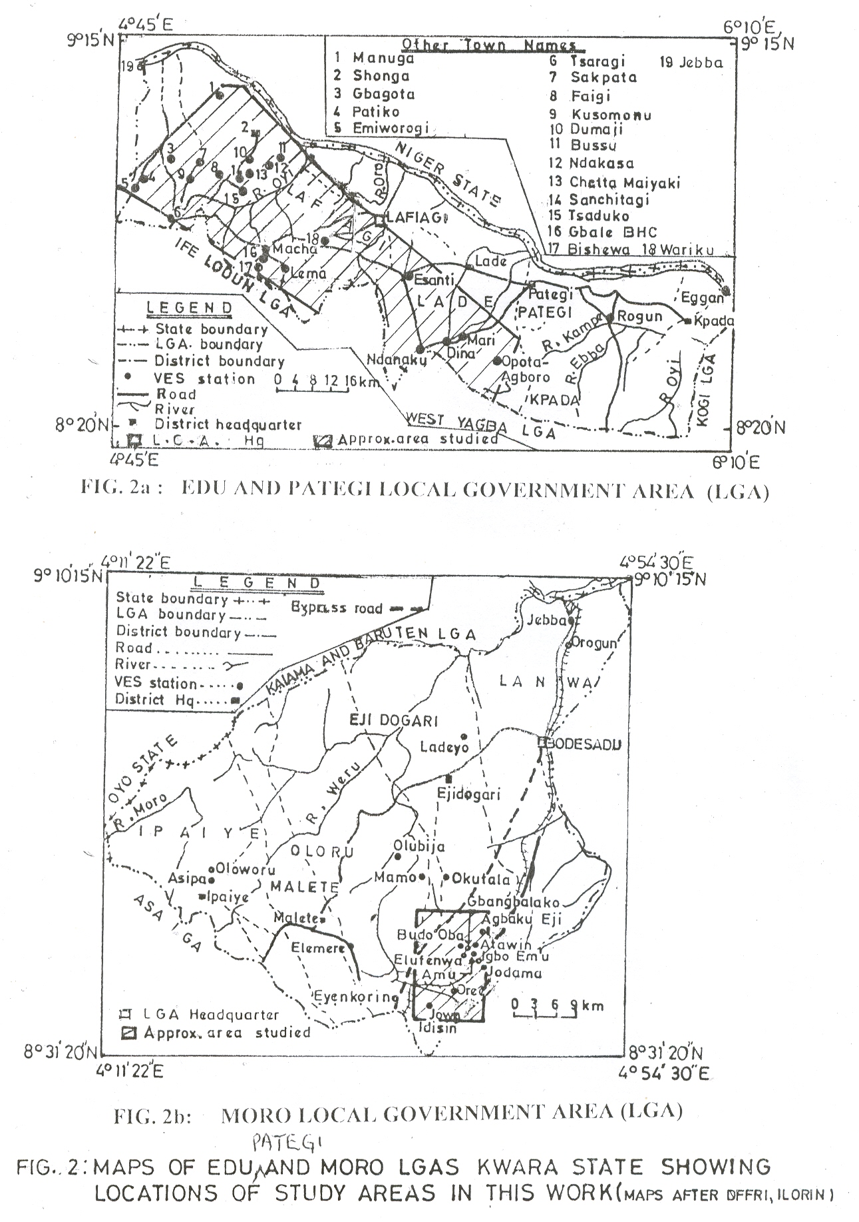
In this work, thirty-six (36) VES data sets and their corresponding borehole (lithologic logs) data were collected from the UNICEF-RUWATSAN Project, Ilorin for the study areas of Edu/Pategi and Moro LGAs. Twenty-five (25) of these sets of data were collected for the predominantly sedimentary region of Edu/Pategi LGA., while eleven (11) similar data sets were obtained for the basement complex studied within Moro LGA of Kwara State.
The thirty-six (36) VES data sets and their corresponding borehole logs were therefore, collected for this work amongst other aims and objectives in order to:
- examine the accuracies of geological deductions from interpreted electrical (VES) data with real geological data obtained from borehole logs;
- determine whether geological setting affects the interpreted (VES) data results of a study area, and
- find out whether information obtained from borehole logs can be confidently and/or adequately used to understand the geology/hydrogeology of an area.

2. Interpreting the VES Data
The interpretation of VES data is primarily concerned with determining the number (n), thickness (h) and resistivity (ρ) of each of the various layers beneath each investigated VES station. These parameters are in turn, used to derive the geological and geoelectrical sections for each VES data studied in order to determine the subsurface formations and structures of interest underlying the concerned VES site. In this study, the VES data was first interpreted using the empirical method (Van Nostrand and Cook, 1966; Shiftan, 1967). From this preliminary or "indirect" interpretation, initial estimates of the thicknesses and resistivities of the various geoelectric layers were interpreted as initial/trial model for a fast computer-aided direct interpretation. The computer program published by Mooney (1980) was modified in this project for use on the CDC Cyber 72 mainframe computer system of the Ahmadu Bello University, Zaria. A typical interpretation of the VES data, collected for VES station in Chetta Maiyaki is shown in fig. 4. For this station, the parameters of the four-layer trial/initial model (iteration rms error 9.285) was h₁ = 2.0m, ρ₁ = 361.81 Ω-m, h₂ = 10.0m, ρ₂ = 550.0Ω-m; h₃ = 34.0 Ω-m, ρ₃ = 425.00 Ω-m, and ρ₄ = 80.18 Ω-m while the parameters of the final models with iteration rms error 1.692 were: h₁ = 2.6m, ρ₁ = 361.6 Ω-m, h₂ = 6.1m, ρ₂ = 841.5 Ω-m; h₃ = 57.2m, ρ₃ = 446.9 Ω-m, and ρ₄ = 44.3 Ω-m. The geologic section (BH) of this station was derived, based on the analysis of the borehole log collected for the completed well at the VES location. The information obtained from the corresponding borehole log had been used to serve as control in the production of the geoelectric section (VES) of the interpreted VES data. The VES data collected for the remaining 35 VES data were similarly analysed following the above procedure.

3. The Work Done
To test the accuracy of the VES interpretation, the borehole log of each of the boreholes studied in this work was compared with the corresponding geoelectric section obtained from the interpreted pre-drilling VES data collected for that borehole site. The first thing to be compared was the number of lithological units in the borehole log against the electrical layers indicated by the interpreted VES data. Secondly, the agreement and/or accuracy of the VES layering viz-a-viz the corresponding borehole logs were examined. Thirdly, the accuracy and or correctness of the borehole logs most especially, the description of lithologies was then studied with respect to layer resistivity. Finally, the issue of whether or not nature of geological environment (for example sedimentary or basement regime) has any major effect on the accuracies of geoelectric layers was also investigated.

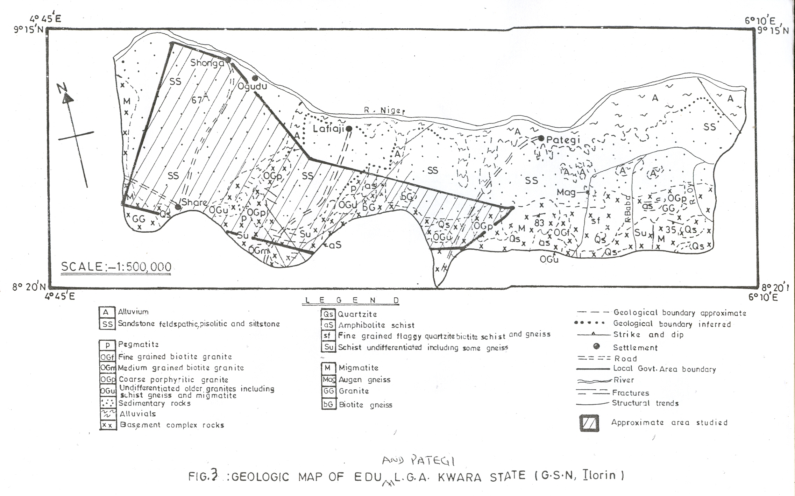

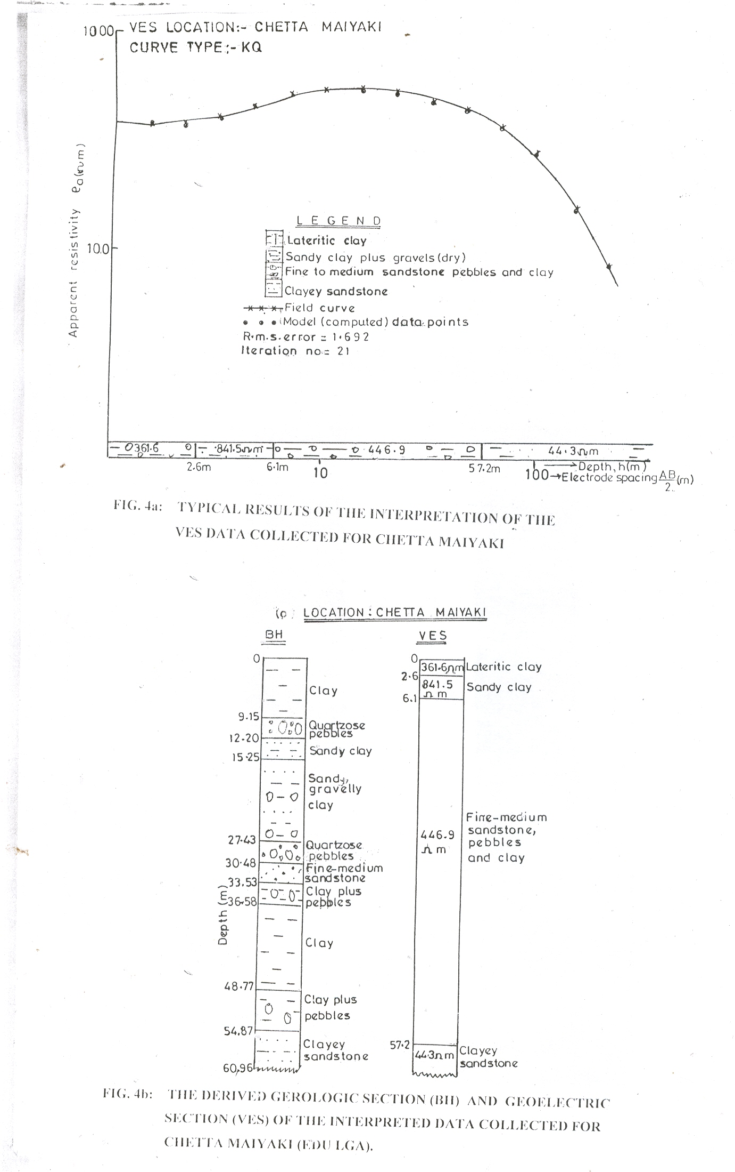

4. Comparing the Derived Geological Sections with Borehole Data
Consequent upon the above stated objectives of this work, four VES stations namely Shonga and Tsaragi which are located within the sedimentary Lower Niger (Bida or Nupe) Basin (Edu/Pategi LGA) as well as Gbangbalako and Atawin which exist in the Southwestern Nigeria Pre-Cambrian Basement Complex of Moro LGA have been chosen for analyses. It is pertinent to point out that Shonga lies within the alluvium of the sedimentary terrain while Tsaragi is found in the contact zone of the Lower Niger Basin. On the other hand, one of the two locations, Atawin stationed in the basement complex of Moro LGA has been identified to be underlain by a very complex geology. This is because, the seven sets of VES data and borehole logs collected for investigation of this station presented seven very different geoelectric and geologic sections. This therefore, means the four stations which have been chosen for examination are expected to be very well representative of the varied nature of the geology of the areas studied within the West-Central part (Kwara State) of Nigeria.

4.1 Discussion of the VES Stations
4.1.1 SHONGA
The borehole log/geologic section as well as the geoelectric section and the derived geologic sections obtained for the VES station in Shonga are shown in figs. 5a(i) and (ii) respectively. The geologic section (borehole log) suggests the existence of 9 geologic layers within the first 51.82m of the earth. On the other hand, the geoelectric section suggests the presence of only 4 geoelectric layers beneath this station to a depth of 53.1 m. As can be seen in fig. 5a(i), the first layer in the borehole log which consists of clayey sand, corresponds to the first geoelectric layer. In the borehole log (BH), the layer is 6.1 m thick, while it is 6.3m thick in the geoelectric (VES) section. Thus, there is a percentage error of ±3.28 % in using the interpreted geoelectric (VES) data to determine the thickness of the first layer. The next four layers in the borehole log correspond to the second geoelectric layer. This layer which is indicated as electric layer 2 in fig. 5a(i) and whose constitution vary from clay and poorly sorted sandstone at the top to gravelly clay and poorly sorted sandstone at the bottom having a resistivity value of 520.3 Ω-m associated with it. The thickness of the layer in the borehole log is 15.24m (21.34m – 6.1m), while it is 16.10m (=22.4m – 6.3 m) in the geoelectric section. Thus, the percentage error associated with using the second layer of the interpreted VES data to determine the thickness of this group of thin layers is +5.34%. The third geoelectric layer (electric layer 3) with a resistivity value of 60-m is made up of 3 geologic layers which consist of 3.05m thick poorly sorted sandstone at the top, a sandy clay formation which is about 7 times thicker than the overlying sandstone existing in the middle of the electric layer 3 and sandy gravel with a thickness of 6.10 m at the bottom. The net thickness of the geologic sub-layers, which constitute this electric layer 3 is (51.82 – 21.34) m = 30.48m, while it is (53.1 – 22.4)m = 30.70m in the geo-electric section. Hence, the percentage error associated with using the interpreted thickness of the third geoelectric layer (electric layer 3) to represent the three (sixth, seventh and eighth) geologic layers lying between depths 21.34 and 51.82m in the borehole log of the borehole site in Shonga is ±0.72 %. The fourth geoelectric layer, that is electric layer 4 consists of sandy clay as can be seen from the borehole log (figs. 5a(i) and (ii)); the layer is associated with a resistivity value of 26 Ω-m and lies at a depth of 51.82m in the geologic (BH) section extending from a depth of 53.1m to an infinite depth, according to the interpreted geoelectric section. Thus, there is a percentage error of ±2.39% in using the geoelectric (VES) section to estimate the depth to the interface between the electric layer 3 and the underlain geoelectric basement at the VES station in Shonga.

4.1.2 TSARAGI
The sections derived from the VES data for the site in Tsaragi which consists of the Nupe Sandstone and the crystalline rocks units within the contact zone of the Nupe Basin are illustrated in figures 5b(i) and (ii). In this case, both the borehole log (BH) and the geoelectric section (VES) suggest the existence of 4 layers at the borehole site. Fig. 5b shows that the first (sandy clay) layer in the borehole log has been resolved into two geoelectric layers that is, a very thin (0.5m) surficial layer and a much thicker (9.0 m) layer of sandy clay. The higher resistivity value of the near surface layer suggests it is more sandy than the thicker second geoelectric layer. The electric layer 1 therefore, seems to correspond to the first and second geoelectric layer in the interpreted VES section. In the geologic section, the electric layer 1 is 9.75m thick, while it is 9.00m thick in the geoelectric section. This means, there is a percentage error of ±8.33% in the interpreted thickness of the electric layer 1 for the VES station at Tsaragi. The electric layer 2 corresponds to the second and third geologic layers in fig. 5b(i) and the third geoelectric layer in fig. 5b(ii). The geologic section (BH) shows that the second and third geologic layers which consist of medium-coarse sand/sandstone, coarse sandstone and clay is 21.34m thick, while its corresponding third geoelectric layer in the geoelectric section (VES) has a thickness of 20.7m. Therefore, the percentage error associated with the interpreted thickness of the electric layer 2 is ±3.09%. It is pertinent to point out that the 3.05m thick third geologic layer which combines with the second geologic layer is shown in fig. 5b(i) as corresponding to electric layer 2 is not detected by the interpreted VES process and is thus not present in the derived geoelectric section (fig. 5b(ii)). The non-detection of this layer is probably due to the principle of suppression (Breusse, 1963; Koefoed, 1976; 1979; Okwueze et al, 1988). The practical implication of this principle is that, a layer is not detected on a VES curve unless it is quite thick or if it has a thickness which is about one-third of its depth of occurrence (Messrs Biwater Shellabear, 1986; Barker, 1989). However, notwithstanding the fact that the third geologic layer which consists of coarse sandstone is not sensed in the VES section, figs. 5b(i) and (ii) show that the weathered basement which represents the electric layer 3 corresponds to the geologic bedrock as well as the geoelectric basement. The electric layer 3 is shown in fig. 5b(i) as extending from a depth of 31.09m beneath the ground at the VES site located in Tsaragi to the total depth of drilling (34.14 m). On the other hand, the geoelectric section (fig. 5b(i) shows that the electric layer 3 which corresponds to the fourth geoelectric layer is interpreted to consist of clayey weathered basement with a low resistivity value of 33.2 Ω-m and extends from a depth of 29.7 m to an infinite depth below the ground level at the VES site in Tsaragi. Therefore, the percentage error associated with interpreting the depth to the electric layer 3 (geoelectric basement) is ±4.68%.

4.1.3 ATAWIN
The geologic section of one of the VES stations investigated in Atawin is presented together with the corresponding derived geoelectric section in figs. 6a(i) and (ii) respectively. While the geologic section (BH) suggests the existence of 6 layers up to a depth of 31.09 m, the geoelectric section suggests only 3 layers exist up to the 32.50 m depth which represent the top of the fresh basement. The two sections show that the first geologic layer corresponds to the first geoelectric layer which is indicated as electric layer 1 in fig. 6a(i). This electric layer (EL 1) which consists of laterite is 0.61m thick in the geologic section and 0.60m thick in the geoelectric section. Thus, there is a percentage error of ±1.64 % in using

the interpreted thickness to estimate the thickness of the surface lateritic layer at the concerned VES station (Atawin 2). Fig. 6a also suggests that the next four geologic layers in the borehole log correspond to the second geoelectric layer (electric layer 2). The figure shows that the combined thickness of these layers in the geologic section of the borehole log (fig. 6a(i)) is 30.48m, while fig. 6a(ii) indicates that, it is 31.90m in the geoelectric (VES) section (fig. 6a(ii)). This means, there is a percentage error of ±4.45 % in the interpretation thickness of the electric layer 2. As can be seen in fig. 6a, the electric layer 3 corresponds to both the geologic basement and the geoelectric basement. The derived sections show that the estimate of the depth to the fresh basement in the geologic (BH) and geoelectric (VES) sections is 31.09m and 32.5m respectively (fig. 6a). Consequently, there is a percentage error of ±4.34% in the interpreted depth to the fresh basement beneath the VES station studied at Atawin.

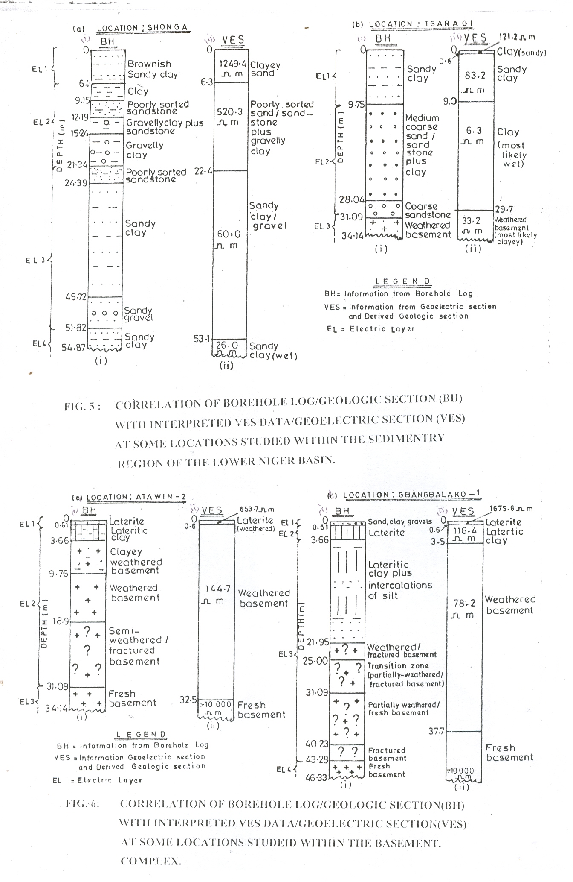

4.1.4 GBANGBALAKO
Finally, figs. 6b (i) and (ii) indicate the geologic section obtained from the borehole log collected for the VES station examined at Gbangbalako and its corresponding geoelectric section. As can be seen in the figures, the first and second geologic layers represent electric layer and 2 respectively. The percentage errors associated with using the interpreted thickness of the first and second geoelectric layers to determine the thickness of the surface layer (electric layer 1) and the second layer (EL2) beneath the VES site at Gbangbalako-2 are ±1.64 % and ±4.92% respectively. The next five geologic layers correspond to the third geoelectric layer (electric layer 3) and is interpreted to be associated with a resistivity value of 78.2 Ω-m. The net thickness of the geologic substrata which constitute this electric layer 3 is 40.23m - 3.66m = 36.57m in the geological section, while it is 34.60 m (= 37.7m – 3.1m) in the geoelectric section. Thus, there is a percentage error of ±5.69 % in the interpreted thickness of this electric layer 3. Furthermore, the depth to the fresh basement is indicated (fig. 6b(ii)) to be 43.28 m in the borehole data while the result of the interpreted VES data shows in fig. 6b(ii) the corresponding value is 37.70m in the geoelectric (VES) section. These therefore, mean that there is an error, of ±12.89 % in the interpreted depth to the fresh basement for the VES site located at Gbangbalako village within the northwest tip of Southwestern Nigerian Pre-Cambrian. Comparison of figs. 6b(i) and (ii) indicate that the last half of the partially weathered layer which is the sixth geologic layer in the BH section and the seventh geologic layer which consists of fractured basement were not resolved in the VES section. The interpreted geoelectric section was not able to discriminate these layers possibly because there is insignificant resistivity contrast between the transition zone and the fractured basement or the layers are relatively thin with respect to their depths of. burial or both. The consequences of these possibilities are the appreciable differences in the thickness values of the electric layer 3 (EL 3) determined from the borehole data and the VES data on one hand, as well as the depth to the boundary (interface) between EL 3 and EL 4.

5. Summary and Conclusion
The results of the geostatistical analyses carried out in this work show that, in all the four representative VES stations examined, low to moderate ranges of values were estimated for the percentage errors associated with the interpreted thickness and boundary depth of the electric layers. For example, the percentage error values characterizing the VES station in Tsaragi. which lies within the contact zone of the southern extent of the Lower Niger Basin (Edu LGA) vary from ±3.009% to ±8.69%. The corresponding low percentage error values associated with the VES station studied in Atawin which is located in the Southwestern Nigeria Pre-Cambrian Basement Complex range from ±1.64 % to ±-4.45%. On the other hand, relatively moderate range of percentage error values of ±0.72% to ±5.34% were determined for the electric layers beneath the VES station in Shonga (Edu LGA) which is located within the alluvium of the Lower Niger basin and ±1.64 % to ±14.80 % for the VES station at Gbangbalako in Moro LGA. Therefore, the results of these analyses suggest that the geologic setting of a VES station does not have any effect on the reliability of the geologic and geoelectric information obtained from an interpreted VES data.

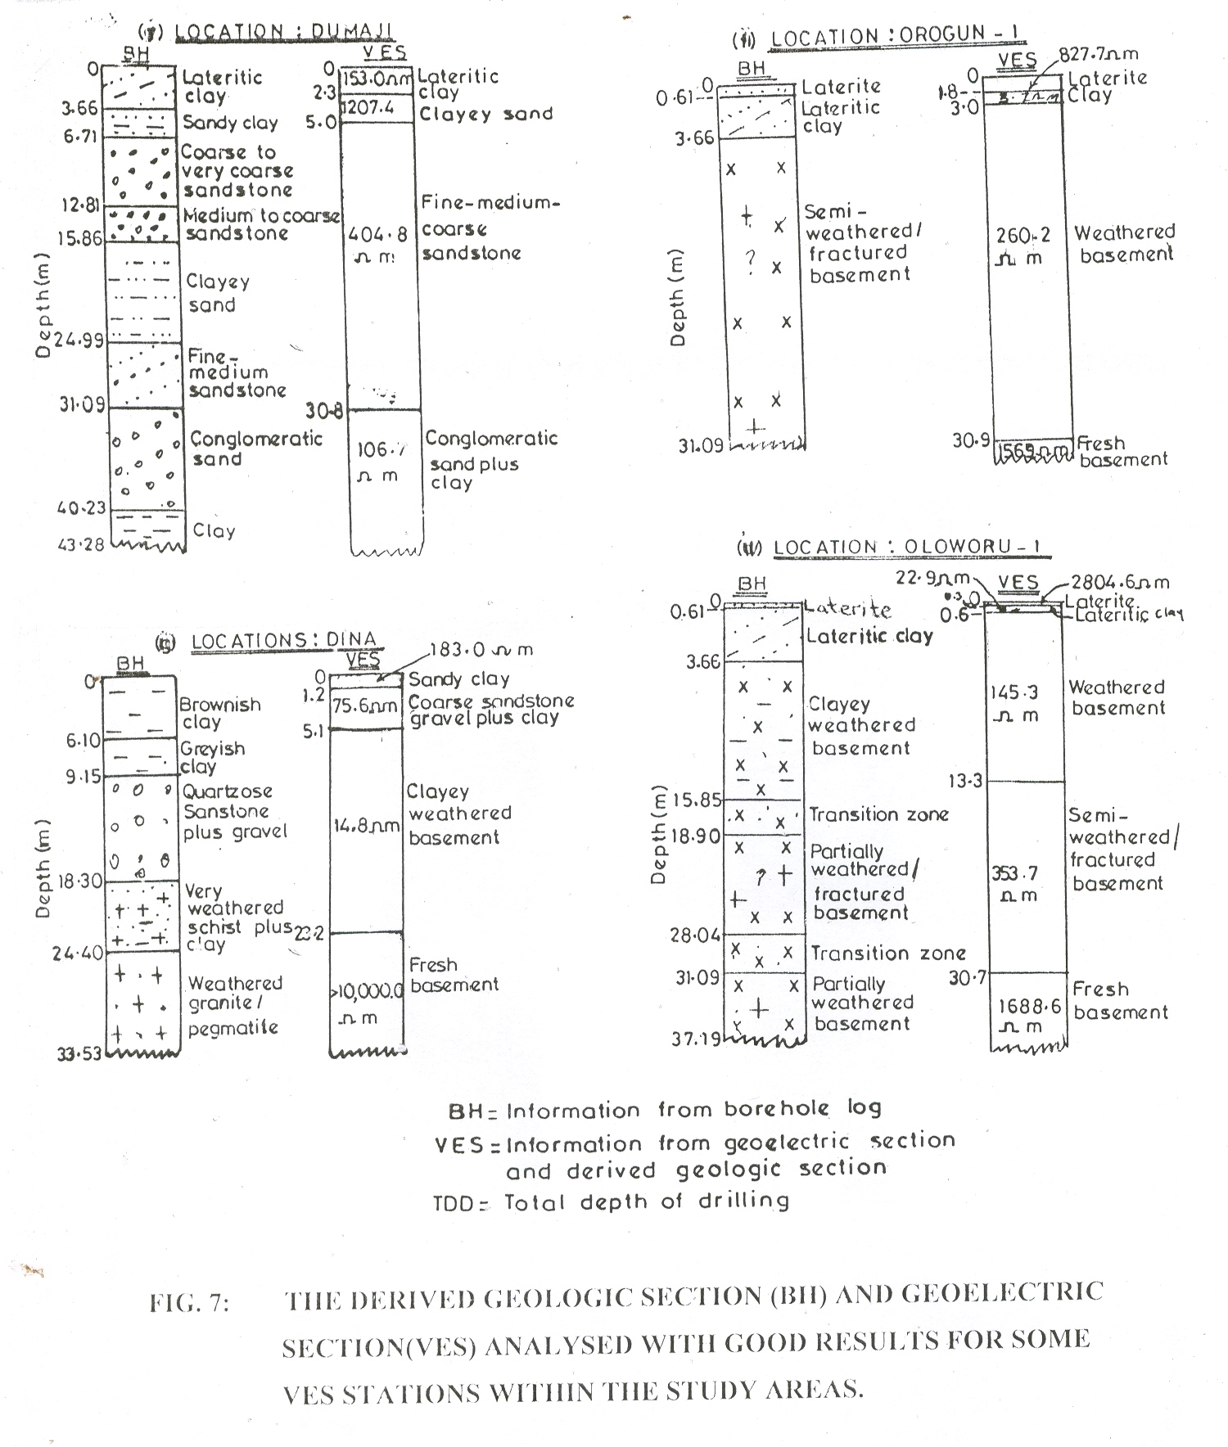

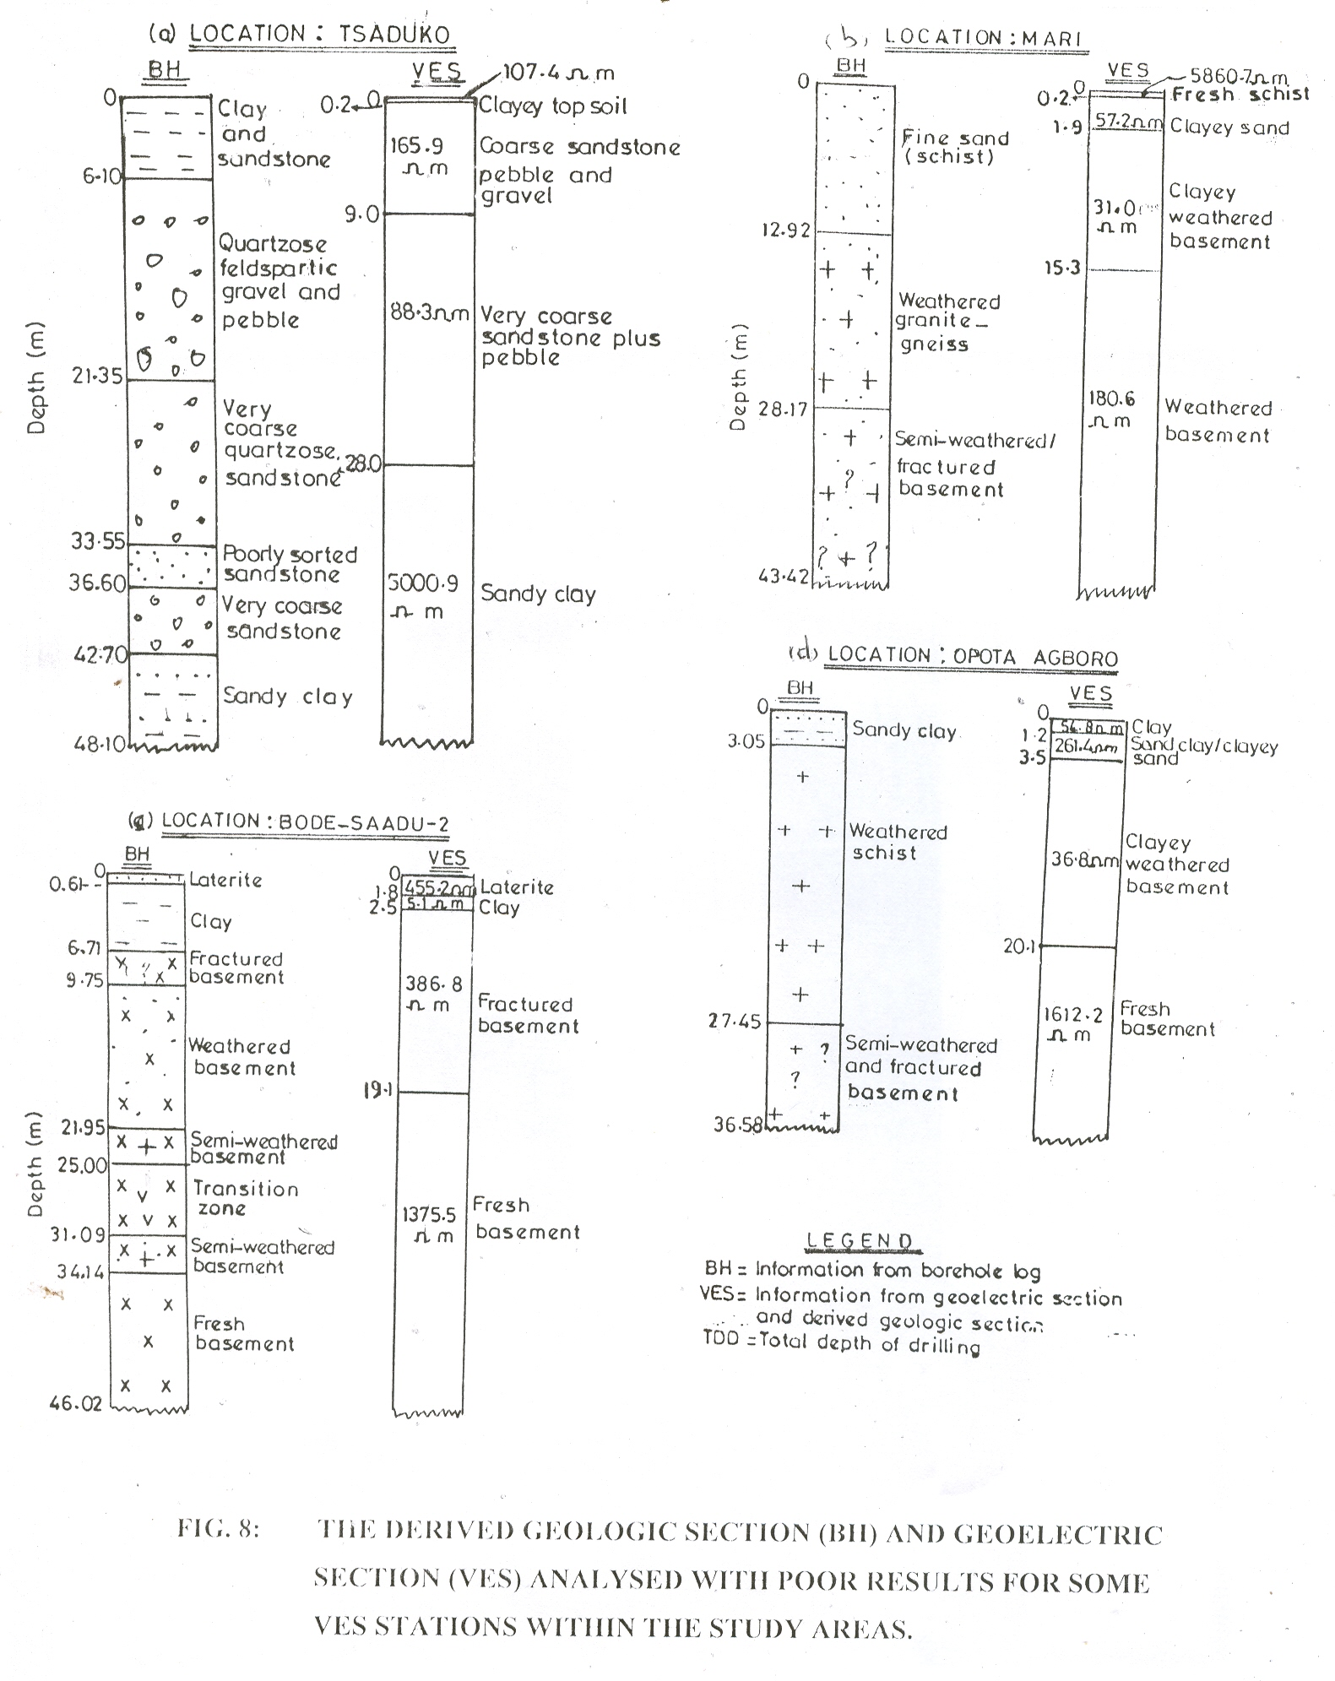

It is also worth stressing that similar geostatistical analyses of the thirty-two (32) remaining sets of data indicate that the confidence limit to put on geological deductions derived from geoelectric sections in this study is highly varied. The various geologic and geoelectric sections suggest that the differences between geologic boundaries obtained from borehole logs and the electric boundaries derived from the interpreted VES sections is insignificant for some VES locations (fig. 7) while, as shown in fig. 8, the degree of agreement between the two sections for some other VES stations is relatively poor.
The possible reasons for some of these non-reliable derived geologic and geoelectric sections are that quantitative interpretations of VES data are often hampered and or influenced by the principle of equivalence and the fact that an electric layer may not necessarily be a geological layer. According to van Overmeeren (1988), the principle of equivalence means that many different layered models may produce practically the same resistivity curves and hence, the non-uniqueness of interpreted VES data results. Moreover, the prominence of alternating thin layers of clay and clayey materials in the Lower Niger Basin (UNICEF-RUWATSAN Project, 1987) as well as the occurrence ofhighly weathered bedrocks in the VES stations studied in Moro LGA (UNICEF-RUWATSAN Project, 1985; Messrs. Biwater Shellabear, 1986; Amadi and Nurudeen, 1990) often result in effects due to suppression. In a related study, Okwueze, et al (1988) also suggested that the presence of highly weathered bedrock not only affects the resistivity of the crystalline rocks to a great extent hut is liable to result in the overestimation of the regolith by borehole drillers.

Correspondence to:
Victor Makinde
P.O.Box 94, UNAAB Post Office,
Alabata, Abeokuta.
e-mail: victor_makindeii@yahoo.com

References
[1] Adeleye, D.R. The Geology of the Middle Niger Basin. In: Kogbe, C.A (Edited), Geology of Nigeria. Elizabethan Publishing Company Limited, Lagos, Nigeria. 1976: 283 - 287.
[2] Ajayi, C.O., Hassan, M. The Delineation of the Aquifer overlying the Basement Complex in the Western Part of the Kubanni Basin of Zaria (Nigeria). Journal of Mining and Geology, 1990: 26(1): 117 - 124.
[3] Amadi, U.M.P., Nurudeen, S.I. Electromagnetic Survey and the Search for Groundwater in the Crystalline Basement Complex of Nigeria. Journal of Mining and Geology. 1990: 26(1): 45– 54.
[4] Barker, R.D. Depth of Investigation of Collinear Symmetrical Four-electrode Arrays. Geophysics. 1989: 54(8): 1031 - 1037.
[5] Breusse, J.T. Modern Geophysical Methods for Subsurface Water Exploration. Geophysics. 1963: 28(2): 633 - 657
[6] Idornigie, A.I., Olorunfemi, M.O. A Geoelectric Mapping of the Basement Structure of the Southern-central Part of the Bida Basin and its Hydrogeological Implications. Journal of Mining and Geology. 1992: 28(1): 93-103.
[7] Koefoed, 0. Recent Development in the Direct Interpretation of Resistivity Soundings. Geoexploration. 1976: 14(2): 243 - 250.
[8] Koefoed, 0. Geosounding Principles 1, Resistivity Sounding Measurement. Methods in Geochemistry and Geophysics. 1979. Elsevier. Press, Netherlands.
[9] Messrs. Biwater Shellabear (Nigeria) Limited, Kwara State Water Supply Scheme. Unpublished Report Submitted to Kwara State Utility Board, Ilorin, Nigeria. 1986.
[10] Mooney, H.M. Handbook of Engineering Geophysics, Vol.2: Electrical Resistivity. Bison Instruments incorporated, Minnesota, United States of America. 1980.
[11] Okwueze, E.E., Ezeanyim, V.I. The Vertical Electrical Sounding (VES) Method in Laterite Regions and in Iron-rich Glaciated Areas. Journal of Mining and Geology. 1985: 22(1 & 2): 193–198.
[12] Okwueze, E.E., Umego, M.N, Baimba, A.A, Ntayi, F.A., Ajakaiye, D.E. Application of Geophysical Methods to Groundwater Exploration in Northern Nigeria. Stylogia. 1988: 4(2): 103 -115.
[13] Olarewaju, V.O., Olorunfemi, M.O. and Alade, O. Chemical Characteristics of Groundwater From Some Parts of the Basement Complex of Central Nigeria. Journal of Mining and Geology. 1997: 33(2): 135-139.
[14] Shemang, EM., Ajayi, C.O., Osazuwa, I.B. The Basement Rocks and Tectonism in the Kubanni River Basin, Zaria, Nigeria: Deductions from D.C. Resistivity Data. Journal of Mining and Geology. 1992: 28(1): 119 - 125.
[15] Shiftan, Z. Interpretation of Geophysics and Hydrogeology in the Solution of Regional Groundwater Problems. In Monroey, L.W. (Edited), Mineral and Groundwater Geophysics. Economic Geological Report, 1970. Ottawa, Canada, 507-516.
[16] UNICEF-RUWATSAN Project. Borehole Logs and VES Data of Boreholes Drilled in Moro LGA of Kwara State, Nigeria Unpublished Reports. Submitted to the Kwara State Utility Board, Ilorin, Nigeria. 1985.
[17] UNICEF-RUWATSAN Project.Borehole Logs and VES Data Boreholes Drilled in Edu LGA of Kwara State, Nigeria. Unpublished Reports. Submitted to the Kwara State Utility Board, Ilorin, Nigeria. 1988.
[18] Van Overmeeren, R.A. Aquifer Boundaries Explored by Geoelectrical Measurements in the Coastal Plain of Yemen. A Case of Equivalence. Geophysics. 1989: 54(1): 38 - 48.

06/09/2009

[19] Van Nostrand, R.G., Cook, K.L. Interpretation of Resistivity Data. United States Geological Survey Professional Paper, 499. 1966.

