Analysis of Precursor Decomposition Temperature in the Formation of CdO Thin Films Prepared by Spray Pyrolysis Method

B.G. Jeyaprakash^{1*}, K. Kesavan ², R. Ashok kumar², S. Mohan², A. Amalarani¹
- Department of Physics, Ponnaiyah Ramajayam College of Engineering and Technology,
Thanjavur- 613 403, Tamilnadu, India
- Department of Physics, PRIST University, Thanjavur – 614 904, Tamilnadu, India
*Corresponding author email: bgjpabr@yahoo.co.in

Abstract: Aqueous solution of Cd(CH₃COO)₂.2H₂O is used to form Cadmium Oxide thin films on glass substrate by spray pyrolysis technique. Based on thermo gravimetric studies of chosen salt films were prepared at 200 and 350ºC insteps of 25ºC. X-ray diffraction (XRD) studies indicate the formation of cubic CdO phase with preferential orientation along (111) plane for all the film prepared at different substrate deposition temperature. Scanning electron microscopy (SEM) confirms spherical shape grains with size lying in the range 34 to 54nm as substrate temperature increases and is comparable with the XRD studies. [Journal of American Science 2010;6(2):75-79]. (ISSN: 1545-1003).

Key words: Spray pyrolysis, line broadening, microstructural parameters

1. Introduction
The chemical technique of spray pyrolysis [Chopra et al 1982] which is simple to handle, economically viable is used for several decades in glass industry and in solar cell production to deposit electrically conducting electrodes. Principle involved in the formation of metal oxide film is that when a droplet of sprayed metallic salt solution in the presence of oxygen atmospheres reaches the hot substrate, undergoes pyrolytic decomposition and forms a thin film. The other volatile by-products escape in the vapour phase. These methods can also produce films on substrates that are less robust materials and on large surfaces. The quality of film obtained by this methods strongly depends on various parameters like substrate temperature, solution concentration, substrate homogeneity, spray nozzle geometry, in-situ annealing treatments and so on [Chamberlin et al 1966; Patil et al Chen et al 1996]. Recently nanostructured metal oxide materials in thin film form were widely used in opto-electronic devices, electrochromic devices, narrow band coating, temperature controllers in satellites, chemical sensors etc. CdO is one such semiconducting materials having wide range of applications as transparent conducting oxide (TCO), solar cells, smart windows, optical communications, flat panel display, phototransistors etc., [Zhao et al 2002; Su et al 1984]. These applications are based on its physical properties which inherently depend on the preparation method. In the present work, home built spray pyrolysis unit is employed to form CdO thin film. The effect of precursor salt decomposition temperature on structural and surface morphology of CdO thin film on glass substrate is analysed and studied.

2. Experimental
To prepare CdO thin films, aqueous solution of analytical grade cadmium acetate [Cd(CH₃COO)₂.2H₂O] of various concentration is sprayed on glass substrate of size 1.5 cm x 7.5 cm using spray pyrolysis technique. A home made spraying system shown in figure (1) has been developed to obtain high quality thin films. The major units were i) spray gun ii) stainless steel plate heater with thermostat and iii) glass chamber with exhaust system.
The solution was sprayed at an angle of 45º onto preheated glass substrate kept at a distance of 50cm from the spray gun. Prior to deposition, the substrate were chemically cleaned. Compressed dry air at a pressure of 2 kg/cm² from an air compressor via an air filter-cum regulator was used as the carrier gas and spray rate of the solution was maintained at 3 ml/min. To avoid excessive cooling of substrates, successive spraying process was used with time period of 15 seconds between successive bursts. Substrate temperature was controlled by a chrome-nickel thermocouple fed to a temperature controller with an accuracy of ± 1ºC. The temperature on top side of the substrate is measured by placing thermocouple on a reference glass substrate kept nearer to the coating substrate so as to measure the exact temperature. Large numbers of films were prepared by varying solution concentration, volume of solution and substrate temperature to analysis the optimum growth condition. For all above varying parameters solution flow rate (3ml / min) and air pressure is kept constant.
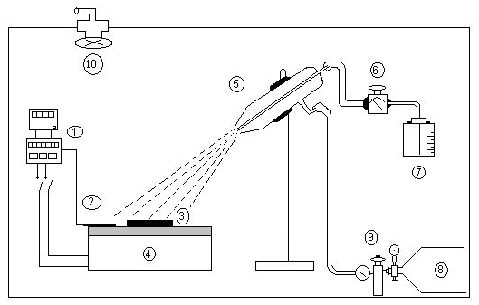

Figure 1. Schematic diagram of home built spray pyrolysis unit
1. Thermostat
2. Thermocouple
3. Substrate
4. Plate heater
5. Spray gun
6. Flow meter
7. Solution reservoir
8. Air compressor tank
9. Pressure regulator
10. Exhaust fan

Thermo gravimetric (TG) analysis for the chosen salts was carried out in air atmosphere using TA Instruments (Model SDT Q600) to determine the decomposition temperature. Film thickness was estimated by weighing method and verified with cross sectional view of SEM image. To investigate the structural detail of the film, PANalytical X-ray diffractometer (Model X’per PRO) using Ni-filtered CuKα radiation (λ = 1.5148Å), was employed with generator setting of 30mA and 40kV. Continuous scanning was applied with a scanning speed of 10º/min. A range of 2θ from 10º to 100º was scanned from a fixed slit type, so that all possible diffraction peaks could be detected. X-ray line broadening technique is adopted to determine grain size. Surface morphology of the films was investigated by using HITACHI Scanning Electron Microscope (Model S-3000H) with an accelerating potential of 18 kV. Prior to imaging, the films were sputtered with thin gold film to enhance the emission of secondary electron for better imaging.

3. Results and discussion
3.1 Structural studies

The TGA curve of dihydrated cadmium acetate precursor shown in figure (2) is a three steps process in which the inflection point coincides with the temperature corresponding to minima and maxima in DTA trace. The thermal decomposition reaction follows

Figure 2. TG and DTA Curves for the decomposition of Cd(CH₃COO)₂.2H₂O in air atmospheres at a heating rate of 10ºCmin⁻¹

Cd(CH3COO)2. 2H2O Cd(CH3COO)2 + 2H2O

Cd(CH3COO)2(s) CdO(s)+CH3COCH_{3(g)} + CO_{2(g)}

The weight loss of precursor begins as heating is applied at 40°C. The mass loss occurs over the temperature range 70 - 180°C corresponds to removal of two water molecules. The continuous mass loss between180 and 250ºC indicates the evolution of some volatile substance. The second stage begins at 250°C, which is due to the onset of decomposition of the dehydrated Cd(CH3COO)2 that proceeds slowly through melting and completes at 315°C with a mass loss of 51% for the release of acetone and carbondioxide in gaseous phase. At about 250°C, CdO phase was formed which remains stable up to 600°C. Beyond 315°C no further weight loss takes place up to 600°C, indicating formation of stoichiometric CdO. Therefore, it is anticipated that the films deposited at various substrate temperature below 250°C were of amorphous and above it crystallization process occurs. However in the present work films were prepared between 200 and 350 insteps of 25ºC to analysis for the possible formation of CdO thin film on glass substrate. Figure (3) shows the XRD pattern of film prepared at 250ºC from the precursor solution concentration of 0.06M.

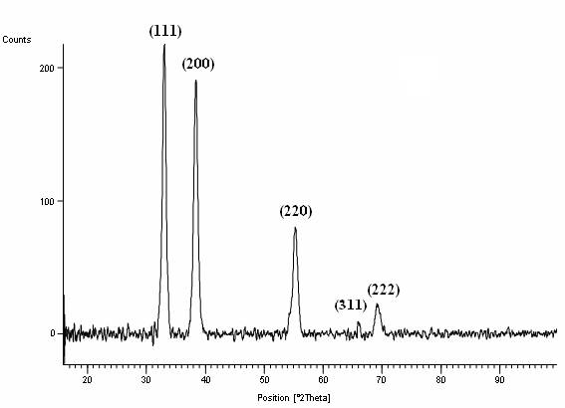
250ºC

Figure 3. XRD pattern of CdO thin film prepared at 250ºC from the precursor solution concentration of 0.06 M

It shows presence of different strong diffraction peaks which confirm polycrystalline cubic CdO phase formation. All the diffraction peaks of the films are indexed to (111), (200), (220), (311) and (222) as compared with standard bulk CdO [JCPDS: 05-0640]. From figure (4) peaks intensity of different plane for the film prepared at various temperatures found to increases up to 250ºC and then decreases. This decrease is attributed to lesser deposition which can be confirmed from the observed film thickness which decreases from 870nm to 610nm prepared between 250ºC and 350ºC. Also from TG studies crystalline nature or formation of CdO should exist at 250ºC and above. But it is observed

Figure 4. XRD peak intensity variation for different plane of CdO thin film prepared at different temperature from precursor solution concentration of 0.06M

the films prepared at 200ºC and 225ºC were crystalline in nature with orientation along (111), (200) and (220) plane. This can be explained as CdO phase may be formed during successive spray time where it undergoes a post annealing of formed amorphous layer of unhydrated molten cadmium acetate compound. However this is not observed for the films prepared from 0.1M precursor concentration where the crystalline CdO phase formed above 250ºC. This is because of larger number of species involves to decompose the molten cadmium acetate compound. Thus the substrate deposition temperature is also a function of precursor concentration. Also the decrease in film thickness or peak intensity at higher temperature is due to vaporization of precursor before it reaches the substrate [Perednis et al 2005]. Texture coefficient (TC) is used to quantify the preferential orientation of the film deposited at different substrate temperature using the following relation [Hadouda et al 1995]. In the relation I is the measured intensity, I_{o} is the Joint Committee on Powder Diffraction Standards (JCPDS) standard intensity and N is the number of diffraction peaks. It is found to be maximum for (111) plane for all the films deposited at different temperature. This indicates no orientation and phase change in the CdO film.

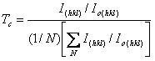

3.2 Grains and Surface morphology studies
X-ray line broadening technique is adopted to determine small crystallite (grain) size of the film by utilizing Scherrer formula [Patterson 1939].
D= Kλ/βcosθ
Where ‘β’ is the breadth of the diffraction line at its full width half maximum intensity (FWHM) in radians, ‘λ‘ is the wavelength of the incident X-ray (1.541 Å), ‘θ’ is the angle at which the maximum peak occurs and ‘K’ is the shape factor which usually takes a value of about 0.89. Grain size value found to vary from 34 to 54 nm calculated for the preferential (111) plane prepared at different temperature. It is observed from figure (5), the grain size found to increases as precursor solution concentration increased. This is due to increase in the number of species involving in the formation of CdO film. Further a uniform compressive or tensile strain (macrostrain) results in peak shift [Sciti et al 2007] of X-ray diffraction lines. However in the present studies there is no appreciable difference in peak shift as compared with standards value. A non-uniform of both tensile and compressive strain results in broadening of diffraction lines (microstrain). In the present studies it is assumed the broadening is due to small crystallite size. Also from figure (5) it shows grain size is lesser for the film deposited at lower temperature 200ºC. It is due to droplet splashes onto the substrate and decomposes to yield smaller grains. But the surface morphology of the film prepared at this temperature shown in figure 6(a) has cracks. This is because a thin, wet layer is present on the film during deposition. Too fast drying of this layer results in stresses and subsequent cracking [Chen et al 1996].Figure 6(b) shows the SEM image of film prepared at 250ºC. It consists of closely packed uniform spherical shape grains without crack. This indicates the film is well adherent with substrate. The grain size as seen from the image is comparable with the XRD studies. At temperature 300ºC and above the deposited spray droplets are almost dry. Therefore, discrete particles are formed on the surface due to slow spreading. This can be explained that at higher temperature the precursor vapourizes before it reaches the substrate and consequently the solid particles are formed as powdery and non-adherent deposit [Perednis et al 2005].

Figure 5. Plot of grain size Vs substrate temperature for different precursor solution concentration

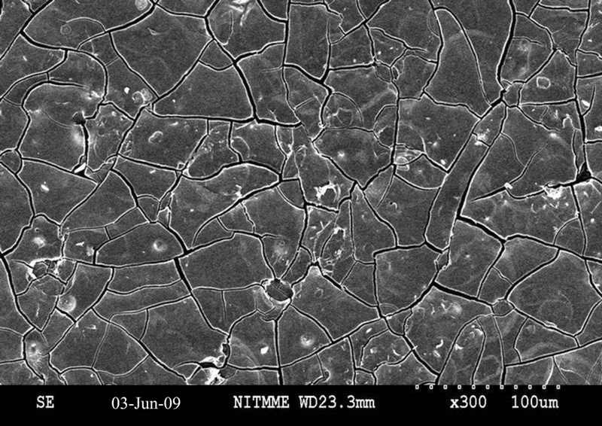

Figure 6(a). SEM image of CdO thin film prepared at 200ºC from precursor solution concentration of 0.06M

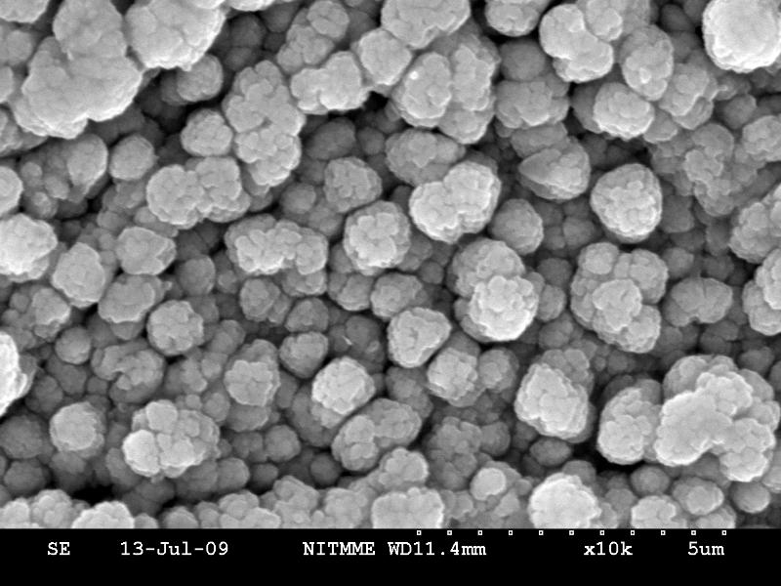

.

Figure 6(b). SEM image of CdO thin film prepared at 250ºC from precursor solution concentration of 0.06M

4. Conclusion
Thin film of CdO on glass substrate is prepared by home built spray pyrolysis unit. TG studies indicate the formation of CdO begins at 250ºC. But XRD pattern confirm CdO phase with preferential orientation along (111) plane at 200ºC due to post annealing of unhydrate molten cadmium acetate compound. X-ray line broadening indicates the grain size in nano meter range and as substrate temperature increased grain size found to increases. Film prepared at 200ºC has microcrack and at 250ºC has spherical shape grains of 45nm size without crack and found to be adherent with substrate. Thus the substrate temperature of 250ºC is an optimum temperature to obtain nano size grains of CdO thin film.

Correspondence to:
Dr. B.G. Jeyaprakash
Department of Physics
Ponnaiyah Ramajayam College of Engineering and
Technology, Thanjavur – 613 403, Tamilnadu, INDIA
Telephone: +91-431-2770145, Mobile: 098654-21411
Email: bgjpabr@yahoo.co.in

References

Chamberlin R R, Skarman J S. Chemical spray deposition process for inorganic Films.
J. Electrochemi Soc., 1966; 113(1): 86-89.

Chen C H, Kelder E M, Vander put P J J M, Schoonman J. Morphology control of thin LiCoO₂ films fabricated using the electrostatic spray deposition (ESD) technique. J. Mat. Chem, 1996; 6(5): 765-771.

Chopra K L, Kainthla R C, Pandya D K , Thakoor A P. In: Physics of Thin films. Academic Press, New york and London, 1982; (12): 167.

Hadouda H, Pouzet J, Bernede J. C, Barreau A. MoS₂ thin film synthesis by soft sulfurization of a molybdenum layer. Mat. Chem. Phys. 1995; 42(4): 291-297.

JCPDS (Joint Committee on Powder Diffraction Standards - Data file: 05-0640).

Patil P S. Versatility of chemical spray pyrolysis technique. Mater. Chem. Phys. 1999; 59 (3): 185-198.

Patterson A L. The Scherrer Formula for X-ray particle size determination. Phys. Rev. 1939; 56: 978-982

Perednis D, Gauckler L J. Thin Film Deposition Using Spray Pyrolysis. J. Electroceramics. 2005; 14(2): 103-111.

Sciti D, Celotti G, Pezzotti G, Guicciardi S. On the toughening mechanisms of MoSi₂ reinforced Si₃N₄ ceramics. Appl. Phys. A. 2007; 86: 243-248.

Su L M, Grote N, Schmitt F. Diffused planar InP bipolar transistor with a cadmium oxide film emitter. Electron. Lett. 1984; 20(18): 716-7.

Zhao Z, Morel D L, Ferekides C S. Electrical and optical properties of tin-doped CdO films deposited by atmospheric metal organic chemical vapor deposition. Thin Solid Films. 2002; 413(1-2): 203-211.

09/21/2009

