Nutrient Status and Economic Analysis of Soils in Oak and Pine Forests in Garhwal Himalaya

Mehraj A. Sheikh and Munesh Kumar
Department of Forestry, HNB Garhwal University, Srinagar Garhwal, Uttarakhand-246174 muneshmzu@yahoo.com

Abstract: The soils of two forest types i.e., oak (Quercus leucotrichophora A. Camus) and pine (Pinus roxburghii Sargent) were analysed for physico-chemical properties and economic analysis. The collected soil samples from both the forests were analysed for texture, water holding capacity, pH, potassium, phosphorus and nitrogen. The results show that the higher percent of moisture and water holding capacity was in oak forest and lower in pine forest. The forest types indicate that the soil of oak forest was acidic and slightly acidic to pine forest. The average SOC in oak forest was 2.19% followed by 1.63% in pine. The nitrogen for oak and pine forests was 0.15 and 0.19% respectively. The available phosphorus in oak forest was higher (17.99 kg ha⁻¹) than in pine forest (16.88 kg ha⁻¹). The exchangeable potassium was 188.92 kg ha⁻¹ in oak forest and 166.43 kg ha⁻¹ in pine forest. The total nutrients generated by soils, as an ecosystem service in oak and pine forests were calculated for market costs. The total market cost of nutrients in oak was 1372.00 Rs ha⁻¹ and in pine 1227.50 Rs ha⁻¹. The maximum contribution among the nutrients was of potassium followed by phosphorus and nitrogen in both the forests. The results of the paper conclude that soil is the principal source of ecosystem services which is generating number of other services. Oak forest are rich in nutrients than pine forest. Thus, oak forest should be preferred to protect, enhance their nutrients level for enhancing the forest ecosystem services. [Journal of American Science 2010;6(2):117-122]. (ISSN: 1545-1003).

Keywords: Soil, physico-chemical, oak, pine, nutrients status, economic analysis.

1. Introduction
Forest soils influenced the composition of forest stand and ground cover, rate of tree growth, vigour of natural reproduction and other silviculturally important factors (Bhatnagar, 1968). Physico-chemical characteristics of forest soils vary in space and time because variation in topography, climate, weathering processes, vegetation cover, microbial activities (Paudel and Sah, 2003) and several other biotic and abiotic factors. Vegetation also plays an important role in soil formation (Champan and Reiss, 1992). The yearly contribution of surface vegetation to soil, in the form of needles, leaves, cones, pollen, branches and twigs, gradually decomposes and becomes a part of the soil (Singh and Bhatnagar, 1997). The nutrient thus, returned in the soil, exerts a strong feed back on the ecosystem processes (Pastor et al., 1984). Plant tissues (above and below ground litter) are the main source of soil organic matter, which influences the physico-chemical characteristics of soil such as, texture, water holding capacity, pH and nutrients availability (Johnston, 1986). Nutrients supply varies widely among ecosystems (Binkly and Vitousek, 1989), resulting in differences in plant community structure and its production (Ruess and Innis, 1977).
Oak is a moderate sized to large evergreen tree occurs in the moist and cool aspects in the western Himalaya between at an altitudes of 800 to 2300 m asl. It is a principal species of the lower west Himalayan temperate forests (Luna, 2005). Pine is the most common resin producing species of India. It is a large evergreen conifer and a principal species of the Himalayan sub-tropical forests (Champion and Seth, 1968).
The nature of soil profile, pH and nutrient cycling between the soils and trees are the important dimensions to determine the site quality. The vegetation influences the physico-chemical properties of the soil to a great extent. It improves the soil structure, infiltration rate and WHC, hydraulic conductivity and aeration (Ilorkar and Totey, 2001; Kumar et al., 2004). With the help of available literature the present study was carried out with the hypothesis that; 1.How oak and pine forests soils differ in physiochemical properties. 2. How economically (Rs) the nutrient (NPK) varies with the local market cost between the forests.

2. Materials and Methods
2.1. Study site
Two dominant forest cover types i.e., oak (1600-2200 m asl) and pine (600-1200 m asl)), were selected in the District Tehri Garhwal of Uttarakhand (located between 30⁰ 18' 15.5" to 30⁰ 20' 40"N and 78⁰ 40' 36.1" to 78⁰ 37' 40.4" E). Each forest type was categorized on different altitude i.e., 1600-1800 m asl (site-I), 1800-2000 m asl (site-II) and 2000-2200 m asl (site-III) and pine forest; 600-800 m asl (site-I), 800-1000 m asl (site-II) and 1000-1200 m asl (site-III) Table-1 for the study. The climate of the area is quite distinct in a year and represents three different seasons i.e., winter, summer and rainy. The mean maximum temperature ranges from 12.8⁰C (December) to 32⁰C (June) and mean minimum between 4⁰C (December) to 16⁰C (June). The mean relative humidity varies from 35% (May) to 92% (August).

Table 1. Site characteristics
Forest Types | Site | Altitude (m asl)
Quercus leuctrichophora | I (1) | 1600-1800
Quercus leuctrichophora | II (2) | 1800-2000
Quercus leuctrichophora | III (3) | 2000-2200
Pinus roxburghii | I (1) | 600-800
Pinus roxburghii | II (2) | 800-1000
Pinus roxburghii | III (3) | 1000-1200

2.2. Methods
The soil characteristics were analysed by collecting samples from three different depths i.e., 0-10, 10-20 and 20-30 from each site in both the forests. A total of 6 forest sites, three each in oak and pine forest type were selected and thus total 54 samples were collected. The moisture (%), water holding capacity (WHC) and texture of soil was determined as the methods described by Misra (1968). Soil pH (1:2.5 ratio of soil: water) was measured with dynamic digital pH meter. Soil organic carbon (SOC) was determined by partial oxidation method (Walkley and Black, 1934). Total nitrogen content determined using of the Kjeldal methods (Jackson, 1958) and phosphorus (P) and potassium (K) by flame photometer methods (Jackson, 1958). The nutrients status was compared among the sites and between the forests. The economic analysis of nutrients (NPK) was estimated per kilogram basis of current market value (Rs kg⁻¹), which was assessed from the local market in the form of nutrients sold in the market. Urea containing only (46%) of nitrogen, so the value (Rs) of urea was converted as per the % of nitrogen available in urea.

3. Results and Discussion

In oak forest, among the physical properties the moisture content ranged from 17.73 % to 24.50 %, 6.22 to 13.18 and 9.89 to 21.79 for site-I , site II and site III respectively. WHC on site II increased with increasing depths however, the trend was altered on site III where higher amount of moisture was in upper layer and decreased with depths, whereas on site I there was no fixed trend. The mean proportion ranged for sand, silt and clay in oak forest was 74.93 to 64.48, 17.82 to 13.28 and 11.77 to 17.67 respectively. The soil of oak forest was sandy loam. The pH values on all sites and depths ranged 5.80 to 6.27 which indicated the soil was acidic to slightly acidic in nature (Fig 1a). The SOC (%) ranged from 1.65 on site I to 2.43 on site III (Fig.1b). It was interesting to note that the SOC was reduced with increasing elevations. The ranged values of nitrogen (%) on all the sites were 0.18 to 0.23 (Fig.1c). Phosphorus 12.52 to 22.25 kg ha⁻¹ (Fig.1d) and potassium 128.20 to 225.76 kg ha⁻¹ (Fig.1e).

Similarly in the pine forest the moisture (%) on depths ranged from 4.70 to 6.0, 6.35 to 8.63 and 12.08 to 13.62 which have no definite trend in the depths but with the altitudes the mean moisture percent increases in order of 5.43 %, 7.11 and 12.88, for site I, site II and site III (Fig.1f) respectively. WHC also increased with increasing elevation. The average WHC on the site was 31.28 %. The average proportion of sand, silt and clay on all the sites and depths were 46.20, 17.35 and 36.42 % respectively. The soil was clay to sandy clayey loam. The pH values ranged 5.42 to 6.71 and average was 6.16. The average SOC on all sites and depths was 1.63 %. Similarly the average values of nitrogen, potassium, phosphorus were 0.15 %, 16.88 kg ha⁻¹ and 164.22 kg ha⁻¹ respectively.
Between the forests, Q. leucotrichophora was the dominant on all sites in oak forest. The associated reported species were Rhododendron arboreum, Myrica esculenta, Lyonia ovalifolia, Prunus cerasoides Pyrus pashi etc. The important noticed shrubs were Pyracantha crenulata, Berberis asiatica, Rubus ellipticus Prinsepia utilis etc. Similar association of species for oak dominated forests of Garhwal Himalaya was also reported by Bhandari et al. (2000) and Kumar et al. (2004).
Pinus roxburghii is one of the important timber and resin yielding species of Garhwal Himalaya. The people of this area used pine forest land for grazing and collect grasses for their cattle feed. Similar importance of pine forest also reported for Himachal Pradesh in India (Gupta and Dass 2007). In the pine dominated forest the main grasses were Heteropogon contortus, Chrysopogon montanus, Apluda mutica, Themeda anathera, Lespideza gerardiana Micromeria biflora, Imperata cylinderica Cyperus spp. Etc. Between oak and pine forests, the higher amount of moisture (Fig. 1f) was in oak forest due to dense and closed canopied forest compared to pine.
Oak forests were characteristically are moist (Saxena and Singh, 1980), fire free (Champion and Seth, 1968) and closed canopied (Saxena, 1979). Similar as moisture, WHC (Fig. 1g) was also higher in oak forest, because dense canopy of oak produced the higher amount of litter which influenced the texture of soil result in, higher water retention capacity.
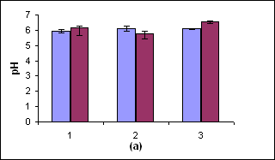

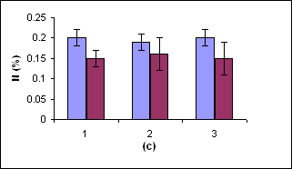

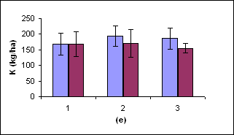

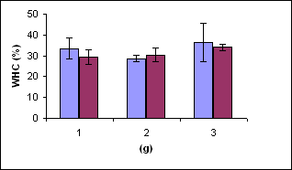

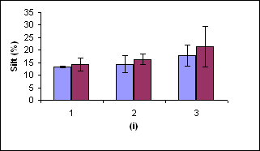

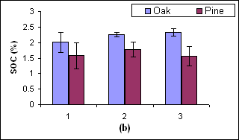

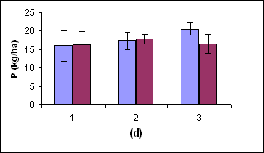

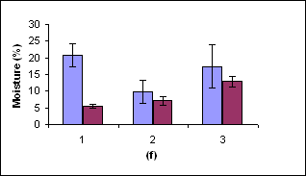

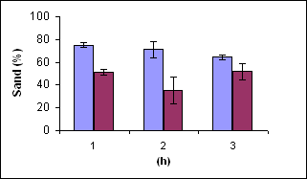

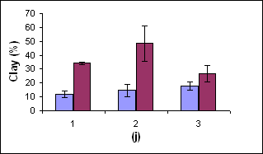

Figures: (1a to 1j) represents the physico-chemical properties of soil in oak and pine forests for Site, 1, 2 & 3.

Among the chemical properties, soil of oak forest was acidic and pine slightly acidic in nature (Fig.1a). The acidic nature of soil is also reported by several other workers for oak dominated and oak-pine mixed forests of Garhwal Himalaya (Bhandari, et al., 2000; Dhanai, et al., 2000; Kumar, et al., 2004). The average SOC (Fig. 1b) was higher in oak forest (2.19 %) followed by pine (1.63 %). The higher SOC in oak could be due to closed canopied forest result in higher inputs of litter which enriches SOC. The lower SOC in pine forest is good indicator of wide spacing of trees which provide low inputs of leaf litter to the soil. The ranged values of nitrogen for oak and pine forests were 0.15 to 0.19 % (Fig. 1c). The nitrogen values reported (0.10 to 0.20 %) for temperate forest of Garhwal Himalaya (Kumar et al., 2004) were close to this study. Phosphorus (Fig. 1d) was also higher (17.99 kg ha⁻¹) compared to pine forest (16.88 kg ha⁻¹). Potassium (Fig. 1e) was 188.92 kg ha⁻¹ in oak forest and 166.43 kg ha⁻¹ in pine forest. The values of phosphorus and potassium in oak and pine forests were comparable as reported by Bhandari et al. (2000) as 14.40 to 21.60 kg ha⁻¹ and Kumar et al. (2004) as 9.3 to 18.2 kg ha⁻¹ for phosphorus. Bhandari et al. (2000) also reported potassium ranged of 170.8 to 295.4 kg ha⁻¹ for Garhwal Himalayan oak forests. Kumar et al. (2006) studied soil on different aspects and reported range values of soil pH (6.33 to 6.47), SOC (0.47 to 0.68 %), phosphorus (9.67 to 10.67 kg ha⁻¹) and potassium (141.87 to 172.48 kg ha⁻¹).
The economic analysis of nutrients in term of money have been analysed with current available market value for the year 2007 for oak (Fig. 2a) and pine (Fig. 2b) soil nutrients. The available form of NPK in market was, urea, diammonium phosphate (DAP) and potash respectively, with market price of rupees 12.80 Rs Kg⁻¹ (urea), 12.50 Rs Kg⁻¹ (DAP) and 6.00 Rs Kg⁻¹ (potash). The amount of nutrients in oak (Fig 3a) was 1.96 kg ha⁻¹ (N), 17.99 kg/ha kg ha⁻¹ (P) and 188.92 kg ha⁻¹ (K) and estimated market cost for NPK for the available nutrients was 25.0 Rs ha⁻¹, 225.0 Rs ha⁻¹ and 133.50 Rs ha⁻¹ respectively. Similarly in pine (Fig. 3b) the available NPK nutrients were 1.53 kg ha⁻¹, 16.88 kg ha⁻¹ and 166.00 kg ha⁻¹ respectively and the market cost was rupees 19.50 Rs ha⁻¹ (N), 212.00 Rs ha⁻¹ (P) and 996.00 Rs ha⁻¹ (K).

4. Conclusion
The results of the paper conclude that oak forests are rich in the nutrients availability than pine. Therefore, oak forests wherever present should be protected and enhanced its plantation in pine forest also to enrich soil nutrient supply.

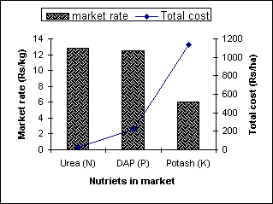

Figure: 2a
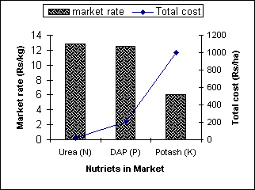

Figure.2b
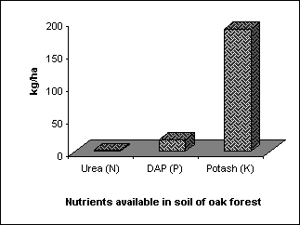

Figure.3a
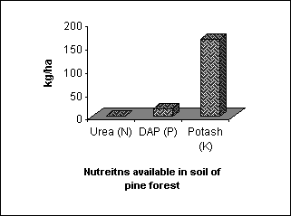

Figure.3b

Oak is the main source of basic requirement to the villagers in form of timber, litter and many other requirements. The excess lopping of forests and surface burning by fire in pine reduced considerable input of nutrients in the forest floor. Thus these nutrients services can be maintained/enhanced through proper management by reducing excess exploitation of forest litter especially for fodder, branch lopping and, surface burning.

5. Acknowledgement
Authors are thankful to Department of forestry HNB Garhwal University for providing laboratory facilities during the work.

Corresponding Author:
Dr Munesh Kumar
Department of Forestry,
HNB Garhwal University,
Srinagar Garhwal-246174, Uttrakhand, India
Email: muneshmzu@yahoo.com

References
- Bhandari BS, Mehta JP, Tiwari SC. Dominance and diversity relations of woody vegetation structure along an altitudinal gradient in a montane forest of Garhwal Himalaya. Journal of Tropical Forest Science 2000; 12(1):49-61
- Bhatnagar HP. Soils from different quality sal (Shorea robusta) forests of Uttar Pradesh. Tropical Ecology 1965; 6: 56-62
- Binkley D, Vitousek PM. Soil Nutrient Availability. In: Pearey, R.W., J. Ehleringer, N.A., Mooney and Rundel, P.W. (eds) Plant Physiological, Field Methods and Instrumentation London; Champan and Hall. 1989; 75-96.
- Champan JL, Reiss MJ. Ecology Principles and Application. Cambridge; Cambridge University Press 1992; 294 p.
- Champion HG, Seth SK. A Revised Survey of the forest type of India. Government of India Publications, Delhi, India. 1968
- Dhanai CS, Panwar VP, Sharma CM. Effect of aspect and soil on the structure of Quercus leucotrichophora natural stands in western Himalaya. Indian Journal of Forestry 2000; 23(3): 349-356
- Gupta B, Dass. Composition of herbage in Pinus roxburghii Sargent stands: basal area and importance value index Caspian Journal of Environmental Science. 2007; 5(2): 93-98 pp.
- Ilorker VM, Totey NG. Floristic diversity and soil studies in Navegaon National Park (Maharashtra). Indian Journal of Forestry 2001; 24(4): 442-447.
- Jakson ML. Soil Chemical Analysis. Prentice Hall, Inc., Engle Wood Cliffs, New jersey. 1958; 498.
- Johnston AE. Soil organic matter; effects on soil and crops. Soil Use Management 1986; 2: 97-105.
- Kumar Munesh, Bhatt VP, Rajwar GS. Plant and soil diversities in a sub-tropical forest of the Garhwal Himalaya. Ghana Journal of Forestry 2006; 19-20:1-19pp
- Kumar Munesh, Sharma CM, Rajwar GS. Physico-chemical properties of forest soil along altitudinal gradient in Garhwal Himalaya. Journal of Hill Research 2004; 17(2):60-64.pp
- Luna RK. Plantation Trees. International Book Distributor, Dehradun 2005
- Misra R. Ecology Work Book. Oxford and IBH Publishing Co., Calcutta, 1968; 244p.
- Pastor J, Aber JD, Mc Clangherty CA, Melillo JM. Above ground production and N and P cycling along a nitrogen mineralization gradient on black hank island,Wisconsin Ecology 1984; 65:256-268
- Paudel S. Sah JP. Physiochemical characteristics of soil in tropical sal (Shorea robusta Gaertn.) forests in eastern Nepal. Himalayan Journal of Sciences 2003; 1(2)107-110
- Ruess JO, Innis GS. A grassland nitrogen flow simulation mode. Ecology 1977; 58: 348-429.
- Singh RD, Bhatnagar VK. Differences in soil and leaf litter nutrient status under Pinus, Cedrus and Quercus. Indian Journal of Forestry. 1997; 147-149p
- Saxena AK. Ecology of vegetation complex of north western catchments of river Gola. Ph. D. Thesis, Kumaun University, Nainital, India 1979;
- Saxena AK, Singh JS, Analysis of forest grassland vegetation in a part of Kumaun Himalaya. Indian Journal of Range Management. 1980; 1:13-32
- Walkey AE, Black JA. An examination of the Degtiga Vett. Method for determining soil organic matter and proposed modification of the chromic acid titration method. Soil Science 1934; 37:29.

10/09/2009

Author informations

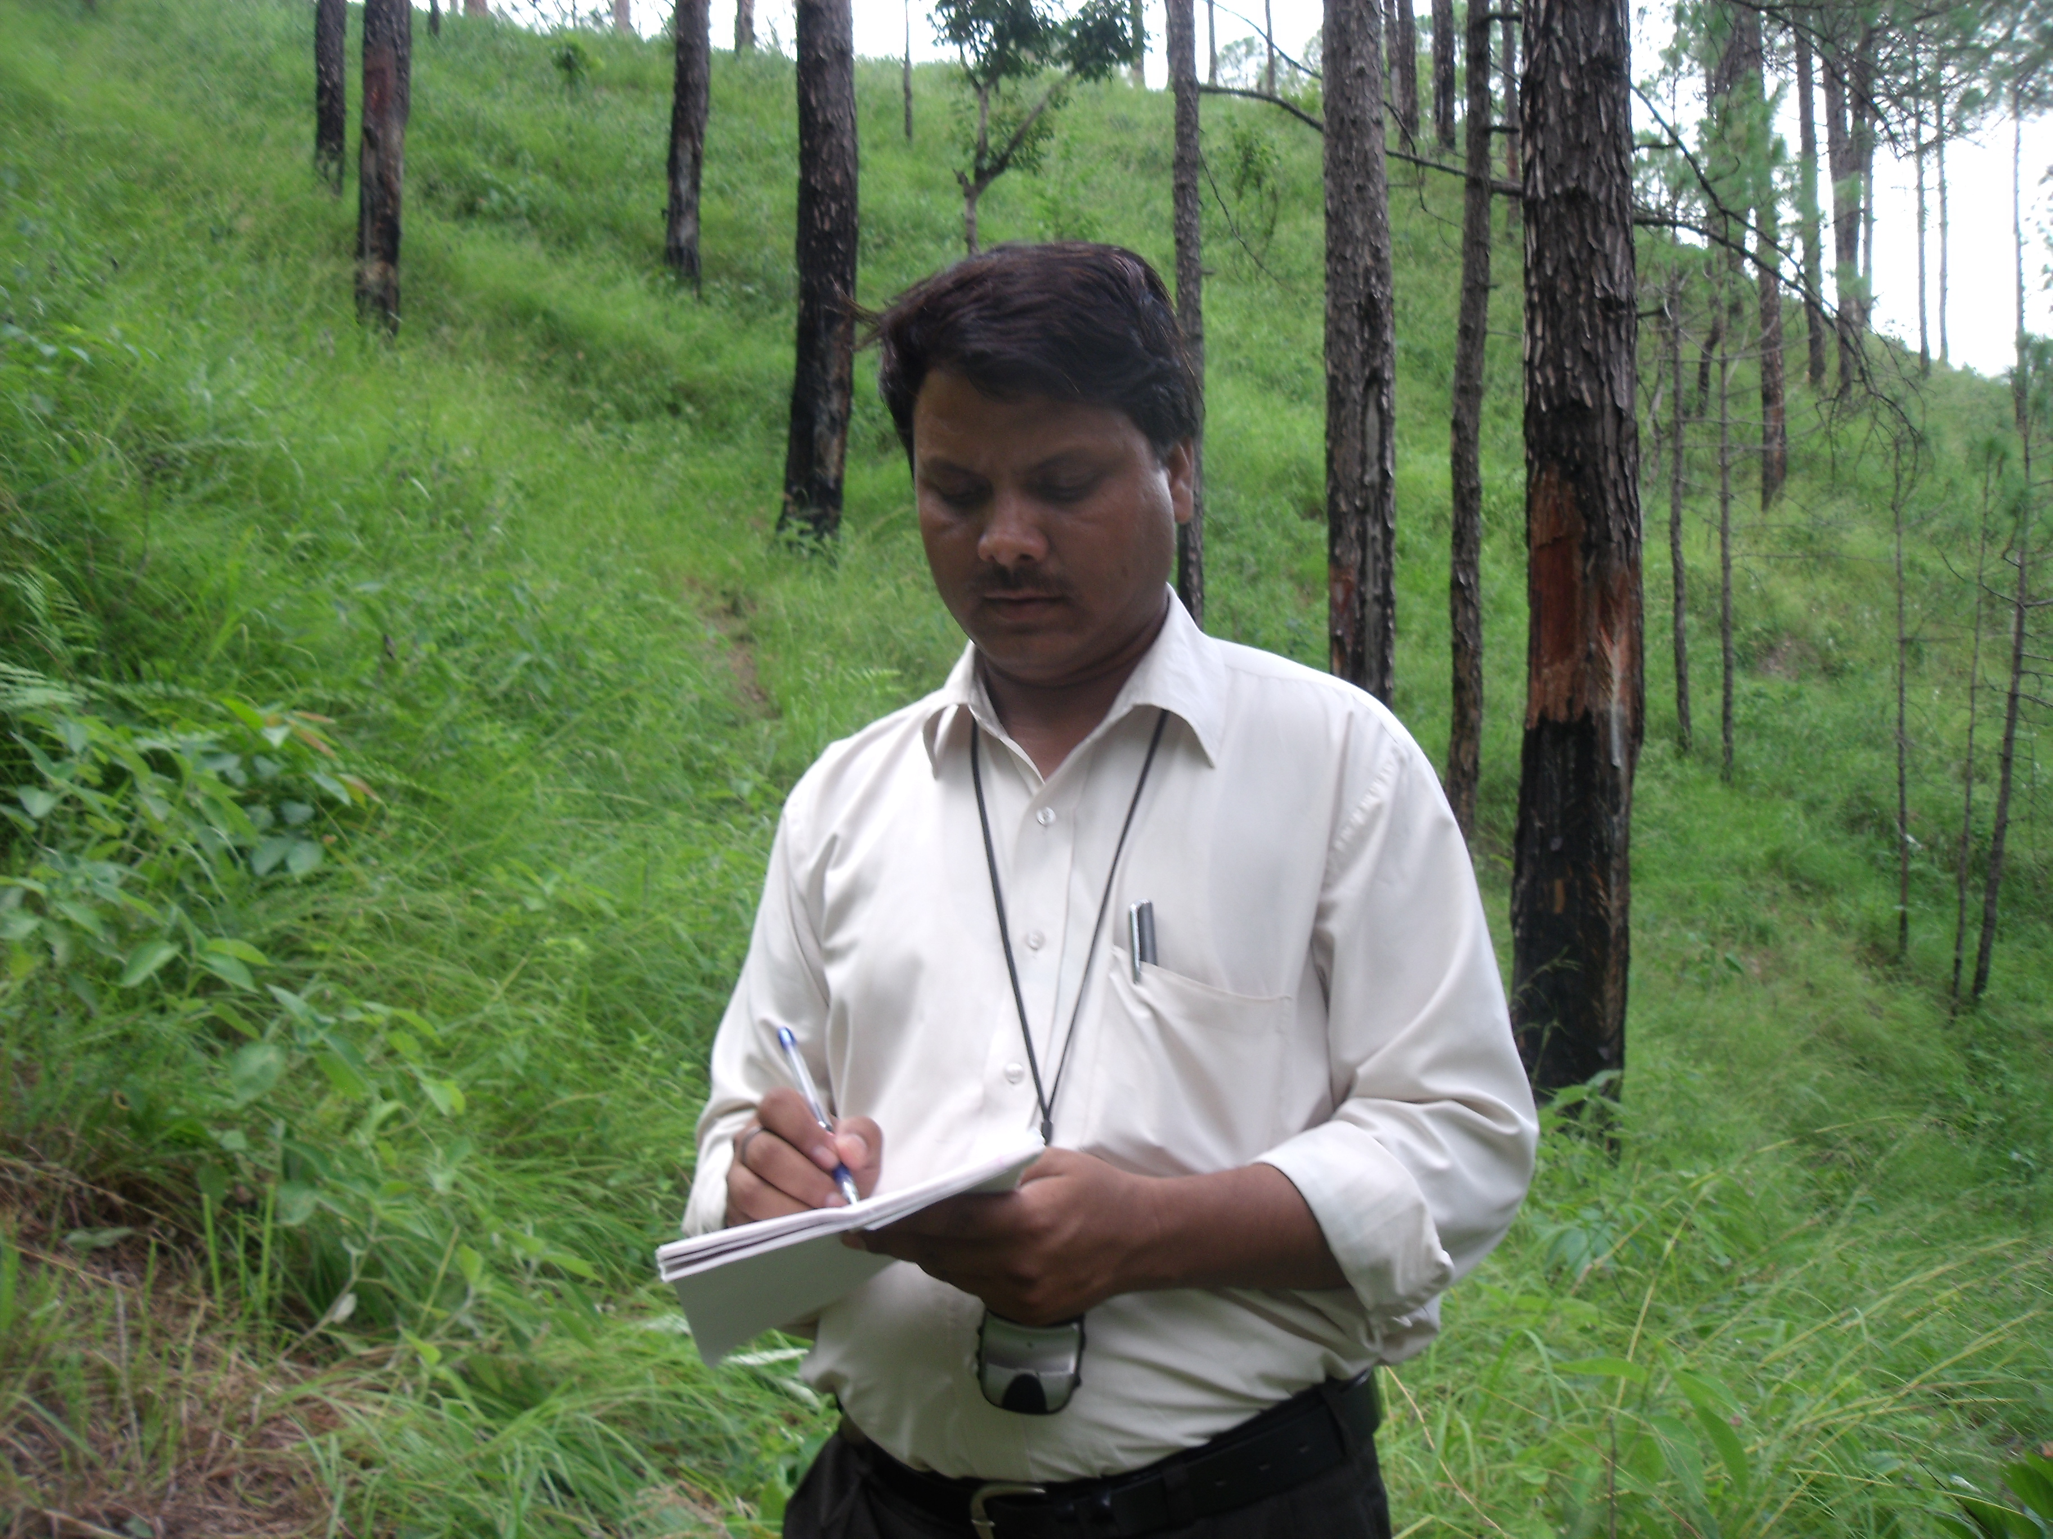
Mehraj A Sheikh Dr Munesh Kumar

Mehraj A Sheikh is a research scholar in Department of Forestry, HNB Garhwal University, and presently working as a Junior Research Fellow in Biodiversity and Climate Change Division, Indian Council of Forest Research and Education, Dehradun, India.

Dr Munesh Kumar is Assistant Professor, Department of Forestry, HNB Garhwal University, Srinagar Garhwal, Uttarakhand-246174, India. His area of specialization is Forest Ecology. The current area of research is disturbance ecology, soil carbon sequestration of Garhwal Himalayan forest.

