Biodegradation of Produced Water Hydrocarbons by Aspergillus Fumigatus

Chuma C. Okoro¹, Olukayode O Amund²

¹ Department of Biological Sciences and Biotechnology, Caleb University, Lagos
² Department of Botany and Microbiology, University of Lagos, Nigeria
Tel: 08033072754, 01-7430285
e-mail: chuma2k2001@yahoo.com
P. O. Box 146, University of Lagos Post Office, Lagos, Nigeria

Abstract: Biodegradation studies of hydrocarbons in untreated produce water from an oil production facility in Nigeria were undertaken over a period of time using pure cultures of Aspergillus fumigatus isolated from the zone of produce water discharge into the receiving sea water. The rate of reduction in some petroleum hydrocarbon fractions such as n-Alkanes, Aromatics, Nitrogen Sulfur and Oxygen (NSO) containing compounds and Polycyclic aromatic hydrocarbons (PAHs) were monitored by means of Gas chromatography and Mass spectrometry using mechanically treated produced water as a reference. Gas chromatographic analysis showed that untreated produced water used in the study had an oil and grease content of 1407mg/l, this includes n-alkanes(608mg/l), Aromatics (13.88mg/l), NSO compounds (12.68mg/l) PAHs(0.833mg/l) and some unidentified greasy components. Upon mechanical treatment, the oil and grease component of produced water was reduced to 44mg/l comprising of n-alkanes (38.40mg/), Aromatics (2.65mg/), NSO compounds(1.78mg/), PAHs (0.0655mg/) and some unidentified greasy component. A pure culture of Aspergillus fumigatus after 120 days of exposure to untreated produce water was able to reduce the hydrocarbons to the following components. n-Alkanes (78.5mg/l), Aromatics(1.58mg/l), NSO compounds (1.22mg/l) and PAHs (0.0168 mg/l). This result indicate that produce water from Chevron’s Escravos tank farm is readily biodegradable and the Aspergillus fumigatus culture used in the study was very effective in degrading the PAHs and NSO components of the hydrocarbon when compared with the conventional mechanical treatment process even though the biodegradation process was very slow. [Journal of American Science 2010;6(3):143-149]. (ISSN: 1545-1003).

Keywords: Pure culture, Produce water, Biodegradation, Oil and Grease.

1. Introduction:
Produced water is defined as the water (brine) brought up from the hydrocarbon bearing strata during the extraction of oil and or gas, this includes formation water, injection water, small volumes of condensed water and trace elements of treatment chemicals (Ayers and Parker,2003). Produced water is the highest volume waste generated in association with oil and gas production operations and is therefore one of the single greatest environmental impediment to natural gas and oil exploration.
Measurable impacts of produced water discharges have been observed in shallow and confined waters where the discharge plume contacts the sea floor, impacts that have been identified include elevated concentrations of petroleum hydrocarbons in the sediment and a possible decrease in diversity of benthic fauna near the discharge point (Ayers and Parker, 2003) but these impacts are rarely observed in open ocean environments where in most cases, the plume either does not contact the seafloor or is well diluted by the time it does.
Marine organisms are capable of bio-accumulating petroleum hydrocarbons, metals and radio nuclides in produce water (Ayers and Parker, 2003). Produced water is also known to be toxic to fishes and other marine animals (Middledich, 1984). A major cause for concern in recent times has been the presence of polycyclic aromatic hydrocarbons (PAHs), such as anthracene, phenanthrene, benzo(a) pyrene and benzo(a)anthracene, in produce water. Some of these compounds are recalcitrant and potential carcinogens, and they have the capability to bioaccumulate in food chains since they are not easily biodegradable (Neff,1985). This is a problem, because the produce water treatment systems currently in use by most oil production companies is primarily designed to remove particulate or dissolved oil and therefore has little effect on the concentrations of dissolved petroleum hydrocarbons and other organics in produce water (Lysyj, 1982).
Produced water is usually treated mechanically to remove as much as possible the oil present but the conventional mechanical treatment process have been unable to remove significantly the aromatic components of the hydrocarbon because they are partially soluble in water. This development has led to the search for an alternative biological treatment process that can complement the conventional mechanical treatment process.
Fungal cultures have been known to be very effective in the degradation of aromatic hydrocarbons. Andrea et al (2001) have successfully used mixed fungal cultures to degrade various fractions of PAHs and over 65% degradation rate was achieved with Phenanthrene and Naphtnalene. The degradation of hydrocarbons by yeasts and filamentous fungi has been investigated previously and it was concluded that most fungal species are excellent hydrocarbon degraders (Sutherland, 2004; Gadd, 2001). However, these studies did not investigate the degradation of produce water hydrocarbons by fungal isolates.
An investigation carried out on the biodegradation of produce water hydrocarbons by Okoro and Amund (2002) showed that produce water hydrocarbons are readily biodegradable by the indigenous microbial flora. Since fungal species form part of the produce water microflora, an attempt was made by Okoro (2008) to establish the role of individual fungal isolates in the degradation of produced water hydrocarbons.
Pure cultures of Aspergillus niger and Penicillium specie isolated from produce water showed extensive degradation of PAHs in produce water (Okoro, 2008). Aspergillus fumigatus, one of the commonest and the most abundant fungal specie found in Escravos river where produced water is continuously been discharged (Okoro,1999), was used to degrade petroleum hydrocarbons in produce water in the present study. An attempt was also made in this study to use this ubiquitous fungal specie to degrade various fractions of petroleum hydrocarbons especially the recalcitrant PAHs in produce water. It is expected that a significant degradation of PAH in produce water by the indigenous fungal species will help to reduce the problem of bioaccumulation of these organic compounds in the marine animals, and also the resultant risks of potential health hazards associated with the consumption of the contaminated sea foods.

2. Materials and Methods

Sample Collection
Untreated produce water samples were collected with sterile 1000 L Wheaton glass bottles at a point before the final process stream of the Wemco treatment plant at Chevron’s Escravos tank farm while the treated produce water samples were collected at a point after the final process stream where it is being discharged to the receiving water.

Enumeration of hydrocarbon utilizing Fungi
Hydrocarbon utilizing fungi in produce water were obtained by plating out at low dilutions 10 ^{–1} – 10⁻² of samples on mineral salt medium of Mills et al ( 1978 ). The composition of the medium is as follows in ( g/L ): NaCl ( 10 ), MgS0₄.7H₂0 ( 0.42 ), KCl ( 0.29 ), KH₂P0₄ (0.83), Na₂HP0₄ (1.25 ), NaN0₃ ( 0.42 ), Agar bacteriological ( 15 ), distilled water ( 1000mls),and pH (7.2 ). The medium was autoclaved at 1.1 kg/cm² for 15 mins. The inoculated mineral agar plates were then inverted over sterile membrane filters moistened with crude oil ( Escravos light ) and held in the lid of the petridishes. The dishes were wrapped round with a masking tape so as to increase the vapour pressure within the petridishes while the plates were incubated at 29 ºC for 7 days. After incubation period, the fungal cultures were stained with methylene blue and observed under a high power resolution microscope ( x40 ), The fungal culture was identified based on its morphological characteristics.

Analytical methods:
Separation of Aliphatic and Aromatic components of hydrocarbons in produced water using High Performance Liquid Chromatography ( HPLC ).
A measured quantity of the oil sample (10ml) was introduced into the bond elute filter to separate the hydrocarbons from the Nitrogen, Sulfur and Oxygen (NSO) containing components of the petroleum mixture. The filtrate (2 ml) containing both the aliphatic and the aromatic components of the petroleum mixture was injected into the HPLC (WATERS 486). The aliphatic component eluted after 18mins while the aromatic component after 45mins. Each fraction ( 0.2 μL ) was subsequently analyzed by means of Gas chromatography attached to a mass selective detector.

Analysis of Total hydrocarbons, n-Alkanes and Polyaromatic hydrocarbons.
The method used in the analysis was described by Neff et al, (1989). The hydrocarbon extract was concentrated in a Kuderna-Danish flask on a 70⁰C water bath to approximately 1.0 ml. The concentrated extract was transferred to a 1-dram vial with a disposable pipette and the flask rinsed twice with 1 ml methylene chloride. The rinses were added to the vial and the volume of the extract was reduced to about 1ml with a gentle stream of purified nitrogen gas.
Total n-alkanes and aromatic concentrations were determined by GC-MS analysis of the F1 and F2 fractions respectively. Both resolved and unresolved hydrocarbons were quantified. The resolved concentrations were determined by summing the total resolved area with valley integration and then using an average n-alkane or PAH response factors to calculate an amount relative to the internal standard. The unresolved concentrations were calculated by integrating the total area of the chromatogram ( both resolved and unresolved complex mixture ( ucm area ), subtracting the resolved area and determining the amount relative to the internal standard.

Gas Chromatography of Oils
Fresh and degraded oil were analyzed by Gas chromatography using Hewlett Packard 5890 series 11 Gas chromatograph equipped with single flame ionization detector (FID) fitted with Perkin Elmer Nelson analog digital converter ( 900 series ) and a Compaq deskpro computer. A J and W scientific DB-1 capillary column of 15 m length and an internal diameter of 0.32 mm wide bore of 1micron film thickness was used. A temperature program of 50-305⁰C increasing at 3.5⁰C per minute for 27.15min was employed. Hydrogen with a flow rate of 2ml per min was used as a carrier gas while the flow rate of air was 400ml per min. The detector temperature was 325⁰C while the injection port temperature was 305⁰C. The oil extracts of culture supernatants were dissolved in methylene chloride while a sample volume of 0.2μl was injected. The nC17/Pristane and nC18/Phytane ratios were subsequently calculated from the height of various chromatograms.

Biodegradation and Growth studies
Growth and degradation studies over a time course were carried out using untreated produce water from Escravos tank farm as the sole carbon and energy source. The untreated produce water used for the study had an initial oil and grease content of 1407 mg/l. Starter cultures were originally prepared using the minimal salts formulations of Mills et al, 1988 and the produce water as the sole carbon and energy source. 10 ml each of the pure fungal culture ( Aspergilus fumigatus) was introduced into 500mL of produce water in a 1000 mL capacity wheaton glass bottle. The bottle was covered with a non-absorbent cotton wool and placed in a slanted position to allow air passage through the pores of the cotton wool. The bottles were shaken manually at regular intervals to allow adequate mixing and homogeneity of the contents. The experimental setup was monitored for a period of 120 days and at a 30 day interval, cultural samples were collected and analysed for microbial load while the residual hydrocarbon was extracted with methylene chloride and analysed by Gas chromatography.

3. Results
The Untreated and Mechanically Treated Produce Water
The untreated produce water used for the experiment had an oil and grease content of 1407mg/l comprising of n-Alkanes ( 608 mg/l ), aromatics ( 13.88mg/l ), NSO compounds ( 12.68 mg/l) and PAHs ( 0.833mg/l ) and an initial nC17/Pristane and nC18/Phytane ratios of 1.41 and 2.93 respectively while the mechanically treated produced water used as a reference had an initial oil and grease content of 44mg/l comprising of n–alkanes ( 38.4 ), aromatics (2.65), NSO compounds ( 1.78 ) and PAHs ( 0.0655 )and an initial nC17/Pristane and nC18/Phytane ratios of 1.24 and 3.0 respectively. The GC chromatograms of both the untreated and the mechanically treated produced water are shown in Figs. 1 and 2 respectively.

Biodegradation of Produce water hydrocarbon with Aspergillus fumigatus
GC chromatogram of untreated produce water after a 120 day treatment with Aspergillus fumigatus is shown in Fig. 3, the corresponding nC17/Pristane and nC18/Phytane ratios are shown in Fig. 4. On the degradation of individual petroleum hydrocarbon components, it was observed that significant concentrations of aromatic components of the petroleum hydrocarbons were removed by the fungal cultures after 120 days of exposure. The residual concentrations of the hydrocarbon fractions are stated as follows; n-Alkanes (78.50mg/l), Total aromatics (1.58mg/l), NSO compounds (1.22mg/l) and PAH(0.0168mg/l).

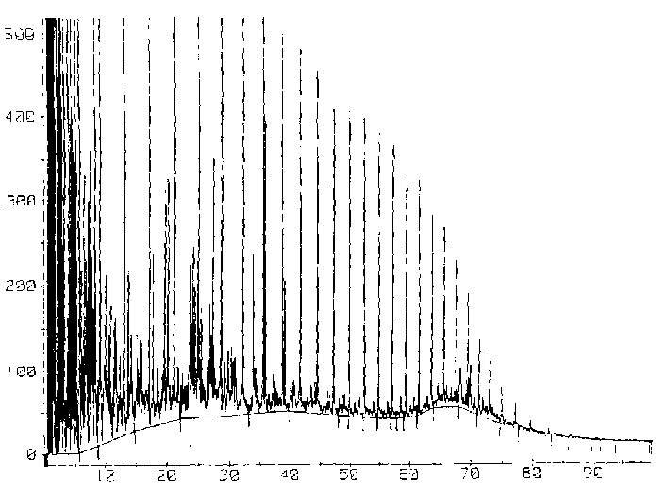
Retention Time (Mins)
Relative Abundance (mV)

Figure 1: GC Chromatogram of untreated produced water from Escravos tank farm (nC17/pr. Ratio = 1.41, nC18/ph. Ratio = 2.93)
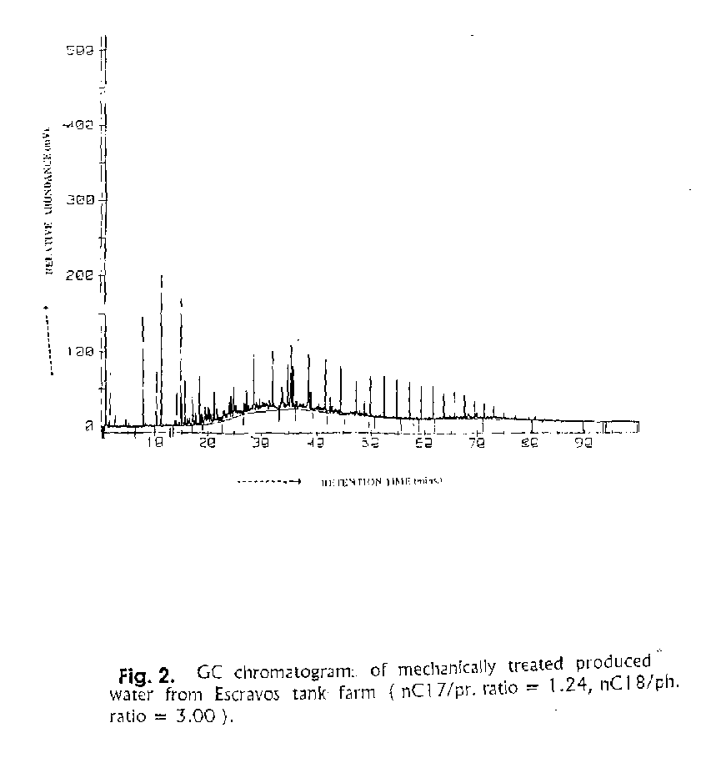
Retention Time (Mins)
Relative Abundance (mV)

Figure 2: GC Chromatogram of mechanically treated produced water from Escravos tank farm (nC17/pr. Ratio = 1.24, nC18/ph. Ratio = 3.00)
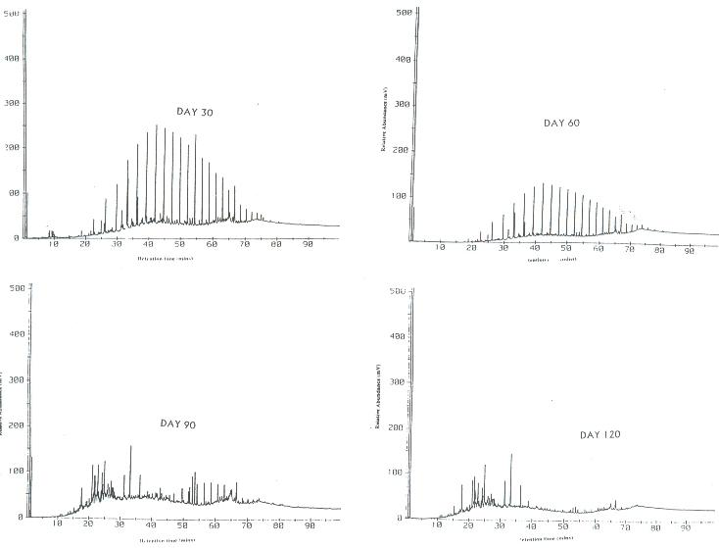
Retention Time (Mins)
Relative Abundance (mV)
Relative Abundance (mV)
Retention Time (Mins)
Relative Abundance (mV)
Retention Time (Mins)
Relative Abundance (mV)
Retention Time (Mins)

Figure 3. GC Chromatograms of untreated produce water after a 120 day exposure to an Aspergillus fumigatus culture
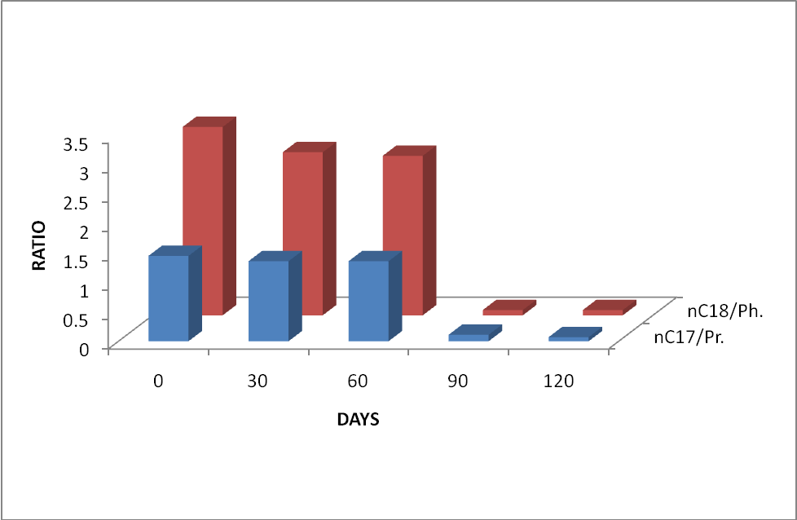
Figure 4. Biodegradation of Untreated produce water with Aspergillus fumigatus culture. The result is evaluated as decrease in nC17/Pristane and nC18/Phytane ratios

4. Discussion:
It has been reported in literature that a significant number of soil Fungi utilise petroleum hydrocarbons very efficiently though slowly (Canniglia et al,1980). Some researchers like Cerninglia (1992), Gadd(2001), Andrea et al, (2001), Sutherland (2004) and Okoro (2008) have also demonstrated that Fungi cultures are very efficient in the degradation of highly recalcitrant Polycyclic Aromatic Hydrocarbons (PAHs).
The predominance of Aspergillus fumigatus species within the discharge zone of produce water effluents (Okoro, 1999) led to the interest in the evaluation of its biodegradation potential especially as it relates to the degradation of highly recalcitrant PAHs in produce water.
The index used to monitor the progress of biodegradation is the rate of decrease in the ratios of nC17/Pristane and nC18/Phytane. Pritchard and Coaster (1991) used the same index to monitor the progress of biodegradation during the EPA Alaska oil spill biodegradation project. The application of this concept is based on the principle that during biodegradation, decreases of total oil residues could occur because of other non biological processes, thus changes in hydrocarbon composition that are indicative of biodegradation must be measured accurately. This is done historically by examining the weight ratios between hydrocarbons known to be readily biodegradable such as the C17 and C18 alkanes and those that biodegrade slowly such as the branched alkanes (Pristane and Phytane ) but with very close chromatographic behaviour. A weight ratio less than 1 signifies considerable biodegradation Pritchard and Coaster (1991).
Both the treated and untreated produced water had weight ratios of nC17/Pristane and nC18/Phytane higher than 1, an indication that the hydrocarbon present was not biodegraded.
Relying on the nC17/Pristane and nC18/Phytane ratio index, Aspergillus fumigatus achieved considerable biodegradation after 90 days of exposure when the ratios dropped to 0.11 and 0.09 respectively. When compared with Aspergillus niger and Penicillium sp. used by Okoro (2008), the degradation pattern was almost similar except that Aspergillus niger and Penicillium sp. achieved considerable biodegradation after 60 days of exposure, this faster degradation rate is expected because the two fungal isolates used were originally isolated from produce water as opposed to Asp. Fumigatus that was isolated from Sea water.
On the degradation of PAHs, over 80% of residual PAHs were removed by Aspergillus fumigatus cultures after 120 days of exposure, a similar trend was observed with the other two fungal species used by Okoro (2008).
The present study have demonstrated that Aspergillus fumigatus is very efficient in the degradation of aromatics including the very recalcitrant PAHs in produce water and since the organism is predominant within the zone of discharge of produce water effluents, it can be very useful in the degradation of accumulated hydrocarbons in the bottom sediment of the discharge zone. This can happen naturally over a long period of time.

ACKNOWLEDGEMENTS
Chevron Nigeria Limited is gratefully acknowledged for providing facilities and logistics for this research.

Corresponding Author:
Dr. Chuma C. Okoro
Department of Biological Sciences and Biotechnology, Caleb University, Lagos
Tel: 08033072754, 01-7430285
E-mail: chuma2k2001@yahoo.com
P. O. Box 146, University of Lagos Post Office, Lagos, Nigeria

References:
- Andrea RC, Tania AA, Lucia RD Biodegradation of polycyclic aromatic hydrocarbons by soil fungi. Braz. J. Microbiol. 2001; 32(4 ):124-129.
- Ayers RC, Parker, M. Offshore Produce water management-Technical report to CAPP. 2003. No:29125.
- Cerniglia CE, Gibson DT. Fungal oxidation of 9,10-dihydroxy-9,10, dehydrobenzo(a)pyrene, 9,10 diol, 7,8, epoxides. Proc. Natl.Acad. Sci. USA. 1980; 77: 4554-4558.
- Cerninglia CE). Biodegradation of polycyclic aromatichydrocarbons. J. Biodegradation 1992;3: 2-3
- Gadd GM. Fungi in Bioremediation. Cambridge University Press, Cambridge. 2001p. 220 .
- Lysyj L. Chemical composition of produced water in some off- shore oil platforms. Report to USEPA, Municipal Environmental Research Lab. Cincinnati, OH. 1982 ;600/282-034.
- Middledich BS. Ecological effects of produced water discharges from offshore oil and gas production platforms. Final report on API project. American Petroleum Institute, Washington, D.C. 1984 NO. 248.
- Mills AL, Breuil C, Colwell RR. Enumeration of petroleum-degrading marine and estaurine microorganisms by the most probable number method. Can. J. Microbiol. 1978. 24: 552-557
- Neff JM. The potential impacts of drilling fluids and other effluents from exploratory drilling in the living resources.. R.H.Bachus (ed.) Cambridge Massachusetts. 1985;224
- Neff JM, Sauer TC, Maciolec N.. Fate and Effects of Produce water discharges in near shore marine waters. American Petroleum Institute, Washington D.C. API Publication No. 4472. 1989
- Okoro CC. Microbial degradation of hydrocarbons in produced water from crude oil production operations in Escravos tank farm. Ph.D. Thesis, University of Lagos. 1999;269 .
- Okoro CC, Amund OO. Biodegradation of hydrocarbons in untreated produce water using pure and mixed microbial cultures.;J. Sci. Tech. and Environ. 2002;2(2): 14-23
- Okoro CC. Biodegradation of hydrocarbons in untreated produce water using pure fungal cultures. Afr. J. Microbiol. Res. 2008 2:217-223.
- Pritchard, P. H. and Coaster, C.F. EPA’S Alaska oil spill bioremediation project. Environ. Sci. Technol. 1991;25 (3): 372-373
- Read AD . Treatment of oily water in North Sea Oil installations. In: Oil Water Discharges; Regulatory, Technical and Scientific Considerations. Johnson C.S.and Morris, R.J. ( ed ). Applied Science Publishers, Barking Essex, England. 1978;127-136.
- Sutherland JB. Degradation of hydrocarbons by yeasts and filamentous fungi. In: Fungi Biotechnology in Agricultural, Food and Environmental Applications. Arora, D.K (ed.). Marcel Dekker Inc., USA. 2004; 324.
- Wills J. A survey of offshore oil field drilling wastes and disposal techniques to reduce the ecological impact of sea dumping. Sakhalin Environment Watch. 2000; 5:22-28

12/7/2009


Dr. Chuma C. Okoro

