STRUCTURAL AND OPTICAL CHARACTERIZATION OF
SPRAY DEPOSITED SnS THIN FILM

B.G. Jeyaprakash^{1*}, R. Ashok kumar², K.Kesavan², A. Amalarani¹

1. Department of Physics, Ponnaiyah Ramajayam College of Engineering and Technology
Thanjavur -613 403, TamilNadu, India
2. Department of Physics, PRIST University, Thanjavur – 614 904, Tamilnadu, India

*Corresponding author email: bgjpabr@yahoo.co.in

Abstract: Tin sulfide thin films were prepared on glass substrate by home built microcontroller based spray pyrolysis unit. X-ray diffraction confirmed the nanocrystalline SnS phase formation with preferential orientation along (111) plane. The intensity of XRD peaks increases with the increase of substrate temperature which implies better crystallinity takes place at higher temperature. Scanning electron micrograph of the film revealed the manifestation of nano SnS with size lying in the range of 31 -49nm as the function of substrate temperature. VIS-NIR spectrophotometric measurement showed high transparency of about 87% in the wavelength range 600-1100nm with a direct allowed bandgap lying in the range of 1.30 – 1.40eV as substrate temperature increases. [Journal of American Science 2010;6(3):22-26]. (ISSN: 1545-1003).

Key words: Tin sulfide, thin film, spray pyrolysis

1. Introduction
Semiconducting metal chalcogenides are used as sensor, polarizers and thermoelectric cooling materials [Lindgren et al 2002]. Among many semiconducting metal chalcogenides, tin sulfides have attracted extensive interest due to its photoconductivity properties for solar energy conversion. Tin sulfide exists in variety of phases such as SnS, Sn₂S₃, Sn₃S₄ and SnS₂ due to bonding characteristics of tin and sulfur [Jiang et al 1998]. Also it has both p and n-type conduction with a direct band gap of 1.3eV and an indirect bandgap of 1.0eV [Valiukonis et al 1986; Engelken et al 1987]. Several methods such as Electrodeposition [Zainal et al 2005], SILAR [Biswajit et al 2008], Spray pyrolysis [Khelia et al 2000; Thangaraju et al 2000] and Co-evaporation [Cifuentes et al 2006] have been studied for preparing tin sulfide thin film. For the past few years thin film nanomaterials based devices are fabricated due to its unique physical and chemical properties which differs from its bulk and enhancing device performance. There are numerous methods for preparing thin film nanomaterials. These methods can be broadly classified into Vapour deposition and Solution deposition method. Each method has its own characteristics merits and demerits in producing homogeneous and defect free thin film nanomaterials and new preparation methods are being evolved to produce controlled size and shape of desired morphology. Spray pyrolysis technique [Chopra et al 1982] has been used for several decades in glass industry and in solar cell production to deposit electrically conducting electrodes. The quality and properties of the films depends largely on substrate temperature, precursor solution concentration, atomization type and substrate [Chamberlin et al 1966; Patil 1999; Chen et al 1996]. In the present work the effect of substrate temperature towards the x-ray diffraction, optical energy band gap and surface morphology of the films on glass substrate was studied.

2. Experimental
Thin film prepared by conventional spray pyrolysis has disadvantages due to i) non-uniformity of film with larger grain size due to uncontrollable spray droplet size ii) wastage of solution i.e. the low ratio of atoms effectively deposited to those supplied iii) low deposition rate. Several workers have made improvement in the spray efficiency. In corona spray the transport of aerosol droplets towards the substrate have been achieved by a control and 80% efficiency is achieved in this method [Siefert 1984]. The films formed in the present spray unit shown in figure 1(a) have good surface uniformity with controlled droplet size. The unit consists of (i) specially designed spray generator shown in figure 1(b) is made up of 50 ml capacity glass vessel having carrier gas nozzle of 0.76mm diameter and an inverted funnel type nozzle of 1mm diameter. By Bernoulli’s action solution spray will take place through this nozzle when air flows through the carrier gas nozzle and a fine mist is produced at the barrier which is allowed to deposit on the pre heated glass substrate. (ii) substrate heater with thermostat coupled with K-type thermocouple (iii) microcontroller based timer for spraying precursor solution and (iv) compact air compressor of flow rate 20Lpm with pressure regulator and (v) exhaust system. Solution wastage is reduced and 90% of the precursor solution is used for deposition. By controlling the carrier gas pressure the grain size of the material in the film can be controlled. This helps for the production of nanomaterials thin films.

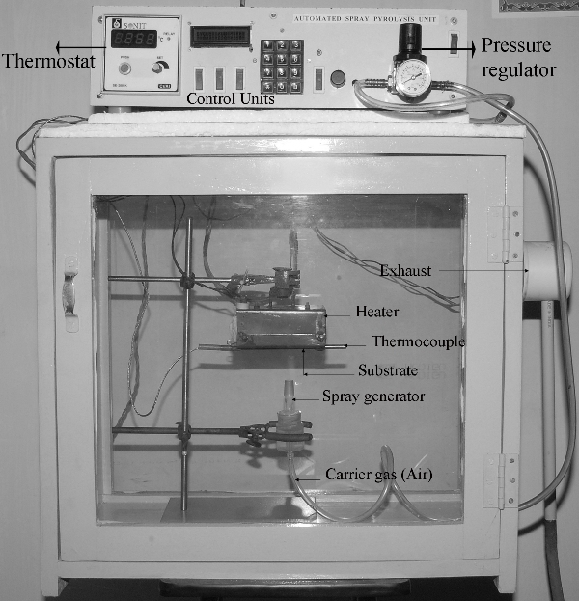

Figure-1(a). Microcontroller based home built automated spray pyrolysis unit
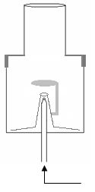
4
3
2
1
Figure-1(b) Spray generator

- Barrier to create mist
- Inverted funnel shape nozzle
- Carrier gas
- Precursor solution

To prepare tin sulfide thin film a precursor solution is prepared by dissolving the salts of Stannous Chloride (SnCl₂.2H₂O) of 0.01M and Thiourea (CS(NH₂)₂) of 0.01 M in deionised water. Few drops (~0.5 ml) of concentrated HCl is added to get clear solution. The aqueous solution was then sprayed as a fine mist containing the reactant molecules on the preheated glass substrate of kept at 20ºC. Compressed dry air at a pressure of 2Kg/ Cm² from an air compressor via an air filter-cum regulator was used as the carrier gas and spray rate of the solution inside the bulb was maintained at 3ml / min. Successive spraying was done, ie solution is sprayed for 30 sec and left off for 15 sec. Similarly films were prepared at 250ºC and 300ºC without changing other parameters.
Film thickness was estimated by weighing method and verified with cross sectional view of SEM image. X-ray diffraction (XRD) studies were carried out using PANalytical X-ray diffractometer (Model X’per PRO). Ni-filtered CuKα radiation (λ = 1.5148Å) was employed with generator setting of 30mA and 40 kV. Continuous scanning was applied with a scanning speed of 10º/min. A range of 2θ from 20º to 80º was scanned from a fixed slit type, so that all possible diffraction peaks could be detected. X-ray line broadening technique is adopted to determine grain size of the film. Surface morphology of the films was investigated by using HITACHI Scanning Electron Microscope (Model S-3000H) with an accelerating potential of 18 kV. Prior to imaging, the films were sputtered with thin gold film to enhance the emission of secondary electron for better imaging.
Optical absorbance and transmission measurements for the film were carried out using computer controlled single beam Elico Spectrophotometer (Model SL159) with uncoated glass as reference. The experimental accuracy for absorbance is ±0.005 Abs and of wavelength is ±0.5 nm.

3. Results and Discussion
3.1. X-ray diffraction Studies
Figure (2) shows the XRD pattern of obtained tin sulfide film at different substrate temperature. It is seen that as temperature increased the peaks intensity found to increases indicating better crystallinity. All reflections can be indexed to pure orthorhombic SnS phase as compared with standard JCPDS card no. 39-354 with no impurities peaks such as elemental tin, sulfur and other tin sulphide phases, indicating the formation of single phase SnS. It is found the optimum temperature to obtaine uniform well adherent SnS film is at 300ºC. Above which lesser deposition occurs due to vapourization of droplet when reaches nearer to substrate. Lower temperature leads to powdery films. The observed XRD lines are broadened in their shape. These may due to instrumental and specimen effects. In the present work instrumental broadening is corrected by using a standard defect free silicon sample. Specimen broadening arises due to small crystalline (grain) size and strain (lattice distortion). Both grain size and strain effects are interconnected in the line broadening of peaks, which makes it difficult to separate. Many approaches exist for the evaluation and separation of size and strain parameters from the occurring line broadening. Williamson-Hall technique [Williamson et al 1953] is adopted in the present work where grain size D and micro strain ε is related as
β_{C} is the instrumental effect corrected full width at half maximum of the peak measured in radian, θ the diffraction angle and λ is the wavelength of X-ray. The slope of the plot between $β_{c}\text{cos}θ/λ$ and $\text{sin}θ/λ$ gives micro strain and the inverse of intercept on y-axis give grain size value. Figure (3) shows the variation of grain size and strain of SnS thin film prepared at different substrate temperature. It shows grain size increases from 31nm to 48nm as substrate temperature increases but strain value decreases from 1.9X10⁻⁴ to 0.8X10⁻⁴.

Figure-2. XRD pattern of SnS thin film prepared at different temperature

3.2. Surface Morphology Studies
Figure 4(a) shows the surface micrograph of film prepared at 300ºC which consists of spherical shape grains. This structure repeats throughout the materials with closely packed to each other indicating good adhesiveness of film with the substrate. The grains size seen is comparable with that calculated value from x-ray diffraction studies. Film prepared at 200ºC shown in figure 4(b) shows discontinuous in nature. This is believed that at low temperature the droplet splashes onto the substrate with lesser decomposition which leads to porous and less adhesive of film which is observed visually.

Figure-3. Williamson-Hall plot to determine grain size and strain of SnS film prepared at different temperature

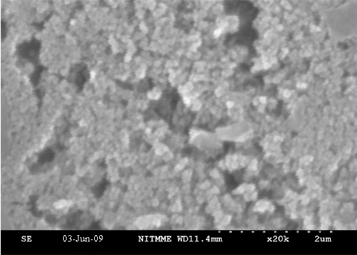
a

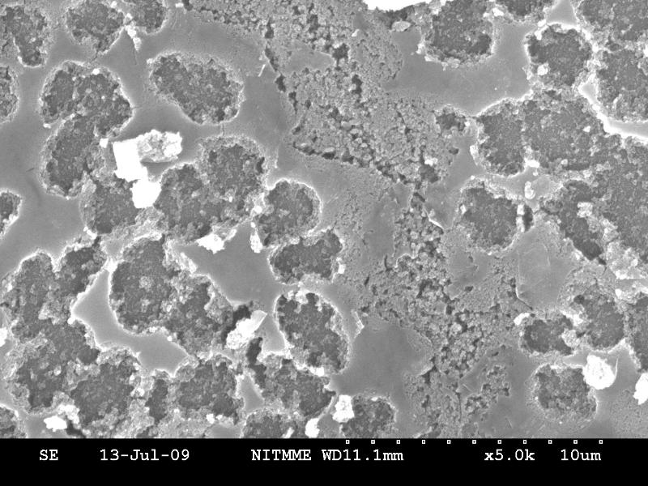

b

Figure-4. Scanning Electron Micrograph of SnS film prepared at a) 300ºC and b) 200ºC

3.3. Optical Studies
Optical absorption measurements were carried out in the wavelength region 380 to 1100nm. Figure (5) shows transmittance of film prepared at 300ºC. It indicates a smooth increase and almost saturate at 600nm to 85% of transmittance. This smooth increase is due to high crystalline nature of the prepared film.

Figure-5. Transmittance spectra of SnS thin film prepared at different temperature

The absorption coefficient α is calculated from Lamberts law (α= (2.303 A) / t) .Where ‘A ‘is optical absorbance and ‘t’ is the film thickness. Optical band gap E_{g} and absorption coefficient is related as
(αhν)^{1/p} = A(hν - E_{g})
Where A is a constant, exponent p is the transition probability. For p = ½ the transition is direct and allowed, p=2 indirect and allowed and p =3/2 for direct forbidden. To determine direct allowed band gap a graph between (αhν)² and hν is plotted and the straight portion of the graph is extrapolated to energy axis to give Eg. From figure (6) the bandgap decreases from 1.40 to 1.30eV with increase in substrate temperature. This is due to lesser grain size and quantum confinement [Brus 1984] at lower temperature.

Figure-6. Bandgap variation of SnS film at different temperature

4. Conclusion
In summary, microcontroller based home built spray pyrolysis method was used to prepare tin sulfide thin film on glass substrate from the precursor solution containing salts of stannuous chloride and thiourea. X-ray diffraction pattern indicates the formation of single phase SnS crystalline material. SEM study shows that the film has spherical shape grains and closely packed together. Optical studies reveal that the film has direct allowed transition with band gap of 1.35eV. It is concluded that to obtain uniform well adherent of spherical grain crystalline SnS film the substrate temperature is fixed to 300ºC.

Correspondence to:
Dr. B.G. Jeyaprakash
Department of Physics
Ponnaiyah Ramajayam College of Engineering and
Technology, Thanjavur–613 403, Tamilnadu, INDIA
Telephone: +91-431-2770145
Cellular phone: 0098654-21411
Email: bgjpabr@yahoo.co.in

References

Biswajit Ghosh, Madhumita Das, Pushan Banerjee, Subrata Das. Fabrication of SnS thin films by the successive ionic layer adsorption and reaction (SILAR) method. Semicond. Sci. Technol. 2008; 23: 125013-125018.
Brus L E. Electron-electron and electron-hole interactions in small semiconductor crystallites: The size dependence of the lowest excited electronic state., J. Chem. Phys. 1984; 80: 4403-4412.
Chamberlin R R, Skarman J S. Chemical spray deposition process for inorganic films. J. Electrochemi Soc. 1966; 113: 86-89.
Chen C H, Kelder E M, Vander put P J J M, Schoonman J. Morphology control of thin LiCoO2 films fabricated using the electrostatic spray deposition(ESD) technique. J. Mat. Chem. 1996; 6(5): 765-771.
Chopra K L, Kainthla R C, Pandya D K, Thakoor A P. In: Physics of Thin films. Academic Press, New york and London, 1982; (12): 167.
Cifuentes C, Botero M, Romero E, Calderon C, Gordillo G. Optical and structural studies on SnS films grown by co-evaporation. Brazilian J. Physics. 2006; 36; 3B.
Engelken R D, McCloud H E, Lee C, Slayton M, Ghoreishi H. Low temperature chemical precipitation and vapor deposition of Sn_{x}S thin films. J. Electrochem. Soc. 1987; 134: 2696-2707.
Jiang T and Ozin G A. New directions in tin sulfide materials chemistry. J. Mater. Chem. 1998; 8:1099-1108.
Khelia C, Marz F, Mnari M, Ben nasrallah T, Amlouk M, Belgacem S. Structural, optical and thermal properties of β-SnS₂ thin films prepared by spray pyrolysis. Eur. Phys. J. AP. 2000; 9: 187-193.
Lindgren T, Larsson M, Lindquist S. Photoelectrochemical characterization of indium nitride and tin nitride in aqueous solution. Sol. Energy Mater. Sol Cells 2002; 73: 377-389.
Patil P S. Versatility of chemical spray pyrolysis technique. Mater. Chem. Phys. 1999; 59 (3): 185-198.
Siefert W. Corona spray pyrolysis: A new coating technique with an extremely enhanced deposition efficiency. Thin Solid Films. 1984; 121: 267-274.
Thangaraju B, Kaliannan P. Spray pyrolytic deposition and characterization of SnS and SnS₂ thin films. J. Phys. D. Appl. Phys. 2000; 33: 1054-1059.
Valiukonis G, Guseinova D A, Krivaite G, Silieika A. Optical spectra and energy band structure of layer-type A^{IV}B^{VI} compounds. Phys. Stat. Solidi B. 1986; 135: 299-307.
Williamson G K, Hall W H. X-ray line broadening from field aluminum and wolfram. Acta Metall. 1953; 1: 22-31
Zainal Z, Nagalingam S, Hua T M. Properties of tin sulphide thin films electrodeposited in the presence of triethanolamine. J. Mat. Sci: Mat. in Electronics 2005; 16: 281-285.

10/29/2009

