Land Management and its problems in Notse, small town in southern togo

Komlan Dela Gake
Master Student in Applied Geographic Information System
China University of Geosciences, 388 LuMo road, Wuhan, China. Zip code 430074
glanok79@hotmail.com

ABSTRACT: Nowadays the analysis of any urban city uses modern techniques such as remote sensing and geographic information system. But in the cities of developing countries this is not often the case, due to lack of means and, on the other hand, lack of political will. The case of Notse, a small town in southern Togo is no exception. Therefore the analysis of the city in this paper will be based on the results of research carried out on the field. However the goal is to reach the constitution of databases that can be used as starting point for the use of the new technologies. Our investigation allowed us to update the problems undermining the development of the town, namely: the lack of reliable data on urban planning, the lack of services and basic facilities to name a few. Further on the assessment will allow us to draw the necessary conclusions and a useful approach to improve the development of the city with new technologies. Consequently, a spatial development plan is proposed to serve as a starting point to a more technological and professional approach of what a 21st century city planning should be. This plan is essentially based on the results of spatial and demographic data analysis. [Journal of American Science 2010;6(3):125-135]. (ISSN: 1545-1003).

Keywords: Field work, Geographic Information System, Database constitution, Spatial Development Plan.

- introduction
The development and planning of cities in West Africa’s former colonies were thought as the western model; timidly taking into account the customs of the countries. Notse, a small town in southern Togo, did not escape this trend. But nearly half-century after independence, the outcome was not as well expected. With the advent of the decentralization, hope for local development was born. Unfortunately, this process was also a failure, because although the central government gave locals authorities decision-making power and almost total autonomy; it failed to support that action by not providing the technical tools that would allow these communities to manage and plan the development of their own cities. Among these tools, GIS (Geographic Information System) appears to be the most important and efficient. Consequently the question arises: “Where does Notse stand in the application of this new planning tool?”
Based on previous research, the answer is alarming as well; the city has none of the modern equipment and tools for planning its development. The city of Notse is the capital town of the Haho district; it is therefore a central point and by extension the nucleus of local and regional development. This has as immediate effect a relative density of the local population. As part of its history, the city gathers each year, in early September, the whole Ewe community in the sub-region and the Diaspora within the framework of celebration of Agbogbozan.
These two factors have resulted in a rapid and unplanned development of the city; which resulted in an uncontrolled urbanization. The city is a sad display of the nonexistent organization and planning, noticeable to the spectator just by walking through it. This situation is even more evident if we take a look at the poor condition of the infrastructures (such as roads and some networks), and the presence of several empty plots. The few existing equipment are unevenly distributed.
Adding to this, the primary activity of the city, agriculture, destroyed the surrounding environment due to: (i) the intensification of agricultural practices, (ii) the cutting of trees for exportation as well as charcoal factories. These practices are depriving the city of its natural curtain of vegetation, which will lead to a long-term problem of erosion, and a consequent possible desertification.

Objective: The aim of this paper is to point out ways for the local sustainable development of the city by highlighting the negative effect of not using the GIS tool for managing and planning.

- MATERIALS AND METHODS

Overview of the study area: With an area of approximately of 2,000 ha and estimated population of 32 950 people, Notse is a land lying in the southern part Togo, between Lat: 6°55'56.37"N and 6°58'24.06"N / Long: 1° 9'2.40"E and 1°11'31.19"E. It is the main city in the prefecture of Haho. It is located 100km north of the city of Lome (capital town of Togo) on the 1st National Road. It occupies a position of city crossroads between the latter and the 5th National Road. (Refer to Map 01)
The city has four seasons including two wet and two dry: Long wet season: from half-march to half-july; Short wet season: from half-september to half-november; Long dry season: from half-november to half-march; Short dry season: from half-july to half-september. The average annual temperature is 27˚C and the average annual rainfall is 1200mm.

Methodologies: The objective will be reached by means of integrating field surveys and geo-technologies such as GIS.
The basic data required for this study is the land cover map. A geographic base map can be generated by using the results of the field survey. Appropriate corrections are required to ensure geographical accuracy such as geo-referencing with satellite images as Google Earth images. Accuracy can be ensured depending on the resolution of the satellite images. Certainly the use of such maps is limited as compared to the ones based on topographical surveys. If possible topographical survey should be made to ensure considerable accuracy.
Information on past land uses when compared to the existing land cover is useful for detecting changes. The survey of the changing landscape would be carried with the help of the field.
Social and economic survey will render information about population, economic activities, equipment and living conditions.

- UNDERSTANDING OF LOCAL LAND TENURE MANAGEMENT
The legislation in Notse as in the whole of Togo stipulates that the land belongs to local authorities. It actually means that the authorities are free to enforce status changes if it suits their interests. These authorities put on the market plots that come under the responsibility of the central government in what concerns project development. Generally, plots destined to construction projects or containing actual buildings generally follow a grid pattern of 20m x 30m (600m²) in most new blocks. Older parts of towns though present irregular frames with areas ranging from 200m² to over 600m².
Referring to year 2003 a 600m² plot in the city centre cost about one million (1,000,000) XOF; in the outskirts it cost about two hundred thousand (200,000) XOF. This huge difference in price is mainly due to the location of plots. In fact the plots located in the old centre, naturally became the first blocks of the city centre. For this reason they benefit from more equipment, both infrastructures and superstructures.
This phenomenon has a negative side since is the ground for price speculation and translates into proliferation of interstitial spaces most often used as dump sites or, in a smaller scale, as areas of urban agriculture.
Due to the scarcity of plots in centre town a large proportion of the population prefer to live in the suburbs while hoping that services (basic amenities such as electricity and water) will be implemented in a short delay, hence causing the proliferation of interstitial spaces.
All these factors combined with the fact that land belongs to local authorities and not the state, help create and maintain the phenomenon of increasing urbanization, which is demonstrated by the disproportionate spatial expansion of the city, disrespecting areas and demographic needs.

Property acquisition methods: At Notse, documents related to real estate are scarce. Consequently statistical data is also scarce. Nevertheless there are three methods to own land: (i)Donation: which can be done within the donor’s lineage or different lineage. In the second case, non-relatives are integrated into the clan exercising their right of usufruct for having explored a plot of land for a number of years. (ii)Inheritance: in this case land passes from father to son and is collectively owned by the descendants of the first landholder. In urban areas this practice often results in the splitting of the assets; several single owners are generated and almost always opt to build houses. (iii)Sale: three steps should be followed when land is acquired through purchase. First, plotted council estate is made available to prospective buyers (plotting of the land is not always strictly legal); Second, after selection of the buyer, a sales contract is produced involving the buyer, the surveyor, the head of the council selling the land, a traditional authority (county chief or district chief), Third, the surveyor is responsible (in a case of a regular plotting) to gather the necessary paperwork issued by the town hall in order to prepare the sales contract, the legal certificate and the title deed.
Role of local authorities in land management: Nowadays and in the absence of up-to-date planning documents and their enforcement, plots are clandestinely assigned by surveyors who do not necessarily obey administrative regulations. In 1989 the technical department of the Notse’s city council made an inventory of all illegal plots and submitted it to the DGHU (National Agency for Habitat and Urbanism) for assessment and approval. At present, town authorities take steps to develop a master development plan and town planning scheme, which will forcibly regulate all construction plans.
Nevertheless the city hall has limited financial resources originating from fees charged for issuing cession documents. This fee corresponds to 5,000 XOF; also each surveyor pays a fee of 7,000 XOF. The goal is to charge sellers as well and 10% of the estate sale price as payment of the administrative certificate.
It should be stressed that in urban areas, land (obtained either by inheritance or sale) that is planned for housing projects is subject to a 50% repossession of the area by the state that can allocate a portion for infrastructures, another portion for superstructures or just file the land as administrative reservation.
If needed, local authorities can allocate plots to carry out specific projects.

- SPATIAL ORGANIZATION AND ITS EVOLUTION
Although commonly city boundaries are defined by decree, in the present case they have been agreed consensually between Haho’s and Notse’s authorities. The city area is roughly over 2000ha of which 60% correspond to the urban habitat and the remaining 40% to intra-urban agricultural areas. The whole of the area consists of 4 major areas broken down into 28 neighbourhoods. Population density among the neighbourhoods (as show in the Table 01 and Map 02) can vary from 2 people/ha in new areas, to 760 people/ha in old areas.
The spatial evolution of Notse can be summarized in three major steps: Step 1: Before the independence of Togo, Notse was a group of scattered villages. Today they constitute the original core, including the following districts: ADIM, DAKPODJI, AGBALADOME, TAKO 1, TCOUMIKPOTA, KRATCHI, WOBEDOME, EKLI, HOUTO, HOUNSA, KPOTA, and TOGBEGNIGBA. All these districts are contained by the Wall of Agokoli. Step 2: Between 1970 and 1990, this period corresponds to the widening of the original core through creation of illegal plots. As a result the districts of TEGBE, TEGBE ZONGO, TEGBE LOM-NAVA, ALINOU, NAOLO and SOEKPE were born. Step 3: 1990 until today, the last expansion dating from the early '90s reflect the influence of the newly launched technical department of Notse’s city hall. As a result land fragmentation had rules to be followed and along with it a proper road network. New neighbourhoods were created: AGBOGBOGODO, AHADJOPEME, BLAKPA-PANI, AKPOVOU, FIAGBEDOU, TAKO 2, and TEGBE-ANAGOKONDJI.
In general terms, the spatial evolution of Notse follows two main axes: the 1st National Road and also the Kpalimé-Tohoun road. The eastern and southern boundaries roughly match the old Wall of Agbogbo. The choice of these two axes is explained by their quality as service roads (mainly the 1st National Road, an important commercial route that enjoys amenities such as electricity and water).
As show in Table 02 and Graphic 01, the urban area went from 306.74 ha in its first stage to 809.40 ha in the second stage and to 2010.05 ha in the third stage. The evolution rates are respectively 37.89% and 40.26%. The increase of the urban area to 809.40 ha corresponds to the post-independence period; this period is known for its important demographic growth as a result of the economic and health policies adopted by the government. The second increase of the urban area was also followed by a population growth. In this case migrants in search of land for agriculture and jobs (possibly at the SOTOCO plant). Also the strong spatial growth of the town was due to increasing assignment of unauthorized plots in the town’s outskirts expanding its boundaries although with low population density. The increasing construction rate is not always in tune with a harmonious development of the city once are not in synchrony with services and basic infrastructure causing sanitary, social and ecological problems.

Table 02: Evolution of Urbanization
N° | Steps | Urban area in ha | Rate in %
1 | Before the independence | 306,74 | 37,89
2 | From 1970 to 1990 | 809,40 | 37,89
2 | From 1970 to 1990 | 809,40 | 40,26
3 | From 1990 until today | 2010,05 | 40,26
Soucre: ourselves

Graph 01: Pace of urbanisation
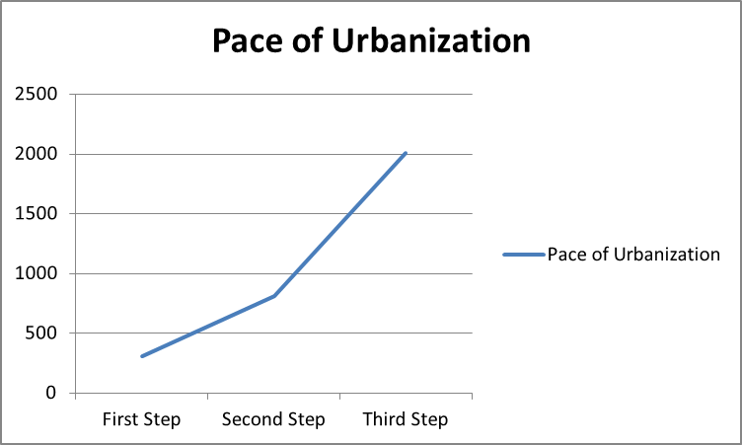

- DEMOGRAPHIC DATA
At this point in time there are no updated data concerning the population of Notse. In fact the last census dates from 1981. Available data derive from the censuses of 1959, 1970 and 1981. Moreover there are estimates provided by the local authorities based on the census referred above and the census conducted by the General Bureau of Statistics in January 1997.
The census of 1959, 1970 and 1981 indicate respectively a population of 3 800, 7 605 and 8 916 inhabitants hence a corresponding growth rate of 6.5% and 1.5%.
In 1991, the evaluation of Yves MARGUERAT proposes a figure of 10,000 inhabitants and a growth rate of 1.2%.
In 1997, the count of the General Bureau of Statistics unveils a population of 27 000 inhabitants and a growth rate of 18%.
In 2003, the population was estimated at 30 000 inhabitants and a growth rate of 1.77%.
From 1959 to 2003 the population of Notse grew from 3 800 to 30 000 inhabitants, a ratio of about 8. This development had two distinct growth rates between 1970 and 1981 and between 1991 and 1997. The first one is due to the demographic and health policies adopted by the Togolese authorities following the independence of the country. The second one is due to the proliferation of administration units followed by the creation of new jobs especially in the tertiary sector. Furthermore it is the result of natural growth as well as the contribution of immigrants to work in cotton fields. Between both ends of the time frame the population grew at an average rate of 4.8%. The latter is within the growth rates of urban centres (4% to 5.3%) as advanced by the Journal of Urban Sectors in Togo of February 1998.
Having in mind the last rate and based on the population of 2003, the 2005’s population estimate is 32 950 inhabitants by using the geometric growth formula: Pop₂₀₀₅=Pop₂₀₀₃ (1+t) ^{x}
Where:
Pop₂₀₀₅ represents the population of 2005
Pop₂₀₀₃ the population of 2003
t represents the average annual absolute change
x represents the number of years between the two times
Table 03: Estimated population
Year | Population | Growth Rate
1959 | 3 800 | 6,50%
1970 | 7 605 | 6,50%
1970 | 7 605 | 1,50%
1981 | 8 916 | 1,50%
1981 | 8 916 | 1,20%
1991 | 10 000 | 1,20%
1991 | 10 000 | 18,00%
1997 | 27 000 | 18,00%
1997 | 27 000 | 1,77%
2003 | 30 000 | 1,77%
2003 | 30 000 | 4,80%
2005 | 32 950 | 4,80%
Source: General Bureau of Statistics

By using the same formula and the average annual absolute change of 4,8%, the population of 2010 should be 41 653 inhabitants.

Graph 02: Population growth
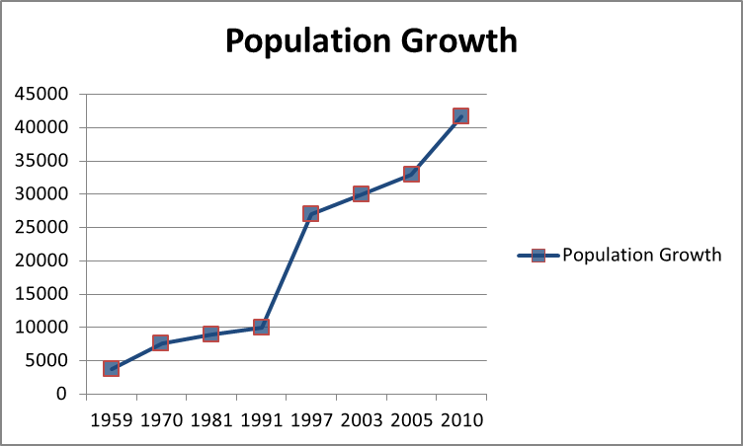

- ENVIRONMENTAL PROBLEMS

Environmental problems related to excess farming: The surrounding areas of Notse show noticeable signs of flora degradation. This degradation, apparent to the naked eye, is due to: firstly, intensive cotton cultivation and secondly, specific human practices such as: an uncontrolled logging of trees for coal and/or heating and an excess of bushfires in drought periods. Eventually, these practices will lead to:
- the destruction of the physical environment changing the nature of the soil and sediments, the microclimate, and soil erosion;
- the disappearance of some animal species;
- the disappearance of some plant species;
- a change in the ecosystem.

Environmental problems related to lifestyle: Although the neighbourhood committee made efforts regarding garbage collection, it is highly regrettable that much remains to be done in the management of domestic waste. A quick stroll around Notse spotlights the disruption in garbage collection and processing. Noticeable details are: the presence of many wild dump sites; the absence of intermediate garbage collectors; and the pollution caused by filth accumulation around the built area.
Notse’s pluvial water collectors system is highly insufficient in face of present needs and there is no drainage system covering domestic waste water. The few roadside gutters in place are used to dump solid waste, causing their obstruction. Very few concessions have adequate toilet facilities, the majority of the population use surrounding nature contributing to spread various epidemic diseases. Also, due to the lack of a sewage system, more than 80% of the waste generated end up in the surrounding nature. The lack of sanitary equipment and ductwork lead to severe hygiene problems.

- BALANCE - DIAGNOSTIC
The analysis of Notse unveils the constraints that undermine the town’s development but also the trumps.

7.1- THE CONSTRAINTS

Physical and natural environment: Notse’s topography is loosely similar to a basin, forming a large number of flood areas mainly during the rainy season. The weak drainage associated with the slight slopes of the terrain creates spots of water retention.
These two factors combined promote the proliferation of pathogens and act as a source of diseases. Also, the rocky structure of the soil prevents easy access to groundwater.

Urban sanitation and environment: The problem of unhealthy urban conditions in Notse has various causes:
- The lack of a proper garbage collection system generating the proliferation of wild dump sites in interstitial spaces, which are often sources of infectious diseases.
- This phenomenon is exacerbated by the lack of adequate rain and waste water drainage systems; the only rain water sewage system in place is used as a dump site and where silt accumulates.
The intensification of farming (especially cotton cultivation) and logging for charcoal around Notse deprives the city of its natural vegetation protection and has an effect on its microclimate.

The land: Most regrettably Notse lacks urban planning documents. The town has to deal with anarchic production practices and space occupancy. The situation is even more serious since many surveyors involved in urban development have insufficient qualifications translating into lack of proper technical knowledge vital for a sound exercise of their functions. The single fact of allocating flood land for building purposes, exposing the population to floods is living proof of that.
Also, administrative reserves that are kept inactive for a number of years end up being fragmented into lots and sold to privates to build houses.
Finally, litigation regarding land becoming more and more frequent is the face of the lack of regulation of land ownership (land title) and land management schemes.

Urbanized areas: The organization of the built area of Notse is in total decrepitude, particularly houses in the old town nuclei. This part of town has an irregular layout and winding, tortuous pathways. This fact does not facilitate service implementation in the area. Construction is rather anarchic. Due to the lack of control from the town hall, inhabitants build according to their means and don’t comply with the legislation ruling land. The proof is the existence of many interstitial spaces, mainly in new neighbourhoods. Indeed, in more recent areas one can see an effort has been made regarding plots layout although it is a more social than administrative effort. Since people look for inexpensive plots they are forced to move away from centre town and carry out their own house plans without knowledge or approval of the authorities.

Infrastructure equipment: Apart from the 1st National Road (often source of noise due to its intense traffic), all other roads are not paved explaining their poor conditions. The increasing traffic along the 1st National Road, besides the noise pollution it causes, will ultimately lead to its degradation unless appropriate measures are taken.
The existing open gutters are used as garbage dumps especially around the central market. The streams that cross town are not subject to proper unblocking. These channels are chosen to dump garbage and an ideal site of proliferation of wild vegetation. This does not facilitate irrigation, causes floods in the rain season, promote stagnation areas that are sources of parasites and breeding grounds for larvae and insects.
Public lighting is not provided, the connection to the electricity, water and telephone networks are feebly provided.

7.2- THE ASSETS
Notse’s population presently is closed to 40 000 inhabitants. The high rate of young population is a reserve and guarantee of the continuity and development of the city and its surrounding areas, if suitable structures are made available to the population in what concerns education, training and health. The melting pot of such heterogynous population is a rich and dynamic development factor.
Notse is the capital of the prefecture of Haho. This status grants the right to have decentralized state services, perform prefectural services and other institutions that could foster investment. The city is a traffic and commerce crossroad linking several directions – inland, Lome and Togo's neighbouring countries (Benin, Burkina-Faso and Ghana). This strategic location is of major importance in what concerns commercial and economic activities. Its market and inherent different fluxes justify its prefectural and regional stature. Such traffic flows may constitute a factor for business development.
The available fertile land suitable for agriculture (both for food and industrial processing), strong pillar of the local economy is decisive for its development. Also the presence of three streams and an artificial lake is a support for fishing activities and a source of irrigation and water supply. The soil is rich in clay adequate to make pottery, second flagship of the town.

- CONCLUSION AND PROPOSITIONS
The analysis of the studied elements will result in a diagnostic assessment which sums up the assets and constraints to development. This helps establish actions for a sustainable development which we can summarize as follows: (i) Strengthening of management and planning capacity of the town, (ii) Creation and strengthening of infrastructure facilities. To do this, the municipality must adopt new space management tools to set up a database. This database will integrate addressing operations and be updated regularly through: studies using the satellite data, the use of remote sensing technology for a clearer and more precise idea of the town evolution in real time, the processing of digital data by GIS software for a better approach and data analysis.
And to timidly start the constitution of digital data, we propose the establishment of a scheme of spatial planning based on data collected in situ (Map 04). Far from being complete it could serve as a basis for the establishment of a real planning plan. This scheme has the advantage of identifying the non-constructible areas from the constructible ones, areas to restructure, areas of expansion, the commercial pole and other.
Areas to restructure: The original site of the city including the old town area is to restructure because of their irregular pattern which makes neither traffic nor access to it easier.

Area to densify: These areas are fields of agriculture which contain a few isolated buildings. This densification should take into account the areas of urban agriculture.

Areas to regulate: This concerns essentially the new neighborhoods where housing estates are being made so far underground.

Easement areas: Especially the parts along the rivers.

Farming areas: These are spaces that can be used to crop agriculture such as cotton.

Commercial pole: It covers the market and its surrounding area. This area is the busiest of the city, and on medium and long term, we expect increased business with the construction of shops and stores.

ACKNOWLEDGMENTS: By far claiming an exhaustive study, we expect with this paper to contribute to the awakening of a collective consciousness in the town of Notse, with the intention of uniting the intervening forces for a better and integrated development. We also wish to sincerely thank the local population for its warm welcome, the City Council and the Prefecture for their help and finally a special thank you to the chief surveyor of the town of Notse.

CORRESPONDING AUTHOR:
Komlan Dela Gake
Master Student in Applied Geographic Information System
China University of Geosciences, 388 LuMo road, Wuhan, China. Zip code 430074.
Email: glanok79@hotmail.com

REFERENCES
- Abdullah Mah (PhD in Remote Sensing), 2000, Urban planning and Monitoring changes using Er Mapper, Training & Applications Consultant. Earth Resource Mapping, Asia Pacific region. GIS Development.net
- AMETSIAGBE Adzewoda (Master thesis), June 1989, Development study of an average city: Notse/Etude de développement d’une moyenne ville: Notse.
- Antwi Effah Kwabena, (PhD research proposal), 2003 Integrating GIS and Remote Sensing for Assessing the Impact of Disturbance on Biodiversity and Land Cover Change in a Post-Mining Landscape. Environmental and Resource Management. BTU Cottbus-Germany.
- GAYIBOR N., Histoire des Togolais. Volume 1, University of Lome – Togo. 1997
- Review of Urban Sector in Togo. Feb 1998
- Kefa M. Otiso & George Owusu, 2008, Comparative urbanization in Ghana and Kenya in time and space, Geojournal, Vol. 71, P. 143-157
- Rolf A. de By, editor. Principles of Geographic Information Systems. The International Institute for Survey and Earth Sciences (ITC), Enschede, Netherlands, 2000

11/25/2009

Map Section

Map 01: Presentation of Notse
Source: Ourselves

Map 02: Density per neighborhood

Map 03: Spatial evolution

Map 04: Zoning Plan
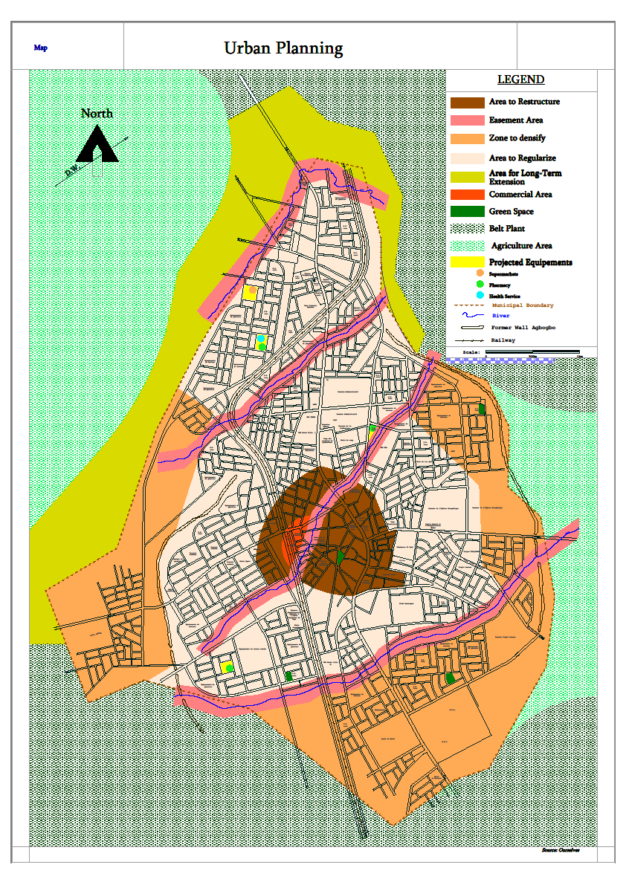

Table section

Table 01: Estimated Population in 2005 per neighborhood
Major Area | Neighbourhoods | Population Size | Areas in hectares | Density in people/ha
1 | Akpovou | 627 | 29,47 | 21,27
1 | Blakpa-Pani | 627 | 30,48 | 20,57
1 | Dzogbé | 405 | 40,45 | 10,01
1 | Fiagbédou | 101 | 54,95 | 1,84
2 | Tégbé | 2430 | 155,21 | 15,65
2 | Tégbé-Zongo | 3634 | 31,50 | 115,36
2 | Tégbé Lom –Nava | 2615 | 187,88 | 13,92
2 | Tégbé Anagokondji | 1822 | 16,68 | 109,23
3 | Tako 1 | 1240 | 1,63 | 760,74
3 | Tako 2 | 1453 | 142,36 | 10,20
3 | Naolo | 1755 | 148,65 | 11,80
3 | Ekli | 1698 | 12,94 | 131,22
3 | Adimé | 338 | 47,61 | 7,10
3 | Tchoumi Kpota | 864 | 136,66 | 6,32
3 | Dakpodji | 542 | 10,58 | 51,23
4 | Wobédomé | 739 | 3,91 | 189,00
4 | Kratchi | 853 | 17,97 | 47,47
4 | Ahadjopémé | 447 | 92,70 | 4,82
4 | Agbogbogodo | 175 | 193,50 | 0,95
4 | Soékpé | 895 | 72,25 | 12,39
4 | Alinou | 3672 | 359,93 | 10,20
4 | Houto | 588 | 7,93 | 74,15
4 | Kpota | 1561 | 19,47 | 80,17
4 | Agbaladomé | 1472 | 29,48 | 49,93
4 | Honsa | 159 | 2,38 | 66,80
4 | Yénou | 525 | 15,95 | 32,91
4 | Laklékpé | 587 | 94,92 | 6,18
4 | Tokpégnigba | 465 | 52,61 | 8,84
Total |  | 32289 | 2010,05
Source: General Bureau of Statistics

