Comparison of the Type of the Web Base Advertising on E-Commerce Improvement

¹Maryam Mazandarani,
¹m93.maryam@yahoo.com

Abstract: There are several investigation that have been shown increase the Ecommerce improvements by web base advertising. Recently and specifically after developing on the personal, news, e-shops and web2 websites have been increase interesting to do E-commerce and improve it by the web based advertising. This investigation have been focused on comparison of the two type of the web base advertise on the visitors direction to the targets websites. Result of this investigation have been shown that the picture banner base advertise inside the news content is more effective to direction of the visitors to the targets website. Researcher in this research has been suggested to make the text base advertising in side the content to improve the E-commerce. [Journal of American Science 2010;6(3):150-156]. (ISSN: 1545-1003).

Keywords: Bossiness, E-commerce, Website, Web2, PHP Programming

Introduction
Recently have been shown increase to people interesting to E-commerce according to the web base works. Web base commerce or at the other hand electronic commerce has been known as new sort of the business by the some company and personal works (Gefen 2000). There are several investigation regard to improve the e-commerce website in some aspect as well as the security, server power and also web applications (Elnikety, Nahum et al. 2004) but there are a few researches regard to design plane and type of the advertise to make more visitor inside these type of the websites.

Recommender systems are being used by an ever-increasing number of E-commerce sites to help consumers find products to purchase. In this article they presented an explanation of how recommender systems are related to some traditional database analysis techniques.
The model predicts online buying by linking the purchase decision to what visitors do and to what they are exposed to while at the site.(Sismeiro and Bucklin 2004)
The failure of many B2C companies has triggered widespread concern about the future prospects of such firms (Saeed, Hwang et al. 2002). Surviving and newly formed companies are reevaluating their strategies and struggling to build a sustainable business model. The results demonstrate that advertising spending alone has only a negligible impact on firm performance. A more appropriate profit-enhancing strategy for B2C companies is to complement advertising spending with a superior shopping experience that augments the value customers gain from the purchase experience.
This paper presents an application of the analytic hierarchy process (AHP) used to select the best web site for online advertising (Ngai 2003). This method adopts a multi-criteria approach that can be used for analysis and comparison of web sites for online advertising. The method is based on pairwise comparison between several factors that affect the selection of the best web site
Electronic Commerce is the paperless exchange of business information using Electronic Data Interchange and related technologies. If you are familiar with Electronic Mail, computer bulletin boards, facsimile machines, Electronic Funds Transfer You can very well understand what is E-commerce. These are all forms of EC. All EC systems replace all or key parts of paper-based work flow with faster, cheaper, more efficient, and more reliable communications between machines. In today's Defense Department procurement arena, however the most important EC technology to know about is Electronic Data Interchange, or ED
An e-Commerce site is a content managed website application which allows members of the public to purchase specific products via transactions secured on the vendor's website. Typically this would involve an administration system which allows the client to manage their inventory, view orders and review transactions within the website database. Orders are typically processed via secure online Payment Service Providers such as World Pay, Pay Pal and Secure Trading or integrated service providers such as Streamline or Realex. Occasionally clients may have in-house card swiping facilities and orders can be relayed directly to their systems.
In conventional commerce, customer groups with similar interests can be observed. Similarly, customers in E-commerce naturally form groups(Wang, Makaroff et al. 2004). That's groups allow the organization to provide quality of service and perform capacity planning. From a system point of view, overall server performance can be improved and resources managed considering customer session behavior. Last studies have grouped customers using clustering technique. Other data metrics have been selected as criteria for grouping, in order to analyze different problems. The limitation for these approaches is that problem is analyzed separate. In solicitation to manage an E-commerce server well, they must analyze many dependent problems Comprehensive rather than separate. For Parable, they would like to know what's the impact on resource usage when optimizing revenue. So, they must understand the diversities and similarities between session groups chosen by different metrics. In that's paper characterizes customer groups for an E-rental business and compares customer groups created according to different criteria including services appealed, navigation pattern and resource usage. A significant finding of that's study shows that using each of the three criteria in relative yields roughly similar results, since customers looking for similar services tend to have similar navigation pattern similar server resource usage. So, it is proper to group customers in only one of these ways. Grouping customers by services solicited is suggested since this method transfers dependent better results and is simple to implement.
The faster mutation of interactive Internet services has led to both a permanent very number of modern web sites and to an increase in their functionality, which in turn makes them more complicated to them(Abbattista, Degemmis et al. 2002). The COGITO project aims at improve innovative software components allowing e-commerce compares to effectively set up and maintain web sites which address customers in personalized and pro-active ways.
Inspects the applicability of determinants identified in a physical services environment to assess the services reporting to e-commerce(Cox and Dale 2001). That is argued the lack of human interaction during the Web site experience means that determinants such as competence, courtesy, and friendliness, helpfulness, commitment, flexibility are not specific relevant in e-commerce. On the other hand, determinants such as accessibility, communication, credibility, understanding, appearance, and availability are equally applicable to e-commerce as they are in physical services. That's paper argues the needed for further researched to identify suitable determinants for the e-commerce operating environment.
Actually E-commerce is thinking an excellent alternative for companies to aim new customers(Albuquerque and Belchior 2002). Sometimes, many E-commerce Web sites have a short time. The prosperity of these virtual stores pertains on many issues, especially their quality; it is such a complex solution. This paper specifies a relevant set of E-commerce Web site quality attributes based on the literature. Research was undertaken to validate and establish the relative importance of these attributes. The results were obtained from a software quality evaluation model.
Typical web analytic packages provide basic key performance indicators and standard reports to help assess traffic patterns on the website(Kohavi and Parekh 2003), evaluate site performance and identify potential problems such as bad links resulting in page not found errors.
Based on they experience in mining data for multiple retail E-commerce sites, they offer several recommendations for supplementary analyses that they have found to be very useful in practice.
that's include analysis from errors, micro-conversions, real estate usage, search, product affinities and based on the construction of a customer signature, which in turn benefits from additional overlays, such as third-party demographic attributes. They describe the construction of such a signature and challenges faced by businesses attempting to construct it.

This research is going to examine effect of difference type of the advertise on the e-commerce improvements and increase the visitors. Have been applied two type of the advertise according to the text and picture banner base publishing to improve the e-commerce in this study. The model of this investigation has been shown at the figure 1.

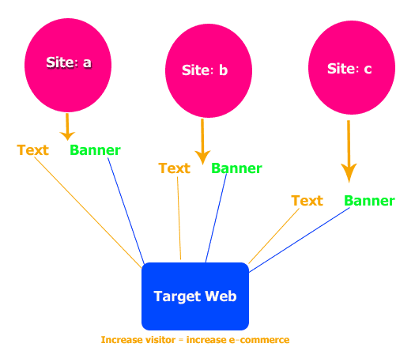
Figure 1: Moder of the target and publisher websites in this research

Methodology
This research is a web base survey. Researcher to make this research has been used one target website and three advertise publisher websites. The entire website in this survey was in Persian language. And all the website was rtl CSS. Alexa ranks (Zeng and Parmanto 2003) in all these website was less than 1000,000 at ranking. The target website domain name in this survey was www.womanday.ir. The advertise website in this research was as the following:

- www.iranianmalezi.com (Site: a)
- www.fitness2100.com (Site: b)
- www .aryamehan.com (Site: c)

Have been made tow type of the advertise in tree publisher website. The Text inside the content and banner ( 200 x 200 px) at right column of all WebPages was applied in three websites. Click target according to the banner script component have been shown number of the clicks on the text advertise. This survey was continued for 1 month (September 2009) .The target website was designed by open source script content management system (Joomla 1.5.1.4) . all the publisher website was updated by the news content daily ( 3 news daily). Banner design and text content as well as the color, size and location of the module was at the same conditions. The uptime of the websites was at 99.99 percent in month and linux dedicated server has been used to run all these websites. Php script banner component have been used for banner advertising and website analytics component was used for determination of the refer type and domain referral.
,
Alexa Rank during this research in all these website are the figure no: 1, 2, 3

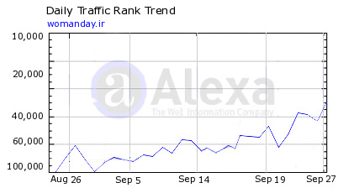
Figure 2: alexa rank for www.womanday.ir

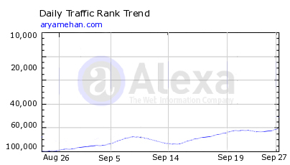

Figure 3: alexa rank for www.aryamehan.com

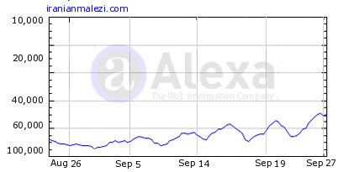
Figure 4; alexa rank for www.iranianmalezi.com

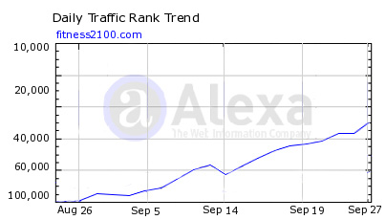
Figure 5: alexa rank for www.fitness2100.com

Statistical Methods:
To compare of the result in tow type of the advertising effect have been used descriptive data and also t-independent test. SPSS version 17 and Excel (OS Windows XP, Office 2003) software was used to analysis of data.

Result

The analysis of data in this investigation has been applied by SPSS software and T-independent test for compare of the mean. P value was applied at .05. have been shown that there are significant difference between the mean and standard error between the text and banner advertise. All the site was used for 30 days and have been shown mean of the visitor by banner type was 53.23, 58.23 and 68.86 respectively in three website. Also mean of the visitor for per day in three website according to text banner was 21.83, 26.83 and 24.36 respectively. Have been shown significant difference between banner and text advertise in all three websites.

Figure 6: Compare the mean and standard deviation at three publisher website

Table 1: Descriptive Data in three publisher website

 | Banner Type | N | Mean | Std. Deviation | Std. Error Mean
Site: a | Picture | 30 | 53.23 | 8.140 | 1.486
Site: a | Text | 30 | 21.83 | 6.232 | 1.138
Site: b | Picture | 30 | 58.2333 | 8.13966 | 1.48609
Site: b | Text | 30 | 26.8333 | 6.23164 | 1.13774
Site: c | Picture | 30 | 68.8667 | 72.46056 | 13.22943
Site: c | Text | 30 | 24.3667 | 6.38686 | 1.16608

Table 2: T-Independent Test
Std. Error Difference | Mean Difference | Sig. (2-tailed) | df | t
1.872 | 31.400 | .000 | 58 | 16.777 | Equal variances assumed | Site: a
1.872 | 31.400 | .000 | 54.303 | 16.777 | Equal variances not assumed | Site: a
1.87161 | 31.40000 | .000 | 58 | 16.777 | Equal variances assumed | Site: b
1.87161 | 31.40000 | .000 | 54.303 | 16.777 | Equal variances not assumed | Site: b
13.28072 | 44.50000 | .001 | 58 | 3.351 | Equal variances assumed | Site: c
13.28072 | 44.50000 | .002 | 29.451 | 3.351 | Equal variances not assumed | Site: c

Discussion
Have been shown the increase the site visitors with the banner base advertise in this investigation. However this research can not be extended in any type of the websites as well as the search engine or forums. This investigation was according to the Persian language and news website and need to more research at the other languages websites. However researcher according to this research have been suggested to the publisher and advertise owner to use the banner base advertise to increase their visitor and e-commerce.

Corresponding Author:
Maryam Mazandarani
Kuala Lumpur, Malaysia
E-mail: m93.maryam@yahoo.com

References:

1- Abbattista, F., M. Degemmis, et al. (2002). Improving the usability of an e-commerce web site through personalization, Citeseer: 20–29.

2- Albuquerque, A. B. and A. D. Belchior (2002). E-commerce Website quality evaluation: 294-300.

3- Cox, J. and B. G. Dale (2001). Service quality and e-commerce: an exploratory analysis, MCB UNIVERSITY PRESS. 11: 121-131.

4- Elnikety, S., E. Nahum, et al. (2004). A method for transparent admission control and request scheduling in e-commerce web sites, ACM New York, NY, USA: 276-286.

5- Gefen, D. (2000). E-commerce: the role of familiarity and trust, Elsevier. 28: 725-737.

6- Kohavi, R. and R. Parekh (2003). Ten supplementary analyses to improve e-commerce web sites, Citeseer.

7- Ngai, E. W. T. (2003). Selection of web sites for online advertising using the AHP, Elsevier. 40: 233-242.

7- Saeed, K. A., Y. Hwang, et al. (2002). Investigating the impact of web site value and advertising on firm performance in electronic commerce, ME Sharpe. 7: 119-141.

9- Sismeiro, C. and R. E. Bucklin (2004). Modeling purchase behavior at an e-commerce web site: a task-completion approach, Am Marketing Assoc. 41: 306-323.

10- Wang, Q., D. J. Makaroff, et al. (2004). Characterizing customer groups for an e-commerce website, ACM New York, NY, USA: 218-227.

11- Zeng, X. and B. Parmanto (2003). Evaluation of web accessibility of consumer health information websites, American Medical Informatics Association. 2003: 743.

6 December 2009

