Investigation Of The Influence Of Systematic Errors In Least Squares Estimation

Eltahir Mohamed Elhadi ¹²and Ehadi.E.Ibrahim²
1-China University of Geosciences Faculty of Resources, Wuhan, 430074, China,
2-Sudan University of Science and Technology Faculty of Engineering, Khartoum, Sudan,
tahirco2006@yahoo.com, hadeena2005@hotmail.com

Abstract The least squares method is widely accepted as a computational method, that covers different branches of Surveying and Photogrammetry.Basically, it is applied when the observations contain random errors only. This paper is directed towards the investigation of the effects of systematic errors on the least squares estimates. The main conclusions are: (1) The use of observations containing systematic errors beside the random ones, gives different values for the parameters and the residuals. (2)The value of the standard error of unit weight will increase in the presence of systematic errors.(3)Modeling of systematic errors will enable the evaluation of systematic errors and their effects. [Journal of American Science 2010;6(3):xx-xx]. (ISSN: 1545-1003).

Keywords: systematic errors, dimensional adjustment, parameters, residuals.

1. Introduction

The main Surveyor’s task is to design the survey systems; plan for field operations, carry out the measurements; and thereafter adjust and analyze his results (Edward, M.andGordon, G., 1981). The analysis of the survey results depends on considering the three types of errors and the cost of the total survey operations (Rainsford, H.F., 1957).In general, any successful survey work has to meet certain requirements. Firstly, the number of observations must be sufficiently enough for the purpose; redundant observations are recommended for computational reasons. Secondly, these observations must have a good quality as far as possible. In addition, the minimum cost of operations and processing is preferable (Cross, 1983).
One of the factors that directly affect the above requirements is the presence of systematic errors. Therefore they have a considerable effect on the analysis of survey networks (Cooper, M.A.R., 1947 and Cross, P.A., 1983). However, with the traditional methods of computation, the existence of errors will cause a misclosure in the final results. This misclosure must be examined to decide whether it is due to systematic, gross or random effects. If it is a systematic effect, it will be compensated for, either graphically or analytically (Wolf, 1985).Recently, the method of least squares appear as an effective computational method, that replaces the traditional methods, because of it’s computational advantages.
The observation equation method of least squares is the most easiest to apply. The application of the observation equations method of least squares gives estimated parameters and residuals that statistically possess certain properties, provided that the observation contains only random errors. (Cross, 1983). However, the case with those observations which contains systematic errors is the aim of this paper. It is directed towards:
- The investigation of the effect of systematic errors on the estimated parameters, residuals and any other related quantities.
- Modeling of systematic effects in the least squares model.
- Comparison between systematic and gross errors.

To satisfy these objectives, a network consisting of six points (Figure 1.1) is established (as in Cooper, M.A.R., 1987) and different types of observations were taken by means of a theodolite and an E.D.M. (Tables (1.1),(1.2),(1.3),(1.4),(1.5),(1.6),(1.7) and (1.8)).

Methodology

In connection with any survey project many tasks must be performed, from planning stage, up to the final presentation. These tasks are based on the so called observations or "measurements". Before any observations can take place certain preparations are necessary. For example centering, levelling, pointing, matching, setting and reading (Allan, A.L.Hollwy, J.R.and Maynes, J.H.B., 1968). The end product is a single numerical value which represents the measurement of a certain quantity. Any measurement taken by the surveyor, by means of a particular instrument, in a certain physical or environmental conditions is subject to variation, due to the above mentioned factors. This variation is known as the error in the measured value. According to the behavior of the observational errors, they have been classically classified to:
1- Gross errors.
2- Systematic errors, and
3- Random errors.

In this paper we used observations containing systematic errors beside the random ones, to investigate the effect of these errors on the estimated parameters, residuals and any other related quantities. Also we made comparison between systematic and random errors. And finally, we discussed the analysis of the least squares results in terms of precision and reliability.

Precision:

Measures of precision are most conveniently done by the use of the variance covariance matrix because it contains all elements of precision. The construction of the variance covariance matrix depends on the weight matrix, Which is equal to the inverse of the variance covariance matrix of the observations,
i.e.
W=c⁻¹_{l}
Where:
W is the weight matrix
c⁻¹_{l} is the inverse of the variance covariance matrix of the observations.

Reliability:

The word reliable is defined as “consistently good in quality or performance, and so deserving trust”. In estimation problems, reliability is meant to be the ability of the system to detect gross error in observation or, as (Cross,P.A.,1983 ) defined it, a measure of the ease with which gross errors may be detected. The detectable error is generally given the term Marginally Detectable Error (MDE) which, in case of a diagonal weight matrix
Generally, we can differentiate between two aspects of reliability; internal and external.

Internal Reliability:

Internal reliability is the one which considers the size of the gross error (assuming normal distribution and the presence of one gross error). If we consider type one error then the simple test can be carried out as follows:
(i) Specify a level of significance (for type one error).
(ii) Determine w-statistic (w_{t}) from tables (using a two tailed test).
(iii) Compute w_{i} using the equation

(iv) Compare with w_{t}
If w_{t} is larger, then no gross error is present.
The test is applied separately to each observation. This is known as data snooping. If we specify the probability of type two error, we can use the equation developed by Barada(1968).

Where $Δ_{i}^{u}$is the MDE
is the value computed from specified probabilities of type one and two errors.

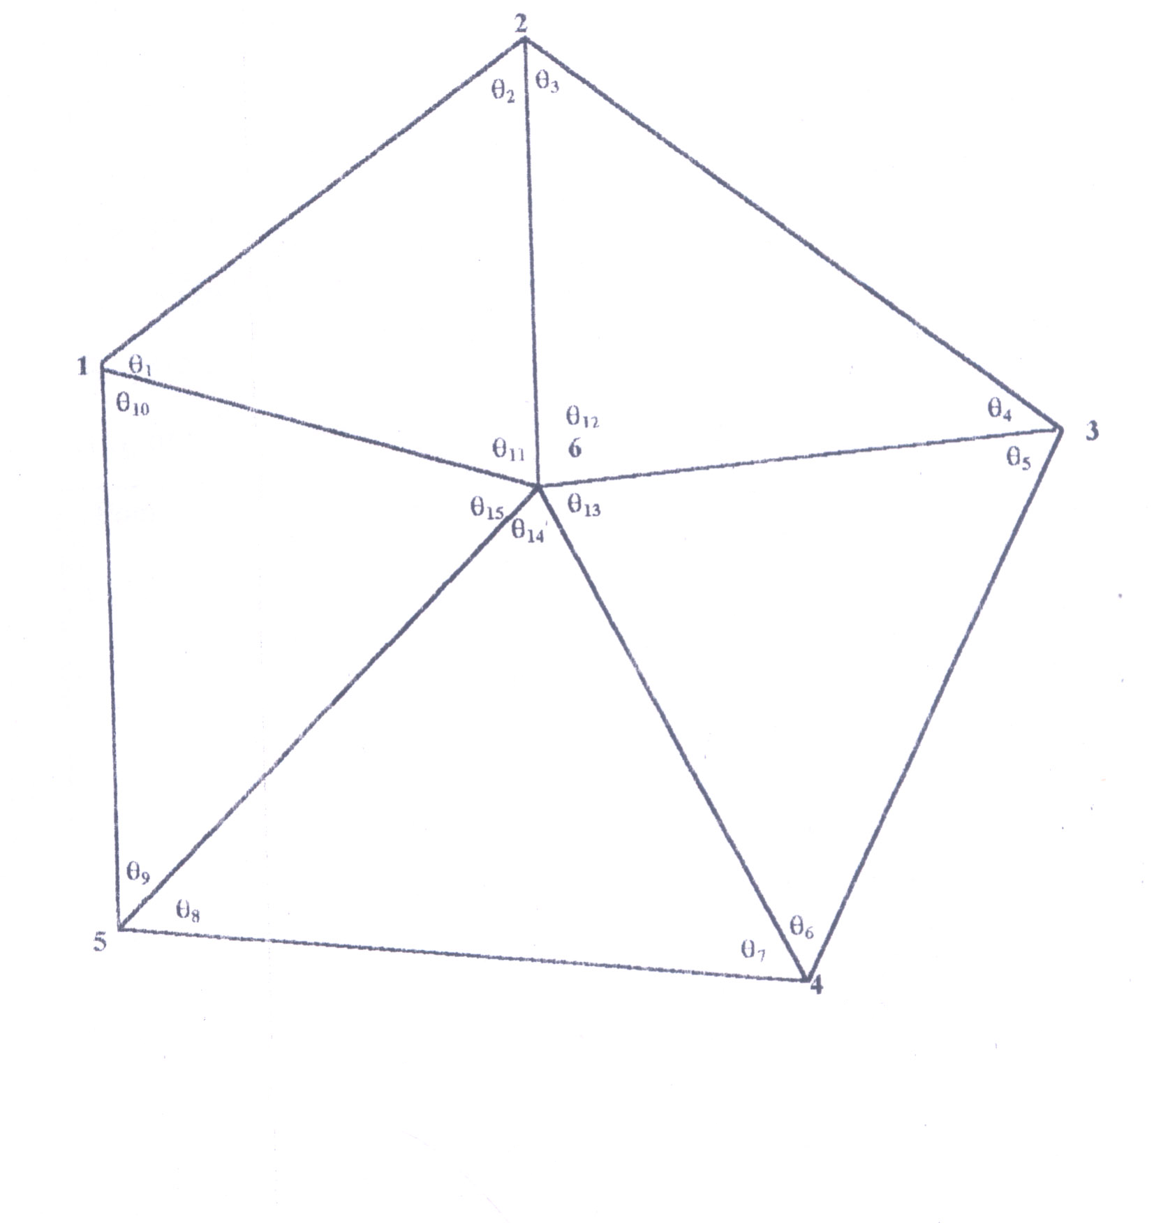

Figure 1. A network consisted of six points

External reliability:

It is the effect of an undetected gross errors on the parameters and on the quantities computed from them, Barada (1968) .In a sense, therefore, external reliability is more important than internal reliability as we don not care too much about the size of an undetected gross error as long as it has no effect on the determined parameters.
After least squares estimation of the parameters, the effect of (MDE) (for each observations) on the parameters is given by:

Where is a null vector except for the ith position which is equal to
The largest elements of will be considered as the a measure of the effect of an undetected gross error of the size of a marginally detectable error on the estimated parameters.
Consider (q) as a quantity estimated from parameters and to be the effect of (MDE) on the derived quantities. It can be shown (see Cross, P.A., 1983) when W is diagonal would be given by

Where:
Is the standard deviation of q
Is standard error of the ith observation
Is the square root of the ith diagonal element of
for un correlated observations, the following could be established:
It follows that if an observation has high internal reliability if must also have high external reliability, and conversely low internal reliability reflects low external reliability.

Testing and results

Before testing the effects of the systematic errors, the coordinates of the unknown points (fig(1-1)) were computed Using the observed data in. (Tables (1.1),(1.2),(1.3),(1.4),(1.5),(1.6),(1.7) and (1.8)).
The following approximate values were obtained:

Table 3.1: The coordinates of unknown
points in fig (1.1).
Point | X  ( easting ) | Y  (northing) | Z
1(fixed) | 1000.00 | 1000.00 | 382.035
2 | 1918.46 | 1150.044 | 382.943
3 | 2023.341 | 669.079 | 384.181
4 | 1455.81 | 153.494 | 383.903
5 | 982.863 | 509.239 | 382.875
6 | 1580.526 | 656.280 | 382.933

One dimensional adjustment

Using the slant distances shown in Table(1.6) and the zenith angles in Table(1.5), ten observations were sued for the one dimensional adjustment (as in Methley, B.D.F., 1986). After applying the above corrections, the adjusted heights of the unknown points together with their standard errors were obtained as in Table(3.2) below:

Table 3.2: The adjusted heights and their standard errors of the unknown points

Point | Z (m) | Standard Error
1 | 382.035 | -
2 | 382.944 | ±0.01
3 | 384.183 | ±0.03
4 | 383.902 | ±0.02
5 | 382.872 | ±0.01
6 | 382.937 | ±0.01
Point | E(m) | S.E | N(m) | S.E | Z(m) | S.E
1(fixed) | 1000.000 | - | 1000.00 | - | 382.035 | -
2(fixed) | 1718.465 | - | 1150.044 | - | 382.943 | -
3 | 2023.348 | ±.006 | 669.083 | ±.006 | 374.183 | ±.01
4 | 1455.832 | ±.01 | 153.480 | ±.005 | 383.906 | ±.02
5 | 982.899 | ±.02 | 509.238 | ±.004 | 382.876 | ±.01
6 | 1580.532 | ±.005 | 656.286 | ±.004 | 382.934 | ±.02

With a standard error of unit weight:

Two dimensional adjustments
A two dimensional adjustment was carried out from observed horizontal angles (1.1), azimuth (1.5) and horizontal distances (1.3). The least squares estimates of the coordinates were obtained as follows:

Table 3.3: The least squares estimates of the coordinates

Point | X(m) | S.E | Y(m) | S.E
1(fixed) | 1000.000 | - | 1000.00 | -
2 | 1718.455 | ±0.01 | 1149.984 | ±0.03
3 | 2023.318 | ±0.01 | 669.000 | ±0.04
4 | 1455.766 | ±0.03 | 153.441 | ±0.02
5 | 982.862 | ±0.02 | 509.241 | ±0.01
6 | 1580.502 | ±0.01 | 656.236 | ±0.03

And the standard error of unit weight:

Three dimensional adjustments
Slant distances and zenith angles in Table (1.6), and Table (1.5) were used for the three dimensional adjustment with the following results (assuming points 1 and 2 as fixed stations):
The value of a standard error of unit weight equals to :
Note that the values of adjusted coordinates in Tables (3.2),(3.3)and (3.4)agree.

Table 3.4: The least squares estimates of the coordinates

Testing of the effects of systematic errors
To test the effect of systematic errors on the estimated parameters, a scale error of (0.996) was introduced on the horizontal observed distances Table (1.7).Thereafter the two dimensional coordinates of different points in the network was estimated. The following results were obtained by using ten of the observations:
The least squares estimates of the coordinates and their standard errors respectively are:
The following table shows the adjusted values of the coordinates of the stations after applying two iterations.

Table 3.5: The adjusted values of the coordinates of the stations
Point | X(m) | S.E | Y(m) | S.E
1(fixed) | 1000.000 | - | 1000.00 | -
2 | 1715.601 | ±0.01 | 1149.384 | ±0.03
3 | 2019.224 | ±0.01 | 670.324 | ±0.04
4 | 1453.943 | ±0.03 | 156.829 | ±0.02
5 | 982.931 | ±0.02 | 511.204 | ±0.01
6 | 1578.180 | ±0.01 | 657.611 | ±0.03

And the standard error of unit weight:
Comparing the values in table (3.3) and table (3.5), it can be easily noticed that, the presence of systematic errors will change the values of the estimated parameters, the estimated residuals and the value of the standard error of unit weight will change as well, which gives the sense as if a gross error exists, while the variance covariance matrix remain the same.

Adjustment with additional parameters
As mentioned above, we can account for the systematic errors in the least squares model, and then estimate the coordinates of the points. Taking into account the scale error inserted in the observed distances as an unknown parameter (assuming that it’s approximate value is one). The following results were obtained.

Table 3.6: The least squares estimates of the coordinates
Point | X(m) | S.E | Y(m) | S.E
1(fixed) | 1000.000 | - | 1000.00 | -
2(fixed) | 1718.467 | - | 1150.040 | -
3 | 2023.379 | ±0.01 | 669.071 | ±0.04
4 | 1455.846 | ±0.03 | 153.435 | ±0.02
5 | 982.891 | ±0.02 | 509.216 | ±0.01
6 | 1580.528 | ±0.01 | 656.278 | ±0.03

With the standard error of unit weight:
Noting that the same values of corrections are obtained, therefore the identical value of the adjusted coordinates will be obtained and the value of is again maintained. And the estimated value for the scale error can be computed by applying the related correction to it’s initial value.i.e:

=1-0.00406=0.996

Which agrees with the introduced value.

Table 1.1: Horizontal Angles
Angle | Observed value
θ₁ | 42° | 25ˊ | 30″
θ₂ | 62 | 35 | 44
θ₃ | 47 | 49 | 46
θ₄ | 59 | 26 | 04
θ₅ | 40 | 35 | 55
θ₆ | 61 | 40 | 36
θ₇ | 39 | 07 | 08
θ₈ | 50 | 46 | 19
θ₉ | 74 | 10 | 41
θ₁₀ | 61 | 22 | 14
θ₁₁ | 74 | 58 | 48
θ₁₂ | 72 | 44 | 07
θ₁₃ | 77 | 43 | 30
θ₁₄ | 90 | 06 | 30
θ₁₅ | 44 | 27 | 01

Table 1.2: Magnetic Bearing
From | To | F.Bearing | B. Bearing
1 | 5 | 180° 00ˊ 00″ | 02° 00ˊ 00″

Table 1.3: Horizontal Distances
From | To | Observed distances(m)
1 | 2 | 733.965
2 | 3 | 569.453
3 | 4 | 766.759
4 | 5 | 591.805
1 | 5 | 591.060
1 | 6 | 674.651
2 | 6 | 512.660
3 | 6 | 442.996
4 | 6 | 518.033
5 | 6 | 615.450

Table 1.4: Difference in Height
From | To | Observed  difference(m) | Remarks
1 | 2 | 0.943 | RISE
2 | 3 | 1.238 | RISE
4 | 3 | 0.278 | RISE
5 | 4 | 0.028 | RISE
1 | 5 | 0.875 | RISE
1 | 6 | 0.933 | RISE
6 | 2 | 0.010 | RISE
6 | 3 | 1.248 | RISE
6 | 4 | 0.970 | RISE
5 | 6 | 0.058 | RISE

Table1.5: Zenith Angles
From | To | Observed zenith  angle
1 | 2 | 89° | 55ˊ | 34″
2 | 3 | 89 | 52 | 31
4 | 3 | 89 | 58 | 45
5 | 4 | 89 | 59 | 50
1 | 5 | 89 | 59 | 23
1 | 6 | 89 | 55 | 14
6 | 2 | 89 | 59 | 51
6 | 3 | 89 | 50 | 20
6 | 4 | 89 | 53 | 30
5 | 6 | 89 | 59 | 45

Table 1.6: Slant Distances
From | To | Observed distances (m)
1 | 2 | 733.965
2 | 3 | 569.456
3 | 4 | 766.762
4 | 5 | 591.805
1 | 5 | 491.062
1 | 6 | 674.652
2 | 6 | 512.660
3 | 6 | 443.000
4 | 6 | 518.038
5 | 6 | 615.458

Table 1.7: Horizontal Distances with Scale Error
From | To | Observed distances (m)
1 | 2 | 731.029
2 | 3 | 567.175
3 | 4 | 763.691
4 | 5 | 589.437
1 | 5 | 489.095
1 | 6 | 671.952
2 | 6 | 510.609
3 | 6 | 441.224
4 | 6 | 515.960
5 | 6 | 612.988

Table1.8 Standard Errors for Observed Quantities:

Observed quantity | S.E.
Horizontal Distance | ±0.003 m
Horizontal Angle | ±3″
Bearing | ±10″
slant distance | ±0.007 m
zenith Angle | ±7″

Conclusion
1. The estimated values for heights obtained from a one dimensional estimation and a three dimensional one are identical, on the other hand the estimated values for eastings & northings obtained from the two dimensional and three dimensional adjustments are identical.
2. When a systematic error is introduced to measured distances the following is noticed:
i) The estimated parameters and residuals will take different values from those with no systematic error.
ii) The value of the standard error of unit weight will also increase.
iiii) Application of least squares model containing additional parameters will enable the evaluation of the systematic errors and their effect.

Acknowledgement:
Many thanks to Doctor Ali Hassan Fagir at the Department of Surveying Engineering, Faculty of Engineering, Sudan University of Science and Technology, Sudan, for providing the data.

Correspondence to:
Eltahir Mohamed Elhadi
China University of Geosciences, Faculty of Resources, Wuhan, 430074, China
Telephone: 00862763962740.
Emails:tahirco2006@yahoo.com, hadeena@hotmail.com

References
1-Allan, A.L.Hollwy, J.R.and Maynes, J.H.B (1968), Practical Field Surveying and Computations, Heinemann.
2-Cooper, M.A.R (1974), Fundamentals of Survey Measurements and Analysis,Granda Publishing Limited.
3-Cooper, M.A.R (1987), Control Surveys in civil Engineering, Collins Professional and Technical Data.
4-Cross, P.A (1983) Least Squares Adjustment Applied to Position Fixing, working paper no (6), North East London Polytechnic Publications.
5-Edward, M. Mikhail and Gordon Gracie (1981) Analysis and Adjustment of Survey Measurment, Van Nostrand Reinhold.
6-Methley, B.D.F (1986), Computational Models in Surveying and Photogrammetry, Blackie&Son Ltd.
7-Rainsford, H.F (1957), Survey Adjustments and Least Squares Constable.

8-
10/17/2009

