Cover letter
Dear editor
I have great pleasure to submit the manuscript entitled
Assessment of cell kinetics in the tissues of brownbanded bamboosharks (Chiloscyllium punctatum) by using bromodeoxyuridine (BrdU) and Anti-BrdU Monoclonal Antibody
I believe that the aspect of this manuscript make it interesting for the general readers of Journal of American Science
Best regard
Dr. Sawsan Ghattas
Assessment Of Cell Kinetics In The Tissues Of Brownbanded Bamboosharks (Chiloscyllium Punctatum) By Using Bromodeoxyuridine (Brdu) And Anti-Brdu Monoclonal Antibody
Konomi Ito¹, Sawsan Ghattas²*, Makio Yanagisawa³, Senzo Uchida³, Hiroki Sakai¹ and Tokuma Yanai¹
¹Department of Veterinary Pathology, Faculty of Applied Biological Sciences, Gifu University, Gifu 501-1193, Japan
²Department of Histology and Cytology, Faculty of Veterinary Medicine, Kafr El Sheikh University, Egypt
³Okinawa Churaumi Aquarium, Motobu Town, Okinawa Prefecture, Japan
dr.sawsan.ghattas@gmail.com

Abstract
The 5-bromo-2’-deoxyuridine (BrdU) labeling method has been used to assess the quantity of proliferative potential in organs and tissues in various mammals. For application of this method in fish, it was necessary to determine conditions that optimize the detection of the BrdU epitope. In the present investigation, we investigated the localization of proliferative cells as well as various conditions for detection of S-phase cells in the tissues of adult brownbanded bamboosharks by means of the BrdU immunohistochemical method. Our results demonstrated that BrdU-positive cells were satisfactorily demonstrated in the tissues of brownbanded bamboosharks treated with BrdU at a dose of 6 mg/kg or higher. However, there was no difference in BrdU reactivity between routes of administration, including intravenous, subcutaneous and intraperitoneal injections. BrdU-incorporated cells were detected both in formalin-fixed and 70% ethanol-fixed tissues with enzymatic treatment and acid hydrolysis in the shark tissues, while formalin-and ethanol-fixed brownbanded bambooshark tissues that did not undergo the enzymatic procedure showed no BrdU reactive cells. Importantly, samples were quickly fixed in heated formalin solution and treated with 5N HCL and 0.01% Nagarase at 37 C for 30 seconds to one minute. In conclusion, the BrdU labeling method was useful in a cell kinetic study detecting S-shaped cells in sharks, as in other mammals. [Journal of American Science 2009;5(7):xx-xx]. (ISSN: 1545-1003)”
Keywords: BrdU, IHC, Labeling method, Brownbanded bambooshark (Chiloscyllium punctatum)

1. Introduction
Evaluation of cell proliferation in animal tissues is essential for various biomedical studies, among them embryology, histology and oncology. In cell kinetic studies, 5-bromodeoxyuridine (BrdU) immunohistochemistry (IHC) has been applied as a standard method, as well as proliferating cell nuclear antigen (PCNA) or Ki-67 IHC.
BrdU is an analog of thymidine which is incorporated into replicating nuclear DNA. It can be detected immunocytochemically by a specific anti BrdU monoclonal antibody (Gratzner 1982). The BrdU IHC method has been used to detect DNA-synthesizing cells, instead of 3H-thymidine autoradiography, in cell cultures and in whole mount preparations (Hamada 1985 and Plickert & Kroiher 1985). This method was applied to teleost fish as an excellent proliferating marker in vivo. Given such factors, BrdU has been manifested for studying the developmental biology of various organs and tissues. It has been detected in the retinas of zebra fish (Hitchcock and Raymond 2004), in the testes of mosquito fish (Koya and Iwase 2004), in the skin of channel catfish (Zhao et al. 2008) and in the gills of killifish (Pierre et al. 2006). Although several lines of evidence have been reported in teleosts, to our knowledge there have been almost no data available in application to shark tissues. Basic techniques for BrdU IHC in sharks, including fixation methods and appropriate pretreatment for antigen retrieval, have not been validated.
The purpose of this study was to establish the optimal BrdU labeling method, including effective administration doses and tissue fixation, in sharks.

2, Materials and Methods
Animals
Six adult brownbanded bamboosharks (Chiloscyllium punctatum) were used in this study (Table 1). Two sharks (Nos. 1 and 3) were females, while the others (Nos. 2, 4, 5 and 6) were males. All were sexually mature. The average total body length and body weight of the sharks were 103 cm (range 97-110 cm) and 4.3 kg (range 3.6-5.6 kg), respectively. The sharks were housed in an open circular tank at the Okinawa Churaumi Aquarium (Motobu Town, Okinawa Prefecture, Japan) and fed filleted fish (Scomber australasicus, Scomber japonicas, Spratelloides gracilis and others) and loliginids (Loligo sp.) twice a week. Seawater was circulated every two and a half hours and the water temperature was adjusted based on the ambient sea temperature (20-30 C). The sharks exhibited no abnormal features at the time of examination.
BrdU solution dispensation and administration
Five-bromo-2’-deoxy-uridine (BrdU) was purchased from Sigma-Aldrich Co. (St. Louis, MO, USA). An amount of 1,000 mg was dissolved in 2 ml of dimethyl sulfoxide (Nakalai Tesque, Kyoto, Japan), and 8 ml of physiological saline solution was added. The resulting solution was put in hot water to dissolve completely. The solution was dispensed at the time of use.
Three of the sharks (Nos. 1-3) were given 6-100 mg/kg of BrdU via a vessel at the axilla of the first dorsal fin under manual restraint, without anesthesia. The other three sharks (Nos. 4-6) were administered 100-200 mg/kg of BrdU subcutaneously or intravenously under general anesthesia. For the anesthesia, we administered 2.0 mg/kg of propofol (Rapinovet®; Schering-Plough K.K., Osaka, Japan) according to Miller et al. (2005) and 5 μg/kg fentanyl (DAIICHI SANKYO PROPHARMA CO., Tokyo, Japan) intravenously. After faint respiration (weak opening and closing of the gill slits) was confirmed, the sharks were taken out of the water and a small incision was made in the skin of the abdomen to insert a needle. To administrate the BrdU, we used a sterilized 50 cm³ syringe (TERUMO Co. Tokyo, Japan) with a 20-gauge indwelling needle (TERUMO Co. Tokyo, Japan). After injection, the incision was stitched with needle-tipped suture thread (Johnson & Johnson Inc., USA ), and the sharks were placed back in the water. Three sharks (Nos. 1-3) were humanely euthanized with an excessive dose of propofol (25-72 mg/kg), while the other three sharks (Nos. 4-6) were euthanized by immersion in an excessive dose of phenoxine (over 2,000 ppm) (2-phenoxyethanol; KANTO CHEMICAL CO., Tokyo, Japan) 2-3 hours after the administration of the BrdU.
Optimization of fixation
To evaluate the sample conditions, including fixation methods, for BrdU-immunoreactivity, the spiral intestine, testis and epigonal organ of each shark were collected, sliced at a thickness of 5 mm, and fixed in 10% neutral buffered formalin at room temperature (RT) for 24 hours, 1 and 2 weeks, or fixed in 70% ethanol at RT for 24 hours. The samples were also immersed in 10% neutral buffered formalin, heated without boiling for 15-30 minutes for rapid fixing, and left overnight.
BrdU immunohistochemistry
The fixed samples were embedded in paraffin wax, and serial sections (4 μm) were cut and stained with hematoxylin and eosin.
Immunostaining of BrdU-incorporated cells was performed as described previously by Moran et al. (1985) and Yanai et al. (1996), and the pretreatment was selected to decide the optimal method in sharks. For BrdU-immunostaining, serial sections were cut and mounted on glass slides coated with 3-aminopropyltriethoxysilane (Sigma, USA) and dried overnight at 50 C. After dewaxing and rehydrating, the serial sections were hydrolysed with HCl (2N or 5N) at RT for 30 minutes to denature the DNA, and neutralized in Palitisch’s boric acid-NaCl-borate buffer (pH 7.6) at 4 C for 5 minutes, repeated 3 times. Some of the sections were then subjected to protease digestion using 0.01% or 0.05% protease (Nagarase, Sigma-Aldrich Co.; 37 C; 30 seconds, 1, 3 and 5 minutes) in PBS, 0.04% Pepsin (Wako Pure Chemical Industries, Osaka, Japan) in 0.01N HCl or 0.05% Trypsin (Life Technologies Inc., MD, USA) in Tris solution, while the other sections were not subjected to this treatment. All sections were inactivated with endogenous peroxidase by 0.3% hydrogen peroxide in methanol at RT and subjected to blocking of nonspecific antibody binding (Protein Block, Serum-Free; Dako Cytomation, CA, USA). The primary anti-BrdU monoclonal antibody (Bu20a, Dako Cytomation, CA, USA) was diluted by 1:200 with PBS and the sections were mounted and incubated overnight at 4 C. After being rinsed three times with PBS for a total of 1 hour, the sections were then incubated with biotinylated anti-mouse IgG goat polyclonal antibody (EnVision+® System Labelled Polymer-HRP Anti-Mouse, Dako Cytomation, CA, USA) for 30 minutes at RT. Following this, they were rinsed three times with PBS for a total of 30 minutes. Images of the labeled cells were created using a diaminobenzidine commercial kit (Liquid DAB+ Substrate Chromogen System; Dako Cytomation, CA, USA). Finally, the sections were counterstained using Mayer’s hematoxylin.
Assessment of immunolabeling
To compare intensities in BrdU-positive reaction in the nuclei under various conditions, the degrees of reactions were classified into four grades (++, intense; +, moderate; +/-, slight; -, negative). Sstaining of nuclei counterstain was evaluated on the basis of three grades (+, well; +/-, minimum; -, no), which reflected any damage to the tissue caused by the treatment procedures. The samples from shark No. 3 (minimum BrdU dose; of 6 mg/kg) which had been fixed in 10% neutral buffered formalin for 24 hours and those from shark No. 6 (maximum BrdU dose of 200 mg/kg) which had been heated in formalin solution were used to evaluate the effect of pretreatment for BrdU-immunoreactivities and nuclear stainability. 5N HCl hydrolysis with or without 0.05% Nagarase treatment for 1 minute was performed to evaluate the effect of the dose, the administration routes of the BrdU, and the fixation method for BrdU-immunoreactivities.
3. Results
Optimal pretreatment condition
The cell nuclei incorporating BrdU were easily recognized in the tissue sections by immunohistochemisity for BrdU, and showed upin a mixture of punctuated and diffuse patterns. Tables 2 and 3 show the effects of pretreatment for BrdU-immunoreactivity and on the stainability of nuclear reactivity. Hydrolyse with 5N HCl and protease treated with 0.01% Nagarase proved to produce the best results among all treatment conditions. However, it was found that the longer the protease treatment time, the poorer the nuclear stain ability. The combination of hydrolyse with 2N HCl and protease treatment with 0.05% Nagarase showed good reactivity in almost all samples, particularly in Shark No. 6, while longer-time protease treatment resulted in poor nuclear stain ability. The samples treated with 5N HCl and 0.05% Nagarase exhibited a strong positive reaction in shark No. 6, but pretreatment was so strong that the tissues and nuclei were damaged and denatured. When protease treatment was excluded and only hydrolyse with HCl was used, the positive reaction was weak (Fig. 1). Protease digestion at 37 C for 30 seconds to 1 minute produced the best reactivity condition. A longer digestive treatment resulted in severe damage to the samples; for example, nuclear counterstaining intensity was lower, and there was denaturing of tissues.
Optimal fixing conditions and the effects of doses and routes on BrdU-immunoreactivities
Details of the various doses and administration routes of BrdU, along with the fixing conditions, are shown in Table 4. Frequent BrdU incorporating nuclei could be detected in samples at doses of more than 6 mg/kg of BrdU in all routes when fixed for no less than 24 hours and treated with protease. However, the immunoreactivities became weaker as the fixation time became longer (Fig.３). Both the formalin fixation and ethanol fixation were useful for BrdU immunohistochemistry when treated with protease.

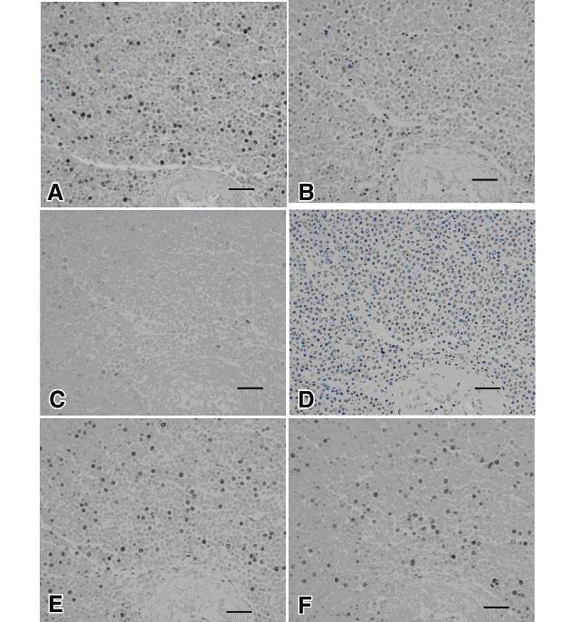

Figure 1. BrdU-immunoreactivities in the epigonal organ of shark C (BrdU 6 mg/kg)fixed with 10%neutral buffer formalin. A: Combination of hydrolyses with 5N HCL and protease treatment with 0.01%nagarase for 30 sec. B:2N HCL and 0.05%nagarase for 30 sec. Intensity of BrdU-reactivities became week.C:5NHCL and 0.05% nagarase for 30 sec.The staining intensity with hematoxylin counterstained also decreasd.D:2N HCL and0.01%nagarase for 30 sec.It could’nt observe the BrdU-positive cells.E:5NHCL and0.01%nagarase treatment for 3 min. F:5NHCL and 0.01%nagarase for 5 min. Long period of protease treatment resulted in decrease of nucleic stainability .Bar＝30um.

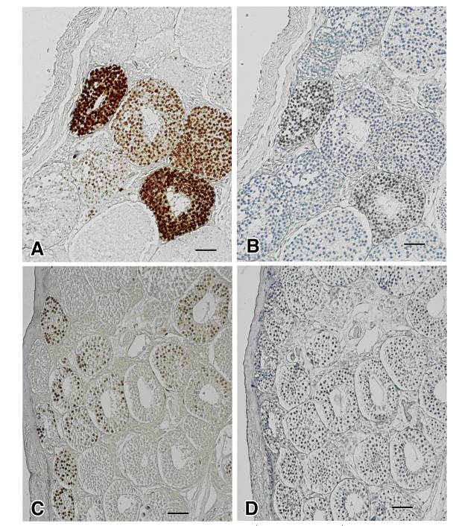

Figure 2 . BrdU-possitive cells in the testis of shark D(BrdU 200mg/kg s.c).
A:Sample was fixed in 10%neutral buffer formalin, and performed in combination of hydrolyse with 5N HCL and protease treatment with 0.01% nagarase. B:Fixed in10%formalin and no protease treatement.C:Fixed in 70%ethanol, 5NHCL and 0.01% nagarase treatment were done. D: Fixed in 70% ethanol, without protease treatment. The stainabilities of BrdU were markedly decrease .Bar＝30um.

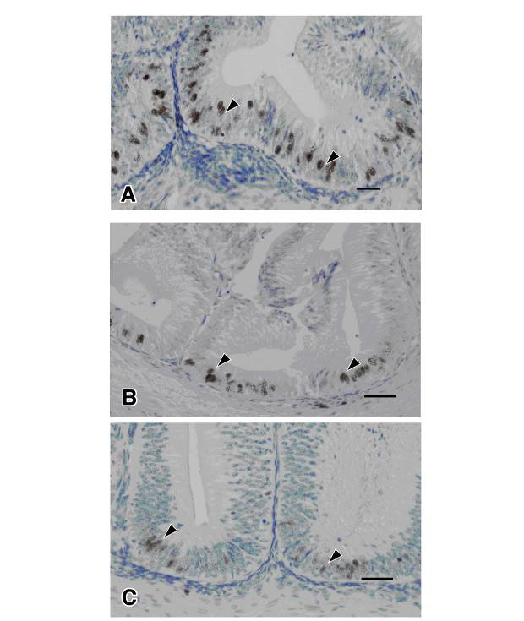

Figure 3 .BrdU-positive cells in the spiral intestine of shark A(BrdU 100 mg / kg i.v.)Samples were fixed with 10% neutral buffer formalin, treated with 5N HCL and 0.01% Nagarase. A : Fixed for 24 h. Fixed for 1 week. C: Fixed for 2 weeks. Nuclear positive reactions were observed in epithelial cells in crypts(arrow heads).Bar ＝30um.

4. Discussion
BrdU is a halogenated nucleotide analogue of thymidine that is incorporated into DNA during the S-phase of the cell cycle (Gratzner 1982). Pulse-labeling of DNA with BrdU and subsequent immunohistochemical (IHC) detection of labeled nuclei is increasingly being used to study the rates of cell proliferation in normal and malignant cells in vivo and in vitro (Sapino et al.1990 and Plickert & Kroiher 1985). Although the BrdU method is similar in specificity and sensitivity to the autoradiographic detection of [³H]-thymidine incorporated into DNA, the BrdU method has the advantage of speed, and analysis is more convenient. Additionally, it obviates the need to use radioisotopes (Thornton et al. 1988 and Sapino et al. 1990 ).
BrdU has been used in conventional laboratories for cell kinetics. The ratio of BrdU-incorporated nuclei to the total number of cell nuclei is defined as the labeling index (Nagashima et al. 1985 and Yanai et al. 1996) in human and cattle tissues (Schulz et al. 2005 and Brodeur et al. 2003) and in fish tissues .
In the present study, BrdU-positive cells were satisfactorily demonstrated in the tissues of brownbanded bamboosharks treated with BrdU at doses of 6 mg/kg or higher. In laboratory animals such as mice and rats, optimal doses for BrdU immunohistochemistry were reported to be 10 mg/kg（Sapino et al, 1990）and 100 mg/kg（Nagasawa 1983）respectively. Yanai et al (1996) reported that administration of BrdU at doses of 2 mg/kg produced sufficient reactivity in cattle. However, Alfei et al (1993 and 1994) and Elger et al (2003) applied BrdU to fish tissues at doses of 100 mg/kg for common carp (Cyprinus carpio) and 150 mg/kg for skate (Leucoraja erinacea). BrdU application is thought to be a compound with a lower level of genetic damage. In one study, human patients with brain tumors were administered BrdU at doses of 500-1,000 mg/day for 4-6 weeks without any serious side effects (Hoshino 1991). The challenge now is to decrease the doses administered in order to reduce costs, as well as to avoid gene damage.
The present investigation revealed that there were no differences in BrdU reactivity among various routes of administration, including intravenous, subcutaneous and intraperitoneal injections. With all three routes, it was possible to examine cell kinetics using BrdU immunohistochemistry in shark tissues.Other BrdU administration routes have also been reported with respect to intramuscular application (Schulz et al. 2005) and oral application (Jecker et al. 1997).
Many factors have been reported to influence the immunoreactivity of the BrdU epitope; prominent among these is the method of tissue fixation (Mitchell et al. 1985; Schutte et al. 1987).
Our findings revealed that BrdU-incorporated cells were detected both in formalin-fixed and 70% ethanol-fixed tissues with enzymatic treatment and acid hydrolysis in the shark tissues. However cattle, dog and cat tissues fixed in 70% ethanol followed by hydrolysis alone showed sufficient reactivity (Yanai et al. 1996 and Ishikawa et al. 2005). Some reports recommended the addition of acetic acid to the alcohol to decrease shrinkage artifact, soften the tissue, and aid in the preservation of nucleoproteins (Carson 1990). In another effort to achieve a balance between the advantages and limitations of alcohol fixation, the use of mixtures of methanol, acetic acid, and chloroform (methacarn) has been proposed as producing both excellent preservation and increased immunoreactivity (Mitchell et al. 1985).
The present study revealed that ethanol or formalin-fixed brownbanded bambooshark tissues that did not undergo the enzymatic procedure did not exhibit BrdU reactive cells. Consequently, the optimal condition for superior BrdU reactivity as well as improved histological preservation was obtained when the samples were quickly fixed in heated formalin solution and treated with 5N HCl and 0.01% Nagarase at 37 C for 30 seconds to 1 minute. Taken together, the samples fixed with formalin for a longer period of time resulted in less active BrdU immunoreactivities, and a longer digestion time resulted in severe histological damage.
Our investigation revealed that the most important factor in improved BrdU immunohistochemistry is thought to be quick and sufficient fixation. As an alternative to enzymatic digestion, heat-induced epitope retrieval (HIER) is useful in recovering immunoreactivity of BrdU epitopes in formalin-fixed tissue. This concurs with the findings of Shi et al. (1991) and Lan et al. (1995). The required duration of enzyme digestion for unmasking varies according to the length of fixation, but this approach can be accompanied by an increase in nonspecific staining, resulting in false-positive staining (Bak and Panos 1997).
Finally, the present study revealed that the BrdU labeling method may be useful in cell kinetic studies aimed at detecting S-phase cells in sharks, as in other animals and in humans.

Table 1:

Sharks, doses of bromodeoxyuridine and routes of administration.

*M, male; F, female
Shark No. | Sex* | Sexual Maturity | Total length(cm) | Body weight(Kg) | Dose  (mg/Kg) | Route**
1 | F | mature | 97 | 4.1 | 100 | i.v.
2 | M | mature | 100 | 4.0 | 25 | i.v.
3 | F | mature | 110 | 5.6 | 6 | i.v.
4 | M | mature | 104 | 3.9 | 200 | s.c
5 | M | mature | 107 | 4.9 | 100 | i.p
6 | M | mature | 100 | 3.6 | 200 | i.p .
** i.v., intravenous; s.c., subcutaneous; i.p., intraperitoneal.
Table 2 : The effects of pretreatment on BrdU-immunoreactivities

Protease | Protease Treatment Time | Shark No.3* |  | Shark No.６ **
Protease | Protease Treatment Time | 5N HCl | 2N HCl | 5N HCl | 2N HCl
0.05%  Nagarase | 30 sec | + | + | ++ | ++
0.05%  Nagarase | 1min. | +/- | + | ++ | ++
0.05%  Nagarase | 3min. | N.T.# | + | ++ | ++
0.05%  Nagarase | 5min. | N.T. | + | N.D# # | ++
0.01%  Nagarase | 30 sec | ++ | - | ++ | +
0.01%  Nagarase | 1min. | ++ | - | ++ | +
0.01%  Nagarase | 3min. | ++ | + | ++ | +
0.01%  Nagarase | 5min. | ++ | + | ++ | +
0.05% Trypsin | 1min. | N.T. | N.T. | ++ | +
0.04% Pepsin | 1min. | N.T. | N.T. | +/- | +/-
No treatment | - | +/- | N.T. | +/- | +/-
++, intense; +, moderate; +/-, slight; - ,negative
N.T.#; Not tested.
N.D# #;Not detected because of heavy tissue denaturation by treatment procedure.
Shark No.3*Minimum dose of BrdU(6mg/Kg i.v.).
Shark No.６ **; maximum dose of BrdU(200mg/Kg i.p.).

Table 3 : The effects of pretreatment on nuclear stainability.
Protease | Protease Treatment Time | Shark No.3* |  | Shark No.６**
Protease | Protease Treatment Time | 5N HCl | 2N HCl | 5N HCl | 2N HCl
0.05% Nagarase | 30 sec | - | + | +/- | +
0.05% Nagarase | 1min. | - | +/- | - | +
0.05% Nagarase | 3min. | N.T.# | +/- | - | +
0.05% Nagarase | 5min. | N.T. | +/- | - | +
0.01% Nagarase | 30 sec | + | + | + | +
0.01% Nagarase | 1min. | - | + | + | +
0.01% Nagarase | 3min. | - | + | + | +
0.01% Nagarase | 5min. | - | + | + | +
0.05% Trypsin | 1min. | N.T. | N.T. | - | +
0.04% Pepsin | 1min. | N.T. | N.T. | + | +
No treatment | - | + | N.T | + | +

+; good stained, +/-; poorly stained, -; not stained.
N.T.#; not tested.

Table 4 : The effects of Dose, Route and Fixation on BrdU-immunoreactivities.
Shark No. | Dose (mg/Kg) | Route | Fixation* | 10% neutral buffered  formalin |  | 70% ethanol
 |  |  |  | Protease** | No protease | Protease** | No protease
1 | 100 | i.v. | 24hr | ++ | -
1 | 100 |  | 1w | + | N.T.
1 | 100 |  | 2w | +/- | N.T
2 | 25 | i.v. | 24hr | ++ | N.T.
2 | 25 |  | 1w | ++ | N.T.
2 | 25 |  | 2w | + | N.T.
3 | 6 | i.v. | 24hr | ++ | +/-
3 | 6 |  | 1w | + | N.T.
3 | 6 |  | 2w | +/- | N.T.
4 | 200 | s.c. | heat*** | ++ | +/- | ++ | +/-
5 | 100 | i.p. | heat | + | N.T. | ++ | N.T.
6 | 200 | i.p. | heat | ++ | +/- | ++ | +/-

++, intense; +, moderate; +/-, slight; -,negative
*; Fixation time or method.
** ; 0.05% Nagarase treatment for 30 sec.
***; The samples heated in formalin for 15-30 min. and fixed overnight.

Acknowledgement
The authors thank Miss Cate Swift for proofreading.

Corresponding Author:
Sawsan Ghattas
Department of Histology and Cytology, Faculty of Veterinary Medicine, Kafr El Sheikh University, Egypt
E-mail dr.sawsan.ghattas@gmail.com Tel /＋20122946244 Fax / +20473231311
References

- Alfei L, Colombari PT, Cavallo D, Eleuteri P. De Vita R . Use of 5’-bromodeoxyuridine immunohistochemistry to examine proliferative activity of fish tissues. Eur J Histochem 1993; 37: 183-189.
- Alfei L , Onali A , Spano L , Colombari P T, Altavista P L, De Vita R . PCNA / cyclin expression and BrdU uptake define proliferating myosatellite cells during hyperplastic muscle growth of fish (Cyprinus carpio L.). Eur J Histochem1994; 38: 151-162.
- Bak PM, Panos RJ . Protease antigen recovery decreases the specificity of bromodeoxyuridine detection in formalin-fixed tissue. J Histochem Cytochem1997;45: 1165-1170
- Brodeur JC, Calvo J, Clark A, Johnston A . Myogenic cell cycle duration in harpagifer species with sub-Antarctic and Antarctic distribution, evidence for cold compensation. J Experimental Biology 2003;206: 1011-1016 .
- Carson FL. Histotechnology 2003; ChicagoASCP Press
- Elger M, Hentschel H, Litteral J, Wallner M, Kirsch T, Luft FC, Haller H . Nephrogenesis is induced by partial nephrectomy in the elasmobranch Leucoraja erinacea. J Am Soc Nephrol 2003;14: 1506-1518.
- Gratzner HG . Monoclonal antibody to 5-bromo and 5-iododeoxyuridine: a new reagent for detection of DNA replication. Science1982; 218: 474-476.
- Hamada S. Adouble labeling technique combining ³H-thymidine autoradiography with BrdU immunohistochemistry. Acta Histochem. Cytochem 1982; 18: 267-270.
- Hitchcock PF and Raymond PA . The teleost retina as a model for developmental and regeneration biology. J Zebra Fish 2004; 1： 257-271.
- Hoshino T . BrdU (bromodeoxiuridine) – Application to brain cancer1991; 862-867 Rinshoutobyouri 9 (7). (In Japanese)
- Ishikawa K, Sakai H, Hosoi M, Ohta G, Yanai T, Masegi T . Immunohistochemical demonstration of S-phase cells in canine and feline spontaneous tumors by anti-bromodeoxyuridine monoclonal antibody. J Toxicol Pathol2005;18: 135-140.
- Jecker P, Beuleke A, Dressendorfer I, Pabst R, Westermann J. Long-term oral application of 5-Bromo-2-Deoxyuridine does not reliably label proliferating immune cells in the LEW rat. J Histochem & Cytochem1979; 45: 393-402.
- Koya Y and Iwase A . Annual reproductive cycle and rate of the spermatogenic process in male mosquitofish Gambusia affinis. J Ichthyological Research 2004;51: 131-136.
- Lan HY, Nikolic–Paterson DJ, Mu W, Atkins RC. Local macrophage proliferation in the progression of glomerular and tubulointerstitial injury in rat anti-gbm glomerulonephritis. Kidney Int1995;49: 753-760.
- Mitchell D, Ibrahim S, Guterson BA. Improved immunohistochemical localization of tissue antigens using modified methacarn fixation. J Histochem Cytochem1985; 33: 491-495.
- Miller S M, Mitchell M A, Heatley J J, Wolf T, Lapuz F, Lafortune M, Smith J A . Clinical and cardiorespiratory effects of propofol in the spotted bamboo shark (Chylloscyllium plagiosum). J Zoo Wild Med 2005; 36: 673-676.
- Moran R, Darzynkiewicz Z, Staiano-Coico L, Melamed M R. Detection of 5-bromodeoxyuridine (BrdUrd) incorporation by monoclonal antibodies: role of the DNA denaturation step. J Histochem Cytochem 1985;33: 821-827.
- Nagasawa H . Jikkendoubutu handbook 1983; Youkendo. (In Japanese.)
- Nagashima T, DeArmond S J, Murovic J, Hoshino T . Immunocytochemical demonstration of S-phase cells by anti-bromodeoxyuridine monoclonal antibody in human brain tumor tissues. Acta Neuropathologica 1985; 67: 155-159.
- Plickert G, Kroiher M , Analysis of cell proliferation kinetics by means of BrdU/anti-BrdU technique. Application to whole mounts of Hydractinia echinata. (Abstract) European J Cell Bio1985;39 : 12- 27.
- Pierre L, Chevalier C, Wood C. Appearance of cuboidal cells in relation to salinity in gills of Fundulus heteroclitus, a species exhibiting branchial Na but not C L uptake in fresh water. J. Cell & Tissue Research 2006; 325: 481–492.
- Sapino A, Macri L, Gugliota P, Bussolati G . Immunocytochemical identification of proliferating cell types in mouse mammary gland. J Histochem Cytochem1990;38: 1541-1547.
- Schutte B, Reynders MJ, Bosman FT, Blijham GH. Effect of tissue fixation on anti-bromodeoxyuridine immunohistochemistry. J Histochem Cytochem 1987; 35: 1343-1345.
- Schulz R W, Menting S, Bogerd J, Franca L R, Vilela A R ,Sertoli cell proliferation in the adult testis - Evidence from tow fish species belonging to different orders. J Biol Reproduct 2005;73: 891-899.
- Shi S, Key ME, Kalra KL . Antigen retrieval in formalin-fixed, paraffin-embedded tissues: an enhancement method for immunohistochemical staining based on microwave oven heating of tissue sections. J Histochem Cytochem1991;39: 741-748.
- Thornton JG, Wells M, Hume WJ. Flash labeling of S-phase cells in short-term organ culture of normal and pathological human endometrium using bromodeoxyuridine and tritiated thymidine. J Pathol.1988; 154: 321-328.
- Yanai T, Matsumoto C, Takashima H, Yoshida K, Sakai H, Isowa K, Iwasaki T, Sato Y and Masegi T .Immunohistochemical demonstration of S-phase cells by anti-bromodeoxyuridine monoclonal antibody in cattle tissues. J Comp Path. 1996;114: 265-272.
- Zhao X, Findly RC, Dickerson H. Coetaneous antibody - secreting cells and B cells in a teleost fish. J Development Comp Immunol. 2008;32: 500- 508.

Submission date:28 /11/ 2009

