Neuroanatomical, Immunocytochemical and Electrophysiological Studies on Cercal Sensory Receptors in the Female Locust

Ehab Tousson and Afaf El-Atrash
Department of Zoology, Faculty of Science, Tanta University
toussonehab@yahoo.com afelatrash@yahoo.com

ABSTRACT: Relatively little is still known about the function, types and location of cercal sensory systems. This system detects and encodes different sensory modalities: wind, touch and gustatory. It is focused on fine structure and distribution of various types of cercal sensilla in the desert locust were investigated with scanning electron microscope and neuroanatomical techniques. Two types of sensory receptors were identified and classified as mechanoreceptors (filiform sensilla) and chemoreceptors (basiconic sensilla). Also, the morphology and the organization of individual sensory receptors (mechanoreceptors or chemoreceptors) in the CNS were examined by immunocytochemical characterization of single neuron. All afferent fibres from individual filiform and basiconic sensilla project in the tenth neuromere of the terminal abdominal ganglion. Projections from single multiply innervated hair sensilla do not segregate with the exception of one afferent of contact chemosensory hairs which terminate only in its segmental neuromere, as was shown for other contact chemoreceptors of the abdomen. Another focus is on the electrophysiological response of individual mechanoreceptors or chemoreceptors to mechanical or chemical stimulation were analyzed. [Journal of American Science 2010; x (x): xx-xx]. (ISSN: 1545-1003).
Keywords: Sensory neurons; Cerci; terminal segments; Innervation; Immunocytochemistry; Electrophysiological recording

1. Introduction
Insect sensory receptors encode in their signals different types of information about the environment that can modify the animal’s behaviour; these signals are integrated and distributed to several segmental ganglia by projection interneurones. Cercal receptor of insects mediate a range of behaviours such as running, jumping and flight (Camhi, 1980; Ritzmann, 1984; Boyan et al. 1989; Boyan and Ball, 1990; Kohstall, 1996), while these behaviours are expressed in a variety of context (Feeding, oviposition, mating, migration), each can be used to escape from a predator. Escape is one of the most dramatic episodes in an animal’s life, and successful escape depends in large measure on the efficiency of the synaptic mechanisms and neuronal pathways linking sensory input to motor activity (Ritzmann, 1984). Both the clarity of its expression and its importance to the animal’s survival has ensured that escape behaviour has attracted much attention from neurobiologists (Kohstall, 1996; Hörner and Heblich 2001; Rogers et al., 2003; Newland, 2004; Tousson and Gaaboub, 2004). In the insect nervous system the sensory afferents of cereal hairs have proved important for the study of presynaptic inhibition. The cerci project posteriorly from the last segment of the abdomen and are covered with two types of sensory hairs. Projection patterns of sensory neurons in the central nervous system, often follow topological rules that can be related the distribution of the sensilla on the body, (Pflüger et al., 1981; Newland and Burrows, 1994; Newland et al. 2000; Newland, 2004; Tousson, 2004 Tousson and Youssef, 2006). In the present study we give an account of the projections of single hair receptors into the terminal abdominal ganglion of locusts is given to reveal their differences in relation to the electrophysiological effects.

2. Materials and Methods
For the present study, adult females Schistocerca gregaria were taken 1-2 weeks after their final moult from crowded colony at the University of Tanta, Egypt. Animals were reared under a 12h light / 12h dark regime, and fed fresh wheat seedlings supplemented. Prior to dissection they were anaesthetized by cooling the preparation to 2-4°C. To identify the sensory receptors on the surface of cerci, scanning electron micrographs of the cuticle surface were taken. The terminal abdominal segments were usually rinsed in chloroform then critical point dried following dehydration in ethanol. After drying they were coated with gold-palladium, examined and photographed on a scanning electron microscope (SEM).
2.1. Neuroanatomical studies:
The distribution and peripheral innervation of sensory receptors on the cerci were revealed in whole-mount preparations with the cobalt chloride backfilling technique (Pitman et al. 1972), and consecutive silver intensification (Bacon and Altman, 1977). Briefly, an intact insect was anaesthetized by chilling on ice and then mounted side down on a piece of non-toxic plasticine in Petri dish. The abdomen was dissected ventrally by an incision in the midline and the two sides of the body wall were pinned down laterally so that the abdominal cavity formed a pool which was filled with locust saline (Clements and May, 1974). The terminal abdominal ganglia, that innervate the cerci, were exposed by an incision along the ventral midline pins. In order to backfill the peripheral nerves and the sensory neurons of the receptors on the cerci, the cut ends of cercal nerve (Cer.N) was exposed, cut before their entrance into the cerci, and the distal stump was put in a small well of Vaseline containing 3 molar cobalt chloride, while the rest of the preparation was bathed in locust saline. The preparation was kept at 4-6°C for 36-48h, and then cobalt chloride in the neuronal structures was precipitated into black cobalt sulphite with 1-3 drops of ammonium sulphide in saline for 10-15 min. After rinsing with pure saline, the preparations were dehydrated and cleared in methyl salicylate. Subsequent silver intensification revealed in more details the cobalt precipitate in the nerve axons, the sensory somata and the sensory dendrites. Sensory neurons and the peripheral nerve distribution were drawn by using a camera Lucida attachment on a Zeiss compound microscope (Carl Zeiss, Germany).
2.2. Immunocytochemical characterization of single neuron:
The central projection of both contact chemoreceptor and mechanoreceptor neurons of cerci were visualized with neurobiotin (Vector Laboratories Inc.) in backfills (Tousson and Hustert, 1998) from single receptors in the periphery. The chemosensitive and the mechanosensitive sensilla from different areas of the cerci were stained by surrounding the receptor with a wall of vaseline. A droplet of distilled water was placed in this well and the sensillum was shaved off with a broken glass microelectrode, exposing the sensory dendrites. The distilled water was replaced with a droplet of 3% aqueous neurobiotin solution. Animals were then incubated for 72-96hr at 4°C or at room temperature for 48-72hr.
After incubation, the 7th and terminal abdominal ganglia were dissected out in insect saline and fixed in 4% Paraformaldehyde for 1 hr, and then dehydrated and cleared in xylene for 30 minutes. Then they were rehydrated and rinsed twice in phosphate-buffered saline (PBS; pH 7.2, 10 minutes each). The labelled ganglia were incubated for 1 h at 37°C in a solution of 1 mg collagenase, 1 mg hyaluronidase in 1 ml PBS, and then rinsed in PBS with two changes of 15 min then three changes of 15 min with 0.5% Triton X-100 added. Peroxidase binding to neurobiotin was achieved by using the avidin-biotin complex in buffer, incubated for 5-12 hr at room temperature. After incubation in the avidin-biotin complex, preparations were rinsed in two changes of buffer with 0.5% Triton X-100 and finally in PBS (each 15 min). Peroxidase bound to neurobiotin in the central afferent projection was localized with the black chromogen 3,3diaminobenzidine tetrahydrochloride (DAB) reaction. The preparations were incubated for 5-15 min in a solution of 30 mg DAB and 45µl hydrogen peroxide (30%) in 100 ml PBS. Then the reaction was stopped by two changes of PBS for 5 min. The preparations were then dehydrated in an ascending alcohol series and cleared in methyl salicylate for whole-mount viewing. The results were drawn by using a camera Lucida attachment on a Zeiss standard compound microscope and photographed by Canon digital Camera. At least five successful stains of afferents were made generally, and one was selected to be used for every representative figure in this study.
2.3. Electrophysiological studies:
The tip-recording technique (Hodgson et al. 1955) was used to record from the sensory neurons innervating both the mechanoreceptors (filiform sensilla) and chemoreceptors (basiconic sensilla) on the cerci. Before recording, filiform sensilla were cut to approximately half their length, but basiconic sensilla were left intact. Blunt glass recording microelectrodes containing 100 mM sodium chloride were then placed directly over the tips of the sensilla. The salt solution in the electrodes evoked spikes in some of the chemosensitive neurons, and movements of the electrode, which deflected the shafts of the sensilla, induced spikes in mechanosensory neurons (Newland and Burrows, 1994). The same electrode was therefore used to evoke and record simultaneously the spikes of both the mechano- and chemosensory afferents. Signals were fed to a standard high impedance D.C. amplifier and then A.C. coupled.

3. Results
The peripheral innervation of the cerci (Fig. 1) was revealed by whole-mount preparations after using the cobalt chloride backfill techniques (Figs. 2A & 2C). The terminal abdominal ganglionic mass in Schistocerca gregaria is an ovate structure lying in the 8th abdominal segment and innervates the abdominal segments number 8, 9, 10 and 11; thus comprising the fused ganglia of last four segments (Fig. 2A). The cercal nerve precedes posterad from the common root passing lateral of the epiproct nerve. A considerable distance caudad of the ganglion, the large rectal nerve (Rec.N) emerges and passes dorsal dividing to innervate the muscles associated with the rectum. The rectal nerves is similar to that in the male as described in Bharadwaj and Banerjee (1971) except for the nerve to the dorsal dilator muscle of the rectum (286) which emerges close to the posterior ramification of the caudal branch and directly opposite to the branch to the lateral dilator muscle of the rectum (290). The remainder of the caudal branch ramifies to the intrinsic muscles of the rectum. The cephalad branch innervates only the intrinsic muscles of the rectum continuing posterad and crossing above the epiproct nerve, the cercal nerve divides into cercal and paraproct branches. The lateral or cercal branch (Figs. 2A-C ) gives rise to a branch which turns lateral passing beneath the cercal nerve to innervate the transverse muscle (292) and a small sensory branch (S) is then received from the ventral region of the 10th tergum (Fig. 2A). The remainder of the cercal branch precedes posterad and divides to innervate the lateral and mesial surfaces of the circus (S).
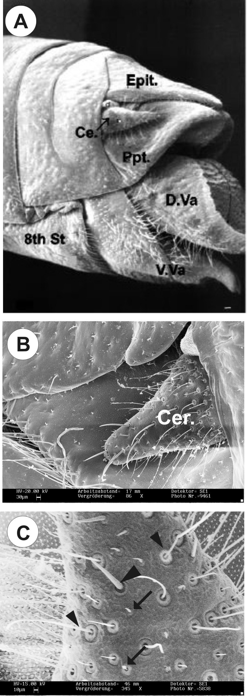
SEM showed that the sensory receptors associated with the cerci (Fig. 1) could be divided into two main types, mechanoreceptors and chemoreceptors (Figs. 1C). Cobalt staining of the peripheral nerves and sensory neurons confirmed the identity of both mechanosensory receptors (filiform sensilla) with one neuron below their cuticular structure and contact chemoreceptors (basiconic sensilla) with five neurons (Figs. 2 & 3) gathered below the small and blunt hair with a terminal pore.
High resolution scanning electron micrographs revealed that basiconic sensilla are peg-like structures (Fig. 1C), 15-30 µm long, about 3-4 µm in basal diameter and showed a pore at its tip (1.2 µm in diameter) that provides access for contact with chemicals. The basiconic sensilla are supplied with groups of five deeply staining neurons (4-5 μm in diameter) that lie beneath each basiconic sensillum. Proximal to the somata each sensory neuron extends its axon, which joins those from the other cells in the group to form a small nerve that finally enters larger nerves (Fig. 3B).
The filiform sensilla act as mono mechanoreceptors that respond to air currents as the wind-sensitive type (Fig. 5). The filiform sensilla are arbitrarily divided by size, shape and type of socket into two main types, the long sensilla over 200 µm in length and about 4.5 µm in diameter at their base and the short sensilla 40-100 µm long and about 3.5 µm in basal diameter (Fig. 1C & 3A).

Fig.1 Scanning electron micrographs of the terminal abdominal segments in female locust. Fig. 1A: Lateral view of the terminal abdominal segment showing the cercus (Cer), the paraproct (Ppt), the epiproct (Ept), the dorsal ovipositor valve (D ov.) and the ventral ovipositor valve (V ov.). Fig. 1B: Lateral view of the cerci with a large number of mechanosensory sensilla and chemosensory sensilla; Scale=30µm. Fig. 1C: Lateral margin of cerci fill with mechanoreceptors (filiform sensilla; arrow head) and contact chemoreceptors (basiconic sensilum; arrow); the basiconic sensilla scattered between the filiform sensilla; Scale=10 µm

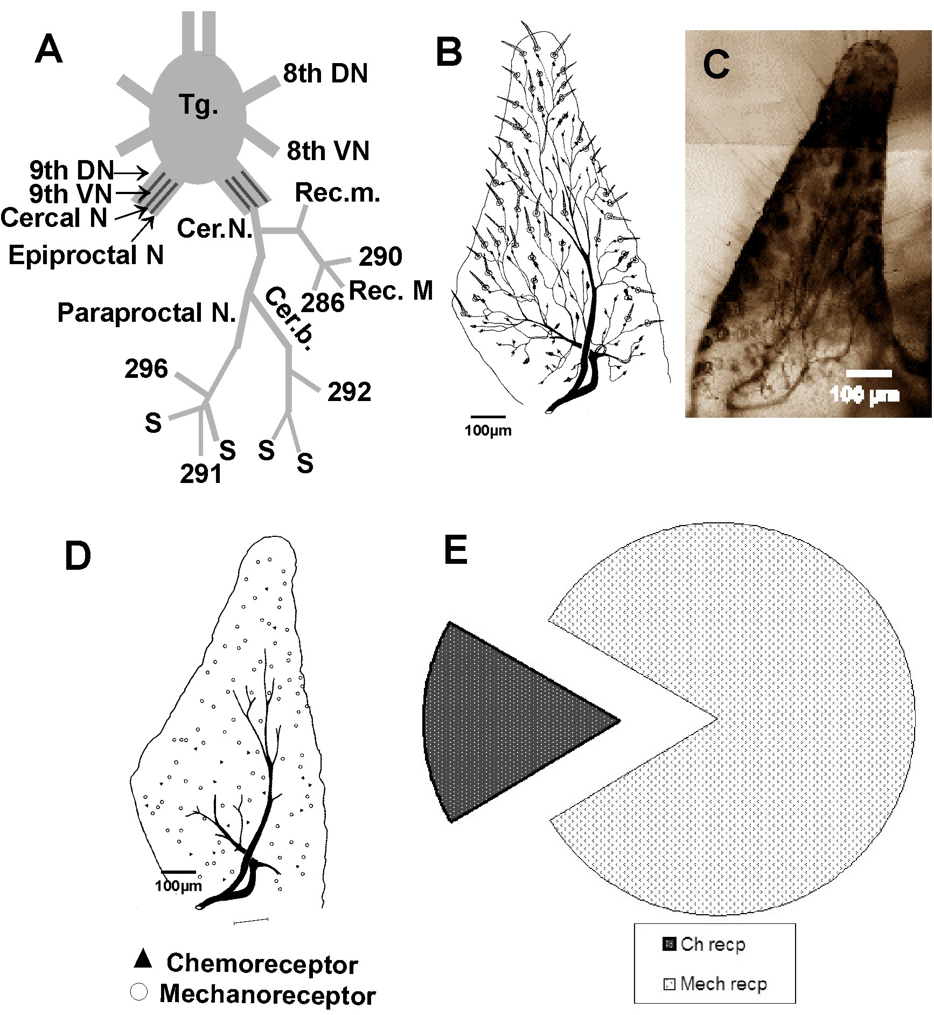
Fig. 2 A: Camera Lucida drawing of the terminal abdominal ganglion mass and the peripheral innervation of the terminal abdominal segments. Fig. 2B: Camera Lucida drawing of the peripheral innervation of the cerci female. Fig. 2C: Light micrograph of a whole mount stained with silver-intensified cobalt staining, showing the cerci sensilla and their innervation. Fig. 3D: Camera Lucida drawing shown the distribution of contact chemoreceptors (filled triangles) and mechanoreceptors (open circle) on the cerci of the female locust. Fig. 3E: Histogram showed the percentage of the contact chemoreceptors to the mechanoreceptors (open circle) on the cerci of the female locust.

As means of estimating the total number of receptors that were found on the locust subgenital plate, two basic types of receptors are present, contact chemoreceptors (Basiconic sensilla) and mechanoreceptors (filiform sensilla). It has been found that approximately 223 ± 5 receptors were identified and the average number of different types of receptors shows a ratio of 1:5 of chemosensory to mechanosensory sensilla (Figs. 2D & 2E).

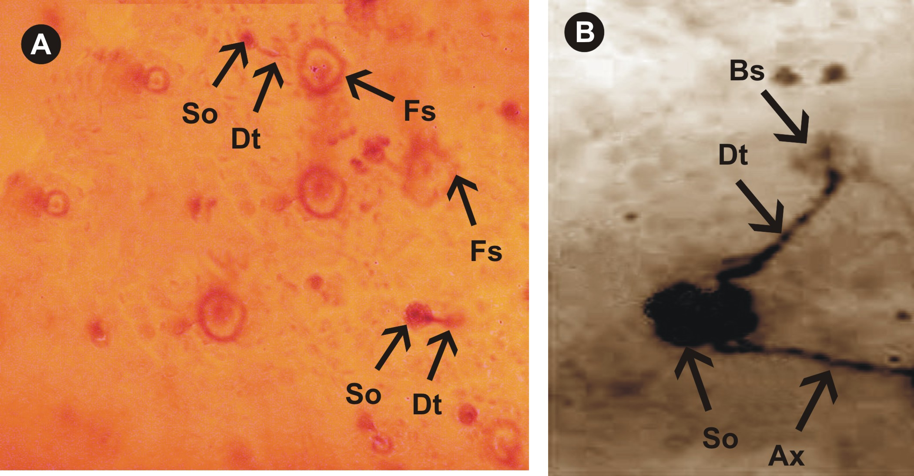
Fig. 3A: Light micrograph for individual filiform sensilla in the locust cerci innervated by single sensory neurons. Fig. 3B: Light micrograph for individual basiconic sensilla in the locust cerci innervated by five sensory neurons; (Fs, filiform sensilla; Bs, basiconic sensilla; So, sensory neuron; Dt, dendrites; Ax, axon).

Filiform sensilla on the cerci are each innervated by a single mechanosensory neuron (Fig. 3A), as indicated by the presence of spikes with single amplitude only in tip recordings from these sensilla following deflection of the hair-shaft (Figs. 5A-C). Similarly, only single sensory neurons were stained in the terminal ganglion in backfills from filiform sensilum using neurobiotin (Fig. 4A). These sensory neuron greater in diameter than the basiconic axon and entering the terminal ganglion via cercal nerve and have projection patterns in the 9th and 8th neuromere that is not resemble the neighboring basiconic afferents (Fig. 4C). The ipsilateral collateral ascends into the preceding ganglion.
Whenever a basiconic sensillum from the cerci was stained iontophoretically, five neurons (one mechanosensory and four presumably chemosensory) were revealed in the whole-mount (Figs. 4B.E). The axons enter the terminal abdominal ganglion via cercal nerve and proceed medially to the 9th and 8th abdominal neuromere. There, all axonal projections branch ventrally and send neuritis medially to the VAC at a median level within the VAC (Fig. 4D & 4E). From there, several branches extend into the contralateral neuropil and one turns posteriorly and only four collaterals proceed ventrally as a compact bundle through the anterior ipsilateral connective and into the 7th abdominal ganglion (Figs. 4B & 4C). These axons then proceed to the medio-ventral contralateral area of the 7th abdominal neuromere where they terminate.

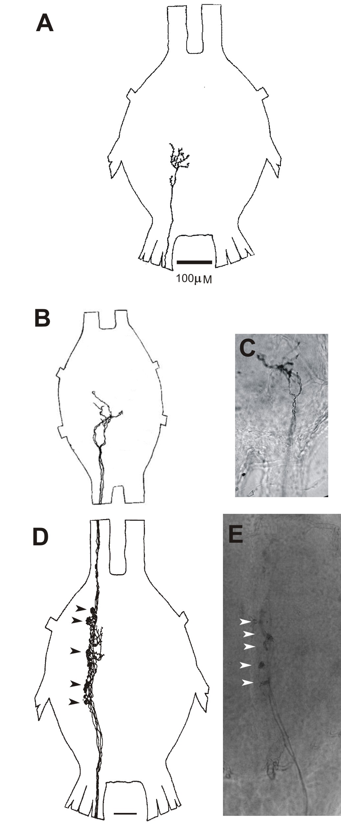
Fig. 4A: Central projections morphology in the terminal ganglion from individual filiform sensilla located on the cerci of the female locust. Fig. 4B-E: Central projections morphology in the terminal ganglion (D & E) and the seventh abdominal ganglion (B & C) from individual basiconic sensilla located on the cerci of the female locust, Five axons enter the terminal ganglion via the cercal nerve and proceed medially to the ninth and eighth abdominal neuromeres with glomeruli like structure (arrowheads) and only four lateral afferent collaterals proceed through the anterior ipsilateral connective on a ventral level into the seventh abdominal ganglion, where they terminate medio ventrally (B & C).
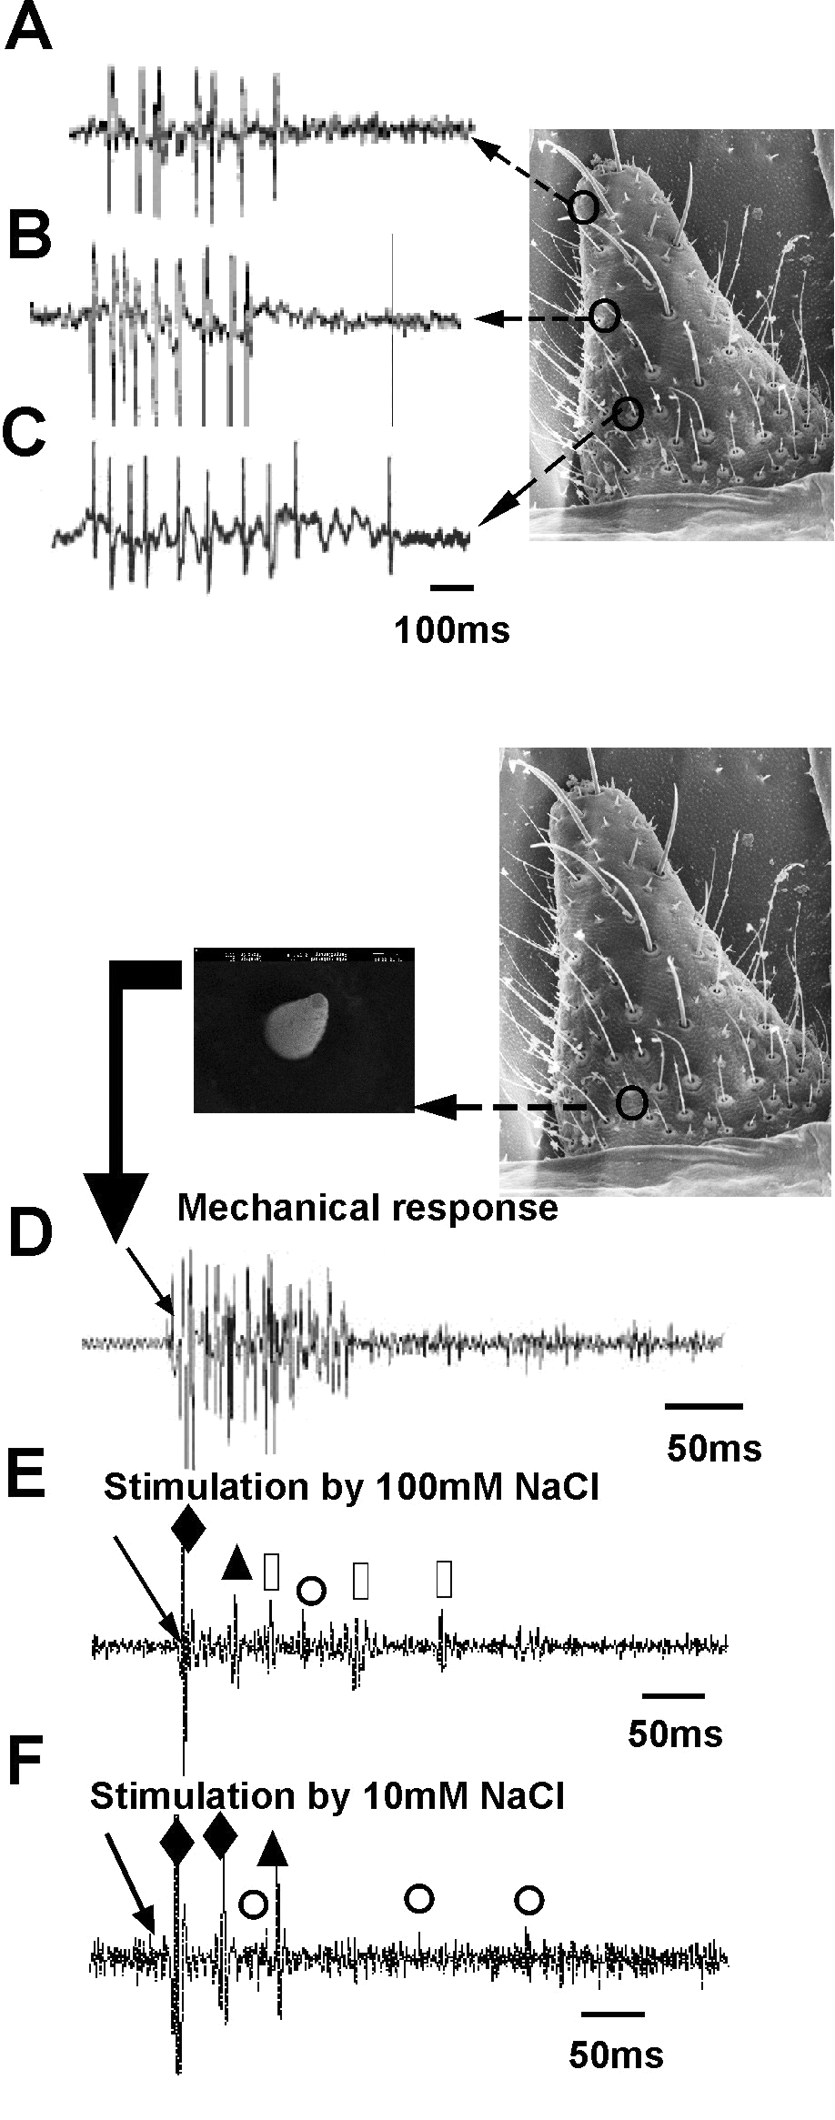
Fig. 5: Responses of individual filiform and basiconic sensilla on the cerci to mechanical and chemical stimulants. Fig. 5A-5C: Response of individual cut shaft filiform sensilla in the locust cerci to deflecting evokes a burst of action potentials of single amplitude, indicating that the filiform sensilum is innervated by a single neuron. Fig. 5D: Deflecting the cut shaft of a basiconic sensilum (arrows) evokes a burst of action potentials of single amplitude, indicating that the basiconic sensilum is innervated by a single mechanosensory neuron. Fig. 5E: Response of individual basiconic sensilla in the locust cerci to 100 mM NaCl evokes a burst of action potentials of different amplitudes (dots indicating the smaller amplitude spikes). Fig. 5F: Spikes of three chemosensitive neurons evoked by stimulation with 10mM NaCl, decreasing the sodium chloride concentration (10mM NaCl) decrease the amplitude of the response without increasing the number of firing neurons.

Stimulation of basiconic sensilla by using the tip recording techniques showed that basiconic sensilla responded to chemical and mechanical stimuli. Spikes with several distinct amplitudes were elicited by placing electrodes containing sodium chloride (100 mM or 10 mM) over basiconic sensilla (Figs. 5E & 5F), indicating that more than one chemosensitive neuron was activated by the salt solution. The response to salt in a single basiconic sensillum is phasic with at least two main units. The characteristic feature of the chemosensory neuron responses to different concentrations of NaCl was a rapid reduction of their spike frequency during maintained chemical stimulation. This rapid adaptation resulted in an almost complete abolition of their responses to a chemical stimulant within one second of its application. Deflecting the shaft of the basiconic sensillum 3 seconds later evoked a further burst of larger amplitude action potentials from a mechanosensitive neuron (Fig. 5D).

Discussion
This work in its first part is focused on the different cerci sensory receptors of the female locust, using the SEM and the neuroanatomical studied by shown the peripheral innervation of cerci with cobalt chloride backfill technique. Another focused on the central projection of single sensory neuron from mechanoreceptors and chemoreceptors in the CNS with immunocytochemical techniques. In addition to the focus on the electrophysiological response of individual mechanoreceptors or chemoreceptors to mechanical or chemical stimulation were analyzed. In the insect nervous system, the sensory afferents of cercal sensilla have proved important for the study of presynaptic inhibition. The cerci project posteriorly from the last segment of the abdomen and are covered with sensory hairs. Filiform sensilla are very sensitive to air currents and even to low-frequency sound (Ritzmann, 1984). Their afferents run into the terminal ganglion where they synapse with giant interneurones that ascend the ventral nerve cord (Boyan et al. 1989; Kalogianni, 1995). Wind stimuli to the cerci can initiate running, jumping or flying in various insects as part of escape behaviour (Ritzmann, 1984; Boyan et al. 1986). For the sensory input evoking such vital behaviour to be interpreted unambiguously, it is necessary that hair displacement brought about by air currents is distinguishable from that caused by movement of the cercus. In the locust, filiform afferents are inhibited by presynaptic depolarization during passive displacement of the cercus (Ritzmann, 1984). This is thought to be evoked by the activity of a stretch receptor at the base of the cercus acting via an unidentified interneurone.
It is difficult to imagine that the female desert locust could perform the complex oviposition behaviour with only a central motor pattern in the absence of tuning by a peripheral sensory loop. The present study shows that the cerci is well endowed with sense organs that could be the source of information about position, movement and the chemical characters of oviposition substrate. The results showed that about 18% of receptors are basiconic chemoreceptors, which are typically contact chemosensory sensilla of the thick-walled type (Slifer, 1970, Zacharuck, 1980). Thus, it is not surprising to find a great number of chemoreceptors on the cerci as those found on the ovipositor valves (Kalogianni, 1996; Tousson, 2001, 2004; Tousson and Hustert, 2000, 2006), on the paraproct (Tousson and Gaaboub, 2004) and on the subgenital plate (Tousson and Youssef, 2006). The central projections and intersegmental interneurons with chemosensory inputs from the contact chemoreceptors in Schistocerca gregaria have never been reported before. Tousson and Hustert (1998) have shown, for the first time, how neurons of a single insect contact chemoreceptors project in the CNS. Previously, cobalt staining of single sensory neuron was performed successfully, mainly in insect mechanoreceptors (Hustert et al., 1981; Pflüger et al., 1981; Hustert, 1983; Tousson et al., 1999; Newland, 2004) but it did not work reliably for axon diameters of less than 1 µm that prevail for insect contact chemoreceptors. In the current study, we used the neurobiotin backfill technique (Tousson and Hustert, 1998) to identify the central projections of a single contact chemoreceptor. The present study also focused on the periphery and sensory innervation of the subgenital plate, in addition to the fine structure and distribution of various types of sensory sensilla investigated with cobalt chloride backfilling and scanning electron microscope. Another focus was on physiological responses and central nervous integration of basiconic sensilla to different concentration of sodium chloride solution. The central projections from cercal basiconic sensilla in the terminal ganglion resemble in outline the parproctal (Tousson and Gaaboub, 2004), but narrow and dense fields of arborization form in the ninth and the eighth neuromere, some of them shaped like glomeruli usually involving three different afferents.These sensilla are multimodal receptors which encode both mechanical and chemical cues. This means that these contact chemoreceptors may help the ovipositor on probing for suitable sites for oviposition and egg laying or may be play the some role in searching for food, similar to chemoreceptors on the tarsi of the fore and middle legs (Tousson et al., 1999; Gaaboub, 2000; Newland, 2004; Gaaboub et al., 2005).

References
Bacon, J. P. and Altman, J. S. (1977): A silver intensification method for cobalt-filled neurons in whole-mount preparations. Brain Res., 138: 395-363.
Bharadwaj, R. K. and Banerjee, S. K. (1971): The nervous system of the desert locust with a discussion on muscle innervation. J. Nat. Hist., 5: 183-208
Boyan, G. S. and Ball, E. E. (1990): Neural organization and information processing in the wind sensitive cercal receptor / giant interneuron system of the locust and other orthopteroid insects. Progress in Neurobiology, 35: 217-243.
Boyan, G. S.; Williams, E. E. and Ball, E. E. (1989): The wind sensitive cercal / giant interneuron system of the Locusta migratoria (Anatomy of the system). J. Comp. Physiol., 165: 495-510.
Camhi, J. M (1980): The escape system of cockroach. Sci. Am., 243: 144-157.
Clements, A. N. and May, T. E. (1974): Studies on locust neuromuscular physiology in relation to glutamic acid. J. Exp. Biol., 60: 673-705.
Gaaboub, I. (2000): Neural processing of chemosensory information from the locust legs. Ph.D. Goettingen University, Germany.
Gaaboub I, Schuppe H, Newland PL, 2005. Receptor sensitivity underlies variability of chemosensory evoked avoidance movements of the legs of locusts. J. Comp. Physiol., 191: 281-289.
Hodgson, E. S.; Lettvin, J. Y. and Roeder, K. D. (1955): Physiology of a primary chemoreceptor unit. Science, 122: 417-418
Heblich, R. and Hörner, M. (2001): Aminergic modulation of the cricket giant pathway: Electrophysiology and pharmacology. Proc. 28th Goettingen Neurobiology Conference, Volume 2: 758 (Abstract).
Hustert R. (1983): Propioceptores responses and covergence of proprioceptive influence on motor neurons in the mesothoracic thoraco-coxal joint of locusts. J. Comp. Physiol., 150: 77-86.
Hustert R, Pflüger HJ, Bräuning P. 1981. Distribution and specific central projections of mechanoreceptors in the thorax and proximal leg joints of locusts. III. The external mechanoreceptors: The campaniform sensilla. Cell Tissue Res., 216: 97-111.
Kalogianni E (1995) Physiological properties of wind-sensitive and tactile sensilla on the ovipositor and their role during oviposition in the locust. J Exp Biol 198:1359 1369
Kalogianni, E. (1996): Morphology and physiology of abdominal intersegmental interneurons in the locust with mechanosensory inputs from ovipositor hair receptors. J. Comp. Neuro. 366: 656-673.
Kohstall, D. (1996): Verarbeitung Cercaler Eingänge durch Lokale und Aszendierende Interneurone im Terminalganglion Laufender Grillen. Ph.D. Dissertation, Goettingen Univ., Germany.
Newland, P.L. (2004). Taste coding in the locust central nervous system. In: Methods in Insect Sensory Neuroscience (Christensen, T., ed). CRC Press, p289-318.
Newland, P. L. and Burrows, M. (1994): Processing of mechanosensory information from gustatory receptors on a hind leg of the locust. J. Comp.Phys., 174: 399-410.
Newland, P. L.; Rogers, S.; Gaaboub, I. and Matheson, T. (2000): Parallel Somatotopic Maps of Gustatory and Mechanosensory Neurons in the CNS of an Insect. J. Comp. Neurol., 425 : 82-96.
Pflüger, H. J.; Bräuning, P. and Hustert, R. (1981): Distribution and specific central projections of mechanoreceptors in the thorax and proximal leg joints of locusts. II. The external mechanoreceptors: Cell Tissue Res., 216: 79-96.
Pitman, R. M.; Tweedle, C. D. and Cohen, K. (1972): Branching of central neurons: Intracellular cobalt injection for light and electron microscopy. Science, 176: 412 –414.
Ritzmann, R. E. (1984). The cockroach escape response. In Neural Mechanisms of Startle Behaviour (ed. R. C. Eaton), pp. 93–131. New York, London: Plenum.
Rogers, S. M., Matheson, T., Despland, E., Dodgson, T., Burrows, M. and Simpson, S. J. (2003). Mechanosensory-induced behavioural gregarization in the desert locust Schistocerca gregaria. J. Exp. Biol. 206, 3991-4002.
Slifer EH. 1970. The structure of arthropod chemoreceptors. Ann. Rev. Entomol., 15: 121-142.
Tousson, E. (2001): Neural processing of chemosensory information from the locust ovipositor. Ph.D. Goettingen University, Germany.
Tousson, E. (2004): Neuroanatomical and electrophysiological studies of identified contact chemoreceptors on the ventral ovipositor valve of 3rd instar larvae of lubber grasshoppers (Taeniopoda eques). Zoology, 107: 65 –73.

Tousson E, Gaaboub I. 2004. Neuroanatomical and electrophysiological relationships between sensory afferent arborizations in the locust paraproctal sensory systems. The 3rd Proc. ICBS, 3: 595 – 614.
Tousson, E. and Hustert R. (1998): Contact chemoreceptors from different sites have different projection patterns in the locust terminal ganglion. Proc. 26th Goettingen Neurobiology Conference, Volume 2. p. 594 (Abstract).
Tousson, E. and Hustert, R (2000): Central projections from contact chemoreceptors of the locust ovipositor and adjacent cuticle. Cell Tissue Res., 302 (2): 285-294.
Tousson E and Hustert H (2006): The Intersegmental Network of Afferents in the locust abdominal ganglia. Cell and Tissue Research, 325: 151-162.
Tousson E and Youssef Z (2006): Innervation, Central Projections and Intersegmental Interneurons with Chemosensory Inputs from the Locust Subgenital Plate Hair Receptors. Egypt. J. Exp. Biol. (Zool.), 2: 21-31.
Tousson, E. M., Gaaboub, I. and Hustert, H (1999): Response characteristics and specificity of contact chemoreceptors from different sites in Locusta migratoria. Proceeding of the 27 th Göttingen Neurbiology conference 1999, volume II, P 348.
Zacharuk RY. 1980. Ultrastructure and function of insect chemosensilla. Annu. Rev. Entomol., 25: 27-47.

