Physico-Chemical and Microbiological Study of Tehri Dam Reservoir, Garhwal Himalaya, India

Ashok K. Agarwal and Govind S. Rajwar
Department of Botany
Government Post Graduate College
Rishikesh 249201, Uttarakhand, India
E-mail: rajwargs@hotmail.com

ABSTRACT : In the present study physico-chemical and microbiological characteristics of the water of Tehri dam reservoir in the Garhwal Himalaya of India were determined during June 2003 through May 2005 when the reservoir was under construction, and was 5 km long and 40 m deep having an area of 2.2 sq km, and is located at 30º23' N latitude, 78º 29'E longitude and 635 m altitude at monthly intervals during June 2003 through May 2005 with an objective to estimate the impact of the reservoir on various physico-chemical and microbiological parameters of the water. Total solids, total suspended solids, total solids, turbidity and sulphate values were maximum on all the sites in rainy months, which may be due to the gradual disturbances in sedimentation of solids as well as dust particles deposited along with runoff rainwater. The alkalinity varied during different months. The values of pH, conductivity, hardness, calcium, dissolved oxygen and biological oxygen demand were higher during summer months. The chloride concentration was highest in the month of January and the nitrate increased in the summer months and early monsoon due to the higher phytoplanktonic production. The maximum number of total coliform, faecal coliform and total plate count was observed during summer and rainy seasons and minimum during winter. [Journal of American Science 2010;6(3):xx-xx]. (ISSN: 1545-1003).

Keywords: Physico-chemical characteristics, Tehri Dam, Himalaya.

1. INTRODUCTION
Water is the elixir of life and abounds on earth, but this vast natural resource has been depleted and turned into scarce commodity with increased usage catering to the needs of ever-expanding population. There is almost a global shortage of water and the world's most urgent and front rank problem today is supply and maintenance of clean drinking water. The climate change and spells of droughts have even stressed regional water tables. There are strides to fight the grim battle of acute shortages of water. The problems relating to water attract the attention to the urgency for investigating causes and suggest remedies in a bid to prepare future plan of action for maintenance of potable waters and related development issues.
The lakes are large or considerable body of water within land (Wetzel, 1983). The maintenance of a healthy aquatic ecosystem is dependent on the physico-chemical properties of water and the biological diversity. A large number of streams and rivers in India have been impounded to store the water for multipurpose beneficial uses like irrigation, fisheries, power generation and drinking water supply. Now-a-days, the ecology of reservoirs is under stressed condition due to fast pace of development, deforestation, cultural practices and agriculture. These activities trigger the rate of sedimentation of the reservoir bed characterised by silt and organic suspended material which initiates the process of eutrophication at a very early stage and show a deterioration of habitat quality.
The main purpose of analysing physical, chemical and microbiological characteristics of water is to determine its nutrient status. Since, the water contains dissolved and suspended materials in various proportions, its physical and chemical characteristics differ along with its biological characteristics. The water quality is also affected by pollutants which act on elements existing in water such as dissolved oxygen or produce substances such as ammonia, nitrates etc. It is not possible to understand biological phenomena fully without the knowledge of water chemistry as the limnobiological and limnochemical components of the ecosystem. If we can find some correlations among these numerous parameters, however, the task of periodic monitoring of water quality may be facilitated to a good extent (Tiwari, 1992). The physico-chemical means are useful in detecting effects of pollution on the water quality but changes in the trophic conditions of water are reflected in the biotic community-structure including species pattern, distribution and diversity (Kaushik and Saksena, 1995). Some ponds of India have been extensively studied by various workers (Michael, 1969; Saha et al., 1971; Vasisht and Sharma, 1975).
The present study has provided detailed information on physico-chemical and microbiological parameters of the Dam reservoir water at three different sites with an objective to indicate changes in the quality of waters at the beginning and lower end of the reservoir. The study will be helpful in estimating the impact of the reservoir on various physico-chemical and biological parameters of the water.

2. MATERIALS AND METHODS
Study Area
The large multipurpose Tehri Dam, during the present study was under final stage of construction near the confluence of the Bhagirathi and Bhilangana rivers near old Tehri Town, has two main catchments of these rivers draining into its reservoir. Both these rivers originate in the glaciers of the higher Himalayan region and flow through deep gorges, dense forests and habitation alike (Figure 1). The source of river Bhagirathi is Gaumukh, while the Bhilangana originates from the comparatively smaller Khatling glacier. The Tehri dam is the highest earth rockfill dam in Asia. During the period of present study the reservoir was 5 km long and 40 m Deep having 2.2 sq km area and is located at 30º 23' N latitude, 78º 29' E longitude and 635 m altitude. Three sites selected for the study along reservoir banks were as follows (Figure 2):
1. Old Tehri Iron Bridge
2. Padiyar Village
3. Kandal Village

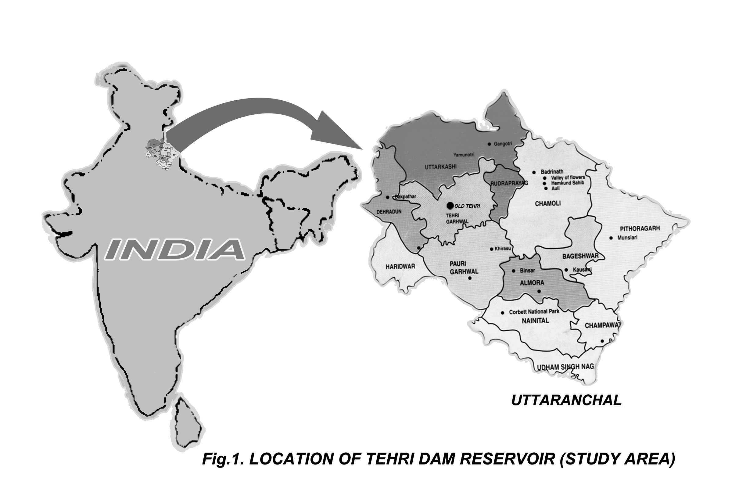
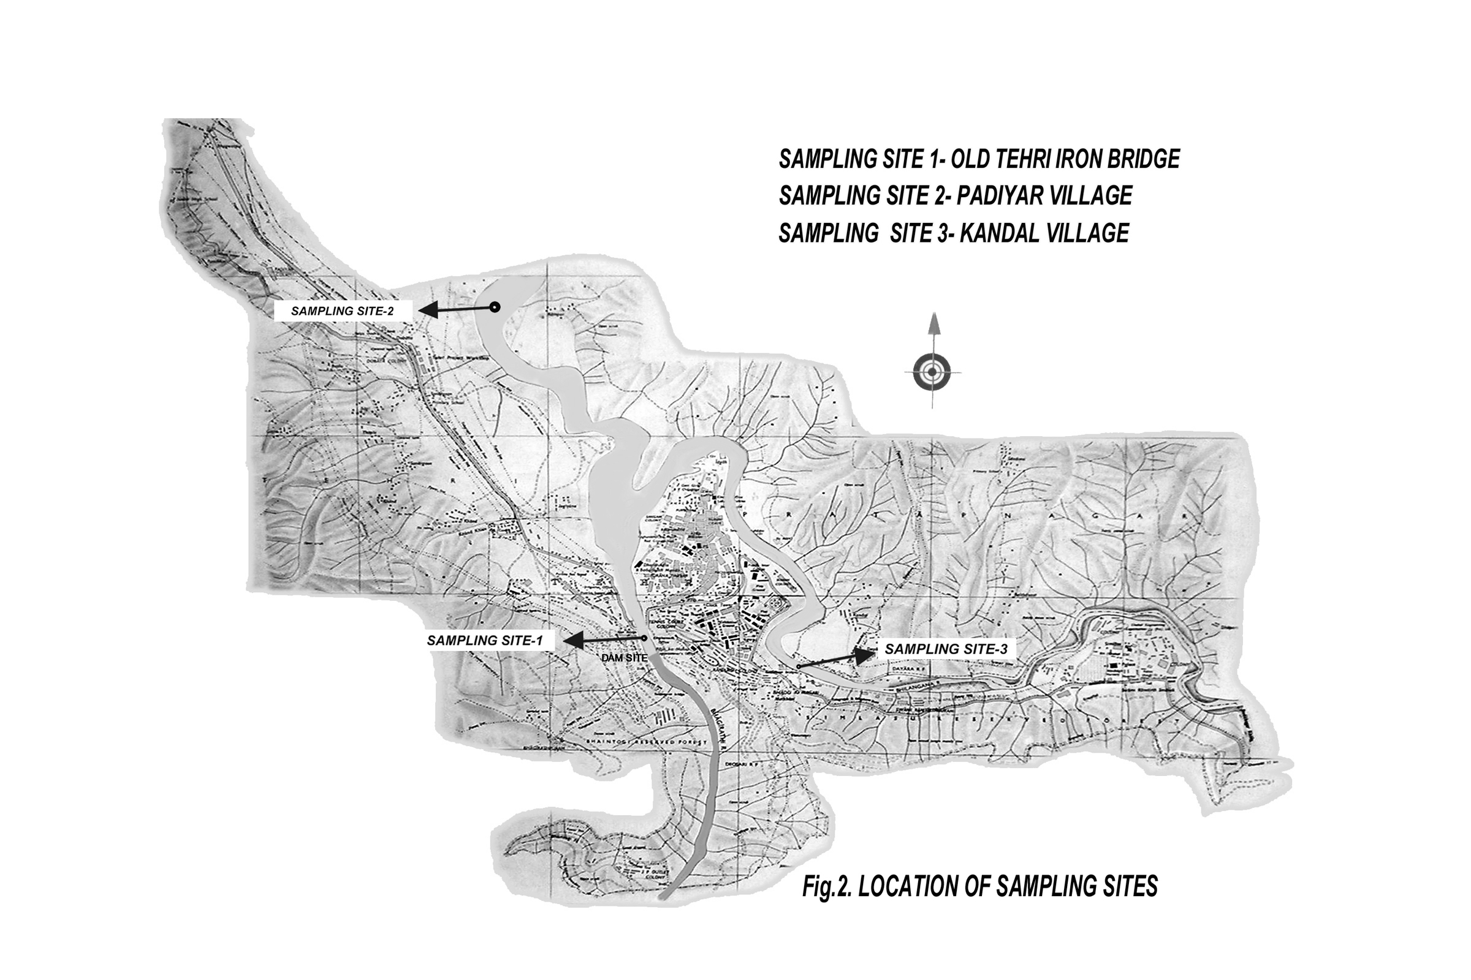

First two study sites were situated on right side of the reservoir and third site was on the left side. The water of the reservoir is generally used for washing the clothes and drinking purposes near the settlements.

Climate
The climate of the study area is tropical monsoonic with three distinct seasons. The atmospheric temperature ranged between a minimum of 5ºC in December and January, and maximum of 37ºC in June during the study period. The maximum rainfall (230 mm) occurred in July, whereas the humidity ranged from 47% (May) to 92% (January).

Methods
Following characteristics were analysed in the study:
1. Physical Characteristics: The physical characteristics included temperature colour, conductivity, turbidity, total dissolved solids (TDS), total suspended solids (TSS), total solids (TS).
2. Chemical Characteristics: The chemical characteristics included alkalinity, hardness, pH, dissolved oxygen (DO), chemical oxygen demand (COD), biological oxygen demand (BOD), total kjeldahl nitrogen (TKN), ammonical nitrogen, chloride, nitrate, phosphate, sulphate and calcium.
4. Microbiological Parameters: The microbiological parameters included green algae, blue-green algae, diatoms, total coliforms (TC), faecal coliforms (FC) and total plate count (TPC).
The water and algal samples were collected, studied and analysed from three study sites at monthly intervals during June 2003 through May 2005. All water samples for the estimation of different parameters were collected in the early hours of morning on a specified date. The samples were pretreated in the field to fix the samples and immediately brought to the laboratory for an on spot physical, chemical and microbiological analysis of various parameters following the standard methods (APHA, 1998). The data were analysed and compared statistically.

3. RESULTS AND DISCUSION
The quality of natural water is generally governed by various physico-chemical and biological parameters. The maximum and minimum values for various parameters during the study period are presented in Tables 1-3.

Water temperature
The maximum and minimum temperatures of reservoir water were observed in the months of June and January respectively on all the sites. The values ranged between 7.03-27.03 0C. Steady change in the atmospheric temperature with the change in the seasons results in the corresponding change in the water temperature. There is a very close similarity between the temperature of atmosphere and water due to the depth of reservoir. High summer temperature and bright sunshine accelerate the process of decay of organic matter resulting into the liberation of large quantities of CO2 and nutrients.

Turbidity
The maximum value of turbidity was recorded during July to September (monsoon period) and minimum during winter period on all the sites. The increased turbidity during rainy months was attributed to soil erosion in the nearby catchment and massive contribution of suspended solids from sewage. Surface runoffs and domestic wastes mainly contribute to the increased turbidity of the reservoir. But in this region, the suspended solids play an important role in governing the turbidity, which enter the reservoir through land erosion.

Total dissolved solids (TDS)
The values of TDS were maximum in the months of April and May. The minimum values were observed in the months of June on sites 2 and 3, and in August on site 1 (Table). Sabata and Nayar (1995) in Ganga water showed wide variation in TDS in different months on different sites.

Table 1. Maximum and minimum values for various physico-chemical characteristics for site I of Tehri dam reservoir

.

PARAMETER | UNIT | MAXIMUM VALUE AND MONTH |  | MINIMUM VALUE AND  MONTH
Temperature | 0C | 26.06 | June | 7.03 | January
Conductivity | µ mhos | 0.162 | May | 0.099 | October, November
Turbidity | NTU | 159 | July | 14.1 | January
TDS | mg/l | 134 | July | 87.3 | August
TSS | mg/l | 116 | July | 13.8 | January
TSS | mg/l | 250.2 | July | 102 | January
Alkalinity | mg/l | 64.2 | July | 40.1 | January
Hardness | mg/l | 72.0 | May | 48.0 | January
pH |  | 7.98 | May | 6.79 | June
DO | mg/l | 8.2 | June | 7.06 | September
COD | mg/l | 24.1 | May | 8.9 | December
TKN | mg/l | 4.48 | April | 0.29 | October
Ammonical nitrogen | mg/l | 0.042 | April | 0.028 | March
Chloride | mg/l | 20.3 | January | 9.0 | October
Nitrate | mg/l | 1.19 | June | 0.25 | February
Phosphate | mg/l | 1.14 | April | 0.03 | February
Sulphate | mg/l | 37.7 | July | 18.7 | June, October, February
Calcium | mg/l | 25.7 | April | 14.4 | February
BOD | mg/l | 3.6 | April, May | 0.5 | September

Table 2. Maximum and minimum values for various physico-chemical parameters for Site II of Tehri dam reservoir

.

PARAMETER | UNIT | MAXIMUM VALUE AND MONTH |  | MINIMUM VALUE AND  MONTH
Temperature | 0C | 27.03 | June | 9.0 | January
Conductivity | µ mhos | 0.441 | February | 0.085 | September
Turbidity | NTU | 295.0 | July | 14.8 | May
TDS | mg/l | 118.0 | April | 80.4 | June
TSS | mg/l | 493.4 | June | 19.1 | January
TSS | mg/l | 573.8 | June | 104.2 | January
Alkalinity | mg/l | 70.1 | May | 37.2 | January
Hardness | mg/l | 72.2 | May | 35.2 | January
pH |  | 7.85 | July | 7.2 | June
DO | mg/l | 8.96 | June | 6.56 | September
COD | mg/l | 39.4 | July | 5.9 | January
TKN | mg/l | 3.92 | February | 0.27 | December
Ammonical nitrogen | mg/l | 0.062 | March | 0.06 | July
Chloride | mg/l | 15.9 | May | 9.9 | July
Nitrate | mg/l | 0.97 | May | 0.12 | June
Phosphate | mg/l | 0.85 | April | 0.05 | October
Sulphate | mg/l | 38.0 | July | 14.2 | November
Calcium | mg/l | 21.1 | May | 11.3 | June
BOD | mg/l | 3.4 | May | 0.5 | June

Table 3. Maximum and minimum values for various physico-chemical parameters for Site III of Tehri dam reservoir.

PARAMETER | UNIT | MAXIMUM VALUE AND MONTH |  | MINIMUM VALUE AND  MONTH
Temperature | 0C | 27.0 | June | 9.03 | January
Conductivity | µ mhos | 0.176 | May | 0.097 | June
Turbidity | NTU | 278.0 | August | 18.0 | January
TDS | mg/l | 126.0 | May | 84.1 | June
TSS | mg/l | 513.9 | June | 28.9 | January
TSS | mg/l | 598.1 | June | 119.5 | January
Alkalinity | mg/l | 71.8 | Feb | 39.0 | September
Hardness | mg/l | 71.9 | October | 38.9 | January
pH |  | 7.91 | May | 7.25 | June
DO | mg/l | 8.56 | June,July | 7.5 | September
COD | mg/l | 32.2 | September | 8.2 | January
TKN | mg/l | 4.22 | April | 0.48 | August
Ammonical nitrogen | mg/l | 0.076 | March | 0.031 | May
Chloride | mg/l | 19.2 | January | 8.0 | October
Nitrate | mg/l | 0.8 | May | 0.08 | June
Phosphate | mg/l | 1.6 | April | 0.03 | November
Sulphate | mg/l | 38.0 | July | 16.3 | February
Calcium | mg/l | 25.6 | April | 11.2 | October
BOD | mg/l | 4.7 | August | 0.3 | July

Total suspended solids (TSS)
The value of TSS ranged between 13.8 and 513.9 mg/l on different sites of the present reservoir. Suspended solids cause ecological imbalance in the aquatic ecosystem by mechanical abrasive action. Suspended solids may be in the form of coarse, floating, fine or colloidal particles as a floating film. Maximum values reported in the present study during monsoon months at all study sites were due to increased surface runoff from nearby catchments. Most of the Indian reservoirs and rivers showed a similar tendency with respect to fluctuations of suspended solids.

Total solids (TS)
TS values were maximum on all the sites in rainy months which may be due to the gradual disturbances in sedimentation of solids as well as dust particles deposited along with runoff rainwater. The high amount of TS on all sites affects the quality of running water and it is unsuitable for any other purpose including irrigation and drinking. The dissolved solids in a reservoir depend on various parameters such as geological character of the watershed, rainfall and amount of surface runoff.

Alkalinity
Alkalinity of water is a measure of weak acid present in it and of the cations balanced against them. Alkalinity plays an important role in controlling enzyme activities. Maximum and minimum values of alkalinity on different sites of the present study showed variations in different months. Venkateswarlu (1969) attributed that there is an indication to suggest that alkalinity concentration is affected directly by rainfall. Similar effect has been noticed in the present investigation immediately often the onset of rains. The alkalinity of this reservoir indicated the productive nature of water as also shown in findings of Banerjea (1979) in a man-made reservoir of India. Man-made water bodies usually show wide range of fluctuation in alkalinity values depending upon a number of factors. According to Michael (1969), alkalinity concentration is affected directly by rainfall. In the present investigation also, alkalinity level reduced in the post-rainy months. Higher level of alkalinity during summer months as observed in the most of the sites has also been reported by Singh and Saha (1987).

Hardness
The water hardness on all study sites of Tehri dam reservoir was higher during summer months which might have caused increased concentration of salts by excessive evaporation as also observed by Bhatt et al. (1999). The hardness of river increases in the polluted waters by the deposition of calcium and magnesium salts. Since the study area is free from industrial pollution, the hardness was observed quite low, which was because of several calcium and magnesium salts coming from the mountain area. The hardness was positively related with rainfall on all the sites (r=0.1762 to 0.3547).

pH
The pH is affected not only by the reaction of carbon dioxide but also by organic and inorganic solutes present in water. Any alteration in water pH is accompanied by the change in other physico-chemical parameters. pH maintenance (buffering capacity) is one of the most important attributes of any aquatic system since all the biochemical activities depend on pH of the surrounding water. In the present study, the range of pH on the study sites was between 6.79 to 7.98. pH increased during summer months and decreased during monsoon and winter months. Maximum values during summer may be due to increased photosynthesis of the algal blooms resulting into the precipitation of carbonates of calcium and magnesium from bicarbonates causing higher alkalinity. The decrease in pH during winter may be due to decrease in photosynthesis, while during monsoon it may be due to greater inflow of water.

Dissolved oxygen (DO)
DO is a very important parameter of water quality and an index of physical and biological process going on in water. In the present study, the maximum concentration of dissolved oxygen was observed in the month of June after the snow melting due to heavy rainfall, which favours solubility of oxygen among the study sites. The highest concentration (8.96 mg/l) was recorded on site 2 but the range was not narrow for other sites. A definite trend in DO concentration was observed on all the sites showing highest values in June and lowest in September. DO is of great importance to all living organisms. It may be present in water due to direct diffusion from air and photosynthetic activity of autotrophs. Concentration of DO is one of the most important parameters to indicate water purity and to determine the distribution and abundance of various algal groups.

Chemical oxygen demand (COD)
COD is a measure of pollution in aquatic ecosystems. It estimates carbonaceous factor of organic matter. The range of values of COD in the present study was 5.9 to 39.4 mg/l. The maximum values of COD at sites 2 and 3 indicated the higher degree of pollution compared to that of site 1. Higher concentration of COD in summer and rainy months may be due to high temperature and higher concentration of suspended and dissolved solids.

Biochemical oxygen demand (BOD)
BOD is the amount of oxygen required by the living organisms engaged in the utilization and ultimate destruction or stabilization of organic water (Hawkes, 1963). It is a very important indicator of the pollution status of a water body. The values of BOD clearly showed higher concentration during most of the summer and rainy months and comparatively low during winter months. Many workers like John (1952), Robert (1969) and Richard (1966) showed higher BOD during summer due to low level at river discharge. This is supported by the results of present study (0.3 to 4.7 mg/l) as the river had low flow during the winter season.

Total kjeldahl nitrogen (TKN)
TKN is a measure of organic nitrogen plus ammonical nitrogen. It plays as important role in the eutrophication of water along with phosphates. The values for different sites ranged from 0.27 to 4.48 mg/l which indicated no organic pollution. The main material source of TKN in aquatic ecosystem is the death and decay of the plant and animal remains which contains nitrogenous substances and is incorporated into the soil.

Ammonical nitrogen
Ammonical nitrogen reaches reservoir through diverse sources, major contributor being domestic wastes. Significant amount of ammonical nitrogen was recorded during March, April and May on all the sites, and in February and July on site 2 ranging showing a range from 0.06-0.076 mg/l. This was low because of no sewage pollution. It was mostly not detected on the sampling sites in most months of the year except summer months. In many samples it could not be detected. Most of the Indian authors have not investigated ammonical nitrogen in rivers.

Chloride
Chloride is one of the important indicators of pollution. Chlorides are present in sewage, effluents and farm drainage. The value of chloride concentration in the present study was highest on site 1 (20.3 mg/l) and site 3 (19.2 mg/l). These values are usually in the lower range of values for different rivers of India (Sabata and Nayar, 1995). The low value in the present study may be attributed to the absence of major pollutants.

Nitrate
Nitrate concentration depends on the activity of nitrifying bacteria which in turn get influenced by presence of dissolved oxygen. In the present study the values of nitrate ranged from 0.08 to 0.97 mg/l showing highest values in summer months and early monsoon on all the sites. This may be due to the higher phytoplanktonic production, decaying macrophytes and concentration of nutrients owing to the evaporation of reservoir water with subsequent increase in nitrate value. These observations have also been stressed by Epstein (1972) in his observations. Decrease in nitrate content during winter months was probably due to its utilization as nutrient by the algal community as evidenced by the luxuriant growth of algae particularly in the winter months.

Phosphate
The amount of phosphate on all the sites of reservoir is observed probably due to the presence and decomposition of aquatic vegetation which releases phosphate. The phosphate is an important constituent not only for the aquatic vascular plants but also for the growth of phytoplankton. Phosphate was found only in smaller amount on all sites. The low concentration of phosphate affects the growth of aquatic flora as it is very essential plant nutrient. The concentration of phosphate was more in summer during which the blooms of algae were observed, while minimum value in winter months was possibly due to its immediate utilization by the overgrowth of phytoplankton.

Sulphate
Sulphur is utilized by all living organisms in the form of both mineral and organic sulphates. The highest concentration of sulphates was observed during rainy season from July to September, which was caused by the surface run-off bringing into the river more suspended solids along with organic matter and soluble salts from the catchment area. The concentration of sulphate was positively related with rainfall showing higher value of correlation coefficent.

Calcium
Calcium is essential for all organisms and regulates various physiological functions. The calcium ions contribute to the hardness of water. The concentration of calcium was highest in the month of April on sites 1 and 3, and in May on site 2. The highest values of calcium were obtained on sites 1 and 3 than on site 2. The lesser amount of calcium was due to more presence of macrophytic vegetation which utilizes calcium as one of the nutrient as also due to large size of phytoplankton.

Coliforms (total and faecal) and total plate count
The luxurious growth of bacterial population during summer and monsoon months is the outcome at the influx of washed organic matter in the reservoir from the surrounding forest areas. It is natural that the incoming nutrient load finds its way first to the surface, thereby encouraging bacterial proliferation during monsoon. Collins (1963) has suggested that the rains bring in particulate matter, which serves as sites of adsorption for bacteria, thereby increasing the bacterial load.
In the present study, the maximum number of total coliforms was in the month of April and June. The minimum number was recorded in the month of January. Total plate count ranged between 15.3 to 94.6 colonies on the study sites. The higher values were recorded on sites 2 and 3 during summer season.

CORRESPONDIG AUTHOR
Dr. Govind S. Rajwar FLS
Department of Botany
Government Post Graduate College
Rishikesh 249201, Uttarakhand
India
Email: rajwargs@hotmail.com

REFERENCES

APHA. Standard methods for the examination of water and waste water, 2nd ed. American Public Health Association, Washington, D.C. 1998.
Banerjea SM. Soil condition and water quality of man-made reservoirs in India. Summ. Inst. Capt. Cult. Fish. Man-made Lakes-India. 7th July-6th August 1979. Barrackpore, Kolkata. 1979.
Bhatt LR, Lacoul P, Lekhak HD, Jha PK. Physico-chemical characteristics and phytoplanktons of Taudaha lake, Kathmandu. Poll. Res. 1999;18(4):353-8.
Collins VG. The distribution and ecology of bacteria in fresh water. Proc. Soc. Wat. Treat. Exam. 1963;12:40-73.
Epstein E. Mineral nutrition of plants: Principles and perspectives. John Wiley and Sons, New York, 1972;412.
Golterman HL. Chemistry. In: Whitton BA, ed. River ecology. Blackwell Scientific Publications, Oxford, London, Edinburgh, Melbourne. 1975;39-80.

Hawkes HA. The ecology of waste water treatment. Pergamon Press, Oxford. 1963.
John DP. Water pollution, its effects on the public health. Proc. Fish Ohio Water Clinic, Ohio State Univ. Eng. Series Bull. 1952;147:34-9.
Kaushik S, Saksena DN. Trophic status and rotifer fauna of certain water bodies in central India. J. Environ Biol. 1995;16(4):283-91.
Michael RG. Seasonal trends in physico-chemical factors and plankton of freshwater fish pond and their role in fish culture. Hydrobiologia 1969;33:145-60.
Richard LW. Environmental hazard of water pollution. New England. J. Medicine 1966;275:819-25.
Robert DH. Water Pollution. Bioscience 1969;19:976.
Sabata BC, Nayar MP. River pollution in India: A case study of Ganga river, 1995;33.
Saha GN, Sehgal PL, Mitri E, Nandy AG. Studies on the seasonal diurnal variation in physicochemical and biological conditions of a perennial freshwater pond. J. Inland. Fish. Soc. India 1971;8:79-102.
Singh B, Saha PK. Primary productivity in a composite fish culture pond at Kulia fish farm, Kalyani, West Bengal. Prod. Nat. Acad. Sci. India 1987;57:124-30.
Tiwari TN. Pollution of lake Hussain Sagar, Hyderabad, India: Correction and cluster analyses. In: Mishra SR, Saksena DN, eds. Aquatic ecology. Ashish Publishing House, New Delhi, 1992;213-29.
Vashisht HS, Sharma BK. Ecology of a typical urban pond in Ambala city of the Haryana State. Ind. J. Ecol. 1975;2:79-86.
Venkateswarlu V. An ecological study of the algae of the river Moosi, Hyderabad (India) with special reference to water pollution-I: Physico-chemical complexes. Hydrobiologia 1969;33:117-43.
Walling DE. Water in catchment ecosystem. In: Gower AM, ed. Water quality in catchment ecosystem. John Wiley and Sons, New York. 1980.
Wetzel RG. Limnology, ed. 1. Saunders College Publishing, Orlando, Florida, Philadelphia. 1983.

