Light Hydrocarbon Correlation of Niger Delta Crude Oils

*Mark O. Onyema and Patience N. Manilla

Department of Pure and Industrial Chemistry, University of Port Harcourt, P.M.B 5323 Choba,
Port Harcourt, 500001, Rivers State, Nigeria
Telephone: +234 803 041 5230 email: onyemark@yahoo.com

ABSTRACT
The light hydrocarbon content of Niger Delta crude oils were studied with a view to providing a means of evaluating the Niger Delta petroleum system independent of higher molecular weight markers. Ultra high resolution gas chromatography was used in separation and analysis of the light hydrocarbons. Heptane ratio of oils ND-A3 (12.30), ND-A6 (12.07) and ND-B7 (10.33) were close and separate from ND-E5 (4.64). Invariance ratios and plot discriminated the oils into two groups. These apparent groups remained distinctly different in their graphical representation of ring preference. Star plots of oils ND-A3, ND-A6 and ND-B7 were shown to follow similar pattern, suggesting a strong similarity between them reflecting oil generation from same source rock, but followed different pattern from oil ND-E5 suggesting a negative correlation. These results strongly are consistent with two homologous sources for oils thus complementing the interpretations of higher molecular weight biomarkers and provide a quick and cost effective tool for correlation studies in Niger Delta, Nigeria. [Journal of American Science 2009;5(7):xx-xx]. (ISSN: 1545-1003).

Keyword: Niger Delta; Light Hydrocarbon; Invariance Ratio; Star Plot; Correlation.

1. Introduction
A good knowledge of petroleum system is usually an important factor in oil exploration in order to know whether one, two or more source rocks may have been responsible for crude oil already discovered. Since petroleum is generated from organic matter of fine grained rocks, it is possible to correlate crude oils having a common source but reservoired in different horizons (Osuji and Anita, 2005). Geochemists have used available technique to evaluate the Niger Delta Petroleum system. Part of the tools so far used include trace metal characterization of kerozen (Akinlua et al, 2007), bulk parameters and whole oil gas chromatographic (GC) fingerprints (Oyekunle and Famakin, 2004; Manilla and Eking, 2007), isotope and biological matter screening by gas chromatography / mass spectrometry (GC/MS) (Ekweozor et al 1979 a,b; Eneogwe and Ekundayo, 2003; Manilla and Eking, 2008). Ekweozor and Udo (1988) reported significant differences between Western and Eastern Niger Delta oils on the basis of the oleanane content, a pentacyclic triterpane. These same results were reported by Manilla and Eking (2008) using both saturates and aromatic biological markers and Onyema (2005) using multivariate plots of low molecular weight marker compounds.
Light hydrocarbons are an important component in petroleum and natural gas and they account for over 50% of the carbon in petroleum. It is widely believed that the light hydrocarbons are products of thermal cracking of higher hydrocarbons (Tissot and Welte, 1984), however Mango (1992) proposed transition metals as catalytic agents in the generation of light hydrocarbons. The light hydrocarbons have proven to be very effective in oil-oil and oil-source correlation (Mango, 1987, 1990, 1994 and 1997; Halpern, 1995; Ten Haven, 1996).
Mango (1990) showed an invariance in the ratios of the sum of concentrations of certain isoheptanes in crude oils regardless of their absolute concentration. These invariant ratios (k₁ and k₂) of isoheptanes are almost constant throughout hydrocarbon generation among homologous sets, namely sets of oils from a common source (Mango, 1997). Ten Haven (1996) however has shown differences in k₁ and used it in oil-oil correlation studies and particularly in oil-condensate and condensate-condensate correlations.
This paper examines the light hydrocarbon contents of some Niger Delta crude oils with a view to providing another means of evaluating its petroleum system independent of the higher hydrocarbon makers in order to provide a quick and inexpensive way of understanding its petroleum system.

2. Material and Methods
The Niger Delta is one of the world’s largest tertiary delta system and an extremely prolific hydrocarbon province. It is situated on the West African continental margin at the apex of the Gulf of Guinea (Doust, 1990). Rocks within the system are from paleocene to recent in age. The source rocks for crude oil in the Niger Delta are the marine shale Akata formation and the shale interbedded with paralic sandstone of the lower Agbada formation. One petroleum system has been identified in the Niger Delta province referred to as the tertiary Niger Delta (Akata-Agbada) petroleum system (Tuttle et al., 1999).
Four crude oils were used for this study. The crude oil samples were collected from the Niger Delta region, Nigeria, by field technicians from the wellheads of producing wells. Two oil samples were collected from Akwa Ibom State, one from Rivers State and the fourth from Delta State and were labeled as ND-A3, ND-A6, ND-B7 and ND-E5 respectively. The light hydrocarbons were analyzed using the Hewlett Packard (HP) 6890 gas chromatography (GC) fitted to a fused silica capillary column (30m x 0.25μm) and equipped with a flame ionization detector (FID). Ultra high resolution gas chromatography oven temperature was programmed from 40ºC to 140ºC at 5ºC/min with a 5min hold at 40ºC and 20mins hold at 140ºC. Light hydrocarbon peak identification was based on data presented by Mango (1987, 1990 and 1994) and area integration of each peak was processed by the HP chemstation software.

3. Results and Discussion
The normalized percent C₇ hydrocarbon distribution of the Niger Delta crude oil samples based on the area integration of the compound peaks are presented in figure 1. Methylcyclohexane was observed to be the most abundant light hydrocarbon in all the Niger Delta crude oils analysed. However the distribution profiles of the normalized percent C₇ hydrocarbons do not permit meaningful distinction between them. This led to the use of the C₇ hydrocarbon compounds. The basis for correlation of compounds is that these compounds should exhibit sample to sample variations that permit correlation and / or differentiation between the fluids.

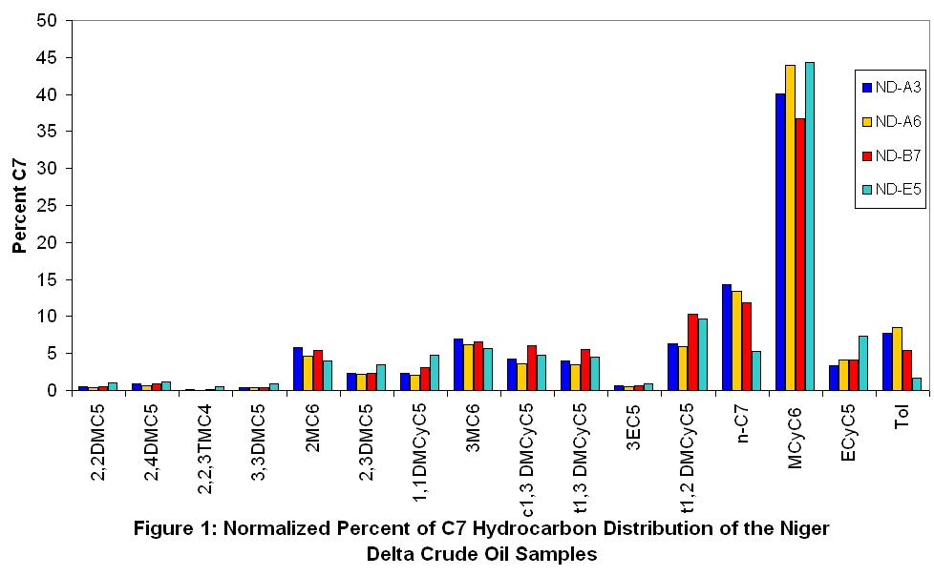

Thompson (1983) used heptane ratio as indicator of source (kerogen type) of crude oil. Heptane ratios of Niger Delta crude oils range from 4.64 to 12.30 (Table 1). However, the heptane ratios of oils ND-A3 (12.30), ND-A6 (12.07) and ND-B7 (10.33) were close and separate from ND-E5 (4.64). These data show that crude oils from the Niger Delta are of at least two different sources.

The invariance of isoheptanes (k₁ and k₂) is very useful in oil correlation studies (Mango, 1990) as their ratio remains remarkably constant throughout hydrocarbon generation, regardless of their absolute concentration, for a set of oils from the same source.
$k1=\frac{\text{2MC6 }+\text{ 2,3DMC5}}{3\text{MC}\text{6 }+\text{ 2,}4\text{DMC}5}$ $k2=\frac{P3}{P2+ N2}$

Table 1: Summary of Light Hydrocarbon Characteristics of Crude Oils from the Niger Delta.

 | Crude oil Sample ID
Light Hydrocarbon Characteristics | ND-A3 | ND-A6 | ND-B7 | ND-E5
Total C₇ | 6127.83 | 2981.80 | 10087.06 | 1194.35
n-C7 | 872.67 | 399.18 | 1195.51 | 63.22
MCyC6 | 2457.09 | 1309.08 | 3706.01 | 529.06
Tol | 477.08 | 252.36 | 550.60 | 20.55
P₂ | 781.78 | 323.89 | 1209.04 | 116.26
P₃ | 305.47 | 124.98 | 496.03 | 94.39
N₂ | 640.06 | 271.89 | 1484.21 | 167.93
Heptane Ratio | 12.30 | 12.07 | 10.33 | 4.64
k₁ | 1.02 | 1.00 | 1.03 | 1.08
k₂ | 0.21 | 0.21 | 0.18 | 0.33

Data is based on peak areas of the selected compound from the GC results.
P₂ = 2MC6 + 3MC6
P₃ = 2,2DMC5 + 2,4DMC5 + 2,2,3TMC4 + 3,3DMC5 + 2,3DMC5 + 3EC5
N₂ = 1,1DMCyC5 + c1,3 DMCyC5 + t1,3 DMCyC5
Heptane Ratio $\frac{\text{n- C7}}{(\sum{}\text{ CyC6 }+\text{ C7 HCs})}×\text{ 100}$

The invariance ratio k₁ (table 1) for oils ND-A3, 1.02; ND-A6, 1.00 and ND-B7, 1.03 were close, but separate from ND-E5 which has a ratio of 1.08. These data suggests different sources responsible for the Niger Delta oils. The invariance

ratio k₂ displays similar resolving power, consistent with different sources for the oils. Graphical representation of the invariance ratios (k₁ vs k₂) is presented in figure 2. The plot of invariance ratios discriminated clearly the studied oils into two distinctly different sources for crude oils in the Niger Delta.

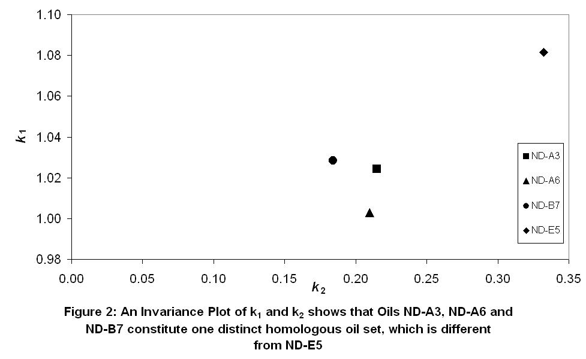

This distinctly difference sources responsible for crude oil in the Niger Delta is also illustrated graphically by the ring preference plot of the oils (figures 3 and 4). The ring preference plots separate the oils clearly into two homologous sets thus supporting the fact that the invariance ratios in oils ND-A3, ND-A6 and ND-B7 remained tightly constrained and distinct form crude oil ND-E5.

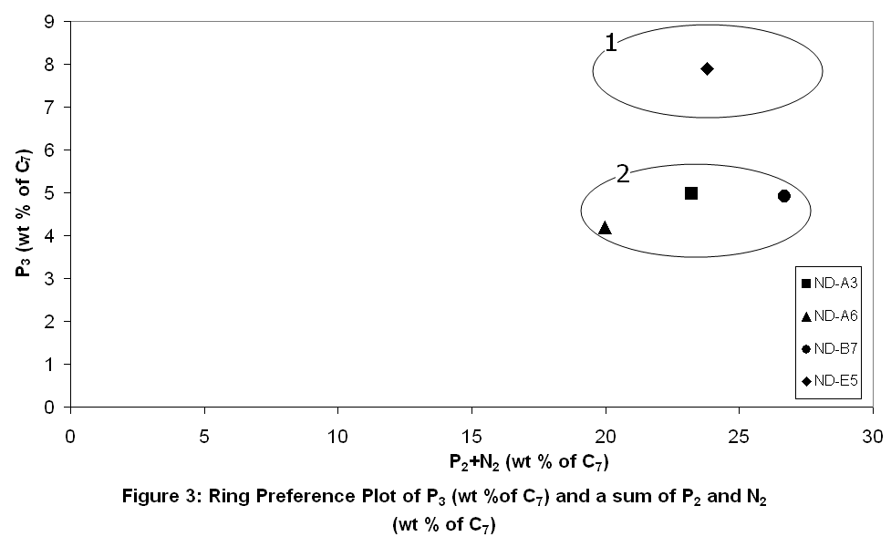

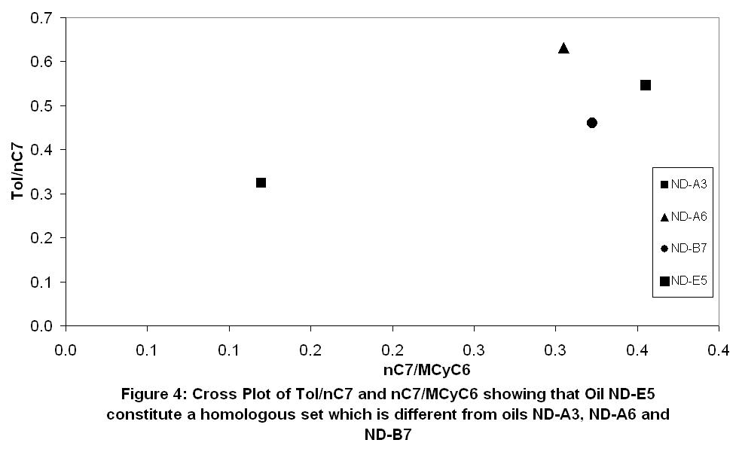

Micro-scale correlation technique using gas chromatographic analysis of light hydrocarbons was used for the purpose of correlation and / or differentiation between the oils. The objective is to correlate the oils by comparing ratios of compounds. These comparisms are put in pictorial form of a star plot diagram to make correlation and / or differentiation of the Niger Delta oils easier. Star plots have been used to represent chemical compositions of oil and water samples from reservoirs, as well as correlation and / or differentiation (Halpern, 1995; Ali et al, 2002; Volk et al; 2005). For clearness, the star plot that will be used in this study will have nine (9) axis.

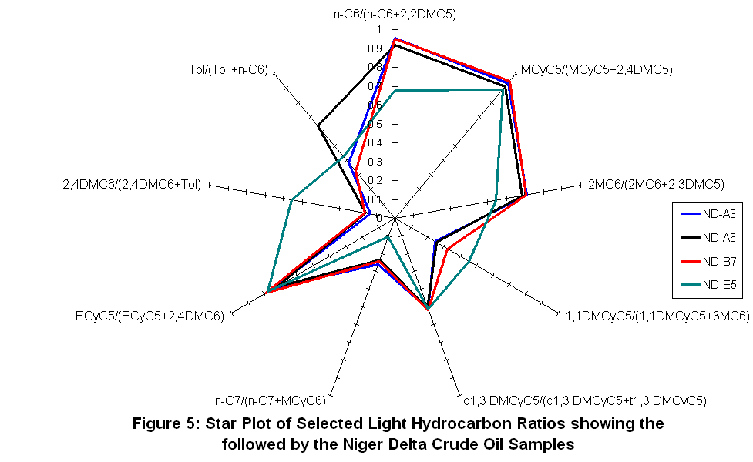

Figure 5 shows the star plot of all crude oils used in the study. Crude oils ND-A3, ND-A6 and ND-B7 were shown by their star plots to follow similar path. This suggests a strong similarity between the oils reflecting oil generation from the same source rock. However, differences were observed in oil ND-E5, which followed patterns that is different from other oils. This differentiation is in line with differences in source rock between the oils (Ali et al; 2002). The oils ND-A3, ND-A6 and ND-B7 correlated positively amongst themselves and negatively with oils ND-E5. The light hydrocarbons exhibited good resolution for the Niger Delta crude oils and thus useful in oil correlation studies of the Niger Delta.

4. Conclusion
Light hydrocarbon ratios and plots prove a powerful tool for correlating Niger Delta crude oils. The ratios and plots are based on the analysis of light hydrocarbons present and separated by ultra high resolution gas chromatography (UHRGC) without any pretreatment. The data presented here (invariance ratios, graphical representations and star plots) indicated two source rocks responsible for crude oils in Niger Delta, thereby complementing the interpretations based on the higher molecular weight hydrocarbons.

Acknowledgements:
I am grateful to the facilities and support provided by Exxon Mobil Co. I am equally grateful to Leo C. Osuji and Chidi I. Eneogwe for introducing me to geochemical markers and light hydrocarbon research.

Corresponding Author:
Mark O. Onyema
Department of Pure and Industrial Chemistry University of Port Harcourt
P.M.B 5323 Choba,
Port Harcourt, 500001,
Rivers State, Nigeria
Telephone: +234 803 041 5230
E-mail: onyemark@yahoo.com

References
- Akinlua, A., Torto, N., Ajayi, T.R. and Oyekunle, J.A.O. Trace Metals Characterization of Niger Delta Kerogens. Fuel 2007; 86(10&11):1358-1364
- Ali, F.M., Al-Khadrawi, R.M, Perzanowski, H. and Halpern, H.J. Central Saudi Arabia Crude Oil: A Geochemical Investigation. Petroleum Science and Technology 2002; 20(5&6):633-654
- Doust, H. Petroleum Geology of the Niger Delta. Geochemical Society, London, Special Publications 1990; 50:365
- Ekweozor, C.M, Okogun, J.I., Ekong, D.E.U. and Maxwell, J.R. Preliminary Organic Geochemical Studies of Samples from the Niger Delta, Nigeria I: Analysis of Crude Oils for Triterpanes. Chemical Geology 1979a; 27(1&2):11-28
- Ekweozor, C.M, Okogun, J.I., Ekong, D.E.U. and Maxwell, J.R. Preliminary Organic Geochemical Studies of Samples from the Niger Delta, Nigeria II. Analysis of Shales for Triterpenoid Derivatives. Chemical Geology 1979b; 27(1&2): 29-37
- Ekweozor, C.M. and Udo, T.O. The Oleananes: Origin, Maturation and Limits of Occurrence in Southern Nigeria’s Sedimentary Basins. Organic Geochemistry 1988; 13:131-140
- Eneogwe C.I. and Ekundayo O. Geochemical Correlation of Crude Oils in the NW Niger Delta, Nigeria. Journal of Petroleum Geology 2003; 26(1):95-103
- Halpern, H. I. Development and Applications of Light -Hydrocarbon-Based Star Diagrams. American Association of Petroleum Geologists Bulletin 1995; 76(6):801–815
- Mango, F. D. An Invariance in the Isoheptanes of Petroleum. Science 1987; 237:514-517.
- Mango, F. D. The Origin of Light Hydrocarbons in Petroleum: A Kinetic Test of the Steady-State Catalytic Hypothesis. Geochimica et Cosmochimica Acta 1990; 54(5):1315-1323.
- Mango, F. D. Transition Metal Catalysis in the Generation of Petroleum and Natural Gas. Geochimica et Cosmochimica Acta 1992; 56(10):553-555.
- Mango, F. D. The Origin of Light Hydrocarbons in Petroleum: Ring Preference in the Closure of Carbocyclic Rings. Geochimica et Cosmochimica Acta 1994; 58(2):895-901.
- Mango, F. D. The Light Hydrocarbons in Petroleum: A Critical Review. Organic Geochemistry 1997; 26(7&8):417-440
- Manilla P. N. and Eking P. A. Typing / Correlation of Nigerian Crude Oils Using Saturates and Aromatic Biomarkers. Global Journal of Pure and Applied Sciences 2008; 14(1):77-83
- Manilla P. N. and Eking P. A. Characterization of Some Crude Oils from the Niger Delta Region of Nigeria using Bulk Parameters and GC Whole-Oil Fingerprint. Journal of Chemical Society of Nigeria 2007; 32(2):191-202
- Onyema, O.M. Geochemical Correlation of Niger Delta Crude Oils using Low Molecular Weight Markers. MSc. Thesis, University of Port Harcourt, Nigeria. 2005
- Osuji, L.C. and Anita B.S. Geochemical Implications of some Chemical Fossil as Indicators of Petroleum Source Rocks. Journal of Applied Science and Environmental Management 2005; 9(1):45-49
- Oyekunle, L. O. and Famakin, O. A. Studies of Nigerian Crudes I. Characterization of Crude Oil Mixtures. Petroleum Science and Technology 2004; 22(5&6):665-675
- Ten Haven, H.L. Applications and Limitations of Mango’s Light Hydrocarbon Parameters in Petroleum Correlation Studies. Organic Geochemistry 1996; 24(10&11):957-976
- Tissot B.P. and Welte D.H. 1984. Petroleum Formation and Occurrence: A New Approach to Oil and Gas Exploration. Spinger-Verlag, Berlin, Germany.
- Thompson, K. F. M. Classification and Thermal History of Petroleum Based on Light Hydrocarbons. Geochimica et Cosmochimica Acta 1983; 47(2):303–316.
- Tuttle, W.L.M, Brownfield, E.M. and Charpentier, R.R. The Niger Delta Petroleum System. Chapter A: Tertiary Niger Delta (Akata-Agbada) Petroleum System, Niger Delta Province, Nigeria, Cameroon and Equatorial Guinea, Africa. U.S. Geolgical Survey, Open File Report 1999; 99-50-H
- Volk, H., George, S.C., Middleton, H. and Schofield, S. Geochemical Comparison of Fluid Inclusion and Present-Day Oil Accumulations in the Papuan Foreland – Evidence for Previously Unrecognized Petroleum Source Rocks. Organic Geochemistry 2005; 36(1):29-51

12/27/2009

