Estimate Biological Nitrogen Fixation in horse bean
Tayeb Saki Nejad
Islamic Azad University, Ahvaz Branch
Tayebsaki1350@yahoo.com
Saki1350@gmail.com

Abstract : Research projects as split plot experiments in a randomized complete block design with four replications in field research in Islamic Azad University of Ahvaz 3 consecutive years (2006,2007,2008) implementation was the main plot assembly, four cultivar horse bean (Vicia FabaL.) plant: BARAKAT,ZOHRE,SHAMI and JAZAYERI, damascene the number of islands in the province have grown and sub-plots in the two years 2006 and 2007 three levels of nitrogen fertilizer (N1,N2 and N3 treatments, respectively 20 and 40 and 80 kg fertilizer N ha simultaneously planting) and the third year, 2008 values were doubled care. After the propagation earth, using cultivar with Rizobium bean plant (Rh.Legominosarum) inoculation and immediately cultured. Survey cultivar, BARAKAT highest percentage of mean total nitrogen plant 1.97 percent won. In sub-plots, with increasing amounts of nitrogen, accumulation of this element bean plants increased. Percent nitrogen treatments nodes N2 and N3 showed a significant difference, but the highest accumulation of nitrogen treatments N1 nodes with 1.67 percent won, thus whatever amount of fertilizer increased, the amount of biological nitrogen fixation nodes decreased. N3 treatment reduced accumulation of 40 to 50 percent nitrogen found in to other treatments. With increasing N rate, weight, number and size of the plant nodes decreased blessing average number of nodes 1250 nodes per plant among the highest number of cultivars grown offered. Number of nodes equal treatment and 1450 to increase the amount of fertilizer treatments 80 kg 998 nodes per plant decreased in all fertilizers in small amounts or how large gland enlargement process was observed. The mean largest tumor diameters in the treatment 1.98 cm were measured. Green and white non-effectiveness of enzyme Nitrogen's stated that usually the primary growth was achieved in pink and red and efficient biological nitrogen fixation, approximately 35 days after planting continued until after flowering and 10 days after flowering, gland Posts brown and black, showed the node representing aging and lack of nitrogen is established.[Journal of American Science 2010; 6(3): xx-xx]. (ISSN: 1545-1003).
Key words: biological nitrogen fixation, horse bean
1. Introduction

During the recent years in the world, food production and consumption of fertilizers has increased gradually. Demand for nitrogen fixation as the chemical and irregular increase is nearly twice (Table 1) due to the current energy crisis situation will be difficult. In addition, chemical nitrogen fixation in the field, since the fundamental solution to reduce the energy required for the traditional method (Haber - Bush) in the production of ammonia is not recommended. Biological nitrogen fixation can produce the crisis and to modulate the nitrogen fertilizer application. Identifying factors influencing production efficiency of this process can be beneficial and highly stabilized nitrogen increased. Province with more than 7000 hectares under cultivation Bean (2007) one of the major producing provinces of the product is high and nitrogen fertilizer application, average 300-250 kilograms per hectare to increase performance is common among farmers These values increased cost of nitrogen fertilizer plant as well as severe pollution to the River that shed all of the search, so the necessity of expanding and increasing the efficiency of biological fixation system, it is felt the product, according to the necessity of this study was to implement appropriate amounts of fertilizers and nitrogen are introduced improved varieties can be used to stabilize natural systems use high nitrogen fertilizer nitrogen prevents said (Table 2).

Table 1. The global need for nitrogen (million tons) during the coming years
Region / Year | 1985 | 1990 | 1995 | 2000 | 2010
Developed countries | 47 | 58 | 71 | 88 | 98
Indeveloping countries | 25 | 33 | 43 | 54 | 70
World | 73 | 92 | 115 | 139 | 178

Table 2. Estimate biological fixation nitrogen in world
countries | legume | year | BNF(Kg/ha)
India | pea | 1979-82 | 16.6
India | Alfalfa | 2004 | 72
Greece | Lens | 1997 | 45
Pakistan | bean | 1998 | 37
Brazil | Horse B. | 2002 | 101
Australia | Pea | 2005 | 20

2. Material and methods
This research farm research - Research, Islamic Azad University of Ahvaz Southern city of Ahwaz in 3 years were, where experiment and semi-arid climate is dry and the 40-year Meteorological Data Ahvaz 94/213 mm average annual rainfall, mean annual temperature of 24/25, the average maximum 92/32 annual temperature, average minimum annual 4 / 18 ° C is. Planting date mid every 3 years was before this date, disk and plow the earth and fire trowel and calcium phosphate fertilizer menu and then the earth was based classification map plots in the field experiment was performed in every plot of 24 square meters the bed took up 10 lines and culture based on the amount of nitrogen fertilizer treatments the tape stack was added. 3 -2 on the test weed weeds was conducted for disposal. Test plan as split plot randomized complete block design with four replications that included four main treatment plant bean varieties that are: blessing
V1, Z. V2, SHAMI V3 and V4 figure JAZAYERI and sub-plots in the first two years 1383 and 2006, Kvass levels (N0 = 20, N3 = 80, N1 = 40 kg per ha) and the third year was double 2008 values were studied. reviews root cylinder method was performed by the full scoop enough of the node number and diameter of root parameters of (BARAKAT) were measured and cut Posts tumor diagnosis was inside color. some plant gland intact shoots, including leaves and stems for the estimated amount of nitrogen using Kjldal was sent to the laboratory. and also using the root Newman and graduated cylinder method of water transport, root volume was measured.. before the implementation experiment to evaluate soil field sampling of the depth of 15-0, 30-15 and 60-30 cm was 15 and a total analysis of soil samples were sent to the laboratory that the final results of this analysis is given in Table 3

N₂ + 8H⁺ + 8e⁻ + 16ATP 2NH₃ + H₂ + 16ADP + 16Pi

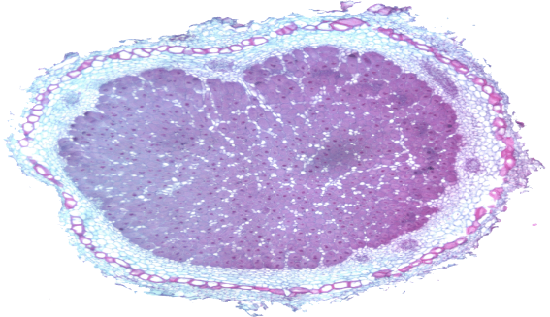
Figure 1. Full nodules

Table 3. Soil chemicals analysis
soil | Deep (cm) | EC | Organic matter (%) | PH | Nitrogen  (ppm)
Silty | 0-15 | 6.5 | 0.6 | 7.7 | 635
Silty | 15-30 | 6.6 | 0.3 | 7.6 | 648
Clay loam | 30-60 | 5.7 | - | 7.3 | 211

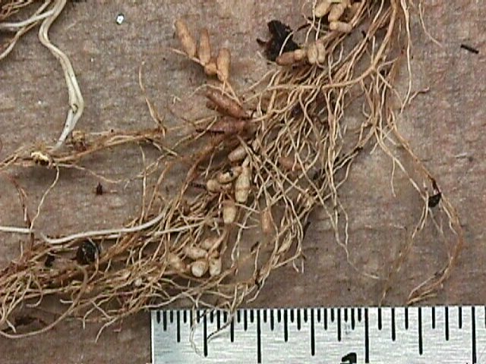
Figure 2. nodules on root
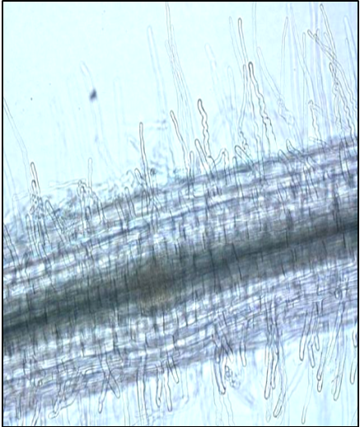
Deformation root
Figure 3. Inoculation on root

3. Results
3.1. Percentage of total plant nitrogen, Analysis of variance showed that treatments of bean cultivars and the amount of fertilizer nitrogen accumulation in plant-level% 1 in every 3 years were significant, cultivar BARAKAT highest percentage of mean total nitrogen plant 1.97 percent won. And cultivar JAZAYERI and ZOHRE. respectively 1.76 and 1.68 percent and Shami figure with 1.43 percent in the next categories were. For sub-plots that V3 with mean 2.73 percent of V1 with the highest and 1.83 percent of the lowest average accumulation of nitrogen element in bean plants showed other words, increasing the amount of nitrogen accumulation of this element increased the bean plant demonstrates the potential for plant uptake is the element that increased dry matter and number of branches is required. (Hard arson and Jetty 2004).
3.2. Percent nitrogen root gland, Percentage of nitrogen nodes to significant amounts of fertilizer and bean cultivars and their interaction showed a 1% level. N2 and N3 treatments statistically the same, but with the N10 treatment, significant differences were present, what amount of nitrogen increased, the amount of biological fixation of this element nodes decreased. N3 treatment reduced accumulation of 40 to 50 percent nitrogen found in to other treatments. Small amounts of soil nitrogen caused the gene is activated and stabilized biological Nitrogen's enzyme, glutathione synthesis of nitrogen into the air in the root of high quantities but do nitrogen, available nitrogen in soil Nitrogen's enzyme in glutathione synthesis is used (Aviv and Hardy 2003) . Percent nitrogen accumulation of blessing the figure was more than other varieties and Hay etal (2005) have stated that the figures that matter most called the root secretion and assembly, which is attracting more Rizobium bacteria in root level and increase the amount established is. Aviv and Hardy (2003) announced that the small amounts of soil nitrogen in the biological fixation gene that is activated enzyme nitrogen's nitrogen into the air Glutathione synthesis in the root and thus stabilize do take place but when large amounts of soil nitrogen by this act nitrogen's enzyme using the available nitrogen in soil occurs in glutathione synthesis (22).Hay etal (2005) in numbers that indicate their more established, have said that the figures that matter most called the root secretion and assembly, which is attracting more Rizobium bacteria in root level and increase the amount established gives (14). Cultivars grown in the review, figure blessing percent more nitrogen accumulation demonstrated that because of this, probably is a Matter of theory Hay and Yvtzy. Tumor characteristics Blessing figure that the highest percentage of nitrogen due to consolidation period from planting to flowering, flowering later than other cultivars (Nadir and Hay 2004), the highest weight (926 mg per plant) and number of nodes (1250 Nodes per plant per day) provided is. With increased fertilizer value, weight and number of nodes on the root node treatment decreased The Number equal to 1450 and increasing fertilizer treatment to 998 nodes per plant decreased.

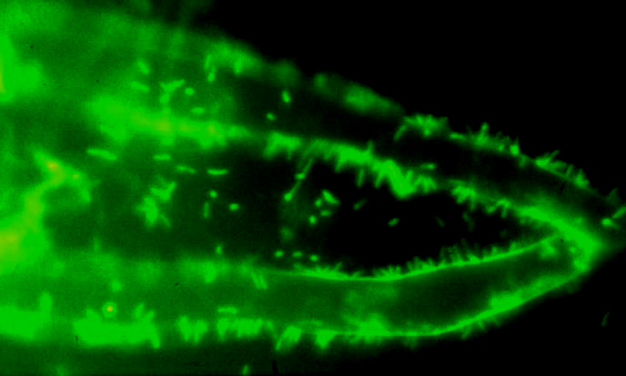
4. Discussion Increasing amount of nitrogen accumulation of this element in the bean plant was increased and this demonstrates the potential for plant uptake is the element that increased dry matter and number of branches is required. (Hard arson and Jetty 2004) Small amounts of soil nitrogen caused the gene is activated and stabilized biological Nitrogenase enzyme, glutathione synthesis of nitrogen into the air in the root of high quantities but do nitrogen, available nitrogen in soil Nitrogenase enzyme in glutathione synthesis is used (Hardy 2003) . Percent of nitrogen accumulation in the root node blessing figure was more than other varieties. Nadir (2005) have stated that the figures that matter most Lectin called the root secretion and assembly, which is attracting more Rizobium bacteria in root level and increases the amount of consolidation. Hardy (2003) announced that small amounts of soil nitrogen caused the gene is activated and stabilized biological Nitrogenase enzyme, glutathione synthesis of nitrogen into the air and thus do roots stabilize the soil nitrogen is high value but when this act by enzyme Nitrogenase using nitrogen in the soil occurs in glutathione synthesis. Nadir (2004) as were the node weight function parameters such as effective during the growth period from planting to flowering increased the amount of nitrogen is established and also the effectiveness of inoculation of bacteria. Blessing figure that the highest percentage of nitrogen due to consolidation period from planting to flowering, flowering later than other cultivars highest weight (926 mg per plant) and number of nodes (1250 nodes per plant per day) can provide. Increasing amount of nitrogen, weight and number of nodes on the roots was reduced so the number of nodes equal to 1450 and attendance increased fertilizer treatment to 998 nodes per plant decreased. Treatment N1 node weight value 759 mg per plant were in a group that care N3 and N2 values of 654 and 644 mg per plant were the group b were statistically significant differences. Theory based on Thomas (1999) in the presence of high amounts of soil nitrogen due to lack of enzyme activity and accumulation of nitrogen in stabilizing node nodes will not be. What Nitrogen fertilizer increased the amount of tumor size was smaller than the other because the plant needs through existing fertilizer plant in soil their investment to reduce tumor development, thus has significantly reduced tumor size. Gland enlargement process (based on the largest diameter) That growth during the flowering period increased the diameter of the nodes is done after flowering in tumor size remains approximately constant and seed filling and maturity of the hand to large amounts of nitrogen and water, especially its smaller size show that sinha (2001) as can be after flowering, plant nutrition support Legume resilient to nodes is very limited, which causes shrinking and loss many node is inside (Table 4).
Assessment of the number of nodes during flowering cultivars were observed when the maximum leaf area index in different bean cultivars reached, the number of root nodes decreased dramatically demonstrated. Sami Field (1996) announced that during the flowering plant metabolism due to Go and spend a lot of energy for its flowering, allocation of carbon hydrate Go to root values that it is used nodes will stop the result of Rizobium bacteria and plant suffered Symbiosis and nodes is impaired due to lack of carbon hydrate reach the plant roots started to make loss, this phenomenon during the flowering of maximum LAI was clearly tested cultivars were observed. Go to the amounts of nitrogen fertilizer increased the base and expanding leaf area index and been in the early stages of growth during the LAI decrease and faster plant growth stage is rapid LAI. Crop growth rate an indicator of production efficiency in the production of ground vegetation is live weight and an indicator of the ability of agricultural production that Watson provided it is calculated. But only for the plants that together, in the coating of packet crop or natural communities grow used to. Assessment values and product trend growth rate of different treatments applied in this experiment is the following corollary: Applied nitrogen fertilizer in the early stages growth increased growth rate and slope product has been early stages of growth (48 days after sowing) been harsh and fast speed growth earlier phase has been that due to high speed net photosynthesis and leaf area index in this period because the growth rate multiplied product is mentioned two parameters. Biological nitrogen fixation trend growth rate in the different levels of nitrogen products to each other has somewhat because the lack of nitrogen could with equal levels of nitrogen to some extent but this equality can be seen in the early stages of growth and to enter the phase of rapid growth and flowering differences in trend growth rate seen in the product.
Figure 4. Rizobium on root

Table 4. Gland enlargement process (cm) during the growing season and its effect on nitrogen fertilizer
88 | 68 | 57  flowering | 45 | 33 | Days after planting / fertilizer ( kg/ha)
1.66 | 1.39 | 1.78 | 0.98 | 0.44 | 20
1.8 | 1.56 | 1.46 | 0.78 | 0.24 | 40
0.48 | 0.53 | 0.51 | 0.12 | 0.1 | 80

Table 5. Mean nitrogen accumulation in plant (Np), nitrogen in the root node (Nr), node root weight (Wn), number of root nodes (Nn), node size (Sn) (Duncan test at 1 % level)
Sn | Nn | Wn | Nr | Np | cultivars
A1.97 | A1.2 | A926 | A1250 | A1.68 | BARAKAT
B1.68 | B0.98 | C625 | B1024 | B1.22 | ZOHRE
BC1.4 | Bc0.8 | C608 | C942 | C0.98 | SHAMI
B1.76 | B0.99 | B875 | B1050 | B1.23 | JAZAYERI
FERTILIZER
(Kg/ha)
B1.83 | A1.73 | A759 | A1450 | A1.98 | 20
A2.66 | B1.01 | B654 | B1020 | B1.22 | 40
A2.73 | B0.98 | B644 | B998 | C0.78 | 80

Acknowledgements:
President of research the Islamic Azad University, Ahvaz branch, Dr. Zarrin Abadi

Corresponding Author:
Dr. Tayeb Saki Nejad
Department of agriculture
Islamic Azad University, Ahvaz Branch, Iran
00989166129260

References
- Hard arson PT, Jutes SD, in biological Nitrogen Fixation, proceedings of the National Symposium held at Indian agriculture research Institute, new poi 2004:3(2):544-51
- Hekio NA, Uotzii LP, Alternating strips of grass and Legumes and Nitrogen fertilization strategy for long term herbage production from a brome – alfalfa stand. Plant science july/juillet, 2006:75(3): 649-654.
- Nadir, LA, Hague I, Forage legume – cereal systems: improvement of soil fertility and agricultural production with special reference to sub- Saharan Africa. In: I. Hague, s. jutzi and P.J.H Negate (ads), potentials of forage resumes in farming systems of sub- Saharan Africa. Proceedings of a workshop held at ILCA, Addis Ababa, Ethiopia. 2005:4(1) : 330- 329
- Okon Y, hardy RWF, Developments in basic and applied biological nitrogen fixation. In: plant physiology. A treatise. Vol. VIII. Nitrogen metabolism academic press, New York. 2003:3
- Thomas, d, Nitrogen from tropical pasture legumes on the African continent. Herbage Abstracts. 1999: 43(2): 33- 39
- Evans GC. The quantativa analysis of plant growth. Oxford: Black well Scientist publications. 1972:41-56
- Gupta G, Bhandari L, in biological Nitrogen Fixation, proceedings of the National Symposium held at Indian agriculture research Institute, new peui1988:1(1): 544-51
- Haxly PJ , Summerfield RJ, , nitrogen nutrition of cow pea (vigna unguiculota)
Effects of applied nitrogen and symbiosis nitrogen fixation on growth and seed yield, Exll agriculture, 1977:3(2) 129-147.
- Abrol YP, pokhriyal T, Nitrate assimilation in relation to total reduced N in bangal gram. Genotypes, India of plant physiology 1980:21:228-234
- Das PC, Principles and practices of crop production part of 10, pulse crops1993: 330-384.
- D lamb GF. Barnes OK, Russelle MP, Ineffectively and effectively Nodalated Alfalfa Demonist bioffectively nitrogen continues with high nitrogen fertilization crop science 1995: 35 (1):153-157
- Fairey NA, lefkovitch LP, Alternating strips of grass and Legume and Nitrogen fertilization strategy for long term herbage production from a brome – alfalfa stand. Plant science july/juillet, 1995:75(3):649-654.
- Chang C, Variation in soil total organic matter content and total nitrogen associated with microrelif, soil science 1995: 75(4): 471-473.
- Kelner T, David G, Nitrogen fixation and growth of on-year stands of non-dormant alfalfa in Manitoba, plant science guly/gaillet 1995: 75 (3): 655-665.
- Rawsthorne S, Hadley P, Summerfield S, effects of supplemental nit ate and thermal on the nitrogen Nutrition of chickpe3 (Cicer aritinum) I. Growth and development, Plant and soil 1985:83(2): 265-277.
- Sinha H. P, Rahman A, saxena M, C, Response of chickpea to Rizobium inoculation, Nitrogen and Phosphorus under different orrigationregimes, chickpea 1981:6(2):23-36

