HIV Coinfections with Urinopathogens in Port Harcourt, Rivers state, Nigeria

Frank-Peterside N, Okonko IO, Okerentugba PO and Nwodo CR

Medical Microbiology Unit, Department of Microbiology, University of Port Harcourt, P.M.B. 5323, Choba, East-West Road, Port Harcourt, Rivers State, Nigeria;
E-mail address: iheanyi.okonko@uniport.edu.ng, Tel: +2348035380891

ABSTRACT: A total of Ninety–six urine samples from male subjects were analyzed, consisting of forty–six (46) HIV-positive subjects attending the anti–retroviral clinic of the University of Port Harcourt Teaching Hospital (UPTH). They were all within the age range of 35 -69 years. The urine samples were cultured on cysteine lactose electrolyte deficient (CLED) agar and sabouraud dextrose agar (SDA). Among the 46 samples from HIV positive subjects, 23.9% had significant bacteria growth while 50.0% had no significant bacteria growth and in the remaining 26.1% no growth. Among the 56 samples from HIV negative individuals (controls), 54.0% had significant growth, 42.0% had no significant growth while 4.0% no growth. The frequency of occurrence of the organisms isolated showed that among the etiologic agent of significant bacteriuria in HIV–positive subjects, Staphylococcus aureus (63.0%) was most predominant. This was followed by Escherichia coil (18.2%), Pseudomonas aeruginosa (9.2%), and Klebsiella pneumoniae (9.1 %). No Proteus sp was found. Among the HIV-negative subjects used as control, Escherichia coli 29.8% was most predominant. This was followed by Klebsiella pneumoniae (22.2%), Staphylococcus aureus (22.2%), Pseudomonas aeruginosa (11.1%), and Proteus sp (14.8%). The antibiograms showed that the Gram-positive bacteria (GPB) were more sensitive to Ceftaxidime (a Cephalosporin) and Nitrofurantoin while Gram–negative bacteria (GNB) were more sensitive to Gentamycin and Ciprofloxacin. This study however further confirmed the presence of HIV and UTI coinfections in Port Harcourt, Nigeria. This study showed a higher prevalence of bacterial uropathogens among the HIV/AIDS patients as compared to other findings on HIV negative patients. The antibiogram showed that the antibiotics of choice were Gentamicin, Nitrofurantoin and Augmentin.
[Frank-Peterside N, Okonko IO, Okerentugba PO and Nwodo CR. HIV Coinfections with Urinopathogens in Port Harcourt, Rivers state, Nigeria. Cancer Biology 2013;3(4):12-16]. (ISSN: 2150-1041). http://www.cancerbio.net. 2

Keywords: Antibiograms, Coinfections, Gram-positive bacteria, Gram-negative bacteria, HIV

1. Introduction
Among the opportunistic infection, urinary tract infection [UTI] accounts for 60% the AIDS defining illness (Deokar et al. 2009). Urinary tract infection represents a considerable health problem amongst HIV infected patients (Samuel et al., 2012). Fabian et al. (2009) in South Africa found 30% leukocyturia, 33% microscopic hematuria, and 44% microalbuminuria/proteinuria in a population of HIV-infected outpatients attending the HIV clinic that were screened for urinary abnormalities (Samuel et al., 2012). In those with leukocyturia, an infective organism was cultured in 29.1% of cases, predominantly Escherichia coli (70%) with sterile leukocyturia comprising the remainder (Samuel et al., 2012).
Recent reports suggest that the incidence of UTI is increased in HIV positive patient. While the spectrum of opportunistic infections due to HIV infection has been widely studied and discussed in some centers (Zouiten et al., 2003; Samuel et al., 2012), there are very limited data available in Nigeria on certain infections such as urinary tract infections (UTI) in HIV-infected subjects (Samuel et al., 2012).
This study therefore aims to determine the prevalence of urinary tract infections among HIV positive males attending the antiretroviral (ART) clinic of University of Port Harcourt Teaching Hospital (UPTH) and identify the pathogens causing such infections and their antibiotic sensitivity pattern.

Materials and methods
2.2. Sources of samples collected
Early morning mid stream urine were collected from the HIV positive patients in the University of Teaching Hospital

2.3. Collection and preservation of samples
A sterile dry wide – naked leak proof wash bottle is given to patient to get 10–20ml specimen. Instruct patient to wash hands before collection and collect MUS to avoid any contamination. As soon as specimen is collected label the container with date and patients name. If immediate test on the specimen is not possible refrigerate urine and also refrigerated.

2.4. Isolation and identification of Isolates
Mix the urine {frostily collected clean – catch specimen} by rotating the container using sterile calibrated wire loop, e.g. one that hold 0.003ml, inoculated a loopful of urine on a quarter plate of CLED and on sabouraud Agar {SDA}. Incubate the plate erotically at 35 – 37ºc over night. The bromothymol blue is the indicator in CLED that helps to differentiate between lactose fermenting {yellow} and non- lactose {colour on plate blue to gray or green colour}. Sub culture on nutrient agar {NA} for antimicrobial susceptibility test and confirmatory biochemical test of isolates

2.5. Presumptive and morphological identification
On CLED E. coli is yellow {lactose fermenting} opaque colonies after slightly deeper center: Klebsiella species are large mucoid yellow or yellow – white colonies. Proteus spp are translucent blue – grey colonies. P. aeruginosa are green colonies with rough periphery {characteristics colour}, Enterococcus feacalis small yellow colonies. Staphylococcus areas are deep yellow to white colonies on SDA, Candida sp are seen as smooth surface, waxy cream colonies.

2.6. Antibiotics Sensitivity pattern
This was done using the agar disc diffusion method. A sterile wire loop was used to pick a colony of the test organism, which was introduced into a Bijou bottle containing peptone water was emulsified and using a pastern pipette about 0.ml of the emulsified organism was placed on the iso – sensitivity test Agar plate and spread evenly with a bent glass rod /Hockey stick. Using a pair of sterile forceps, it was then used to place the antibiotic disc on the inoculated Agar plate. The diameter was incubated at 37⁰c for 24hrs. The diameter of the zones of inhibition less than 2.5mm showed resistance while those greater than 2.5mm showed sensitivity.

reSULTS
A total of Ninety six male subject urine samples were analyzed consisting of forty –six HIV patient attending the anti-retroviral clinic of the University of Port Harcourt Teaching Hospital {UPTH} and fifty apparently healthy HIV–seronegative individuals. They are all within the age range of 35-69. The urine sample were cultured or cysteine lactose electrolyte deficient {CLED} agar and sabourard Dextrose agar {SDA}; using the streaking method and incubated aerobically at 370c for 24hrs. In the case which are the HIV patient eleven urine samples had significant bacteria growth {23.9%} on culture twenty – three had no significant growth {50.0%} and in the remaining twelve there was no growth at all. In the control i.e. HIV negative individuals, twenty –seven urine sample had significant bacteria growth {54.0%} on culture, twenty – one there was no significant growth at all {4.0%}. As shown in chart the distribution of the etiological agent in both cases and control is showed in table 3.6, agent in both 3.2. The Gram- positive organism are mostly sensitive to Ceftaxidime (a Cephalosporin), Nitrofurantoin while Gram – negative organisms are mostly sensitive to Gentamyin and ciprofloxacin.

Table 1: Prevalence of significant bacteriuria in HIV Positive subjects
Condition Occurrence (%)
S. B. G 11(24)
NSBG 23(50)
NBG 12(26)
Total 46(100)
KEY
SBG – Significant bacteria growth {10⁵ organisms per ml, distinct colony}
NSBG – No significant bacteria growth {10⁵ organisms per ml, no distinct colony}
NBG – No bacterial growth

Table 2: Prevalence of significant bacteriuria in control
Condition Occurrence (%)
SBG 27(54)
NSBG 21(42)
NBG 2(4)
Total 50(100)
KEY
SBG – Significant bacteria growth {10⁵ organisms per ml, distinct colony}
NSBG – No significant bacteria growth {10⁵ organisms per ml, no distinct colony}
NBG – No bacterial growth

Table 3: Frequency of isolated micro-organisms In HIV –Positive subjects
Organism | Frequency (%)
Staphylococcus aureus | 7() | 63 . 6 | 15 . 2
Klebsiella sp | 1() | 9 . 1 | 2 . 2
Escherichia coli | 2() | 18 .2 | 4 . 4
Pseudomonas aeruginosa | 1() | 9. 1 | 2 . 2
Total | 11()

Table 4: Frequency of isolated micro–organisms in control
Organism | Frequency (%)
Staphylococcus aureus | 6 | 22 . 2 | 12 . 0
Estuarial coli | 8 | 29 . 6 | 16 . 0
Klebsiella sp | 6 | 22 . 2 | 12 .0
Pseudomonas aeruginosa | 3 | 11 . 1 | 6 . 0
Proteus sp | 4 | 14 . 8 | 8 . 0
Total | 27()

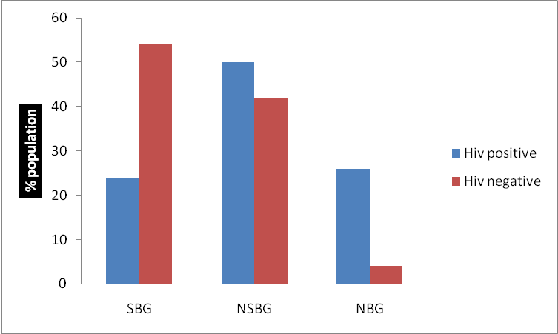

Chart 1: Distribution of growth pattern on CLED agar according to HIV status

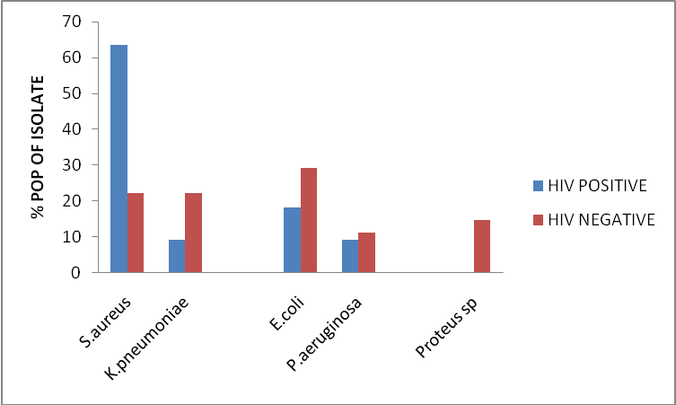

Chart 2: Distribution of significant bacteria (SB) isolate according to HIV status

Table 5: Antibiotic Sensitivity pattern
Organism | Ceft | Amp | Chl | Clox | er | pen | Tet | Cot | Gen | Nit | nal | cip | aug | amo | str
Pseudomonas aeruginosa | R | R | R | R | R | R | R | R | R | R | R | R | R | R | R
Staphylococcus aureus | R | R | R | R | R | R | R | R | R | R | R | R | R | R | R
Staphylococcus aureus | R | R | R | R | R | R | R | R | R | R | R | R | R | R | R
Staphylococcus aureus | R | R | R | R | R | R | R | R | R | R | R | R | R | R | R
Escherichia coli | R | R | R | R | R | R | R | R | R | R | R | R | R | R | R
Staphylococcus aureus | R | R | R | R | R | R | R | R | R | R | R | R | R | R | R
Escherichia coli | R | R | R | R | R | R | R | R | R | R | R | R | R | R | R
Staphylococcus aureus | R | R | R | R | R | R | R | R | R | R | R | R | R | R | R
Staphylococcus aureus | R | R | R | R | R | R | R | R | R | R | R | R | R | R | R
Klebsiella sp | R | R | R | R | R | R | R | R | R | R | R | R | R | R | R
Staphylococcus aureus | R | R | R | R | R | R | R | R | R | R | R | R | R | R | R
Proteus sp | R | R | R | R | R | R | R | R | R | R | R | R | R | R | R

4. Discussion
A study in the 1980 reported a 17% incidence in urinary tract infections and was reduces to 5% in 2003, {Heyns et al 2009}, probably because of the highly active antiretroviral therapy {HAART} {Heyns et al 2009}. The result of these studies showed that no man had Candida albicans and that HIV–negative men had more significant bactericidal then HIV–positive men. More than 90% acute UTI’S in patients with normal anatomic structure and function are caused by certain strains of Escherichia coli. In complicated cases of VTI, such as resulting from anatomic obstruction, or from catheterization the most common causes of UTI are E. Coil, Klebsiella Pneumoniae, Proteus mirabilis, P. aeruginosa ,Enterococcus sp. Rare cases Candida albicans causes UTI {Chamberlain et al 2010}. From this study staphylococcus aureus 7{63%} is predominant in HIV-patient significant bacteriuria. Other isolates are P. aeruginosa 1{9.1%}, K. pneumoniae 1{9.1%}, E. coli. 2{18.2%} no Proteus sp was found, while that of control E. coli 8{29.8%}. was more, K. pneumoniae 6{22.2%}, S. aureus 6{22.2%} P. aeruginosa 3{11.1%}, Proteus sp 4{14.8%} Antibiotic therapy should be long term and should initially include parenteral bactericidal agents such as broad-spectrum penicillin derivatives, third generation ceptalosporins {Heynset al 2009}. This explains the result of this study; most gram positive organisms were sensitive to ceftaxidime {a cephalosporin}, Nitrofurantion and Gran negative are sensitive to Gentamycin and Ciprofloxacin.

5. Conclusion
Since the advent of HAART, the prognosis of HIV –infected patients has improved dramatically and life expecting for patient with access to HAART currently seems to be similar to that of HIV – negative individuals. Virologic complications in HIV-infected patients who receive HAART are mostly resultant adverse effects of treatment in particular renal dysfunction, which is many cases due to antiviral, antibacterial or antifungal medication and urolithiasis {stone in the urinary tract} caused by anti – retroviral drug {protease inhibitor} indinavir { Heyns et al, 2009}. Apart from sexual abstinence, absolute monogamy or rigorous condom use, these is currently no preventive measures that been shown to be more effective than adult male circumcision. Prospective clinical trials and epidemiological studies in areas with low prevalence of male circumcision and a high prevalence of HIV show that to reduce the risk of HIV and urinary tract infection above 50% circumcision prevents three specific conditions UTI, penile cancer and phimosis. The biological explanation is that the increased propensity of delicate fore skin mucosa to tear during intercourse providing a portal of entry for HIV, they helps in binding uropathic bacteria e.g. E. coli and P. aeruginosa giving rise to penile bacteria colonization. Therefore, it is necessary to circumcise infant to reduce prevalence of UTI as well as HIV {schoen et al, 2000]. The antibiograms of urinary opportunistic pathogens in HIV reactive patient was significant finding indicating severity of infection in this group {Deokar et al 2009} it also seems that UTI in HIV –positive patient has a tendency of recrudescence requiring longer treatment {Schonwald et al, 2011}.

References
- Chamberlain, N. R, M. L. Wilson, L. Craidon {2010} urinary tract infection http: how atsu. Edu / . ./ iti. htm
- Cheesbrough Monica {2006}, District Laboratory practice in tropical countries part 11. combridge University press pg {105 – 114}
- Deokar, S. D., M. G. Bodhankar {2009}, studies on emergence of drug resistance in HIV associated Bacteria urinary tract infections. American journal of infections disease 5{3}, 183 – 187
- De Pinho, A. M., S. G. Lopes et al {1994}; urinary tract infection in men with AIDS. Genitourin med; 70 : 30 – 34
- Dubey, R. C., D. K. Maheshwar: {2008}, A Text book of Microbiology pg {412 – 414}
- Evans, J. K. A. Mc Owan. et al {1995}; Incidence of symptomatic Urinary tract infections in HIV seropositive Patient. Genitourin Med; 71: 120 – 122
- Fabian . J., S . Naicker. et al {2009} Urinary screening abnormalities in HIV – Infected patients Ethnicity and disease Vol 19, 81 – 80
- Heyns C.F., A.E. Groeneveld and N.B. Sigarroa {2009}; Urologic complications of HIV and AIDS. Nat clin pract Vrol 6{1} : 32 – 43
- Jawetz, Melnick, Adel bergs, Brocks. G .F. et al {2010}; Medical Microbiology, 25th Edition Mc Grow Hill Lange United states of America pg 612 – 619 Meg Gwynne Ferris {2008}; Epidemiology of HIV www. bipai org / curriculums / HIV –curri
- Omoregie. R. N. O. Eghafona {2009} Effect of Urinary tract infection on the prevalence of anaemia among HIV patients NZ J med lab sci : 63 : 44 – 46
- Schoen, E. J., T. E. Wiswell, and Moses. S. {2000}, New policy on circumcision – cause for concern pediatrics Vol. 105 N0 3 pg 620 - 623
- Schowald. S., J. Begovac, V. Skerk {1999}, urinary tract infections in HIV disease. In Antimicrobial Agents 309 -11
- UNAIDS – 2009 AIDS Epidemic update. Available at http: www. Unaids. Org /en/ data analysis/ epid.
- Yusuf . K. M., A. Shogaba et al {2010}, seroprevalence of anti – retroviral antibody in HIV infected patients. African journal of biotechnology Vol. 9 pp 545 – 553.

10/19/2013

