“J” Shall Mean “JOULE”?...
(A new theory on Trinity Law of Nature)

  M.Arulmani, B.E.  (Engineer)  m.arulmani58@gmail.com |   V.R.Hema Latha, M.A., M.Sc., M.Phil.  (Biologist)  vrhemalatha58@gmail.com

Abstract: The “J” shall be considered as the super-natural human and whose “heart” is consistently emanating “super-natural radiation”. The super-natural radiation considered comprising of the 3 fundamental particles of universe. These three particles shall also be considered as 3 sons of “J” who make the “Law of Nature”.
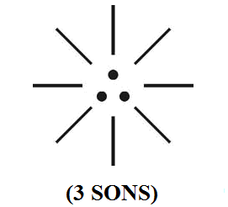

[M. Arulmani, B.E., V. R. Hema Latha, M. A. “J” Shall Mean “JOULE”?.(A new theory on Trinity Law of Nature). Cancer Biology 2013;3(4):39-43]. (ISSN: 2150-1041). http://www.cancerbio.net. 5

Key Words:
    - The philosophy of “Trinity Nature”
    - The philosophy of “Joule”
    - The Etymology of Joule

- Introduction:
In cosmological term “J” shall be considered as Source of “FREE ENERGY” of Universe required for creation of Matters and making flow of energy required for the expanding universe. The 3 Sons shall be hypothetically called as Nikola Tesla, Isaac Newton, Albert Einstein. The law made by 3 sons of “J” shall be considered as fundamental “TRINITY” law of Nature.

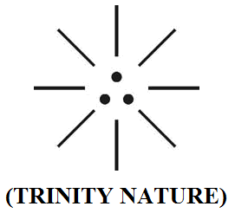

- Previous Publication:
The philosophy of origin of first life and human, the philosophy of model Cosmo Universe, the philosophy of fundamental neutrino particles have already been published in various international journals mentioned below. Hence this article shall be considered as extended version of the previous articles already published by the same author.

    - Cosmo Super Star – IJSRP, April issue, 2013
    - Super Scientist of Climate control – IJSER, May issue, 2013
    - AKKIE MARS CODE – IJSER, June issue, 2013
    - KARITHIRI (Dark flame) The Centromere of Cosmo Universe – IJIRD, May issue, 2013
    - MA-AYYAN of MARS – IJIRD, June issue, 2013
    - MARS TRIBE – IJSER, June issue, 2013
    - MARS MATHEMATICS – IJERD, June issue, 2013
    - MARS (EZHEM) The mother of All Planets – IJSER, June issue, 2013
    - The Mystery of Crop Circle – IJOART, May issue, 2013
    - Origin of First Language – IJIRD, June issue, 2013
    - MARS TRISOMY HUMAN – IJOART, June issue, 2013
    - MARS ANGEL – IJSTR, June issue, 2013
    - Three principles of Akkie Management (AJIBM, August issue, 2013)
    - Prehistoric Triphthong Alphabet (IJIRD, July issue, 2013)
    - Prehistoric Akkie Music (IJST, July issue, 2013)
    - Barack Obama is Tamil Based Indian? (IJSER, August issue, 2013)
    - Philosophy of MARS Radiation (IJSER, August 2013)
    - Etymology of word “J” (IJSER, September 2013)
    - NOAH is Dravidian? (IJOART, August 2013)
    - Philosophy of Dark Cell (Soul)? (IJSER, September 2013)
    - Darwin Sir is Wrong?! (IJSER, October issue, 2013)
    - Prehistoric Pyramids are RF Antenna?!... (IJSER, October issue, 2013)
    - HUMAN IS A ROAM FREE CELL PHONE?!... (IJIRD, September issue, 2013)
    - NEUTRINOS EXIST IN EARTH ATMOSPHERE?!... (IJERD, October issue, 2013)
    - EARLY UNIVERSE WAS HIGHLY FROZEN?!... (IJOART, October issue, 2013)
    - UNIVERSE IS LIKE SPACE SHIP?!... (AJER, October issue, 2013)
    - ANCIENT EGYPT IS DRAVIDA NAD?!... (IJSER, November issue, 2013)
    - ROSETTA STONE IS PREHISTORIC “THAMEE STONE” ?!... (IJSER, November issue, 2013)
    - The Supernatural “CNO” HUMAN?... (IJOART, December issue, 2013)
    - 3G HUMAN ANCESTOR?... (AJER, December issue, 2013)
    - 3G Evolution?... (IJIRD, November issue, 2013)
    - God Created Human?... (IJERD, December issue, 2013)
    - Prehistoric “J” – Element?... (IJSER, December issue, 2013)
    - 3G Mobile phone Induces Cancer?... (IJERD, December issue, 2013)

- Hypothesis:
- “J” shall be considered as the source of “Free energy” of universe and considered as fundamental radiant source of creation energy through which the entire matter was created.

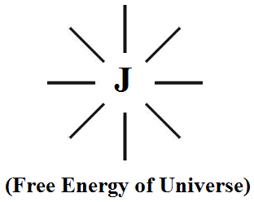

- The 3 Sons of “J” shall be considered as 3 fundamental “neutrino particles” of universe, photon, electron, proton.

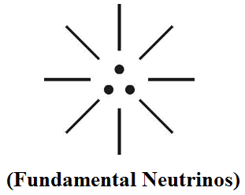

- The 3 sons of “J” shall be considered as co-existing always with symmetrical displacement and never be separated from the heart of “J”.

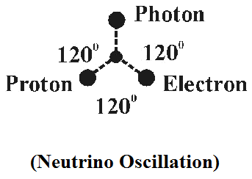

- In quantum physics “J” shall be considered as “Super Scientist” and the 3 particles of radiating energy shall also be called as 3 sons of “J”.
i) Photon Neutrino - Nikola Tesla (1st Son)
ii) Electron Neutrino - Isaac Newton (2nd Son)
iii) Proton Neutrino - Albert Einstein (3rd Son)

(i)
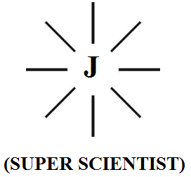

(ii)
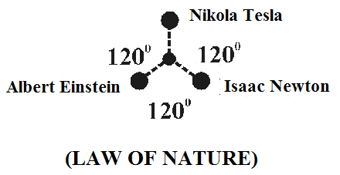

- Hypothetical Narrations:
    - “J” is God?...:
In cosmological term “J” shall be considered as “GOD” and creator of all matters. Sun, Earth, Moon shall be considered as 3 fundamental organs of “J” for making creation of matters in the universe. Sun shall be considered as “heart”, Earth shall be considered as “left hand” and Moon shall be considered as “right hand”. The three sons of “J” shall be considered as evolved from the heart of “J”.

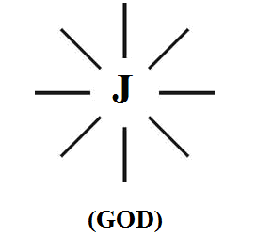

The 3 sons of “J” shall be considered as world leading scientists considered making law of universe and “J” shall be considered as the “super-scientist” and creator of the universe.

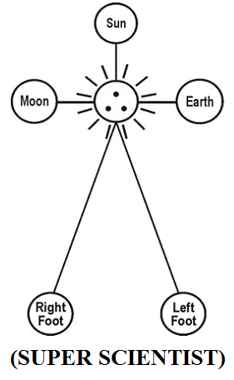

    - Philosophy of Joule:
In quantum physics the term Joule shall be considered as unit of representing “Energy”. It is hypothesized that “J” shall be considered as the super-natural source of “free energy” available in the Universe formulated by Tesla. The philosophy of word Joule in quantum physics shall be considered as derived from the philosophy of “J”.



    - The Etymology of word “Joule”:
It is hypothesized that the Etymology of Joule might have been derived from pre-historic Tamil phonetics “Chule”. “Chule” shall be considered as fundamental radiating energy or hot rays. It is further hypothesized that the Philosophy of Word “SOLAR” “CELL” might have been derived from the philosophy of “Chule”.

(i)
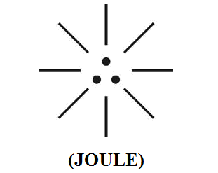

(ii)


(iii)
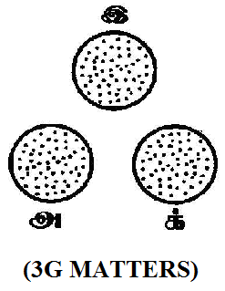

- Conclusion:
It is focused that the entire material universe shall be considered as composed of filled with “J” – RADIATION, comprising of 3 fundamental particles Photon, Electron, Proton. It is further focused that the fundamental “J” radiation shall be considered as responsible for creation of billions of matters in the universe. In the expending universe the billions of initially created matter shall be considered under-going 3 major genetic changes which shall be considered as 3 generation of matters. Further in the universe the existence of Sun, Earth, Moon shall be considered as organs of the super-natural “J” rather than evolved matters.

- REFERENCE
- Intensive Internet “e-book” study through, Google search and wikipedia
- M.Arulmani, “3G Akkanna Man”, Annai Publications, Cholapuram, 2011
- M. Arulmani; V.R. Hemalatha, “Tamil the Law of Universe”, Annai Publications, Cholapuram, 2012
- Harold Koontz, Heinz Weihriah, “Essentials of management”, Tata McGraw-Hill publications, 2005
- M. Arulmani; V.R. Hemalatha, “First Music and First Music Alphabet”, Annai Publications, Cholapuram, 2012
- King James Version, “Holy Bible”
- S.A. Perumal, “Human Evolution History”
- “English Dictionary”, Oxford Publications
- Sho. Devaneyapavanar, “Tamil first mother language”, Chennai, 2009
- Tamilannal, “Tholkoppiar”, Chennai, 2007
- “Tamil to English Dictionary”, Suravin Publication, 2009
- “Text Material for E5 to E6 upgradaton”, BSNL Publication, 2012
- A. Nakkiran, “Dravidian mother”, Chennai, 2007
- Dr. M. Karunanidhi, “Thirukkural Translation”, 2010
- “Manorama Tell me why periodicals”, M.M. Publication Ltd., Kottayam, 2009
- V.R. Hemalatha, “A Global level peace tourism to Veilankanni”, Annai Publications, Cholapuram, 2007
- Prof. Ganapathi Pillai, “Sri Lankan Tamil History”, 2004
- Dr. K.K. Pillai, “South Indian History”, 2006
- M. Varadharajan, “Language History”, Chennai, 2009
- Fr. Y.S. Yagoo, “Western Sun”, 2008
- Gopal Chettiar, “Adi Dravidian Origin History”, 2004
- M. Arulmani; V.R. Hemalatha, “Ezhem Nadu My Dream” - (2 Parts), Annai Publications, Cholapuram, 2010
- M. Arulmani; V.R. Hemalatha, “The Super Scientist of Climate Control”, Annai Publications, Cholapuram, 2013, pp 1-3.

12/11/2013

