“J”- HOUSE IS A HEAVEN?...
(A new theory on Heaven)

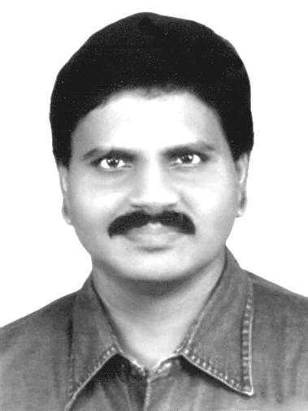  M.Arulmani, B.E.  (Engineer)  m.arulmani58@gmail.com |   V.R.Hema Latha, M.A., M.Sc., M.Phil.  (Biologist)  vrhemalatha58@gmail.com

Abstract:
A scientific research in this article focus that “J”-House shall be considered as a superstructure house constructed with ever most advanced High Technology by Super scientist “J”. The “J”-House shall be considered as Tower like structure consists of three rooms in Tier formation for providing and balancing three most fundamental needs of Human Life. The structure of “J”-House shall be formulated as below.
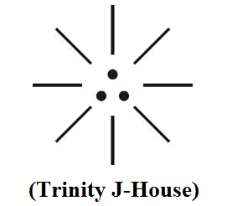
- Right dot - J-Conference Hall
- Left dot - J-Study Room
- Centre dot - J-Sleep room

This research focused in this article is speculated to provide solution to the many current controversial theories about Origin and shape of Cosmo Universe

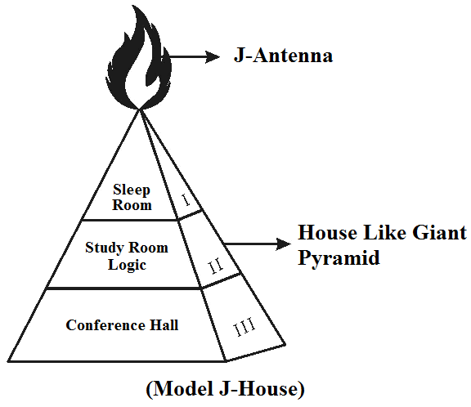
.

“J-House shall be considered as a Heaven filled with full of spirit of confidence, Joy and Peace. The Philosophy of Parliament House might be derived from the Philosophy of J-House.”
- Author

[M. Arulmani, B.E., V. R. Hema Latha, M. A. The Supersonic JET FLIGHT-2014? (A New Theory on Flying Human). Cancer Biology 2013;3(4):44-51]. (ISSN: 2150-1041). http://www.cancerbio.net. 6

Key Words:
    - Philosophy of upper room (Heaven)
    - Philosophy of middle room (Creation)
    - Philosophy of lower room (Matter Existence)
    - Philosophy of J-Food (Nutrient Food)
    - Philosophy of J-Radiation (Creative Force)

- Introduction:
The term Heaven is normally referred to the House of “GOD” and the term “HELL” is referred to the region where Human experiences full of suffering after death. The HEART shall be considered as the region where Human deriving full of logistics required for life. The fundamental logic shall be considered as plasma tablet which shall be called in medical term as stem cell.
The J-Conference Hall shall be considered as “Divine Court” for periodically reviewing the progress of conversion of plasma logic into Fruitful Matter for cherishing and making human life joyful.
J-House shall be considered as having no “Kitchen room” as it contains infinity level of inbuilt “Internal Energy” for performing the required job.

(i)
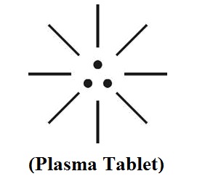

(ii)


“The J-House shall alternatively considered as “HOLY TEMPLE”. In other words the Universe containing full of CASTE FREE MATTER. All caste based matter shall be considered kept in the Hell of Fire”.
- Author

- Previous Publication:
The philosophy of origin of first life and human, the philosophy of model Cosmo Universe, the philosophy of fundamental neutrino particles have already been published in various international journals mentioned below. Hence this article shall be considered as extended version of the previous articles already published by the same author.

    - Cosmo Super Star – IJSRP, April issue, 2013
    - Super Scientist of Climate control – IJSER, May issue, 2013
    - AKKIE MARS CODE – IJSER, June issue, 2013
    - KARITHIRI (Dark flame) The Centromere of Cosmo Universe – IJIRD, May issue, 2013
    - MA-AYYAN of MARS – IJIRD, June issue, 2013
    - MARS TRIBE – IJSER, June issue, 2013
    - MARS MATHEMATICS – IJERD, June issue, 2013
    - MARS (EZHEM) The mother of All Planets – IJSER, June issue, 2013
    - The Mystery of Crop Circle – IJOART, May issue, 2013
    - Origin of First Language – IJIRD, June issue, 2013
    - MARS TRISOMY HUMAN – IJOART, June issue, 2013
    - MARS ANGEL – IJSTR, June issue, 2013
    - Three principles of Akkie Management (AJIBM, August issue, 2013)
    - Prehistoric Triphthong Alphabet (IJIRD, July issue, 2013)
    - Prehistoric Akkie Music (IJST, July issue, 2013)
    - Barack Obama is Tamil Based Indian? (IJSER, August issue, 2013)
    - Philosophy of MARS Radiation (IJSER, August 2013)
    - Etymology of word “J” (IJSER, September 2013)
    - NOAH is Dravidian? (IJOART, August 2013)
    - Philosophy of Dark Cell (Soul)? (IJSER, September 2013)
    - Darwin Sir is Wrong?! (IJSER, October issue, 2013)
    - Prehistoric Pyramids are RF Antenna?!... (IJSER, October issue, 2013)
    - HUMAN IS A ROAM FREE CELL PHONE?!... (IJIRD, September issue, 2013)
    - NEUTRINOS EXIST IN EARTH ATMOSPHERE?!... (IJERD, October issue, 2013)
    - EARLY UNIVERSE WAS HIGHLY FROZEN?!... (IJOART, October issue, 2013)
    - UNIVERSE IS LIKE SPACE SHIP?!... (AJER, October issue, 2013)
    - ANCIENT EGYPT IS DRAVIDA NAD?!... (IJSER, November issue, 2013)
    - ROSETTA STONE IS PREHISTORIC “THAMEE STONE” ?!... (IJSER, November issue, 2013)
    - The Supernatural “CNO” HUMAN?... (IJOART, December issue, 2013)
    - 3G HUMAN ANCESTOR?... (AJER, December issue, 2013)
    - 3G Evolution?... (IJIRD, November issue, 2013)
    - God Created Human?... (IJERD, December issue, 2013)
    - Prehistoric “J” – Element?... (IJSER, December issue, 2013)
    - 3G Mobile phone Induces Cancer?... (IJERD, December issue, 2013)
    - “J” Shall Mean “JOULE”?... (IRJES, December issue, 2013)

- Hypothesis:
- The J-House shall be considered as a “Model Cosmo Universe” having three distinguished regions of Radiation. The Upper Room shall be considered as Heaven, the Middle Room shall be considered as Heavenly Logic and the Bottom Room shall be considered as material universe which contain all matters of universe such as planets, gas, life matters, plants, Animals, Humans.

- The J-House shall be considered as dwelling place of super-scientist “J”. The super-scientist shall be called as GOD.

- The super scientist “J” shall be considered emanating J-Radiation. The “J-Radiation” shall be considered as having “Creative effect” and maintaining “equilibrium” of matter in the Material Universe.

- The J-Radiation shall be considered as “White Flame” comprising of Billion of rays containing fundamental neutrinos Photon, Electron, Proton having definite structural and genetic value for creation of matters. The J-Radiation shall be containing neutrino particles with “ZERO MASS”.

- The expanding Universe shall be considered as the stage when the created matter undergoes three genetic variation in three stages of cosmological period and the species matters produced in each period shall be considered as three generations matter(i.e.) 1st generation matter, 2nd generation matter & 3rd generation matter.

- The present material universe shall be considered still undergoing expansion in Region III and various new species are considered produced in 3rd generation genus till end of cosmological period.

(i)


(ii)
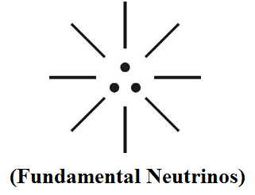

(iii)
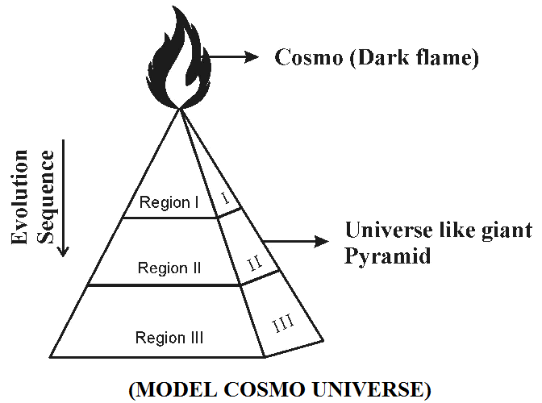

Region – I .. Antineutrinos radiation region (Black radiation)
Region – II .. Neutrinos radiation region (Stardust radiation)
Region – III .. EMR and Matter region (Einstein region)

The Cosmo region shall be considered as the highly Cold region emitting Black radiation. Region III shall be considered as the highly hot region.

- Hypothetical Narrations:
- Philosophy of “J-Food”?...
The upper room shall be considered as the HEAVEN consists of full of dark matter, Dark energy required for creation effect of Universe. The super scientist “J” shall be considered as having initiate level of Internal energy in the form of Dark Energy, Dark Matter derived from in-built Dark Fame.

The super scientist “J” shall not consider need any material form of food like Idly, Chatney, Sambar, Rasam, etc. The super scientist considers taking only “Dark Tablet”.



- Philosophy of “Heaven”?...
The upper room shall be considered as Heaven for resting of Soul in sleep mode. In other words the Neutrino Particles shall be considered as existing in highly freezed state or in sleep mode or Not in Motion.

- Philosophy of “J-Logic”?...
The Middle Room of Universe (Region II) shall be considered as Neutrino Particles gained some energy and moving randomly at the speed more than the “Speed of Light”. In this region the Neutrino Particles shall be considered having “Negative Mass”. The existence of Neutrino Particles in the Middle Region shall be considered as J-Logic having Billions of sub programme required for creation of Matters in this Universe.

- Philosophy of J-Radiation?...
The J-radiation shall be considered as the absolutely “Pure White Flame” consisting of Billions of rays for creation of Billions of Matters in the Material Universe (Region III). Each ray shall be considered having Three-in-one fundamental Neutrino particles Photon, Electron, Proton having Zero Mars.



- Philosophy of “HELL”?...
The bottom room shall be considered as Material Universe having Billions of Billions of Matters and its species grouped under 3rd generation genus. The Billions of Billions Matters shall be considered having individual colour derived from fundamental White Flame J-Radiation. The material universe (Region-III) shall alternatively be called as hell.

- Philosophy of Hydrogen, Helium?...
It is focused that Hydrogen, Helium shall be considered as Plasma form of matters and considered as derived from the Super Plasma matter of J-Radiation. The J-Radiation shall be considered as first born element in the Material Universe. The so called Magnetar star in Astrophysics shall be considered as species Plasma matter derived from J-Radiation and considered as Mother of all stars and all Planets. The J-Radiation shall also be called as in astronomical term as MORNING STAR.



- Case study on Bible, Quran:
- From the Bibilical understanding the Super Scientist “J” shall also be considered as “Heavenly Father” dwelling in J-House. The J-House shall also be considered as “TABERNACLE” or “HOLY TEMPLE” having full of dark energy, dark matter. The “J-Radiation” shall be considered as “White Flame” emanated from Super Scientist “J” which might have created Billions of Matter in the Material Universe (Region III). The so called “HOLY SPIRIT” shall also be Hypothetically called J-Radiation. The fundamental Three “New Covenant Tablet” shall be considered having three fundamental Neutrino Particles Photon, Electron, Proton.

(a)


(b)
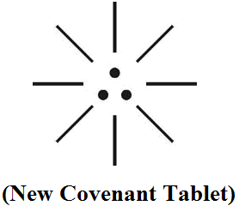

(c)
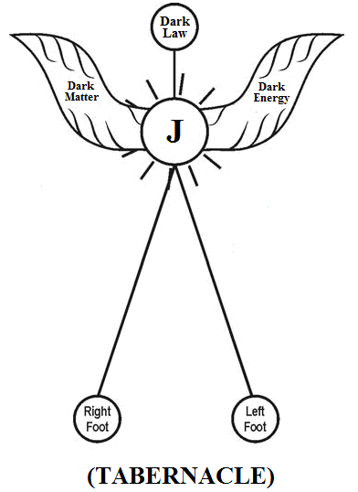

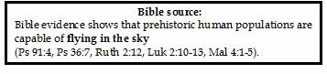

- It is speculated that the so called “MANNA” food shall be considered as food matter derived from White Flame (J-Radiation) having full of Nutrients required for human strength derived from fundamental three-in-one Neutrino Particles Photon, Electron, Proton. From Biblical understanding “JESUS” shall be considered as Plasma like matter and Considered as “MANNA” or J-Food. The J-Food shall be considered as Divine Food. The philosophy of J-Food might be derived from Philosophy of “Pre-historic Tamil Food” “PANIARAM”. PANIARAM shall mean plasma like soft food (Wafers) with sweet honey taste. (Bible Ref.: Exodus 16:31)
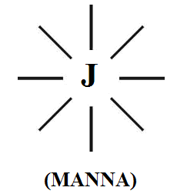

- The philosophy of “New covenant” shall be considered as “J-Logic” consists of Billions of sub programme for existence of matters in the Universe. Billions of matters existing in three generations of cosmological periods shall be considered as “3G Matters” derived from fundamental J-Radiation comprising of three-in-one fundamental Neutrino Particles.

(a)
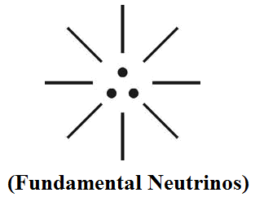

(b)
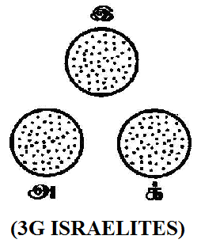
“Thousands of various denomination churches existing all over the World shall be considered as derived from fundamental J-Logic and Manna Food. Manna Food shall mean Holy Food like one flesh without any “Social and Caste Discrimination”. It is speculated that JESUS shall be considered as the “NEW HOLY CHURCH” to filler the holy elements from the Selfish Devil Elements and give REDEMPTION FOR EVERLASTING PEACE. [Bible Ref: Numbers 16:44 & 45]



- Conclusion:
It is focused that the J-House shall be considered in political term as Parliament House which shall enact new laws for promoting peace among human. “J-Radiation” shall alternatively mean peace promoter. J-House shall alternatively mean divine house or the land of NEW JERUSALEM.

- REFERENCE
- Intensive Internet “e-book” study through, Google search and wikipedia
- M.Arulmani, “3G Akkanna Man”, Annai Publications, Cholapuram, 2011
- M. Arulmani; V.R. Hemalatha, “Tamil the Law of Universe”, Annai Publications, Cholapuram, 2012
- Harold Koontz, Heinz Weihriah, “Essentials of management”, Tata McGraw-Hill publications, 2005
- M. Arulmani; V.R. Hemalatha, “First Music and First Music Alphabet”, Annai Publications, Cholapuram, 2012
- King James Version, “Holy Bible”
- S.A. Perumal, “Human Evolution History”
- “English Dictionary”, Oxford Publications
- Sho. Devaneyapavanar, “Tamil first mother language”, Chennai, 2009
- Tamilannal, “Tholkoppiar”, Chennai, 2007
- “Tamil to English Dictionary”, Suravin Publication, 2009
- “Text Material for E5 to E6 upgradaton”, BSNL Publication, 2012
- A. Nakkiran, “Dravidian mother”, Chennai, 2007
- Dr. M. Karunanidhi, “Thirukkural Translation”, 2010
- “Manorama Tell me why periodicals”, M.M. Publication Ltd., Kottayam, 2009
- V.R. Hemalatha, “A Global level peace tourism to Veilankanni”, Annai Publications, Cholapuram, 2007
- Prof. Ganapathi Pillai, “Sri Lankan Tamil History”, 2004
- Dr. K.K. Pillai, “South Indian History”, 2006
- M. Varadharajan, “Language History”, Chennai, 2009
- Fr. Y.S. Yagoo, “Western Sun”, 2008
- Gopal Chettiar, “Adi Dravidian Origin History”, 2004
- M. Arulmani; V.R. Hemalatha, “Ezhem Nadu My Dream” - (2 Parts), Annai Publications, Cholapuram, 2010
- M. Arulmani; V.R. Hemalatha, “The Super Scientist of Climate Control”, Annai Publications, Cholapuram, 2013, pp 1-3.

12/11/2013

