The Supersonic JET FLIGHT-2014?...
(A New Theory on Flying Human)

  M.Arulmani, B.E.  (Engineer)  m.arulmani58@gmail.com |   V.R.Hema Latha, M.A., M.Sc., M.Phil.  (Biologist)  vrhemalatha58@gmail.com

Abstract: A scientific research in this article focus that the Jet Flight-2014 shall be considered as the 3rd generation flight designed to travel at the speed of Sound. The Jet Flight-2014 shall be considered as Proto type of prehistoric “J-Flight”. The dark box of J-Flight shall be considered as emitting J-Radiation consists of J-Logics. This research focus that, in the expanding Universe, the design of flight model shall be considered undergone three evolution due to variation in three type of cosmic rays variation, i.e. UV-Light, RF-Light, IR-Light. This research further emphasize that the word “Flight” shall be considered meaning as Super-natural Flying Human. The super-natural human ancestor shall be considered as having “TAIL” like flame and constantly oscillating the tail as a Pendulum for maintaining Absolute Balance during the flight journey. This article is speculated to provide solution to the current confused theories on “Human Ancestor”.
“The philosophy of word FLIGHT shall be considered as derived from prehistoric FLYING HUMAN rather than from the Philosophy of “Flying Bird”.
- Author
[M. Arulmani, B.E., V. R. Hema Latha, M. A. The Supersonic JET FLIGHT-2014? (A New Theory on Flying Human). Cancer Biology 2013;3(4):52-59]. (ISSN: 2150-1041). http://www.cancerbio.net. 7

Key Words: Philosophy of J-Wave; Philosophy of J-Box; Philosophy of J-Wings; Philosophy of “F-Light”; Philosophy of 3G-CNO Cycle Variation; Philosophy of J-Engine; Philosophy of J-Fuel

- Introduction:
The whole Cosmo Universe shall be considered as a “Standstill Flight”. The super-natural flying human shall be considered as pilot of Flight having in-built infinite level of “Internal Energy” required for three generations of Cosmological period.
The pre-historic Flight shall be considered as having super structural, Architectural design to overcome the CNO Variations in space Environment in three cosmological period. The prehistoric flight shall be considered to be highly stable and balanced to the fundamental space parameters consideration.

- Aerostatic Balance
- Aerodynamic Balance
- Electromagnetic Balance

In modern time Thousands of flight models having varied model of aero engine and varied type of aero fuel shall be considered as “Species” to prehistoric J-Flight.

- Previous Publication:
The philosophy of origin of first life and human, the philosophy of model Cosmo Universe, the philosophy of fundamental neutrino particles have already been published in various international journals mentioned below. Hence this article shall be considered as extended version of the previous articles already published by the same author.

    - Cosmo Super Star – IJSRP, April issue, 2013
    - Super Scientist of Climate control – IJSER, May issue, 2013
    - AKKIE MARS CODE – IJSER, June issue, 2013
    - KARITHIRI (Dark flame) The Centromere of Cosmo Universe – IJIRD, May issue, 2013
    - MA-AYYAN of MARS – IJIRD, June issue, 2013
    - MARS TRIBE – IJSER, June issue, 2013
    - MARS MATHEMATICS – IJERD, June issue, 2013
    - MARS (EZHEM) The mother of All Planets – IJSER, June issue, 2013
    - The Mystery of Crop Circle – IJOART, May issue, 2013
    - Origin of First Language – IJIRD, June issue, 2013
    - MARS TRISOMY HUMAN – IJOART, June issue, 2013
    - MARS ANGEL – IJSTR, June issue, 2013
    - Three principles of Akkie Management (AJIBM, August issue, 2013)
    - Prehistoric Triphthong Alphabet (IJIRD, July issue, 2013)
    - Prehistoric Akkie Music (IJST, July issue, 2013)
    - Barack Obama is Tamil Based Indian? (IJSER, August issue, 2013)
    - Philosophy of MARS Radiation (IJSER, August 2013)
    - Etymology of word “J” (IJSER, September 2013)
    - NOAH is Dravidian? (IJOART, August 2013)
    - Philosophy of Dark Cell (Soul)? (IJSER, September 2013)
    - Darwin Sir is Wrong?! (IJSER, October issue, 2013)
    - Prehistoric Pyramids are RF Antenna?!... (IJSER, October issue, 2013)
    - HUMAN IS A ROAM FREE CELL PHONE?!... (IJIRD, September issue, 2013)
    - NEUTRINOS EXIST IN EARTH ATMOSPHERE?!... (IJERD, October issue, 2013)
    - EARLY UNIVERSE WAS HIGHLY FROZEN?!... (IJOART, October issue, 2013)
    - UNIVERSE IS LIKE SPACE SHIP?!... (AJER, October issue, 2013)
    - ANCIENT EGYPT IS DRAVIDA NAD?!... (IJSER, November issue, 2013)
    - ROSETTA STONE IS PREHISTORIC “THAMEE STONE” ?!... (IJSER, November issue, 2013)
    - The Supernatural “CNO” HUMAN?... (IJOART, December issue, 2013)
    - 3G HUMAN ANCESTOR?... (AJER, December issue, 2013)
    - 3G Evolution?... (IJIRD, November issue, 2013)
    - God Created Human?... (IJERD, December issue, 2013)
    - Prehistoric “J” – Element?... (IJSER, December issue, 2013)
    - 3G Mobile phone Induces Cancer?... (IJERD, December issue, 2013)
    - “J” Shall Mean “JOULE”?... (IRJES, December issue, 2013)
    - “J”- HOUSE IS A HEAVEN?... (AJER, December issue, 2013)

- Author’s fundamental Clarification?...
  - What does mean FLIGHT?...
  - What does mean TRINITY BALANCE?...
  - Why Octane number of Fuel varies?...
  - What is the fundamental source of Aero fuel?...
  - What is the type of Fuel Injection in prehistoric flight?...
  - Can we say God Particle is the source of Aero Fuel?...
  - Can we say Sun, Earth, Moon are the Trinity Parameter of Electromagnetic balance of Flight?...
  - Can we say J-Flight as standstill stable flight?...
  - Can we say Flight radiation as White Flame?...
  - Can we say Flight as “F-LIGHT”?...
  - Can we say Flight as FLYING HUMAN?...

- Hypothesis:
- It is hypothesized that “J-FLIGHT” shall be considered as existing with Wings and Tail and considered as stand-still element of Cosmo Universe. The right wing shall be considered as representing Dark Matter (functional part); the left wing shall be considered as Dark Energy (structural part); the Tail (law part) shall be considered as regulating mechanism; Engine shall be considered as the Heart of Flight. The fundamental CNO fuel element shall be considered as the three-in-one wheel base of Flight. In medical term the flight fundamental parameters shall be narrated as below.
a) Right wing - Dark matter (DNA)
b) Left wing - Dark Energy (HORMONE)
c) Tail - HYDROGEN (RNA)
d) Engine - J-RADIATION
e) Trinity wheel base - Fundamental CNO
f) Aero fuel source - GOD Particles
(Photon, Electron, Proton)
g) Aero dynamic balance - Trinity of Sun, Earth, Moon
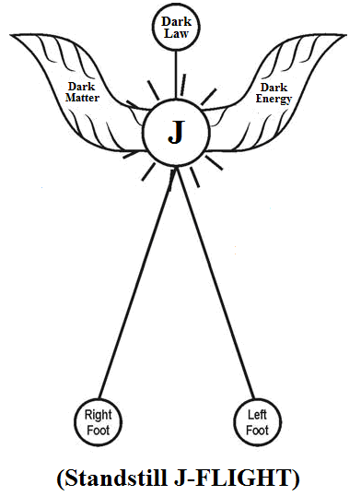

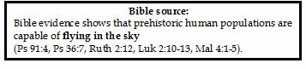
- The flight shall be considered as a super-natural Flying Human emanating white flame (J-Radiation) from his Heart (Dark Box). All the matters in the universe shall be considered “Created” in six phases in six different colour light emanated from white flame (J-Radiation). Different colour light shall be considered as having different Neutrino Mass called as “Genus”.
- 1st Phase - A - Light
- 2nd Phase - B – Light
- 3rd Phase - C – Light
- 4th Phase - D – Light
- 5th Phase - E – Light
- 6th Phase - F – Light

Human Ancestor shall be considered created with “F-Light”. Flying Human Ancestor shall also be called as “FLIGHT”. FLIGHT shall mean “F-LIGHT”. - Author

- The J-Radiation shall be considered as fundamental Radiant Matter. The radiant matter shall be considered as composed of three-in-one fundamental Neutrino Particles Photon, Electron, Proton. The J- Radiation shall be considered as composed of Billions of light rays contain three-in-one fundamental particles. Each ray shall be considered as representing each genus of every created matter of universe.

- All initially created matters shall be considered undergoing three genetic variation in three cosmological period due to impact of three different radiation.
i) 1st generation - UV-Light (Prehistoric time)
ii) 2nd generation - UV-Light, RF-Light (Ancient time)
- 3rd generation - UV-Light, RF-Light,
IR-Light (Modern time)
- The 3 generation matters shall be considered as three species matters to the fundamental created matters due to impact CNO variation in three geological periods.

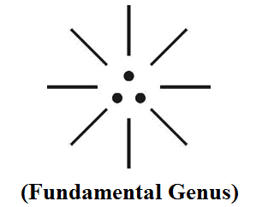
(b)
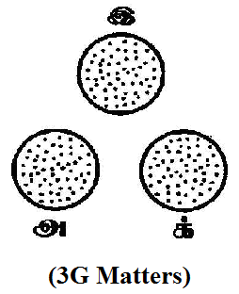

- The DARK BOX emanating GOD particles shall be considered having sustained oscillation which enable existence of matters in the Universe under electromagnetic Equilibrium.

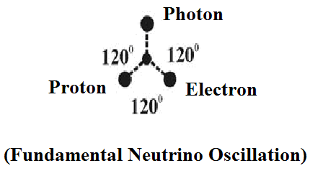

- The white flame (J-Radiation) shall be considered as having “Wave Property” (J-Wave) which enable 1st generation human capable of flying in the space. The 1st generation human shall be considered capable of Flying in the speed of Light. The modern supersonic Jet Flight - 2014 shall be considered traveling only at the speed of sound which is much lower than the speed of Light.
- The prehistoric Flight shall be considered as having definite Technical and Architectural value. The superstructural design enable the flight having accurate centre of buoyancy and stability at all varied environment condition. The Dark flame shall be considered as Internal energy source for providing dark energy fuel to the Flight.

(a)
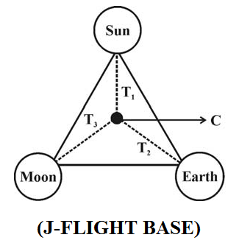
(b)
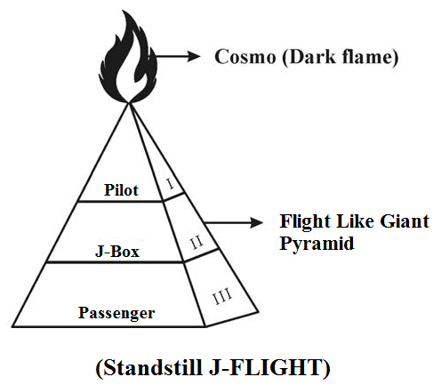

- Hypothetical Narrations:
- Aero dynamics creates matter in thee space?...
Aero dynamics is the study related to the force, motion of the objects such as planets, rockets, projectiles, etc. of the existing matters in the Universe. In brief it is stipulated that the properties of Aerodynamics can not create matter but shall lead to expansion of matter.

- Philosophy of J-Fuel?...
J-fuel shall be considered as the three fundamental particles derived from the Dark Flame of Universe. The various types of Aero fuel such as petroleum based Jet fuel, AV gas shall be considered as species fuel derived from Neutrino Particles.

- Philosophy of J-Engine?...
The “J-Engine” shall be considered as the super- efficient Prehistoric flight engine. The J-Engine shall be considered using super-refined high quality fuel derived from GOD Particles Photon, Electron, Proton. The philosophy of “Jet Engine” being used in Modern flights shall be considered derived from the philosophy of “J-Engine”.

- Philosophy of J-Pulse Injection?...
The J-Engine shall be considered deriving fuel through Pulse Injection based on “Neutrino Sustained Osillation”. The philosophy of complicated Electronic Fuel Injection (EFI)b in Jet Engines shall be considered derived from the philosophy of “J-Pulse”. Further the philosophy of special type of nozzle “J-Spout” shall also be considered from J-Pulse.

- Philosophy of J-Box?...
The J-Box shall be considered as the “Dark Box” of Pre-historic flight consists of J-logics. The philosophy of “Black Box” used in the Modern flights shall be considered derived from the philosophy of “J–Box”.

- Flying human is possible?

Prehistoric Flying Fish exist.
Prehistoric Flying Frog exist.
Prehistoric Flying Lizard exist.
Prehistoric Flying Snakes exist.
Flying Birds exist.
Flying Insects exist.
Why not Flying Human?...

It is focused that the flying human shall be considered as 1st generation human exist in Prehistoric time due to impact of UV-light environment. During the course of time the 2nd generation human, 3rd generation human might have lost flying capability gradually due to subsequent influence of RF-Light, IR-Light in the Universe.

It is further focused that the 1st generation flights could have traveled in the speed of Light. Subsequently due to growth of various cosmic radiations the properties of Aero fuel might have been altered which might lead to evolution different types of Aero engines and their speed might be reduced to much lower lever than the speed of light.

- Biblical Adam could fly?...
It is focused that the ADAM, EVE, ANGEL shall be considered as 1st generation human and might have traveled in the space at the speed of Light.

However the NOAH Origin, JESUS Origin shall be considered as 2nd and 3rd generation human and lost the flying capability gradually.

“ADAM, EVE might not worried about Petrol / Diesel
Price increase as they were capable of flying”.
- Author

- Great Pyramids Construction?...
It is speculated that the Great Pyramids of Giza, Egypt might have been constructed by 1st generation human without any difficulty.

It is speculated that the Great Pyramids might have been constructed by “J-Logics”.

- The philosophy of J-Box?...
In the commercial flight the so called Black Box is meant to record data during the time of flight accident for further investigation. The Black Box is normally being operated in the temperature range of (-)55ºC to (+)70ºC and carries a minium 25 hours of flight data.

The J-Box shall be considered as a “Heavenly Record” which shall be considered containing all the data of created matter. Billions of species evolved within the respective created genus shall also be recorded in the J-Box. The J-Box shall be considered working in the Highly freezed region temperature and containing the Data of Billions of Billions matters. In biblical term J-Box shall also be considered as box of “NEW COVENANT”. The J-Box is kept in the “Chest” of Flight rather than in the Tail of Commercial Flight.



- Conclusion:
The philosophy of Cosmo Universe shall be considered as huge pyramid like structure in which different vehicles are flying at different speed in the specified region. The Sun, Earth, Moon shall be considered as three-in-one foundation of the Pyramid and Dark Flame shall be considered as the energy provider white flame shall be considered as the Creative Soul of the Flight.

“The flying human shall also be considered
as “GOD” or “J” Flight.”
- Author.

- REFERENCE
- Intensive Internet “e-book” study through, Google search and wikipedia
- M.Arulmani, “3G Akkanna Man”, Annai Publications, Cholapuram, 2011
- M. Arulmani; V.R. Hemalatha, “Tamil the Law of Universe”, Annai Publications, Cholapuram, 2012
- Harold Koontz, Heinz Weihriah, “Essentials of management”, Tata McGraw-Hill publications, 2005
- M. Arulmani; V.R. Hemalatha, “First Music and First Music Alphabet”, Annai Publications, Cholapuram, 2012
- King James Version, “Holy Bible”
- S.A. Perumal, “Human Evolution History”
- “English Dictionary”, Oxford Publications
- Sho. Devaneyapavanar, “Tamil first mother language”, Chennai, 2009
- Tamilannal, “Tholkoppiar”, Chennai, 2007
- “Tamil to English Dictionary”, Suravin Publication, 2009
- “Text Material for E5 to E6 upgradaton”, BSNL Publication, 2012
- A. Nakkiran, “Dravidian mother”, Chennai, 2007
- Dr. M. Karunanidhi, “Thirukkural Translation”, 2010
- “Manorama Tell me why periodicals”, M.M. Publication Ltd., Kottayam, 2009
- V.R. Hemalatha, “A Global level peace tourism to Veilankanni”, Annai Publications, Cholapuram, 2007
- Prof. Ganapathi Pillai, “Sri Lankan Tamil History”, 2004
- Dr. K.K. Pillai, “South Indian History”, 2006
- M. Varadharajan, “Language History”, Chennai, 2009
- Fr. Y.S. Yagoo, “Western Sun”, 2008
- Gopal Chettiar, “Adi Dravidian Origin History”, 2004
- M. Arulmani; V.R. Hemalatha, “Ezhem Nadu My Dream” - (2 Parts), Annai Publications, Cholapuram, 2010
- M. Arulmani; V.R. Hemalatha, “The Super Scientist of Climate Control”, Annai Publications, Cholapuram, 2013, pp 1-3.

12/11/2013

