“J”-Radiation Is Mother Of Hydrogen?...
(A New theory on Supernature, Nature, Science)

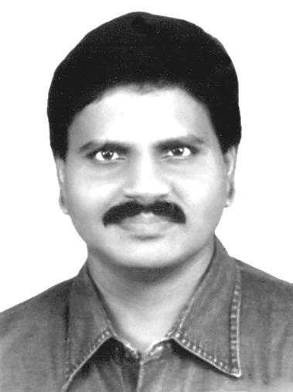  M.Arulmani, B.E.  (Engineer)  m.arulmani58@gmail.com |   V.R.Hema Latha, M.A., M.Sc., M.Phil.  (Biologist)  vrhemalatha58@gmail.com

Abstract: This Scientific research article focus that the early void Universe shall be considered from Hydrogen and CNO. The J-Radiation shall be considered as the Mother of Hydrogen. The 1st generation CNO element shall be considered as three fundamental species to Hydrogen and considered as highly pure matter of the Universe. The above article focus that the various life organisms could have been originated in the Universe after formation of fundamental Pure CNO environment (Mixture of Carbon, Nitrogen, Ozone) derived from Hydrogen. The existence of life under fundamental CNO environment shall be considered as “oxygen free” 1st generation life”. CNO shall mean Carbon, Nitrogen, Ozone; Oxygen shall be considered as 3rd Generation element and species to ozone. Ozone is like “ICE”; oxygen is like “WATER”. It is speculated that the 1st Generation life might have subsisted with OZONE BREATH.

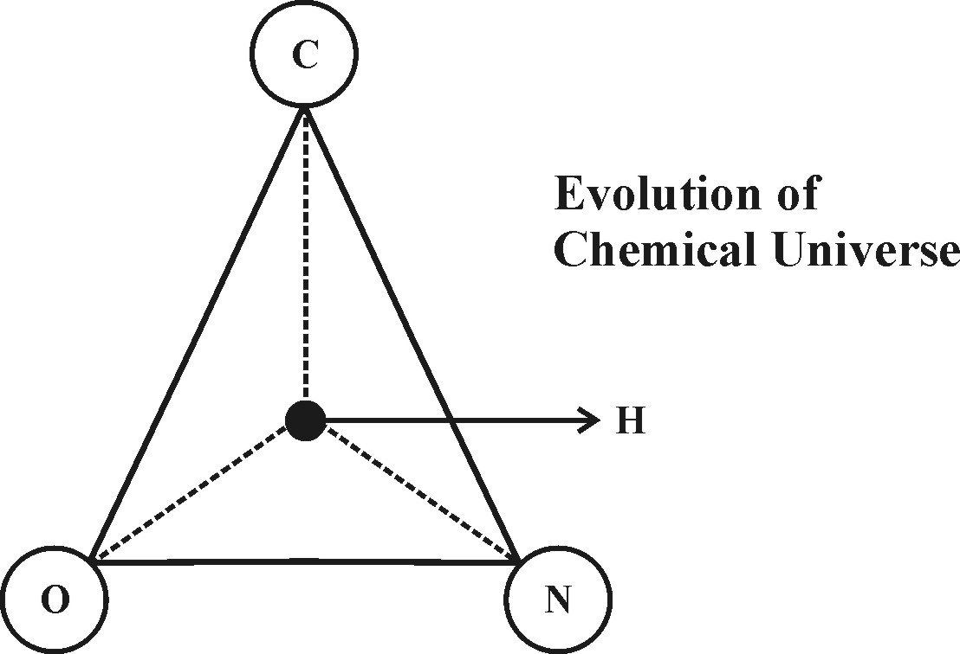

In the expanding Universe the subsequent evolution of oxygen during modern time (3rd Generation) might have added more impurities to fundamental CNO environment in three different geological periods and the Universe polluted. Present day climate changes issues, global warming issues might be due to severe CNO imbalance due to growth of higher oxygen and lower carbon level. Further the increase in cancer growth rate is considered due to higher content of oxygen in the atmosphere.
[M. Arulmani, B.E., V. R. Hema Latha, M. A. “J”-Radiation Is Mother Of Hydrogen? (A New theory on Supernature, Nature, Science). Cancer Biology 2013;3(4):60-68]. (ISSN: 2150-1041). http://www.cancerbio.net. 8

“The Prehistoric life might have switched over to oxygen breath gradually from ozone breath due to Natural Selection in 2nd, 3rd generation. The oxygen free environment shall be considered as Highly Pure environment”.
- Author.

Key Words:
1) Philosophy of J-Radiation
2) Philosophy of Pure Science
3) Philosophy of Pure Colours
4) Philosophy of Pure Energy
5) Philosophy of Pure Human

- Introduction:
In existing universe it is focused that the environmental change shall be considered as changes in CNO environment which shall result in altering the fundamental properties of preexisting matter. Further in the occurrence of “CNO Cycle” there is no current theory how CNO Variation is initiated?. If it is due to Nature means then What is Nature?... If it is due to Supernature or Science act means then What does mean Supernature?... What does mean Science?... Even Science itself there is a thought about existence of Pure Science. If so what does mean pure Science?... Some theory further focus about mixture of Nature and Science called as Natural Science. If so what does mean Natural Scince? I am sorry… Now I am totally confused!... Science shall confuse Human mind?...

What we observe is Nature!...
What we Experience is Science!!...
What the Real Truth behind mystery is Supernature!!!...
- Author

- Previous Publication:
The philosophy of origin of first life and human, the philosophy of model Cosmo Universe, the philosophy of fundamental neutrino particles have already been published in various international journals mentioned below. Hence this article shall be considered as extended version of the previous articles already published by the same author.

    - Cosmo Super Star – IJSRP, April issue, 2013
    - Super Scientist of Climate control – IJSER, May issue, 2013
    - AKKIE MARS CODE – IJSER, June issue, 2013
    - KARITHIRI (Dark flame) The Centromere of Cosmo Universe – IJIRD, May issue, 2013
    - MA-AYYAN of MARS – IJIRD, June issue, 2013
    - MARS TRIBE – IJSER, June issue, 2013
    - MARS MATHEMATICS – IJERD, June issue, 2013
    - MARS (EZHEM) The mother of All Planets – IJSER, June issue, 2013
    - The Mystery of Crop Circle – IJOART, May issue, 2013
    - Origin of First Language – IJIRD, June issue, 2013
    - MARS TRISOMY HUMAN – IJOART, June issue, 2013
    - MARS ANGEL – IJSTR, June issue, 2013
    - Three principles of Akkie Management (AJIBM, August issue, 2013)
    - Prehistoric Triphthong Alphabet (IJIRD, July issue, 2013)
    - Prehistoric Akkie Music (IJST, July issue, 2013)
    - Barack Obama is Tamil Based Indian? (IJSER, August issue, 2013)
    - Philosophy of MARS Radiation (IJSER, August 2013)
    - Etymology of word “J” (IJSER, September 2013)
    - NOAH is Dravidian? (IJOART, August 2013)
    - Philosophy of Dark Cell (Soul)? (IJSER, September 2013)
    - Darwin Sir is Wrong?! (IJSER, October issue, 2013)
    - Prehistoric Pyramids are RF Antenna?!... (IJSER, October issue, 2013)
    - HUMAN IS A ROAM FREE CELL PHONE?!... (IJIRD, September issue, 2013)
    - NEUTRINOS EXIST IN EARTH ATMOSPHERE?!... (IJERD, October issue, 2013)
    - EARLY UNIVERSE WAS HIGHLY FROZEN?!... (IJOART, October issue, 2013)
    - UNIVERSE IS LIKE SPACE SHIP?!... (AJER, October issue, 2013)
    - ANCIENT EGYPT IS DRAVIDA NAD?!... (IJSER, November issue, 2013)
    - ROSETTA STONE IS PREHISTORIC “THAMEE STONE” ?!... (IJSER, November issue, 2013)
    - The Supernatural “CNO” HUMAN?... (IJOART, December issue, 2013)
    - 3G HUMAN ANCESTOR?... (AJER, December issue, 2013)
    - 3G Evolution?... (IJIRD, November issue, 2013)
    - God Created Human?... (IJERD, December issue, 2013)
    - Prehistoric “J” – Element?... (IJSER, December issue, 2013)
    - 3G Mobile phone Induces Cancer?... (IJERD, December issue, 2013)
    - “J” Shall Mean “JOULE”?... (IRJES, December issue, 2013)
    - “J”- HOUSE IS A HEAVEN?... (AJER, December issue, 2013)
    - The Supersonic JET FLIGHT-2014?... (IJSER, January issue, 2013)

- Hypothesis:
As per existing current theories, there is no clear distinguished definition about
i) What does mean Supernature?
ii) What does mean Nature?
iii) What does mean Science?

(a) It is hypothesized that Supernature, Nature, Science shall be considered as a “Three-in-one” Members of Universe family, and these three members of the family can not be separated. DARK FLAME shall be considered as Hydrogen based internal energy of the supernature.

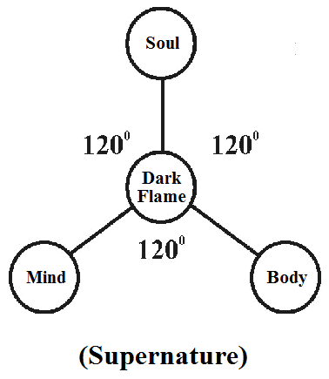

(b) The fundamental Hydrogen, CNO shall be considered as NATURAL MATTER derived from “J-Radiation”.

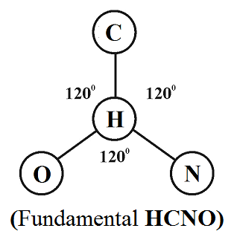

(c) In Medical Term Supernature, Nature, Science shall be considered as equivalent to DNA (Nature), HORMONE (Science), RNA (Supernature).

(d) In scientific codal language the Supernature, Nature, Science of Universe shall be formulated as below.

(i)
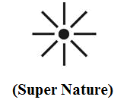
(ii)
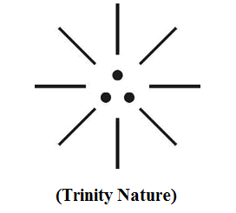

(iii)
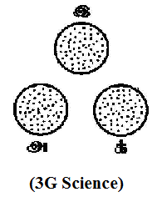

(e) In the early Universe, there was no existence of matter and the whole Universe shall be considered as VOID and shall be considered as matter free Universe. The philosophy of supernature, nature, science shall be considered as three integral part of Cosmo Universe as mentioned below:

(i)
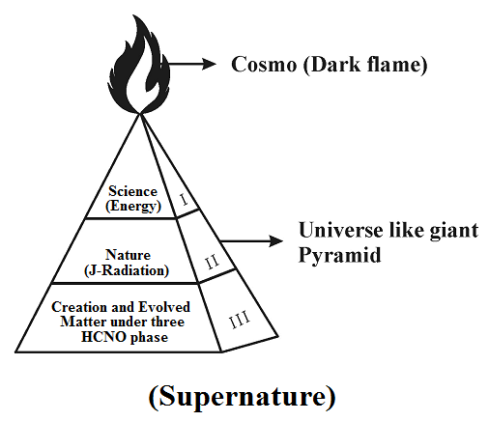

(ii)

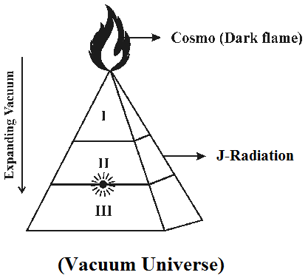

Region I – Perfect vacuum region (Anti-Neutrinos radiation)
Region II – Partial vacuum region (Neutrinos radiation)
Region III – Observable Vacuum region (EMR radiation)

(iii)
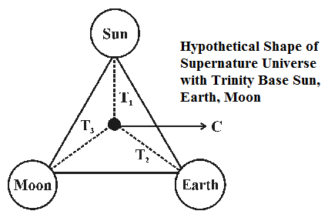

(f) The three HCNO phase shall be considered existing due to impact of three different types of EVOLVED RADIATION in three geological period as mentioned below:

- 1st Generation – UV Radiation only
- 2nd Generation – UV, RF Radiation only
- 3rd Generation – UV, RF, IR Radiation

(g) The region-I of Universe shall be considered as highly freezed zone, region-II shall be considered as moderate freezed zone (Tesla region), region-III shall be considered as highly hot zone (Einstein region).

- Hypothetical Narrations:
a) It is focused that Natural Matter, Natural substance shall be considered as absolutely free from Hydrogen, and CNO elements. In the early universe the first chemical elements Hydrogen, CNO Molecule shall be considered as originated from absolutely pure and Hydrogen free Natural Radiation called as “J-Radiation” or White Flame.

In the Cosmo Universe all the Hydrogen, the early CNO based matters such as planets, Gas molecules, Human, Animals, Plants shall be considered as derived from J-RADIATION. Thousands of various other radiations such as Alpha, Beta, Gamma shall be considered as HCNO content and species radiations to “PURE J-RADIATION”.

“J-Radiation shall be considered as absolutely free from Hydrogen, CNO elements and contains only Neutrino Particles Photon, Electron, Proton. The Neutrino Particles shall also be called as “GOD Particles”.
- Author.

b) In J-Radiation shall be considered as containing three-in-one fundamental energy properties, i.e. Electric, Magnetic, Optic which shall be considered derived due to impact of Anti-Neutrinos. Hydrogen and Carbon, Nitrogen, Ozone (CNO) required for life shall be considered as 1st generation pure elements derived from “J-Radiation”. All other elements in the Universe shall be considered as “Species Elements” with added impurities called as “3G Matters” under the varied environment of 3 generations of CNO Cycle due to UV, RF, IR impact in three geological periods.

c) The Molecular structure properties of all matters of Universe, i.e. Physical, Chemical, Mathematical properties under varied composition of Pressure, Temperature, Density. The varied molecular structure of matters shall be considered as varied “SIM NUMBER” in Mobile Phone System.

d) The 1st generation of human and life organisms shall considered derived from Billions of rays emitted from J-Radiation under 1st generation Hydrogen, CNO environment. The 1st generation human and all life organisms shall be considered as having “DARK COLOUR” on origin and varied colour properties might be derived from 2nd, 3rd generation CNO environment.

“Dark Colour, White colour shall be considered as fundamental Pure colours. “White born of Dark”. Billions of other colours shall be considered as Colours with added Impurities and species to fundamental Dark and white”. Author.

e) The fundamental study about various cosmic radiations and associated varied mass level of fundamental Neutrino Particles Photon, Electron, Proton shall be considered as “PURE SCIENCE”.

“Pure Science shall be considered as the study of Physical, Chemical, Mathematical behavior of fundamental Particles radiation rather than study of various auxiliary branch area such as medical science Plant Science, Animal Science, Environmental Science, etc.” Author.

f) “Pure human” shall be considered as the 1st generation human who lived under 1st generation Hydrogen, CNO environment and could breath Highly Purified “OZONE AIR”. The 2^{nd,} 3rd generation human (so called Modern Post Modern Human) shall be considered as “Impure human” who breath Oxygen air which shall be considered as species air to highly pure ozone Air. The pure human shall be considered as “Creative Product” or “Natural Human”.

g) The entire Cosmo Universe shall be considered like a “Supernatural human” having infinite level of Dark matter, Dark energy. J-Radiation shall be considered as the pure creative force of all matter of universe. The Dark matter, Dark energy shall be considered as containing full of Anti-Neutrino Particles and J-Radiation shall be considered as full of Neutrino particles. Neutrino Particles shall be considered possessing exactly opposite charge properties and characteristics to Anti-Neutrino Particles.

The whole Cosmo Universe shall be considered as “Three-in-one” regions as stated below.

a) Region I “BODY” (Structural)
b) Region II -“HEART” (J-Logics)
c) Region III -“MIND” (Functional)

- Lamp is like Universe?...
The lamp shall be considered as Universe and composed of three-in-one parameter of Supernature, Nature, Science.


        - Fuel – Dark energy
        - Thiri (Thread) – Neutrino particles
        - Flame – Creative Rays (J-Radiation)

- Candle is like Universe?...
The candle light shall be considered as Universe composed of three-in-one parameter of Supernature, Nature, Science.

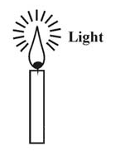
- Wax – Science
- Thiri (Thread) – Nature
- Flame – Creative Rays (J-Radiation)

- Morning Star is like Universe?...
The star illumination shall be considered as Universe composed of three-in-one Neutrino particles responsible for emission of J-Radiation. Thousands of illuminating colour stars in the sky shall be considered as illuminating Neutrino Particles.



- Philosophy of H, CNO Variation?...
It is hypothesized that the fundamental initially created H, CNO matter shall be considered undergone three major genetic changes in three geological periods due to change in the relative position of SUN, EARTH, MOON which is considered as the base of Cosmo Universe rather than various current theorires about CNO, HCNO Variation.

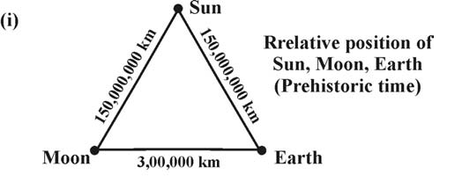
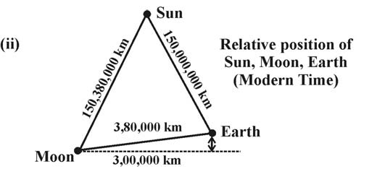

- Philosophy of Oxygen Origin?...
It is focused that Oxygen shall be considered as 3rd Generation matter formed only in modern periods due to impact of 3rd Generation radiation and 3rd Generation HCNO phase. The prehistoric life shall be considered as living with super immunity under Oxygen free environment.

- Oxygen influences Cancer and Climatic Changes?...
It is focused that the growth of higher Oxygen and lower carbon level growth shall be considered as having great impact on fast Cancer growth and frequent climate change issues such as frequent cyclone, volcanic activity, sudden forest fire, growth of new disease microbes and bacteria.

- Oxygen influences O-type blood evolution?...
It is focused that the evolution of Oxygen in modern time shall be considered as having great impact on evolution of O-type blood and WBC in human. It is focused that the prehistoric human had only single type blood AB. Further three more types of blood might be originated in three different geological period due to impact of three different radiations and three CNO phase.

- AB Type – Human Origin
- AB, A Type – 1st Generation
- AB, A, B Type – 2nd Generation
- AB, A, B, O Type – 3rd Generation

- Biblical ADAM, EVE ANGEL could breath Ozone?...
It is focused that ADAM, EVE, ANGEL shall be considered as 1st generation Human Populations subsisting with Ozone Breath and eaten MANNA Food. Manna Food shall be considered as Holy Food derived from “J-Radiation”. JESUS CHRIST shall be considered as 3rd Generation population and born of O-Type blood and WBC origin. The three different generations based on Biblical understanding shall be narrated as below.
- Angel, Adam, Eve – AB Type only (1st Generation)
- NOAH – AB, A, B Type only (2nd Generation)
- Jesus Christ – AB, A, B, O (3rd Generation)

Further the philosophy of word “AMEN” shall be considered as creation logic also called as J-Logic or Holy spirit. The creator of Universe shall be called as supernature or JEHOVAH.

(i)
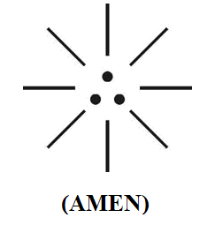

(ii)


(iii)
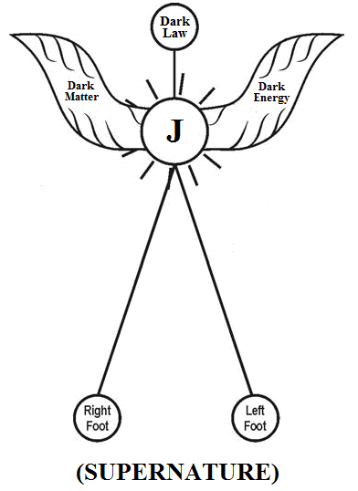

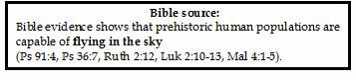

The philosophy of J-LOGIC shall be alternatively called as follows.

- J-logic shall mean law of Universe
- J-logic shall mean First born element
- J-logic shall mean carol of Ariro… Araro…
- J-logic shall mean new hope of good news
- J-logic shall mean virgin mother
- J-logic shall mean mother of hydrogen
- J-logic shall mean mercy of J-mass
- J-logic shall mean J-angel of “Indo-Canaanite”
- J-logic shall mean castless blood of holy communion
- J-logic shall mean new covenant of peace
- J-logic shall mean born love of holy cross
- J-logic shall mean radiation hope of morning star
- J-logic shall mean redemption plan of J-kingdom
- J-logic shall mean Canaanites of J-family
- J-logic shall mean pyramid of confidence
- J-logic shall mean holistic medicine of olive leaves
- J-logic shall mean holy water of Jordan
- J-logic shall mean holy food of Manna
- J-logic shall mean command of Sinai
- J-logic shall mean holy temple of new Canaan
- J-logic shall mean “POPE-AMMA” of New Jerusalem
- J-logic shall mean visible Jehovah
- J-logic shall mean “AMEN”

- CONCLUSION:
Three-in-one Neutrino Particles shall be considered as “Law of Universe” which make the universe.

i) GOD is like “Supernature”
ii) HUMAN is like “Nature”
- LAW is like “SCIENCE”

“What is observed is Science and Nature. What is Truth is Supernature”
- Author.
- REFERENCE
- Intensive Internet “e-book” study through, Google search and wikipedia
- M.Arulmani, “3G Akkanna Man”, Annai Publications, Cholapuram, 2011
- M. Arulmani; V.R. Hemalatha, “Tamil the Law of Universe”, Annai Publications, Cholapuram, 2012
- Harold Koontz, Heinz Weihriah, “Essentials of management”, Tata McGraw-Hill publications, 2005
- M. Arulmani; V.R. Hemalatha, “First Music and First Music Alphabet”, Annai Publications, Cholapuram, 2012
- King James Version, “Holy Bible”
- S.A. Perumal, “Human Evolution History”
- “English Dictionary”, Oxford Publications
- Sho. Devaneyapavanar, “Tamil first mother language”, Chennai, 2009
- Tamilannal, “Tholkoppiar”, Chennai, 2007
- “Tamil to English Dictionary”, Suravin Publication, 2009
- “Text Material for E5 to E6 upgradaton”, BSNL Publication, 2012
- A. Nakkiran, “Dravidian mother”, Chennai, 2007
- Dr. M. Karunanidhi, “Thirukkural Translation”, 2010
- “Manorama Tell me why periodicals”, M.M. Publication Ltd., Kottayam, 2009
- V.R. Hemalatha, “A Global level peace tourism to Veilankanni”, Annai Publications, Cholapuram, 2007
- Prof. Ganapathi Pillai, “Sri Lankan Tamil History”, 2004
- Dr. K.K. Pillai, “South Indian History”, 2006.
- M. Varadharajan, “Language History”, Chennai, 2009
- Fr. Y.S. Yagoo, “Western Sun”, 2008.
- Gopal Chettiar, “Adi Dravidian Origin History”, 2004
- M. Arulmani; V.R. Hemalatha, “Ezhem Nadu My Dream” - (2 Parts), Annai Publications, Cholapuram, 2010
- M. Arulmani; V.R. Hemalatha, “The Super Scientist of Climate Control”, Annai Publications, Cholapuram, 2013, pp 1-3.

12/11/2013

