Assessment of the Physico-chemical Parameters and Quality of Water of the New Calabar-Bonny River, Porthacourt, Nigeria

¹Agbugui, M. O. and ²Deekae, S.N.

¹ Department of Biological Sciences, Ahmadu Bello University Zaria, Nigeria,
² Department of Fisheries and Aquatic Environment, Rivers State University of Science and Technology, Porthacourt, Nigeria
marianuseni@yahoo.com

Abstract: The physico-chemical characters of the New Calabar-Bonny River were investigated for two years to determine its water quality for aquaculture production and human domestic uses. Three stations were chosen to check for the variations in the selected waters parameters. pH, Temperature, salinity, Dissolved oxygen, Alkalinity, Conductivity and Turbidity were analysed monthly from June 2011 to May 2013 using standard method s and procedures. The ranges obtained were found to be comparable to other Nigerian and African Reservoirs. Mean values obtained were: temperature 28.62±0.62ºC, 28.37±0.7ºC, 28.41±0.57ºC, pH 6.36±0.34, 6.19±38, 2.27±0.74, salinity 11.50±7.71 º/oo, 12.15±5.24 º/oo, 0.58±0.94 º/oo, and dissolved oxygen 6.88±0.51mg/l, 6.92±0.58mg/l, 6.88±0.63mg/l for stations 1, station 2 and station 3 respectively. There was significant difference in salinity level between the three stations, revealing that station 1 is a salt water area, station 2 is brackish/tidal and station 3 is predominantly fresh water. Alkalinity had a mean of 12.61 ± 1.19mg/l. Station 2 recorded the highest alkalinity level (13.60 ± 8.86mg/l) while station 3 recorded the lowest (10.93 ± 10.37 mg/l). Station 1 had the highest mean TDS concentration (10128.2 ± 9069.11 ppm) while station 3 had the lowest mean TDS concentration (2732.90 ± 2644.01 ppm). Mean conductivity was 3752.74 ± 257.58µs/cm. An annual mean of Turbidity 9.81 ± 3.74 NTU was recorded. Station 3 recorded the lowest mean turbidity of 5.12 ± 3.55 NTU while station 1 recorded the highest mean turbidity of 14.29 ± 8.76 NTU. Turbidity was low in the dry season and high in the rainy season. This study concludes that the physico-chemical parameters of water of the New Calabar-Bonny River meet the recommended and obtainable state of the aquaculture production and for human consumption.
[Agbugui, M. O. and Deekae, S.N. Assessment of the Physico-chemical Parameters and Quality of Water of the New Calabar-Bonny River, Porthacourt, Nigeria. Cancer Biology 2014;4(1):1-9]. (ISSN: 2150-1041): (ISSN: 2150-105X (online). http://www.cancerbio.net. 1

Key words: physico-chemical parameters, New Calabar-Bonny River, Salinity, Aquaculture production, water quality.

Introduction:
The productivity of a given body of water is determined by its physical, chemical and biological properties. The environmental properties of water need to be conducive for aquaculture and especially for fish to grow well therefore, an ideal water condition is a necessity for the survival of fish since the entire life processes of the fish is wholly dependent on the quality of its environment. Water quality is determined by the physical and chemical state of the water body. This includes all the physical, chemical and biological factors of water that influences the beneficial use of the water. Water quality is important in drinking water supply, irrigation, fish production, recreation and other purpose to which the water must have been created (Moshood, 2008). It was also stated that water quality deterioration in natural rivers usually comes from excessive nutrient inputs, eutrophication, acidification, heavy metal contamination, organic pollution and obnoxious fishing practices. The effects of these ``inputs” in the water body do not only affect the socio-economic functions of the water negatively, but also bring loss of structural biodiversity. According to Ademoroti (1996), water from market stalls, slaughter houses, street washing and flushing sewage which flow through drains into rivers cause pollution. Other sources include industrial activities (oil spillage on water, loading and washing of oil tanks) and frequent discharges of agricultural wastes. These pollutants in the water body greatly affect the quality. The changes in the characteristics like temperature, transparency and chemical elements of water such as dissolved oxygen (DO), hydrogen ion concentration (pH) and electrical conductivity (Lind, 1979) provide valuable information on the quality of water and their impacts on the functions and biodiversity of the water body.
This study is aimed at investigation the physico-chemical parameters of the river and its quality for aquaculture production and human consumption. The results obtained to add to the existing information on the status of the river for fish production and a baseline for monitoring and tracking changes in the water quality.

Materials and Methods:
The study area is located at the upper limits of the New Calabar-Bonny River near Porthacourt metropolis. Rivers State, Nigeria. It is located between latitude 4º36’ and 4º55’N and longitude 6º45’ and 7º72’E. Three stations were selected along the river for the purpose of this study based on the salinity of the river as reported by Nedeco, (1961) and Deekae, (1993). The station1 is oligohaline, station 2 is mesohaline and station 3 is polyhaline. There are a lot of activities by various companies along the river side. These include Shell BP (pipe sites), Indomie noodles, Wilbros and Eagle cement. They discharge their waste into the river which affects the water quality.
Bottles measuring one hundred and fifty milliliters each were used to collect water samples. The bottles were immersed to about 6cm below the water surface and filled to capacity. The bottle was then brought out, properly closed and covered wholly with black polythene bag.
The values of the water parameters (pH, Temperature, salinity, Dissolved oxygen, Alkalinity, Total Dissolved Solids, Conductivity and Turbidity) were taken using a multiple insitu meter, model U – 10 micro, Horiba limited, Japan. This was done by inserting the electrode into the beaker of water sample and the readings were made. An average value was taken after three readings and was recorded. Water samples were collected fortnightly.

Statistical Analyses:
The SPSS (2004) was used to deduce the means, Standard deviation (SD), Standard error (SE) of the physico-chemical parameters of water. The significance of differences of water parameters was analysed using ANOVA (SPSS). Pearson correlation was used to determine association between physicochemical parameters of water. T-test was used to test difference between seasons.

Results:
The pH value ranged from 6.43, 6.36, and 6.43 in stations 1, 2 and three respectively with an average mean of 6.41 ± 0.03(Figure 1). There were no significant difference in pH (P> 0.05) within the three stations sampled. In the wet season, the pH recorded was between 5.20 and 7.20 with a mean of 6.39± 0.14, while the dry season had a pH mean of 6.42 ± 0.20 with values between the range of 5.90 and 7.25. There was no significant difference (P>0.05) in pH between the seasons.
The temperature recorded was between 28.05ºC and 28.43^{O}C and a mean of 28.22 ± 0.16 ºC. Station 1 had the highest temperature of 22.43 ºC while station 2 had the lowest temperature of 28.05 ºC. Dry season temperature (29.02 ± 0.11) was higher (P<0.05) than wet season temperature (27.63 ±0.25). No significant difference was observed in temperature between the stations. Temperature had a high positive correlation with pH (0.76).
Salinity fluctuated between the lowest value at station 3 (0.73ppt) to (18.81ppt) at station 1. Statistically, differences were observed in salinity between the stations and within the seasons, with the dry season (8.29±6.38) having lower values than the wet season (9.20 ± 8.05). Low positive correlations were observed between salinity and pH (0.07), and salinity and TºC (0.59).
The total mean dissolved oxygen concentration recorded in the New Calabar – Bonny River ranged between 5.30 mg/l – 7.89mg/l with a mean of 7.76 ± 1.57 mg/l. The dissolved oxygen in water ranged from 7.01mg/l and 7.22mg/l in the wet season and the mean value was 7.11 ± 0.10mg/l. In the dry season the values were between 6.63mg/l and 6.83mg/l with a mean value of 6.73 ± 0.10mg/l. There was no significant difference (P>0.05) in the dissolved oxygen between the seasons. The trend of dissolved oxygen concentration is shown in figure 4. Dissolved oxygen had positive correlation with pH (0.50) but negative correlation with TºC (-0.17) and salinity (-0.87) which was not significant (P>0.05).
Alkalinity recorded for this study ranged between 0.00 mg/l – 30.10 mg/l with a mean of 12.61 ± 1.19mg/l. Station 2 recorded the highest alkalinity level (13.60 ± 8.86mg/l) while station 3 recorded the lowest (10.93 ± 10.37 mg/l). No significant difference (P>0.05) was observed between the stations. Alkalinity in the wet season ranged from 5.60 mg/l to 20.70 mg/l with a mean of 11.98 ± 0.74mg/l while the dry season had a higher range of 5.5 mg/l to 22.80mg/l and a mean of 13.41 ± 0.41mg/l. Statistically, there was no significant difference (P>0.05) in alkalinity between the wet season and the dry season. The alkalinity pattern of the river was variable within the seasons. Negative correlations were observed between alkalinity and pH (-0.56), alkalinity and DO (-1.00), but positive correlations between alkalinity and TºC (0.10) and salinity (0.87).

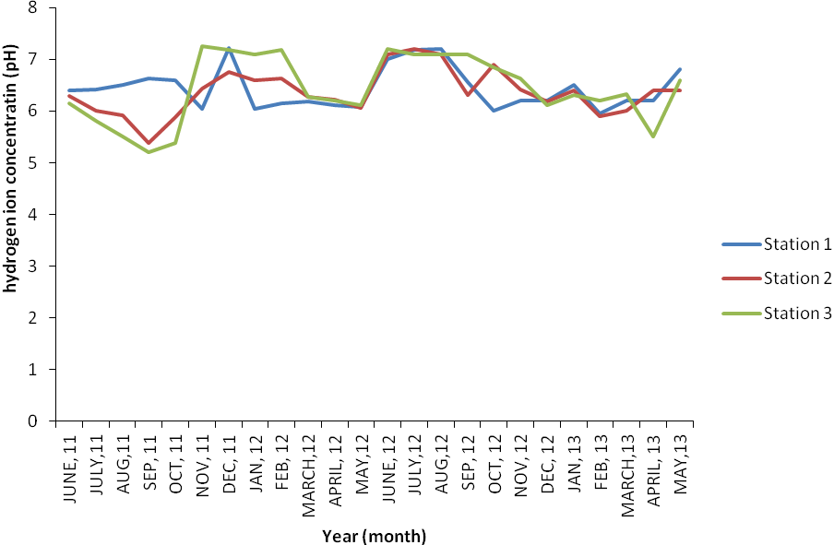

Figure 1: Hydrogen ion concentration in New Calabar-Bonny River 2011-2013

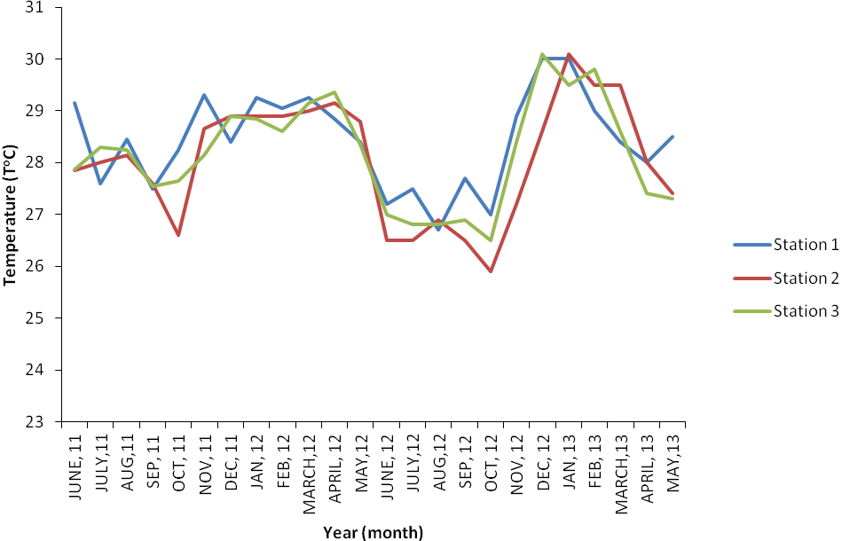

Figure 2: Temperature of New Calabar-Bonny River 2011- 2013

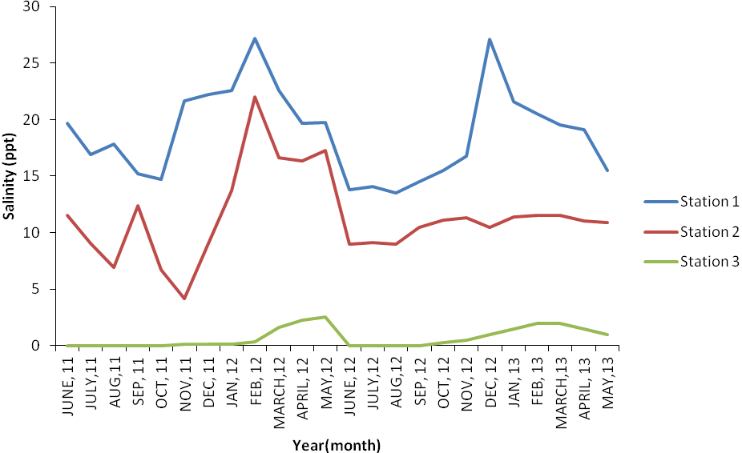
Figure 3: Salinity of New Calabar-Bonny River 2011-2013

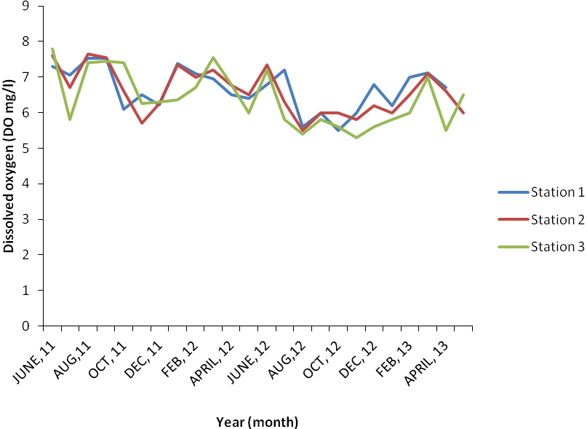

Figure 4: Dissolved oxygen of New Calabar-Bonny River (2011-2013)

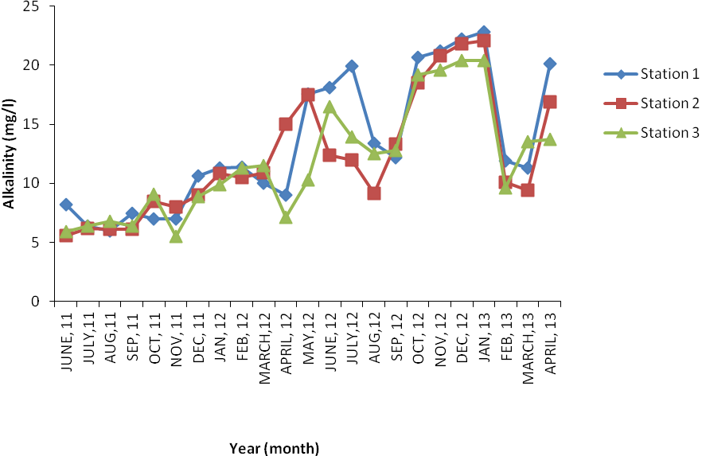
Figure 5: Alkalinity of New Calabar-Bonny River 2011-2013

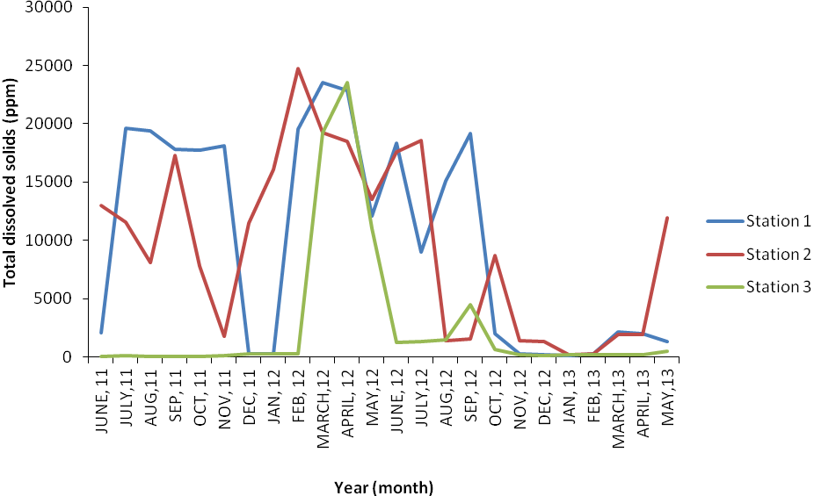

Figure 6: Total dissolved solids of New Calabar-Bonny River 2011-2013

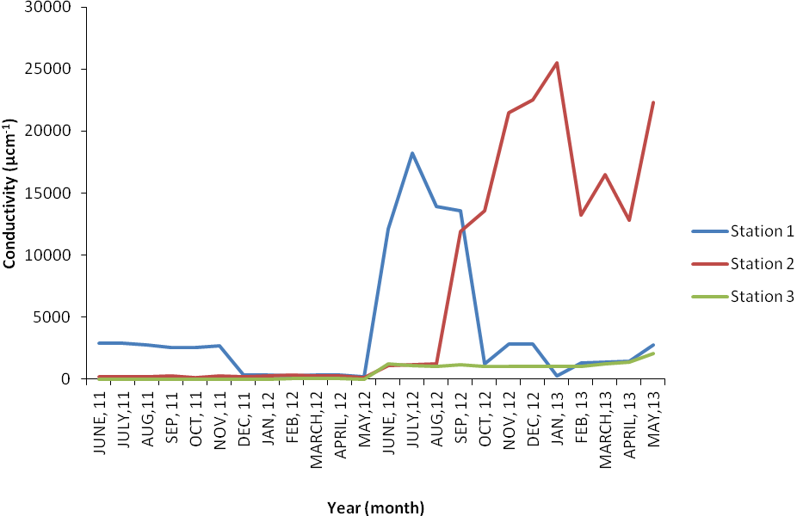
Figure 7: Conductivity of New Calabar-Bonny River 2011-2013

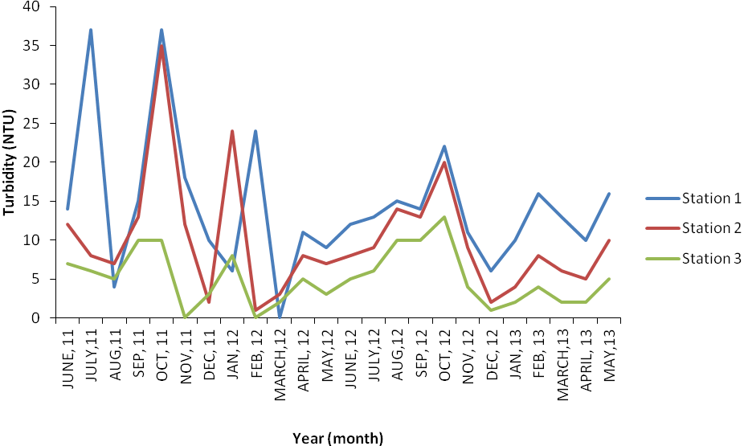

Figure 8: Turbidity of New Calabar-Bonny River 2011-2013

The Total dissolved solids concentration ranged from 20.00 ppm – 24710.00ppm (7475.70 ± 3359.78ppm). Station 1 had the highest mean TDS concentration (10128.2 ± 9069.11 ppm) while station 3 had the lowest mean TDS concentration (2732.90 ± 2644.01 ppm). The mean total dissolved solids in the wet season was 7120.46 ± 3701.86 ppm and ranged from 20.00ppm – 2352.00ppm, while the dry season had a lower mean of 4937.34 ± 2721.90ppm and ranged from 104.00ppm – 24710.00ppm. There was no significant difference (P>0.05) in TDS between the wet season and the dry season. TDS correlated negatively with pH (-0.31) and DO (1.00), positively with TºC (0.27), salinity (0.94), and alkalinity (0.99).
The conductivity of The New Calabar – Bonny River ranged between 1.8 µs/cm – 2900µs/cm and the mean conductivity was 3752.74 ± 257.58µs/cm. The mean seasonal variation for conductivity was 761.88 ± 727.00µs/cm for wet season and 226.36 ± 212.43µs/cm for dry season. Significant difference (P<0.05) was observed for conductivity between the seasons. Conductivity had negative correlation with pH (-0.81), TºC (-0.24) and DO (-0.91) but positive correlations with Salinity (0.65), alkalinity (0.94) and TDS (0.87).
The range of turbidity was from 0.00 NTU – 37.00 NTU with an annual mean of 9.81 ± 3.74 NTU. Station 3 recorded the lowest mean turbidity of 5.12 ± 3.55 NTU while station 1 recorded the highest mean turbidity of 14.29 ± 8.76 NTU. Turbidity was low in the dry season and high in the rainy season. Turbidity was higher 11.78 ± 4.72 (NTU) in the wet season than 7.03 ± 4.40(NTU) for the dry season. Significant difference (P<0.05) was observed in turbidity between the wet season and dry season. Turbidity correlated negatively wit pH (-0.01) and DO (0.87), then positively with TºC (0.64), salinity (1.00), alkalinity (0.83), TDS (0.91) and conductivity (0.91).

Discussion
The hydrogen ion concentration, (pH) of the New Calabar – Bonny River in this study ranged from acidic to alkaline (pH 5.20 – 7.80). It has been noted that the fresh waters of the Niger Delta tend to be acidic with pH range of 5.50 – 7.00 (Adeniyi, 1986 and Chindah, 2003), while estuaries are alkaline (7.18 – 8.88) (Chindah and Braide 2004). The mean pH values obtained in this study are within the limits to support aquatic life as suggested by Boyd (1979) for optimum fish production (5.0 – 9.0). However the water is slightly acidic, a situation also observed by Garricks (2008) with pH of 5.5 – 7.45 in the Sombreiro River and Kosa (2007) for upper Luubara creek (pH 6.6 – 6.7). Variation in pH during the wet (6.40 ± 0.14) and dry season (6.42 ± 0.20) were observed though statistically no difference (P > 0.05) was obtained between the seasons, an indication that pH was relatively constant throughout the seasons. The positive correlations observed between pH and temperature is an indication that pH is dependent on temperature.
The water temperature obtained for the New Calabar-Bonny River during the study (26.20ºC – 30.10ºC) with a mean of (28.22ºC ± 0.16) fall within the range for optimal survival and growth of fish (Sikoki and Veen, 2004). The water temperature is also considered normal with reference to its location in the Niger Delta which is described as humid/semi hot equatorial climate (Nedeco, 1961). This result is comparable to that of Erondu and Chindah (1999) for the upper reaches of the new Calabar River (25.5ºC – 27ºC). This trend was equally observed by Davies et al. (2008) at Woji creek, Deekae (2009) in Luubara Creek (25.05 ºC – 32.20ºC) in the studies of the Niger Delta. Garrick, (2008) obtained water temperature of (25.50ºC – 29.50ºC) and Amakiri (2012) (25.50ºC – 29.40ºC in the Sombreiro River. The slight variations observed in the water temperature could be attributed to changes in climatic conditions, rainfall, volume of water and degree of exposure to sunlight. Seasonal variations in temperature observed in the study area indicated that temperature values were significantly higher in the dry season than the wet season. This is expected since heat from sunlight increases water temperature. Temperature for the wet season (27.63 ± 0.25ºC) and dry season (29.09ºC) is in agreement with the report of Jamabo (2008) in the Mangrove swamps of the Upper Bonny River (27.00ºC) and (29.0ºC) for wet and dry season respectively. This result is different from those of Allison (2006) and Amakiri (2012) were wet season temperature was 26.64 ± 0.76ºC and 26.0ºC respectively and the mean temperature in the dry months were 27.18 ± 0.91ºC for Amakiri (2012) and Allison’s result of 31.0ºC. This none uniformity in seasonal variation of water temperature could be attributed to the nature of the river at a particular time, water current and time of day. Statistically there was significant difference (P< 0.05) in temperature between the wet season and the dry season. The positive relationship observed between temperature and conductivity shows its correlation (the higher the temperature, the higher the conductivity of the water) (www.epa.gov).
The salinity at Abonema Warf (station 1) was between 13.50 and 27.10(ppt), this is an indication that this part of the river is predominantly salt water. Its closeness to Bonny River might be responsible for the salt water intrusion. Iwofe (station 2) had salinity between 4.14 ppt and 22.0 (ppt), this area is tidal; a mixture of salt water and fresh water. Choba (station 3) had salinity level of 0.00 ppt – 2.50 (ppt) which reveals that the station is mainly fresh water (downstream). Statistically, there was significant difference in salinity between the stations. Seasonal variation was observed along the river course. The mean value of salinity in the wet season (9.24±8.05 ppt) was higher than the dry season (8.29±6.38 ppt). Seasonal variation is related to rainfall regime although, rainfall is all year round and the dry season has fewer months than the wet season. Sikoki and Zabbey (2006) observed that Woji creek provides a gradual transition from saltwater to fresh water due to the influx of seawater downstream. Fluctuations in salinity observed in this study are not uncommon as estuaries are known for their fluctuating environmental variables (Venberg and Venberg, 1981). Salinity showed positive and significant correlations with pH and temperature. The salinity level obtained for this river during the course of the study is within the range for optimal survival of fish.
Dissolved oxygen content showed slight variations among the station but ranged from 6.56 mg/l – 9.97mg/l (7.76±1.57mg/l) which is within the range for desired fish production (Anyanwu, 1988). The oxygen level observed in this study compare favourable with that of Erondu and Chindah (1991) in the New Calabar River (5.0 mg/l – 7.0mg/l); Hart and Zabbey (2006) in Woji creek (1.6 -10.1mg/l) and Deekae (2009) in the Luubara creek (4.0 – 7.5mg/l). The wet season had more DO values (6.57 ± 0.10) than the dry season (6.43 ± 0.12 mg/l). Higher DO values recorded during the rainy season is considered normal since there is an inverse relationship between temperature and dissolved oxygen in water. At high temperature, the solubility of oxygen decreases which explains the lower mean DO value recorded during the dry season. Allison. (2006) and Amakiri (2012) also recorded high oxygen concentrations in the wet season than the dry season for the Nun River and the Lower Sombreiro River respectively. No significant difference (P>0.05) was observed in the DO values within the station and between seasons.
The presence of ions (alkalinity) in the New Calabar – Bonny River observed with a mean value of 11.98± 0.75 which is low but adequate to neutralize acid (www.epa.org); (www.aqua.org). The mean alkalinity for the dry season (13.41 ± 0.49) is higher than the wet season (11.98 ± 0.75). This could be attributed to the increased evaporation and concentration of ions in water during the dry season. Davies et al. (2008) reported higher concentrations of alkalinity during the dry season than the wet season for Woji creek. There was no significant difference (P>0.05) between the stations and between seasons.
Turbidity levels fluctuated during the month for the different stations which could be attributed to heavy rains and increased flow velocity experienced during the sampling period. Turbidity depends on the amount of dissolved or suspended matter in the water which affects light penetration and hence photosynthetic activity for primary production (www.epa.org); (http://www.standardmethods.org/). The low values obtained (0.00 – 37.00)NTU in this study shows that the river had little suspended particles thus, enough light penetration into the water/river for the survival of its constituents organisms. These values are however higher than that obtained by Garricks (2008) in the lower Sombreiro river (1.7 NTU – 2.0 NTU) and Deekae (2009) in Luubara creek (1.00 – 10.00) NTU. High values in turbidity were also obtained by Dublin Green (1990) and Sikoki and Zabbey, (2006). Seasonal variation was also observed in the turbidity with the rainy season having higher values than the dry season. According to Lucinda and Martin (1999) turbidity is caused by wind, current, erosion that sweeps sediments from land into water. This situation is more often experienced during the rainy season because of the continuous rainfall hence the runoff from surrounding catchment areas carrying a lot of suspended materials in the river leading to high turbidity values. Furthermore the suspended particles in the water are always in motion due to water circulation whereas in the dry season the particles tend to settle as there is little turbulence. Statistically there was significant difference in turbidity between the stations and between seasons.
The conductivity of water in this study ranged from 1.8 µs/cm to 2900µs/cm (418±606.92 µs/cm). The fresh water section of the river (station 3) had a range of 1.8 – 37 µs/cm which compares favorably with the range obtained by Deekae and Henrion (1993) for the fresh waters section of the New Calabar river (22 - 350µmhos). The wide range of conductivity value obtained in the study is an indication that the river could be fresh water, salt water and or a mixture of both. Based on the classification of Egborge, (1994), waters with conductivity values less than 100 µs/cm are fresh water. Waters above 100 µs/cm to 500 µs/cm are brackish while those above 500 µs/cm are salt water (http://www.standardmethods.org/). From the results of this study it is evident that station 1, station 2 and station 3 of the New Calabar River are fresh water, brackish and salt water respectively. The rise in conductivity during the wet season could be as a result of the concentration of ions by the influx of materials from the surrounding area during rainfall. High conductivity during the wet season has also been reported by Ajibade et al. (2008) in the major rivers of Kanji Park, Deekae and Henrion (1993); Idodo-Umeh (2002) in the water bodies of Areba Olomoro Isoko, South Delta State; Egborge (1994) in Okumu forest reserve. There was significant difference (P < 0.05) in conductivity between the stations and between the seasons.
The total dissolved solids (TDS) observed during this study ranged from 20.00 – 24710.00ppm. These observations are very high when compared to the findings of Idodo-Umeh (2002) for River Areba in Olomoro, Delta state (5.71-16.23ppm); Sridhar and Ademoroti, (1984) (7.20mg/l) for Ogun State and 7.0 – 22.50ppm for Sombreiro river by Amakiri, (2010). It is however noted that waters with TDS less than 50mg/l is regarded as fresh water and those higher than 500mg/l are undesirable for drinking and many industrial uses. Generally, the high values obtained and the variation observed between the stations in this study might be as a result of environmental factors and the kind of domestic and industrial activities taking place at the various stations. There was significant difference (P<0.05) observed between the station and betwee The hydrogen ion concentration, (pH) of the New Calabar – Bonny River in this study ranges from acidic to alkaline (pH 5.20 – 7.80). It has been noted that the fresh waters of the Niger Delta tend to be acidic with pH range of 5.50 – 7.00 (Adeniyi, 1986 and Chindah, 2003), while estuaries are alkaline (7.18 – 8.88) (Chindah and Braide 2004). The mean pH values obtained in this study are within the limits to support aquatic life as suggested by Boyd (1979) for optimum fish production (5.0 – 9.0). However the water is slightly acidic, a situation also observed by Garricks (2008) with pH of 5.5 – 7.45 in the Sombreiro River and Kosa (2007) for upper Luubara creek (pH 6.6 – 6.7). Variation in pH during the wet (6.40 ± 0.14) and dry season (6.42 ± 0.20) were observed though statistically no difference (P > 0.05) was obtained between the seasons, an indication that pH was relatively constant throughout the seasons. The positive correlations observed between pH and temperature is an indication that pH is dependent on temperature.
The water temperature obtained for the New Calabar-Bonny River during the study (26.20ºC – 30.10ºC) with a mean of (28.22ºC ± 0.16) fall within the range for optimal survival and growth of fish (Sikoki and Veen, 2004). For The water temperature is also considered normal with reference to its location in the Niger Delta which is described as humid/semi hot equatorial climate (Nedeco, 1961). This result is comparable to that of Erondu and Chindah (1999) for the upper reaches of the new Calabar River (25.5ºC – 27ºC). This trend was equally observed by Davies et al. (2008) at Woji creek, Deekae (2009) in Luubara Creek (25.05 ºC – 32.20ºC) in the studies of the Niger Delta. Garrick, (2008) obtained water temperature of (25.50ºC – 29.50ºC) and Amakiri (2012) (25.50ºC – 29.40ºC in the Sombreiro River. The slight variations observed in the water temperature could be attributed to changes in climatic conditions, rainfall, volume of water and degree of exposure to sunlight.
Seasonal variations in temperature observed in the study area indicated that temperature values were significantly higher in the dry season than the wet season. This is expected since heat from sunlight increases water temperature. Temperature for the wet season (27.63 ± 0.25ºC) and dry season (29.09ºC) is in agreement with the report of Jamabo (2008) in the Mangrove swamps of the Upper Bonny River (27.00ºC) and (29.0ºC) for wet and dry season respectively. This result is different from those of Allison (2006) and Amakiri (2012) were wet season temperature was 26.64 ± 0.76ºC and 26.0ºC respectively and the mean temperature in the dry months were 27.18 ± 0.91ºC for Amakiri (2012) and Allison’s result of 31.0ºC. This none uniformity in seasonal variation of water temperature could be attributed to the nature of the river at a particular time, water current and time of day. Statistically there was significant difference (P< 0.05) in temperature between the wet season and the dry season. The positive relationship observed between temperature and conductivity shows its correlation (the higher the temperature, the higher the conductivity of the water) (www.epa.gov).
The salinity at Abonema Warf (station 1) was between 13.50 and 27.10(ppt), this is an indication that this part of the river is predominantly salt water. Its closeness to Bonny River might be responsible for the salt water intrusion. Iwofe (station 2) had salinity between 4.14 ppt and 22.0 (ppt), this area is tidal; a mixture of salt water and fresh water. Choba (station 3) had salinity level of 0.00 ppt – 2.50 (ppt) which reveals that the station is mainly fresh water (downstream). Statistically, there was significant difference in salinity between the stations. Seasonal variation was observed along the river course. The mean value of salinity in the wet season (9.24±8.05 ppt) was higher than the dry season (8.29±6.38 ppt). Seasonal variation is related to rainfall regime although, rainfall is all year round and the dry season has fewer months than the wet season. Sikoki and Zabbey (2006) observed that Woji creek provides a gradual transition from saltwater to fresh water due to the influx of seawater downstream. Fluctuations in salinity observed in this study are not uncommon as estuaries are known for their fluctuating environmental variables (Venberg and Venberg, 1981). Salinity showed positive and significant correlations with pH and temperature. The salinity level obtained for this river during the course of the study is within the range for optimal survival of fish.
Dissolved oxygen content showed slight variations among the station but ranged from 6.56 mg/l – 9.97mg/l (7.76±1.57mg/l) which is within the range for desired fish production (Anyanwu, 1988). The oxygen level observed in this study compare favourable with that of Erondu and Chindah (1991) in the New Calabar River (5.0 mg/l – 7.0mg/l); Hart and Zabbey (2006) in Woji creek (1.6 -10.1mg/l) and Deekae (2009) in the Luubara creek (4.0 – 7.5mg/l). The wet season had more DO values (6.57 ± 0.10) than the dry season (6.43 ± 0.12 mg/l). Higher DO values recorded during the rainy season is considered normal since there is an inverse relationship between temperature and dissolved oxygen in water. At high temperature, the solubility of oxygen decreases which explains the lower mean DO value recorded during the dry season. Allison. (2006) and Amakiri (2012) also recorded high oxygen concentrations in the wet season than the dry season for the Nun River and the Lower Sombreiro River respectively. No significant difference (P>0.05) was observed in the DO values within the station and between seasons.
The presence of ions (alkalinity) in the New Calabar – Bonny River observed with a mean value of 11.98± 0.75 which is low but adequate to neutralize acid (www.epa.org); (www.aqua.org). The mean alkalinity for the dry season (13.41 ± 0.49) is higher than the wet season (11.98 ± 0.75). This could be attributed to the increased evaporation and concentration of ions in water during the dry season. Davies et al. (2008) reported higher concentrations of alkalinity during the dry season than the wet season for Woji creek. There was no significant difference (P>0.05) between the stations and between seasons.
Turbidity levels fluctuated during the month for the different stations which could be attributed to heavy rains and increased flow velocity experienced during the sampling period. Turbidity depends on the amount of dissolved or suspended matter in the water which affects light penetration and hence photosynthetic activity for primary production (www.epa.org); (http://www.standardmethods.org/). The low values obtained (0.00 – 37.00)NTU in this study shows that the river had little suspended particles thus, enough light penetration into the water/river for the survival of its constituents organisms. These values are however higher than that obtained by Garricks (2008) in the lower Sombreiro river (1.7 NTU – 2.0 NTU) and Deekae (2009) in Luubara creek (1.00 – 10.00) NTU. High values in turbidity were also obtained by Dublin Green (1990) and Sikoki and Zabbey, (2006). Seasonal variation was also observed in the turbidity with the rainy season having higher values than the dry season. According to Lucinda and Martin (1999) turbidity is caused by wind, current, erosion that sweeps sediments from land into water. This situation is more often experienced during the rainy season because of the continuous rainfall hence the runoff from surrounding catchment areas carrying a lot of suspended materials in the river leading to high turbidity values. Furthermore the suspended particles in the water are always in motion due to water circulation whereas in the dry season the particles tend to settle as there is little turbulence. Statistically there was significant difference in turbidity between the stations and between seasons.
The conductivity of water in this study ranged from 1.8 µs/cm to 2900µs/cm (418±606.92 µs/cm). The fresh water section of the river (station 3) had a range of 1.8 – 37 µs/cm which compares favorably with the range obtained by Deekae and Henrion (1993) for the fresh waters section of the New Calabar river (22 - 350µmhos). The wide range of conductivity value obtained in the study is an indication that the river could be fresh water, salt water and or a mixture of both. Based on the classification of Egborge, (1994), waters with conductivity values less than 100 µs/cm are fresh water. Waters above 100 µs/cm to 500 µs/cm are brackish while those above 500 µs/cm are salt water (http://www.standardmethods.org/). From the results of this study it is evident that station 1, station 2 and station 3 of the New Calabar River are fresh water, brackish and salt water respectively. The rise in conductivity during the wet season could be as a result of the concentration of ions by the influx of materials from the surrounding area during rainfall. High conductivity during the wet season has also been reported by Ajibade et al. (2008) in the major rivers of Kanji Park, Deekae and Henrion (1993); Idodo-Umeh (2002) in the water bodies of Areba Olomoro Isoko, South Delta State; Egborge (1994) in Okumu forest reserve. There was significant difference (P < 0.05) in conductivity between the stations and between the seasons.
The total dissolved solids (TDS) observed during this study ranged from 20.00 – 24710.00ppm. These observations are very high when compared to the findings of Idodo-Umeh (2002) for River Areba in Olomoro, Delta state (5.71-16.23ppm); Sridhar and Ademoroti, (1984) (7.20mg/l) for Ogun State and 7.0 – 22.50ppm for Sombreiro river by Amakiri, (2010). It is however noted that waters with TDS less than 50mg/l is regarded as fresh water and those higher than 500mg/l are undesirable for drinking and many industrial uses. Generally, the high values obtained and the variation observed between the stations in this study might be as a result of environmental factors and the kind of domestic and industrial activities taking place at the various stations. There was significant difference (P<0.05) observed between the station and between seasons.
The ranges of physico-chemical parameters of the New Calabar-Bonny River are comparable to those found in the non-polluted African Reservoirs and are within the allowable and recommended limits recognized by WHO (1997) for drinking water as well as fish production.

References
- Moshood, K.M. (2008). Assessment of Water Quality of Oyun Reservoir, Offa, Nigeria, Using Selected Physico-chemical Parameters. Turkish Journal of fisheries and Aquatic Sciences 8: 309-319.
- Ademoroti, C.M.A. (1996). Environmental Chemistry and Toxicology. Foluder Press Ltd. Ibadan P 85-140.
- Lind, O.T. (1979). Handbook of common methods in Limnology. 2nd Ed. The C.V. Mosby Publishers, Missouri, USA. pp. 199
- NEDECO. (1961). The waters of the Niger Delta: Reports of an investigation by (Netherlands engineering consultants) NEDECO. The Hague. 98pp.
- Deekae, S.N. and Henrion, R. (1993).Multivariate analysis of species distribution: A survey on occurrence of Mangrove mollusc in the Bonny and New Caliber River of the Niger Delta. Acta hydrochim: hydrobiol, 21 (5): 273-279
- SPSS (2004). Statistical package for science and social sciences. Version 13 for windows. Apache software foundations and lead technologies. SA.
- Boyd, C. E. (1979). Water quality in warm water fish ponds. Univ.Press, Alabama, U.S.A. 59pp.
- Adeniyi, I. F. (1986). The ecology of Bonny estuary; The chemical composition of the rivers and creeks. Paper presented at Man and Biosphere (MAB) Workshop held at Federal Secretariat, Porthacourt August 2006, 27pp
- Chindah, A. C. (2003). The physico-chemical, plankton and periphyton of a swamp forest stream in Lower Delta. Scentia Africana 1(2) 1-15
- Chindah, A. C. and Braide, S. A. (2004). The physico-chemical quality and phytoplankton community of tropical waters. A case of four biolopes in the lower Bonny River, Niger Delta, Nig. Bioline International 16 (2) 2-35
- Garricks, D. U. (2008). Aspects of the fisheries and ecology of the lower Sombreiro river, Rivers State, Nigeria. Master of Science Thesis in fisheries biology and management, Rivers State University of Science and Technology, Porthacourt, 109pp
- Kosa, T. E. (2007). Plankton community in Upper Luubara Creek Niger Delta. Post graduate diploma project in aquaculture. Rivers state University of Science and Technology, Porthacourt. 100pp.
- Sikoki, F.D. and Veen, J. V. (2004). Aspects of water quality and the potential for fish production of Shiroro reservoir, Nigeria. Living System for Sustainable Development. 27pp.
- Erondu, E. S. and Chindah, A. S. (1991). Variations in the physico-chemical features and phytoplankton of the New Caliber River at Aluu, Rivers State Nigeria. Nigeria Inst. of Oceanography and Marine Research, Tech. Paper No 75, 3-18.
- Davies, O.A., Ugwamba, A.A.A and Abolude, D.S. (2008). Physico-chemistry quality of Trans-Amadi (Woji) creek, Porthacourt, Niger Delta Nigeria. J of Fish International 3(3): 91-97.
- Deekae, S.N. (2009). Population biology of Machrobrachium machrobrachium in Luubara creek. Unpublished Ph.D Thesis. Rivers state University of Science and Technology. Porthacourt. 257pp
- Amakiri, N. E. (2011). Aspects of ecology and population dynamics of Chrysichthys furcatus (Gunther, 1964) from Upper Sombreiro River, Nigeria. Unpublished M. Sc Thesis, Rivers State University of Science and Technology. 269pp.
- Jamabo, N. A. (2008). Ecology of Tympanotonus fuscatus var fuscatus in the mangrove swamps of the Upper Bonny River, Niger Delta, Nigeria. Unpublished M. Sc Thesis, Rivers state University of Science and Technology, Porthacourt. 232pp.
- Allison, M. E. (2006). The Ecology And Fishery Of Parailia pellucida (Boulenger 1901) (Shilbeidae) in Lower Nun River of the Niger Delta. Unpublished PhD Dissertation, Uniport. 267 pp.
- www.epa.gov. Environmental Protection Agency. Retrieved 13th of March 2013.
- Sikoki, F. D. and Zabbey. N. (2006). Environmental gradient and benthic community of the middle reaches of Imo River South Eastern Nigeria. Environment and Ecology 24 (1): 32-36.
- Venberg F. J. and Venberg, W. B. (1981). Functional adaptations of marine organisms. Academic Press. Inc. New York. 347pp
- Anyanwu, P. E. (1988). Water quality management in fish ponds. Paper presented at an aquaculture workshop organized by directorate of food and rural infrastructure and Nig. Inst. for oceanic and marine research at Ibadan and Abeokuta, 25pp.
- Hart, A.I and Zabbey, N. (2006). Physico-chemist and benthic fauna of Woji creek in the Lower Niger Delta, Nigeria. Environ. Ecol. 23 (2) 361 – 368.
- http://www.aqua.org. Aquaculture Organisation. Retrieved 13th of March 2013.
- http://www.waterstandardmethod.org. Water standard methods. Retrieved 13th of March 2013.
- Dublin Green, C. O. (1990). The foraminifera fauna of the Bonny Estuary. A base line study. Nigeria Institute for Oceanography and Marine Research Lagos. Technical paper. No. 64.27
- Lucinda, C. and Martin, N. (1999). Oxford English Mini-Dictionary. Oxford University Press. Inc. New York. 200-535.
- Ajibade, W. A., Ayodele, I.A. and Agbede, S. A. (2008). Water quality parameters in the major rivers of Lake Kianji National Park, Nigeria. African Journal of Environmental Sci. and Tech. 2 (7) 185-196.
- Egborge, A. B. M. (1994). Water pollution in Nigeria, Biodiversity and Chemistry of warri River, Ben Miller Books, Nigeria Ltd. 33pp.
- Idodo-Umeh, G. (2002). Assessment of water bodies in Olomoro, Isoko South Delta State Nigeria using physical, chemical and biological indices. Unpublished Ph.D. Dissertation Dept. Fisheries. University of Benin, Benin City. 378pp
- Davies, O.A., Ugwamba, A.A.A and Abolude, D.S. (2008). Physico-chemistry quality of Trans-Amadi (Woji) creek, Porthacourt, Niger Delta Nigeria. J of Fish International 3(3): 91-97.

1/23/2014

