WHITE REVOLUTION 2014-15?...

(A new theory on Neutrino Milk)

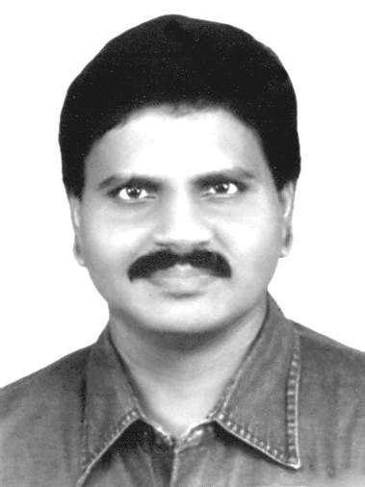  M.Arulmani, B.E.  (Engineer)  m.arulmani58@gmail.com |   V.R.Hema Latha, M.A., M.Sc., M.Phil.  (Biologist)  vrhemalatha58@gmail.com

- Abstract:
This scientific research based article focus that “NEUTRINO MILK” shall be considered as the Natural Product of “J-RADIATION”. The J-Radiation in the cosmic universe shall be considerer having capability to product large amount of Neutrino milk in the space.
The Neutrino milk shall be considered as have been produced in the so called expanding universe at specific “TIME” and “SPACE”. The point of time when neutrino milk was produce in the universe shall be called as “MILKY REVOLUTION”. In Prehistoric Tamil the milk revolution shall be called as “CHEI CHUTRU” (chei + chutru).
(i) “CHEI” shall mean “INFANT”
(ii) “CHUTRU” shall mean “REVOLOTION”

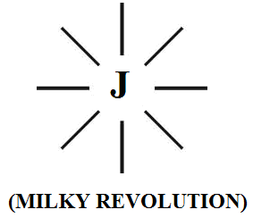
The physical state of Neutrino milk shall be considered exist like “white plasma cloud” and hence the neutrino milk shall also be called in prehistoric tamil as “MUKKIL”. Mukkil shall mean “White plasma milk”.
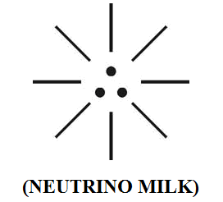
The neutrino milk shall be considered as highly “Nutrient food” composed of “three-in-one” fundamental neutrino particles proton, electron, photon. These particles shall also be considered as white particles having high immunity.
Further in the expanding universe the various types of milk shall be considered evolved called as “CROP MILK” in three nuclear Evolution. The crop milk produced in three nuclear evolution shall be classified under three nuclear family as stipulated below:
i) “BLUE EVOLUTION” – “γ family milk”
ii) “GREEN EVOLUTION” – “β family milk”
iii) “RED EVOLUTION” – “α family milk”
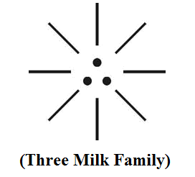
It is speculated that the new theory focused on “Neutrino milk” shall provide solution to the current misconceptional theories about “Dark hole”, “White hole” formation and existence in Quantum physics.

“The so called milk produced during white revolution (around 1960s) under “AMUL BRAND” and current strategy of milk production for uplifting the social status of farmers and rural economy under various brands shall be considered as 3rd generation α family milk”.
- Author

[M.Arulmani, B.E., V.R.Hema Latha, M.A., M.Sc., M.Phil. WHITE REVOLUTION 2014-15?..(A new theory on Neutrino Milk). Cancer Biology 2014;4(1):46-63]. (ISSN: 2150-1041): (ISSN: 2150-105X (online). http://www.cancerbio.net. 5

- Key Words:
      - Philosophy of Cosmo universe
      - Philosophy of J-CELL
      - Philosophy of Galaxies
      - Philosophy of Milkyway
      - Philosophy of Dark hole
      - Philosophy of White hole
      - Philosophy of Plasma milk
      - Philosophy of Blue, Green, Red milk
      - Etymology of word “Milky way”
      - Philosophy of word revolution and evolution
      - Philosophy of “White revolution Logo”
      - Philosophy of “Crop Milk evolution”

- Introduction:
In the history of human, different types of “Revolution” were considered initiated such as white revolution, Blue revolution, Green revolution, red revolution during different occasions. White revolution refers to rural development and uplifting the economy status of rural farmer populations. The various strategies such as producing milk in large scale and dairy development, strengthening state co-operative milk producers federation, etc..
In Iran, the concept of white revolution refers to series of reforms taken (in 1963) by “Shah Mohammed Reze Pahlavi”. It was intended to be “non-violent” regeneration of Iranian society through economic and social reforms.
In India “Dr.VargheseKurien” regarded as the father of White revolution. In India, Gujarat and Rajasthan achieved excess production of milk in 1970. The white revolution strengthened the milk co-operative movement under brand name “AMUL” (Anand Milk union Limited) and made INDIA as the “World’s largest” milk producing country.
Further this white revolution slowly gained much popularity in world level and Amul has agreed to assist World Bank in replicating operation food in African Nations.
The “Green revolution” refers to production of cereals, wheat, rice during 1960s and 1970s because of better seed and new agricultural technology. Similarly the “Blue revolution” considered as Water equivalent of green revolution for producing water for drinking, crop irrigation needed for many millions of people world wide. The “Red revolution” considered as taken place in Russia for development of Russian society having their own strategies.
In this research article it is focused that the philosophy of various types of “Human revolution” shall be considered as derived from the philosophy of “J-Revolution” of milky way and Nuclear revolution took place in the early universe.
In the early universe various regions of “milky way galaxies” shall be considered evolved due to impact of “J-Radiation” or “Cosmic white flame” Revolution.


“The formation of large scale of WHITE PLASMA CLOUDS regions in the universe (milky way galaxies) shall be considered as based on revolution of J-RADIATION. The white plasma clouds shall alternatively be called as “NEUTRINO MILK”.
- Author

- Previous Publication:
The philosophy of origin of first life and human, the philosophy of model Cosmo Universe, the philosophy of fundamental neutrino particles have already been published in various international journals mentioned below. Hence this article shall be considered as extended version of the previous articles already published by the same author.

    - Cosmo Super Star – IJSRP, April issue, 2013
    - Super Scientist of Climate control – IJSER, May issue, 2013
    - AKKIE MARS CODE – IJSER, June issue, 2013
    - KARITHIRI (Dark flame) The Centromere of Cosmo Universe – IJIRD, May issue, 2013
    - MA-AYYAN of MARS – IJIRD, June issue, 2013
    - MARS TRIBE – IJSER, June issue, 2013
    - MARS MATHEMATICS – IJERD, June issue, 2013
    - MARS (EZHEM) The mother of All Planets – IJSER, June issue, 2013
    - The Mystery of Crop Circle – IJOART, May issue, 2013
    - Origin of First Language – IJIRD, June issue, 2013
    - MARS TRISOMY HUMAN – IJOART, June issue, 2013
    - MARS ANGEL – IJSTR, June issue, 2013
    - Three principles of Akkie Management (AJIBM, August issue, 2013)
    - Prehistoric Triphthong Alphabet (IJIRD, July issue, 2013)
    - Prehistoric Akkie Music (IJST, July issue, 2013)
    - Barack Obama is Tamil Based Indian? (IJSER, August issue, 2013)
    - Philosophy of MARS Radiation (IJSER, August 2013)
    - Etymology of word “J” (IJSER, September 2013)
    - NOAH is Dravidian? (IJOART, August 2013)
    - Philosophy of Dark Cell (Soul)? (IJSER, September 2013)
    - Darwin Sir is Wrong?! (IJSER, October issue, 2013)
    - Prehistoric Pyramids are RF Antenna?!... (IJSER, October issue, 2013)
    - HUMAN IS A ROAM FREE CELL PHONE?!... (IJIRD, September issue, 2013)
    - NEUTRINOS EXIST IN EARTH ATMOSPHERE?!... (IJERD, October issue, 2013)
    - EARLY UNIVERSE WAS HIGHLY FROZEN?!... (IJOART, October issue, 2013)
    - UNIVERSE IS LIKE SPACE SHIP?!... (AJER, October issue, 2013)
    - ANCIENT EGYPT IS DRAVIDA NAD?!... (IJSER, November issue, 2013)
    - ROSETTA STONE IS PREHISTORIC “THAMEE STONE” ?!... (IJSER, November issue, 2013)
    - The Supernatural “CNO” HUMAN?... (IJOART, December issue, 2013)
    - 3G HUMAN ANCESTOR?... (AJER, December issue, 2013)
    - 3G Evolution?... (IJIRD, December issue, 2013)
    - God Created Human?... (IJERD, December issue, 2013)
    - Prehistoric “J” – Element?... (IJSER, January issue, 2014)
    - 3G Mobile phone Induces Cancer?... (IJERD, December issue, 2013)
    - “J” Shall Mean “JOULE”?... (IRJES, December issue, 2013)
    - “J”- HOUSE IS A HEAVEN?... (IJIRD, January issue, 2014)
    - The Supersonic JET FLIGHT-2014?... (IJSER, January issue, 2014)
    - “J”-RADIATION IS MOTHER OF HYDROGEN?... (AJER, January issue, 2014)
    - PEACE BEGINS WITH “J”?... (IJERD, January issue, 2014)
    - THE VIRGIN LIGHT?... (IJCRAR, January issue 2014)
    - THE VEILED MOTHER?... (IJERD, January issue 2014)
    - GOD HAS NO LUNGS?... (IJERD, February issue 2014)
    - Matters are made of Light or Atom?!... (IJERD, February issue 2014)
    - THE NUCLEAR “MUKKULAM”?... (IJSER, February issue 2014)

- Hypothesis:
- Philosophy of white plasma clouds?...
It is hypothesized that the white clouds shall be considered as the “white plasma matter” created from J-Radiation (white flame). The J-Radiation shall be considered as composed of Billions of Absolute white rays. Each ray shall be considered as composed of fundamental three-in-one Neutrio particles Photon, Electron, proton called as J-CELL. The fundamental particles shall be considered as coexist always and can’t be further sub-divided. The source of J-Radiation shall be considered as originated at “SPECIFIC POINT” of Cosmo universe and derived from ”dark matter”, “dark energy” of universe.

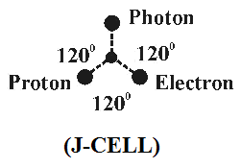
i) Right dot - Proton
ii) Left dot - Electron
iii) Centre dot - Photon

- Philosophy of J-Beam?...
It is hypothesized that “J-Beam” shall be considered as the source of J-Radiation having billions of “MINUTE HOLES” Each ray shall be considered emitted from each hole representing genetic structure of each created matter of universe initially. Every ray shall be considered as having well defined genetic structure. With minute variation in mass in the fundamental neutrino particles (J-CELL). Further the neutrino particles shall be considered displaced symmetrically and subject to sustained oscillations to keep the matter of the universe under equilibrium condition. The sustained oscillation shall be considered as “Neutrino Revolution”
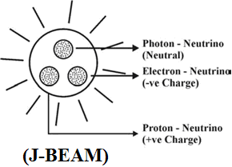

The fundamental particles shall be considered as having fundamental energy say Electric, Magnetic, Optic and having definite polarity and under the strong gravitation force of “Dark flame”.

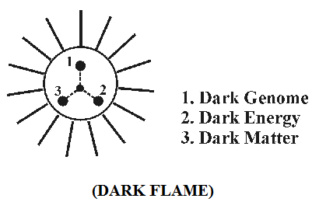

- Philosophy of Milky way galaxies?...
It is hypothesized that in the expanding universe, during the course of “SPACE” and “TIME” three milky way galaxies shall be considered “evolved” in three “Nuclear evolution” say BLUE EVOLUTION, GREEN EVOLUTION, RED EVOLUTION”. The three milky way galaxies shall be considered belong to three distinguished families having different property and different genetic characteristics existing under different pressure, temperature, density.
- Blue evolution - γ family galaxy
- Green evolution - β family galaxy
- Red evolution - α family galaxy

(i)
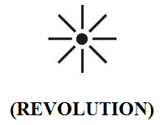

(ii)
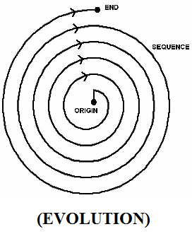

“MILKY WAY shall be considered as “REVOLUTION”. GALAXIES shall be considered as “EVOLUTION” and species to white galaxy due to impact of Human Involvement”
- Author

- Philosophy of model Cosmo universe and galaxies?...
It is hypothesized that the Cosmo universe shall be considered as “TOTAL” and existence of galaxies shall be considered as “PART” within the Cosmo universe. Alternatively the whole Cosmo universe shall be considered like a “GIANT HUMAN” and existence of Milky way galaxy and three species galaxies shall be considered like “BELLY” of giant human or like a MOTHER carrying her “INFANT” in her UTERUS. In prehistoric Tamil the Cosmo universe shall be called as AKKILEM (AKKIE + EZHEM). “Akkie” shall mean “Dark flame”; “Ezhem” shall mean “White flame” region.

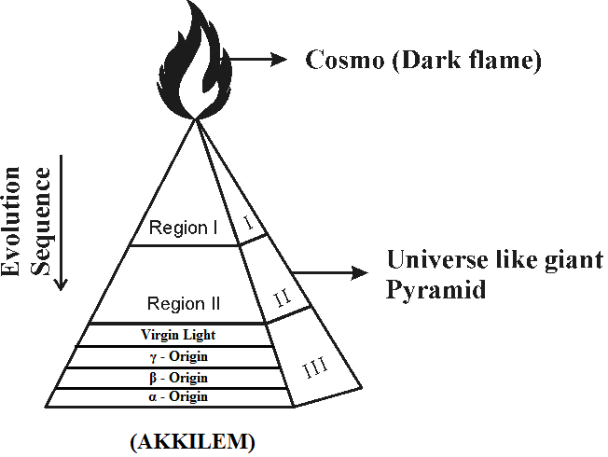
“The milky way and three species galaxies shall be considered under STRONG GRAVITATIONAL FORCE of Dark Flame”
- Author

- Sun, Earth, Moon, Marks are stars?...
It is hypothesized that the existence of sun, earth, moon, mars shall not be considered as elements of so called “solar system” in the galaxy. In fact the whole Cosmo universe shall be considered as “GIANT HUMAN” and sun, earth, moon, mars shall be considered like organs.
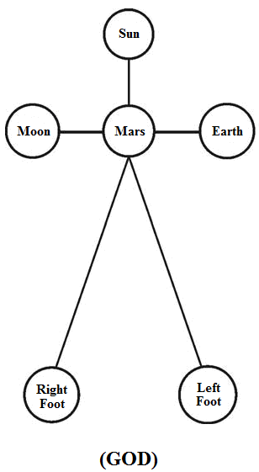
- Mars – heart (J-Radiation)
- Moon – Right hand
- Earth – Left hand
- Sun – Brain
The present day material universe (Region III) shall be considered containing. Initially created matters, and newly evolved matters (species) in three nuclear evolution say Blue evolution, green evolutions, red evolution. In prehistoric tamil the gain human shall be called as “Akkilen” Akkilen shall mean “GOD”.

- Human ancestor evolved from APES?...
It is hypothesized that Human, Apes shall be considered as the distinguished created matters of “GOD” from “J-Radiation”. Further human and apes “evolution” might have occurred as species in three Nuclear evolution in their respective lineage.
- White revolution – Human origin
- Blue evolution – 1st generation human
- Green evolution – 2nd generation human
- Red evolution – 3rd generation human
The human on origin shall be considered as created human. In prehistoric Tamil the created human shall be called as “CHEITHAN” (OR) “AMMUTHAN” (OR) THAMEEN. Cheithan, Ammuthan, Thameen shall mean “Godly Persons”.
It is further focused that the prehistoric human shall be considered expert in Astronomy, Astrophysics, Bioscience.
The etymology, philosophy of so many cosmological words in English shall be considered derived from philosophy of prehistoric Tamil phonetics as stipulated below:
- Akkilen – God, Alien, Angel
- Akkilem – cosmo universe
- Akkie – Neutrino particels
- Akkini – Fire
- Mukkil – Milky way, Cloud
- Ammutham – Neutrino milk
- Chutru – Revolution
- Ulavu – Evolution
- Thantai – Spectrum
- Thantavam – Region, galaxy
- Kollu – Decay
- Kolusu – White spectrum
- Chalankai – White particles
- Chei - Early universe (Infant)

- Etymology of word “Milky”?...
Case study shows that the etymology of word “Milky way”, “galaxy” might be derived from Greek word “galactose” meaning milk. It is hypothesized that the philosophy of milky way, galaxy might be derived from prehistoric tamil phonetics “Mukkil”. Mukkil shall mean “white plasma cloud” composed of “Three-in-one” fundamental neutrino particles. Mukkil shall also be called as “Neutrino milk”.

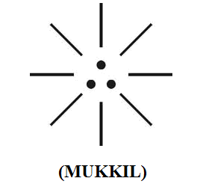

“Mukkil (Plasma cloud) shall be considered as the “ORIGIN POINT” of all matters such as snow, hydrogen, ozone, nitrogen, carbon, oxygen, Acid rain, Ocean water, petroleum products etc.”
-Author

- Hypothetical Narration
  - Philosophy of Void Universe?...
The void universe shall be considered as existence of universe before creation of matters. The whole Cosmo universe shall be considered like “CLOSED TRIPOD CONTAINER” having three distinguished regions I, II, III and energy transfer takes place among three regions through the “Barrier”. The barrier shall be considered as under “equilibrium state”. The dark flame shall be considered as source of infinity level of dark matter, dark energy required for creation and sustainability of matters.

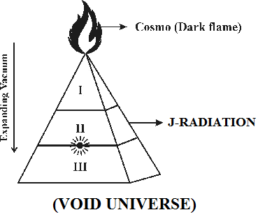

  - Philosophy of White Revolution?...
The white revolution shall be considered as the stage when energy transfer takes place just like “first breath of Human” and thereafter continuing of Inspiration and expiation. The act of Inspiration Expiration shall be considered like a “Pendulum Oscillation” through Black Hole, White hole.

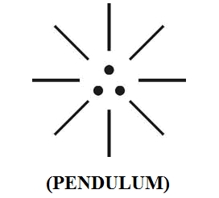

i) Inspiration – “Black hole”
ii) Expiration – “White hole”
iii) Respiration – Centre point at Barrier
  - Philosophy of expanding Universe?...
The philosophy of Expanding Universe shall be considered as the relative position of Sun, Earth, Moon in three geological periods. The three different relative position shall be considered as three different cosmic evolution say blue evolution, green evolution, red evolution when the initially created matters in Milky clouds shall be considered attaining three genetic level having distinguished structure, property, characteristics under different pressure, temperature, density conditions. These three distinguished regions shall be called as three distinguished “galaxies”. UNIVERSE IS STILL EXPANDING?... Yes… Yes… Yes… The universe is constantly expanding Every hour… Every minute… Every second…

  - Mother’s womb is like galaxy?...
It is hypothesized that the “MOTHER’S WOMB” shall be considered as model expanding universe having three galaxies and considers as expanding every second taking its energy from the inbuilt source. It is focused that three evolutions shall be considered taking place within mother’s womb in three “TRIMESTER” periods.

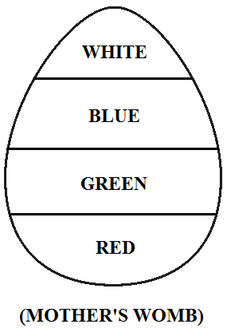
i) White revolution – Embryo stage
ii) Blue evolution – 1st trimester
iii) Green evolution – 2nd trimester
iv) Red evolution – 3rd trimester

“The HUMAN SEED shall be considered as undergoing three evolution process within mother’s womb and finally giving beautiful INFANT JACK FRUIT”
- Author

  - 1st generation human do not have red blood?...
It is focused that “Human blood” shall be considered as “Neutrino Milk” composed of proton, electron, photon. The modern human red blood shall be considered as 3rd generation “RED MILK” due to impact of RED EVOLUTION.
- White revolution – “White Milk” (Human origin)
- Blue evolution – “Blue Milk” (1st generation)
- Green evolution – “Green milk” (2nd generation)
- Red evolution – “Red Milk” (3re generation)

“EVERY INFANT during the growth within mother’s womb shall be considered as having three type of different colour blood say BLUE BLOOD, GREEN BLOOD, RED BLOOD”
- Author

  - Case study on Quantum physics?...
Case study shows that “white hole” is considered as hypothetical celestial object which expands outwards from a space-time and emits energy in the manner of time reversed black holes. The black hole is considered as a super dense region of space usually star which has become so massive. Further black hole is considered as a region of space having “gravitational field” so intense that no matter (or) radiation can escape.
Study also shows that the milky way is considered as a galaxy contains the solar system consists of millions of stars that can be seen as a diffuse band of light stretching across the Night sky.
Further there are so many controversial theories focused about whether white hole, black hole really exist?...
(i)
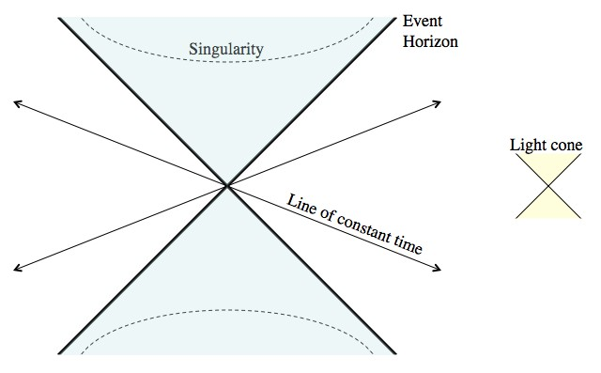
Spacetime gets seriously messed up near and inside of a black hole. To make the math easier, and to help make the situation easier to picture, the Kruskal-Szekeres coordinate system was created.

(ii)
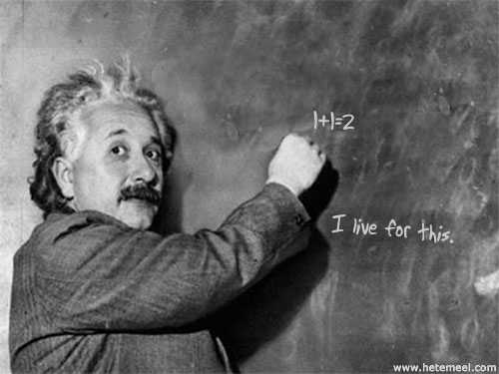
“There is no escape from a black hole in classical theory, but quantum theory enables energy and information to escape”
-Hawking

Clarification:
It is speculated by the author that the prehistoric Tamil Based Indian (1st generation) shall be considered as expert in Astronomy, Astrophysics, Bio-science and formulated the Philosophy of universe and its characteristics with “Three Tiny dot” which shall be called as “LAW OF UNIVERSE”.
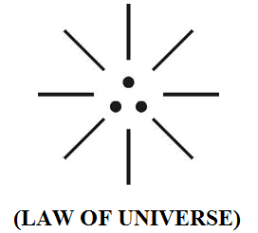
i) Right dot – Functional part of universe
ii) Left dot – structural part of universe
iii) Centre dot – Law part (genome) of universe

Further it shall be focused that the three Tiny dot shall be considered as the “Relative position of Sun, Earth, Moon” and its characteristics shall be considered as “inter dependent” to one another. “MARS” shall be considered as the “ENERGY TRANSFORMATION CENTRE” where the neutrino particles gets acceleration which enable origin of first matter in the universe including all 1st generation planets. In 2nd& 3rd generation so many species planets, matters might have been evolved from the fundamental matter. The energy transformation point shall be considered as the WHITE HOLE region.
(i)
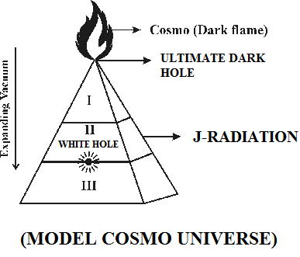
(ii)
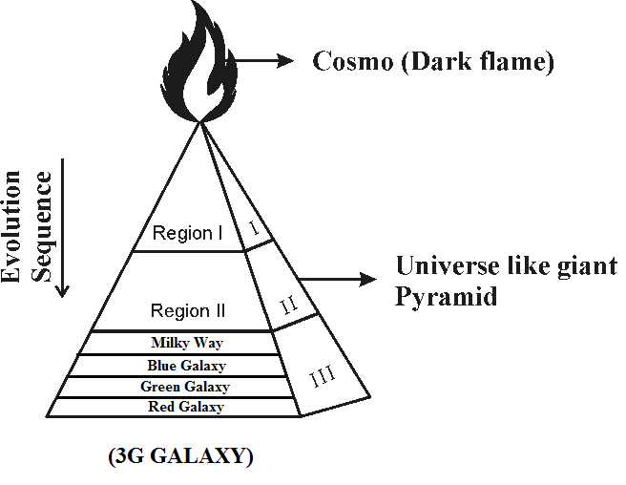
(iii)
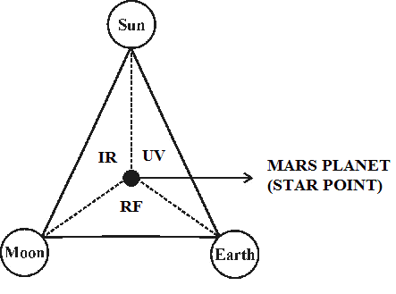
Further in the matter universe (Region III) all matters shall be considered as existing in different region of “galaxies” under natural electromagnetic spectrum called as UV, RF, IR with different properties and characteristics. The human made electromagnetic spectrum shall be considered existing as “species” to the fundamental natural electro-magnetic spectrum. The region I & II, of universe shall be considered as the region of existence of neutrino particles, anti-neutrino particles capable travelling more than the speed of light (3x10⁸ meter/sec) and under strong “Gravitational Binding” to the Junction point of “Dark Flame”. The junction point shall be considered as the “Ultimate Black Hole”.

  - Case study on Bible:
From Biblical understanding the philosophy of “HOLY SPIRIT” shall be considered as the “Mukkil” which is considered as the “origin point” of all matter universe. Further the “MANNA FOOD” shall be considered as the “HOLY WHITE BREAD” composed of fundamental particles proton, electron, photon.
(i)
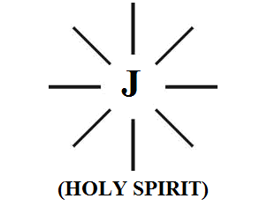
(i)
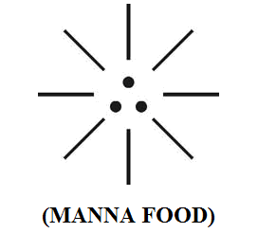

  - Dr. Kurien is Father of White revolution?...
It is focused that “AKKILEN”, the first Tamil based Indian shall be considered as the “Father” of white revolution responsible for 1st generation “Neutrino Milk”. Dr. Kurien shall be considered as the 3rd generation INDIAN responsible for white revolution of 3rd generation milk.
It is further speculated that the Philosophy of “AMUL” brand might be derived from the philosophy of prehistoric Tamil phonetics AMMU BRAND, AMMUTHAM (NEUTRINO MILK).
- Ammu shall mean “Neutrino mother”
- Ammutham shall mean “Neutrino milk”
- Ammu shall mean “Divine Music” which enables growth of infant within mother’s womb and feeds Neutrino Milk.

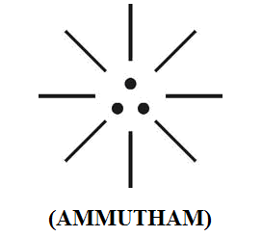

The Philosophy of Ammutham shall be defined within the following scope.
  - Ammutham shall mean Holy milk
  - Ammutham shall mean have High immunity
  - Ammutham shall mean Prevent Polio
  - Ammutham shall mean Prevent Diabetics
  - Ammutham shall mean Prevent Cancer
  - Ammutham shall mean Prevent Heart attack
  - Ammutham shall mean Prevent Baldness

“AMMUTHAM can’t be substituted with AMUL, AMUL Powder”

- Author

- CONCLUSION:

It is focused that the etymology of word “MILK” might be derived from the philosophy of “MUKKIL”. Mukkil shall be considered as the Highly nutrient food that every “INFANT” needs for healthy life from mother.
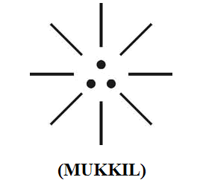

The neutrino milk shall be considered as composed of LOVE, MERCY, HOPE.

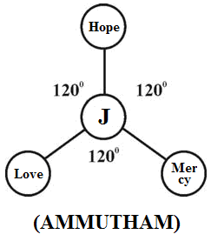

“Ammutham shall be considered as the natural product of J-Radiation”
- Author

- REFERENCE
- Intensive Internet “e-book” study through, Google search and wikipedia
- M.Arulmani, “3G Akkanna Man”, Annai Publications, Cholapuram, 2011
- M. Arulmani; V.R. Hemalatha, “Tamil the Law of Universe”, Annai Publications, Cholapuram, 2012
- Harold Koontz, Heinz Weihriah, “Essentials of management”, Tata McGraw-Hill publications, 2005
- M. Arulmani; V.R. Hemalatha, “First Music and First Music Alphabet”, Annai Publications, Cholapuram, 2012
- King James Version, “Holy Bible”
- S.A. Perumal, “Human Evolution History”
- “English Dictionary”, Oxford Publications
- Sho. Devaneyapavanar, “Tamil first mother language”, Chennai, 2009
- Tamilannal, “Tholkoppiar”, Chennai, 2007
- “Tamil to English Dictionary”, Suravin Publication, 2009
- “Text Material for E5 to E6 upgradaton”, BSNL Publication, 2012
- A. Nakkiran, “Dravidian mother”, Chennai, 2007
- Dr. M. Karunanidhi, “Thirukkural Translation”, 2010
- “Manorama Tell me why periodicals”, M.M. Publication Ltd., Kottayam, 2009
- V.R. Hemalatha, “A Global level peace tourism to Veilankanni”, Annai Publications, Cholapuram, 2007
- Prof. Ganapathi Pillai, “Sri Lankan Tamil History”, 2004
- Dr. K.K. Pillai, “South Indian History”, 2006
- M. Varadharajan, “Language History”, Chennai, 2009
- Fr. Y.S. Yagoo, “Western Sun”, 2008
- Gopal Chettiar, “Adi Dravidian Origin History”, 2004
- M. Arulmani; V.R. Hemalatha, “Ezhem Nadu My Dream” - (2 Parts), Annai Publications, Cholapuram, 2010
- M. Arulmani; V.R. Hemalatha, “The Super Scientist of Climate Control”, Annai Publications, Cholapuram, 2013, pp 1-3

2/15/2014

