THE KACHCHA THEEVU?...
(A New theory on “ Islands”)
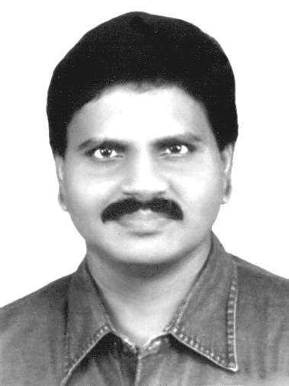  M.Arulmani, B.E.  (Engineer)  m.arulmani58@gmail.com |   V.R.Hema Latha, M.A., M.Sc., M.Phil.  (Biologist)  vrhemalatha58@gmail.com

Abstract: This Scientific research article focus that in geological term “PLASMA LAND MASS”, also called as “e-LAND” shall be considered as the land origin where first Human origin started living on the “Earth Planet”. In proto Indo Europe language the plasma land of Earth shall be called as “Kachcha theevu”. In Dravidian language the land of Karcha theevu shall also be called as “KARI NADU” called in short as “K-NADU”. Kari Nadu shall mean land of medically enriched “FISH-CURRY”. In the history of geological evolution there are thousands of “Islands” such as Madagascar, Sri Lanka, British isle, Greenland exist all over the world. This article emphasize that “Kachcha theevu” shall be considered as the “SOUL” of all Islands and Continental Nations. Based on human historical culture the logo of Katcha Theevu shall be indicated as below. Kachcha shall mean “GOD”.


This article further emphasize that clear understanding about the philosophy of Kachcha theevu shall pave path for formation of new theories about geological origin of various land origin as well as Human origin on the Earth planet.
Kachcha Theevu shall be considered as the fundamental “ENERGY SOURCE” of Earth resource like crude oil, coal, coke, natural gas, including fish. The closure of “OCEANIC DUCT” of Kachcha Theevu shall mean exhaust of all oil fields of Earthly nations.
- Author

[M. Arulmani, B.E., V.R. Hema Latha, M.A., M.Sc., M.Phil. THE KACHCHA THEEVU? (A New theory on “ Islands”). Cancer Biology 2014;4(2):30-37]. (ISSN: 2150-1041): (ISSN: 2150-105X (online). http://www.cancerbio.net. 4

Key Words:
  - Philosophy of “Plasma clay soil”
  - Philosophy of “Theevu”
  - Philosophy of “Ezhem”
  - Philosophy of “e-Son”
  - Philosophy of “Blue eye Iris”

1

Introduction:
Based on Big Bang Standard modal theory it is understood that the entire Universe was formed about 13.7 Billion years ago form the Molecular cloud of star dust. But global level scientist still could not clarify for the following.
- First land origin on Earth was rock (or) clay?...
- The name of first Island origin?...
- The name of first main land origin?...
- The Land origin where first Human dwell?...
- How mountains were formed on the Earth?...
- Egyptian pyramids are natural or human made?...
- When Blue eye Iris human originated?....

In this article it is focused that Katch theevu shall be considered as the “Embryo” of continental nation of “Mother Earth” just like embryo of “INFANT” developed within Mother’s womb. “Kachcha theevu is like “Thai-e land”, and all Islands and continental nations are like “Kutties”.
- Author
- Hypothesis and Narration
- Philosophy of “Thee”?...
It is hypothesized that “J-Radiation” emanated near “White hole region” of Universe shall be considered as the “Soul” and energy provider for existence of all matters such as various planets, stars, Elements, Atoms, Molecule etc. In proto Indo Europe language the J-Radiation shall be called as “THEE”. Thee shall be defined within the following scope.

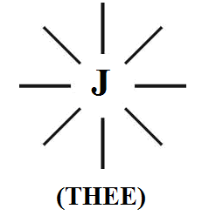

- Thee shall mean composed of THREE-IN-ONE fundamental particles Photon, Electron, Proton having optic, Electric, Magnetic parameter and charge properties having Zero mass.
- Thee shall be considered evolved near white hole region due to impact of “ACCRETION” of Dark Matter cells due to growth of downward gravity.
- Thee shall be considered exist under Highly Endothermic, Zero entropy environment and considered free form UV, RF, IR interferences.

- Philosophy of MARS PLANET?...
It is hypothesized that “MARS PLANET” (also called as EZHEM or e-NADU) shall be considered as “Mother of all planets” in the whole Universe. The mother planet shall also be called as White star composed of exclusively Photon, Electron, Proton ions and free from “Atoms”. Further MARS consider exist under “RAIN” environment rather than Sea water, Ocean water. The Rain shall be considered composed of only charged ions of Photon, Electron, Proton having Zero PH value, and free from atoms like Hydrogen, Carbon, Nitrogen, Ozone, Oxygen etc.

- MARS Planet contains water?...
No… No… No… “WATER” considered differs from “RAIN”. Mars Soil considered exist under the environment of Rain rather then water having high acidic value. Water, sea, ocean consider having different “Salinity potential gradient” exist only on Earth planet having increased alkalic value.

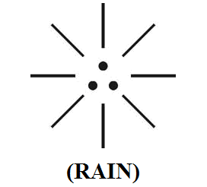

- Philosophy of Kachcha Theevu?...
It is hypothesized that in the early universe the Earth planet shall be considered surrounded and submerged by “SEA WATER” (low salinity level). The Katch Theevu shall be considered as “land mass” descended form mars planet.
The Mars land mass formed on the Earth planet shall be called as “J-PLASMA” look like white clay soil matter composed of only photon, Electron, Proton ions and free form Hydrogen and other atoms. The prehistoric time “ETHIA” shall be considered as SINGLE SUPER CONTINENT evolved after formation of Kachcha Theevu on the Earth Planet. The super continent mass on earth planet shall be considered as strong binding to crust of techtonic plates of Earth planets just like “TOOTH IS ATTACHED TO GUM”. The philosophy of Mars Planet, Kachcha Theevu, Super Continent Ethia shall be hypothetically represented as below.

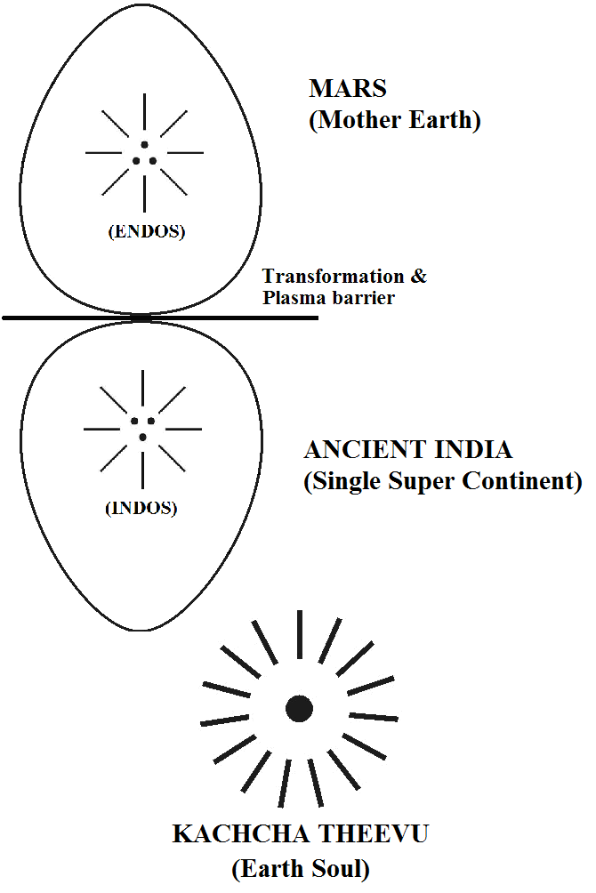

It is further focused that the ancient Ethia super continent (also called later as INDO continent) Considered contains only three Sea with low salinity. During the course of expanding Universe water source like Arctic, Antarctic, Atlantic, Pacific (having high salinity level) might be formed due to natural process of “Osmosis” and “Reverse Osmosis”. The formation of huge mountains like Himalya, Alps on the Earth planet might be formed due to impact of “salinity potential gradient” within various regions of water, sea, oceans over earth planet.

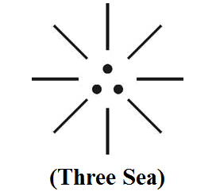
- Right dot - Bengal Sea
- Left dot - Arabic Sea
- Centre dot - Indo sea (Called as sea rather than ocean)

- Philosophy of Islands?...
Case study shows that there are about 45,000 islands exists in different regions of earth planet. The islands are considered as formed due to impact of techtonic plates forces of earth crust.

It is hypothesized that Island shall be considered as Land Mass clay like soil (Plasma Soil) derived from Mars Planet during geological evolutions in the early universe. In modern English the Plasma Soil shall be called as “Marsh Land”. It is focused that the prehistoric Mars land mass shall be considered containing only fundamental ions Photon, Electron, Proton and free from Hydrogen and other atoms In proto Indo Europe Language the “Plasma land” region shall be called as “THEEVU” (or) “e-LAND”. Theevu shall mean soil made up of “THEE” (Photon, Electron, Proton).
THEEVU → Thee + eevu.

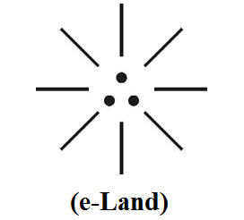

It is hypothesized that “Kachcha Theevu” shall mean Land mass made up of “THEE”. “KACHCHABI” shall mean “GOD”.

- Etymology of Island?...
Case study shows that the etymology of word island derived from igland, iland, eiland. It is hypothesized that the etymology of word island might be derived from proto Indo Europe language word “e” pronounced as “i". It is focused that the Philosophy of “e”, “i" shall be considered involved nature behavior and mathematics and other scientific calculations. “e”, “i" shall be considered as godly constants in the behavior of nature universe.

(i)
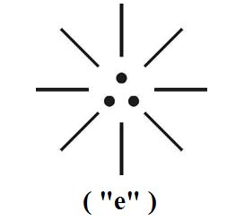

(ii)
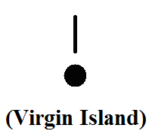

- Philosophy of formation of Sri Lanka?...

Case study shows that there is no clear theories about formation of Sri Lanka. Sri Lanka is considered as oceanic island. It is hypothesized that the ancient Sri Lanka (also called as Ezhem, e-Nadu) shall be considered as “kutty” of mother Ethia (ancient super continent).

(i)
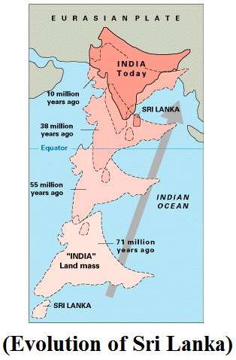

(ii)
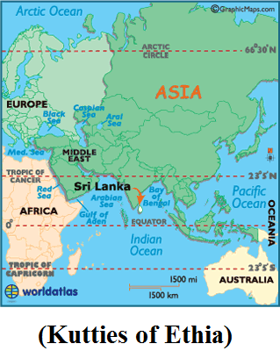

(iii)
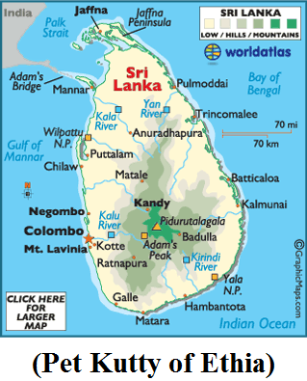

- Philosophy of Blue Iris human?...
It is hypothesized that the Ancient population lived in Kachcha Theevu shall be considered containing eye of “Blue-Iris” called family name “Thai-e” populations. During expending universe different colored eye Iris population might be evolved in three geological periods due to variant “CNO Cycle” environment.

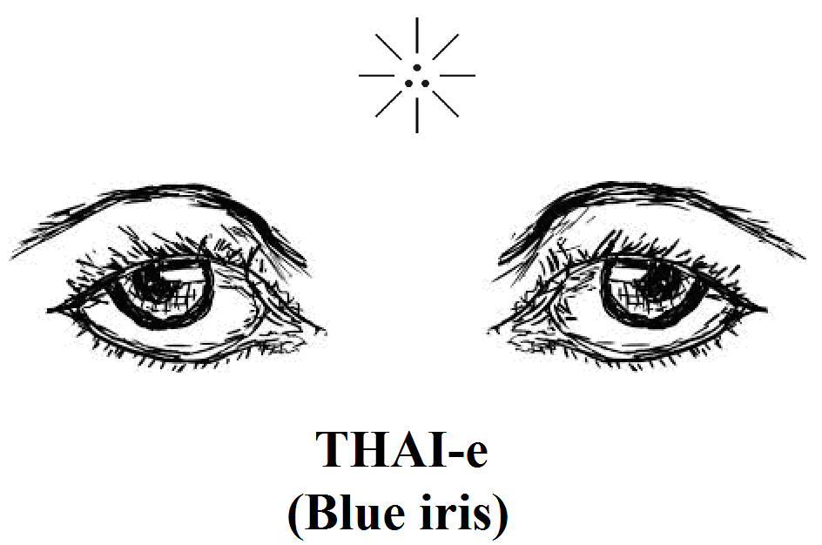

- Adam, Eve lived in Kachcha Theevu?...
It is hypothesized that Adam, Eve belong to “Angel family” who might have lived in MARS PLANET (mother of Earth Planet). They might have descended to Earth planet after consuming forbidden fruit and become “Human family” with distinguished genetic structure. It is further hypothesized that during living on Earth Planet Adam, Eve might have changed their names as “MARAN”, MARI-e” for numerological reasons. Maran, Mari-e shall mean human descended from “MARS PLANET” (also called as EZHEM (or) e-NADU)

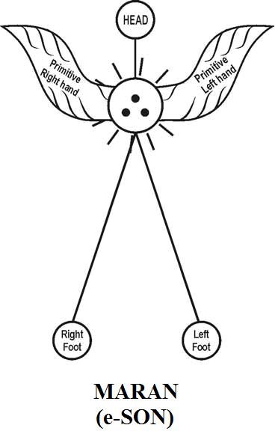

“Maran, Mari-e shall mean dark populations of Kachcha theevu (K-Nadu). Rajan, Patchan, Velan, Ammu, Ram, Seethai shall mean, loving children of Maran, Mari-e”
- Author

- Maran, Mari-e constructed pyramids?...
It is hypothesized that Maran, Mari-e shall be considered expert in Astrophysics, Astronomy and formulated the relative position of MARS, SUN, EARTH, MOON and considered Material Universe having shape like “TRIPOD” structure with Sun, Earth, Moon as base and mars as Vertex. They were able to control the relative position of Various planets by “e-Logics” code called (Akkie code). The “Egyptian pyramids” shall be considered as constructed by them as “Ground based Antennas” for remote control of various planets. Further the stone structures of pyramids shall also be considered as “level Indicators” of ocean level above Earth surface in the early universe.

(i)
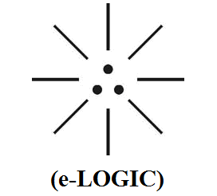

(ii)
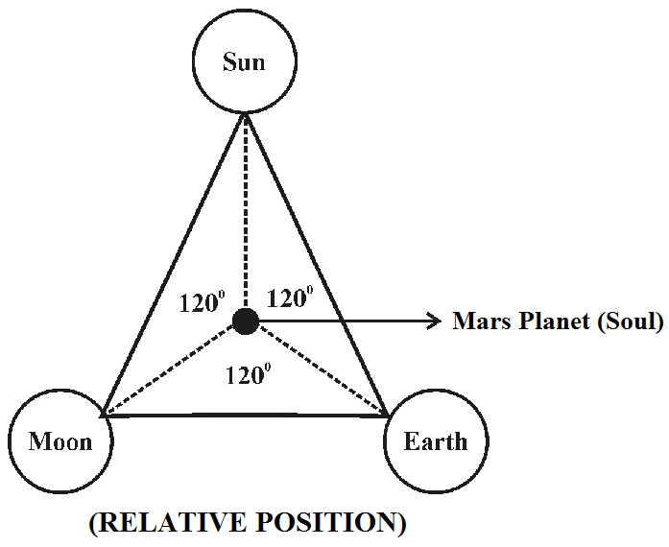

- Conclusion:
It is focused that the Ancient world exist like a single super continent (Ancient India). In proto Indo Europe language the single continent shall be called as “ETHIA”. Ethia shall mean supreme mother of continental Nations derived from land mass of “Kachcha Theevu”. The Philosophy of (international maritime boundary line) might be derived from the Philosophy of Ethian in ancient time.
“Ancient Ethians (also called as Dravidians) use to communicate through “e-logics” rather than writing letters (KADITHAM)”
- Author

- Previous Publication:
The philosophy of origin of first life and human, the philosophy of model Cosmo Universe, the philosophy of fundamental neutrino particles have already been published in various international journals mentioned below. Hence this article shall be considered as extended version of the previous articles already published by the same author.
    - Cosmo Super Star – IJSRP, April issue, 2013
    - Super Scientist of Climate control – IJSER, May issue, 2013
    - AKKIE MARS CODE – IJSER, June issue, 2013
    - KARITHIRI (Dark flame) The Centromere of Cosmo Universe – IJIRD, May issue, 2013
    - MA-AYYAN of MARS – IJIRD, June issue, 2013
    - MARS TRIBE – IJSER, June issue, 2013
    - MARS MATHEMATICS – IJERD, June issue, 2013
    - MARS (EZHEM) The mother of All Planets – IJSER, June issue, 2013
    - The Mystery of Crop Circle – IJOART, May issue, 2013
    - Origin of First Language – IJIRD, June issue, 2013
    - MARS TRISOMY HUMAN – IJOART, June issue, 2013
    - MARS ANGEL – IJSTR, June issue, 2013
    - Three principles of Akkie Management (AJIBM, August issue, 2013)
    - Prehistoric Triphthong Alphabet (IJIRD, July issue, 2013)
    - Prehistoric Akkie Music (IJST, July issue, 2013)
    - Barack Obama is Tamil Based Indian? (IJSER, August issue, 2013)
    - Philosophy of MARS Radiation (IJSER, August 2013)
    - Etymology of word “J” (IJSER, September 2013)
    - NOAH is Dravidian? (IJOART, August 2013)
    - Philosophy of Dark Cell (Soul)? (IJSER, September 2013)
    - Darwin Sir is Wrong?! (IJSER, October issue, 2013)
    - Prehistoric Pyramids are RF Antenna?!... (IJSER, October issue, 2013)
    - HUMAN IS A ROAM FREE CELL PHONE?!... (IJIRD, September issue, 2013)
    - NEUTRINOS EXIST IN EARTH ATMOSPHERE?!... (IJERD, October issue, 2013)
    - EARLY UNIVERSE WAS HIGHLY FROZEN?!... (IJOART, October issue, 2013)
    - UNIVERSE IS LIKE SPACE SHIP?!... (AJER, October issue, 2013)
    - ANCIENT EGYPT IS DRAVIDA NAD?!... (IJSER, November issue, 2013)
    - ROSETTA STONE IS PREHISTORIC “THAMEE STONE” ?!... (IJSER, November issue, 2013)
    - The Supernatural “CNO” HUMAN?... (IJOART, December issue, 2013)
    - 3G HUMAN ANCESTOR?... (AJER, December issue, 2013)
    - 3G Evolution?... (IJIRD, December issue, 2013)
    - God Created Human?... (IJERD, December issue, 2013)
    - Prehistoric “J” – Element?... (IJSER, January issue, 2014)
    - 3G Mobile phone Induces Cancer?... (IJERD, December issue, 2013)
    - “J” Shall Mean “JOULE”?... (IRJES, December issue, 2013)
    - “J”- HOUSE IS A HEAVEN?... (IJIRD, January issue, 2014)
    - The Supersonic JET FLIGHT-2014?... (IJSER, January issue, 2014)
    - “J”-RADIATION IS MOTHER OF HYDROGEN?... (AJER, January issue, 2014)
    - PEACE BEGINS WITH “J”?... (IJERD, January issue, 2014)
    - THE VIRGIN LIGHT?... (IJCRAR, January issue 2014)
    - THE VEILED MOTHER?... (IJERD, January issue 2014)
    - GOD HAS NO LUNGS?... (IJERD, February issue 2014)
    - Matters are made of Light or Atom?!... (IJERD, February issue 2014)
    - THE NUCLEAR “MUKKULAM”?... (IJSER, February issue 2014)
    - WHITE REVOLUTION 2014-15?... (IJERD, February issue 2014)
    - STAR TWINKLES!?... (IJERD, March issue 2014)
    - “E-LANKA” THE TAMIL CONTINENT?... (IJERD, March issue 2014)
    - HELLO NAMESTE?... (IJSER, March issue 2014)
    - MOTHERHOOD MEANS DELIVERING CHILD?... (AJER, March issue 2014)
    - E–ACHI, IAS?... (AJER, March issue 2014)
    - THE ALTERNATIVE MEDICINE?... (AJER, April issue 2014)
    - GANJA IS ILLEGAL PLANT?... (IJERD, April issue 2014)
    - THE ENDOS?... (IJERD, April issue 2014)
    - THE “TRI-TRONIC” UNIVERSE?... (AJER, May issue 2014)
    - Varied Plasma Level have impact on “GENETIC VALUE”?... (AJER, May issue 2014)
    - JALLIKATTU IS DRAVIDIAN VETERAN SPORT?... (AJER, May issue 2014)
    - Human Equivalent of Cosmo?... (IJSER, May issue 2014)
    - THAI-e ETHIA!... (AJER, May issue 2014)
    - THE PHILOSOPHY OF “DALIT”?... (AJER, June issue 2014)
    - THE IMPACT OF HIGHER QUALIFICATION?... (AJER, June issue 2014)
    - THE CRYSTAL UNIVERSE?... (AJER July 2014 issue)
    - THE GLOBAL POLITICS?... (AJER July 2014 issue)

- REFERENCE
- Intensive Internet “e-book” study through, Google search and wikipedia
- M.Arulmani, “3G Akkanna Man”, Annai Publications, Cholapuram, 2011
- M. Arulmani; V.R. Hemalatha, “Tamil the Law of Universe”, Annai Publications, Cholapuram, 2012
- Harold Koontz, Heinz Weihriah, “Essentials of management”, Tata McGraw-Hill publications, 2005
- M. Arulmani; V.R. Hemalatha, “First Music and First Music Alphabet”, Annai Publications, Cholapuram, 2012
- King James Version, “Holy Bible”
- S.A. Perumal, “Human Evolution History”
- “English Dictionary”, Oxford Publications
- Sho. Devaneyapavanar, “Tamil first mother language”, Chennai, 2009
- Tamilannal, “Tholkoppiar”, Chennai, 2007
- “Tamil to English Dictionary”, Suravin Publication, 2009
- “Text Material for E5 to E6 upgradaton”, BSNL Publication, 2012
- A. Nakkiran, “Dravidian mother”, Chennai, 2007
- Dr. M. Karunanidhi, “Thirukkural Translation”, 2010
- “Manorama Tell me why periodicals”, M.M. Publication Ltd., Kottayam, 2009
- V.R. Hemalatha, “A Global level peace tourism to Veilankanni”, Annai Publications, Cholapuram, 2007
- Prof. Ganapathi Pillai, “Sri Lankan Tamil History”, 2004
- Dr. K.K. Pillai, “South Indian History”, 2006
- M. Varadharajan, “Language History”, Chennai, 2009
- Fr. Y.S. Yagoo, “Western Sun”, 2008
- Gopal Chettiar, “Adi Dravidian Origin History”, 2004
- M. Arulmani; V.R. Hemalatha, “Ezhem Nadu My Dream” - (2 Parts), Annai Publications, Cholapuram, 2010
- M. Arulmani; V.R. Hemalatha, “The Super Scientist of Climate Control”, Annai Publications, Cholapuram, 2013, pp 1-3.

6/15/2014

