THE PREGNANT MAN?...

(A New theory on “Male Pregnancy”)

  M.Arulmani, B.E.  (Engineer)  m.arulmani58@gmail.com |   V.R.Hema Latha, M.A., M.Sc., M.Phil.  (Biologist)  vrhemalatha58@gmail.com

Abstract: This scientific research article focus that the “Human Ancestor” lived in “Mars Planet’ in the early universe shall be considered having distinguished genetic characteristics compared to “Modern Human” living in earth Planet especially in reproduction of population. This research further focus that MALE PARENT shall be considered as “become pregnant” and responsible for child birth. During the course of “Space” and “Time” of expanding universe the mars populations consider have descended to Earth planet due to varied climatic condition and FEMALE PARENT become pregnant and responsible for child birth at later stage of “Nuclear age”

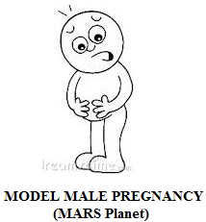

It is hypothesized that male parent might have “laid egg” for the reproduction. Projected belly of male (Beer belly) is due to excess deposit of fat cell?... No… No… No… It is due to gene transfer of male parent Pregnancy. “The uterus need not be considered as an essential organ for reproduction for human child birth” in the early universe. - Author
[M.Arulmani, B.E., V.R.Hema Latha, M.A. THE PREGNANT MAN? (A New theory on “Male Pregnancy”). Cancer Biology 2014;4(3):35-43]. (ISSN: 2150-1041). http://www.cancerbio.net. 4

Key Words:
  - Philosophy of “Male Pregnancy”?...
  - Philosophy of “Angel” and “Woman”?...
  - Philosophy of “Infant” and “child”?...
  - Philosophy of “trisomy” and “transgender”?...
  - Philosophy of “sea-horse” and “amoeba”?...
  - Philosophy of “Jayam+”?...
  - Philosophy of “J-Cloning”?...

- Introduction:
This research article focus that “child birth” in human life is “Gift of nature” rather than effort of parents. It is a general trend in human society on child birth to ask that the child looks like “Father” (or) “Mother” and used to ask grown child that you are mother’s child?... (or) Father’s child?... The child some time simply smiles without answering…
If the child do not resemble either like father (or) Mother, treated as “THIRD COPY” and mother being tortured by mother-in-law and husband and sometime lead to state of Thalak… Thalak… Thalak…
This research further emphasize that for reproduction, the act of “Sex Indulge” and “Uterus Mechanism” not essentially required and many reptiles, plants can generate the populations without the mechanism of uterus and by Process of Partheonogenisis (Asexual reproduction). The state of inheritance of sexual reproduction and Female pregnancy shall be considered originated during origin of Life in Earth Plant at later stage.
(i)


(ii)

“In the early universe there is no torture problem of ‘Mother-in-law’ to daughter-in-law as the “son” is responsible for male pregnancy and child birth”.
- Author

- Hypothesis and Narration
- Is male pregnancy possible?...
Medical Science claims that female parent in human is only responsible for pregnancy and child birth. Why not male parent?... Male Parent do not know the pain of child birth?... Male Parent can’t conceive?...
It is hypothesized that “Human Ancestor” lived in Mars planet considered responsible for ‘reproduction” through male pregnancy by laying of “Egg”. The egg shall be considered formed through impact of “J-Radiation” (Zero hour radiation of Universe) also called as Virgin light. The egg shall be considered exist under “zero gravity”, “high Endothermic environment”. The “embryo” formed within the egg shall be considered as contains fundamental Akki-e particles (also called as God particles) photon, Electron, Proton having zero mass.

(i)

(ii)
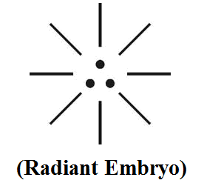
(iii)
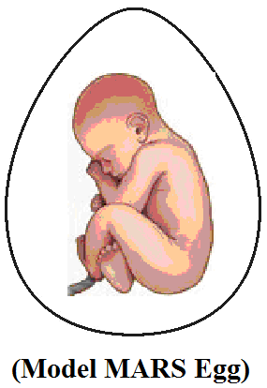

It is further focused that the egg shall be considered as grown within the ‘stomach’ of male parent till mature without the mechanism of ‘conventional uterus’ exist in Female Parent.

- Has human ancestor ever laid egg?...
Darwin Sir did not confirm in his evolution theory that human ancestor ever laid egg for regeneration purpose even in primates. Further cases study shows that a baby girl at the age of 16 to 20 weeks of progress ovaries, female fetus contain 6 to 7 million “eggs” and gradually decreased in every women’s menstrual cycle and completely exhausted during menopause stage. It is the question of Author where did the ovary eggs come from?...

It is hypothesized that ovary eggs of women shall be considered as derived from eggs of male parents. It is further focused that global level research is going on regarding origin of Y chromosome in origin of life. It is hypothesized that Y chromosome might be derived from the male pregnancy egg of human ancestor lived in Mars planet. The philosophy of Y chromosome transfer shall be described as below.
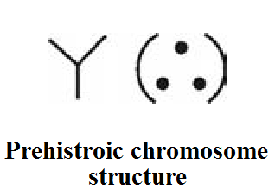

- Do Angels have “Naval”?...
It is hypothesized that the ‘Angel population’ shall be considered as born of ‘Egg’ and lived under ‘low gravity’ environment in the upper part of universe (mars planet). The Female Angel shall be considered as simply assisting Male Pregnant Angel for safe delivery. The Female angel shall be considered as “Queen” controlling the Male Angel.
It is focused that the existence of umbilical chord attached to navel of female parent shall be considered as exist in later generation population (living on earth planet). It is focused that the population of mars planet shall be considered as having “No Naval”. It is further focused that the philosophy of ”angel”, “Alien” might be derived from the etymology of proto Indo Europe language root “Alle-e”. “Alle-e” shall mean male parent responsible for “Egg laying”.
It is further focused that the “Female Angel” shall be considered as having ‘Flat chest” (Without developed breast) as feeding of child is not required after birth as the child born of high immunity.

- Is ‘Sex act” required for reproduction?...
Pregnancy scientifically refers to fertilization of germ cells (Egg and Sperm) by sexual act of Male and Female development of one or more off-spring known as embryo or fetus processed within the Female uterus.
It is hypothesized that Angel population shall be considered as “asexual” and born of Egg formed due to impact of “J-Radiation” consists of three-in-one fundamental particles photon, electron, proton responsible for formation of ‘White Embryo” also called as “Radiant embroyo” (White Logic).
The INFANT ANGEL born of Egg and asexual means shall also be called as Jayam+ (Cloning birth). In proto Indo Euprope “Jayam” shall mean Chei or Chisu”.

(i)
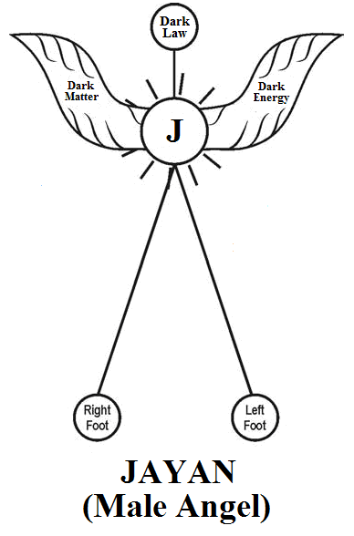

(ii)
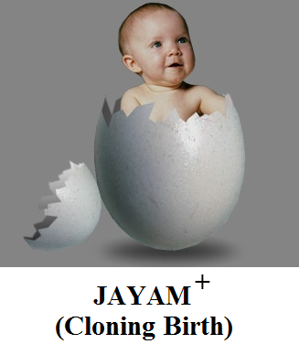
“Jayam+ shall mean godly child born of Egg without involvement of sex act of parents” (Partheonogenisis).
- Author

- Philosophy of Infant, child?...
It is hypothesized that ‘Infant’ and ‘child’ shall be considered as having distinguished genetic characteristics. Infant shall mean “Alien” pertain to Angel family, living under ‘Upward Gravity’. Child shall mean Earthly man. Pertain to man family living under downward gravity.

(i)
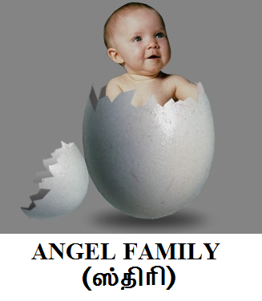

(ii)


- Philosophy of Temple and Family?...
It is hypothesized that “Temple” shall mean pertain to “Angel family” born of Egg. laid by male parent. “Family” shall mean pertain to “man family” of parents of Female pregnancy. The philosophy of Temple and Family shall be described as below.
- Philosophy of 3 Kingdom of life?...
In biological science taxonomy of life is classified fundamentally under two divisions, say “Animal Kingdom” & “Plant Kingdom”. It is hypothesized that human origin shall not be classified within the scope of animal kingdom but it shall be considered as separate kingdom, say “Angel Kingdom”, (Born of male pregnancy) because of varied generation lineage.

It is further hypothesized that the origin of human life, animal life, plant life shall be considered as originated in Mars Planet in the early universe due to impact of “J Radiation”. The J Radiation comprises of billions of rays and each ray shall be considered as responsible for genetic-characteristics of each life. Further it is hypothesized that the smallest unit of each ray shall be considered as composed of three-in-one nuclei of each life matter and having only “three chromosome” on origin derived one each from Photon, Electron & Proton. The three Chromosome shall be considered as “TRISOMY”. Trisomy shall mean “state of Male Pregnancy”.

During the course of expanding universe the “trisomy organism” shall be considered as undergoing plasma stage like “trans-gender”, “amoeba”, “prokaryotes”, etc., before full-fledged genetically developed life matters on the earth planet. Further, the concept of “female pregnancy” with ovary eggs formation might have been derived from fundamental “male parent eggs” of Mars Planet. In various animals billions of genetically varied eggs in the ovary of animals shall be considered derived from the eggs of Mars Planet. Similarly billions of different “seeds” of the plants shall be considered as genetically varied distinguished egg Nuclie derived from the eggs of Mars Planet. The philosophy of three hypothetical kingdom of life with distinguished male and female genetic characteristics origin shall be described as below.

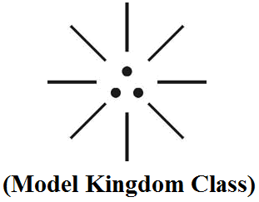

i) Right dot - Plant Kingdom (Like Proton)
ii) Left dot - Animal Kingdom (Like Electron)
iii) Centre dot - Angel Kingdom (Like Photon)

Sl. No. | Category (Family) | Mars Planet (Origin) | Plasma Stage (Transformation) | Earth Planet Life (Origin)
1. | Angel Kingdom (Alle-e) | Trisomy Human  (Male Pregnancy) | Trans-gender human  (No sex identity) | Tribe Population (With female pregnancy)
2. | Animal Kingdom (Archaea) | Trisomy Animal  (Male Pregnancy) | Amoeba  (No sex identity) | Procaryotes, eucaryotes, bacteria (With female pregnancy)
3. | Plant Kingdom  (Aceae) | Trisomy Plant  (Male Pregnancy) | Marijuna  (No sex Pregnancy) | Cannabis  (With Female Pregnancy)

- Case Study on Male Pregnancy?...
Case study shows that Male pregnancy refers to incubation of one or more embryos or Fetus by male member of any species in nearly all heterogamous, animals species, off-spring or ordinarily carried by the female until birth. But in the Fish of “SYNGNATHIDAE FAMILY” male perform his function (pipe fish, sea-horse)is best known for being one of the only male family in the world to get pregnant. The female deposits her eggs into his brood. Then he fertilize eggs.
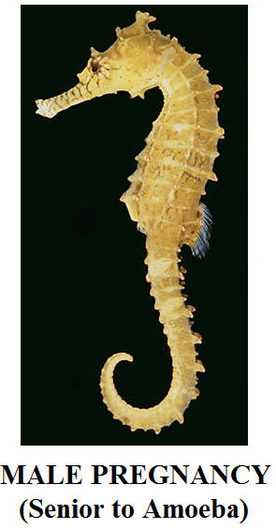
It is hypothesized that “sea-horse” shall be considered as the earliest known family lived in the mars planet and descended to earth plant and lived on the earth planet. It is further hypothesized that sea-horse animal shall be considered as “trisomy” animal (Male Pregnancy) and originated much before origin of Amoeba, Procaryotes, eucayotes and bacteria on the earth planet.

- Philosophy of ‘Male Chauvinist”?...
Case study shows that “Male Chauvinist” refers to a person who has an aggressive and unreasonable belief that their own country is better than all others. It also considers refer to “male egoism” over female that male is superior sex than female.

It is hypothesized that male chauvinism shall be referred to “male pregnancy” that male parent is responsible for laying “reproductive egg” for growth of human populations. It is further focused that growth of ‘Belly’ in so called modern human shall be considered as “genetic reflection of male pregnancy” of early universe rather than deposit of fat cells in the stomach. In proto Indo Europe root “Chauvinism’ shall mean “Chanmam”, Chananam.

“The philosophy of “female chauvinism” considers refers to state of egoism of “female pregnancy” on the earth planet”.
- Author
- “Egg” is associated with word “Zero”?...
“Zero” means no value?... No… No… No… Zero shall mean origin of high energetic value of “Egg Nuclei” due to impact of “J-Radiation” (Zero hour radiation).

It is further focused that Billions of various seeds of plants, Animal eggs shall be considered as genetically varied “Rain drops” like Jana Nayagam, Pana Nayagam, Marutha Nayagam, Peria Nayagam, Pramma Nayagam, Nabigal Nayagam Arumai Nayagam, etc derived from common source of “White clouds”. In Proto Indo Europe language the white cloud shall be called as “MUKIL” (NAYAKI).


- Case study on “Cloning”?...
Case study shows that Clones are organisms that are exact genetic copies of parent cell. Modern Scientists came out with Medical advancement of making cloning in two different types say “Artificial embryo twinning”, “Somatic Cell Nuclear Transfer (SCNT)” popularly known as Cloning the organism, Cloning the gene.
It is the question of Author that “Is it possible to make exact genetic copy of one organism by cloning?... No… No… No…

In the expanding universe the genetic value of matters, organisms considered undergoes Micro Micro level changes every second, every minute, every hour… then where is the question of making “exact genetic copy” one organism by cloning process?... Further is it possible to make “Universal Chromosome compatible cloning”?...

It is hypothesized that “J-CLONING” shall mean natural cloning produces billions of varied allele matter from PARENT TIRSOMY CELL having consistent genetic value irrespective of varied pressure, temperature, density.

It is further hypothesized that in the early Universe billions of matters considered originated from single tirsomy organism. During the course of expanding Universe the chromosome of each organism consistently varies to adopt different environmental conditions. Human also have different chromosome level in different nuclear age as stipulated below.
              - Human origin - Trisomy
              - Plasma age - 20
              - First Generation - 30
              - Second Generation - 40
              - Third Generation - 46

“J-CLONING” shall mean “CREATION WITHOUT TOUCH”.
- Author

- Conclusion:
It is focused that ‘Darwin Sir’ has claimed that “Human Ancestor” consider originated from “Apes family”. It is hypothesized that Human ancestor shall be considered born of “Egg” laid by male parents pertain to “Angel family” (Trisomy) rather than descended from Apes family of Earth Planet having “48 Chromosome”.

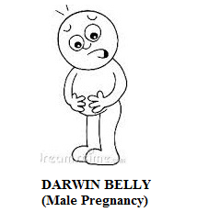

The Belly of Male Pregnancy shall also be hypothetically called by Author as “Darwin Belly”.
“Male Pregnancy would certainly possible by having an embryo implanted in a Man’s abdomen with a placenta attached to an internal organ such as bowl and later delivered by Caesarean Section.”
- Robert Winstor
(Pioneer of Vitro Fertilisation)

- Previous Publication:
The philosophy of origin of first life and human, the philosophy of model Cosmo Universe, the philosophy of fundamental neutrino particles have already been published in various international journals mentioned below. Hence this article shall be considered as extended version of the previous articles already published by the same author.
    - Cosmo Super Star – IJSRP, April issue, 2013
    - Super Scientist of Climate control – IJSER, May issue, 2013
    - AKKIE MARS CODE – IJSER, June issue, 2013
    - KARITHIRI (Dark flame) The Centromere of Cosmo Universe – IJIRD, May issue, 2013
    - MA-AYYAN of MARS – IJIRD, June issue, 2013
    - MARS TRIBE – IJSER, June issue, 2013
    - MARS MATHEMATICS – IJERD, June issue, 2013
    - MARS (EZHEM) The mother of All Planets – IJSER, June issue, 2013
    - The Mystery of Crop Circle – IJOART, May issue, 2013
    - Origin of First Language – IJIRD, June issue, 2013
    - MARS TRISOMY HUMAN – IJOART, June issue, 2013
    - MARS ANGEL – IJSTR, June issue, 2013
    - Three principles of Akkie Management (AJIBM, August issue, 2013)
    - Prehistoric Triphthong Alphabet (IJIRD, July issue, 2013)
    - Prehistoric Akkie Music (IJST, July issue, 2013)
    - Barack Obama is Tamil Based Indian? (IJSER, August issue, 2013)
    - Philosophy of MARS Radiation (IJSER, August 2013)
    - Etymology of word “J” (IJSER, September 2013)
    - NOAH is Dravidian? (IJOART, August 2013)
    - Philosophy of Dark Cell (Soul)? (IJSER, September 2013)
    - Darwin Sir is Wrong?! (IJSER, October issue, 2013)
    - Prehistoric Pyramids are RF Antenna?!... (IJSER, October issue, 2013)
    - HUMAN IS A ROAM FREE CELL PHONE?!... (IJIRD, September issue, 2013)
    - NEUTRINOS EXIST IN EARTH ATMOSPHERE?!... (IJERD, October issue, 2013)
    - EARLY UNIVERSE WAS HIGHLY FROZEN?!... (IJOART, October issue, 2013)
    - UNIVERSE IS LIKE SPACE SHIP?!... (AJER, October issue, 2013)
    - ANCIENT EGYPT IS DRAVIDA NAD?!... (IJSER, November issue, 2013)
    - ROSETTA STONE IS PREHISTORIC “THAMEE STONE” ?!... (IJSER, November issue, 2013)
    - The Supernatural “CNO” HUMAN?... (IJOART, December issue, 2013)
    - 3G HUMAN ANCESTOR?... (AJER, December issue, 2013)
    - 3G Evolution?... (IJIRD, December issue, 2013)
    - God Created Human?... (IJERD, December issue, 2013)
    - Prehistoric “J” – Element?... (IJSER, January issue, 2014)
    - 3G Mobile phone Induces Cancer?... (IJERD, December issue, 2013)
    - “J” Shall Mean “JOULE”?... (IRJES, December issue, 2013)
    - “J”- HOUSE IS A HEAVEN?... (IJIRD, January issue, 2014)
    - The Supersonic JET FLIGHT-2014?... (IJSER, January issue, 2014)
    - “J”-RADIATION IS MOTHER OF HYDROGEN?... (AJER, January issue, 2014)
    - PEACE BEGINS WITH “J”?... (IJERD, January issue, 2014)
    - THE VIRGIN LIGHT?... (IJCRAR, January issue 2014)
    - THE VEILED MOTHER?... (IJERD, January issue 2014)
    - GOD HAS NO LUNGS?... (IJERD, February issue 2014)
    - Matters are made of Light or Atom?!... (IJERD, February issue 2014)
    - THE NUCLEAR “MUKKULAM”?... (IJSER, February issue 2014)
    - WHITE REVOLUTION 2014-15?... (IJERD, February issue 2014)
    - STAR TWINKLES!?... (IJERD, March issue 2014)
    - “E-LANKA” THE TAMIL CONTINENT?... (IJERD, March issue 2014)
    - HELLO NAMESTE?... (IJSER, March issue 2014)
    - MOTHERHOOD MEANS DELIVERING CHILD?... (AJER, March issue 2014)
    - E–ACHI, IAS?... (AJER, March issue 2014)
    - THE ALTERNATIVE MEDICINE?... (AJER, April issue 2014)
    - GANJA IS ILLEGAL PLANT?... (IJERD, April issue 2014)
    - THE ENDOS?... (IJERD, April issue 2014)
    - THE “TRI-TRONIC” UNIVERSE?... (AJER, May issue 2014)
    - Varied Plasma Level have impact on “GENETIC VALUE”?... (AJER, May issue 2014)
    - JALLIKATTU IS DRAVIDIAN VETERAN SPORT?... (AJER, May issue 2014)
    - Human Equivalent of Cosmo?... (IJSER, May issue 2014)
    - THAI-e ETHIA!... (AJER, May issue 2014)
    - THE PHILOSOPHY OF “DALIT”?... (AJER, June issue 2014)
    - THE IMPACT OF HIGHER QUALIFICATION?... (AJER, June issue 2014)
    - THE CRYSTAL UNIVERSE?... (AJER July 2014 issue)
    - THE GLOBAL POLITICS?... (AJER July 2014 issue)
    - THE KACHCHA THEEVU?... (AJER July 2014 issue)
    - THE RADIANT MANAGER?... (AJER July 2014 issue)
    - THE UNIVERSAL LAMP?... (IJOART July 2014 issue)
    - THE MUSIC RAIN?... (IJERD July 2014 issue)
    - THIRI KURAL?... (AJER August 2014 issue)
    - THE SIXTH SENSE OF HUMAN?... (AJER August 2014 issue)
    - THEE… DARK BOMB?... (IJSER August 2014 issue)
    - RAKSHA BANDHAN CULTURE?... (IJERD August 2014 issue)
    - THE WHITE BLOOD ANCESTOR?... (AJER August 2014 issue)
    - THE PHILOSOPHY OF “ZERO HOUR”?... (IJERD August 2014 issue)
    - RAMAR PALAM?... (AJER September 2014 issue)
    - THE UNIVERSAL TERRORIST?... (AJER September 2014 issue)
    - THE “J-CLOCK”!... (AJER September 2014 issue)
    - “STUDENTS” AND “POLITICS”?... (EJAE September 2014 issue)

- REFERENCE
- Intensive Internet “e-book” study through, Google search and Wikipedia.
- M.Arulmani, “3G Akkanna Man”, Annai Publications, Cholapuram, 2011.
- M. Arulmani; V.R. Hemalatha, “Tamil the Law of Universe”, Annai Publications, Cholapuram, 2012.
- Harold Koontz, Heinz Weihriah, “Essentials of management”, Tata McGraw-Hill publications, 2005.
- M. Arulmani; V.R. Hemalatha, “First Music and First Music Alphabet”, Annai Publications, Cholapuram, 2012.
- King James Version, “Holy Bible”.
- S.A. Perumal, “Human Evolution History”.
- “English Dictionary”, Oxford Publications.
- Sho. Devaneyapavanar, “Tamil first mother language”, Chennai, 2009.
- Tamilannal, “Tholkoppiar”, Chennai, 2007.
- “Tamil to English Dictionary”, Suravin Publication, 2009.
- “Text Material for E5 to E6 upgradaton”, BSNL Publication, 2012.
- A. Nakkiran, “Dravidian mother”, Chennai, 2007.
- Dr. M. Karunanidhi, “Thirukkural Translation”, 2010.
- “Manorama Tell me why periodicals”, M.M. Publication Ltd., Kottayam, 2009.
- V.R. Hemalatha, “A Global level peace tourism to Veilankanni”, Annai Publications, Cholapuram, 2007.
- Prof. Ganapathi Pillai, “Sri Lankan Tamil History”, 2004.
- Dr. K.K. Pillai, “South Indian History”, 2006.
- M. Varadharajan, “Language History”, Chennai, 2009.
- Fr. Y.S. Yagoo, “Western Sun”, 2008.
- Gopal Chettiar, “Adi Dravidian Origin History”, 2004.
- M. Arulmani; V.R. Hemalatha, “Ezhem Nadu My Dream” - (2 Parts), Annai Publications, Cholapuram, 2010.
- M. Arulmani; V.R. Hemalatha, “The Super Scientist of Climate Control”, Annai Publications, Cholapuram, 2013, pp 1-3.

9/17/2014

