Effectiveness of different solvents extracts from edible mushrooms in inhibiting the growth of tumor cells

Ahmed Younis^{1,2*}, Jennifer Stewart¹, Fang-Sheng Wu¹, Hussien El Shikh ^{2,4}, Fathy Hassan³, Mahmoud Elaasser ⁴

¹ Department of Biology, Collage of Humanities and Science, Virginia Commonwealth University, Richmond, VA, 842012, USA.
² Department of Botany and Microbiology, Faculty of Science, Al Azhar University, 11787 Nasr City, Cairo, Egypt.
³ Food Technology Research Institution, Agricultural Research Center, Giza, Egypt.
⁴ The Regional Center for Mycology and Biotechnology, Al Azhar University, 11787 Nasr City, Cairo, Egypt.
E mails: a.younis81@yahoo.com, amyounis@vcu.edu, mmelaasser@hotmail.com, jstewart@vcu.edu.
*Corresponding author: Ahmed Younis - Department of Biology, Collage of Humanities and Science, Virginia Commonwealth University, Richmond, VA, 842012, USA. Email: a.younis81@yahoo.com. phone: +2 01007055145, +1 8048280650.

Abstract: Edible mushrooms have become so bountiful and nourishing as they are a valuable source of nutritional ingredients and biologically active compounds. Moreover, edible mushroom have many medicinal properties, including antitumor activity. In this study, we extracted various parts of three edible mushrooms including Flammulina velutipes, Ganoderma lucidum and Pleurotus eryngii by different polar and non-polar solvents and tested the effectiveness of these extracts in inhibiting the growth of three carcinoma cell lines including human liver carcinoma (Hep G2), the human colonic epithelial carcinoma (HCT 116) and the human cervical cancer cells (HeLa) using 3-(4,5-Dimethylthiazol-2-yl)-2,5-diphenyltetrazolium bromide (MTT) assay. We observed that the extracts of fresh and lyophilized fruiting bodies had a stronger antitumor effect than extracts from mycelia and broth when extracted by water and methanol. The highest antitumor activity was by the water extract of F. velutipes lyophilized fruiting bodies with half maximal inhibitory concentration (IC₅₀) values of 7.3±0.7, 6.9±0.5and 5.2±0.4 µg/ml against Hep G2, HCT 116 and HeLa cells, respectively. Also water extracts of G. lucidum lyophilized fruiting bodies showed high antitumor effect with IC₅₀ of 10.5±1.1, 7.9±0.6 and 21.4±2.1 µg /ml against Hep G2, HCT 116 and HeLa cells, respectively. The lowest effect was observed by ether extract of F. velutipes broth with maximal inhibitory percentage of 5.1±0.8% against HCT 116 cells. In summary, common edible mushrooms may be a source of antitumor compounds.
[Ahmed Younis, Jennifer Stewart, Fang-Sheng Wu, Hussien El Shikh, Fathy Hassan, Mahmoud Elaasser. Effectiveness of different solvents extracts from edible mushrooms in inhibiting the growth of tumor cells. Cancer Biology 2014;4(4):1-15]. (ISSN: 2150-1041). http://www.cancerbio.net. 1

Keywords: Antitumor activity, Ganoderma lucidum; Flammulina velutipes; Pleurotus eryngii, edible mushroom.

1. Introduction
Cancer also known as a malignant tumor is a group of diseases involving abnormal cell growth with the potential to invade or spread to other parts of the body. Cancer is a leading cause of death worldwide resulting in 8.2 million or 14.6% of all human deaths in 2012 (Jemal et al., 2011; Lozano, 2012). Lung, liver, stomach, colorectal and breast cancers cause the most cancer deaths each year. Tobacco use is the cause of about 22% of cancer deaths. In the developing world nearly 20% of cancers are due to infections such as hepatitis B, hepatitis C, and human papillomavirus. The financial costs of cancer have been estimated at $1.16 trillion US dollars per year as of 2010 (Kushiet et al., 2012; de Martel et al., 2012; WHO, 2014).
Many scientists search for new antitumor substances from various natural sources to develop more effective and safer agents to inhibit the growth of cancer cells. Natural products from bacteria, fungi and plants have played a leading role in cancer drug discovery resulting in a large number of clinically useful agents (Cragg and Newman, 2005; Chung et al., 2010; Syam et al., 2011; Ren et al., 2012; Bladt et al., 2013; Zhao et al., 2013; Evidente et al., 2014). Experimental studies demonstrated that many naturally occurring agents have anticancer potential in a variety of bioassays systems and animal models, having relevance to human diseases (Sun, 2011).
Many species of mushrooms are not toxic and have been used for food consumption since ancient times (Kalac, 2009). Mushrooms contain highly valued nutritional ingredients (Vaz et al., 2011; Atri et al., 2013; Boda et al., 2012; Lau et al., 2013), as well as medicinal ingredients with medical activities including antimicrobial (Alves et al., 2012; Chang and Wasser, 2012; Krishnaveni and Manikandan, 2014); antiviral (Pan et al., 2013 ); antioxidant (Ferreira et al., 2009; Liu et al., 2013; Stajic et al., 2013); anti-hypertensive (Ebigwai et al., 2012) cholesterol-lowering, cardiovascular diseases preventative (Berger et al., 2004; Guillamon et al., 2010; Sato et al., 2013); liver protective (Wu et al., 2013); anti-fibrotic (Iwalokun et al., 2007; Soares et al., 2013); anti-inflammatory (Ganeshpurkar and Rai, 2013; Gunawardenaet al., 2013); anti-diabetic (Lo and Wasser, 2011) and antitumor (Ren et al., 2012; Fontana et al., 2014; Xu et al., 2014) activities.
There are many other examples of isolated mushroom compounds with beneficial properties against cancer (Ferreira et al., 2010; Wu et al., 2011; Finimundy et al., 2013). Many polysaccharides isolated from mushrooms have strong antitumor activities (Zhang et al.,2007; Moharib et al.,2014); for example, Lentinan a polysaccharide isolated from of Lentinula edodes showed strong antitumor activities and had been used in the clinic for treating of several cancers, especially stomach cancer (Ng and Yap, 2002; Yamaguchi et al., 2011). In addition, mushroom-derived glucans showed anti-inflammatory and anticancer effects (Schwartz and Hadar, 2014).
In recent years, much attention has been focused on polysaccharides isolated from natural sources such as bacteria, fungi, algae and plants (Jwanny et al., 2009; Sun, 2011). The hot water extracts of five commonly consumed mushrooms of maitake (Grifola frondosa), crimini (Agaricus bisporus), portabella (A. bisporus), oyster (P. ostreatus) and white button (A. bisporus) significantly suppressed cellular proliferation of MCF-7 cells suggesting common mushrooms may be chemo protective against breast cancer (Martin and Brophy, 2010).
In this study, we investigated the antitumor activity in extracts of several mushroom species against three tumor cell lines. Both polar and nonpolar solvents were used to extract active compounds.

2. Materials and Methods:
2.1. Mushroom strain and culture conditions:
The three edible mushrooms used in this study including F. velutipes, G. lucidum and P. eryngii, both F. velutipes and P. eryngii were kindly obtained from the Agriculture Research Center, Cairo, Egypt, and cultivated on rice stew. While, fruiting bodies of G. lucidum were collected from natural growth on trees trunk located at Richmond, Virginia, USA. Mycelia were isolated from the fruiting bodies and transferred to potato dextrose agar (PDA), consisting of 4 g/L potato extract (Sigma-Aldrich, Missouri, USA), 20 g/L dextrose (Pharmacia, New York, USA), 20 g/L agar (Sigma-Aldrich).
For liquid culture, the mycelia of the three mushroom strains were grown in 250 ml Erlenmyer flasks containing 100 ml of a potato dextrose broth (PDB) medium consisting of 4 g/L potato extract and 20 g/L dextrose, and incubated at 24° C for 15 days. To separate the mycelia from the broth, the cultures were filtered with 0.2 µm filter, and the filtrates were concentrated by lyophilization with a Virtis BT4KZL-105 lyophilizer (SP Industris, Warminster, PA, USA) and stored at -20° C until use.

2.2. Mushroom extracts:
The extraction was performed with distilled water, methanol (Sigma-Aldrich), ether (Sigma-Aldrich) and ethyl acetate (Sigma-Aldrich) on the fresh and lyophilized fruiting bodies as well as mycelia and broth of the three mushrooms growing on PDB.

Fresh fruiting bodies:
The fresh fruiting bodies were washed with distilled water, blot dried, cut into pieces (1x1 cm approximately), and added into the following solvents at 10g/100ml (wt/v): distilled water, methanol, ether or ethyl acetate. The samples then soaked overnight at 4° C and ground with a Waring commercial laboratory blender (Fisher Scientific, Inc.,Waltham, MA, USA), On the second day, the samples were sonicated in an ultra-sonicator (Fisher Model 300 Sonic Dismembrator- Fisher Scientific, Inc., Waltham, MA, USA) for 30 min at 25 KHz. The mixtures were centrifuged (Beckman CS-6R Centrifuge- Beckman Coulter, Inc. Atlanta, GA, USA) at 10,000 xG for 20 minutes, and supernatants were collected. The water extract was concentrated by lyophilization with a Labconco FreeZone Benchtop Freeze Dry System (Kansas City, MO- USA). Other extracts were concentrated by air drying and resuspended in dimethyl sulfoxide (DMSO) (Fisher).

Lyophilized fruiting bodies:
The lyophilized fruiting bodies were weighted and added into the following solvents at 10g/100ml (wt/v): distilled water, methanol, ether or ethyl acetate. Then the above method was used for the extractions.

Mycelia and broth:
The mycelia of the three mushrooms were grown on PDB medium, collected and washed with distilled water, blot dried, and added into the following solvents at 10g/100ml (wt/v): distilled water, methanol, ether or ethyl acetate. The samples were then soaked overnight in at 4° C and ground by a blender. On the second day the samples are sonicated with the ultra-sonicator for 30 min at 25 KHz.
The mixtures were centrifuged at 10,000 x G for 20 minutes, and the supernatants were collected. Also, the lyophilized broth was dissolved in distilled water, methanol, ether and ethyl acetate at 1g/10ml (wt/v). The water extract was concentrated by lyophilization. Other extracts were concentrated by air drying and resuspended in dimethyl sulfoxide.

2.3- Assay of antitumor activity of the mushroom extracts against carcinoma cells lines:
Three carcinoma cell lines were used to test the antitumor activity of the mushroom extracts, including human liver carcinoma cells (Hep G2) (ATCC® HB-8065™) that cause hepatocellular carcinoma, the human colonic epithelial carcinoma (HCT 116) (ATCC® CCL-247™) that causes colorectal carcinoma, and the human cervical cancer cells (HeLa) (ATCC® CCL-2™) from an adenocarcinoma.
The HepG2 cell lines were maintained in RPMI 1640 (Life Technologies Inc., Grand Island, NY, USA) supplemented with 10% (v/v) heat-inactivated fetal bovine serum (FBS) (Gemini Bio-Products Inc., West Sacramento, CA. USA), 5 mM HEPES (4-(2-hydroxyethyl)-1-piperazineethanesulfonic acid - Life Technologies Inc., Grand Island, NY, USA) (pH 7.3), 5 mM sodium pyruvate (Life Technologies Inc., Grand Island, NY, USA) 5 mM non-essential amino acid (Life Technologies Inc., Grand Island, NY, USA) and 5 mM penicillin/streptomycin solution pen/strep (10,000 U/μg/ml; Life Technologies Inc., Grand Island, NY, USA). The HCT 116 and HeLa cell lines were maintained in modified Dulbecco’s modified minimum essential medium (DMEM) (Life Technologies Inc., Grand Island, NY. USA) supplemented with 10% (v/v) heat-inactivated FBS, 2 mM glutamine, and 5 mM pen/step. The three carcinoma cell lines were incubated in 75 cm² culture corning flask (Fisher Scientific Inc., Loughborough, Leicester, United Kingdom) at 37°C in a water jacketed incubator (Forma Scientific series II, (Thermo Scientific Inc., Waltham, MA, USA). An inverted microscope (Olympus, CKX41; Shinjuku, Tokyo, Japan) was used to view the cell monolayer and confirm the absence of bacterial and fungal contaminants. To count the number of cells, the cell monolayer was washed with 5 ml phosphate buffer saline (PBS) without Ca2+/Mg2+ (Life Technologies) then 2.5 ml of 0.53 mM trypsin/EDTA (Life Technologies) was added to the culture flask, and incubated for 7-15 min. When cells were displaced from the flask, 6 ml of maintainace media were added to stop the action of the trypsin. A hemocytometer was used to determine the number of viable cells using trypan blue staining (Life Technologies).
For antitumor assays, cells were suspended in medium at concentration 5x10⁴ cell/well in 200 μl/well of Corning 96-well tissue culture plates (Fisher Scientific Inc., Loughborough, Leicester, United Kingdom), then incubated for 24 hr. Mushroom extracts were then dispensed into 96-well plates in 50 µl volumes to achieve six concentrations for each extract = 50, 25, 12.5, 6.25, 3.125, 1.56 µg/ml, and each concentration was repeated 5 times. Five vehicle controls with media or 0.5 % DMSO were run for each 96 well plate as a control. After incubating for 24 h, the numbers of viable cells were determined by the MTT 3-(4,5-dimethylthiazol-2-yl)-2,5-diphenyltetrazolium bromide (Sigma-Aldrich) test. As follow: The media was removed from the 96 well plate and replaced with 100 µl of fresh culture RPMI 1640 medium without phenol red (Life Technologies) then 10 µl of the 12 mM MTT stock solution (5 mg of MTT in 1 mL of PBS) to each well including the untreated controls. The 96 well plate was then incubated at 37°C and 5% CO2 for 4 hours. An 85 µl aliquot of the media was removed from the wells, and 50 µl of DMSO was added to each well and mixed thoroughly with the pipette and incubated at 37°C for 10 min. The optical density was measured at 590 nm with the micro plate reader (Bio-TekuQuantmicroplate spectrophotometer BioTek, inc, Winooski, VT. USA). The antitumor activity of the mushroom extracts was determined by the mean percent inhibition of the tumor cells remaining after the treatment by the following formula: (ODt/ODc) x100%, where ODt and ODc are the optical densities of wells with treated and untreated cells, respectively (Mosmann, 1983; Wu and Wang, 2010; Elaasser et al., 2011).
The half maximal inhibitory concentration (IC₅₀) was determined after plotting the dose response curve for each conc. using Graphpad Prism software (San Diego, CA. USA).

3. Results:
3.1- The antitumor activities of F. velutipes extracts:
The antitumor activity of F. velutipes extracts against the three carcinoma cell lines is shown in Table 1. Where the maximal inhibition of cell viability was determined with 50 μg/ml of each extract, and IC50 was determined from a range of concentrations shown in Figures 1-3. All values are mean ± SD.
The water extracts consistently showed the highest antitumor effect whereas ether extracts showed the lowest antitumor effect against the three carcinoma cells. The water extract of lyophilized fruiting bodies showed the highest antitumor effect with maximum inhibitory percentages of 92.9±2.1, 90.9±2.1 and 84.5±1.4 % against Hep G2, HCT 116 and HeLa cells with IC₅₀ 7.3±0.7, 6.9±0.5 and 5.2±0.4 µg/ml, respectively. Also, the water extract of fresh fruiting bodies showed high maximum inhibitory percentages of 92.3±1.8, 85.9±1.9 and 78.2±1.9 % against Hep G2, HCT 116 and HeLa cells with IC₅₀ 10.6±0.8, 14.3±0.9 and 16.5±0.9 µg/ml, respectively. In comparison, the methanol extract of fresh and lyophilized fruiting bodies showed lower antitumor effect than the water extracts with maximal inhibition ranged between 74 – 35%.
The ethyl acetate extracts and water extract of mycelia and broth showed moderate inhibitory effect against the three tumor cell lines (Fig. 1-3) where the highest observed by ethyl acetate of lyophilized fruiting bodies against Hep G2 cells with IC₅₀ 35.9±1.9 µg/ml and the lowest observed by ethyl acetate of broth against Hep G2 cells with IC₅₀ 17.7±0.6 µg/ml. On the other hand, ether extract from all F. velutipes parts showed the lowest inhibition effect with maximal activity (48-5 %) against most tumor cell lines, where the lowest effect was observed against HCT 116 tumor cells (Fig.1-3).

3.2- The antitumor activities of G. lucidum extracts:
G. lucidum extracts in Different solvents exhibited different levels of antitumor against the three cancer cell lines, with lower effects than the F. velutipes extracts. The water extracts of lyophilized fruiting bodies showed the highest antitumor effect with maximal inhibition of 87.5±2.1, 87±2.5 and 76.4±2.6 % against Hep G2, HCT 116 and HeLa cells and with IC₅₀ 10.5±1.1, 7.9±0.6 and 21.4±2.1 µg/ml, respectively. The water extracts of fresh fruiting bodies those showed maximal inhibition of 80±2.9, 71.8±1.2 and 69.4±2.5 % against Hep G2, HCT 116 and HeLa cells with IC₅₀ 8.9±0.9, 17.7±0.9 and 25.7±1.8 µg/ml, respectively.
In comparison, the methanol extract showed less effect than the water extract against the three-carcinoma cells. The methanol extract of both fresh and lyophilized fruiting bodies had approximately the same ranges of maximal activity (79-58 %) and IC₅₀ (16-34 μg/ml) against most tumor cell lines. In contrast, the ethyl acetate extract and ether extract of fresh and lyophilized fruiting bodies showed lower effect than water and methanol extracts with IC₅₀ ranged between 45-114 µg/ml (Fig.4-6).
The water extracts from mycelia and broth showed moderate effects on the three cell lines. The highest effect was shown by the water extract of mycelia against HCT 116 with maximal activity 73.3±1.9 % and IC₅₀ of 26.2±1.6 µg/ml. The methanol, ethyl acetate and ether extracts from mycelia and broth showed lower inhibitory effect against the three tumor cell lines. The lowest inhibitory effect was observed with the ether extract of mycelia against HeLa cells with maximal activity 7.2±0.2 % (Fig.4-6).

3.3- The antitumor activities of P. eryngii extracts:
The in vitro antitumor activities of P. eryngii showed lower inhibitory effect against the three carcinoma cell lines than both F. velutipes and G. lucidum extracts (Table 3). The highest inhibitory effect was observed with the water extract of lyophilized fruiting bodies with maximal activity 68.3±1.2, 69.3±1.8 and 72.1±1.9 % against Hep G2, HCT 116 and HeLa cells with IC₅₀ 22.1±1.5, 19.1±0.8 and 17.1±0.9 µg/ml, respectively. The water extract of fresh fruiting bodies had maximal inhibition of 59.1±2.2, 60.5±1.9 and 61.7±1.6 % against Hep G2, HCT 116 and HeLa cells with IC₅₀ 29.9±2.1, 34.8±1.6 and 33.5±1.6 µg/ml, respectively (Fig. 7-9).
In contrast, the ethyl acetate extract of fresh and lyophilized fruiting bodies had higher inhibitory effect than the methanol and ether extracts but lower than the water extracts with approximately the same ranges of maximal activity (59-32 %) and IC₅₀ values of (33-67μg/ml) against the three cell lines.
Methanol and ether extracts of fresh and lyophilized fruiting bodies showed the lowest inhibitory effect against the three tumor cells, with the highest effect against HeLa cells with IC₅₀ of 41.2±2.3 µg/ml by ether extract of lyophilized fruiting bodies (Table 3).
Moreover, extracts from broth and mycelia had lower antitumor effect against the three cell line than the fruiting bodies extracts, except the effect of water and methanol extracts of mycelia and water extract of broth against HeLa cells exhibited maximal activity of 61.9±2.5 and 54.9±1.5 and 50.3±1.9 %, respectively (Fig. 7-9). The lowest effect was observed with the ether extract of mycelia against Hep G2 with maximal inhibition12.8±1.8 %.

Table 1. The antitumor activities of F. velutipes extracts against the three carcinoma cell lines.
Sample | Solvent | HepG2 |  | HCT 116 |  | HeLa
Sample | Solvent | Maximum inhibitory % | IC₅₀ (μg/ml) | Maximum inhibitory % | IC₅₀ (μg/ml) | Maximum inhibitory % | IC₅₀  (μg/ml)
Fresh fruiting bodies | Water | 92.3±1.8 | 10.6±0.8 | 85.9±1.9 | 14.3±0.9 | 78.2±1.9 | 16.5±0.9
Fresh fruiting bodies | Methanol | 66.3±1.9 | 32.3±1.6 | 43.3±1.6 | 54.5±2.6 | 64.4±2.1 | 38.1±2.2
Fresh fruiting bodies | Ether | 32.8±1.9 | 63.8±2.9 | 27.9±2.1 | 69.2±2.9 | 38.9±3.1 | 64.3±3.2
Fresh fruiting bodies | Ethyl Acetate | 40.3±2.1 | 59.3±2.6 | 19.9±1.4 | 75.1±3.4 | 50.9±1.5 | 50.7±2.5
Lyophilized fruiting bodies | Water | 92.9±2.1 | 7.3±0.7 | 90.9±2.1 | 6.9±0.5 | 84.5±1.4 | 5.2±0.4
Lyophilized fruiting bodies | Methanol | 74.1±2.7 | 30.8±1.7 | 35.7±1.2 | 74.7±3.5 | 71.4±2.5 | 31.6±2.3
Lyophilized fruiting bodies | Ether | 48.8±1.5 | 51.2±2.5 | 30.1±1.7 | 79.6±3.7 | 41.2±2.2 | 57.9±2.5
Lyophilized fruiting bodies | Ethyl Acetate | 60.9±1.9 | 35.9±1.9 | 55±2.5 | 40.9±2.1 | 60±2.4 | 38.9±2.1
Mycelia | Water | 49.1±1.2 | 51.1±2.2 | 45.2±2.2 | 57.6±2.6 | 42.9±1.8 | 65.3±2.8
Mycelia | Methanol | 27±1.2 | 68.8±2.9 | 33.5±3.1 | 74.5±3.5 | 39.6±1.5 | 70.9±3.5
Mycelia | Ether | 9.1±0.5 | 448±3.5 | 16.9±1.8 | 388±4.8 | 9.3±0.8 | 248±3.8
Mycelia | Ethyl Acetate | 17.7±0.6 | 324±3.6 | 35.5±2.1 | 68.5±3.1 | 41.9±0.9 | 57.2±2.9
Broth | Water | 39.2±1.1 | 62.2±3.1 | 36.4±1.4 | 60.4±3.2 | 56.3±1.1 | 45.5±2.5
Broth | Methanol | 17.4±2.1 | 200±2.5 | 32.2±2.1 | 65.9±2.9 | 45±2.1 | 54.8±2.8
Broth | Ether | 10.5±0.9 | 237±3.9 | 5.1±0.8 | 408±5.8 | 21.7±1.2 | 195±3.4
Broth | Ethyl Acetate | 26.7±0.8 | 248±3.5 | 42.4±1.8 | 58.7±2.8 | 31±0.9 | 69.3±2.9

Table 2. The antitumor activities of G. lucidum extracts against the three carcinoma cell lines.
Sample | Solvent | HepG2 |  | HCT 116 |  | HeLa
Sample | Solvent | Maximum inhibitory % | IC₅₀ (μg/ml) | Maximum inhibitory % | IC₅₀ (μg/ml) | Maximum inhibitory % | IC₅₀  (μg/ml)
Fresh fruiting bodies | Water | 80±2.9 | 8.9±0.9 | 71.8±1.2 | 17.7±0.9 | 69.4±2.5 | 25.7±1.8
Fresh fruiting bodies | Methanol | 74.6±2.3 | 17.3±1.2 | 58.8±2.1 | 34.3±2.4 | 62.7±2.7 | 32.7±1.9
Fresh fruiting bodies | Ether | 26.9±1.9 | 73.2±3.9 | 46.7±2.2 | 51.3±2.6 | 36.4±2.5 | 78.8±3.5
Fresh fruiting bodies | Ethyl Acetate | 40.6±2.1 | 57.6±3.2 | 45.3±2.0 | 51.9±2.3 | 44.4±2.1 | 56.4±3.1
Lyophilized fruiting bodies | Water | 87.5±2.1 | 10.5±1.1 | 87±2.5 | 7.9±0.6 | 76.4±2.6 | 21.4±2.1
Lyophilized fruiting bodies | Methanol | 78.9±2.3 | 15.9±1.4 | 73.1±1.9 | 18.5±0.9 | 63.1±2.7 | 31.1±2.1
Lyophilized fruiting bodies | Ether | 22±1.2 | 114±3.1 | 37.8±1.9 | 68.5±2.6 | 39.1±2.9 | 65.2±2.9
Lyophilized fruiting bodies | Ethyl Acetate | 33.1±1.3 | 68.6±3.3 | 51.6±1.9 | 45.6±1.7 | 42.7±2.5 | 58.8±2.4
Mycelia | Water | 39.7±2.5 | 74.6±3.5 | 35.9±2.2 | 76.6±2.8 | 45.9±0.4 | 44.7±2.5
Mycelia | Methanol | 47.4±2.3 | 65.6±3.5 | 46.1±2.1 | 52.4±2.2 | 32.3±1.4 | 72.1±3.4
Mycelia | Ether | 13.2±1.2 | 272±3.5 | 21.3±1.1 | 179.5±2.9 | 7.2±0.2 | 336±5.1
Mycelia | Ethyl Acetate | 25.1±2.5 | 372±7.1 | 28±1.2 | 77.4±2.7 | 17.2±0.9 | 196±3.2
Broth | Water | 36.2±1.4 | 62.6±3.4 | 73.3±1.9 | 26.2±1.6 | 70.8±2.2 | 31.2±2.1
Broth | Methanol | 32.6±2.1 | 66.2±3.3 | 62.1±2.8 | 34±1.8 | 30.3±1.5 | 79.7±3.5
Broth | Ether | 10.5±0.9 | 356±6.1 | 32.7±2.1 | 77.3±2.8 | 24.7±1.2 | 115±2.2
Broth | Ethyl Acetate | 25.2±1.1 | 352±8.1 | 44.8±2.1 | 52.8±2.3 | 36.4±1.3 | 70.7±3.4

Table 3. The antitumor activities of P. eryngii extracts against the three carcinoma cell lines.
Sample | Solvent | HepG2 |  | HCT 116 |  | HeLa
Sample | Solvent | Maximum inhibitory % | IC₅₀ (μg/ml) | Maximum inhibitory % | IC₅₀ (μg/ml) | Maximum inhibitory % | IC₅₀  (μg/ml)
Fresh fruiting bodies | Water | 59.1±2.2 | 29.9±2.1 | 60.5±1.9 | 34.8±1.6 | 61.7±1.6 | 33.5±1.6
Fresh fruiting bodies | Methanol | 22.4±1.9 | 244±4.9 | 30.1±2.9 | 82.3±3.9 | 32.1±1.3 | 69.1±3.3
Fresh fruiting bodies | Ether | 41.1±2.8 | 76.7±3.8 | 45.3±2.1 | 53.1±2.4 | 53.7±2.4 | 41.2±2.3
Fresh fruiting bodies | Ethyl Acetate | 32±1.7 | 67.1±3.7 | 35.6±1.8 | 63.2±2.8 | 53.4±2.5 | 45.6±2.3
Lyophilized fruiting bodies | Water | 68.3±1.2 | 22.1±1.5 | 69.3±1.8 | 19.1±0.8 | 72.1±1.9 | 17.1±0.9
Lyophilized fruiting bodies | Methanol | 24.1±1.9 | 161±3.9 | 53.4±1.5 | 40.7±1.9 | 38.4±1.4 | 60.1±3.6
Lyophilized fruiting bodies | Ether | 42.2±1.2 | 58.5±2.5 | 41.1±2.5 | 57.4±2.3 | 23.2±2.2 | 110±3.7
Lyophilized fruiting bodies | Ethyl Acetate | 33.9±1.5 | 63.9±3.5 | 35.6±2.9 | 63.1±2.8 | 59.6±2.2 | 33.7±2.3
Mycelia | Water | 29.8±2.6 | 70.1±3.6 | 34±2.2 | 69.1±3.2 | 61.9±2.5 | 34.2±2.3
Mycelia | Methanol | 14.6±1.6 | 204±4.6 | 17.1±1.1 | 404±4.6 | 54.9±1.5 | 41.8±2.5
Mycelia | Ether | 32.3±1.1 | 87.3±4.2 | 32.3±1.8 | 87.3±3.8 | 17.2±1.9 | 113±3.7
Mycelia | Ethyl Acetate | 12.8±1.8 | 208±4.6 | 42.3±2.3 | 55.7±3.3 | 22.3±1.8 | 103±3.8
Broth | Water | 28.1±1.4 | 368±5.6 | 38.7±1.5 | 63.6±3.5 | 39.4±1.5 | 60.1±2.8
Broth | Methanol | 25.2±1.3 | 398±6.8 | 27.6±1.4 | 80.2±3.9 | 50.3±1.9 | 47.5±2.7
Broth | Ether | 16.9±1.5 | 493±7.5 | 19.8±1.5 | 493±7.5 | 20.9±1.1 | 120±3.9
Broth | Ethyl Acetate | 21.4±1.4 | 368±4.9 | 25.1±1.5 | 91.3±4.1 | 24.9±1.1 | 93.6±4.5

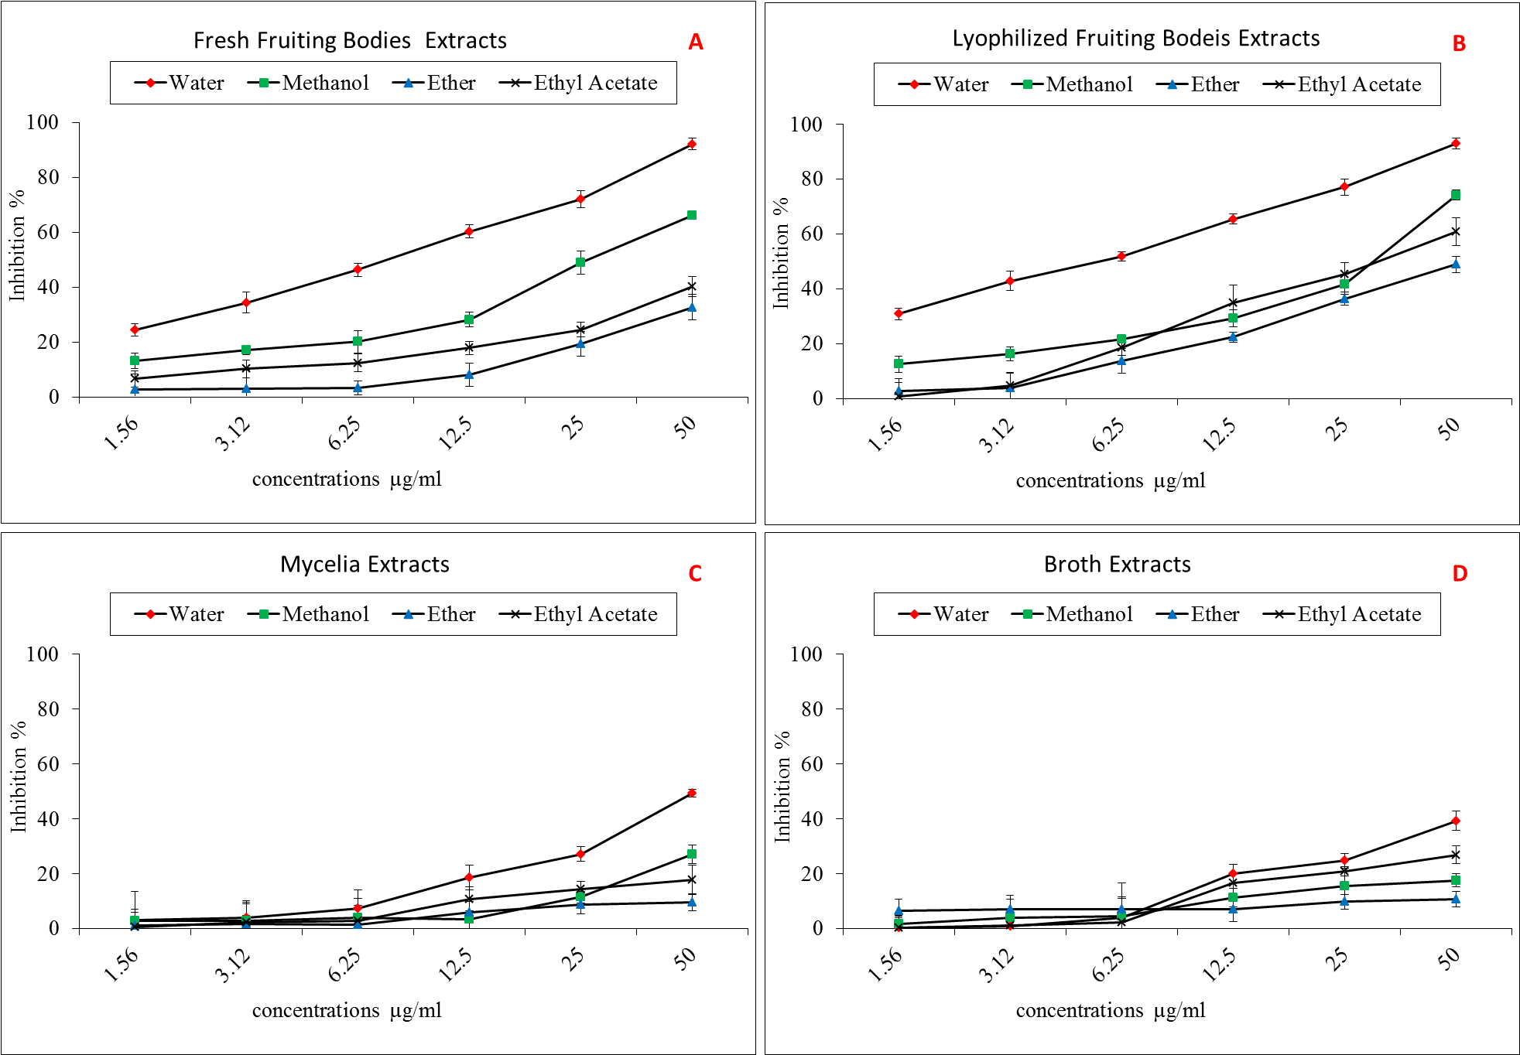
Fig. 1. The antitumor activities of F. velutipes extracts against Hep G2 cell line.

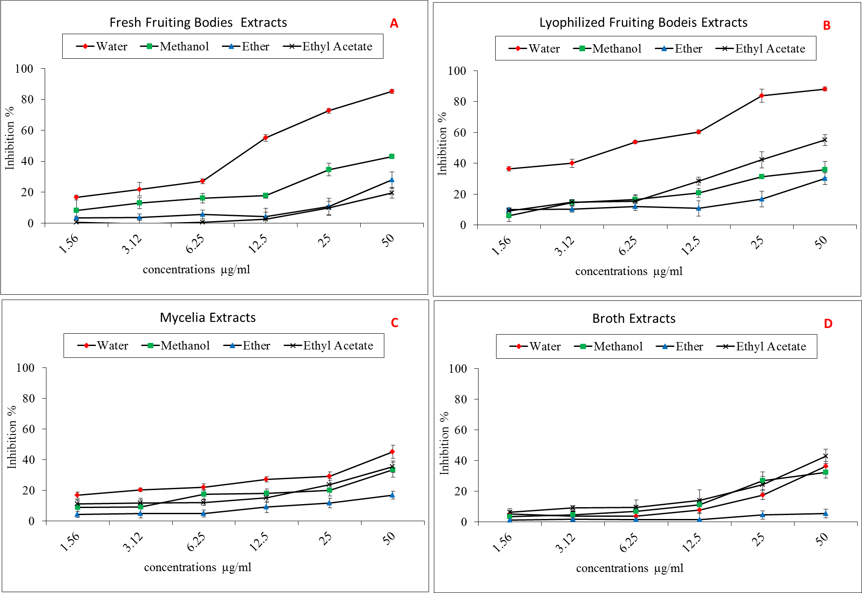
Fig. 2. The antitumor activities of F. velutipes extracts against HCT 116 cell line.

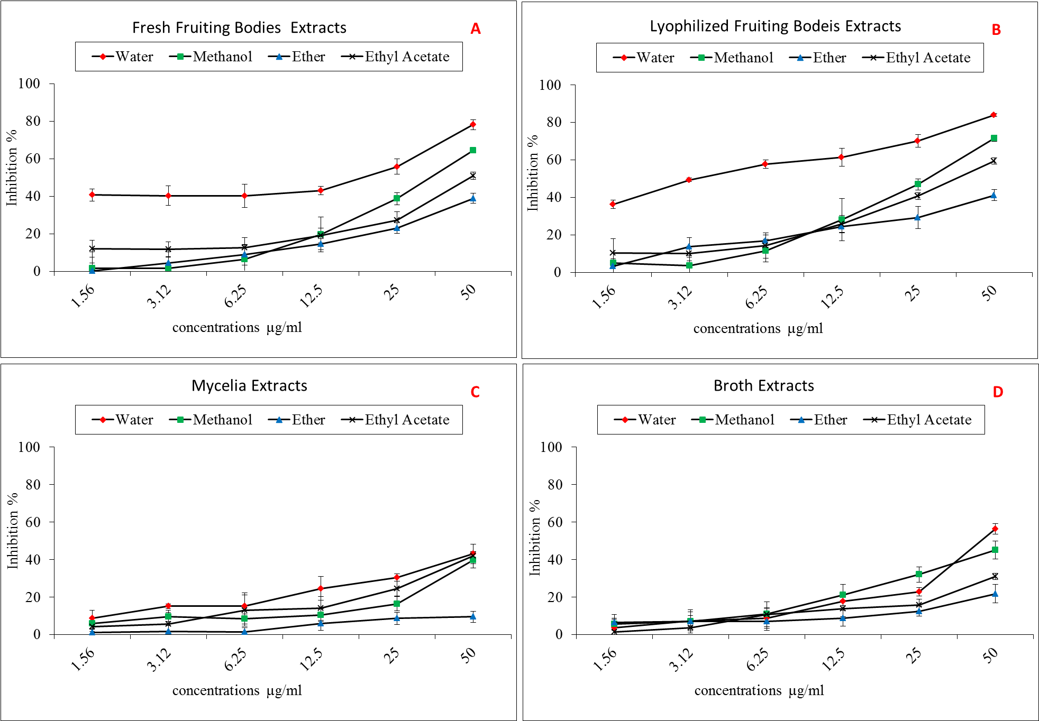
Fig. 3. The antitumor activities of F. velutipes extracts against HeLa cell line.

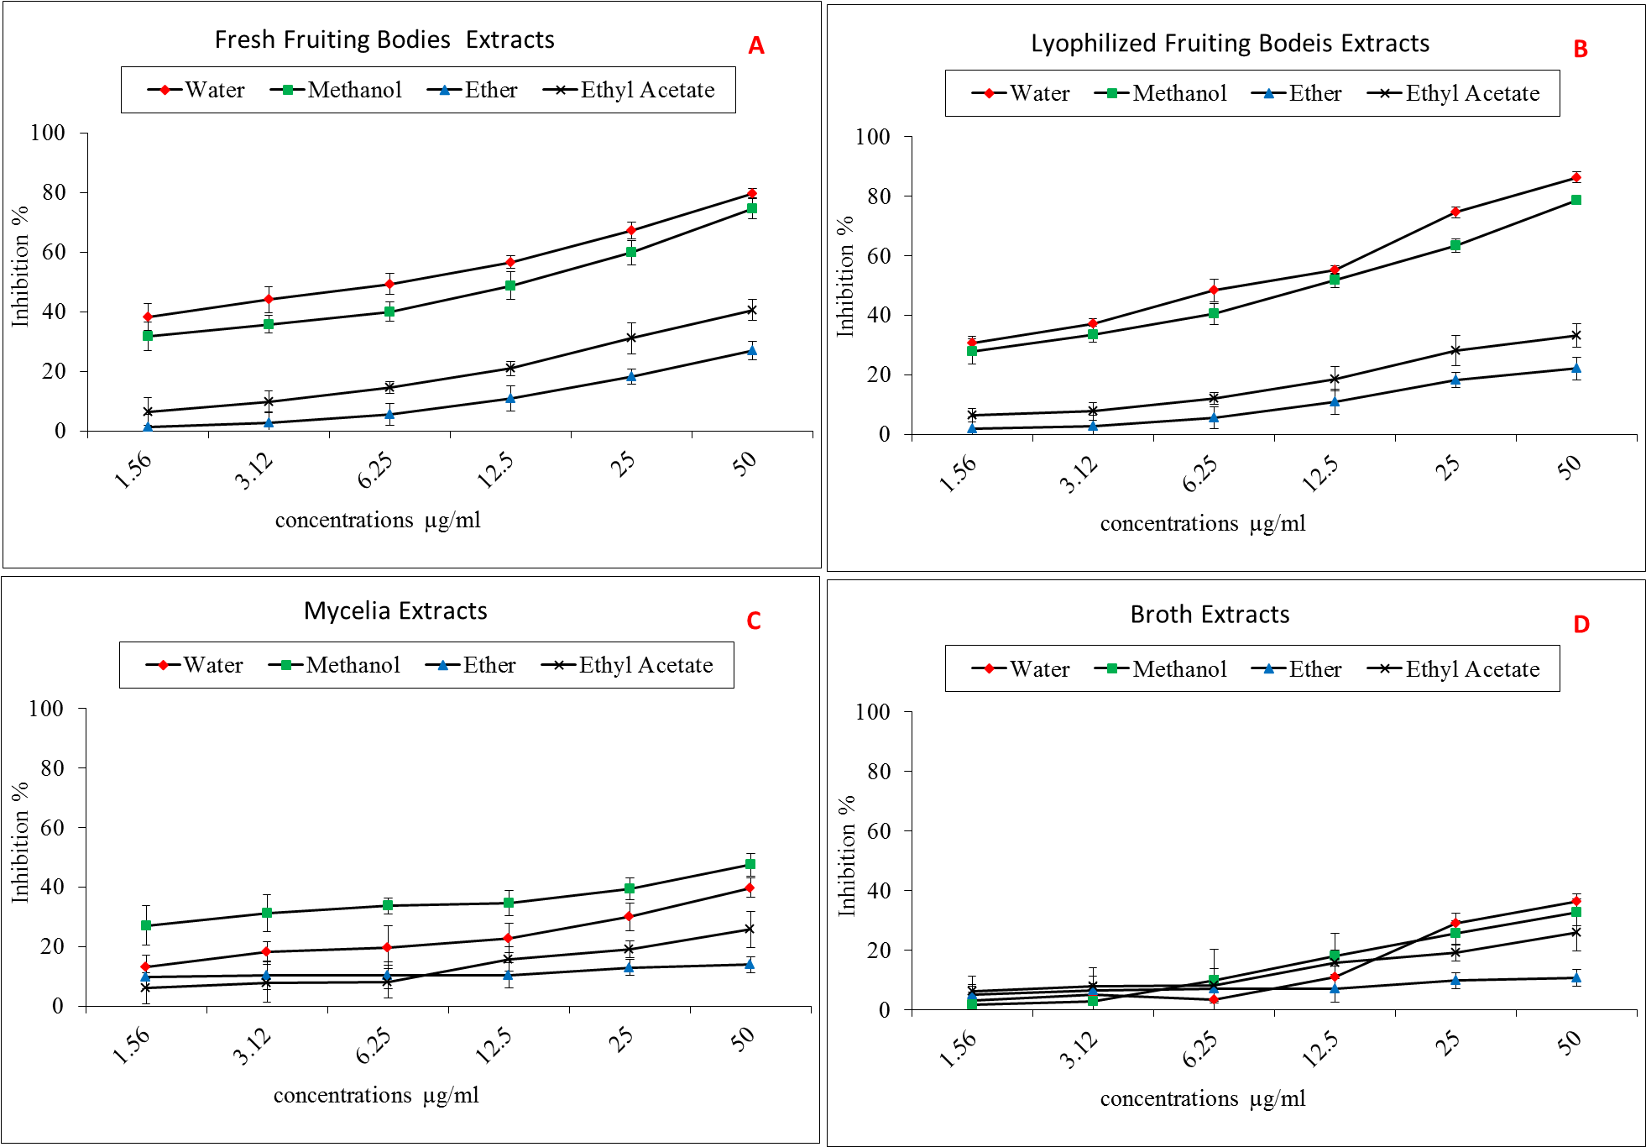
Fig. 4. The antitumor activities of G. lucidum extracts against Hep G2 cell line.

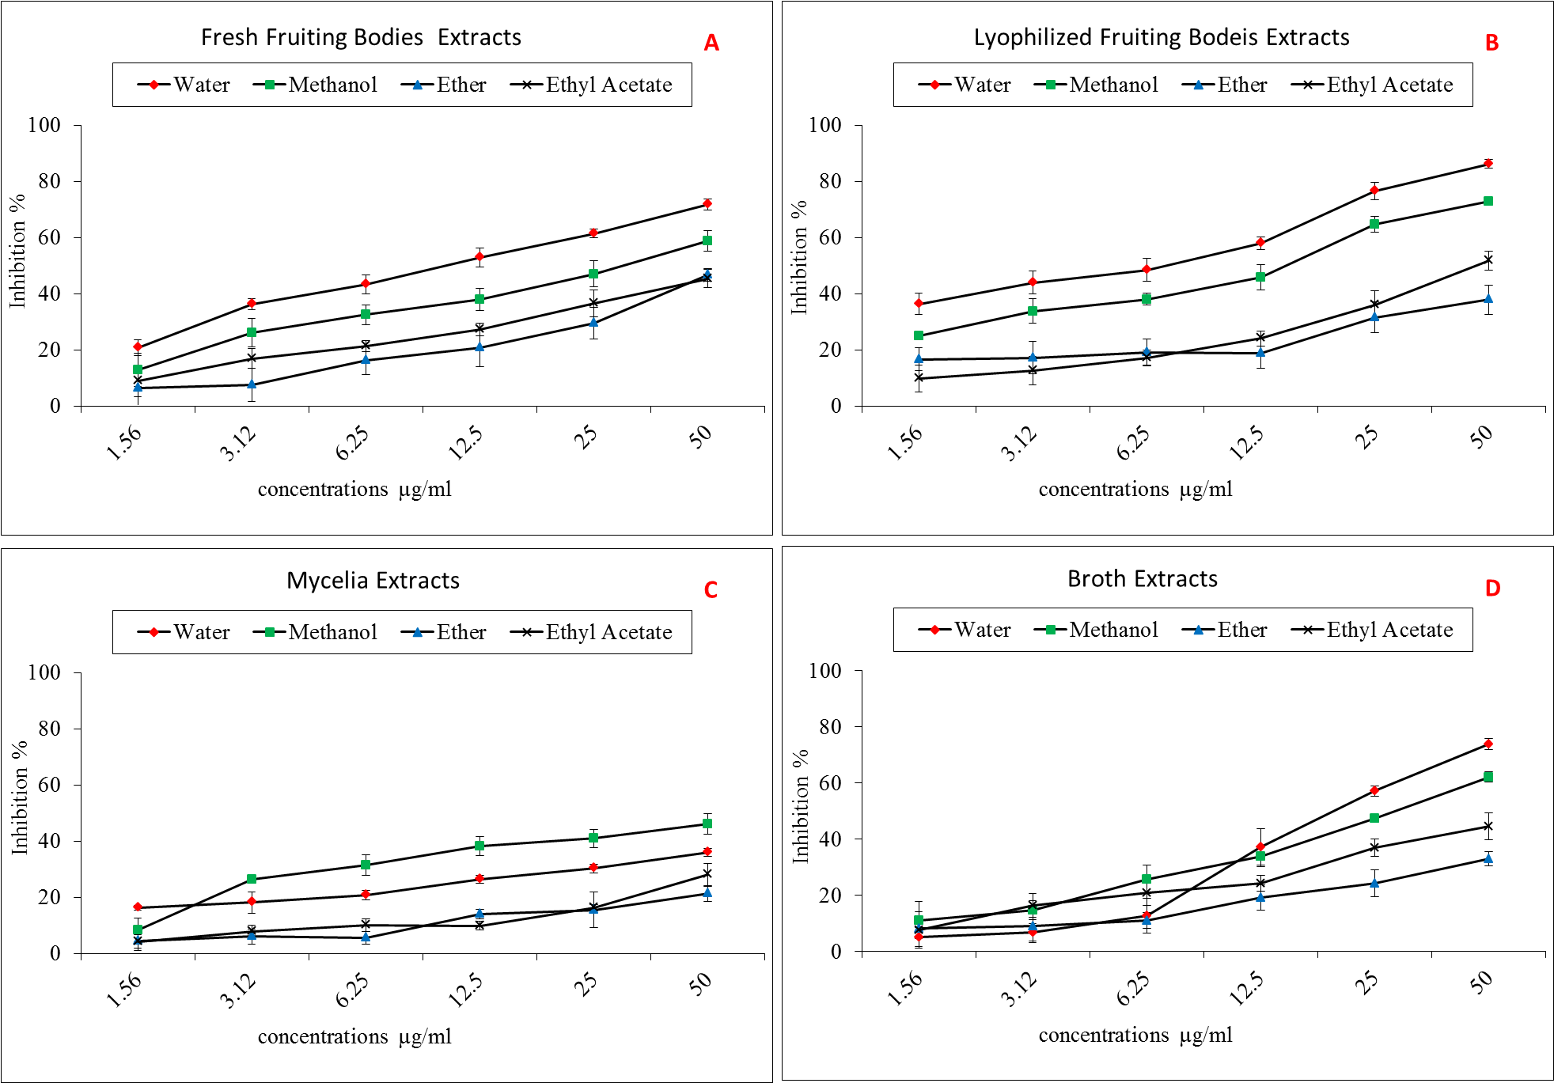
Fig. 5. The antitumor activities of G. lucidum extracts against HCT 116 cell line.

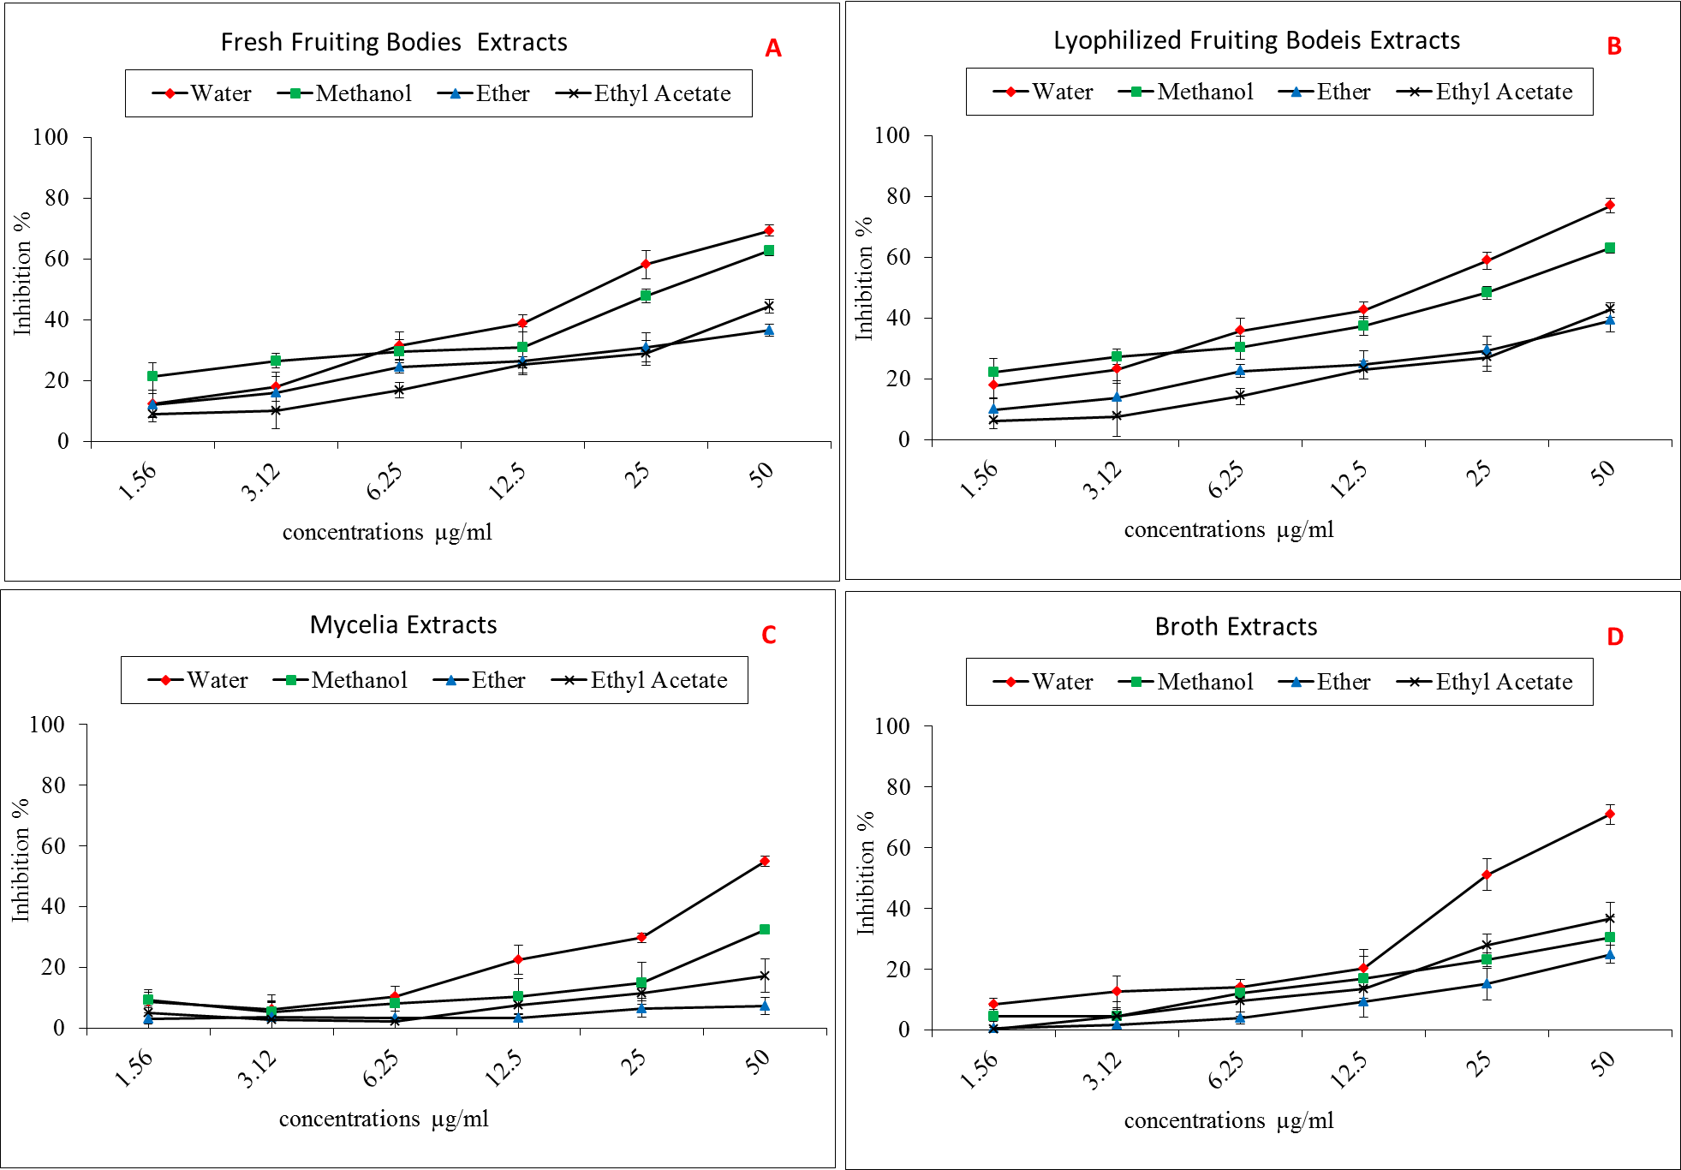
Fig. 6. The antitumor activities of G. lucidum extracts against HeLa cell line.

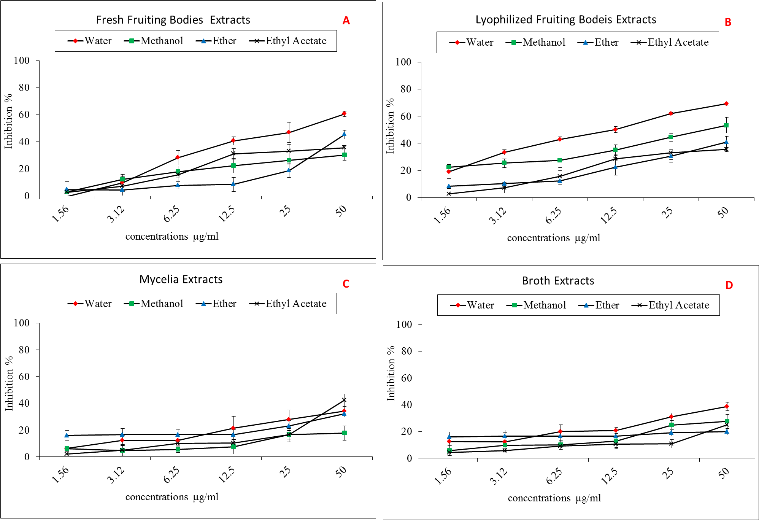
Fig. 7. The cytotoxicity activities of P. eryngii extracts against Hep G2 cell line.

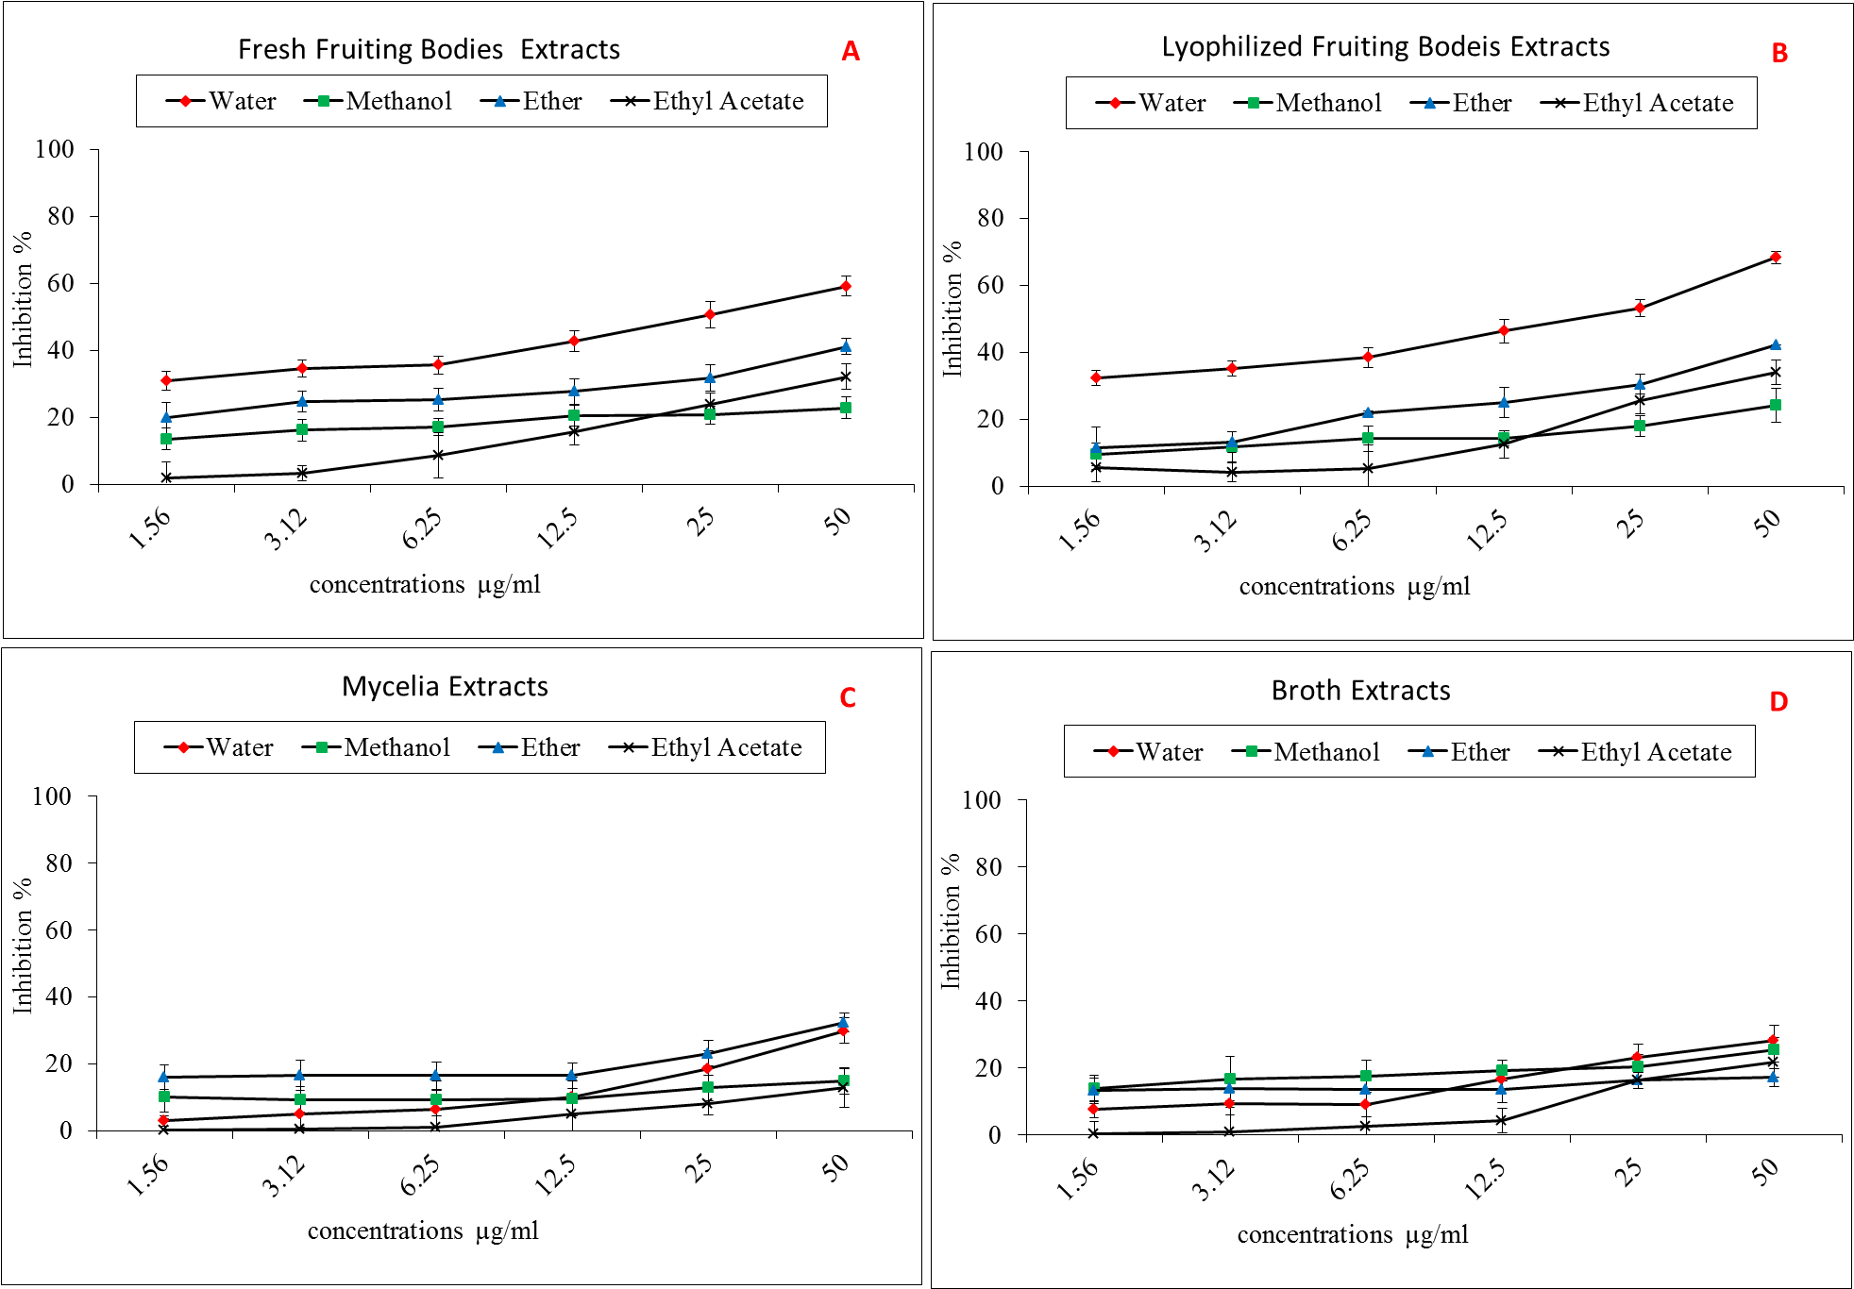
Fig. 8. The antitumor activities of P. eryngii extracts against HCT 116 cell line.

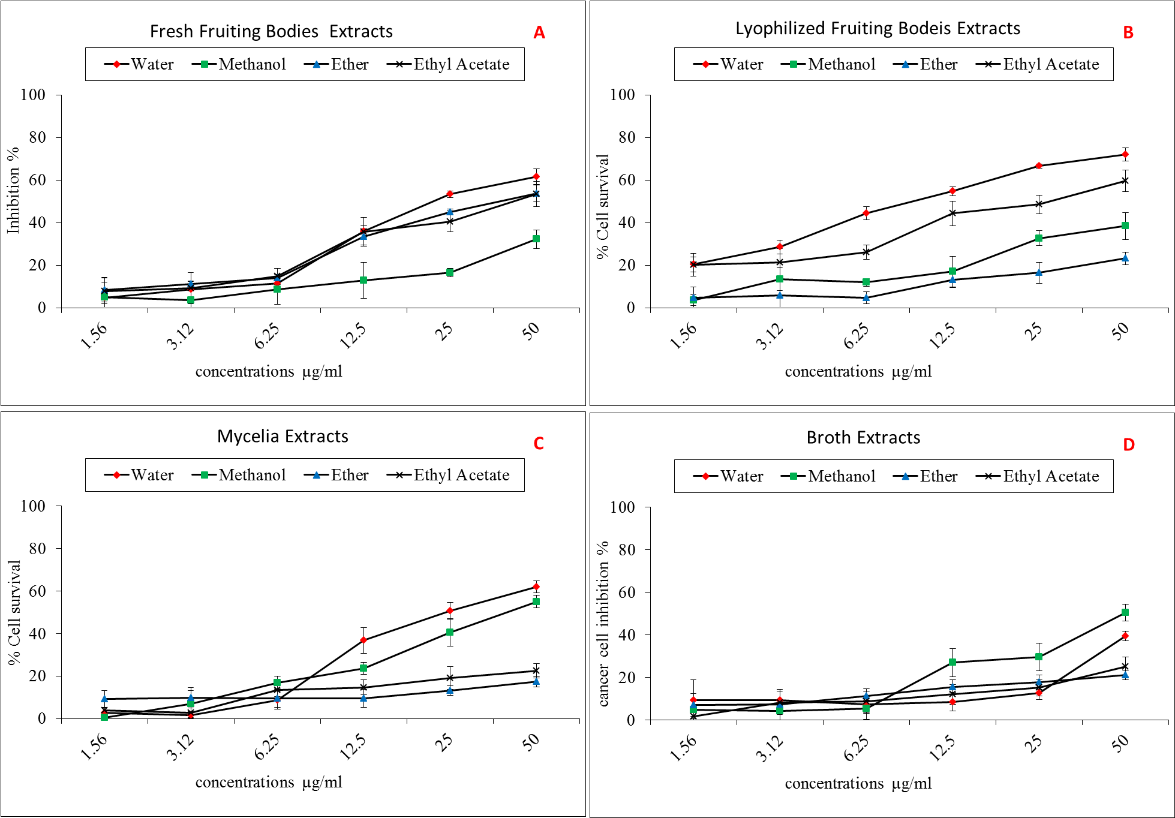
Fig. 9. The antitumor activities of P. eryngii extracts against HeLa cell line.

4. Discussion:
The treatment options of cancer including surgery, chemotherapy, radiation therapy, and palliative care often are expensive and have side effects. For example, most chemotherapeutic agents for the treatment of cancer destroy tumors and stop cancer progress but also damage healthy cells and tissues. Due to these side effects, researchers search for new antitumor substances from various natural sources, especially fungi (Cui et al., 2011; Rajendran et al., 2013; Evidente et al., 2014). More than 140 fungal metabolites have shown confirmed activity in tumor cell line bioassays (Wang et al., 2011). Although F. velutipes, G. lucidum and P. eryngii, are also fungi, their antitumor activities have not been fully exploited.
Our results demonstrated that mushroom extracts can be a good source for antitumor substances, and these results are consistent with reports indicating that mushrooms extracts had antitumor effects. For examples, low-molecular weight mushroom substances have been studied, and reported to interact with particular intracellular signaling pathways related to processes such as inflammation, cell differentiation and survival, apoptosis, angiogenesis, tumor progression and metastasis (Petrova, 2012). Many polysaccharide or polysaccharide protein complexes isolated from mushrooms exhibit antitumor activity (Wasser, 2002; Ma et al., 2013). Lentinan, a polysaccharide isolated from water extract of L. edodes has strong antitumor activities against stomach cancer (Ng and Yap, 2002; Kim et al., 2007; Ina et al., 2013). Also, Finimundy et al. (2013) reported high inhibitory activities against both HeLa and Hep G2 cell lines by water extracts of L. edodes.
Our results clearly indicated that the extracts from lyophilized fruiting bodies were the most potent extracts with inhibitory effects against the tumor cells followed by the extracts from fresh fruiting bodies. In contrast, the extracts from mycelia and broth had the least antitumor activity against the three carcinoma cell lines. Also, in general the extracts by water and methanol had a stronger inhibitory effect than the extracts by ether and ethyl acetate.
In our results, water extracts of F. velutipes fruiting bodies showed the highest inhibition effect against the three tumor cells with IC₅₀ ranging between 5-16 μg/ml. This result is similar to reports observed by Ikekawa et al. (1983) who isolated an antitumor polysaccharide EA501 from F. velutipes composed of D-glucose 42.3%, D-galactose 17.3%, D-mannose 12.2%, D-xylose 6.7% and L-arabinose 14.7%. A similar polysaccharide has been isolated from F. velutipes with antitumor activity (Leung et al., 1997). Also, a protein-bound polysaccharideisolated from F. velutipes can prolong the lifespan of mice challenged with leukemic cells (Otagiriet et al., 1983).
Several ribosome inactivating proteins have been purified from F. velutipes, including flammulin (40 kDa) (Wang and Ng, 2000), velutin (13.8 kDa) (Wang and Ng, 2001), flammin (30 kDa) and velin (19 kDa) (Ng and Wang, 2004).
In our study the methanol and water extracts of G. lucidum fruiting bodies showed highly inhibitory activities against the three tumor cells with IC₅₀ ranging between 7.9±0.6 and 32.7±1.9 µg/ml. Other studies also show that G. lucidum extracts possess anti-proliferative effects on many tumor cell lines in vitro (Suarez-Arroyo et al., 2013), such as anti-proliferative effects against a colorectal prostate cancer cell line (Berovic et al., 2003), lung cancer cell line (Jiang et al., 2005), acute myelogenous leukemia cancer cell line (Cheng et al., 2007), breast cancer cell line (Thyagarajan et al., 2006), colorectal cancer cell line (Xie et al., 2006), and bladder cancer cell line (Paterson, 2006). The water extract and the polysaccharides fraction of G. lucidum exhibited significant antitumor effect in several tumor-bearing animals, mainly through its immunoenhancing activity (Wang and Wang, 2006). Studies also showed that the alcohol extract or the triterpene fraction of G. lucidum possessed antitumor effect, which seemed to be related to the antitumor activity against tumor cells directly (Lin and Zhang, 2004).
In our study, the water extracts of P. eryngii fruiting bodies showed the highest inhibitory activities by P. eryngii extracts but lower than water extracts of F. velutipes and G. lucidum fruiting bodies against the three tumor cells with IC₅₀ ranging between 17.1±0.9 and 34.8±1.6 µg/ml. There are also many reports of antitumor effects of water-soluble polysaccharide isolated from P. eryngii (Zhang et al., 2013; Kawai et al., 2014; Fontana et al., 2014). In addition, Ma et al. (2014) isolated three water-soluble polysaccharides named PEPE-1, PEPE-2 and PEPE-3 from P. eryngii and mainly composed of glucose, sulfate and uronic acid content with antitumor activities against HepG-2. Also, Yang et al. (2013) reported significant inhibition of the tumor growth of mice bearing renal cancer with water-soluble polysaccharide isolated from P. eryngii at the doses of 50, 100 and 200mg/kg.
Cancer is a leading cause of death worldwide resulting in 8.2 million or 14.6% of all human deaths, with financial costs estimated at $1.16 trillion US dollars per year (WHO, 2014). Moreover, new antitumor agents that are available on the market are very limited and with unwanted side effects (Chang et al., 2010). The discovery of new antitumor compounds is therefore becoming more important. The facts that edible mushrooms are non-toxic and contain various compounds beneficial to human health; encouraged us to study the mushrooms activities as a sources of antitumor drugs. Our finding that the water extracts from the three mushrooms F. velutipes, G. lucidum and P. eryngii contain antitumor compounds that are effective against the three tumor cell lines. In addition, these active mushroom extracts can be used in combination with traditional chemotherapy or might be considered alternative sources for adjuvant cancer therapy, as they have no unfavorable effects and they activate the cells of the immune system (Barros et al., 2007; Jedinak and Sliva, 2008; Patel and Goyal, 2012).
More studies will be needed to isolate and identify the active compounds and determine the antitumor effect of these active compounds, as well as the effects on normal healthy cells. We believe that it is worthwhile to exploit the potential of these antitumor compounds in treating the cancer diseases.

Author contributions:
Younis A, Stewart J and Elaasser M contributed equally to this work; Wu F, El Shikh H and Hassan F designed the research; Younis A and Stewart J performed the research; Younis A and Stewart J analyzed the data; Younis A and Elaasser M wrote the paper.
E mails: a.younis81@yahoo.com, amyounis@vcu.edu, mmelaasser@hotmail.com, jstewart@vcu.edu.

Corresponding author:
Ahmed Younis
Department of Biology, Collage of Humanities and Science, Virginia Commonwealth University, Richmond, VA, 842012, USA.
Email: a.younis81@yahoo.com
phone: +2 01007055145, +1 8048280650.

Reference:
- Jemal A, Bray F, Center MM, Ferlay J, Ward E, Forman D. Global cancer statistics. CA Cancer J Clin. 2011;61:69-90.
- Lozano, R. Global and regional mortality from 235 causes of death for 20 age groups in 1990 and 2010: a systematic analysis for the global burden of disease study 2010. Lancet. 2012;380:2095-2128.
- Kushi LH, Doyle C, McCullough M, Rock CL, Wahnefried WD, Bandera EV, Gapstur S, Patel AV, Andrews K, Gansler T. American Cancer Society Guidelines on nutrition and physical activity for cancer prevention: reducing the risk of cancer with healthy food choices and physical activity. CA Cancer J Clin. 2012;62:30-67.
- de Martel C, Ferlay J, Franceschi S, Vignat J, Bray F, Forman D, Plummer M. Global burden of cancers attributable to infections in 2008: a review and synthetic analysis. The Lancet Oncology 2012;13:607-615.
- WHO, World Health Organization. World Cancer Report 2014. WHO Press, Geneva, Switzerland, 2014; Chapter 4.7.
- Cragg GM, Newman DJ. Plants as a source of anti-cancer agents. J Ethnopharmacology. 2005; 100:72–79.
- Chung M, Chung CK, Jeong Y, Ham SS. Anticancer activity of subfractions containing pure compounds of Chaga mushroom (Inonotus obliquus) extract in human cancer cells and in Balbc/c mice bearing Sarcoma-180 cells. Nutr Res Pract. 2010;4:177-182.
- Syam S, Abdul AB, Sukari MA, Mohan S, Abdelwahab SI, Wah TS. The growth suppressing effects of girinimbine on Hep G2 involve induction of apoptosis and cell cycle arrest. Molecules. 2011;16:7155-7170.
- Ren L, Perera C, Hemar Y. Antitumor activity of mushroom polysaccharides: a review. Food Funct. 2012; 3:1118-1130.
- Bladt TT, Frisvad JC, Knudsen PB and Larsen TO. Anticancer and Antifungal Compounds from Aspergillus, Penicillium and Other Filamentous Fungi. Molecules. 2013:18:11338-11376.
- Zhao J, Li C, Wang W, Zhao C, Luo M, Mu F, Fu Y, Zu Y, Yao M. Hypocrealixii, novel endophytic fungi producing anticancer agent cajanol, isolated from pigeon pea (Cajanuscajan Millsp). J Appl Microbiol. 2013;115:102-13.
- Evidente A, Kornienko A, Cimmino A, Andolfi A, Lefranc F, Mathieud V, Kiss R. Fungal metabolites with anticancer activity. Nat Prod Rep. 2014;31:617-627.
- Sun Y. Structure and biological activities of the polysaccharides from the leaves, roots and fruits of Panax ginseng C.A. Meyer: An overview. Carbohydrate Polymers. 2011;85:490-499.
- Kalac P. Chemical composition and nutritional value of European species of wild growing mushrooms. Food Chem. 2009;113:9-16.
- Vaz JA, Barros L, Martins A, Santos-Buelga C, Vasconcelos MH, Ferreira ICFR. Chemical composition of wild edible mushrooms and antioxidant properties of their water soluble polysaccharidic and ethanolic fractions. Food Chem. 2011;126:610-616.
- Atri N, Sharma SK, Joshi R, Gulati A, Gulati A. Nutritional and neutraceutical composition of five wild culinary-medicinal species of genus Pleurotus (higher Basidiomycetes) from northwest India. Int J Med Mushrooms. 2013;15:49-56.
- Boda RH, Wani AH, Zargar MA, Ganie BA, Wani BA, Ganie SA. Nutritional values and antioxidant potential of some edible mushrooms of Kashmir valley. Pak J Pharm Sci. 2012;25:623-637.
- Lau BF, Abdullah N, Aminudin N. Chemical composition of the tiger's milk mushroom, Lignosusrhinocerotis (Cooke) Ryvarden, from different developmental stages. J Agric Food Chem. 2013;61:4890-4897.
- Alves MJ, Ferreira IC, Dias J, Teixeira V, Martins A, Pintado M. A review on antimicrobial activity of mushroom (Basidiomycetes) extracts and isolated compounds. Planta Med. 2012;78:1707-1718.
- Chang ST, Wasser SP. The role of culinary medicinal mushrooms on human welfare with a pyramid model for human health. Int J Med Mushrooms. 2012;14:95-134.
- Krishnaveni M, Manikandan M. Antimicrobial activity of mushrooms. Res J Pharm and Technol. 2014;7:399-400.
- Pan HH, Yu XT, Li T, Wu HL, Jiao CW, Cai MH, Li XM, Xie YZ, Wang Y, Peng T. Aqueous extract from a Chaga medicinal mushroom, Inonotus obliquus (higher Basidiomycetes), prevents herpes simplex virus entry through inhibition of viral-induced membrane fusion. Int J Med Mushrooms. 2013;15:29-38.
- Ferreira IC, Barros L, Abreu RM. Antioxidants in wild mushrooms. Curr Med Chem. 2009;16:1543-1560.
- Liu J, Jia L, Kan J, Jin CH. In vitro and in vivo antioxidant activity of ethanolic extract of white button mushroom Agaricus bisporus. Food Chem Toxicol. 2013;51:310-316.
- Stajic M, Vukojevic J, Knežević A, Laušević SD, Milovanović I. Antioxidant protective effects of mushroom metabolites. Curr Top Med Chem. 2013;13:2660-2676.
- Ebigwai JK, Edu EA, Itam EH, Mofunanya AJ. Activity of crude cold-water extract of the culinary-medicinal oyster mushroom, Pleurotus ostreatus, P. Kumm. (higher Basidiomycetes), and timolol maleate on induced ocular hypertension. Int J Med Mushrooms. 2012;14:467-470.
- Berger A, Rein D, Kratky E, Monnard I, Hajjaj H, Meirim I, Piguet-Welsch C, Hauser J, Mace K, Niederberger P. Cholesterol-lowering properties of Ganoderma lucidum in vitro, ex vivo, and in hamsters and minipigs. Lipids Health Dis. 2004;3:1-12.
- Guillamon E, García-Lafuente A, Lozano M, D'Arrigo M, Rostagno MA, Villares A, Martínez JA. Edible mushrooms: role in the prevention of cardiovascular diseases. Fitoterapia. 2010;81:715-723.
- Sato M, Tokuji Y, Yoneyama S, Fujii-Akiyama K, Kinoshita M, Chiji H, Ohnishi M. Effect of dietary Maitake (Grifola frondosa) mushrooms on plasma cholesterol and hepatic gene expression in cholesterol-fed mice. J Oleo Sci. 2013;62:1049-1058.
- Wu X, Zeng J, Hu J, Liao Q, Zhou R, Zhang P, Chen Z. Hepatoprotective effects of aqueous extract from Lingzhi or Reishi medicinal mushroom Ganoderma lucidum (higher basidiomycetes) on α-amanitin-induced liver injury in mice. Int J Med Mushrooms. 2013;15:383-391.
- Iwalokun BA, Usen UA, Otunba AA, Olukoya DK. Comparative phytochemical evaluation, antimicrobial and antioxidant properties of Pleurotus ostreatus. Afr J Biochnol. 2007;6:1732-1739.
- Soares AA, de Sá-Nakanishi AB, Bracht A, da Costa SM, Koehnlein LA, de Souza CGM, Peralta RM. Hepatoprotective effects of mushrooms. Molecules. 2013;18:7609-7630.
- Ganeshpurkar A, Rai G. Experimental evaluation of analgesic and anti-inflammatory potential of oyster mushroom Pleurotus florida. Indian J Pharmacol. 2013;45:66-70.
- Gunawardena D, Shanmugam K, Low M, Bennett L, Govindaraghavan S, Head R, Ooi L, Münch G. Determination of anti-inflammatory activities of standardized preparations of plant- and mushroom-based foods. Eur J Nutr. 2013;52:1287-1305.
- Lo HC., and Wasser SP. Medicinal mushrooms for glycemic control in diabetes mellitus: history, current status, future perspectives, and unsolved problems. Int J Med Mushrooms. 2011;13:401-26.
- Fontana S, Flugy A, Schillaci O, Cannizzaro A, Gargano ML, Saitta A, De Leo G, Venturella G, Alessandro R. In vitro antitumor effects of the cold-water extracts of Mediterranean species of genus Pleurotus (higher Basidiomycetes) on human colon cancer cells. Int J Med Mushrooms. 2014;16:49-63.
- Xu B, Li C, Sung C. Telomerase inhibitory effects of medicinal mushrooms and lichens, and their anticancer activity. Int J Med Mushrooms. 2014;16:17-28.
- Ferreira IC, Vaz JA, Vasconcelos MH, Martins A. Compounds from wild mushrooms with antitumor potential. Anticancer Agents Med Chem. 2010;10:424-436.
- Wu JY, Chen CH, Chang WH, Chung KT, Liu YW, Lu FJ, Chen CH. Anti-cancer effects of protein extracts from Calvatia lilacina. Pleurotus ostreatus and Volvariella volvacea. Evid Based Complement Alternat Med. 2011;2011:1-10.
- Finimundy TC, Gambato G, Fontana R, Camassola M, Salvador M, Moura S, Hess J, Henriques JA, Dillon AJ, Roesch-Ely M. Aqueous extracts of Lentinula edodes and Pleurotus sajor-caju exhibit high antioxidant capability and promising in vitro antitumor activity. Nutr Res. 2013;33:76-84.
- Zhang M, Cui S, Cheung P, Wang Q. Antitumor polysaccharides from mushrooms: a review on their isolation process, structural characteristics and antitumor activity. Trends Food Sci Technol. 2007;18:4-19.
- Moharib SA, Maksoud NA, Ragab HM Shehata MM. Anticancer Activities of Mushroom Polysaccharides on Chemically-Induced Colorectal Cancer in Rats. J App Pharm Sci. 2014;4: 054-063.
- Ng ML, Yap AT. Inhibition of human colon carcinoma development by lentinan from shiitake mushrooms (Lentinus edodes). J Altern Complement Med. 2002;8: 581-9.
- Yamaguchi Y, Miyahara E, Hihara J. Efficacy and safety of orally administered Lentinulaedodes mycelia extract for patients undergoing cancer chemotherapy: a pilot study. Am J Chin Med 2011;39:451-9.
- Schwartz B, Hadar Y. Possible mechanisms of action of mushroom-derived glucans on inflammatory bowel disease and associated cancer. Ann Transl Med. 2014;2:8-19.
- Jwanny EW, Moharib SA, Rasmy GE. Effect of two polysaccharides on chemically-induced colorectal cancer in rats. Adv Food Sci. 2009;31:202-209.
- Martin KR, Brophy SK. Commonly consumed and specialty dietary mushrooms reduce cellular proliferation in MCF-7 human breast cancer cells. Exp Biol Med Maywood. 2010;235:1306-14.
- Mosmann T. Rapid colorimetric assay for cellular growth and survival: application to proliferation and cytotoxicity assays. J Immunol Methods. 1983;65:55-63.
- Wu, Y, Wang, Y. Inhibition of Astragalusm embranaceus polysaccharides against liver cancer cell Hep G2. Afr J Microbiolo Res. 2010;4:2181-2183.
- Elaasser MM, Abdel-Aziz MM and El-Kassas RA. Antioxidant, antimicrobial, antiviral and antitumor activities of pyranone derivative obtained from Aspergillus candidus. J Microbiol Biotech Res. 2011;1:5-17.
- Cui J, Guo S, Xiao P. Antitumor and antimicrobial activities of endophytic fungi from medicinal parts of Aquilaria sinensis. J Zhejiang Univ Sci B. 2011;12:385–392.
- Rajendran L, Rajagopal K, Subbarayan K, Ulagappan K, Sampath A, and Karthik G. Efficiency of fungal taxol on human liver carcinoma cell lines. American J Res Communication, 2013;1:112-121.
- Wang LW, Zhang YL, Lin FC, Hu YZ, Zhang CL Natural products with antitumor activity from endophytic fungi. Mini Rev Med Chem. 2011;11:1056-74.
- Petrova RD. New scientific approaches to cancer treatment: can medicinal mushrooms defeat the curse of the century? Int J Med Mushrooms. 2012;14:1-20.
- Wasser S.P. Medicinal mushrooms as a source of antitumor and immunomodulating polysaccharides. Appl Microbiol Biotechnol. 2002;60:258-274.
- Ma L, Chen H, Dong P, Lu X. Anti-inflammatory and anticancer activities of extracts and compounds from the mushroom Inonotus obliquus. Food Chem. 2013;139:503-508.
- Kim HY, Kim JH, Yang SB, Hong SG, Lee SA, Hwang SJ, Shin KS, Suh HJ, Park MH. A polysaccharide extracted from rice bran fermented with Lentinus edodes enhances natural killer cell activity and exhibits anticancer effects. J Med Food 2007;10:25–31.
- Ina K, Kataoka T, Ando T. The use of lentinan for treating gastric cancer. Anticancer Agents Med Chem. 2013;13:681-688.
- Ikekawa T, Ikeda Y, Yoshioka Y, Nakanishi K, Yokoyama E, Yamazaki E. Studies on antitumor polysaccharides of Flammulina velutipes (Curt. ex Fr.) Sing.II.he structure of EA3 and further purification of EA5. J Pharmacobiodyn. 1982;5:576-81.
- Leung MY, Fung KP, Choy YM. The isolation and characterization of an immunomodulatory and anti-tumor polysaccharide preparation from Flammulina velutipes. Immunopharmacology. 1997;35:255–263.
- Otagiri K, Ohkuma T, Ikekawa T, Tanaka S. Intensification of antitumor-immunity by protein-bound polysaccharide, EA6, derived from Flammulina velutipes (Curt. ex Fr.) Sing. combined with murine leukemia L1210 vaccine in animal experiments. J Pharmacobiodyn. 1983;6:96–104.
- Wang HX, Ng TB. Flammulin: a novel ribosome-inactivating protein from fruiting bodies of the winter mushroom Flammulina velutipes. Biochem Cell Biol. 2000;78:699-702.
- Wang HX, Ng TB. Isolation and characterization of velutin, a novel low-molecular-weight ribosome-inactivating protein from winter mushroom (Flammulina velutipes) fruiting bodies. Life Sci. 2001;68:2151-8.
- Ng TB, Wang HX. Flammin and velin: new ribosome inactivating polypeptides from the mushroom Flammulina velutipes. Peptides 2004;25:929–933.
- Suarez-Arroyo IJ, Rosario-Acevedo R, Aguilar-Perez A, Clemente PL, Cubano LA, Serrano J, Schneider RJ, Martínez-Montemayor MM. Anti-Tumor Effects of Ganoderma lucidum (Reishi) in Inflammatory Breast Cancer in In Vivo and In Vitro Models. Plos One. 2013;8: e57431.
- Berovic M, Habijanic J, Zore I, Wraber B, Hodzar D, Boh B, Pohleven F. Submerged cultivation of Ganoderma lucidum biomass and immunostimulatory effects of fungal polysaccharides. J Biotechnol. 2003;103:77–86.
- Jiang Y, Wang H, Lu L, Tian GY. Chemistry of polysaccharide Lzps-1 from Ganoderma lucidum spore and anti-tumor activity of its total polysaccharides. Yao Xue Xue Bao. 2005;40:347-350.
- Cheng KC, Huang HC, Chen JH, Hsu JW, Cheng HC, Ou CH, Yang WB, Chen ST, Wong CH, Juan HF. Ganoderma lucidum polysaccharides in human monocytic leukemia cells: from gene expression to network construction. BMC Genomics 2007;8:411.
- Thyagarajan A, Jiang J, Hopf A, Adamec J, Sliva D. Inhibition of oxidative stress-induced invasiveness of cancer cells by Ganoderma lucidum is mediated through the suppression of interleukin-8 secretion. Int J Mol Med 2006;18:657-664.
- Xie JT, Wang CZ, Wicks S, Yin JJ, Kong J, Li J, Li YC and Yuan CS. Ganoderma lucidum extract inhibits proliferation of SW 480 human colorectal cancer cells. Exp Oncol. 2006;28:25-29.
- Paterson RR. Ganoderma a therapeutic fungal biofactory. Phytochemistry. 2006;67:1985-2001.
- Wang DH, Weng XC. Antitumor activity of extracts of Ganoderma lucidum and their protective effects on damaged HL-7702 cells induced by radiotherapy and chemotherapy. Zhongguo Zhong Yao Za Zhi. 2006;31:1618-22.
- Lin ZB, Zhang HN. Anti-tumor and immunoregulatory activities of Ganoderma lucidum and its possible mechanisms. Acta Pharmacol Sin. 2004;25:1387-95.
- Zhang, HP, Zhang J, Nan Z, Sun RG, Zhang P, Liu A, Lang T. Structure characterization and antitumor activity of polysaccharide WPP2 from Pleurotus eryngii. Chemical Journal of Chinese Universities. 2013;34:2327-2333.
- Kawai J, Andoh T, Ouchi K, Inatomi, S. Pleurotus eryngii Ameliorates Lipopolysaccharide-Induced Lung Inflammation in Mice. Evidence-Based Complementary and Alternative Medicine. 2014;2014:,1-7.
- Ma, G. Yang, W. Mariga, A. M., Fang, Y. Ma, N. Pei, Hu, Q. Purification, characterization and antitumor activity of polysaccharides from Pleurotus eryngii residue. Carbohydrate Polymers. 2014;114:297-305.
- Yang Z, Xu J, Fu Q, Fu X, Shu T, Bi Y, Song B. Antitumor activity of a polysaccharide from Pleurotus eryngii on mice bearing renal cancer. Carbohydr Polym. 2013;95:615-20.
- Chang HH, Hsieh KY, Yeh CH, Tu YP, Sheu F. Oral administration of an Enoki mushroom protein FVE activates innate and adaptive immunity and induces anti-tumor activity against murine hepatocellular carcinoma. Int Immunopharmacol. 2010;10:239-46.
- Barros L, Baptista P, Estevinho LM, Ferreira ICFR. Bioactive properties of the medicinal mushroom Leucopaxillus giganteus mycelium obtained in the presence of different nitrogen sources. Food Chem. 2007;105:179–186.
- Jedinak A, Sliva D. Pleurotus ostreatus inhibits proliferation of human breast and colon cancer cells through p53-dependent as well as p53- independent pathway. Int J Oncol. 2008;33:1307-1313.
- Patel S, Goyal A. Recent developments in mushrooms as anti-cancer therapeutics: a review. Biotech, 2012;2:1-15.

9/30/2014

